3GPP TSG-RAN WG2 Meeting # 116-E R2-211xxxx
Electronic Meeting, November, 2021

Title: LS on inter-frequency DAPS handover with overlapping bandwidth
Response to:
Release: Rel-16
Work Item: NR_Mob_enh-Core

Source: OPPO [to be RAN2]
To: RAN1, RAN4
Cc:

Contact Person:
Name: Qianxi Lu
E-mail Address: qianxi.lu@OPPO.com

Send any reply LS to: 3GPP Liaisons Coordinator, mailto:3GPPLiaison@etsi.org

Attachments: -

1. Overall Description:
RAN2 discussed the use case for Rel-16 DAPS handover in RAN2#116-e, and did not conclude on whether the following scenario as a valid case as shown in the figure below
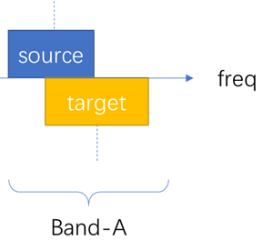
Figure 1 Intra-band inter-frequency DAPS handover where source-cell overlap with target cell

Which is an intra-band inter-frequency DAPS handover, yet the bandwidth of source-cell and bandwidth of target-cell is overlapping with each other.
RAN2 respectively ask RAN1 and RAN4 to feedback whether the scenario above is a valid case for R16 DAPS handover.

2. Actions:
To RAN1 and RAN4:
ACTION: RAN2 respectfully asks RAN1 and RAN4 to feedback whether the scenario above is a valid case for R16 DAPS handover.

3. Date of Next TSG WG RAN2 Meetings:
TSG-RAN WG2 Meeting #116bis-e 17 - 25 Jan 2022 E-meeting
TSG-RAN WG2 Meeting #117bis-e 21 Feb - 03 Mar 2022 E-meeting

