3GPP TSG RAN WG#123 R1-2509577
Dallas, USA, Nov 17th – 21st, 2025

Title: Draft LS on 400MHz maximum bandwidth around 7GHz

Response to:
Release: Rel-20
Work Item: FS_6G_Radio

Source: CMCC [RAN1]
To: RAN4
Cc:

Contact person: Xiaodong Shen
shenxiaodong@chinamobile.com

Send any reply LS to: 3GPP Liaisons Coordinator, mailto:3GPPLiaison@etsi.org

Attachments: -

1 Overall description
RAN 1 has discussed maximum bandwidth around 7GHz and have the following agreements.
Agreement
- RAN1 assumes 400MHz maximum channel bandwidth at network side and 30kHz SCS around 7GHz
  - Study whether and how to enable UE to support 400MHz bandwidth
Agreement
For how to enable UE to support 400MHz bandwidth when a network supports 400 MHz Channel Bandwidth (CBW), the following options 1/2/3/4/5 are considered from RAN1 understanding for studying
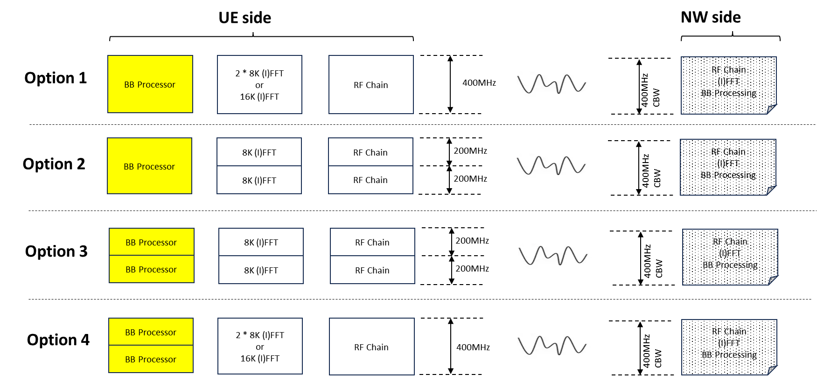
  - Option 5: Variance of Option 3 by assuming single FFT and 2 RF chain.
  - FFS which aspects of the BB processor in option 3 and 4 should be separated/parallelled.
  - Note: DL and UL design options may be considered independently.
  - To provide potential specification impact of each option.
  - To provide investigations on performance/energy efficiency/cost/complexity for the above options.
  - Inform RAN4 about the above information.

2 Actions
To RAN WG1:
ACTION: RAN1 would like to inform RAN4 about the above information.

3 Dates of next TSG RAN WG1 meetings
RAN1#124 9th – 13th February 2026 Stor-Göteborg, Sweden
RAN1#124bis 13th – 17th April 2026 Malta, MT

