RAN1#123 Online Session Schedule
Lone Star Ballroom B
Seminar Theater
Dallas Ballroom B
 | Monday |  |  | Tuesday |  |  | Wednesday |  |  | Thursday |  |  | Friday
08:30  ~  10:30  (120 min) | RAN1#123 commences at 09:00 on Monday  Agenda items 1, 2, 3, 4, 5  Maintenance 8.3 |  |  | 6GR  Channel coding (40)  Evaluation (40)  Overall (40) | R19UE features (120) | AI 8 (60)  . 8.8  R20 Coverage (60) | 6GR  Overall (40)  Waveform (40)  Channel coding (40) | AI 8 (120)  MIMO (60)  NES (60) | R19 UE features (120) | 6GR  Waveform (80)  Overall (40) | AI 8 (120)  AI/ML (40)NTN-NR (40)  NTN-IoT (40) | R20 Coverage (60)  R20 ISAC (60) | 6GR  Energy (40)  Channel coding (40)  Evaluation(40) | R20 NR-NTN (120) | R20 A-IoT (120)
Morning coffee break: 10:30 ~ 11:00
11:00  ~  13:00  (120 min) | Maintenance (70)  . 8.3  . 8.6  6GR (50)  Overall (50) |  |  | 6GR  AI/ML (70)  Waveform (50) | AI 8 (120)  NTN-NR (40)  NTN-IoT (40)  AI/ML (40) | AI 8 (30)  . 8.4  R20 A-IoT (90) | 6GR  Modulation (40)  AI/ML (80) | AI 6,7 (60)  R20 NR-NTN (60) | AI 8 (30)  . 8.4  R20 A-IoT (90) | 6GR  AI/ML (40)  Channel coding (40)  Energy(40) | R20 MIMO (120) | R20 A-IoT (120) | Sweep  AI 8  6GR  Short break: 13:00-13:30  Resume at 13:30
Lunch break: 13:00 ~ 14:30
14:30  ~  16:30  (120 min) | 6GR  Energy (80)  Frame structure (40) | AI 6, 7 (60)  AI 8 (60)  MIMO (30)  NES (30) | AI 8 (60)  . 8.8  R20 Coverage (60) | 6GR  Energy (80)  Frame structure (40) | R20  MIMO (60)  R20  NR-NTN (60) | R20 ISAC (60)  R20 A-IoT (60) | UE features wrap up  6GR  Energy (80)  Frame structure (40) | NR-NTN (60)  R20  MIMO (60) | R20 ISAC (60) (60)  R20 Coverage (60) | AI 8 (120) | R20 NR-NTN (60)  AI 8 (60) | AI 8 (60)  . 8.8  R20 ISAC (60) | Any other open issues  . Session reports  . etc  RAN1#123 expected to close at 14:30
Afternoon coffee break: 16:30 ~ 17:00
17:00  ~  19:30  (150 min) | 6GR (150)  Waveform(50)  Modulation (50)  Energy (50) | R20 AI/ML (50)  R20  NTN (50)R20  MIMO (50) | R20 A-IoT (100)  R20 ISAC(50) | 6GR (150)  Channel coding(50)  Modulation (50)  Evaluation (50) | AI 6, 7 (60)  R20 AI/ML (90) | R20 A-IoT (150) | 6GR (90)  Evaluations (90) | R20 AI/ML (90) | R20 A-IoT(90) | 6GR  Frame structure (40)  Modulation (50)  Evaluation(60) | R20 AI/ML (150) | R20 A-IoT (150)
All sessions end at 19:45 – no exceptions
RAN1#123 Offline Session Schedule
Lone Star Ballroom A4
City View 8
 | Monday |  |  | Tuesday |  | Wednesday |  | Thursday |  | Friday
08:30  ~  10:30  (120 min) |  |  |  | Xiaodong (120)  6GR  Overall (60)  AI/ML (60) | Hiroki (120)  AI 8.4 (30)  R20 A-IoT (60)  AI 8.8 (30) | Xiaodong (120)  6GR  Modulation (60)  AI/ML (60) | Sorour(40)  R20 NR-NTN (40)  Hiroki (80)  R20 A-IoT (80) | Sorour (60)  R20 MIMO (60)  Xiaodong (60)  6GR  AI/ML (60) | Hiroki (120)  R20 A-IoT (120) | Xiaodong (120)  6GR  Evaluations (75) | Xiaodong (120)  6GR  Modulation (60)  Frame structure (60)
Morning coffee break: 10:30 ~ 11:00
11:00  ~  13:00  (120 min) | Xiaodong (120)  6GR  Overall (60)  Frame structure (60) |  | Hiroki  R20 A-IoT (40)  Xiaodong (80)  6GR  Energy (80) | Xiaodong (120)  6GR  Waveform (60)  Energy (60) | Hiroki (40)  R20 ISAC (40)  Sorour (80)  R20 MIMO (40)  R20 NR-NTN (40) | Xiaodong (120)  6GR  Frame structure (40)  Energy (80) | Hiroki (80)  R20 Coverage (40)  R20 ISAC (40)  Sorour(40)  R20 MIMO (40) | Xiaodong (80)  6GR  Energy (80)  Hiroki (40)  R20 ISAC (40) | Sorour (120)  R20 NR-NTN (60) R20 AI/ML (60)
Lunch break: 13:00 ~ 14:30
14:30  ~  16:30  (120 min) | Xiaodong (120)  6GR  Waveform (60)  Modulation (60) | Sorour (60)  R20 AI/ML (60)  Hiroki (60)  R20 A-IoT (60) |  | Xiaodong (120)  6GR  Frame structure (40)  Channele coding (80) | Hiroki (40)  R20 Coverage (40)  Sorour (80)  R20 AI/ML (80) | Xiaodong (120)  6GR  Overall (40)  . TR skeleton (40)  Evaluation (80) | Sorour (120)  R20 AI/ML (60)  TBD (60) [AI 8 (60) / R20 NTN (60)] | Xiaodong (120)  6GR  AI/ML (40)  Modulation (40)  Frame structure (40) | Hiroki (120)  R20 A-IoT (120) | To be assigned by Sorour  To be assigned by Hiroki
Afternoon coffee break: 16:30 ~ 17:00
17:00  ~  19:30  (150 min) | Hiroki (40)  ISAC (40)  Xiaodong (110)  6GR  Evaluation (60)  Channel coding (50) | Sorour (90)  R20 NTN (40)  R20 MIMO (50)  Hiroki (60)  R20 Coverage (60) |  | Xiaodong (150)  6GR  AI/ML (50)  Overall (50)  Waveform (50) | Xiaodong (150)  6GR  Modulation (50)  Frame structure(50)  TBD (50) [UE features, if necessary] | Xiaodong (90)  6GR  Waveform (90) | Xiaodong (90)  6GR  Channel coding (50)  Overall (40) | Xiaodong (150)  6GR  Evaluation (90)  Waveform (60) | Xiaodong (150)  6GR  Energy (90)  Overall (60)
All sessions end at 19:45 – no exceptions

RAN1#123 Detailed Schedule for RAN1 Main Session

 | Monday | Tuesday | Wednesday | Thursday | Friday
08:30  ~  10:30  (120 min) | Agenda items 1, 2, 3, 4, 5  Maintenance 8.3 | 6GR  Channel coding (40)  Evaluation (40)  Overall (40) | 6GR  Overall (40)  Waveform (40)  Channel coding (40) | 6GR  Waveform (80)  Overall (40) | 6GR  Energy (40)  Evaluation(40)  Channel coding (40)
Morning coffee break: 10:30 ~ 11:00
11:00  ~  13:00  (120 min) | Maintenance (70)  . 8.3  . 8.6  6GR (50)  Overall (50) | 6GR  AI/ML (70)  Waveform (50) | 6GR  Modulation (40)  AI/ML (80) | 6GR  AI/ML (40)  Channel coding (40)  Energy(40) | Sweep  AI 8  6GR  Short break: 13:00-13:30  Resume at 13:30
Lunch break: 13:00 ~ 14:30
14:30  ~  16:30  (120 min) | 6GR  Energy (80)  Frame structure (40) | 6GR  Energy (80)  Frame structure (40) | UE features wrap up  6GR  Energy (80)  Frame structure (40) | AI 8 (120)  . 8.3  . 8.6 | Any other open issues  . Session reports  . etc  RAN1#123 expected to close at 14:30
Afternoon coffee break: 16:30 ~ 17:00
17:00  ~  19:30  (150 min) | 6GR (150)  Waveform (50)  Modulation (50)  Energy (50) | 6GR (150)  Channel coding (50)  Modulation (50)  Evaluation (50) | 6GR (90)  Evaluations (90) | 6GR  Frame structure (40)  Modulation (50)  Evaluation(60)
All sessions end at 19:45 – no exceptions

RAN1 Meeting Rooms: RAN1_Main, RAN1_Off1
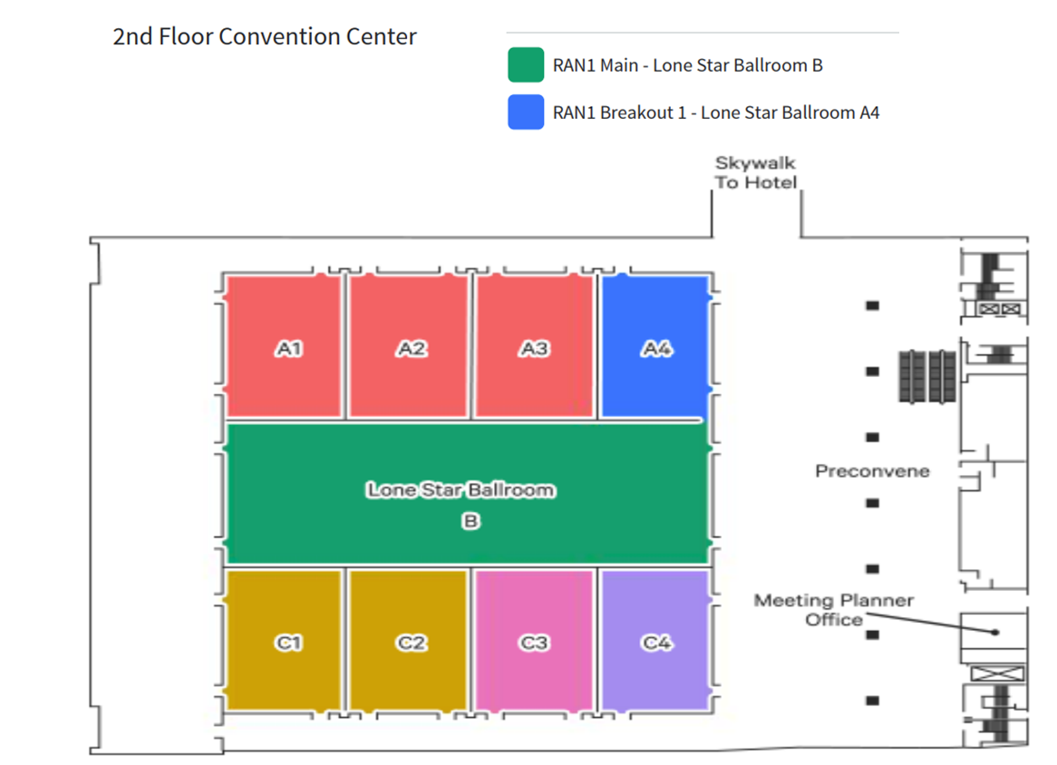

RAN1 Meeting Room: RAN1_Brk1
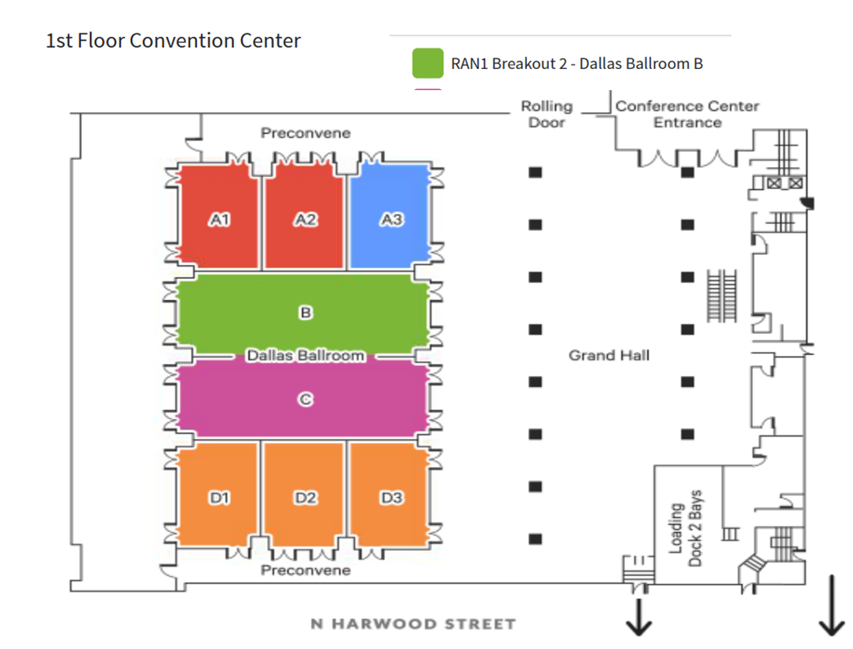

RAN1 Meeting Rooms: RAN1_Brk2, RAN1_Off2
