3GPP TSG RAN WG1 Meeting #102-e R1-2xxxxxx
E-meeting, August 17-28, 2020

Agenda Item: 7.2.5.1
Source: Moderator (Huawei)
Title: Feature lead summary#1 on PDCCH enhancements
Document for: Discussion and Decision

Introduction
This document summarizes the key issues discussed under agenda item 7.2.5.1 based on the views in [2][3][4][5][6][7][8][9][10][11][12][13][14][15], and aims to identify a set of critical issues for RAN1#102-e email discussion.

Summary of issues raised for PDCCH enhancements
This section summarize the issues raised by companies on PDCCH enhancements, among which a set of issues can be identified for RAN1#102-e email discussions per the guidance from Chairman. Note that per the guidance from Chairman, only critical issues should be included and no more “nice to have” features.
Draft recommendation on the email threads and scope are given in section 2.1 and the summary of detailed issues are given in section 2.2.

Recommendation for the scope of email threads

Draft recommendation for the scope of email threads
Based on the summary of issues in section 2.2, the following recommendation are made for the scope of email threads.
---------------------------------------------------------------------------------------------------------------------------
Email discussion #1
Email discussion/approval on remaining issues on DCI format design:
- Issue A-1: Remaining issue on DCI size alignment in TS 38.212
- Issue A-2: Type2 HARQ-ACK codebook construction related to DAI bit width

Companies are encouraged to provide views on whether to include the following issues to the scope.
Company | Issue A-3 | Issue A-4 | Issue A-5 | Comments on other issues if any

Email discussion #2
Email discussion/approval on remaining issues on enhanced PDCCH monitoring capability:
- Issue B-1: Corrections on span definition
- Issue B-2: Corrections on “aligned spans” case
- Issue B-3: Whether to apply M-TRP on the Rel-15 cells for case 3
- Issue B-5-3 & B-5-4 & B-5-6: Miscellaneous editorial corrections

Companies are encouraged to provide views on whether to include the following issues to the scope.
Company | Issue B-4 | Issue B-5-1 | Issue B-5-2 | Comments on other issues if any

Summary of detailed issues
Issues raised on DCI format design
Issue # | Description | Source | Recommended handling
A-1 | Remaining issue on DCI size alignment in TS 38.212  - Whether to ensure different DCI size for DCI format 0_1 and DCI format 1_2, and ensure different DCI size for DCI format 1_1 and DCI format 0_2  - Whether a UE is not expected to monitor DCI formats with same size only when the PDCCH candidates of corresponding DCI formats are mapped to the same resource  Note: Details seen in section 3 | Ericsson  Huawei/HiSilicon  Intel  ZTE  CATT  Qualcomm | Included in email discussion #1  Reason:  - Open issues need to be solved, otherwise specification is not complete
A-2 | Type2 HARQ-ACK codebook construction related to DAI bit width | Huawei/HiSilicon  WILUS | Included in email discussion #1  Reason:  - Critical correction, otherwise the spec is not correct
A-3 | Correction on missing case of PUSCH release for search space sharing | Sharp | More inputs from companies on whether to include or not. If agreed then will be included under email discussion #1.  Reason:  - Issue is valid but a few companies feel not necessary based on initial discussion in previous meeting
A-4 | Correction on Transmission configuration indication in DCI format 1_2 | ASUSTeK | More inputs from companies on whether to include or not. If agreed then will be included under email discussion #1.  Reason:  The issue is valid, but some companies doubt the necessity
A-5 | Ambiguity of subselection indication for DCI format 0_1 and DCI format 0_2 | Sharp | More inputs from companies on whether to include or not. If agreed then will be included under email discussion #1.  Reason:  The issue is valid, but some companies doubt the necessity
A-6 | Changing the candidate RV values from {0, 3} to {0, 2} in case of 1 bit for Redundancy version for DCI format 0_2 | Ericsson  CATT | No discussion in RAN1#102-e again  Reason:  - Belongs to optimization  - Much discussion but no consensus in previous meetings  - Chairman mentioned hope not to see the discussion again  - Chairman guidance: No “nice to have” feature
A-7 | Priority indication via DCI format 0_1/1_1 and 0_2/1_2  - How to determine the priority of transmissions scheduled by the DCI formats 0_1/1_1/0_2/1_2 for a UE that doesn’t support a DCI format scheduling PDSCH with different HARQ-ACK priorities or PUSCH with different priorities when both DCI format 0_1/1_1 and DCI format 0_2/1_2 are configured to monitor?  Note: Details seen in section 3 | Vivo | Continued to be discussed under UCI enhancements  Reason:  - Discussed under UCI enhancements in previous meetings

Issues raised on enhanced PDCCH monitoring capability
Issue # | Description | Source | Recommended handling
B-1 | Corrections on span definition | Apple  Qualcomm  Samsung  Quectel | Included in email discussion #2  Reason:  - Remaining issues from RAN1#101-e
B-2 | Corrections on “aligned spans” case | Ericsson | Included in email discussion #2  Reason:  - Missing essential part from the agreed TPs from RAN1#101-e
B-3 | Whether to apply M-TRP on the Rel-15 cells for case 3 (i.e. both cell(s) with Rel-15 monitoring capability and cell(s) with Rel-16 monitoring capability are configured) | Samsung  ZTE  Quectel | Included in email discussion #2  Reason:  - Essential correction otherwise the specification is not complete
B-4 | PDCCH monitoring for cross-carrier scheduling | Quectel | More inputs from companies on whether to include or not. If agreed then will be included under email discussion #2.  Reason:  - Most part of the TP is on multi-TRP under MIMO WI  - Further clarification on the issue for the text for URLLC needed
Miscellaneous corrections
B-5-1 | Search space determination | Samsung | More inputs from companies on whether to include or not.  Reason:  - Belongs to optimization  - Chairman guidance: No “nice to have” feature
B-5-2 | PDCCH monitoring within a slot | Samsung | More inputs from companies on whether to include or not.  Reason:  - Seems the extension is not necessary since the current restriction is for case 1_2
B-5-3 | PDCCH candidate having common REs with a SS/PBCH block | Samsung | Included in email discussion #2  Reason:  - Essential editorial correction
B-5-4 | Maximum number of UE-specific DCI formats for CA operation | Samsung | Included in email discussion #2  Reason:  Essential editorial correction
B-5-5 | High layer parameters alignment | Huawei/HiSilicon  ZTE | Handled by editor
B-5-6 | Missing descriptions on PDCCH monitoring capability for Rel-16 cells in CA case 2 and case 3 if configured carrier number is equal to or less than UE capability | ZTE  Spreadtrum | Included in email discussion #2  Reason:  Essential editorial correction

DCI format scheduling Rel-16 URLLC
Based on the contributions from companies, the following issues related to DCI format design are discussed.

Issue A-1: Remaining issue on DCI size alignment due to the introduction of DCI format 0_2/1_2
In RAN1#101-e meeting, DCI size alignment was discussed and the following agreements were made:
Agreement
- A UE is not expected to monitor a first decoding candidate with DCI format 0_0/1_0 and a second candidate with DCI format 0_2/1_2, where the two decoding candidates are mapped to the same resource and the DCI formats 0_0/1_0 and 0_2/1_2 have the same size.
- A UE is not expected to monitor a first decoding candidate with DCI format 0_1/1_1 and a second candidate with DCI format 0_2/1_2, where the two decoding candidates are mapped to the same resource and the DCI formats 0_1/1_1 and 0_2/1_2 have the same size.
However, the specification is not complete for the above agreement, since there is no consensus on the following two bullets:
- There is no need for gNB to ensure different DCI size for DCI format 0_1 and DCI format 1_2
- There is no need for gNB to ensure different DCI size for DCI format 1_1 and DCI format 0_2
Some companies provide views on the above issue in the contribution and the position is summarized as below:
  - Support: (i.e. there is no need for gNB to ensure different DCI size for DCI format 0_1 and DCI format 1_2, and there is no need for gNB to ensure different DCI size for DCI format 1_1 and DCI format 0_2)
    - Ericsson, Intel, ZTE, Huawei, HiSilicon, CATT

  - Reasons
    - The “Identifier for DCI formats” field in DCI formats can always be used to differentiate UL DCI format and DL DCI format, therefore no need for gNB to ensure different DCI size.
    - If we force different sizes for DL and UL, it will introduce draw backs like increasing the DCI size unnecessary, increasing more difficulty at gNB side to ensure different size unnecessary, etc.
    - The current agreement exactly means that the DCI size alignment is only performed between DL DCI formats or UL DCI formats. The text in the RAN1 agreement is consistent only if “0_x/1_x” is interpreted as “0_x and 1_x, respectively”, and not if interpreted as “x_0 and x_1”. This is because a decoding candidate cannot correspond to more than one DCI format, unless they are of the same size, and if they are of the same size, then it the issue is moot.

  - Note support: any DCI format of 0_1 and 1_1 cannot be size-aligned with any DCI of 0_2 and 1_2
    - Qualcomm
  - Reasons
    - Simplifies the UE implementation, as it allows the UE to determine the DCI format (between 0_1/1_1 and 0_2/1_2) prior to decoding the PDCCH.

Feature lead view #1: The above issue was discussed a lot last meeting, and there is very strong majority view. Therefore, it is recommended to go to the majority view.

In addition, Ericsson (R1-2005506) additionally pointed that if the CORESET and search space configurations do not lead to any PDCCH candidates of different DCI formats having the same CCE mapping, it is not necessary that the sizes of those DCI formats need to be different.
- RAN1#101e agreement covers the cases where a UE is not expected to monitor DCI formats with same size only when the PDCCH candidates of corresponding DCI formats are mapped to the same resource.
  - Support: Ericsson

Feature lead view #2: In theory it is true that there is no need to ensure different size when there is no overlap. However, it can be expected that more complexity will be increased at both gNB and UE sides. Therefore, it is recommended to keep what given in the current specification.

Based on the situation for the above two issues, it is recommended to go with the proposal below:

Proposal 3-1: Endorse the text proposal in R1-2xxxxxx for TS 38.212 Section 7.3.1.0.

7.3.1.0 DCI size alignment
*** Unchanged text is omitted ***
The UE is not expected to handle a configuration that, after applying the above steps, results in
- the total number of different DCI sizes configured to monitor is more than 4 for the cell; or
- the total number of different DCI sizes with C-RNTI configured to monitor is more than 3 for the cell; or
- the size of DCI format 0_0 in a UE-specific search space is equal to DCI format 0_1 in another UE-specific search space; or
- the size of DCI format 1_0 in a UE-specific search space is equal to DCI format 1_1 in another UE-specific search space; or
- the size of DCI format 0_0 in a UE-specific search space is equal to DCI format 0_2 in another UE-specific search space; or
- the size of DCI format 1_0 in a UE-specific search space is equal to DCI format 1_2 in another UE-specific search space ; or
- the size of DCI format 0_2 in a UE-specific search space is equal to DCI format 0_1 in the same or another UE-specific search space; or
- the size of DCI format 1_2 in a UE-specific search space is equal to DCI format 1_1 in the same or another UE-specific search space.
*** Unchanged text is omitted ***

Company | View

Issue A-2: Type2 HARQ-ACK codebook construction related to DAI bit width
In RAN1#101-e meeting, type 2 HARQ-ACK codebook construction related to DAI bit width was discussed under PDCCH enhancements, and the following agreement was achieved:
Agreement
If UE is configured to monitor DCI format 1_2/0_2, the HARQ-ACK codebook size for type-2 HARQ-ACK codebook is determined by
Further, the pseudo-code related to the agreement was also specified in section 9.1.3 of TS38.213 v16.2.0:
9.1.3.1 Type-2 HARQ-ACK codebook in physical uplink control channel
[…]
If the UE transmits HARQ-ACK information in a PUCCH in slot $n$ and for any PUCCH format, the UE determines the , for a total number of $O_{ACK}$ HARQ-ACK information bits, according to the following pseudo-code:
Set – PDCCH with DCI format scheduling PDSCH reception or SPS PDSCH release monitoring occasion index: lower index corresponds to earlier PDCCH monitoring occasion
Set
Set
Set
Set
Set to the number of serving cells configured by higher layers for the UE
[…]
Set to the number of PDCCH monitoring occasion(s)
while
[…]
end while
if
end if
if harq-ACK-SpatialBundlingPUCCH is not provided to the UE and the UE is configured by maxNrofCodeWordsScheduledByDCI with reception of two transport blocks for at least one configured DL BWP of a serving cell,
$$O^{ACK}=2⋅\left(T_{D}⋅j+\left(\left(V_{temp2}-1\right)mod T_{D}+1\right)\right)$$
else
$$O^{ACK}=T_{D}⋅j+\left(\left(V_{temp2}-1\right)mod T_{D}+1\right)$$
end if
for any

However, Huawei (R1-2005790) and WILUS (R1-2006882) pointed out that some error exists with the pseudo highlight in yellow.
Huawei R1-2005790
Take the case shown in Table 1 as an example, where the gNB sends 3 DL DCIs with 1-bit counter DAI in three monitoring occasions and one UL grant with 2-bit UL DAI=3. If there is no missed DCI in the given example, then both gNB and the UE will have the same understanding about the codebook size, i.e. O^{Ack} = 3. However, if the DL DCI in MO#3 is missed, based on the value in Table 1 and the pseudo code highlighted in yellow above, the value of j is still equal to 0, which will result in O^{Ack} = 1 according to the equation $O^{ACK}=T_{D}⋅j+\left(\left(V_{temp2}-1\right)mod T_{D}+1\right)$ for type 2 HARQ-ACK codebook construction. The reason for this problem is that the yellow-marked pseudo-code “$if V_{temp2}<V_{temp}, j=j+1, end if$” will not update the value of $j$ in this case, because $V_{temp2}=3$ is not smaller than $V_{temp}=2$ in this case because of the different number of bits that are used for counter DAI and total DAI.
Table 1 - Last DCI is missed (2-bits UL DAI and 1-bit counter DAI)
 | MO#1 | MO#2 | MO#3 | UL grant
 | cDAI=1 | cDAI=2 | cDAI=1 | UL DAI=3
Correct value of $j$ assuming no missed DCI | 0 | 0 | 1
Value of j according to the pseudo code in the spec if DCI in MO#3 is missed | 0 | 0

Note that when no DCI is missed or one DCI but not the last one is missed, then there is no problem as shown in table 2 below.
Table 2 - No DCI or one DCI but not the last one is missed (2-bits UL DAI and 1-bit counter DAI)
 | MO#1 | MO#2 | MO#3 | UL grant
 | cDAI=1 | cDAI=2 | cDAI=1 | UL DAI=3
Correct value of $j$ assuming no missed DCI | 0 | 0 | 1
Value of j according to pseudo code in the spec if DCI in MO#1 is missed |  | 0 | 1
Value of j according to pseudo code in the spec if DCI in MO#2 is missed | 0 |  | 1

To solve this issue, we propose to change the yellow pseudo-code to “$if \left(V_{temp2}-1\right)modT_{D}+1<V_{temp}, j=j+1, end if$”. Then the value of $j$ will be updated correctly even if the DCI in MO#3 is missed.
Proposal 3: Change the pseudo-code “$if V_{temp2}<V_{temp}, j=j+1, end if$” to “$if \left(V_{temp2}-1\right)modT_{D}+1<V_{temp}, j=j+1, end if$” in section 9.1.3.1 of 38.213. Endorse the TP below.
9.1.3.1 Type-2 HARQ-ACK codebook in physical uplink control channel
***Unchanged text is omitted***
if Vtemp2<Vtemp Vtemp2-1modTD+1<Vtemp
end if
***Unchanged text is omitted***

WILUS R1-2006882
In the revised pseudo-code, the type-2 HARQ-ACK codebook size is determined based on V_{temp2} as well as the value of j. Also, the value of j is incremented when V_{temp2} is less than V_{temp} (as shown in the yellow part in the pseudo-code). Note that V_{temp2} is coming from UL DAI value, which is one of {1, 2, 3, 4}, and V_{temp} is the last counter-DAI value, which is one of {1, 2, … $2^{T_{D}}$}, among counter-DAI values included in received PDCCHs. The range of two values such as V_{temp} and V_{temp2} is not aligned due to configurable counter-DAI field size, T_{D}. Therefore, it is necessary to align the range of two values by comparing the two values in the pseudo-code. Similarly, as in the modifications by the agreement at RAN1#101-e meeting, since the range of V_{temp2} can be re-interpreted to that of V_{temp}, the comparison should be performed by the re-interpreted value of V_{temp2}, i.e., $\left(\left(V_{temp2}-1\right)mod T_{D}+1\right)$.
  - Proposal 1: In case of HARQ-ACK multiplexing on PUSCH, the value of j is determined by comparing between the re-interpreted value of V_{temp2}, i.e.,$\left(\left(V_{temp2}-1\right)mod T_{D}+1\right)$, and V_{temp}.
  - Proposal 2: Adopt the following text proposal for TS38.213

Feature lead view: The issue does exist and needs to be addressed. The proposal from Huawei and WILUS looks reasonable.

Proposal 3-2: Endorse the text proposal in R1-2xxxxxx for TS 38.213 Section 9.1.3.1.

9.1.3.1 Type-2 HARQ-ACK codebook in physical uplink control channel
***Unchanged text is omitted***
if Vtemp2<Vtemp Vtemp2-1modTD+1<Vtemp
end if
***Unchanged text is omitted***

Please provide your views on proposal 3-2.
Company | View

Issue A-3: Missing case of PUSCH release for search space sharing
In Rel-15, DCI format 0_1 is used for search space sharing. Note that although DCI format 0_1 cannot be used for release of type 2 PUSCH but can be used for release of semi-persistent CSI transmission on PUSCH.
In Rel-16, the DCI format 0_1 and 0_2 are further agreed to support release of type 2 PUSCH transmission. However, the above description of search space sharing captures the DCI format scheduling PDSCH reception, SPS PDSCH release, DCI format scheduling PUSCH transmission but miss capturing the PUSCH release. Therefore, PUSCH release should be captured to make the description of search space sharing correct and precise.
Sharp (R1-2006563) proposes to adopt the following TP for section 10.1 in TS 38.213 to compensate for a missing case of PUSCH release for search space sharing.
TP2
TS 38.213 V16.1.0 (2020-03)

10.1 UE procedure for determining physical downlink control channel assignment
< Unchanged parts are omitted >
A UE that
- is configured for operation with carrier aggregation, and
- indicates support of search space sharing through searchSpaceSharingCA-UL or through searchSpaceSharingCA-DL, and
- has a PDCCH candidate with CCE aggregation level in CORESET for a first DCI format scheduling PUSCH transmission or releasing PUSCH transmission, other than DCI format 0_0, or for a second DCI format scheduling PDSCH reception or SPS PDSCH release, other than DCI format 1_0, having a first size and associated with serving cell ,
can receive a corresponding PDCCH through a PDCCH candidate with CCE aggregation level in CORESET for a first DCI format or for a second DCI format, respectively, having a second size and associated with serving cell if the first size and the second size are same.
< Unchanged parts are omitted >

Feature lead view: The issue is valid. As to the TP, some companies commented that it might have impact on the Rel-15 behavior, e.g. it may give the impression that in Rel-15 DCI format 0_1 can be used for releasing of type 2 PUSCH. However, if it is an issue then it seems the issue exist for SPS PDSCH release also. Probably ok to have simple correction here since anyway there is other sections in the spec which define the corresponding DCI format (s) for PUSCH release and SPS release.

Proposal 3-3: Endorse the text proposal in R1-2xxxxxx for TS 38.213 Section 10.1.

10.1 UE procedure for determining physical downlink control channel assignment
< Unchanged parts are omitted >
A UE that
- is configured for operation with carrier aggregation, and
- indicates support of search space sharing through searchSpaceSharingCA-UL or through searchSpaceSharingCA-DL, and
- has a PDCCH candidate with CCE aggregation level in CORESET for a first DCI format scheduling PUSCH transmission or releasing PUSCH transmission, other than DCI format 0_0, or for a second DCI format scheduling PDSCH reception or SPS PDSCH release, other than DCI format 1_0, having a first size and associated with serving cell ,
can receive a corresponding PDCCH through a PDCCH candidate with CCE aggregation level in CORESET for a first DCI format or for a second DCI format, respectively, having a second size and associated with serving cell if the first size and the second size are same.
< Unchanged parts are omitted >

Please provide your views whether the TP is needed or not.
Company | View

Issue A-4: Correction on Transmission configuration indication in DCI format 1_2
ASUSTeK R1-2006865

In Rel-15 NR, whether a TCI bitfield is in DCI format 1_1 is determined based on TCI-PresentInDCI in CORESET information element. If TCI-PresentInDCI is enabled, size of TCI bitfield is 3 bits in DCI format 1_1. Otherwise, TCI bitfield is not present (e.g., 0 bits) in DCI format 1_1. In addition, since TCI-PresentInDCI is a CORESET specific parameter rather than a BWP specific parameter, for a DCI indicating BWP switching, UE assumes that size of TCI bitfield (e.g., 0 or 3 bits) in target BWP is the same as scheduling CORESET in current BWP. In other words, in case TCI-PresentInDCI is enabled, UE receives scheduled PDSCH in target BWP via a TCI state indicated by the TCI bitfield in scheduling DCI. In case TCI-PresentInDCI is disabled, UE receives scheduled PDSCH in target BWP via a TCI state of the scheduling CORESET.
For new DCI format (i.e., DCI format 1_2) scheduling Rel-16 URLLC, a more compact size of DCI is considered. In RAN1 #99 meeting, size of TCI bitfield in DCI format 1_2 is agreed to be configured with more candidate values like 1, 2 bits additional to 0, 3 bits. According to current running CR [3], handling TCI bitfield for BWP switching DCI format 1_2 is similar to DCI format 1_1 in Rel-15 NR. However, since TCI-PresentInDCI could be configured as 1, 2, 3 bits, it’s not clear for the size of TCI bitfield of target BWP according to current running CR that the UE assume TCI bitfield is enabled for all CORESETs in target BWP. It may have impact on whether the UE performs zero padding or truncating on the TCI bitfield. In addition, it may cause problem if different assumption of size of TCI bitfield for all CORESETs in target BWP between UE and gNB. For example, in figure 1, a UE is configured with tci-PresentInDCI-ForDCIFormat1_2 as 2 bits for a DCI format 1_2 in a CORESET. For a received DCI format 1_2 indicating BWP switching, if spec does not specify how many bits of TCI bitfield the UE assume for all CORESETs in target BWP, it may cause misalignment between gNB and UE when gNB assumes no truncation or zero padding for TCI bitfield “10” while truncated TCI bitfield state “0” is performed by UE (if UE assumes 1 bits of TCI bitfield for all CORESETs in target BWP).
TCI bitfield value | TCI state |  | TCI bitfield value | TCI state
00 | A |  | 0 | A
01 | B |  | 1 | B
10 | C
11 | D
Current BWP |  |  | UE assume 1 bits for TCI bitfield for all CORESETs in target BWP

Figure. 1
In our view, since TCI state association or a TCI code-point could be reused after BWP change, it’s not necessary for UE to assume less bits for TCI bitfield. In addition, it may be fine for UE to assume larger bits for TCI bitfield since padding zero does not change the amount of TCI states that DCI format 1_2 can indicate. However, in our view, it’s simpler to follow similar logic in Rel-15 NR that by assuming same size of TCI bitfield as current CORESET for all CORESETs in target BWP for a BWP switching DCI. In other words, for a DCI format 1_2 indicating BWP switching and with configured tci-PresentInDCI-ForDCIFormat1_2, the UE assume same size of TCI bitfield in DCI format 1_2 and enabled for all CORESETs in target BWP. Figure 2 is an example for illustrating the solution.
TCI bitfield value | TCI state |  | TCI bitfield value | TCI state
00 | A |  | 00 | A
01 | B |  | 01 | B
10 | C |  | 10 | C
11 | D |  | 11 | D
Current BWP |  |  | UE assume the same number of bits for TCI bitfield for all CORESETs in target BWP

Figure. 2
Observation: For TCI bitfield with configured tci-PresentInDCI-ForDCIFormat1_2 in a DCI format 1_2 indicating BWP switch, it’s not clear how the UE assume size of TCI bitfield for all CORESETs in target BWP.
Proposal: Adopt following TP.
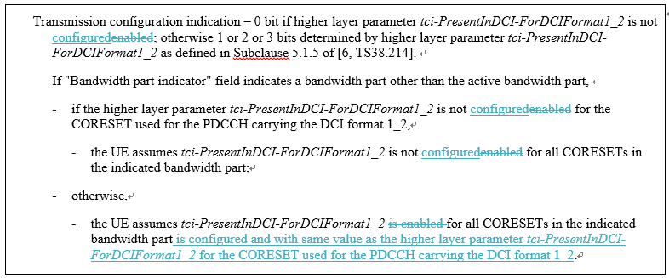

Feature lead view: The issue looks valid. However, during the preparation phase in RAN1#100b-e, some companies commented that the change is not needed. More views are needed. The following proposal is made for further discussion.
Proposal 3-4: Endorse the text proposal in R1-2xxxxxx for TS 38.212 Section 7.3.1.2.3.

7.3.1.2.3 Format 1_2
***Unchanged text is omitted***
- Transmission configuration indication – 0 bit if higher layer parameter tci-PresentForDCI-Format1-2 is not configured; otherwise 1 or 2 or 3 bits determined by higher layer parameter tci-PresentForDCI-Format1-2 as defined in Clause 5.1.5 of [6, TS38.214].
If "Bandwidth part indicator" field indicates a bandwidth part other than the active bandwidth part,
- if the higher layer parameter tci-PresentForDCI-Format1-2 is not configured for the CORESET used for the PDCCH carrying the DCI format 1_2,
- the UE assumes tci-PresentForDCI-Format1-2 is not configured for all CORESETs in the indicated bandwidth part;
- otherwise,
- the UE assumes tci-PresentForDCI-Format1-2 is configured for all CORESETs in the indicated bandwidth part with the same value configured for the CORESET used for the PDCCH carrying the DCI format 1_2.
***Unchanged text is omitted***

Please provide your views on proposal 3-4, including whether need it or not.
Company | View

Issue A-5: Ambiguity of subselection indication for DCI format 0_1 and DCI format 0_2

Sharp (R1-2006563)
According to the TS 38.214 [1], aperiodic CSI-RS trigger procedure for DCI format 0_1 is applied to that for DCI format 0_2 by applying the higher layer parameter reportTriggerSize-ForDCIFormat0_2 instead of reportTriggerSize. Furthermore, as described in 5.2.1.5.1 in TS 38.214, when the number of configured CSI triggering states in CSI-AperiodicTriggerStateList is greater than , the UE would receive a subselection indication for selection of the configured aperiodic triggering states. For a case where the number of configured CSI triggering states would be larger than the corresponding number indicated by the reportTriggerSize and also be larger than the corresponding number indicated the reportTriggerSize-ForDCIFormat0_2, it would give an impression that the UE 102 would receive two subselection indications. However, the subselection indication is common for the DCI format 0_1 and 0_2.
Moreover, the number of selected CSI trigger states in the subselection indication should be a maximum number between the number indicated by the reportTriggerSize and the number indicated the reportTriggerSize-ForDCIFormat0_2. That is, the CSI request field with less bitwidth in a DCI format is used to map to the first selected CSI trigger states of the selected CSI trigger states in the subselection indication.
Proposal 1: Adopt the following TP in TS 38.214 to precisely describe the subselection indication used for aperiodic CSI-RS trigger procedure for DCI format 0_1 and DCI format 0_2.

TS 38.214 V16.2.0 (2020-06)

5.2.1.5.1 Aperiodic CSI Reporting/Aperiodic CSI-RS when the triggering PDCCH and the CSI-RS have the same numerology
< Unchanged parts are omitted >
A trigger state is initiated using the CSI request field in DCI.
- When all the bits of CSI request field in DCI are set to zero, no CSI is requested.
- When the number of configured CSI triggering states in CSI-AperiodicTriggerStateList is greater than , where is the number of bits in the DCI CSI request field, the UE receives a subselection indication, as described in clause 6.1.3.13 of [10, TS 38.321], used to map up to first trigger states to the codepoints of the CSI request field in DCI. is configured by the higher layer parameter reportTriggerSize where . When the UE would transmit a PUCCH with HARQ-ACK information in slot n corresponding to the PDSCH carrying the subselection indication, the corresponding action in [10, TS 38.321] and UE assumption on the mapping of the selected CSI trigger state(s) to the codepoint(s) of DCI CSI request field shall be applied starting from the first slot that is after slot $n+{3N}_{slot}^{subframe,µ}$ where μ is the SCS configuration for the PUCCH. For the case that the number of configured CSI triggering states in CSI-AperiodicTriggerStateList is greater than , where is the number of bits in the DCI CSI request field in either of DCI format 0_1 and DCI format 0_2, the subselection indication is applied to both DCI format 0_1 and DCI format 0_2.
- When the number of CSI triggering states in CSI-AperiodicTriggerStateList is less than or equal to , the CSI request field in DCI directly indicates the triggering state.

Feature lead view: The issue looks valid. However, more views are needed before making decision on how to correct the specification.

Please provide your views on the proposed TP above.
Company | View

Issue A-6: Whether to change the candidate RV values from {0, 3} to {0, 2} in case of 1 bit for Redundancy version for DCI format 0_2?
Ericsson R1-2005506
For DCI format 1_2 scheduling PDSCH, if only one bit is signalled, the redundancy version to be applied is either 0 or 3. This is a reasonable choice for PDSCH since both RV 0 and 3 are self-decodable for high code rate, and error cases exist where the gNB cannot tell whether the UE received the first transmission and stored the corresponding soft values or not. This is not the case for PUSCH. If the UE does not transmit the PUSCH correctly due to a missed grant, it is possible for the gNB to detect this, e.g. by looking at the noise level estimate based on DMRS. In this case the gNB can schedule the retransmission using RV 0 (basically treating it as the first transmission), which gives better performance than using RV 3 for a first transmission. On the other hand, if the first PUSCH transmission is transmitted correctly, but not decoded at the gNB due to a noisy transmission, the gNB would like to schedule the retransmission using RV 2, and soft combine with the first transmission. This gives better performance than using RV 3, as can be seen in [3] where Figure 1 appears. For this case, LDPC base graph (BG) #1 is used for information block size of K=1056 bits, and two consecutive transmissions are soft combined before decoding. As can be observed from Figure 1, for medium to high code rates above 2/3 (=0.67), the difference between using RV 3 and RV 2 for the second transmission is more than 1.5 dB over an AWGN channel.
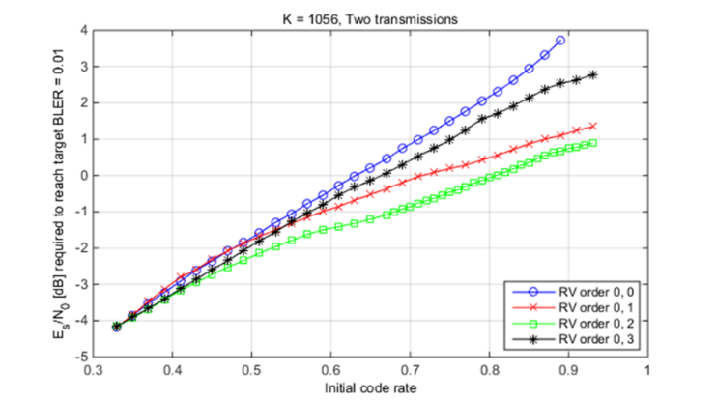
Figure 1 Required SNR for decoding after two transmissions for different RV orders for BG1. K is the TBS including CRC bits.

Dynamically scheduled PUSCH is a case where there is no ambiguity about whether transmission occurred, or which instance of a transmission occurred. Self-decodability is not important for an individual retransmission. Hence the gNB should be able to schedule for best performance, i.e. it should be able to signal RV 2.

- For dynamically scheduled PUSCH, there is no ambiguity at the gNB whether the first transmission occurred or not, and RV should be chosen to maximize performance.

During the email discussion in RAN1 #101e [4], different proposals were discussed. There are strong supports from companies to change RV candidate set to {0,2} for DCI format 0_2 in case of 1-bit RV field based on the better overall performance. There is also a proposal to change to {0,2} for DL DCI format 1_2 as well. And lastly there is a proposal to introduce a new RRC parameter to configure between {0,2} and {0,3} where it was argued that {0, 3} can be beneficial for some repetition case.
First, we note that there is no significant performance difference between {0,2} and {0,3} for the case of PUSCH repetition case.
- The number of repetitions can be dynamically indicated. If we use 4 repetitions, then RVs are cycled through the whole sequence and there would not be any performance difference between the two RV candidate sets.
- When repetition is used to increase reliability, the initial code rate is likely to be small, and the repetitions are used to lower it further. In this case, there is little difference between the two RV candidate sets.
The only case where {0,3} may be better than {0,2} is when the number of repetitions is 2 and the code rate of each repetition is high. However, this case should be seen as a corner case and is not a typical scheduling case as it is more likely to use a single repetition with lower code rate, because repetition with high code rate is inferior to single transmission with low code rate.
Therefore, considering the overall performance including the repetition case, the RV candidate set {0,2} is much better than {0,3}.

- For dynamically scheduled PUSCH, considering the overall performance including repetition case, the RV candidate set {0,2} is much better than {0,3}.

Regarding DL transmission, there can be issues of mis-detection of PDCCH and loss of HARQ-ACK for PDSCH. If HARQ-ACK is transmitted together with other HARQ-ACK bits by a Type-1 HARQ-ACK codebook, gNB would not be able to distinguish between the case of missed PDCCH and the case of correct PDCCH but failed PDSCH decoding. The same holds also for Type-2 HARQ-ACK codebook where the UE will insert a 0 bit for a missed PDCCH that the UE can infer due to DAI. The gNB is not able to distinguish a 0 due to failed decoding or an inserted 0 due to PDCCH mis-detection. Since {0,3} provides better robustness than {0,2}, we do not see a strong need to change the RV candidates for DL DCI.

- For PDSCH, there is no strong need to change RV candidates from {0,3} as there exists the issue of mis-detection of PDCCH and loss of HARQ-ACK for PDSCH where {0,3} can provide good robustness.

Regarding a new RRC parameter to configure between {0, 3} and {0, 2}, we don’t see any justification for it. As discussed above, the overall performance from {0, 2} is much better than {0, 3}. The only exception might be for the case of 2 repetitions with high code rate which is a corner case. In fact, since PUSCH repetition can be dynamically indicated and the number of repetitions can change dynamically, there would be no benefit from RRC configuration the choice of RV candidates in order to optimize the performance based on repetition.

- There is no benefit from RRC configuring the choice of RV candidates in order to optimize the performance based on repetition since the number of repetitions can change dynamically.

Based on the analysis above, we propose that the RV candidates is {0, 2} when only one bit is used to signal RV in DCI format 0_2. This is motivated from performance reasons as well as to align with the agreement made for NR-U on a similar issue. The text proposal for TS 38.212 is provided below.

- When only one bit is used to signal RV in DCI format 0_2, it indicates either RV 0 or RV 2.

--------------------------- Text Proposal for 38.212 Section 7.3.1.1.3 ---------------------------------------------

*** Unchanged text is omitted ***
- Redundancy version – 0, 1 or 2 bits determined by higher layer parameter NumberofbitsforRV-ForDCIFormat0_2
- If 0 bit is configured, rv_{id} to be applied is 0;
- 1 bit according to Table 7.3.1.2.3-1 7.3.1.1.2-34;
- 2 bits according to Table 7.3.1.1.1-2.

*** Unchanged text is omitted ***
----------------------------------------------End of proposed TP --------------------------------------------------

CATT R1-2005672
During the last meeting, it was extensively discussed whether to change the RV sequence {0,3} to {0,2} if 1 bit RV indicator is configured in the DCI format 0_2. The motivation of making this change is gNB can judge whether the scheduled UL transmission is the initial transmission or a re-transmission. Consequently, gNB could determine to indicate RV0 or RV2 to obtain additional combination gain. The performance gain is verified by the evaluation results provided in contribution [1]. Although the benefits derived from RV sequence {0,2} compared to RV sequence {0,3} were recognized by companies, there are three potential optimizations on the table for now:
- Change the candidate RV sequence from {0, 3} to {0, 2} in case of 1 bit for Redundancy version for DCI format 0_2
- Change the candidate RV sequence from {0, 3} to {0, 2} in case of 1 bit for Redundancy version for both DCI format 0_2 and DCI format 1_2
- Introduce a new RRC parameter to configure which RV sequence is applied in case of 1 bit for Redundancy version for both DCI format 0_2 and DCI format 1_2
From our perspective, there is no issue to change the candidate RV sequence from {0, 3} to {0, 2} in case of 1 bit for Redundancy version for DCI format 1_2. gNB can still determine whether the scheduled TB is new or re-transmitted. It can indicate the RV value accordingly and make the scheduled UE enjoy the coding gain coming from the more proper redundancy version.
The motivation of introducing a new RRC parameter is RV sequence {0,2} is not as good as {0,3} if two repetitions occur. Furthermore, RV sequence {0,2} cannot bring additional gains compared to {0,3} if the network does not support DTX detection. However, the new RRC parameter should be introduced very carefully at such a late stage. It is not critical and the system works as well as it is without the new RRC parameter. We think change the candidate RV sequence from {0, 3} to {0, 2} in case of 1 bit for Redundancy version for both DCI format 0_2 and DCI format 1_2 is a reasonable .

Proposal 1: Change the candidate RV sequence from {0, 3} to {0, 2} in case of 1 bit for Redundancy version for both DCI format 0_2 and DCI format 1_2.

Feature lead view: This issue was discussed in RAN1#101-e and no consensus was achieved even we took big effort. And it seems Chairman mentioned that he hoped to see no this discussion again. Therefore, it is recommended not to discuss again in this meeting.

Issue A-7: Priority indication via DCI format 0_1/1_1 and 0_2/1_2
The following agreements was made in RAN1#99:
Agreement:
When both DCI format 0_1/1_1 and DCI format 0_2/1_2 are configured to be monitored per BWP, a DCI format (from the formats 0_1/1_1/0_2/1_2) can be used to schedule PDSCH with different HARQ-ACK priorities or PUSCH with different priorities.
- This feature is UE optional

Working assumption:
When a single PDSCH/PUSCH processing timeline is configured in the carrier, at least when only DCI format 0_1/1_1 is configured or only DCI format 0_2/1_2 is configured in USS per BWP, a DCI format (from the formats 0_1/1_1/0_2/1_2) can be used to schedule PDSCH with different HARQ-ACK priorities or PUSCH with different priorities.
- 1-bit field in DCI can be configured as the PHY identification of the priority
- No indication of different priorities by DCI formats 0_0/1_0
In RAN1#101-e meeting, companies has different understanding on the agreements above and no consensus was achieved:

PHY priority when both DCI format 0_1/1_1 and DCI format 0_2/1_2 are configured to be monitored per BWP
If a UE is NOT capable of supporting dynamic switching of HARQ-ACK/PUSCH priority via both DCI format 0_1/1_1 and 0_2/1_2, and the UE is configured with DCI format 0_1 / 1_1 and 0_2/1_2, down-select from the belows:
- Alt-1 (based on Interpretation 1): The UE is expected to assume fixed priority by DCI format (i.e., low priority for DCI format 0_1/1_1, high priority for DCI format 0_2/1_2).
- Alt-1d (based on Interpretation 1): The UE is expected to assume a low priority for any DCI format from the DCI formats 0_1/1_1/0_2/1_2.
- Alt-2 (based on Interpretation 2): The UE is expected to assume low priority for DCI format 0_1/1_1, and to follow the indicated priority (low or high), if configured, in the scheduling DCI format for DCI format 0_2/1_2.
  - Note: If the indicated priority field is not configured in DCI format 0_2/1_2, follow the solution for "Default priority".

Some companies also shared views under PDCCH agenda and the position is summarized as below:
- Option 1: DCI formats 0_1/1_1 may only schedule PUSCH or HARQ-ACK transmission with priority index 0, while DCI formats 0_2/1_2 may still schedule PUSCH or HARQ-ACK transmission associated with either priority index 0 or 1.
  - Support: Vivo

- Option 2: DCI formats 0_1/1_1 only schedule PUSCH or HARQ-ACK transmission with priority index 0, while DCI formats 0_2/1_2 only schedule PUSCH or HARQ-ACK transmission associated with priority 1.
  - Support:

Feature lead view: The issue was discussed under UCI enhancements agenda in RAN1#101-e, and it is assumed it will be continued there also.

Enhanced PDCCH monitoring capability
This section summarize the issues on enhanced PDCCH monitoring capability.

Remaining issues on scaling PDCCH monitoring capability if the number of CCs configured is larger than the reported capability

Issue B-1: Corrections on span definition
The following text has been captured in section 10 of TS38.213.
A UE can indicate a capability to monitor PDCCH according to one or more of the combinations $\left(X,Y\right)$ = (2, 2), (4, 3), and (7, 3) per SCS configuration of $μ=0$ and $μ=1$. A span is a number of consecutive symbols in a slot where the UE is configured to monitor PDCCH. Each PDCCH monitoring occasion is within one span. If a UE monitors PDCCH on a cell according to combination $\left(X,Y\right)$, the UE supports PDCCH monitoring occasions in any symbol of a slot with minimum time separation of X symbols between the first symbol of two consecutive spans, including across slots. A span starts at a first symbol where a PDCCH monitoring occasion starts and ends at a last symbol where a PDCCH monitoring occasion ends, where the number of symbols of the span is up to Y.

Regarding the text for span, the following updates were proposed by companies:

Proposed update #1:

Apple R1-2006487
Another issue related to PDCCH monitoring is time-invariance of span pattern across slots at a CC. Towards the end of RAN1 101-e’s email discussion, it seems companies were ready to agree on that. But due to limited time, the exact wording could not be finalized. The formulation used for Feature 3-5b “In order to determine a suitable span pattern, first a bitmap b(l), 0<=l<=13 is generated, where b(l)=1 if symbol l of any slot is part of a monitoring occasion, b(l)=0 otherwise” can be adopted to handle the span definition across all slots.

In Rel-16, scheduling latency due to limited PDCCH monitoring occasions has been extensively discussed at both the SI and WI stages, and the Rel-16 PDCCH monitoring capability is supported to reduce scheduling/alignment latency. First, we fail to see what URLLC traffic profile would benefit from time-varying span pattern across slots; second allowing time varying span pattern across slots leads to UE implementation challenge. Continuing the discussion from then, we have:
Proposal 2: on a CC, the same span pattern repeats in every slot; adopt the text proposal for Proposal 2 in Appendix.

--------------------------------------Start of Text Proposal on TS 38.213--------------------------------------
10 UE procedure for receiving control information

<Unchanged parts are omitted>
A UE can indicate a capability to monitor PDCCH according to one or more of the combinations $\left(X,Y\right)$ = (2, 2), (4, 3), and (7, 3) per SCS configuration of $μ=0$ and $μ=1$. A span is a number of consecutive symbols in a slot where the UE is configured to monitor PDCCH. Each PDCCH monitoring occasion is within one span. The same span pattern repeats in every slot.
If a UE monitors PDCCH on a cell according to combination $\left(X,Y\right)$, the UE supports PDCCH monitoring occasions in any symbol of a slot with minimum time separation of X symbols between the first symbol of two consecutive spans, including across slots. A span starts at a first symbol where a PDCCH monitoring occasion starts and ends at a last symbol where a PDCCH monitoring occasion ends, where the number of symbols of the span is up to Y.

<Unchanged parts are omitted>
---------------------------------------End of Text Proposal on TS 38.213 ----------------------------------

Qualcomm R1-2006774
So far, RAN1 based the design of the new PDCCH monitoring capability on FG 3-5b; some components of 3-5b are now explicitly brought into TS 38.213, while some others are still pending.

To conclude this topic, RAN1 needs to either specify or conclude the following two aspects:

Proposal#1:
- Similar to FG 3-5b, spans are formed by overlaying the monitoring occasions of all search spaces in one slot, and,
- Span patterns are repeating in every slot, i.e., the span formation is not time varying.

Samsung R1-2006109
It is currently allowed for the $\left(X,Y\right)$ combination to be different across slots. For single cell operation, that would lead to different $M_{PDCCH}^{max,\left(X,Y\right),μ}$ and $C_{PDCCH}^{max,\left(X,Y\right),μ}$ in different slots – this has no specification impact but, based on the configuration of search space sets, the UE needs to compute in every slot the values of $M_{PDCCH}^{max,\left(X,Y\right),μ}$ and $C_{PDCCH}^{max,\left(X,Y\right),μ}$. For CA operation, the possibility to change $\left(X,Y\right)$ per slot would mean that the allocation of PDCCH candidates/non-overlapping CCEs per cell can also change per slot. This is already the case in Rel-15 as the active DL BWP on a cell can change per slot (between BWP with different SCS configuration $μ$). Nevertheless, even for a UE supporting dynamic active DL BWP change (including between dormant and non-dormant BWPs), the UE needs to recalculate PDCCH candidates/non-overlapping CCEs once after an active DL BWP change instead of across time based on the search space set configurations. For Rel-16 PDCCH monitoring, there is no identifiable use-case for having different search space set configurations in different slots; allowing the UE to expect the same $\left(X,Y\right)$ per slot is reasonable for UE complexity.

Configuration of search space sets for Rel-16 (span-based) PDCCH monitoring within a slot relies on monitoringSymbolsWithinSlot to determine the PDCCH MOs. A restriction from Rel-15 is that PDCCH monitoring beyond the first 3 symbols of a slot is supported only for 15 kHz SCS. For Rel-16 PDCCH monitoring, 30 kHz SCS should also be included.

Proposal 1: A UE expects the combination $\left(X,Y\right)$ on the active DL BWP of a cell to be same across slots. Update TS 38.213 v16.2.0 in Clause 10.1 as follows.

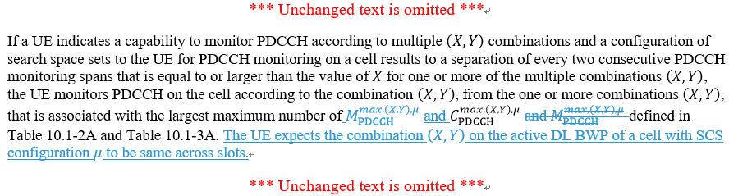

Quectel R1-2006549
In our view, whether this constraint is applied may have impacts to both network configuration and UE implementation. Given the constraint “the same span pattern repeats in every slot”, a UE does not need to track span distributions slot by slot and can construct a span pattern in a slot and reuse the pattern for all subsequent slots. On the other hand, even without this constraint a UE may still be able to construct span distributions across slots in advance based on RRC configuration (or reconfiguration). There could be some UE computation complexity savings when this constraint is applied. According to current search space set configurations, the monitoring occasions for a search space set are distributed over slots in a SPS-alike manner, i.e., $T_{s}$ consecutive slots every $k_{s}$slots, $T_{s}<k_{s}$. The network by this constraint may have to configure PDCCH monitoring occasions every slot. Although it is likely to configure much denser monitoring occasions for URLLC, it may still be useful for network to configure the UE to skip some slots for PDCCH monitoring. In this sense, ensuring same span pattern across slots that contain monitoring occasion could be sensible from both UE and network perspective.
Proposal 1: A same span pattern within a slot repeats in every slot containing a monitoring occasion.

Accordingly, the proposed text changes are as follows:
******************************************* Start of TP ************************
10.1 UE procedure for determining physical downlink control channel assignment
< Unchanged parts are omitted >
A UE can indicate a capability to monitor PDCCH according to one or more of the combinations $\left(X,Y\right)$ = (2, 2), (4, 3), and (7, 3) per SCS configuration of $μ=0$ and $μ=1$. A span is a number of consecutive symbols in a slot where the UE is configured to monitor PDCCH. Each PDCCH monitoring occasion is within one span. A same span pattern within a slot repeats in every slot containing a PDCCH monitoring occasion. If a UE monitors PDCCH on a cell according to combination $\left(X,Y\right)$, the UE supports PDCCH monitoring occasions in any symbol of a slot with minimum time separation of X symbols between the first symbol of two consecutive spans, including across slots. A span starts at a first symbol where a PDCCH monitoring occasion starts and ends at a last symbol where a PDCCH monitoring occasion ends, where the number of symbols of the span is up to Y.
< Unchanged parts are omitted >
******************************************** End of TP ********************

Feature lead view: The main idea of the proposal from the companies are similar, and as to the TP it looks like one from Samsung better considering we don’t have definition of “span pattern” in the specification.
Proposal 4.1-1: Endorse the text proposal in R1-2xxxxxx for TS 38.213 Section 10.

10 UE procedure for receiving control information
*** Unchanged text is omitted ***
If a UE indicates a capability to monitor PDCCH according to multiple $\left(X,Y\right)$ combinations and a configuration of search space sets to the UE for PDCCH monitoring on a cell results to a separation of every two consecutive PDCCH monitoring spans that is equal to or larger than the value of $X$ for one or more of the multiple combinations $\left(X,Y\right)$, the UE monitors PDCCH on the cell according to the combination $\left(X,Y\right)$, from the one or more combinations $\left(X,Y\right)$, that is associated with the largest maximum number of $M_{PDCCH}^{max,\left(X,Y\right),μ}$ and $C_{PDCCH}^{max,\left(X,Y\right),μ}$ defined in Table 10.1-2A and Table 10.1-3A. The UE expects the combination $\left(X,Y\right)$ on the active DL BWP of a cell with SCS configuration μ to be same across slots.
*** Unchanged text is omitted ***

Company | View

Issue B-2: Corrections on “aligned spans” case
The following text has been captured in section 10.1 of TS38.213 for scaling PDCCH monitoring capability.
If a UE is configured only with $N_{cells,r16}^{DL,μ}$ downlink cells for which the UE is provided monitoringCapabilityConfig-r16 = r16monitoringcapability and with associated PDCCH candidates monitored in the active DL BWPs of the scheduling cell(s) using SCS configuration $μ$, and with $N_{cells,r16}^{DL,(X,Y),μ}$ of the $N_{cells,r16}^{DL,μ}$ downlink cells using combination $\left(X,Y\right)$ for PDCCH monitoring, where $\sum_{μ=0}^{1}{N_{cells,r16}^{DL,μ}}>N_{\text{cells}}^{\text{cap-r16}}$, a DL BWP of an activated cell is the active DL BWP of the activated cell, and a DL BWP of a deactivated cell is the DL BWP with index provided by firstActiveDownlinkBWP-Id for the deactivated cell, the UE is not required to monitor more than $M_{\text{PDCCH}}^{\text{total,(X,Y),}μ}=\left\lfloor N_{\text{cells}}^{\text{cap-r16}}⋅M_{\text{PDCCH}}^{\text{max,(X,Y),}μ}⋅{N_{cells,r16}^{DL,(X,Y),μ}}/{\sum_{j=0}^{1}{N_{cells,r16}^{DL,j}}}\right\rfloor$ PDCCH candidates or more than $C_{\text{PDCCH}}^{\text{total,(X,Y),}μ}=\left\lfloor N_{\text{cells}}^{\text{cap-r16}}⋅C_{\text{PDCCH}}^{\text{max,(X,Y),}μ}⋅{N_{cells,r16}^{DL,(X,Y),μ}}/{\sum_{j=0}^{1}{N_{cells,r16}^{DL,j}}}\right\rfloor$ non-overlapped CCEs
- per set of spans on the active DL BWP(s) of all scheduling cell(s) from the $N_{cells,r16}^{DL,(X,Y),μ}$ downlink cells, if the union of PDCCH monitoring occasions on all scheduling cells from the $N_{cells,r16}^{DL,(X,Y),μ}$ downlink cells results to PDCCH monitoring according to the combination $\left(X,Y\right)$ and any pair of spans in the set is within $Y$ symbols, where first $X$ symbols start at a first symbol with a PDCCH monitoring occasion and next $X$ symbols start at a first symbol with a PDCCH monitoring occasion that is not included in the first $X$ symbols
- per set of spans across the active DL BWP(s) of all scheduling cells from the $N_{cells,r16}^{DL,(X,Y),μ}$ downlink cells, with at most one span per scheduling cell for each set of spans, otherwise
where $N_{cells,r16}^{DL,j}$ is a number of configured cells with SCS configuration $j$. If a UE is configured with downlink cells for which the UE is provided both monitoringCapabilityConfig-r16 = r15monitoringcapability and monitoringCapabilityConfig-r16 = r16monitoringcapability, $N_{\text{cells}}^{\text{cap-r16}}$ is replaced by $N_{\text{cells,r16}}^{\text{cap-r16}}$.

Regarding the text for “aligned spans” case, the following updates were proposed by companies:

Proposed update #1:

Ericsson R1-2005506
In RAN1 #101-e, the following TP in R1-2005117 was endorsed for the editor’s CR on TS 38.213 for the CA scaling for the “aligned spans” case. However, not all the details are captured in the specification. For completeness, we propose the following TP.
- The following TP is adopted to completely capture the agreement from RAN1 #101_e for the CA scaling for the “aligned spans” case.

------------------------------ Text Proposal for 38.213, Section 10.1 --------------------------------------

*** Unchanged text is omitted ***
If a UE is configured only with $N_{cells,r16}^{DL,μ}$ downlink cells for which the UE is provided monitoringCapabilityConfig-r16 = r16monitoringcapability and with associated PDCCH candidates monitored in the active DL BWPs of the scheduling cell(s) using SCS configuration $μ$, and with $N_{cells,r16}^{DL,(X,Y),μ}$ of the $N_{cells,r16}^{DL,μ}$ downlink cells using combination $\left(X,Y\right)$ for PDCCH monitoring, where $\sum_{μ=0}^{1}{N_{cells,r16}^{DL,μ}}>N_{\text{cells}}^{\text{cap-r16}}$, a DL BWP of an activated cell is the active DL BWP of the activated cell, and a DL BWP of a deactivated cell is the DL BWP with index provided by firstActiveDownlinkBWP-Id for the deactivated cell, the UE is not required to monitor more than $M_{\text{PDCCH}}^{\text{total,(X,Y),}μ}=\left\lfloor N_{\text{cells}}^{\text{cap-r16}}⋅M_{\text{PDCCH}}^{\text{max,(X,Y),}μ}⋅{N_{cells,r16}^{DL,(X,Y),μ}}/{\sum_{j=0}^{1}{N_{cells,r16}^{DL,j}}}\right\rfloor$ PDCCH candidates or more than $C_{\text{PDCCH}}^{\text{total,(X,Y),}μ}=\left\lfloor N_{\text{cells}}^{\text{cap-r16}}⋅C_{\text{PDCCH}}^{\text{max,(X,Y),}μ}⋅{N_{cells,r16}^{DL,(X,Y),μ}}/{\sum_{j=0}^{1}{N_{cells,r16}^{DL,j}}}\right\rfloor$ non-overlapped CCEs
- per set of spans on the active DL BWP(s) of all scheduling cell(s) from the $N_{cells,r16}^{DL,(X,Y),μ}$ downlink cells within every X symbols, if the union of PDCCH monitoring occasions on all scheduling cells from the $N_{cells,r16}^{DL,(X,Y),μ}$ downlink cells results to PDCCH monitoring according to the combination $\left(X,Y\right)$ and any pair of spans in the set is within $Y$ symbols, where first $X$ symbols start at a first symbol with a PDCCH monitoring occasion and next $X$ symbols start at a first symbol with a PDCCH monitoring occasion that is not included in the first $X$ symbols
- per set of spans across the active DL BWP(s) of all scheduling cells from the $N_{cells,r16}^{DL,(X,Y),μ}$ downlink cells, with at most one span per scheduling cell for each set of spans, otherwise

*** Unchanged text is omitted ***
----------------------------------------------End of proposed TP ----------------------------------------------------

From feature view: It is true that “within every X symbols” is missing and the correction is necessary.
Proposal 4.2-2: Endorse the text proposal in R1-2xxxxxx for TS 38.213 Section 10.1.

10 UE procedure for receiving control information

*** Unchanged text is omitted ***
If a UE is configured only with $N_{cells,r16}^{DL,μ}$ downlink cells for which the UE is provided monitoringCapabilityConfig-r16 = r16monitoringcapability and with associated PDCCH candidates monitored in the active DL BWPs of the scheduling cell(s) using SCS configuration $μ$, and with $N_{cells,r16}^{DL,(X,Y),μ}$ of the $N_{cells,r16}^{DL,μ}$ downlink cells using combination $\left(X,Y\right)$ for PDCCH monitoring, where $\sum_{μ=0}^{1}{N_{cells,r16}^{DL,μ}}>N_{\text{cells}}^{\text{cap-r16}}$, a DL BWP of an activated cell is the active DL BWP of the activated cell, and a DL BWP of a deactivated cell is the DL BWP with index provided by firstActiveDownlinkBWP-Id for the deactivated cell, the UE is not required to monitor more than $M_{\text{PDCCH}}^{\text{total,(X,Y),}μ}=\left\lfloor N_{\text{cells}}^{\text{cap-r16}}⋅M_{\text{PDCCH}}^{\text{max,(X,Y),}μ}⋅{N_{cells,r16}^{DL,(X,Y),μ}}/{\sum_{j=0}^{1}{N_{cells,r16}^{DL,j}}}\right\rfloor$ PDCCH candidates or more than $C_{\text{PDCCH}}^{\text{total,(X,Y),}μ}=\left\lfloor N_{\text{cells}}^{\text{cap-r16}}⋅C_{\text{PDCCH}}^{\text{max,(X,Y),}μ}⋅{N_{cells,r16}^{DL,(X,Y),μ}}/{\sum_{j=0}^{1}{N_{cells,r16}^{DL,j}}}\right\rfloor$ non-overlapped CCEs
- per set of spans on the active DL BWP(s) of all scheduling cell(s) from the $N_{cells,r16}^{DL,(X,Y),μ}$ downlink cells within every X symbols, if the union of PDCCH monitoring occasions on all scheduling cells from the $N_{cells,r16}^{DL,(X,Y),μ}$ downlink cells results to PDCCH monitoring according to the combination $\left(X,Y\right)$ and any pair of spans in the set is within $Y$ symbols, where first $X$ symbols start at a first symbol with a PDCCH monitoring occasion and next $X$ symbols start at a first symbol with a PDCCH monitoring occasion that is not included in the first $X$ symbols
- per set of spans across the active DL BWP(s) of all scheduling cells from the $N_{cells,r16}^{DL,(X,Y),μ}$ downlink cells, with at most one span per scheduling cell for each set of spans, otherwise

*** Unchanged text is omitted ***

Company | View

Proposed update #2:

Apple R1-2006487
The scaled limits for Rel-16 PDCCH monitoring are for carrier aggregation. Two cases can be considered separately: intra-band CA and inter-band CA. In the RAN4 specification, the MRTD (Maximum Receive Time Difference) requirements for intra-band CA and inter-band CA are specified. It can be seen for inter-band CA, the MRTD can be as high as 33 microseconds, roughly equal to one symbol duration at 30 KHz SCS.

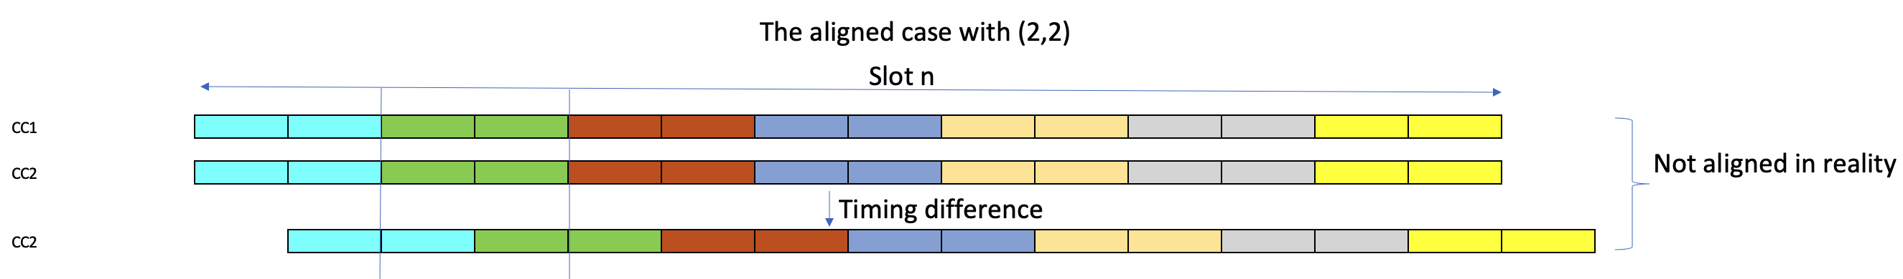
Figure 5 Nominally aligned CCs are unaligned in reality due to MRTD

From the example in Figure 5, it is seen when the maximum 33 microseconds’ MRTD is present, the nominally aligned spans across CC1 and CC2 are actually unaligned, the scaled limit no longer reflects well the UE processing complexity.

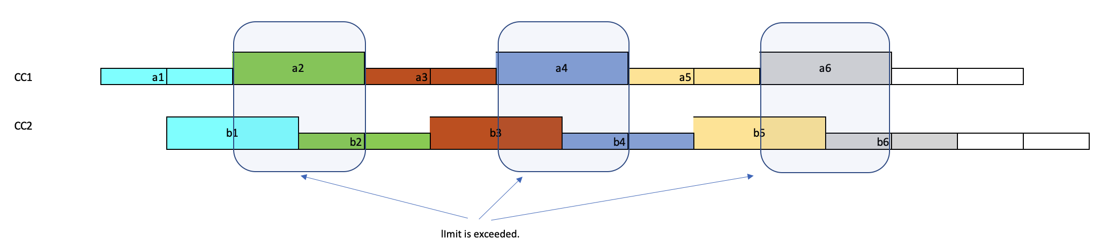

For all practical purposes, the limits for the “unaligned” case should be applied instead of those for the aligned case. Hence the inter-band CA case, irrespective of the PDCCH monitoring configurations by the gNB, all the spans of CCs at the same numerology should be considered as unaligned. Without that, declaring the UE capability to support Rel-16 PDCCH monitoring capability constitutes the support for both intra-band CA and inter-band CA cases. Either the UE modem processing capability has to be powerful/complicated enough to handle all cases, or the UE won’t declare such a capability even the UE can handle the intra-band case and encounters problem with the inter-band case only. We see neither case as desirable. Thus, we have

Proposal 1: for inter-band CA, at a given numerology and given span pattern, all CCs are considered unaligned; adopt text proposal for Proposal 1 in Appendix.

--------------------------------------Start of Text Proposal on TS 38.213--------------------------------------

10.1 UE procedure for determining physical downlink control channel assignment
<Unchanged parts are omitted>

If a UE is configured only with $N_{cells,r16}^{DL,μ}$ downlink cells for which the UE is provided monitoringCapabilityConfig-r16 = r16monitoringcapability and with associated PDCCH candidates monitored in the active DL BWPs of the scheduling cell(s) using SCS configuration $μ$, and with $N_{cells,r16}^{DL,(X,Y),μ}$ of the $N_{cells,r16}^{DL,μ}$ downlink cells using combination $\left(X,Y\right)$ for PDCCH monitoring, where $\sum_{μ=0}^{1}{N_{cells,r16}^{DL,μ}}>N_{\text{cells}}^{\text{cap-r16}}$, a DL BWP of an activated cell is the active DL BWP of the activated cell, and a DL BWP of a deactivated cell is the DL BWP with index provided by firstActiveDownlinkBWP-Id for the deactivated cell, the UE is not required to monitor more than $M_{\text{PDCCH}}^{\text{total,(X,Y),}μ}=\left\lfloor N_{\text{cells}}^{\text{cap-r16}}⋅M_{\text{PDCCH}}^{\text{max,(X,Y),}μ}⋅{N_{cells,r16}^{DL,(X,Y),μ}}/{\sum_{j=0}^{1}{N_{cells,r16}^{DL,j}}}\right\rfloor$ PDCCH candidates or more than $C_{\text{PDCCH}}^{\text{total,(X,Y),}μ}=\left\lfloor N_{\text{cells}}^{\text{cap-r16}}⋅C_{\text{PDCCH}}^{\text{max,(X,Y),}μ}⋅{N_{cells,r16}^{DL,(X,Y),μ}}/{\sum_{j=0}^{1}{N_{cells,r16}^{DL,j}}}\right\rfloor$ non-overlapped CCEs
- for intra-band carrier aggregation, per set of spans on the active DL BWP(s) of all scheduling cell(s) from the $N_{cells,r16}^{DL,(X,Y),μ}$ downlink cells, if the union of PDCCH monitoring occasions on all scheduling cells from the $N_{cells,r16}^{DL,(X,Y),μ}$ downlink cells results to PDCCH monitoring according to the combination $\left(X,Y\right)$ and any pair of spans in the set is within $Y$ symbols, where first $X$ symbols start at a first symbol with a PDCCH monitoring occasion and next $X$ symbols start at a first symbol with a PDCCH monitoring occasion that is not included in the first $X$ symbols
- per set of spans across the active DL BWP(s) of all scheduling cells from the $N_{cells,r16}^{DL,(X,Y),μ}$ downlink cells, with at most one span per scheduling cell for each set of spans, otherwise
where $N_{cells,r16}^{DL,j}$ is a number of configured cells with SCS configuration $j$. If a UE is configured with downlink cells for which the UE is provided both monitoringCapabilityConfig-r16 = r15monitoringcapability and monitoringCapabilityConfig-r16 = r16monitoringcapability, $N_{\text{cells}}^{\text{cap-r16}}$ is replaced by $N_{\text{cells,r16}}^{\text{cap-r16}}$.
<Unchanged parts are omitted>
---------------------------------------End of Text Proposal on TS 38.213 -------------------------------------

From feature view: In Rel-15 we don’t differentiate intra-band CA and inter-band CA either. However, more views are needed from other companies.

Please provide your views on the above TP on limiting aligned span case to intra-band CA case.
Company | View

Issue B-3: Whether/how to extend Rel-16 PDCCH monitoring capability to multi-TRP case
A common understanding in the RAN1 #101 email discussion is that there is no need to extend the M-TPR in Rel-16 MIMO with Rel-16 PDCCH monitoring capability ^{[4]} because all enhancements for reliability (URLLC) are through single-DCI based operations (assuming ideal backhaul) in M-TRP operation, which does not require any modification of Rel-15 spec on monitoring capability. However whether the M-TPR in Rel-16 MIMO can be extended to only the Rel-15 cells in CA case 3 (mixed Rel-15 and Rel-16 monitoring capabilities) is not clear.
- Interpretation 1: M-TPR in Rel-16 MIMO can be extended to only the Rel-15 cells in CA case 3.
  - Support: ZTE, Samsung, Quectel

- Interpretation 2: M-TPR in Rel-16 MIMO cannot be extended to the Rel-15 cells in CA case 3.
  - Support: Quectel (ok),

From feature view: It seems we need to discuss this issue in order to make the specification clear. However, more views are needed before making any proposal here.

Please indicate which interpretation do you prefer and please also provide your reasons also.
Company | View

Issue B-4: PDCCH monitoring for cross-carrier scheduling
Quectel (R1-2006549) proposed to clarify the scheduled cell grouping rules for cross-carrier scheduling are based on scheduling cells rather than scheduled cells with the following TP:

******************************************* Start of TP *****************************
10 UE procedure for receiving control information
< Unchanged parts are omitted >
If a UE can support
- a first set of $N_{\text{cells,0}}^{\text{DL}}$ serving cells where the UE is either not provided CORESETPoolIndex or is provided CORESETPoolIndex with a single value for all CORESETs on all DL BWPs of each scheduling cell of the first set of serving cells, and
- a second set of $N_{\text{cells,1}}^{\text{DL}}$ serving cells where the UE is provided CORESETPoolIndex with a value 0 for a first CORESET and with a value 1 for a second CORESET on any DL BWP of each scheduling cell of the second set of serving cells
the UE determines, for the purpose of reporting pdcch-BlindDetectionCA, a number of serving cells as $N_{\text{cells,0}}^{\text{DL}}+R⋅N_{\text{cells,1}}^{\text{DL}}$ where $R$ is a value reported by the UE.
< Unchanged parts are omitted >
10.1 UE procedure for determining physical downlink control channel assignment
< Unchanged parts are omitted >
If a UE is configured with $N_{\text{cells,0}}^{\text{DL,}μ}+N_{\text{cells,1}}^{\text{DL,}μ}$ downlink cells with associated PDCCH candidates monitored in the active DL BWP(s) of the scheduling cell(s) using SCS configuration $μ$ where $\sum_{μ=0}^{3}{\left(N_{\text{cells,0}}^{\text{DL,}μ}+γ∙N_{\text{cells,1}}^{\text{DL,}μ}\right)}≤N_{\text{cells}}^{\text{cap}}$, the UE is not required to monitor, on the active DL BWP(s) of the scheduling cell(s),
- more than PDCCH candidates or more than non-overlapped CCEs per slot for each scheduled cell from the $N_{\text{cells,0}}^{\text{DL,}μ}$ downlink cells, or
- more than $M_{\text{PDCCH}}^{\text{total,slot,}μ}=γ∙M_{\text{PDCCH}}^{\text{max,slot,}μ}$ PDCCH candidates or more than $C_{\text{PDCCH}}^{\text{total,slot,}μ}=γ∙C_{\text{PDCCH}}^{\text{max,slot,}μ}$ non-overlapped CCEs per slot for each scheduled cell from the $N_{\text{cells,1}}^{\text{DL,}μ}$ downlink cells
- more than $M_{\text{PDCCH}}^{\text{max,slot,}μ}$ PDCCH candidates or more than $C_{\text{PDCCH}}^{\text{max,slot,}μ}$ non-overlapped CCEs per slot for CORESETs with same CORESETPoolIndex value for each scheduled cell from the $N_{\text{cells,1}}^{\text{DL,}μ}$ downlink cells
If a UE
- is configured with $N_{\text{cells,0}}^{\text{DL,}μ}+N_{\text{cells,1}}^{\text{DL,}μ}$ downlink cells for the scheduling cell(s) of which the UE is not provided monitoringCapabilityConfig-r16 or is provided monitoringCapabilityConfig-r16 = r15monitoringcapability,
- with associated PDCCH candidates monitored in the active DL BWPs of the scheduling cell(s) using SCS configuration $μ$, where $\sum_{μ=0}^{3}{\left(N_{\text{cells,0}}^{\text{DL,}μ}+γ∙N_{\text{cells,1}}^{\text{DL,}μ}\right)}>N_{\text{cells}}^{\text{cap}}$, and
- a DL BWP of an activated cell is the active DL BWP of the activated cell, and a DL BWP of a deactivated cell is the DL BWP with index provided by firstActiveDownlinkBWP-Id for the deactivated cell,
the UE is not required to monitor more than $M_{\text{PDCCH}}^{\text{total,slot,}μ}=\left\lfloor N_{\text{cells}}^{\text{cap}}⋅M_{\text{PDCCH}}^{\text{max,slot,}μ}⋅{\left(N_{\text{cells,0}}^{\text{DL,}μ}+γ∙N_{\text{cells,1}}^{\text{DL,}μ}\right)}/{\sum_{j=0}^{3}{\left(N_{\text{cells,0}}^{\text{DL,}j}+γ∙N_{\text{cells,1}}^{\text{DL,}j}\right)}}\right\rfloor$ PDCCH candidates or more than $C_{\text{PDCCH}}^{\text{total,slot,}μ}=\left\lfloor N_{\text{cells}}^{\text{cap}}⋅C_{\text{PDCCH}}^{\text{max,slot,}μ}⋅{\left(N_{\text{cells,0}}^{\text{DL,}μ}+γ∙N_{\text{cells,1}}^{\text{DL,}μ}\right)}/{\sum_{j=0}^{3}{\left(N_{\text{cells,0}}^{\text{DL,}j}+γ∙N_{\text{cells,1}}^{\text{DL,}j}\right)}}\right\rfloor$ non-overlapped CCEs per slot on the active DL BWP(s) of scheduling cell(s) of the $N_{\text{cells,0}}^{\text{DL,}μ}+N_{\text{cells,1}}^{\text{DL,}μ}$ downlink cells.
For each scheduled cell from the $N_{\text{cells,0}}^{\text{DL,}μ}$ downlink cells, the UE is not required to monitor on the active DL BWP with SCS configuration $μ$ of the scheduling cell more than PDCCH candidates or more than non-overlapped CCEs per slot.
For each scheduled cell from the $N_{\text{cells,1}}^{\text{DL,}μ}$ downlink cells, the UE is not required to monitor on the active DL BWP with SCS configuration $μ$ of the scheduling cell
- more than $\min\left({γ∙M}_{\text{PDCCH}}^{\text{max,slot,}μ},M_{\text{PDCCH}}^{\text{total,slot,}μ}\right)$ PDCCH candidates or more than $\min\left({γ∙C}_{\text{PDCCH}}^{\text{max,slot,}μ},C_{\text{PDCCH}}^{\text{total,slot,}μ}\right)$ non-overlapped CCEs per slot
- more than $\min\left(M_{\text{PDCCH}}^{\text{max,slot,}μ},M_{\text{PDCCH}}^{\text{total,slot,}μ}\right)$ PDCCH candidates or more than $\min\left(C_{\text{PDCCH}}^{\text{max,slot,}μ},C_{\text{PDCCH}}^{\text{total,slot,}μ}\right)$ non-overlapped CCEs per slot for CORESETs with same CORESETPoolIndex value
If a UE is configured only with $N_{cells,r16}^{DL,μ}$ downlink cells for the scheduling cell(s) of which the UE is provided monitoringCapabilityConfig-r16 = r16monitoringcapability and with associated PDCCH candidates monitored in the active DL BWPs of the scheduling cell(s) using SCS configuration $μ$, and with $N_{cells,r16}^{DL,(X,Y),μ}$ of the $N_{cells,r16}^{DL,μ}$ downlink cells for which combination $\left(X,Y\right)$ is used for PDCCH monitoring, where $\sum_{μ=0}^{1}{N_{cells,r16}^{DL,μ}}>N_{\text{cells}}^{\text{cap-r16}}$, a DL BWP of an activated cell is the active DL BWP of the activated cell, and a DL BWP of a deactivated cell is the DL BWP with index provided by firstActiveDownlinkBWP-Id for the deactivated cell, the UE is not required to monitor more than $M_{\text{PDCCH}}^{\text{total,(X,Y),}μ}=\left\lfloor N_{\text{cells}}^{\text{cap-r16}}⋅M_{\text{PDCCH}}^{\text{max,(X,Y),}μ}⋅{N_{cells,r16}^{DL,(X,Y),μ}}/{\sum_{j=0}^{1}{N_{cells,r16}^{DL,j}}}\right\rfloor$ PDCCH candidates or more than $C_{\text{PDCCH}}^{\text{total,(X,Y),}μ}=\left\lfloor N_{\text{cells}}^{\text{cap-r16}}⋅C_{\text{PDCCH}}^{\text{max,(X,Y),}μ}⋅{N_{cells,r16}^{DL,(X,Y),μ}}/{\sum_{j=0}^{1}{N_{cells,r16}^{DL,j}}}\right\rfloor$ non-overlapped CCEs
- per set of spans on the active DL BWP(s) of all scheduling cell(s) of the $N_{cells,r16}^{DL,(X,Y),μ}$ downlink cells, if the union of PDCCH monitoring occasions on all scheduling cells of the $N_{cells,r16}^{DL,(X,Y),μ}$ downlink cells results to PDCCH monitoring according to the combination $\left(X,Y\right)$ and any pair of spans in the set is within $Y$ symbols, where first $X$ symbols start at a first symbol with a PDCCH monitoring occasion and next $X$ symbols start at a first symbol with a PDCCH monitoring occasion that is not included in the first $X$ symbols
- per set of spans across the active DL BWP(s) of all scheduling cells of the $N_{cells,r16}^{DL,(X,Y),μ}$ downlink cells, with at most one span per scheduling cell for each set of spans, otherwise
where $N_{cells,r16}^{DL,j}$ is a number of configured cells with associated PDCCH candidates monitored in the active DL BWPs of the scheduling cell(s) using SCS configuration $j$. If a UE is configured with downlink cells for which the UE is provided both monitoringCapabilityConfig-r16 = r15monitoringcapability and monitoringCapabilityConfig-r16 = r16monitoringcapability, $N_{\text{cells}}^{\text{cap-r16}}$ is replaced by $N_{\text{cells,r16}}^{\text{cap-r16}}$.
For each scheduled cell, from the $N_{cells,r16}^{DL,(X,Y),μ}$ downlink cells using combination $\left(X,Y\right)$ the UE is not required to monitor on the active DL BWP with SCS configuration $μ$ of the scheduling cell, , more than $\min\left(M_{PDCCH}^{max,(X,Y),μ},M_{PDCCH}^{total,(X,Y),μ}\right)$ PDCCH candidates or more than $\min\left(C_{PDCCH}^{max,(X,Y),μ},C_{PDCCH}^{total,(X,Y),μ}\right)$ non-overlapped CCEs per span.
< Unchanged parts are omitted >
******************************************** End of TP *****************************

From feature view: It seems most part of the TP is related to multi-TRP, is seems better to discuss under MIMO WI. As to the TP for URLLC part, I feel the current specification is correct. Probably Quectel can elaborate a little bit more. Views from other companies are needed.

Should issue B-4 be included for the email discussion? Please provide your reason also.
Company | View

Miscellaneous corrections

Issue B-5-1: Search space determination
Samsung R1-2006109
The search space determination is as follows and is inherited from LTE.
For a USS, $Y_{p,n_{s,f}^{μ}}=\left({A_{p}⋅Y}_{p,n_{s,f}^{μ}-1}\right)modD$, $Y_{p,-1}=n_{RNTI}≠0$, $A_{p}=39827$ for $pmod3=0$, $A_{p}=39829$ for $pmod3=1$, $A_{p}=39839$ for $pmod3=2$, and $D=65537$. The purpose of $Y_{p,n_{s,f}^{μ}}$ is to avoid time-permanent collisions among PDCCH candidates for different UEs sharing a same CORESET. While randomizing CCE locations per slot was appropriate for LTE and for Rel-15, it is not for Rel-16 PDCCH monitoring targeting low latency applications using e.g. $\left(X,Y\right)=(2,2)$. PDCCH blocking is already a problem for URLLC (e.g. [3-5]) where a blocking probability is much larger than a target PDCCH BLER even for Rel-15 PDCCH monitoring where the number of PDCCH candidates/non-overlapping CCEs is materially larger than for Rel-16 PDCCH monitoring with $\left(X,Y\right)=(2,2)$ or $\left(X,Y\right)=(4,3)$.

Permanent collisions of PDCCH candidates for different UEs within a slot (for example, for 7 consecutive PDCCH MOs for $\left(X,Y\right)=(2,2)$) should be minimized for URLLC operation with low latency scheduling (e.g. as required from $\left(X,Y\right)=(2,2)$). Basically, randomization of starting CCE locations for span-based PDCCH monitoring should be per span. Using the span, and not the slot, as the time unit for randomizing locations of PDCCH candidates requires using a span index $n_{s_{Y},f}^{μ}$, instead of a slot index $n_{s,f}^{μ}$, in the search space equation. For a maximum of $\left\lceil {14}/X\right\rceil$ spans per slot, the span index in time is $n_{Y,f}^{μ}=n_{s,f}^{μ}⋅\left\lceil {14}/X\right\rceil +i_{Y}$ where $i_{Y}$ is the span index within a slot, $0≤i_{Y}<\left\lceil {14}/X\right\rceil$.

Proposal 3: Update TS 38.213 v16.2.0 in Clause 10.1 as follows.

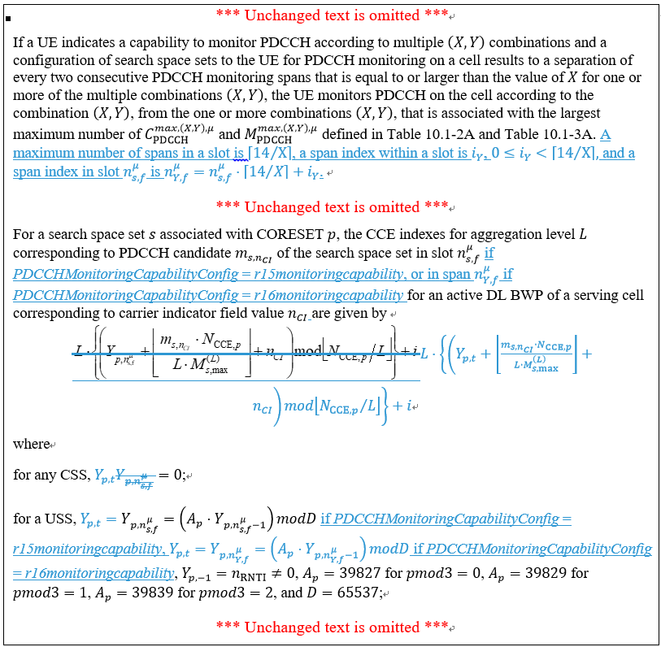

Feature lead view: The issue is true, but it belongs to optimization. Following the guidance from Chairman, optimization or “nice to have” is not allowed at this late stage. Therefore, it is recommended not to include it for the email discussion for this meeting unless critical issues are identified. Companies input are needed also.
Company | View

Issue B-5-2: PDCCH monitoring within a slot

Samsung R1-2006109
Configuration of search space sets for Rel-16 (span-based) PDCCH monitoring within a slot relies on monitoringSymbolsWithinSlot to determine the PDCCH MOs. A restriction from Rel-15 is that PDCCH monitoring beyond the first 3 symbols of a slot is supported only for 15 kHz SCS (e.g. to support LTE-NR coexistence). For Rel-16 PDCCH monitoring, 30 kHz SCS should be included. Also, for PDCCH monitoring for detection of DCI format 2_4, 30 kHz should be included.

Further, in the current text below, the “that are same in every slot where the UE monitors PDCCH for all search space sets” may be considered to be removed to avoid potential confusion as the “that are same in every slot where the UE monitors PDCCH” is a consequence of the RRC signaling and not additional specification and the “for all search space sets” can be misinterpreted as meaning that the “consecutive symbols are same in every slot” among all search space sets.

Proposal 4: Capture in Clause 10.1 of TS 38.213 v16.2.0 that a UE configured for Rel-16 PDCCH monitoring or for detection of DCI format 2_4 is expected to be able to monitor PDCCH within a slot for 30 kHz SCS.

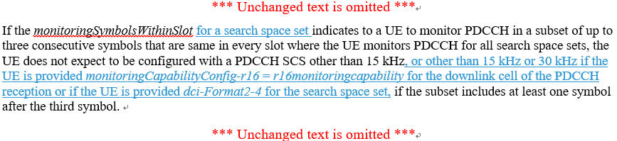

Feature lead view: The restriction of 15 kHz is mainly for PDCCH monitoring case 1-2, while the URLLC features is mainly based on PDCCH monitoring case 2. Therefore, it seems not necessary to do the extension here. But views from companies are needed first.
Company | View

Issue B-5-3: PDCCH candidate having common REs with a SS/PBCH block

Samsung R1-2006109
The “or in a span” has been missed in the second paragraph of the text below. It is suggested to add it or, preferably, remove the “in a slot and in a span” from the first paragraph and the “in a slot” from the second paragraph to avoid unnecessary text and be consistent with the text in the remaining paragraphs where “in a slot or in a span” is not mentioned.

Proposal 5: Update TS 38.213 v16.2.0 in Clause 10 as follows.

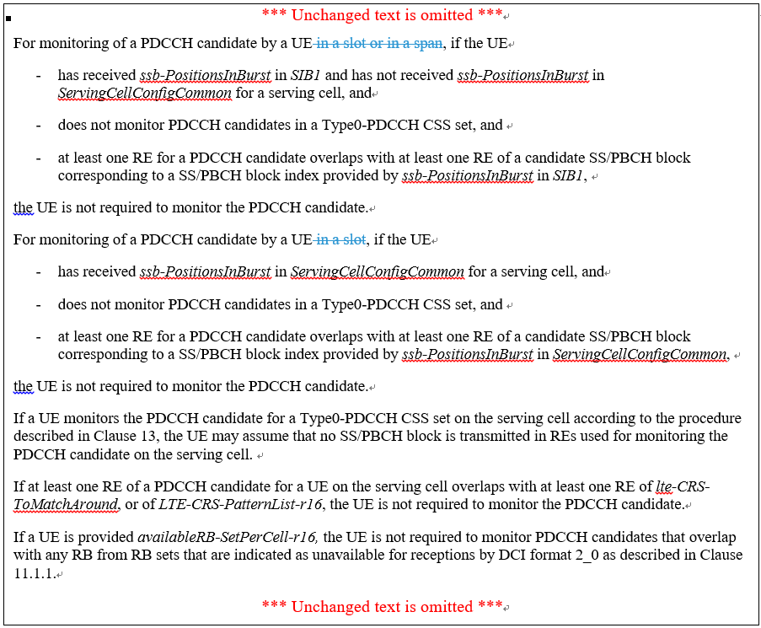

Feature lead view: The correction is necessary.
Proposal 4.2-1: Endorse the text proposal in R1-2xxxxxx for TS 38.213 Section 10.

10 UE procedure for receiving control information

*** Unchanged text is omitted ***
For monitoring of a PDCCH candidate by a UE, if the UE
- has received ssb-PositionsInBurst in SIB1 and has not received ssb-PositionsInBurst in ServingCellConfigCommon for a serving cell, and
- does not monitor PDCCH candidates in a Type0-PDCCH CSS set, and
- at least one RE for a PDCCH candidate overlaps with at least one RE of a candidate SS/PBCH block corresponding to a SS/PBCH block index provided by ssb-PositionsInBurst in SIB1,
the UE is not required to monitor the PDCCH candidate.
For monitoring of a PDCCH candidate by a UE, if the UE
- has received ssb-PositionsInBurst in ServingCellConfigCommon for a serving cell, and
- does not monitor PDCCH candidates in a Type0-PDCCH CSS set, and
- at least one RE for a PDCCH candidate overlaps with at least one RE of a candidate SS/PBCH block corresponding to a SS/PBCH block index provided by ssb-PositionsInBurst in ServingCellConfigCommon,
the UE is not required to monitor the PDCCH candidate.
If a UE monitors the PDCCH candidate for a Type0-PDCCH CSS set on the serving cell according to the procedure described in Clause 13, the UE may assume that no SS/PBCH block is transmitted in REs used for monitoring the PDCCH candidate on the serving cell.
If at least one RE of a PDCCH candidate for a UE on the serving cell overlaps with at least one RE of lte-CRS-ToMatchAround, or of LTE-CRS-PatternList-r16, the UE is not required to monitor the PDCCH candidate.
If a UE is provided availableRB-SetPerCell-r16, the UE is not required to monitor PDCCH candidates that overlap with any RB from RB sets that are indicated as unavailable for receptions by DCI format 2_0 as described in Clause 11.1.1.
*** Unchanged text is omitted ***

Company | View

Issue B-5-4: Maximum number of UE-specific DCI formats for CA operation
Samsung R1-2006109
The maximum number of activated cells for CA operation remains 16 and DCI formats 0_2 and 1_2 need to also be captured in the following.

Proposal 6: Update TS 38.213 v16.2.0 in Clause 10.1 as follows.

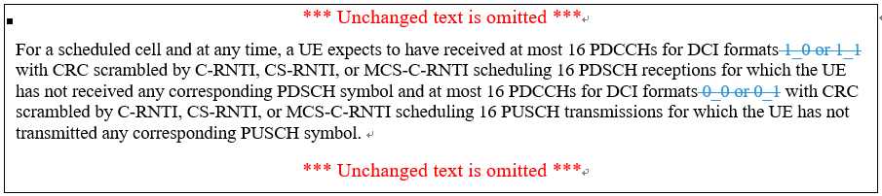

Sharp (R1-2006563) proposed the same thing as Samsung.
Feature lead view: The correction is necessary.

Proposal 4.2-2: Endorse the text proposal in R1-2xxxxxx for TS 38.213 Section 10.1.

10.1 UE procedure for determining physical downlink control channel assignment

*** Unchanged text is omitted ***
For a scheduled cell and at any time, a UE expects to have received at most 16 PDCCHs for DCI formats with CRC scrambled by C-RNTI, CS-RNTI, or MCS-C-RNTI scheduling 16 PDSCH receptions for which the UE has not received any corresponding PDSCH symbol and at most 16 PDCCHs for DCI formats with CRC scrambled by C-RNTI, CS-RNTI, or MCS-C-RNTI scheduling 16 PUSCH transmissions for which the UE has not transmitted any corresponding PUSCH symbol.
*** Unchanged text is omitted ***

Company | View

Issue B-5-5: High layer parameters alignment

Huawei R1-2005790
In Rel-16, a new higher layer parameter is introduced to configure the UE behaviour for PDCCH monitoring on a scheduling cell. It describes whether the CCE/PDCCH candidate limits shall be applied per slot or per span, captured as “r15monitoringcapability” or as “r16monitoringcapability” in “monitoringCapabilityConfig-r16” in TS 38.331-g00. However, in section 10 of 38.213, different names are used for the same parameter. Therefore, we propose to change the parameter naming in 38.213 to make it consistent with 38.331.
Proposal 2: Adopt the TP below for 38.213 to make the parameter naming consistent between TS 38.331 and TS 38.213.

10.1 UE procedure for determining physical downlink control channel assignment
*** Unchanged text is omitted ***
For same cell scheduling or for cross-carrier scheduling, a UE does not expect a number of PDCCH candidates, and a number of corresponding non-overlapped CCEs per slot or per span on a secondary cell to be larger than the corresponding numbers that the UE is capable of monitoring on the secondary cell per slot or per span, respectively. If a UE is provided monitoringCapabilityConfig-r16= r16monitoringcapability for the primary cell, except the first span of each slot, the UE does not expect a number of PDCCH candidates and a number of corresponding non-overlapped CCEs per span on the primary cell to be larger than the corresponding numbers that the UE is capable of monitoring on the primary cell per span.
*** Unchanged text is omitted ***
The UE allocates PDCCH candidates for monitoring to USS sets for the primary cell having an active DL BWP with SCS configuration $μ$ in a slot if the UE is not provided monitoringCapabilityConfig-r16 for the primary cell or if the UE is provided monitoringCapabilityConfig-r16 = r15monitoringcapability for the primary cell, or in the first span of each slot if the UE is provided monitoringCapabilityConfig-r16 = r16monitoringcapability for the primary cell, according to the following pseudocode. If for the USS sets for scheduling on the primary cell the UE is not provided CORESETPoolIndex for first CORESETs, or is provided CORESETPoolIndex with value 0 for first CORESETs, and is provided CORESETPoolIndex with value 1 for second CORESETs, and if $\min\left({γ∙M}_{\text{PDCCH}}^{\text{max,slot,}μ},M_{\text{PDCCH}}^{\text{total,slot,}μ}\right)>\min\left(M_{\text{PDCCH}}^{\text{max,slot,}μ},M_{\text{PDCCH}}^{\text{total,slot,}μ}\right)$ or $\min\left({γ∙C}_{\text{PDCCH}}^{\text{max,slot,}μ},C_{\text{PDCCH}}^{\text{total,slot,}μ}\right)>\min\left(C_{\text{PDCCH}}^{\text{max,slot,}μ},C_{\text{PDCCH}}^{\text{total,slot,}μ}\right)$, the following pseudocode applies only to USS sets associated with the first CORESETs. A UE does not expect to monitor PDCCH in a USS set without allocated PDCCH candidates for monitoring. In the following pseudocode, if the UE is provided monitoringCapabilityConfig-r16 = r16monitoringcapability for the primary cell,$M_{\text{PDCCH}}^{\text{max,slot,}μ}$and $C_{\text{PDCCH}}^{\text{max,slot,}μ}$are replaced by $M_{\text{PDCCH}}^{\text{max,(X,Y),}μ}$and $C_{\text{PDCCH}}^{\text{max,(X,Y),}μ}$ respectively, and $M_{\text{PDCCH}}^{\text{total,slot,}μ}$and $C_{\text{PDCCH}}^{\text{total,slot,}μ}$are replaced by $M_{\text{PDCCH}}^{\text{total,(X,Y),}μ}$and $C_{\text{PDCCH}}^{\text{total,(X,Y),}μ}$ respectively.
*** Unchanged text is omitted ***
If a UE is not provided monitoringCapabilityConfig-r16, and
- is not configured for NR-DC operation and indicates through pdcch-BlindDetectionCA a capability to monitor PDCCH candidates for downlink cells and the UE is configured with downlink cells or uplink cells, or
- is configured with NR-DC operation and for a cell group with downlink cells or uplink cells
*** Unchanged text is omitted ***

ZTE (R1-2005413) proposed the same thing also.

Feature lead view: The correction is necessary, but we can bring it to editor to make the change.

Issue B-5-6: Missing descriptions on PDCCH monitoring capability for Rel-16 cells in CA case 2 and case 3 if configured carrier number is equal to or less than UE capability
ZTE R1-2005413
In addition, there are some missing descriptions for or in case the number of cells configured is not larger than the reported capability, and corresponding Text Proposal #5 is provided.
Proposal 4: Adopt the following Text Proposal #5 for section 10.1 in TS38.213.
--------------------------------------------Text Proposal #5 for Section 10 in TS38.213------------------------
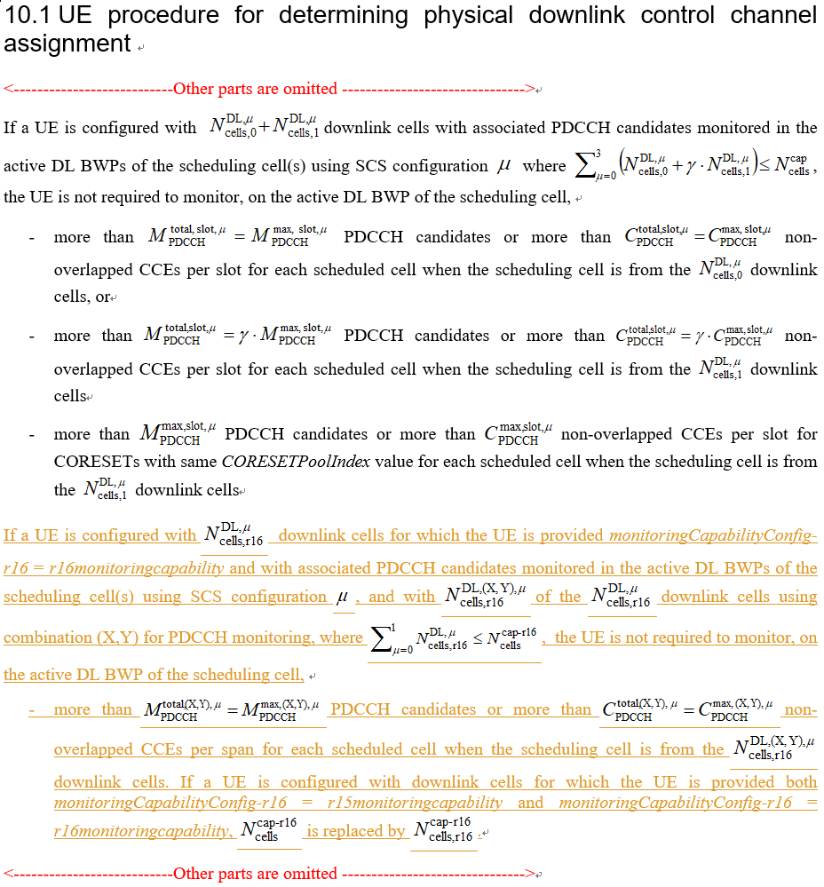

Spreadtrum R1-2006278
For the limits of Rel-16 PDCCH monitoring BDs/non-overlapped CCEs, there is only the definition of the limits for the condition of configured carrier number is more than UE capability. However, it misses the condition of configured carrier number is equal to or less than UE capability. So the following text proposal for 38.213 section 10.1 should be adopted.
- Adopted the text proposal for BDs/non-overlapped CCEs limits.
**********************************************************************************
10.1 UE procedure for determining physical downlink control channel assignment
<Text omitted>
If a UE is configured only with $N_{cells,r16}^{DL,μ}$ downlink cells for which the UE is provided monitoringCapabilityConfig-r16 = r16monitoringcapability and with associated PDCCH candidates monitored in the active DL BWPs of the scheduling cell(s) using SCS configuration $μ$, and with $N_{cells,r16}^{DL,(X,Y),μ}$ of the $N_{cells,r16}^{DL,μ}$ downlink cells using combination $\left(X,Y\right)$ for PDCCH monitoring, where $\sum_{μ=0}^{1}{N_{cells,r16}^{DL,μ}}≤N_{\text{cells}}^{\text{cap-r16}}$, the UE is not required to monitor, on the active DL BWP of the scheduling cell more than MPDCCHtotal,(X,Y),μ=MPDCCHmax,(X,Y),μ PDCCH candidates or more than CPDCCHtotal,(X,Y),μ=CPDCCHmax,(X,Y),μ non-overlapped CCEs per slot for each scheduled cell.
If a UE is configured only with $N_{cells,r16}^{DL,μ}$ downlink cells for which the UE is provided monitoringCapabilityConfig-r16 = r16monitoringcapability and with associated PDCCH candidates monitored in the active DL BWPs of the scheduling cell(s) using SCS configuration $μ$, and with $N_{cells,r16}^{DL,(X,Y),μ}$ of the $N_{cells,r16}^{DL,μ}$ downlink cells using combination $\left(X,Y\right)$ for PDCCH monitoring, where $\sum_{μ=0}^{1}{N_{cells,r16}^{DL,μ}}>N_{\text{cells}}^{\text{cap-r16}}$, a DL BWP of an activated cell is the active DL BWP of the activated cell, and a DL BWP of a deactivated cell is the DL BWP with index provided by firstActiveDownlinkBWP-Id for the deactivated cell, the UE is not required to monitor more than $M_{\text{PDCCH}}^{\text{total,(X,Y),}μ}=\left\lfloor N_{\text{cells}}^{\text{cap-r16}}⋅M_{\text{PDCCH}}^{\text{max,(X,Y),}μ}⋅{N_{cells,r16}^{DL,(X,Y),μ}}/{\sum_{j=0}^{1}{N_{cells,r16}^{DL,j}}}\right\rfloor$ PDCCH candidates or more than $C_{\text{PDCCH}}^{\text{total,(X,Y),}μ}=\left\lfloor N_{\text{cells}}^{\text{cap-r16}}⋅C_{\text{PDCCH}}^{\text{max,(X,Y),}μ}⋅{N_{cells,r16}^{DL,(X,Y),μ}}/{\sum_{j=0}^{1}{N_{cells,r16}^{DL,j}}}\right\rfloor$ non-overlapped CCEs
- per set of spans on the active DL BWP(s) of all scheduling cell(s) from the $N_{cells,r16}^{DL,(X,Y),μ}$ downlink cells, if the union of PDCCH monitoring occasions on all scheduling cells from the $N_{cells,r16}^{DL,(X,Y),μ}$ downlink cells results to PDCCH monitoring according to the combination $\left(X,Y\right)$ and any pair of spans in the set is within $Y$ symbols, where first $X$ symbols start at a first symbol with a PDCCH monitoring occasion and next $X$ symbols start at a first symbol with a PDCCH monitoring occasion that is not included in the first $X$ symbols
- per set of spans across the active DL BWP(s) of all scheduling cells from the $N_{cells,r16}^{DL,(X,Y),μ}$ downlink cells, with at most one span per scheduling cell for each set of spans, otherwise
where $N_{cells,r16}^{DL,j}$ is a number of configured cells with SCS configuration $j$. If a UE is configured with downlink cells for which the UE is provided both monitoringCapabilityConfig-r16 = r15monitoringcapability and monitoringCapabilityConfig-r16 = r16monitoringcapability, $N_{\text{cells}}^{\text{cap-r16}}$ is replaced by $N_{\text{cells,r16}}^{\text{cap-r16}}$.
For each scheduled cell, the UE is not required to monitor on the active DL BWP with SCS configuration $μ$ of the scheduling cell, from the $N_{cells,r16}^{DL,(X,Y),μ}$ downlink cells using combination $\left(X,Y\right)$, more than $\min\left(M_{PDCCH}^{max,(X,Y),μ},M_{PDCCH}^{total,(X,Y),μ}\right)$ PDCCH candidates or more than $\min\left(C_{PDCCH}^{max,(X,Y),μ},C_{PDCCH}^{total,(X,Y),μ}\right)$ non-overlapped CCEs per span.
<Text omitted>
*********************************************************************************

From feature view: The issue is valid and correction is needed. It seems the TP from ZTE is more complete but as to the location of the change it seems the one from Spreadtrum is better.

Proposal 4.2-3: Endorse the text proposal in R1-2xxxxxx for TS 38.213 Section 10.1.

10.1 UE procedure for determining physical downlink control channel assignment

*** Unchanged text is omitted ***
If a UE
- is configured with $N_{\text{cells,0}}^{\text{DL,}μ}+N_{\text{cells,1}}^{\text{DL,}μ}$ downlink cells for which the UE is not provided monitoringCapabilityConfig-r16 or is provided monitoringCapabilityConfig-r16 = r15monitoringcapability,
- with associated PDCCH candidates monitored in the active DL BWPs of the scheduling cell(s) using SCS configuration $μ$, where $\sum_{μ=0}^{3}{\left(N_{\text{cells,0}}^{\text{DL,}μ}+γ∙N_{\text{cells,1}}^{\text{DL,}μ}\right)}>N_{\text{cells}}^{\text{cap}}$, and
- a DL BWP of an activated cell is the active DL BWP of the activated cell, and a DL BWP of a deactivated cell is the DL BWP with index provided by firstActiveDownlinkBWP-Id for the deactivated cell,
the UE is not required to monitor more than $M_{\text{PDCCH}}^{\text{total,slot,}μ}=\left\lfloor N_{\text{cells}}^{\text{cap}}⋅M_{\text{PDCCH}}^{\text{max,slot,}μ}⋅{\left(N_{\text{cells,0}}^{\text{DL,}μ}+γ∙N_{\text{cells,1}}^{\text{DL,}μ}\right)}/{\sum_{j=0}^{3}{\left(N_{\text{cells,0}}^{\text{DL,}j}+γ∙N_{\text{cells,1}}^{\text{DL,}j}\right)}}\right\rfloor$ PDCCH candidates or more than $C_{\text{PDCCH}}^{\text{total,slot,}μ}=\left\lfloor N_{\text{cells}}^{\text{cap}}⋅C_{\text{PDCCH}}^{\text{max,slot,}μ}⋅{\left(N_{\text{cells,0}}^{\text{DL,}μ}+γ∙N_{\text{cells,1}}^{\text{DL,}μ}\right)}/{\sum_{j=0}^{3}{\left(N_{\text{cells,0}}^{\text{DL,}j}+γ∙N_{\text{cells,1}}^{\text{DL,}j}\right)}}\right\rfloor$ non-overlapped CCEs per slot on the active DL BWP(s) of scheduling cell(s) from the $N_{\text{cells,0}}^{\text{DL,}μ}+N_{\text{cells,1}}^{\text{DL,}μ}$ downlink cells.
For each scheduled cell, the UE is not required to monitor on the active DL BWP with SCS configuration $μ$ of the scheduling cell from the $N_{\text{cells,0}}^{\text{DL,}μ}$ downlink cells more than PDCCH candidates or more than non-overlapped CCEs per slot.
For each scheduled cell, the UE is not required to monitor on the active DL BWP with SCS configuration $μ$ of the scheduling cell from the $N_{\text{cells,1}}^{\text{DL,}μ}$ downlink cells
- more than $\min\left({γ∙M}_{\text{PDCCH}}^{\text{max,slot,}μ},M_{\text{PDCCH}}^{\text{total,slot,}μ}\right)$ PDCCH candidates or more than $\min\left({γ∙C}_{\text{PDCCH}}^{\text{max,slot,}μ},C_{\text{PDCCH}}^{\text{total,slot,}μ}\right)$ non-overlapped CCEs per slot
- more than $\min\left(M_{\text{PDCCH}}^{\text{max,slot,}μ},M_{\text{PDCCH}}^{\text{total,slot,}μ}\right)$ PDCCH candidates or more than $\min\left(C_{\text{PDCCH}}^{\text{max,slot,}μ},C_{\text{PDCCH}}^{\text{total,slot,}μ}\right)$ non-overlapped CCEs per slot for CORESETs with same CORESETPoolIndex value
If a UE is configured with downlink cells for which the UE is provided monitoringCapabilityConfig-r16 = r16monitoringcapability and with associated PDCCH candidates monitored in the active DL BWPs of the scheduling cell(s) using SCS configuration , and with of the downlink cells using combination (X,Y) for PDCCH monitoring, where , the UE is not required to monitor, on the active DL BWP of the scheduling cell,
- more than PDCCH candidates or more than non-overlapped CCEs per span for each scheduled cell when the scheduling cell is from the downlink cells. If a UE is configured with downlink cells for which the UE is provided both monitoringCapabilityConfig-r16 = r15monitoringcapability and monitoringCapabilityConfig-r16 = r16monitoringcapability, is replaced by .
If a UE is configured only with $N_{cells,r16}^{DL,μ}$ downlink cells for which the UE is provided monitoringCapabilityConfig-r16 = r16monitoringcapability and with associated PDCCH candidates monitored in the active DL BWPs of the scheduling cell(s) using SCS configuration $μ$, and with $N_{cells,r16}^{DL,(X,Y),μ}$ of the $N_{cells,r16}^{DL,μ}$ downlink cells using combination $\left(X,Y\right)$ for PDCCH monitoring, where $\sum_{μ=0}^{1}{N_{cells,r16}^{DL,μ}}>N_{\text{cells}}^{\text{cap-r16}}$, a DL BWP of an activated cell is the active DL BWP of the activated cell, and a DL BWP of a deactivated cell is the DL BWP with index provided by firstActiveDownlinkBWP-Id for the deactivated cell, the UE is not required to monitor more than $M_{\text{PDCCH}}^{\text{total,(X,Y),}μ}=\left\lfloor N_{\text{cells}}^{\text{cap-r16}}⋅M_{\text{PDCCH}}^{\text{max,(X,Y),}μ}⋅{N_{cells,r16}^{DL,(X,Y),μ}}/{\sum_{j=0}^{1}{N_{cells,r16}^{DL,j}}}\right\rfloor$ PDCCH candidates or more than $C_{\text{PDCCH}}^{\text{total,(X,Y),}μ}=\left\lfloor N_{\text{cells}}^{\text{cap-r16}}⋅C_{\text{PDCCH}}^{\text{max,(X,Y),}μ}⋅{N_{cells,r16}^{DL,(X,Y),μ}}/{\sum_{j=0}^{1}{N_{cells,r16}^{DL,j}}}\right\rfloor$ non-overlapped CCEs
- per set of spans on the active DL BWP(s) of all scheduling cell(s) from the $N_{cells,r16}^{DL,(X,Y),μ}$ downlink cells, if the union of PDCCH monitoring occasions on all scheduling cells from the $N_{cells,r16}^{DL,(X,Y),μ}$ downlink cells results to PDCCH monitoring according to the combination $\left(X,Y\right)$ and any pair of spans in the set is within $Y$ symbols, where first $X$ symbols start at a first symbol with a PDCCH monitoring occasion and next $X$ symbols start at a first symbol with a PDCCH monitoring occasion that is not included in the first $X$ symbols
- per set of spans across the active DL BWP(s) of all scheduling cells from the $N_{cells,r16}^{DL,(X,Y),μ}$ downlink cells, with at most one span per scheduling cell for each set of spans, otherwise
where $N_{cells,r16}^{DL,j}$ is a number of configured cells with SCS configuration $j$. If a UE is configured with downlink cells for which the UE is provided both monitoringCapabilityConfig-r16 = r15monitoringcapability and monitoringCapabilityConfig-r16 = r16monitoringcapability, $N_{\text{cells}}^{\text{cap-r16}}$ is replaced by $N_{\text{cells,r16}}^{\text{cap-r16}}$.
For each scheduled cell, the UE is not required to monitor on the active DL BWP with SCS configuration $μ$ of the scheduling cell, from the $N_{cells,r16}^{DL,(X,Y),μ}$ downlink cells using combination $\left(X,Y\right)$, more than $\min\left(M_{PDCCH}^{max,(X,Y),μ},M_{PDCCH}^{total,(X,Y),μ}\right)$ PDCCH candidates or more than $\min\left(C_{PDCCH}^{max,(X,Y),μ},C_{PDCCH}^{total,(X,Y),μ}\right)$ non-overlapped CCEs per span.
*** Unchanged text is omitted ***

Company | View

References
- R1-2005347 PDCCH enhancements for URLLC vivo
- R1-2005413 Remaining issues on PDCCH enhancements for NR URLLC ZTE
- R1-2005506 Remaining Issue of PDCCH Enhancements for NR URLLC Ericsson
- R1-2005672 Remaining issues on PDCCH enhancements CATT
- R1-2005790 Corrections on PDCCH enhancement for URLLC Huawei, HiSilicon
- R1-2005850 Remaining corrections for PDCCH enhancements for URLLC Intel Corporation
- R1-2006051 PDCCH enhancements for URLLC OPPO
- R1-2006109 Maintenance on PDCCH enhancements Samsung
- R1-2006278 Remaining issues of PDCCH enhancements for URLLC Spreadtrum Communications
- R1-2006487 Remaining issues on PDCCH enhancements Apple
- R1-2006549 Remaining Issues on PDCCH Enhancements for Rel-16 URLLC Quectel
- R1-2006563 Remaining issues on PDCCH enhancements for NR URLLC Sharp
- R1-2006774 Remaining issues on PDCCH Enhancements for URLLC Qualcomm Incorporated
- R1-2006865 Remaining issue for TCI field ASUSTeK
- R1-2006882 Remaining issues on PDCCH for NR URLLC WILUS Inc.

