[5G-ACIA] Email discussion
December 14 – 18, 2020

Source: ZTE
Title: 5G-ACIA evaluations - 1st round of simulation results

Discussion
In the RAN#89-e meeting, RAN discussed the LS from 5G-ACIA on Rel-16 URLLC and IIoT performance evaluation [1], and approved a way forward in [2].
During October 12-16, the simulation assumptions and URLLC features for evaluation were discussed, with reaching the following agreements.
Agreements:
- The simulation assumptions given in the table are agreed
- Additional simulation parameters are taken from TR 38.824.
Parameters | 5G-ACIA LS | Agreement
Factory hall size | 120x50 m | As in 5G-ACIA LS
Room height | 10 m | As in 5G-ACIA LS
Inter-BS/TRP distance | Depending on the number of TRPs, which are evenly deployed in the factory hall. Simulation company should provide the number of BSs/TRPs used in the simulation. | According to proposed layout below
BS/TRP antenna height | 1.5 m for InF-SL and InF-DL  8m for InF-SH and InF-DH | As in 5G-ACIA LS
Layout – BS/TRP deployment | Depending on the number of TRPs | 12 TRPs within area with the same 2D placement as in TR 38.901 and TR 38.824.
Channel model | UC-2: InF-DH > InD-DL > InF-SH > InF-SL | Mandatory: InF-DH  Optional: InD-DL, InF-SH, InF-SL
Carrier frequency and simulation bandwidth | TDD  4 GHz: 100 MHz  30 GHz: 160 MHz | As in 5G-ACIA LS
TDD DL-UL configuration | Simulation company should report the used DL-UL configuration. | Companies should report the used DL-UL configuration. 1:1 DL-UL configuration is recommended.
Number of UEs per service area | Up to 50 per service area, e.g., 10, 20, 40, and 50 | As in 5G-ACIA LS
UE distribution | All UEs randomly distributed within the respective service area. | As in 5G-ACIA LS
Message size | 48 bytes | 48 bytes
DL traffic model | DL traffic arrival with option-1, option-2, and option-3. | 5G-ACIA Option 1 is mandatory. Companies are also encouraged to provide results for option 3
UL traffic model | UL traffic is symmetric with DL, and DL-UL traffic arrival time relationship with option-1 and option-2 | As in 5G-ACIA LS with Option 1 as mandatory
CSA requirements | UC-#2: 99.9999% | UC-#2: 99.9999%
Performance metrics | 1) CSA: single CDF of CSA distribution of all UEs in factory hall  2) Latency: single CDF of latency distribution of all UEs in factory hall  3) Percentage of UEs satisfying requirements  4) resource utilization | As in 5G-ACIA LS with 3) and 4) as low priority  Note: For metric 2) it is clarified that a packet transmission cannot be performed after the latency deadline. The collected statistics cannot exceed the latency requirement. The packets exceeding the deadline are visible in the UE packet error statistics
E2E latency & air interface latency | E2E latency: 1 ms for UC#2 | E2E latency: 1 ms for UC#2  Air interface latency: 1ms
UE speed | Linear movement | Linear movement: 75 km/h  No explicit UE mobility (nor handovers) are modeled in the evaluations.
BS antenna mount |  | Option 1 (1 sector per BS) from 38.824 is used

For the Rel-15 baseline, the following is agreed:
- Rel-15 URLLC features included in the baseline are as follows, while it is up to each proponent to decide which Rel-15 features are used, and detail this when providing the results:
  - UE Processing capability 2
  - UL Configured grant
  - DL Semi-persistent scheduling

Regarding Rel-16 features, the following is agreed:
- It is up to each proponent to decide on which Rel-16 features to provide simulations results for in addition to the Rel-15 baseline
- This can be revisited after the first round of simulations have been provided in December.

In this contribution, we provide our views on URLLC features and simulation assumptions for 5G-ACIA evaluation.

Evaluation for FR1

Frame structure
1:1 DL-UL configuration with ‘DDDDDDGGUUUUUU’ is assumed in our evaluation. Regarding the signaling overhead, one DL symbol per slot is used for PDCCH and one UL symbol per slot is assumed for PUCCH/SRS transmission. Thus, 5-symol DL/UL duration is assumed for scheduling SPS PDSCH/CG PUSCH respectively. It’s our understanding that even using 2-symbol DL/UL TTI with SPS/CG transmission, there is no time for scheduling re-transmission within 1ms by considering PDCCH alignment for re-transmissions and the processing times as agreed in [4].
In Figure 1, the frame structure assumed in our evaluation is provided below. More detailed simulation assumptions are given in Appendix.
Figure 1 Frame structure assumed in evaluation

Performance metric
The agreed CSA requirement is 99.9999%. Since the CSA is derived from the probability of occurrence of two or more consecutive TB reception errors, it needs to determine the BLER target for each TB transmission to derive CSA value. In our evaluation, we assume packet errors are uncorrelated, i.e., 1e-3 BLER is assumed.

Evaluation results
In our evaluation, we assume all 12 BSs can be fully coordinated. When the number of UEs is less than 273 RBs, the UEs could be FDMed to reduce interference.
In Table 1, the evaluation results including CSA, percentage of UEs satisfying requirements and RU are presented. The CSA is 100% for no more than 40 UEs per service area, and the CDF of CSA for 50 uses per service area is provided in Figure 2.
Table 1 Evaluations results (CSA, percentage of UEs satisfying requirements and RU)
Number of UEs per service area |  | DL/UL | CSA | Percentage of UEs satisfying requirements | RU
10 users | DL |  | 100% | 100% | 1.85%
10 users | UL |  | 100% | 100% | 1.96%
20 users | DL |  | 100% | 100% | 3.76%
20 users | UL |  | 100% | 100% | 3.71%
40 users | DL |  | 100% | 100% | 7.87%
40 users | UL |  | 100% | 100% | 6.07%
50 users | DL |  | Figure 2 | 36.67% | 10.08%
50 users | UL |  | Figure 2 | 90% | 9.26%

Figure 2 CDF of CSA for 50 UEs per service area

The CDF of E2E latency for different number of uses per service area are provided in Figure 2 and Figure 3 for DL and UL respectively. Note that, the packet arrival is randomly generated in symbol level in our simulation for now.
10 UEs per service area 20 UEs per service area
40 UEs per service area 50 UEs per service area
Figure 3 CDF of E2E latency for different number of uses per service area for DL

10 UEs per service area 20 UEs per service area
40 UEs per service area 50 UEs per service area
Figure 4 CDF of E2E latency for different number of uses per service area for UL

Based on above evaluation results, we have the following observation.

Observation 1:
- For FR1 with the number of UEs per service area no more than 40 UEs, the CSA and percentage of UEs satisfying the reliability and latency requirement are 100% for both DL and UL.
- For FR1 with the number of UEs per service area of 50 UEs,
  - for DL, the CSA cannot satisfy the 99.9999% requirement and 36.67% of UEs satisfying the reliability and latency requirement.
  - for UL, the CSA cannot satisfy the 99.9999% requirement and 90% of UEs satisfying the reliability and latency requirement.

Conclusion
Observation 1:
- For FR1 with the number of UEs per service area no more than 40 UEs, the CSA and percentage of UEs satisfying the reliability and latency requirement are 100% for both DL and UL.
- For FR1 with the number of UEs per service area of 50 UEs,
  - for DL, the CSA cannot satisfy the 99.9999% requirement and 36.67% of UEs satisfying the reliability and latency requirement.
  - for UL, the CSA cannot satisfy the 99.9999% requirement and 90% of UEs satisfying the reliability and latency requirement.

Reference
- 3GPP RAN1#102-e, R1-2006953, LS on 3GPP NR Rel-16 URLLC and IIoT performance evaluation, 5G ACIA.
- 3GPP RAN#89-e, RP-202069, Way forward and RAN work for 5G ACIA requested simulations, Ericsson.
- 3GPP TS 22.104, Service requirements for cyber-physical control applications in vertical domains.
- 3GPP RAN1 #AH1901, R1-1901472, Email discussion/approval on converging the proposals for eURLLC processing timeline, Qualcomm.

Appendix
Table A-1 Simulation assumptions for 4GHz
Parameter | Assumption
Factory hall size | 120x50 m
Room height | 10 m
Layout – BS/TRP deployment | Single layer as defined in 38.802  Indoor floor:12 BSs per 120 m x 50 m  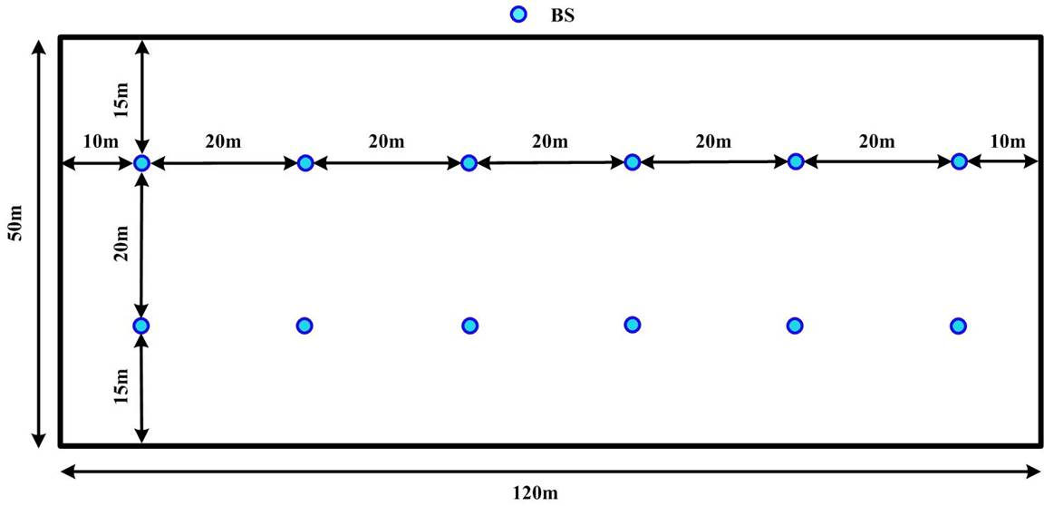
BS/TRP antenna height | 1.5 m for InF-SL and InF-DL  8m for InF-SH and InF-DH
Channel model | InF-DH
Carrier frequency and simulation bandwidth | TDD  4 GHz: 100 MHz
TDD DL-UL configuration | DDDDDDGGUUUUUU
Number of UEs per service area | Up to 50 per service area, e.g., 10, 20, 40, and 50
UE distribution | All UEs randomly distributed within the respective service area.
Message size | 48 bytes
DL traffic model | Option 1, i.e., all UEs’ DL messages arriving at NG-RAN node in the first transfer interval are  uniformly random distributed within the TI time window.
UL traffic model | Same as DL
CSA requirements | UC-#2: 99.9999%
Performance metrics | 1) CSA: single CDF of CSA distribution of all UEs in factory hall  2) Latency: single CDF of latency distribution of all UEs in factory hall  3) Percentage of UEs satisfying requirements  4) resource utilization
E2E latency & air interface latency | E2E latency: 1 ms for UC#2
UE speed | Linear movement
BS antenna mount | Option 1 (1 sector per BS) from 38.824 is used
Carrier frequency | 4 GHz
UE Tx power | 23dBm
BS antenna element gain + connector loss | 5 dBi
BS receiver noise figure | 5dB
BS antenna configurations | 4 Tx/4 Rx antenna ports  (M, N, P, Mg, Ng; Mp, Np) = (1, 2, 2, 1, 1; 1, 2) for 4 Tx/4 Rx antenna ports;  dH = dV = 0.5 λ
BS antenna height | 10 m
UE antenna configuration | 2 Tx/4 Rx antenna ports  Panel model 1: Mg = 1, Ng = 1, P = 2, dH = 0.5  (M, N, P, Mg, Ng; Mp, Np) = (1, 2, 2, 1, 1; 1, 2) for 4 Rx;  (M, N, P, Mg, Ng; Mp, Np) = (1, 1, 2, 1, 1; 1, 1) for 2 Tx;
UE antenna height | Follow the modelling of TR 38.901 (e.g. 1.5m)
UE antenna gain | 0dBi as starting point
BS Tx power | 24 dBm per 20 MHz
BS receiver | MMSE-IRC as the baseline receiver
UE receiver noise figure | 9 dB
SCS | 30 kHz
Channel estimation | Realistic

