3GPP TSG RAN WG1 email discussion [5G-ACIA]
E-mail discussion, December 14 - 18, 2020
Source: ITRI
Title: Simulation Assumptions and URLLC Performance Evaluations for 5G-ACIA Performance Evaluation Round 1
Document for: Discussion

1 Introduction
Following the agreements discussed during the first week of the 5G ACIA e-meeting in October 2020 [1] and the plan agreed in Appendix 2, simulations assessing the URLLC/IIOT performance have been performed.

Agreements:
- The simulation assumptions given in the table are agreed [1]
- Additional simulation parameters are taken from TR 38.824.

For the Rel-15 baseline, the following is agreed:
- Rel-15 URLLC features included in the baseline are as follows, while it is up to each proponent to decide which Rel-15 features are used, and detail this when providing the results:
  - UE Processing capability 2
  - UL Configured grant
  - DL Semi-persistent scheduling

Regarding Rel-16 features, the following is agreed:
- It is up to each proponent to decide on which Rel-16 features to provide simulations results for in addition to the Rel-15 baseline
- This can be revisited after the first round of simulations have been provided in December.

The goal is to provide performance evaluations to 5G-ACIA for their LS on 3GPP NR Rel-16 URLLC. The target date for the completion of this activity is TSG RAN Meeting #91e in March 2021.

We provide initial simulation results following the previous agreements on the 5G-ACIA evaluation in this contribution. Section 2 presents simulation parameters and models, whereas Section 3 includes results on frequency range 1 (FR1). Finally, conclusions are presented in Section 4.

2 Simulation Parameters and Models

2.1 Performance Metric
From 5G-ACIA LS, four performance metrics are provided:
1) CSA: single CDF of CSA distribution of all UEs in factory hall
2) Latency: single CDF of latency distribution of all UEs in factory hall
3) Percentage of UEs satisfying requirements and
4) Resource utilization

2.1 Simulation Parameters

2.1.1 Network Topology

A factory hall of 120m x 50m x 10m, which is then fully covered by 12 service areas of 50m x 10m. BS antenna height is 8m for InF-DH. The number of BS is 12.

Inter-BS distance | 20 m as in TR 38.824 (reproduced in Figure 1 below) for the factory automation use case.
BS antenna height | 8 meter
Channel model | InF-DH

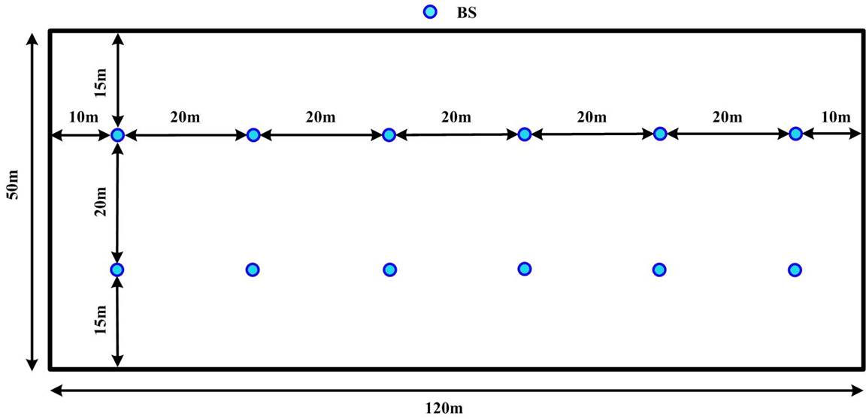
Figure 1. Base station layout for factory automation use case in TR 38.824.
Figure 2. Service area for factory automation

2.1.2 Traffic model downlink and uplink

For both downlink and uplink, Option 1 is chosen, hence:
- Option-1: all UEs’ messages both in DL and UL arriving at NG-RAN node in the first transfer interval are uniformly random distributed within the TI time window.

In addition, “For DL-UL traffic arrival time relationship” the option 1 is considered.

- Option-1: DL and UL traffic arrival time instants are independent

2.1.3 Number of UEs per cell

In the 5G-ACIA scenario, the UEs are randomly distributed within the respective service area.

Number of UEs per service area | {10}  The UEs are randomly distributed in each service area.

2.1.4 Other assumptions for FR 1

The same parameters are assumed in 5G-ACIA LS and TR 38.824, and summarized below.

Duplex | TDD
Carrier frequency | 4 GHz
Simulation bandwidth | 100 MHz
SCS | 30 kHz

2.1.5 TDD Frame and slot structure
TDD DL-UL configuration in the simulations is determined according to R4-1809555. {SU}, S={D12,G2}. Downlink slots (special sub-frames) consist of 12 downlink symbols and two gap symbols for time advance and transition, and uplink slots consist of 14 uplink symbols, where periodically the last 2 symbols is used for transmitting SRS.

In addition, the following SPS, CG configurations are used:

- UL CG with one 7-symbol mini-slot configuration.
- DL SPS with one 7-symbol mini-slot configuration.

2.1.6 Summary

A summary of simulation parameters and models can be seen as below

Parameters | 5G-ACIA LS
Factory hall size | 120x50 m
Room height | 10 m
Inter-BS/TRP distance | 20 m
BS/ antenna height | 8m for InF-DH
Layout – BS/TRP deployment | 12 BS
Channel model | InF-DH
Carrier frequency and simulation bandwidth | TDD  4 GHz: 100 MHz
TDD DL-UL configuration | {SU}, S={D12,G2}
Number of UEs per service area | 10
UE distribution | All UEs randomly distributed within the respective service area.
Message size | 48 bytes
DL traffic model | DL traffic arrival with option-1
UL traffic model | UL traffic is symmetric with DL, and DL-UL traffic arrival time relationship with option-1
CSA requirements | UC-#2: 99.9999%
Performance metrics | Percentage of UEs satisfying requirement, where requirement is PER:0.01% (10⁻⁴)
E2E latency & air interface latency | E2E latency: 1 ms for UC#2 in Appendix 1
UE speed | Linear movement: 75 km/h
UE Tx Power | 23 [dBm]
BS Tx Power | 31 [dBm]
BS Antenna Configuration | Ceiling-mount pattern  (M, N, P, Mg, Ng; Mp, Np) = (1, 2, 2, 1, 1; 1, 2)  dH = dV = 0.5 λ
UE Antenna Configurationl | Omnidirectiona  (M, N, P, Mg, Ng; Mp, Np) = (1, 2, 2, 1, 1; 1, 2)  dH = dV = 0.5 λ
Receiver Noise Figure | 5dB for BS and 9dB for UE
Clutter information | Cluster density: 60%  Cluster height: 6m  Cluster size: 2m
Addition model | Absolute time of arrival
UL CG / DL SPS configurations | UL CG and DL SPS with 7-symbol duration in mini-slot configuration.
UE processing capability | UE processing capability 2

3 Simulation Results
As mentioned above, there are 10 UEs per service area, which means that there are 120 UEs in the whole system. The simulation time is equal to 5 seconds

 | Resource Utilization | Percentage of UEs satisfying requirements | CSA
DL SPS | 56.8964% | 76.67% | 100%
UL CG | 56.9541% | 71.67% | 100%

Simulation results show that the percentage of UEs satisfying requirements is not as high as CSA. One main reason is that the configuration of DL SPS or UL CG is not adequate with the traffic arrival time. A postponed transmission happens in the simulation while the performance could be enhanced with a proper configuration.

Figure 3. CDF of DL Latency.
Figure 4. CDF of UL Latency.
Figure 5. CDF of CSA

4 Conclusions
In this contribution, we have provided initial system-level simulation results following the agreements related to the 5G-ACIA performance evaluation. The obtained results are summarized with the following observations:

Observation 1: For the FR1 deployment with InF-DH, the CSA requirement in DL and UL is satisfied with 10 UEs per service area.

Observation 2: For TDD configuration {SU}, where S={D12,G2}, with 30kHz SPS in FR1 InF-DH scenario, 76.67% of UEs in DL SPS are satisfied within delay constraint, while 71.67% of UEs in UL CG are satisfied within delay constraint.

The baseline performance is presented at the first phase. Results with other assumptions, further features and optimizations will be presented in the next phase.

5 References
- 3GPP 5G-ACIA, “Agreements on URLLC Features and Simulation Assumptions for 5G-ACIA”,
- RP-202069, “Way forward and RAN work for 5G ACIA requested simulations”, Ericsson
- TR 38.824.
- TR 38.901.
- TS 22.104.

Appendix 1. Performance requirements in TS 22.104
The services requirements of motion control are copied below from TS 22.104 V17.4.0.

TS 22.104 V17.4.0, Table 5.2-1: Periodic deterministic communication service performance requirements
Characteristic parameter |  |  |  | Influence quantity
Communication service availability: target value (note 1) | Communication service reliability: mean time between failures | End-to-end latency: maximum (note 2) (note 12a) | Service bit rate: user experienced data rate (note 12a) | Message size [byte] (note 12a) | Transfer interval: target value (note 12a) | Survival time (note 12a) | UE  speed (note 13) | # of UEs | Service area  (note 3) | Remarks
99.999 % to 99.999 99 % | ~ 10 years | < transfer interval value | – | 50 | 500 μs | 500 μs | ≤ 75 km/h | ≤ 20 | 50 m x 10 m x 10 m | Motion control (A.2.2.1)
99.999 9 % to 99.999 999 % | ~ 10 years | < transfer interval value | – | 40 | 1 ms | 1 ms | ≤ 75 km/h | ≤ 50 | 50 m x 10 m x 10 m | Motion control (A.2.2.1)
99.999 9 % to 99.999 999 % | ~ 10 years | < transfer interval value | – | 20 | 2 ms | 2 ms | ≤ 75 km/h | ≤ 100 | 50 m x 10 m x 10 m | Motion control (A.2.2.1)
NOTE 1: One or more retransmissions of network layer packets may take place in order to satisfy the communication service availability requirement.
NOTE 2: Unless otherwise specified, all communication includes 1 wireless link (UE to network node or network node to UE) rather than two wireless links (UE to UE).
NOTE 3: Length x width (x height).
NOTE 12a: It applies to both UL and DL unless stated otherwise.
NOTE 13: It applies to both linear movement and rotation unless stated otherwise.

Appendix 2. Activity plan
As it was agreed in [2]:
- Discussions are on the RAN1_NR reflector
  - Email activity only during short periods (< week) distributed across the time allocated to the activity
  - No email activity in weeks before/during/after RAN1 meetings or RAN defined inactive periods
Based on statements above, the following activity plan has been proposed:
- 12-16 October 2020
  - Discussion on which URLLC features to include in the evaluations and simulation assumptions
- 14-18 December 2020
  - First round of simulation results
- 22-26 February 2021
  - Second round of simulation results
- 8-12 March 2021
  - Finalization of the report to RAN#91

