3GPP TSG-SA WG6 Meeting #50-e meeting S6-222161
22nd – 31st August 2022, Online

Source: vivo
Title: Solution update for PIN server IP address recovery from PIN configuration server
Spec: 3GPP TR 23.700-78
Agenda item: 9.1
Document for: Approval
Contact: Huazhang Lv (Huazhang.lv@vivo.com)

1. Introduction
This pCR proposes to put forward a solution update for solution 5.
2. Reason for Change
There exists an issue of PIN service provided by multi-vendor and also focuses to solve the problem in KI#1 to support the PIN server discovery.
As indicated in the Figure 2-1, that in order to support to create a PIN, the provider of PINE (device 1), the UE1, PEMC (PIN client) and the PIN server are all provided by vendor 1.
When user inserts the SIM card to UE 1, in order to support to connect to device 1, the user should install the application from vendor 1 (the PEMC) and the PEMC triggers the PIN create to PIN server which is provided also by vendor 1.
But when the user changes the UE, from UE 1 to UE 2 which is provided by vendor 2. After inserting the SIM card, in order to support the PIN service or connect to device 1, the user should install the application provided by vendor 2 (because sometimes there may not exist the application from vendor 1 on the application store in vendor 2, only the application from vendor 2 is available). The application from vendor 2 can only access to PIN server from vendor 2.
The vendor of PIN service provider, PEMC, UE and PIN server are bound together and barriers arises due to the availability of services by individual manufacturers.
Observation: There exists the situation that in order to provide the PIN service, the vendor of UE, PEMC and PIN server are all the same. And if user change the UE, the PEMC and PIN server will also be changed to the same vendor of UE to maintain the PIN service.
But the drawback of this design is, the user has to discover a new PIN server and all of the PIN profile in vendor 1 will be lost.
In order to recover the old PIN server IP address and recover the old PIN profile, the 3GPP should has the mechanism that the user can recover the profile even when user changes the UE.
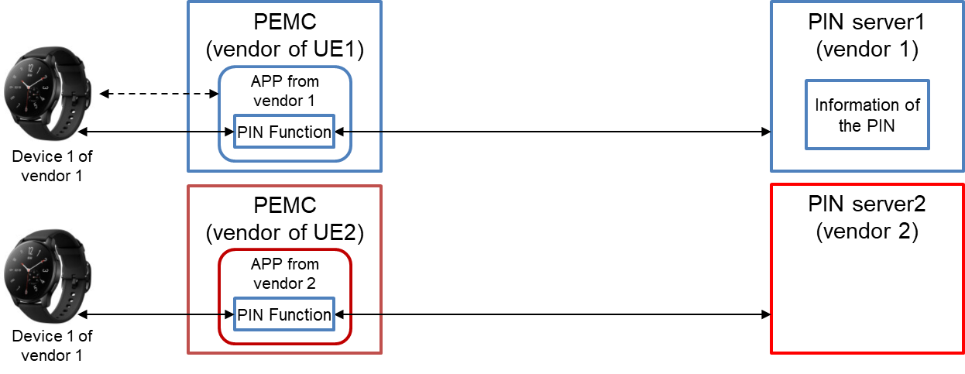
Figure 2-1: The situation of user changing the UE and the PIN server also changed
In this solution, it has a design of PIN configuration server which is used to store the user’s configuration of PIN. When user changes the UE, and user can still recover the PIN server IP address and other configuration from PIN configuration server.
3. Conclusions
N/A
4. Proposal
It is proposed to agree the following changes to 3GPP TR 23.700-78 v 0.4.0.

* * * First Change * * * *

7.8 Solution #7: PIN server discovery

7.8.1 Architecture enhancements
The architecture of PIN is referred to the solution 1 in clause 7.
PIN configuration server: Deployed to support to store and recover the PIN server IP address.

7.8.2 Solution description

7.8.2.1 General
This solution addresses aspects of Key Issue #1.
Before the PEMC triggers the PIN establishment, or the PEMC triggers PIN modification or PIN delete, a certain PIN server should be discovered. The PIN server is responsible to perform the request of PIN create, PIN modification and PIN delete from PEMC of a PIN.
Due to the PIN server in a PLMN can be multiple, so it is important to PIN elements to discover the appropriate PIN server to connect.

7.8.2.2 Procedures of PIN server discovery

7.8.2.2.1 Procedures of PIN server discovery based on receiving PIN server endpoint information
The aim of PIN server discovery procedure is to receive one or more endpoint information (e.g. URI(s), FQDN(s), IP address(es)) of PIN server. And the PEMC, PEGC, PIN elements are all able to receive the PIN server endpoint information.
The PIN server can be discovered by the following method:
- pre-configured in the PIN elements or PIN clients;
- configured by the user;
- provisioned by MNO through 5GC procedure; or
- derived from HPLMN identifier for non-roaming scenario or from VPLMN identifier for roaming scenario.
It may be possible to provide the PIN server endpoint information to the PIN client or PIN elements from the 5GC. If the PIN server endpoint information is provided by 5GC and available at the PEMC, the PEMC shall use the information for the PIN management procedure (e.g.: PIN creation/modification/delete).
Otherwise, the PEMC shall use pre-configured PIN server endpoint information for PIN management procedure if pre-configured PIN server endpoint information is available in PEMC.
After the PIN discovery, the PIN client can trigger the per-GPSI store of PIN server IP address or another PIN profile into PIN configuration server. If the user changes the UE, in order to keep the configuration consistency and still use the old PIN server for PIN service, the PIN client can recover the PIN server IP address or another PIN profile from PIN configuration server. And the PIN client may not have the PIN server discovery any more.

7.8.2.2.2 Procedures of PIN server discovery via PEGC
Due to for some of the PIN elements can have the application interaction towards the PEGC, for example, via WiFi or Bluetooth pairing, so the PEGC can provide the PIN server end point information to PIN elements.
For some of the PEGC, it has the open access capability to accept the application layer connection from the PIN elements.
Figure 7.8.2.2.2.-1 illustrates PIN server discovery via PEGC based on request/response model.
Pre-conditions:
1. The PIN elements or PIN client has application layer connection with PEGC;
2. The UE Identifier or PIN client Identifier is available;
Figure 7.8.2.2.1-1: PIN server discovery via PEGC
1. The PIN element or PIN clients has already had the application layer connection towards PEGC. For example, the PIN elements can communicate with PEGC via WiFi or Bluetooth.
2. The PEGC delivers the PIN server end point information to PIN elements or PIN client. The end point information of PIN server includes URI(s), FQDN(s), IP address(es)) of PIN server.
Editor's note: Whether and how the PIN elements discover the PIN server needs more study.
Editor's note: Whether and how the PEMC distributes the PIN server IP address to other PIN elements needs more study.

7.8.2.2.3 Procedures of PIN server IP address store and recovery from PIN configuration server
In order to recover the old PIN server IP address and recover the old PIN profile, it should has the mechanism that the user can recover the profile even when user changes the UE.
Figure 7.8.2.2.3.-1 illustrates PIN server IP address store and recovery based on request/response model.
Pre-conditions:
1. The PIN elements or PIN client has received the PIN configuration server IP address;
2. The UE Identifier or PIN client Identifier is available;
Figure 7.8.2.2.3-1: PIN server IP address store and recovery from PIN configuration server
1. The PEMC in UE 1 receives the address of PIN configuration server.
NOTE: The PIN configuration server IP address can be pre-configured in PEMC that provided by each vendor. The PIN configuration server is used to store the PIN server IP address used by PEMC.
2. The PEMC in UE 1 triggers the request to store the PIN server IP address to PIN configuration server. The request also includes the GPSI, PIN server IP address and security credentials.
3. The PIN configuration server sends successful response to PEMC. If the request fails, the PIN configuration server should give the failure response to indicates that indicates the cause of request failure.
4. The user changes to another UE 2.
5. The PEMC in UE 2 triggers the request to recover the PIN server IP address from PIN configuration server. The request also includes the GPSI and security credentials.
6. The PIN configuration server sends successful response to PEMC and provide the PIN server IP address. If the request fails, the PIN configuration server should give the failure response to indicates that indicates the cause of request failure.

* * * End of Change * * * *

