3GPP TSG-SA WG6 Meeting #50-e meeting S6-222158
22nd – 31st August 2022, Online

Source: vivo
Title: Solution update for PEMC and PIN server discovery for PINE
Spec: 3GPP TR 23.700-78
Agenda item: 9.1
Document for: Approval
Contact: Huazhang Lv (Huazhang.lv@vivo.com)

1. Introduction
This pCR proposes to update the solution 5 and solution 7 of PIN discovery and PIN server discovery.
2. Reason for Change
In solution 5 and solution 7, they design the potential way for PINE to discover the PIN and PIN server. But details of how the PINE firstly discovers the PEMC, and how to PINE to discover.
For example, in solution 5, the procedure of Figure 7.6.2.2.2-1 has a precondition that, the PINE has already had an application layer connection with PEMC:
1. The PIN element has already had an application layer connection with a PEMC which manages a PIN.
But this solution doesn’t give the details that, how can the PINE discover the PEMC, if the PINE connects to PEGC. It is more general that the PEGC has the open access for the PINE at home or office.
And another example is in solution 7, there exists the ENs, that how to PINE discover the PIN server is FFS.
Editor's note: Whether and how the PIN elements discover the PIN server needs more study.
In this solution, we refer to an IP mechanism of broadcast to solve the problem. If the destination of IP address is 0.0.0.0, it can represent all of the hosts in the network. It helps the router send packets that cannot be queried in the routing table.
The PEMC of a PIN can configure the PIN server IP address or PEMC IP address on PEGC. And when PEGC receives the IP packet from PINE and the destination IP address of this packet is 0.0.0.0, the PEGC can identify that this is the discovery message and the PEGC delivers the message to PEMC or PIN server. The PIN server and PEMC can reply to the PINE with the PIN server IP address and PEMC IP address respectively.
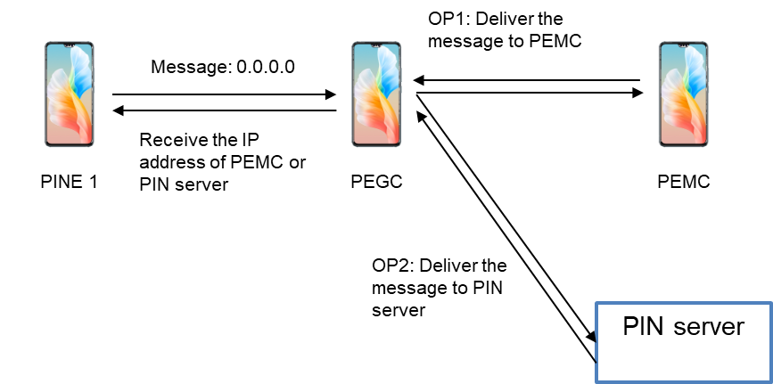
Figure 2-1: Illustration of PINE requests the PEMC/PIN server IP address

Firstly, the PINE1 connects to the PEGC, via application layer mechanism, for example, WiFi or others. And the PEGC can be accessed open by PINE.
And the PINE sends a random message (e.g.: HTTP message) which the destination IP address is 0.0.0.0 to PEGC. And the PEGC can be set the rules by PEMC. When PEGC receives the IP packet to 0.0.0.0, the PEGC can redirect the IP packet to either PEMC of a PIN or to the PIN server.
When the PIN server or the PEMC receives the IP packet from PEGC, the PIN server or PEMC replies with the PIN server IP address and PEMC IP address respectively to PEGC. And the PEGC sends the response to PINE.
At last, the PINE finally receives the PEME IP address and PIN server IP address via PEGC.
3. Conclusions
N/A
4. Proposal
It is proposed to agree the following changes to 3GPP TR 23.700-78 v 0.4.0.

* * * First Change * * * *

7.6.2 Solution description

7.6.2.1 General
This solution addresses aspects of Key Issue #1.
For a certain PIN element, the PIN should be discovered and the PIN element can decide whether to join in the PIN. There are two situations that the PIN elements can discover the PIN as following:
- If the PIN elements can have an application layer communication with the PEMC which manages a PIN, the PIN elements can receive the PIN ID,PIN description and the PIN service that a PIN can provide, and decides whether to join the PIN;
- The PEGC can be set as open access and the PIN element can communicate with PIN server to receive the PIN ID,PIN description and the PIN service that a PIN can provide from PIN server via the PEGC.
Before the two situations above, the PINE can receive the PIN server IP address or PEMC IP address via PEGC according to the IP mechanism of broadcast. If the destination of IP address is 0.0.0.0, it can represent all of the hosts in the network. It helps the router send packets that cannot be queried in the routing table.
The PEMC of a PIN can configure the PIN server IP address or PEMC IP address on PEGC. And when PEGC receives the PIN discovery request which the destination IP address is 0.0.0.0 from PINE, the PEGC can identify that this is the discovery message and the PEGC delivers the message to PEMC or PIN server. The PIN server and PEMC can reply to the PINE with the PIN server IP address and PEMC IP address respectively.

* * * End of Change * * * *

* * * Second Change, all new text * * * *

7.6.2.2.3 Procedures of PINE receives the PIN server IP address or PEMC IP address
Due to for some of the PIN elements can have the application interaction towards the PEGC, for example, via WiFi or Bluetooth pairing, and the PIN element can send PIN discovery request that with destination IP address of 0.0.0.0 to PEGC. If the destination of IP address is 0.0.0.0, it can represent all of the hosts in the network. It helps the router send packets that cannot be queried in the routing table.
The PEMC configures the rules by PEMC. When PEGC receives the PIN discovery request with IP packet to 0.0.0.0, the PEGC can redirect the requests to either PEMC of a PIN or to the PIN server.
Figure 7.6.2.2.3-1 illustrates PINE receives the PIN server IP address or PEMC IP address based on request/response model.
Pre-conditions:
1. The PIN elements or PIN client has already connected to PEGC;
2. The UE Identifier or PIN client Identifier is available;
3. The PEGC has been authorized to communicate with the PIN server or PEMC;

Figure 7.6.2.3.3-1: PIN discovery triggered by PINE
0. The PIN element or PIN clients has already had the application layer connection towards PEGC. For example, the PIN elements can communicate with PEGC via WiFi or Bluetooth.
0. The PEMC configures the rules on PEGC when PEGC receives the PIN discovery request and the destination IP of request is 0.0.0.0, the PEGE can redirect the PIN discovery request to either PEMC or PIN server.
1. The PINE sends a PIN discovery request (PINE ID, PINE IP address) which the destination IP address of the request is 0.0.0.0 to PEGC. And the PEGC can be set the rules by PEMC. When PEGC receives the PIN discovery request from PINE which the destination IP address is 0.0.0.0, the PEGC can redirect the IP packet to either PEMC of a PIN or to the PIN server.
2a. According the rules configured by PEMC, after receiving the PIN discovery request which the destination IP of request is 0.0.0.0 from PINE, the PEGC can redirect the IP packet to PEMC of a PIN.
2b. According the rules configured by PEMC, after receiving the PIN discovery request which the destination IP of request is 0.0.0.0 from PINE, the PEGC can redirect the IP packet to PIN server.
3a-3b. When the PIN server or the PEMC receives the PIN discovery request from PEGC, the PIN server or PEMC replies with the PIN discovery response (PIN server IP address or PEMC IP address) respectively to PEGC. And the PEGC sends the response to PINE.

4. The PEGC sends the PIN discovery response (PEMC IP address or PIN server IP address) from PEMC or PIN server to PINE.
After PINE receives the IP address of PEMC or PIN server, it can trigger the procedure defined in section 7.6.2.2.1 and 7.6.2.2.2.

* * * End of Change * * * *

* * * Third Change * * * *

7.8.2.2.2 Procedures of PIN server discovery via PEGC
Due to for some of the PIN elements can have the application interaction towards the PEGC, for example, via WiFi or Bluetooth pairing, so the PEGC can provide the PIN server end point information to PIN elements.
For some of the PEGC, it has the open access capability to accept the application layer connection from the PIN elements.
Figure 7.8.2.2.2.-1 illustrates PIN server discovery via PEGC based on request/response model.
Pre-conditions:
1. The PIN elements or PIN client has application layer connection with PEGC;
2. The UE Identifier or PIN client Identifier is available;
Figure 7.8.2.2.1-1: PIN server discovery via PEGC
1. The PIN element or PIN clients has already had the application layer connection towards PEGC. For example, the PIN elements can communicate with PEGC via WiFi or Bluetooth.
2. The PEGC delivers the PIN server end point information to PIN elements or PIN client. The end point information of PIN server includes URI(s), FQDN(s), IP address(es)) of PIN server.

Editor's note: Whether and how the PEMC distributes the PIN server IP address to other PIN elements needs more study.
According to the procedure defined in section 7.6.2.2.3, the PEMC of a PIN can configure the PIN server IP address or PEMC IP address on PEGC. And when PEGC receives PIN discovery request which the destination IP address of the PIN discovery request is 0.0.0.0, the PEGC can identify that this is the discovery message and the PEGC delivers the message to PEMC or PIN server. The PIN server and PEMC can reply to the PINE with the PIN server IP address and PEMC IP address respectively.

* * * End of Change * * * *

