3GPP TSG-SA WG6 Meeting #50-e meeting S6-222157
22nd – 31st August 2022, Online

Source: vivo
Title: Solution update for multiple PEMCs in PIN create
Spec: 3GPP TR 23.700-78
Agenda item: 9.1
Document for: Approval
Contact: Huazhang Lv (Huazhang.lv@vivo.com)

1. Introduction
This pCR proposes to put forward a solution update for solution 2.
2. Reason for Change
For a certain PIN, it may have the multiple PEMCs for this PIN.
Just like at home or office, there can be multiple managers. For example, at home, the role of managers can be the parents. And at office, the different leaders or maintainers can have the role of PEMC.
Also, if one PEMC is out of touch or switched off, and the PIN may not be able to update by other PINEs. So, the multiple PEMCs are reasonable for a certain PIN.
It is not convenient, in a PIN it limits that there is only one PEMC.
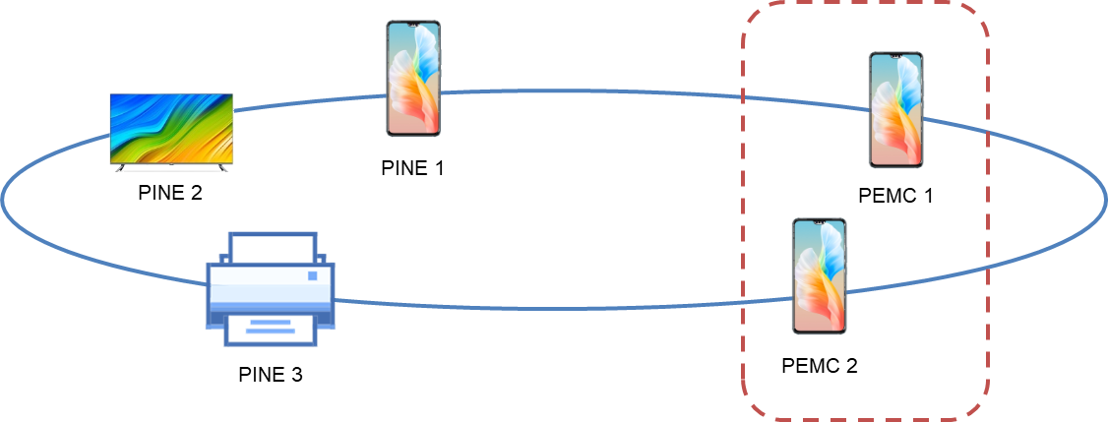
Figure 2-1: Multiple PEMCs in a certain PIN
3. Conclusions
N/A
4. Proposal
It is proposed to agree the following changes to 3GPP TR 23.700-78 v 0.4.0.

* * * First Change, all new text * * * *

7.3.2.2 Procedures of Creation of PIN
This procedure presents a high-level overview of Solution #X.
Figure 7.3.2.2.2.-1 illustrates PIN creation procedure based on request/response model.
Pre-conditions:
1. The UE (PINAPP) has been pre-configured or has discovered the address (e.g. IP address, FQDN, URI) of the PIN server;
2. The UE Identifier or PIN client Identifier is available;
3. The PINAPP has been authorized to communicate with the PIN server;
4. The UE or PINAPP has already received the role of PEMC from PIN server;

Figure 7.3.2.2.2-1: Creation of PIN
1. The UE or PINAPP which is the role of PEMC sends a PIN creation request to the PIN server to request to create a PIN. The PIN creation request includes the security credentials of the UE or PINAPP received during PINAPP authorization procedure and may include the UE identifier such as GPSI, PIN client ID, UE location and PINAPP profile(s) information. The PEMC can also indicate the PIN service that the PIN can provide to PIN server.
The PEMC can request to create a PIN that including other PIN elements that has already communicated with PINAPP (PEMC). If so, the PEMC sends the PIN creation request including the PIN elements information for example, UE identifier such as GPSI, PIN client ID, UE location and PINAPP profile(s) information.
If there are no other PIN elements in the request, the PEMC requests to create a PIN that including only one element that the PEMC.
In order to save the procedure of several PEMCs to be included into the certain PIN, the PEMC can have the additional PEMC GPSIs in the PIN create request, to indicate additional PEMCs that are allowed to manage the PIN. This procedure doesn’t have conflict with the PEMC to be included into the certain PIN separately.
NOTE: For a certain PIN, only one PEMC at a time can be set active.
2. Upon receiving the request, the PIN server performs an authorization check to verify whether the PINAPP (PEMC) has authorization to perform the operation.
If additional PEMC GPSIs are received, the PIN server checks with the 5GS whether the additional PEMCs identified by the additional PEMC GPSIs.
Editor's Note: Whether and how the 5GC involved in the PIN creation is FFS.

3. The PIN server sends a successful response to PINAPP (PEMC), which includes a newly assigned PIN ID to indicate the PIN. If the PIN creation request fails, the PIN server should give the failure response to indicates that indicates the cause of PIN creation request failure. If the UE identified by the additional PEMC GPSI is not authorized to be a PEMC, the response includes the corresponding error information.
If there are no other PIN elements in the PIN creation request and the PIN creation is successful, the PEMC indicates the PINAPP (PEMC) to be the PEGC. The PINAPP who has already had the role of PEMC can also has the role of PEGC.
If the PEGC is indicated, the PIN server sends PIN client ID (that represents the PEGC), assigned IP address or port number in successful response to PINAPP (PEMC). And, the PIN Server also sends the PEGC information about access control in the response, including:
- Access control information includes: user name, account, SSID, BSSID. All the information is used by PIN elements (PINAPP) in PIN to access 5G or access other application outside of PIN;
NOTE 1: How to PIN server receives or derive PEGC information about access control is in the scope of SA2.
After the procedure above, the PINAPP (PEMC) creates a PIN with PINAPP(PEGC) and other accepted PIN elements in PIN.

* * * End of Change * * * *

* * * Second of Change * * * *

7.3.2.3.1 PIN modification triggered by PEMC
If the management of PIN should be changed to other PIN elements in UE, the original PEMC of a PIN should trigger the PIN modification procedure to PIN server.
Figure 7.3.2.3.1-1 illustrates PIN modification procedure based on request/response model.
Pre-conditions:
1. The PEMC in a PIN has been pre-configured or has discovered the address (e.g. IP address, FQDN, URI) of the PIN server;
2. The PIN has already been created and a PIN ID is distributed by PIN server;
3. The PEMC has been authorized to communicate with the PIN server;
4. A PIN client has already received the role of PEMC from PIN server;

Figure 7.3.2.3.2-1: Modification of PIN triggered by PEMC
1. The PEMC sends a PIN modification request to the PIN server to request to change the role of PIN management. The PIN modification request includes the security credentials of the PIN client received during PIN client authorization procedure and may include the UE identifier such as GPSI, PIN client ID, UE location and PIN client profile(s) information and PIN ID. The PIN ID indicates the management of this PIN will be changed.
The PEMC can also include the potential PEMC in this PIN that represented by GPSI, PIN client ID. But this propose by PEMC is only for recommendation towards PIN server. If there are more than one potential PEMCs are included in PIN modification request, the original PEMC can label the priority of these potential PEMCs.
Also, if the PIN service in PIN has updated, for example, the service in PINE (in this PIN) is newly added or the service in PINE (in this PIN) is deactivated or disabled, the PEMC should trigger PIN modification request includes the updated PIN services.
In order to save the procedure of several PEMCs to be included into the certain PIN, the PEMC can have the additional PEMC GPSIs in the PIN modification request, to indicate additional PEMCs that are allowed to manage the PIN. This procedure doesn’t have conflict with the PEMC to be included into the certain PIN separately.
NOTE: For a certain PIN, only one PEMC at a time can be set active.
2. Upon receiving the request, the PIN server performs an authorization check to verify whether the PEMC has authorization to perform the operation. The PIN server also updates and stores the PIN service of this PIN as PIN profile.
3. The PIN server sends a successful response to original PEMC, which includes a stop of administrator permissions of PIN and the PIN client ID of the new PEMC. If the PIN modification request fails, the PIN server should give the failure response to indicates that indicates the cause of PIN modification request failure.
The PIN server can decide the new PEMC from the PIN elements in the PIN, and can also consider the potential PEMC that indicated by old PEMC.
After the new PEMC is selected, the new PEMC can either be configured with the PIN Profile information by PIN server, or the PIN Profile information can be configured by the old PEMC. The PIN Profile information includes the PIN elements in PIN (for example, IP address or ID), access control information of each PIN elements.
4. After receiving the successful of PIN modification response, the old PEMC stops the administrator permissions of a PIN which is represented by PIN ID. And the PIN server delivers the PIN Profile information to the new PEMC according to new PEMC IP address or ID indicated in successful PIN modification request.

* * * End of Change * * * *

