3GPP TSG-SA WG6 Meeting #49-bis-e S6-221755
e-meeting, 22nd June – 1st July 2022 (revision of S6-22xxxx)

Title: LS on Clarification of Edge Node Sharing
Response to:
Release: Release-18
Work Item: FS_eEDGEAPP

Source: 3GPP SA6
To: GSMA OPG
Cc:

Contact person: Yanmei Yang
yangyanmei@huawei.com

Send any reply LS to: 3GPP Liaisons Coordinator, mailto:3GPPLiaison@etsi.org

Attachments:

1 Overall description

During SA6 discussion on the solutions for OP Federation, there are some views about GSMA OP requirements on OP federation relationship and communication.
In SA6 discussion, there are two solutions for Edge application discovery in Edge Node sharing scenario. These solutions are based on different understanding of Edge Node deployment and shared resources. Figure 1-1 and figure1-2 shows the two different interpretation of with and without presence of local DN with edge node platform from home OP (OP A) at Edge at Edge Node sharing location.

In the Figure1-1, Operator B have no Edge Node resource available at the location 1, where Operator B deploys its EAS to Operator A’s edge resource. Correspondingly, the shared resource to operator B includes EES A deployed by operator A.

While in the Figure 1-2, Operator B have Edge Node resource available at the location 1, but he still want to deploy its EAS to Operator A’s edge resource. Correspondingly, the shared resource to operator B does not includes EES A deployed by operator A.

In both deployment 1 and 2, there is also a controversial understanding about the represent of shared edge node resource: whether the EES A can be shared by Operator A to Operator B.
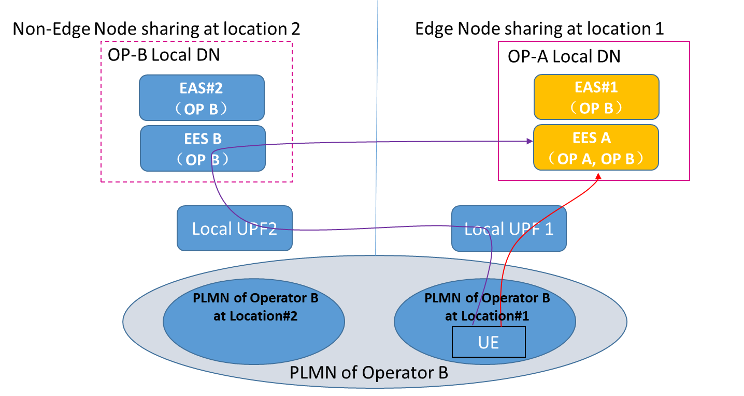
Figure1-1: Deployment without Home OP’ local DN at Edge Node sharing location

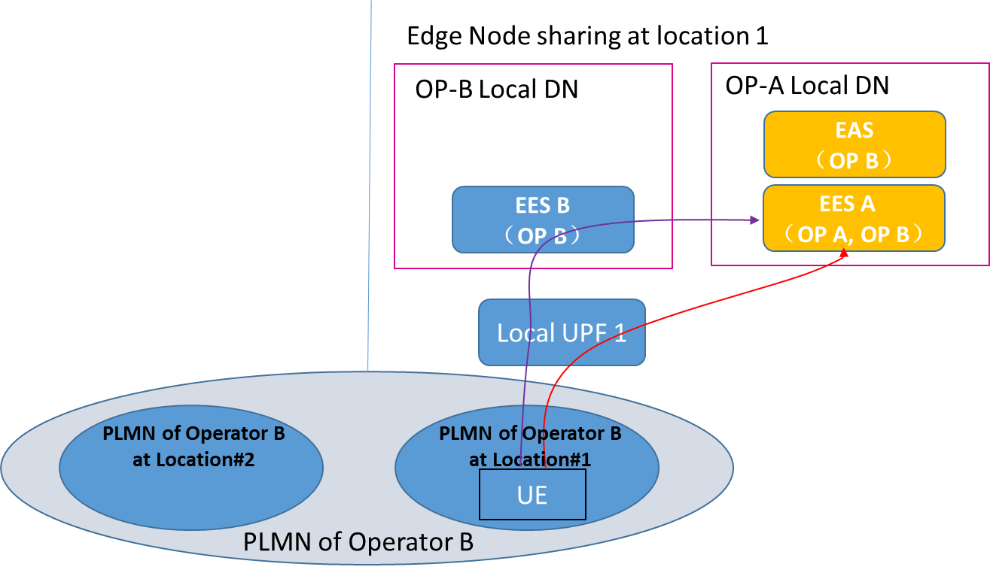
Figure1-2: Deployment with Home OP’ local DN at Edge Node sharing location
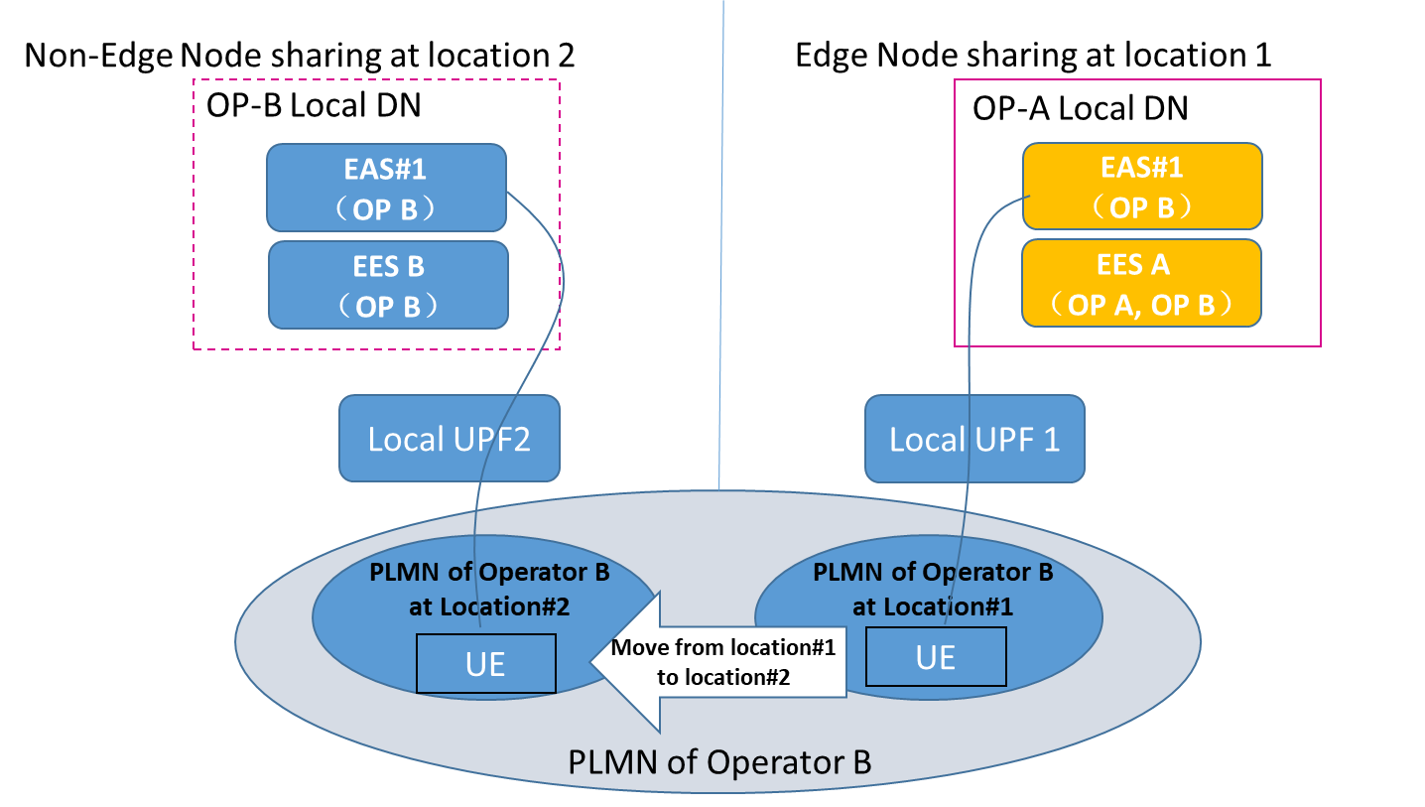
Figure1-3: Deployment with Home OP’ local DN at Edge Node sharing location

SA6 would like to ask GSMA OPG to answer the following question:

Q1: Which deployment case is the correct understanding of the Edge Node Sharing scenario? With or without Edge Node resource from home Operator (OP B) at the location #1?
Q2: Whether the EES A deployed by operator A is shared to Operator B for serving Operator B’s end user (as it represented by red line in figure1-1)?
Q3: If deployment as in figure1-1 exists, does the end user has to connect to EES B presenting at non-sharing location remotely, then to EES A to obtains EES A’s services (as it represented by purple line in figure1-1)?
Q4: If deployment as in figure1-2 exists, does the end user has to connect to EES B, then to EES A to obtain EES A’s services (as it represented by purple line in figure1-2)?
Q5: If deployment as in figure1-2 exists, does the end user is allowed to directly connect to EES A to obtain EES A’s services (as it represented by red line figure1-2)?
Q6: Whether is it possible that Operator B deploys the same EAS at non-edge node sharing location (location 2), as which it deploys on operator A’s Edge node resource at (location1) (as it represented by in figure1-3)?
Q7: What is the purpose of Operator B deploying its EAS to share edge node resource, is it for its own end user? Or it is also for serving operator A’s end user?

SA6 would like to request answers to the above questions from GSMA OPG

2 Actions
To GSMA OPG
ACTION: SA6 requests GSMA to provide response to the questions, with applicable use case(s).

3 Dates of next TSG SA WG 6 meetings
SA6#50-e 22nd August – 31st August 2022 online meeting
SA6#51-e 10th October – 19th October 2022 online meeting

