3GPP TSG-SA WG6 Meeting #42-e S6-210472
e-meeting, 1st – 9th March 2021 (revision of S6-210250)

Source: Lenovo, Motorola Mobility
Title: Update of Solution #16 on TSN policy negotiation
Spec: 3GPP TR 23.745 v1.2.0
Agenda item: 8.2
Document for: Approval
Contact: Manos Pateromichelakis <epateromiche@lenovo.com>

1. Introduction
This contribution provides an update of solution #16 on TSN policy negotiation via FAE layer.
2. Reason for Change
This contribution provides an update of the solution #16. This is the further update to capture the concerns received related to the compatibility of Steps 3-4 to the IEEE protocols as well as the feasibility / usefulness of this solution.
Some considerations are provided below:
- For critical communication streams, the CNC can manage the entire path of time-sensitive streams from end to end via scheduled traffic according to IEEE 802.1Qbv. CNC receives the transmission schedule of end devices (TSN talkers) via the CUC. The CNC can define traffic schedules for each traffic class at the egress port of TSN bridges.
- The task of CUC is to collect the requirements of the various applications in the network and forward them in collections per stream (“one talker, multiple listeners”) to the CNC. After configuration by the CNC, the CUC forwards the final configurations to the end-devices. CUC is an optional node that discovers end stations, their capabilities and user requirements, and configures delay-optimized TSN features.
- IEEE 802.1Qcc specifies a “User/Network Protocol” and information to be exchanged for CUC - CNC communication for schedule management, path management, etc.
The figure below provides an illustration from 5G-ACIA whitepaper on the IEEE 802.1Qbv centrally managed network with traffic-class-based scheduling [1]. CUC is interacting with end devices for getting application QoS requirements and for providing the configurations which were obtained by the CNC.
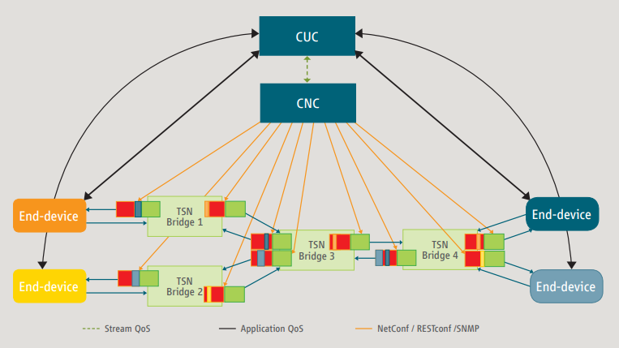
Figure x IEEE 802.1Qbv centrally managed network with traffic-class-based scheduling [1]
Observation 1: In Solution #16, the FAE server can be assumed to be acting as CUC. In this case, the FAE clients will provide application requirements to FAE server, then FAE server will pass these requirements to CNC, and after configuration by CNC, the FAE server will provide the configurations to FAE clients.
Observation 2: Some application requirements, like the survival time (which is defined as an application characteristic is the maximum number of consecutive frames whose loss can be tolerated by a given application) are not understood by the CNC. So, the setting/update of the survival time needs to be translated at the enabler layer to a trigger for an action which may impact the configuration (e.g. change of the tolerance to loss value).
Observation 3: CNC does not provide a one-time configuration to CUC; but could be updated based on updated application requirements by the end devices. An end device mobility change (e.g. mobile robots change speed/distance) may also affect the application requirements which need to be translated at the CUC / FAE server and trigger a transmission schedule update at the CNC.
The solution is therefore justified and feasible, if the FAE server is acting as CUC. This translation capability is also beneficial for scenarios where the application requirements or network conditions change, since FAE server is acting as CUC and also is capable of receiving network/QoS monitoring events from 5GC/SEAL.

[1] 5G-ACIA whitepaper, “Integration of 5G with Time-Sensitive Networking for Industrial Communications”.

3. Proposal
It is proposed to agree the following changes to 3GPP TR 23.745 v1.2.0.

* * * Change * * * *

7.16 Solution #16: TSN policy negotiation via FAE layer

7.16.1 Solution description
This solution function addresses the Key issue #4 for enabling the negotation via the FAE layer of the TSN application QoS requirements (e.g. survival time) and their mapping to network policies / QoS parameters.

7.16.1.1 General
This solution takes as input a trigger event based on the monitored QoS parameters (by SEAL / NRx or by the network) and based on this, it generates a trigger which may be in the form of a proposed action, which can be a policy related to the 1) adaptation of application requirements (e.g. survival time, TSC service area, mobility change) or 2) adaptation of port management policies (DS-TT, NW-TT policies). TSN system (FF application specific server which is equivalent to CNC) may then provide a request for adaptation of the configuration based on these requirements, and FAE server will send these policies to the corresponding Devices (FAE clients)
An example for TSN policy negotiation corresponding to port management policies and service requirements is when high jitter is monitored for an ongoing session, the hold & forward buffering parameters may be adapted to de-jitter the TSC flows. However, this will have impact on the survival time, since the delayed reception of the traffic, may lead to service termination (due to reaching the survival time threshold). In this case, FAE server interacts with the CNC for triggering the adaptation of the survival time/ tolerance to loss value, in combination with the hold & forward buffering parameters.

7.16.1.2 Procedure
Pre-condition 1: UE is registered to 5GS and FAE client has established a connection with FAE server.
Pre-condition 2: FF application specific server has subscribed to FAE server to receive TSN related triggers.
Pre-condition 3: FAE server has subscribed to the SEAL server / NRx (based on Solution #10 of TR 23.745) or to the PLMN (e.g. QoS monitoring for URLLC as specified in clause 5.33.3 of TS 23.501) for receiving QoS events.

Figure 7.16.1.2-1: TSN Policy update negotiation
1a. A QoS monitoring event is send from either SEAL/NRx (based on Solution #10 of TR 23.745) or PLMN/NEF to the FAE server based on the subscription (e.g. event related to high jitter for TSC flow).
1b. Alternatively to 1a, a UE related monitoring event, which may relate to a UE related event (e.g. change of UE or group mobility/speed, inter-UE distance change, location reporting) or a application-related event (notification that maximum survival time is reached for the TSC service, high jitter, etc).
2. FAE server upon receiving the QoS and/or UE-related monitoring event for one or more TSC flows, determines a trigger, which can be a proposed TSN policy update for all or subsets of the TSC flows within the FF application. The trigger may take the form of a new service requirement, QoS requirement or network requirement for the TSC flows, taking also into account the location of the UEs (which can be provided by LM server).

3. The FAE server, acting as CUC, sends an abstracted report, enclosing a notification on an experienced/expected change of application requirement /application QoS metric based on the received event to FF application specific server / CNC. CNC may adapt the configuration, and then sends a TSN policy update to FAE server, including the new policy parameters based on the proposed policy parameters. The new policy update may take the form of a new QoS/network/service requirement for the TSC flows of the end devices. This exchanged is performed via User/Network protocol as being specified in IEEE 802.1Qdc.
4. The FF application specific server sends a TSN flow configuration update to the NRz server (NRz server, acting as TSN AF, receives from FF application specific server, acting as CNC, policy parameters and related flow information according to IEEE 802.1Q), if the TSN policy update relates to the update of the QoS policies for the TSN flows. If the TSN policy update relates to NW-TT/DS-TT port management policy update, NRz interacts with NW-TT and DS-TT to apply the new policy (TSN AF to NW-TT/ DW-TT transfer of port or bridge management information, as defined in TS23.501, clause 5.28.3.2). NRz server has been defined in Solution #22 of TR23.745.
5. The FAE server sends a service requirement update message to the involved FAE clients. This message includes the agreed policy update type and parameters. Then, further interaction with FF application specific client is needed for applying the new parameters (e.g. survival time increase).

7.16.2 Solution evaluation
This solution provides a mechanism, involving the FAE, for transforming a monitoring event from the network or UE side, to an abstracted report which can be used by FF application specific server to adapt the TSN policies for one or more devices running TSC services. This solution provides an enhancement for pro-actively alerting the CNC on expected performance downgrade, while minimizing the complexity/overhead at the FF application specific server (for processing all related network/UE triggered monitoring events).
TSN-based ecosystems are configured to explicitly support required QoS at the application layer. This solution provides a mechanism to enable adjustments for QoS conditions; however, it is still unclear in which use such QoS abnormalities occur in TSN networks. This solution will be considered for normative work if a valid use case is identified where this solution provides value

* * * End of Change * * * *

