3GPP TSG-SA WG6 Meeting #41-e S6-xxxxxx
E-meeting, 18th – 26th January 2021 Revision of S6-210035

Source: ZTE Corporation
Title: Evaluation of solution #8
Spec: 3GPP TR 23.745 v1.2.0
Agenda item: 8.2
Document for: Approval
Contact: Shao Weixiang, shao.weixiang@zte.com.cn

1. Introduction
This contribution provides evaluation of Solution #8 for QoS monitoring.
2. Reason for Change
This contribution adds evaluation of Solution #8.

3. Proposal
It is proposed to agree the following changes to 3GPP TR 23.745 v1.2.0.

* * * First Change * * * *

7.8 Solution #8: QoS monitoring

7.8.1 Solution description
This solution addresses Key issue 5 - QoS monitoring.
QoS monitoring is a critical requirement for many FF applications.
The issue to address here via the NEF, according to the procedures defined in 3GPP TS 23.502 [12] clause 4.15. NEF supports APIs of exposure of network events, analytics for QoS monitoring.
The detail procedures over NEF Northbound Interface are defined in 3GPP TS 29.522 [11] clause 4.4:
- Procedures for setting up an AF session with required QoS, which defines QoS monitoring event (QOS_MONITORING) within "QoSMonitoring_5G" feature
- Procedures for analytics information exposure, which defines analytics event (QOS_SUSTAINABILITY) within "QoS_Sustainability" feature

7.8.1.1 QoS monitoring procedure
Pre-conditions:
1. The FF UE has already registered, configured, provisioned.
2. The FF UE has an established connection to 5G network.
The procedure for QoS monitoring is illustrated in figure 7.8.1.1-1.
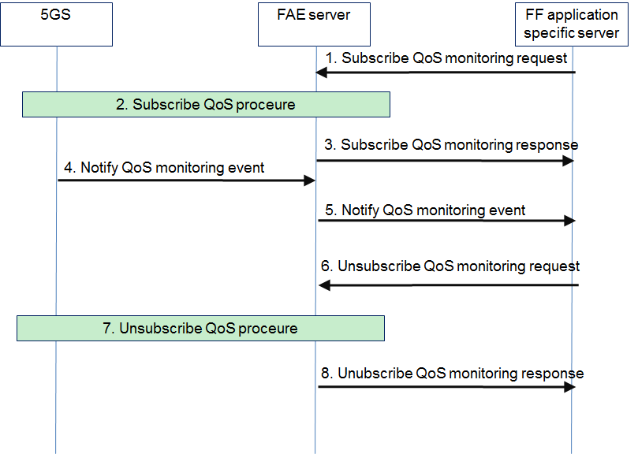
Figure 7.8.1.1-1: QoS monitoring procedures
1. The FF application specific server sends a QoS monitoring subscribe request to the FAE server.
2. The FAE server interacts with NEF to subscribe to QoS monitoring events, including:
- QOS_MONITORING, supported by AsSessionWithQoS API of 3GPP TS 29.522 [11]
- QOS_SUSTAINABILITY, supported by AnalyticsExposure API API of 3GPP TS 29.522 [11]
Editor's Note: QoS monitoring events for TSC cases are FFS.
3. The FAE server sends a QoS monitoring subscribe response to the FF application specific server.
4. When QoS monitoring event is triggered, NEF sends a QoS monitoring notification to the FAE server.
5. The FAE server determines the QoS monitoring event information to send to the FF application specific server. The transport related information received from 3GPP system should be translated to application related information by the FAE server.
NOTE: Steps 4 and 5 are repeated when QoS monitoring events occur.
6. When the FF application specific server decides to unsubscribe for the QoS monitoring, the FF application specific server sends a QoS monitoring unsubscribe request to the FAE server.
7. The FAE server interacts with NEF to unsubscribe from QoS monitoring events.
8. The FAE server sends a QoS monitoring unsubscribe response to the FF application specific server.

7.8.2 Solution evaluation
This solution provides QoS monitoring directly through FAE invoking NEF without SEAL, which is based on 5G core network capabilities already specified in 3GPP TS 23.501 [7] and 3GPP TS 23.502 [12]. QoS monitoring for vertical should be part of eSEAL work, this solution is no need follow-up normative work.

* * * End Change * * * *

