3GPP TS 32.665 V9.0.0 (2009-12)
Technical Specification
3rd Generation Partnership Project;
Technical Specification Group Services and System Aspects;
Telecommunication management;
Configuration Management (CM);
Kernel CM Integration Reference Point (IRP);
eXtensible Markup Language (XML) definitions
(Release 9)


The present document has been developed within the 3rd Generation Partnership Project (3GPP TM) and may be further elaborated for the purposes of 3GPP.
The present document has not been subject to any approval process by the 3GPP Organizational Partners and shall not be implemented.
This Specification is provided for future development work within 3GPP only. The Organizational Partners accept no liability for any use of this Specification.
Specifications and reports for implementation of the 3GPP TM system should be obtained via the 3GPP Organizational Partners' Publications Offices.

Keywords
GSM, UMTS, Management
3GPP
Postal address

3GPP support office address
650 Route des Lucioles - Sophia Antipolis
Valbonne - FRANCE
Tel.: +33 4 92 94 42 00 Fax: +33 4 93 65 47 16
Internet
http://www.3gpp.org
Copyright Notification
No part may be reproduced except as authorized by written permission.
The copyright and the foregoing restriction extend to reproduction in all media.

© 2009, 3GPP Organizational Partners (ARIB, ATIS, CCSA, ETSI, TTA, TTC).
All rights reserved.
UMTS™ is a Trade Mark of ETSI registered for the benefit of its members
3GPP™ is a Trade Mark of ETSI registered for the benefit of its Members and of the 3GPP Organizational Partners
LTE™ is a Trade Mark of ETSI currently being registered for the benefit of its Members and of the 3GPP Organizational Partners
GSM® and the GSM logo are registered and owned by the GSM Association
Contents
Foreword 4
Introduction 4
1 Scope 5
2 References 5
3 Definitions and abbreviations 5
3.1 Definitions 5
3.2 Abbreviations 5
4 Kernel CM IRP XML Definitions 6
4.1 Kernel CM IRP XML Definitions 6
4.2 Kernel CM IRP XML Schema (file name "kernelCMIRPNotif.xsd") 8
Annex A (informative): Void 11
Annex B (informative): Change history 12

Foreword
This Technical Specification has been produced by the 3rd Generation Partnership Project (3GPP).
The contents of the present document are subject to continuing work within the TSG and may change following formal TSG approval. Should the TSG modify the contents of the present document, it will be re-released by the TSG with an identifying change of release date and an increase in version number as follows:
Version x.y.z
where:
x the first digit:
1 presented to TSG for information;
2 presented to TSG for approval;
3 or greater indicates TSG approved document under change control.
y the second digit is incremented for all changes of substance, i.e. technical enhancements, corrections, updates, etc.
z the third digit is incremented when editorial only changes have been incorporated in the document.

Introduction
The present document is part of a TS-family covering the 3rd Generation Partnership Project: Technical Specification Group Services and System Aspects; Telecommunication management; as identified below:
32.661 Configuration Management (CM); Kernel CM requirements
32.662 Configuration Management (CM); Kernel CM Information Service (IS)
32.663 Configuration Management (CM); Kernel CM Integration Reference Point (IRP); Common Object Request Broker Architecture (CORBA) Solution Set (SS)
32.665 Configuration Management (CM); Kernel CM Integration Reference Point (IRP); eXtensible Markup Language (XML) definitions
32.667: Configuration Management (CM); Kernel CM Integration Reference Point (IRP); SOAP Solution Set (SS)
Configuration Management (CM), in general, provides the operator with the ability to assure correct and effective operation of the 3G network as it evolves. CM actions have the objective to control and monitor the actual configuration on the Network Elements (NEs) and Network Resources (NRs), and they may be initiated by the operator or by functions in the Operations Systems (OSs) or NEs.
CM actions may be requested as part of an implementation programme (e.g. additions and deletions), as part of an optimisation programme (e.g. modifications), and to maintain the overall Quality of Service (QOS). The CM actions are initiated either as single actions on single NEs of the 3G network, or as part of a complex procedure involving actions on many resources/objects in one or several NEs.

1 Scope
The present document specifies the XML Definitions for the Kernel CM Integration Reference Point (IRP) as it applies to Itf-N, in accordance with Kernel CM IRP IS definitions [3] as well as Notification Log IRP XML Definitions [4].
This specification is related to 3GPP TS 32.662 V9.0.X.

2 References
The following documents contain provisions which, through reference in this text, constitute provisions of the present document.
- References are either specific (identified by date of publication, edition number, version number, etc.) or non-specific.
- For a specific reference, subsequent revisions do not apply.
- For a non-specific reference, the latest version applies. In the case of a reference to a 3GPP document (including a GSM document), a non-specific reference implicitly refers to the latest version of that document in the same Release as the present document.
[1] 3GPP TS 32.101: "Telecommunication management; Principles and high level requirements".
[2] 3GPP TS 32.102: "Telecommunication management; Architecture".
[3] 3GPP TS 32.662: "Telecommunication management; Configuration Management (CM); Kernel CM: Information Service (IS)".
[4] 3GPP TS 32.335: "Telecommunication management; Notification Log (NL) Integration Reference Point (IRP): eXtensible Markup Language (XML) solution definitions".
[5] 3GPP TS 32.331: "Telecommunication management; Notification Log (NL) Integration Reference Point (IRP): Requirements".

3 Definitions and abbreviations

3.1 Definitions
For the purposes of the present document, the terms and definitions given in 3GPP TS 32.101 [1], 3GPP TS 32.102 [2], and 3GPP TS 32.331 [5] apply.

3.2 Abbreviations
For the purposes of the present document, the following abbreviations apply:
IRP Integration Reference Point
IS Information Service
NL Notification Log
UML Unified Modelling Language
IRP Integration Reference Point
NRM Network Resource Model
XML eXtensible Markup Language

4 Kernel CM IRP XML Definitions

4.1 Kernel CM IRP XML Definitions
This section provides XML definitions of Kernel CM IRP notifications as defined in [3].

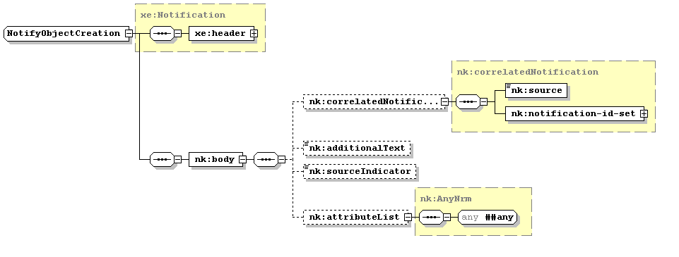

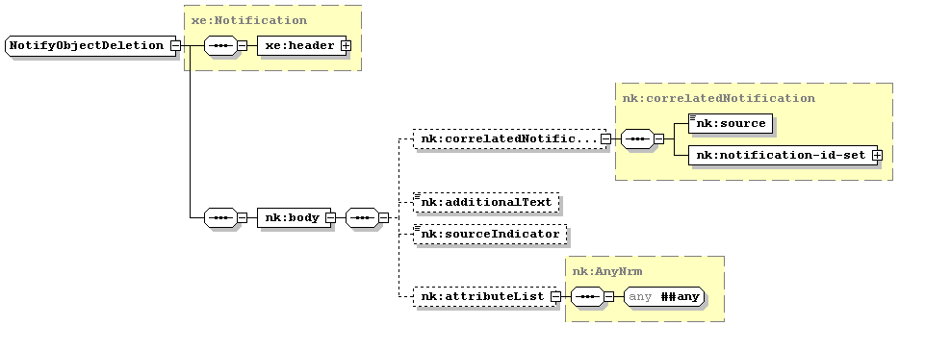

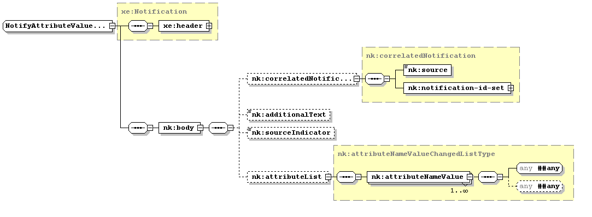

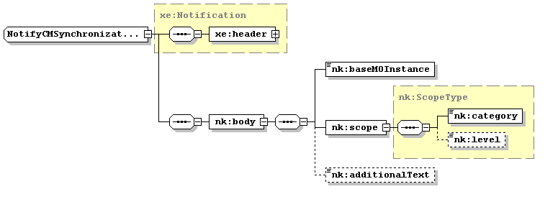

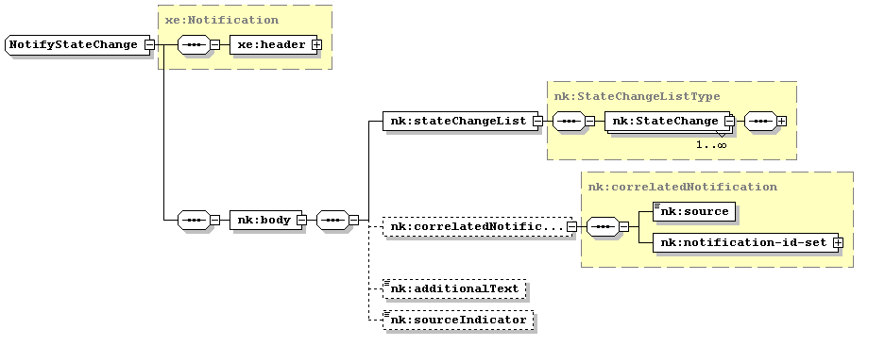

4.2 Kernel CM IRP XML Schema (file name "kernelCMIRPNotif.xsd")
<?xml version="1.0" encoding="UTF-8"?>
<schema xmlns="http://www.w3.org/2001/XMLSchema" xmlns:nk="http://www.3gpp.org/ftp/specs/archive/32_series/32.665#kernelNtf" xmlns:xe="http://www.3gpp.org/ftp/specs/archive/32_series/32.305#notification" xmlns:sm="http://www.3gpp.org/ftp/specs/archive/32_series/32.675#stateManagementIRP" xmlns:xn="http://www.3gpp.org/ftp/specs/archive/32_series/32.625#genericNrm" targetNamespace="http://www.3gpp.org/ftp/specs/archive/32_series/32.665#kernelNtf" elementFormDefault="qualified" attributeFormDefault="unqualified">
<import namespace="http://www.3gpp.org/ftp/specs/archive/32_series/32.305#notification"/>
<import namespace="http://www.3gpp.org/ftp/specs/archive/32_series/32.675#stateManagementIRP"/>
<import namespace="http://www.3gpp.org/ftp/specs/archive/32_series/32.625#genericNrm"/>
<complexType name="correlatedNotification">
<sequence>
<element name="source" type="xn:dn"/>
<element name="notification-id-set">
<complexType>
<sequence>
<element name="notification-id" type="xe:NotificationId" minOccurs="0" maxOccurs="unbounded"/>
</sequence>
</complexType>
</element>
</sequence>
</complexType>
<simpleType name="SourceIndicatorType">
<restriction base="string">
<enumeration value="Resource_operation"/>
<enumeration value="Management_operation"/>
<enumeration value="SON_operation"/>
<enumeration value="Unknown"/>
</restriction>
</simpleType>
<complexType name="attributeNameValueChangedListType">
<sequence>
<element name="attributeNameValue" maxOccurs="unbounded">
<complexType>
<sequence>
<any namespace="##any" processContents="lax" id="newAttribute"/>
<any namespace="##any" processContents="lax" id="oldAttribute" minOccurs="0"/>
</sequence>
</complexType>
</element>
</sequence>
</complexType>
<complexType name="ScopeType">
<sequence>
<element name="category" type="nk:ScopeCategoryType"/>
<element name="level" type="unsignedLong" minOccurs="0"/>
</sequence>
</complexType>
<simpleType name="ScopeCategoryType">
<restriction base="string">
<enumeration value="BASE_OBJECT_ONLY"/>
<enumeration value="NTH_LEVEL_SUBORDINATES"/>
<enumeration value="BASE_NTH_LEVEL"/>
<enumeration value="BASE_ALL"/>
</restriction>
</simpleType>
<complexType name="StateChangeListType">
<sequence>
<element name="StateChange" maxOccurs="unbounded">
<complexType>
<sequence>
<any namespace="http://www.3gpp.org/ftp/specs/archive/32_series/32.675#stateManagementIRP" processContents="strict" id="newState"/>
<any namespace="http://www.3gpp.org/ftp/specs/archive/32_series/32.675#stateManagementIRP" processContents="strict" id="oldState" minOccurs="0"/>
</sequence>
</complexType>
</element>
</sequence>
</complexType>
<complexType name="AnyNrm">
<sequence>
<any namespace="##any" processContents="lax"/>
</sequence>
</complexType>
<!-- notifyObjectCreation notification definition -->
<complexType name="NotifyObjectCreation">
<complexContent>
<extension base="xe:Notification">
<sequence>
<element name="body">
<complexType>
<sequence>
<element name="correlatedNotification" type="nk:correlatedNotification" minOccurs="0"/>
<element name="additionalText" type="string" minOccurs="0"/>
<element name="sourceIndicator" type="nk:SourceIndicatorType" minOccurs="0"/>
<element name="attributeList" type="nk:AnyNrm" minOccurs="0"/>
</sequence>
</complexType>
</element>
</sequence>
</extension>
</complexContent>
</complexType>
<!-- notifyObjectDeletion notification definition -->
<complexType name="NotifyObjectDeletion">
<complexContent>
<extension base="xe:Notification">
<sequence>
<element name="body">
<complexType>
<sequence>
<element name="correlatedNotification" type="nk:correlatedNotification" minOccurs="0"/>
<element name="additionalText" type="string" minOccurs="0"/>
<element name="sourceIndicator" type="nk:SourceIndicatorType" minOccurs="0"/>
<element name="attributeList" type="nk:AnyNrm" minOccurs="0"/>
</sequence>
</complexType>
</element>
</sequence>
</extension>
</complexContent>
</complexType>
<!-- notifyAttributeValueChange notification definition -->
<complexType name="NotifyAttributeValueChange">
<complexContent>
<extension base="xe:Notification">
<sequence>
<element name="body">
<complexType>
<sequence>
<element name="correlatedNotification" type="nk:correlatedNotification" minOccurs="0"/>
<element name="additionalText" type="string" minOccurs="0"/>
<element name="sourceIndicator" type="nk:SourceIndicatorType" minOccurs="0"/>
<element name="attributeList" type="nk:attributeNameValueChangedListType" minOccurs="0"/>
</sequence>
</complexType>
</element>
</sequence>
</extension>
</complexContent>
</complexType>
<!-- notifyCMSynchronizationRecommended notification definition -->
<complexType name="NotifyCMSynchronizationRecommended">
<complexContent>
<extension base="xe:Notification">
<sequence>
<element name="body">
<complexType>
<sequence>
<!--element name="baseMOClass" type="string"/-->
<element name="baseMOInstance" type="string"/>
<element name="scope" type="nk:ScopeType"/>
<element name="additionalText" type="string" minOccurs="0"/>
</sequence>
</complexType>
</element>
</sequence>
</extension>
</complexContent>
</complexType>
<!-- notifyStateChange notification definition -->
<complexType name="NotifyStateChange">
<complexContent>
<extension base="xe:Notification">
<sequence>
<element name="body">
<complexType>
<sequence>
<element name="stateChangeList" type="nk:StateChangeListType"/>
<element name="correlatedNotification" type="nk:correlatedNotification" minOccurs="0"/>
<element name="additionalText" type="string" minOccurs="0"/>
<element name="sourceIndicator" type="nk:SourceIndicatorType" minOccurs="0"/>
</sequence>
</complexType>
</element>
</sequence>
</extension>
</complexContent>
</complexType>
<element name="NotifyObjectCreation" type="nk:NotifyObjectCreation"/>
<element name="NotifyObjectDeletion" type="nk:NotifyObjectDeletion"/>
<element name="NotifyAttributeValueChange" type="nk:NotifyAttributeValueChange"/>
<element name="NotifyCMSynchronizationRecommended" type="nk:NotifyCMSynchronizationRecommended"/>
<element name="NotifyStateChange" type="nk:NotifyStateChange"/>
</schema>

Annex A (informative):
Void

Annex B (informative):
Change history
Change history
Date | TSG # | TSG Doc. | CR | R | Subject/Comment | Cat | Old | New
Dec 2006 | SA_34 | SP-060743 | -- | -- | Submitted to TSG SA#34 for Approval | -- | 1.0.0 | 7.0.0
Mar 2007 | -- | -- | -- | -- | Delete reference to the 32.664 CMIP SS. Reason: SA#35 endorsed the SA5 decision to not propagate the CMIP Solution Sets to Rel-7 (TS 32.3x4, TS 32.4x4, TS 32.6x4) | -- | 7.0.0 | 7.0.1
Jul 2007 | -- | -- | -- | -- | Added a filename for the XML code to be extracted from  4.2 Kernel CM IRP XML Schema (file name "kernelCMIRPNotif.xsd")  and stored in http://www.3gpp.org/ftp/specs/archive/32_series/32665/schema/ | -- | 7.0.1 | 7.0.2
Dec 2008 | SA_42 | -- | -- | -- | Upgrade to Release 8 | -- | 7.0.2 | 8.0.0
Mar 2009 | SA_43 | SP-090207 | 001 | -- | Indicating Self-X in sourceIndicator of create-/delete-/change-notifications | F | 8.0.0 | 8.1.0

