3GPP TSG-SA5 (Telecom Management)  S5-070214

Meeting SA5#51, 22 - 26 Jan 2007, Seville, SPAIN
CR-Form-v9.3
CHANGE REQUEST
 | 32.335 | CR | 0003 |  rev | - |  Current version: | 6.2.0 | 
For HELP on using this form look at the pop-up text over the  symbols. Comprehensive instructions on how to use this form can be found at http://www.3gpp.org/specs/CR.htm.

Proposed change affects:  | UICC apps |  | ME |  | Radio Access Network | X | Core Network | X

Title:  | Add Notification XML definition in NotificationLogIRP
Source to WG:  | Huawei, Yangli (afi@huawei.com)
Source to TSG:  | S5
Work item code:  | OAM7-NIM |  |  |  |  |  |  | Date:  |  | 26/01/2007
Category:  | B |  |  |  |  |  |  | Release:  |  | Rel-7
 | Use one of the following categories:  F (correction)  A (corresponds to a correction in an earlier release)  B (addition of feature),  C (functional modification of feature)  D (editorial modification)  Detailed explanations of the above categories can  be found in 3GPP TR 21.900. |  |  |  |  |  |  |  | Use one of the following releases:  R97 (Release 1997)  R98 (Release 1998)  R99 (Release 1999)  Rel-4 (Release 4)  Rel-5 (Release 5)  Rel-6 (Release 6)  Rel-7 (Release 7)  Rel-8 (Release 8)
Reason for change:  |  | Notification XML definition is missing in 32.335.
Summary of change:  |  | Add NotificationLogIRP Notification XML Definitions
Consequences if   not approved: |  | Notification of NotificationLogIRP can’t be logged.
Clauses affected:  |  | 4.6, Annex C
 |  | Y | N
Other specs  |  |  | x | Other core specifications 
affected: |  |  | x | Test specifications
 |  |  | x | O&M Specifications
Other comments: 

1st Modified Section

4.6 NL IRP Notification XML Definitions
This clause provides XML definitions of Notification Log IRP notifications as defined in [4].
The structure of the NotificationLogIRP Notification XML Definitions is shown in graphical depiction below:

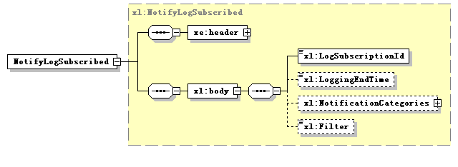

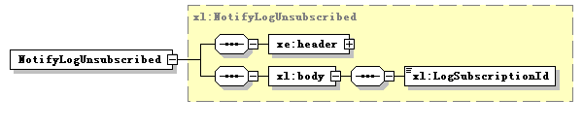

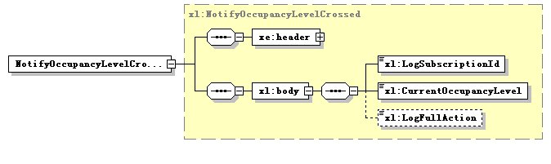

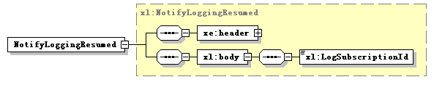
Note: The use of XML schema key word “sequence” to support IS-defined set (not sequence) is for the purpose of XML processor efficiency. This shall not imply the use of “sequence” in other technology.

Next Modified Section

Annex C (normative):
NotificationLogIRP Notification XML schema (file name "ntfLogNotif.xsd")
<?xml version="1.0" encoding="UTF-8"?>
<!--
3GPP TS 32.335 NotificationLogIRP Notification XML Schema
ntfLogIRPNotif.xsd
-->
<schema xmlns:xl="http://www.3gpp.org/ftp/specs/archive/32_series/32.335#ntfLogIRPNotif" xmlns:xe="http://www.3gpp.org/ftp/specs/archive/32_series/32.305#notification" xmlns="http://www.w3.org/2001/XMLSchema" targetNamespace="http://www.3gpp.org/ftp/specs/archive/32_series/32.335#ntfLogIRPNotif" elementFormDefault="qualified" attributeFormDefault="unqualified">
<import namespace="http://www.3gpp.org/ftp/specs/archive/32_series/32.305#notification"/>
<simpleType name="LogSubscriptionId">
<restriction base="string">
<minLength value="1"/>
</restriction>
</simpleType>
<simpleType name="CurrentOccupancyLevel">
<restriction base="short">
<maxInclusive value="100"/>
<minInclusive value="0"/>
</restriction>
</simpleType>
<simpleType name="LogFullAction">
<restriction base="string">
<enumeration value="Wrap"/>
<enumeration value="Halt"/>
</restriction>
</simpleType>
<complexType name="NotificationCategories">
<sequence>
<element name="IRPVersion" type="string" maxOccurs="unbounded"/>
</sequence>
</complexType>
<complexType name="NotifyLogSubscribed">
<complexContent>
<extension base="xe:Notification">
<sequence>
<element name="body">
<complexType>
<sequence>
<element name="LogSubscriptionId" type="xl:LogSubscriptionId"/>
<element name="LoggingEndTime" type="dateTime" minOccurs="0"/>
<element name="NotificationCategories" type="xl:NotificationCategories" minOccurs="0"/>
<element name="Filter" type="string" minOccurs="0"/>
</sequence>
</complexType>
</element>
</sequence>
</extension>
</complexContent>
</complexType>
<complexType name="NotifyLogUnsubscribed">
<complexContent>
<extension base="xe:Notification">
<sequence>
<element name="body">
<complexType>
<sequence>
<element name="LogSubscriptionId" type="xl:LogSubscriptionId"/>
</sequence>
</complexType>
</element>
</sequence>
</extension>
</complexContent>
</complexType>
<complexType name="NotifyOccupancyLevelCrossed">
<complexContent>
<extension base="xe:Notification">
<sequence>
<element name="body">
<complexType>
<sequence>
<element name="LogSubscriptionId" type="xl:LogSubscriptionId"/>
<element name="CurrentOccupancyLevel" type="xl:CurrentOccupancyLevel"/>
<element name="LogFullAction" type="xl:LogFullAction" minOccurs="0"/>
</sequence>
</complexType>
</element>
</sequence>
</extension>
</complexContent>
</complexType>
<complexType name="NotifyLoggingResumed">
<complexContent>
<extension base="xe:Notification">
<sequence>
<element name="body">
<complexType>
<sequence>
<element name="LogSubscriptionId" type="xl:LogSubscriptionId"/>
</sequence>
</complexType>
</element>
</sequence>
</extension>
</complexContent>
</complexType>
<element name="NotifyLogSubscribed" type="xl:NotifyLogSubscribed"/>
<element name="NotifyLogUnsubscribed" type="xl:NotifyLogUnsubscribed"/>
<element name="NotifyOccupancyLevelCrossed" type="xl:NotifyOccupancyLevelCrossed"/>
<element name="NotifyLoggingResumed" type="xl:NotifyLoggingResumed"/>
</schema>

End of modifications

Annex D (informative):
Change history
Change history
Date | TSG # | TSG Doc. | CR | Rev | Subject/Comment | Cat | Old | New
Sep 2004 | S_25 | SP-040564 | -- | -- | Submitted to TSG SA#25 for Information | -- | 1.0.0
Jun 2005 | S_28 | SP-050291 | -- | -- | Submitted to TSG SA#28 for Approval | -- | 2.0.0 | 6.0.0
Mar 2006 | SA_31 | SP-060091 | 0001 | -- | Correct a validating error in notificationLog.xsd | F | 6.0.0 | 6.1.0
Dec 2006 | SA_34 | SP-060709 | 0002 | -- | Correct XML schema | F | 6.1.0 | 6.2.0

