Invitation and General Information
on 3GPP SA2#171/SA3#124/SA5#163/SA5#163-CH SWG/ SA6#69 Meetings

from Monday 13 to Friday 17 of October 2025 in Wuhan, China

Beijing, 14 July 2025

Dear Delegate,

The Chinese Friends of 3GPP (CF3) has the pleasure of inviting you to the 3GPP SA2#171, SA3#124, SA5#163, SA5#163-CH SWG, and SA6#69 meetings in Wuhan, China.

SA3#124, SA5#163, and SA5#163-CH SWG meetings will be held in Wanda Realm Wuhan.

SA2#171 and SA6#69 meetings will be held in Wanda Reign Wuhan.

The location of the hotel is shown in the following map.

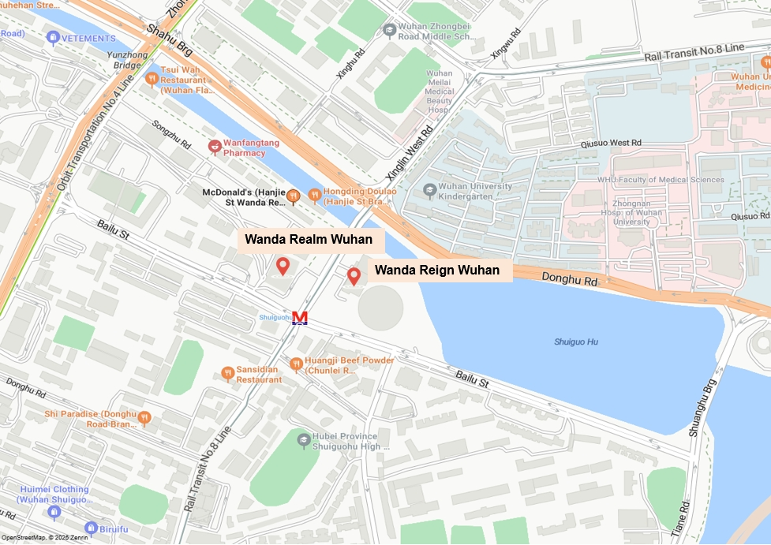

We look forward to seeing you all in Wuhan, China.

Yours sincerely,
the Chinese Friends of 3GPP

Accommodation
CF3 is not responsible for reservation confirmations, canceled or changed reservations or no-shows. Please contact the hotel directly to make the reservation.

Meeting Venue for SA3#124, SA5#163, and SA5#163-CH SWG
Wanda Realm Wuhan
No.105 Donghu Road, Wuchang District,Wuhan, Hubei, 430000, P.R. China
Tel: 86-027-5900 8888
Group Rates:
- Deluxe King, No Smoking：CNY 530 net per room per night with one daily breakfast; CNY 580 net per room per night with two daily breakfasts
- Deluxe Twin No Smoking：CNY 530 net per room per night with one daily breakfast; CNY 580 net per room per night with two daily breakfasts
- Grand Deluxe King, No Smoking：CNY 630 net per room per night with one daily breakfast; CNY 680 net per room per night with two daily breakfasts
- Grand Deluxe Twin, No Smoking：CNY 630 net per room per night with one daily breakfast; CNY 680 net per room per night with two daily breakfasts
- Executive Floor Deluxe King No Smoking,: CNY 780 net per room per night with one daily breakfast；CNY 830 net per room per night with two daily breakfasts
- Executive Floor Deluxe Twin No Smoking,: CNY 780 net per room per night with one daily breakfast；CNY 830 net per room per night with two daily breakfasts

* The above rate includes Service Charge and Estimated government taxes and fees. Broadband Internet access is complimentary in guest rooms.
* Cancellation Policy: Free cancellation is made 1 day before you check in, or the first night will be charged from your credit card. If you want to cancel or change, you can also contact the hotel . The telephone number is 86- 027-5900 8888 and the e-mail address is diana.wang@wandahotels.com
Hotel cut-off date, 30 Sep 2025
Hotel booking(Corporate ID：044C3GPP)

Meeting Registration
Please register for the meetings online at:
on-line registration

Meeting Venue for SA2#171 and SA6#69
Wanda Reign Wuhan
No. 138 Donghu Road, Shuiguohu Street, Wuchang District, Wuhan, Hubei Province 430077, P.R. China
Tel: 86-027-5959 9999
Group Rates:
- Deluxe King No Smoking：CNY 690 net per room per night with one breakfast; CNY 750 net per room per night with two breakfasts
- Deluxe Twin Hollywood Bed：CNY 690 net per room per night with one breakfast; CNY 750 net per room per night with two breakfasts
- Deluxe Twin No Smoking：CNY 690 net per room per night with one breakfast ;CNY 750 net per room per night with two breakfasts
- Grand Deluxe King：CNY 790 net per room per night with one breakfast; CNY 850 net per room per night with two breakfasts
- Grand Deluxe King No Smoking：CNY 790 net per room per night with one breakfast; CNY 850 net per room per night with two breakfasts
- Grand Deluxe Twin Accessible：CNY 790 net per room per night with one breakfast; CNY 850 net per room per night with two breakfasts
- Executive Floor Deluxe King No Smoking: CNY 990 net per room per night with two breakfasts
- Executive Floor Deluxe King With View No Smoking: CNY 1290 net per room per night with two breakfasts
- Executive Floor Deluxe Twin With View: CNY 1290 net per room per night with two breakfasts

* The above rate includes Service Charge and Estimated government taxes and fees. Broadband Internet access is complimentary in guest rooms.
* Cancellation Policy: Free cancellation is made 1 day before you check in, or the first night will be charged from your credit card. If you want to cancel or change, you can also contact the hotel . The telephone number is 86- 027-5959 9999 and the e-mail address is Jennifer.jia@wandahotels.com
Hotel cut-off date, 30 Sep 2025
Hotel booking(Corporate ID：3GPP251012)

Meeting Registration
Please register for the meetings online at:
on-line registration

Visa letter
If you need an invitation letter for VISA for 3GPP SA2#171, SA3#124, SA5#163, SA5#163-CH SWG, and SA6#69 meetings to be held from Monday 13 to Friday 17 of October 2025 in Wuhan, China, please visit the website https://www.ccsa.org.cn/english/eventsDetail/?id=18

User name: 3GPPWuhan
Password: 3GPP123

to fill in the invitation letter request form online no later than 12 September, 2025 (Beijing time, GMT+8).

Please contact the Chinese Embassy at your country for further information.

Contact person for invitation letter:
Mr. Ruixiao BAI (CCSA)
E-mail: bairuixiao@ccsa.org.cn; ccsavisa@163.com
Tel: +86-010-62304847

Time Zone
GMT +8 hours

Voltage
Commercial power in China is 220V. Please be sure you have the correct adapter. Voltage converters will not be provided at the meeting.
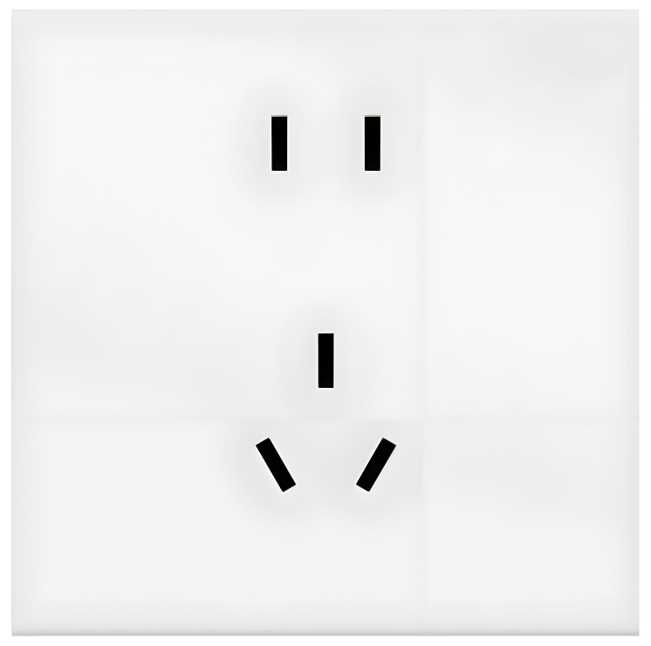
City Profile/ Area Attractions
Wuhan Tours
Host Contact
For any questions about anything relating to the meeting please contact:
Mr. Ruixiao BAI
Tel.: +86-10-6230 4847
- mail: bairuixiao@ccsa.org.cn

Mr. Xu QI
Tel.: +86-10-6230 4200
E-mail: qixu@ccsa.org.cn

Mr. Shizhuo ZHAO
Tel.: +86-10-6230 2645
E-mail: zhaosz@ccsa.org.cn
Attachment 1: Transport Information about the meeting venue
Attachment 1: Transport Information about Meeting Venue

Wanda Realm Wuhan
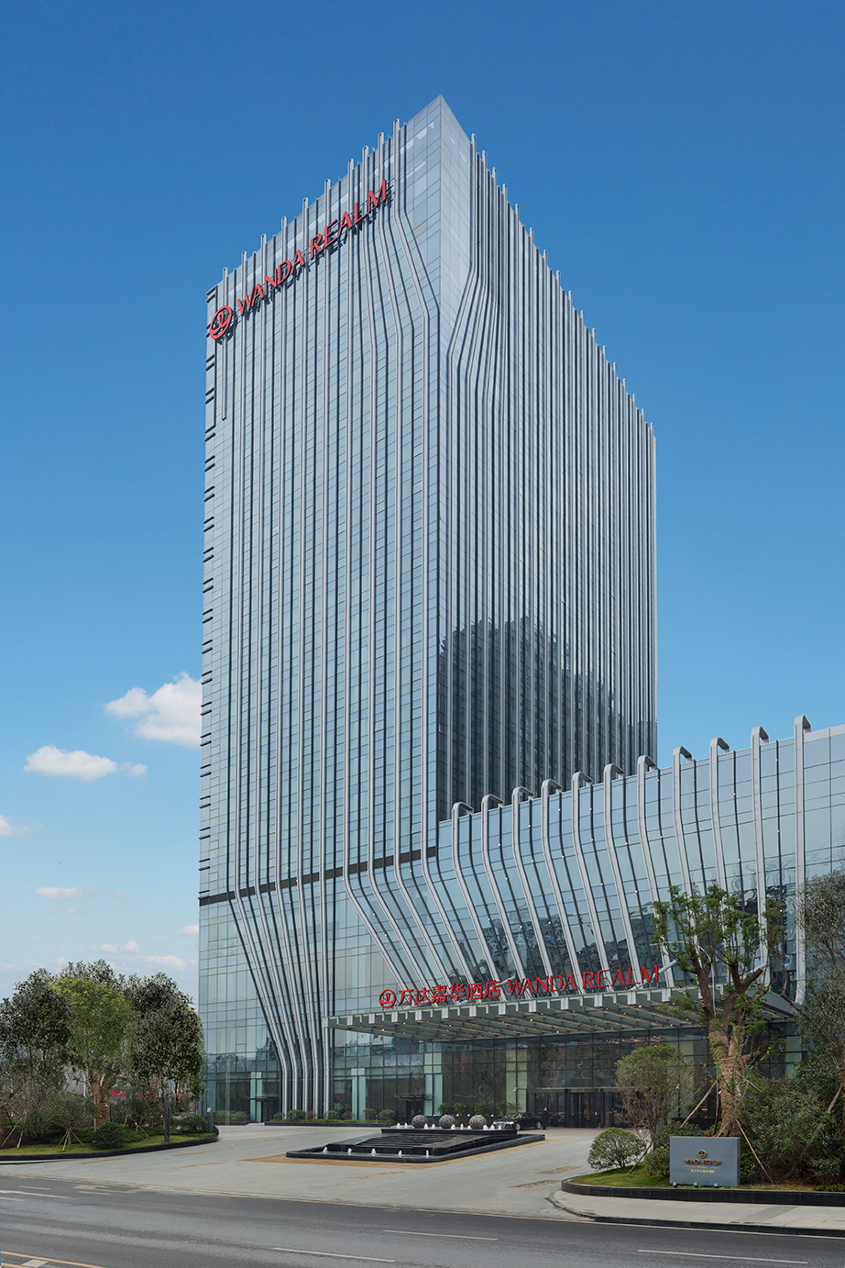
Wanda Realm Wuhan is about 34 km and 46mins by car from Wuhan Tianhe Airport.The fare for taxi from the Airport to the hotel is around CNY 120 per way. (Please take the taxi which can provide the invoice for your trip)

In case of taking a taxi, please print the following note which shows taxi driver the address of Wanda Realm Wuhan in both English and Chinese.

Please take me to Wanda Realm Wuhan
Address: No.105 Donghu Road, Wuchang District,Wuhan, Hubei Province , China

TEL：(86) 027 5900 8888

请送我到武汉富力万达嘉华酒店

地址:中国湖北省武汉市武昌区东湖路105号

电话: (86) 027 5900 8888

Wanda Reign Wuhan
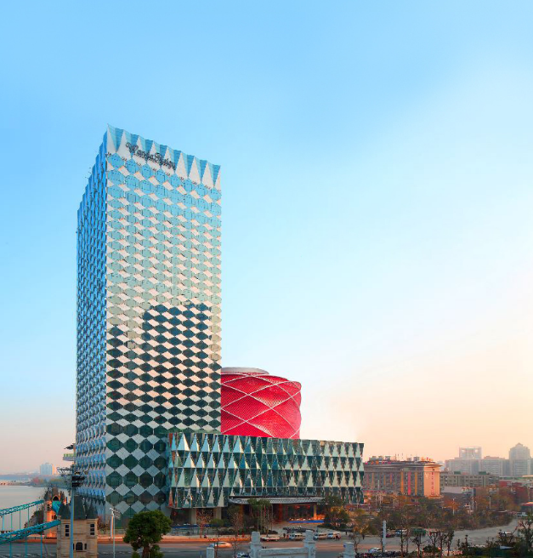
Wanda Reign Wuhan is about 34.5km and 48mins by car from Wuhan Tianhe Airport.The fare for taxi from the Airport to the hotel is around CNY 120 per way. (Please take the taxi which can provide the invoice for your trip)

In case of taking a taxi, please print the following note which shows taxi driver the address of Wanda Reign Wuhan in both English and Chinese.

Please take me to Wanda Reign Wuhan
Address: No. 138 Donghu Road, Shuiguohu Street, Wuchang District, Wuhan, Hubei Province 430077, P.R. China

TEL：(86) 027 5959 9999

请送我到武汉万达瑞华酒店

地址:中国湖北省武汉市武昌区水果湖街东湖路138号

电话: (86) 027 5959 9999



Have a successful meeting and enjoy your stay in Wuhan!

