**3GPP TSG SA WG5 Meeting#146-bis-e S5-231103**

**e-meeting, 16-19 January 2023**

**Source: Ericsson, Deutsche Telekom**

**Title: Comparison of ordering a service or ordering intent**

**Document for: Endorsement**

**Agenda Item: 6.1.1**

# 1 Decision/action requested

***The group is asked to endorse the detailed proposal in section 4.***

# 2 References

[1] [TS 28.531](https://www.3gpp.org/DynaReport/28531.htm) Management and orchestration; Provisioning

[2] [TS 28.541](https://www.3gpp.org/DynaReport/28541.htm) Management and orchestration; 5G Network Resource Model (NRM); Stage 2 and stage 3

[3] [TS 28.312](https://www.3gpp.org/DynaReport/285312) Management and orchestration; Intent driven management services for mobile networks

# 3 Rationale

## 3.1 Introduction

With the introduction of Intent, the specifications support two methods for a service management system (MnS consumer) to order network slice resources. The first method is to use TS 28.531, see reference [1], together with the TS 28.541, see reference [2], which is based on conveyance of service profile parameters from an MnS consumer to an MnS producer and the second method is to use TS 28.312, see reference [3] which is based on the conveyance of expectations from an MnS consumer to an MnS producer.

This discussion paper describes two scenarios:

- the network operator receives an order with service profile parameter(s)

- the network operator receives an order with intent expectation(s)

In both scenarios the objective of the order is to deliver the service, based on the information in the order. This may result in a network slice instance creation or modification. The network operator checks the parameters of the service (service description) in the order and decides if the service description matches the capabilities and capacity of the resources.

## 3.2 Ordering using service profile

The network operator receives an order which maybe to create, modify or delete a service. An example of such service order could be an AllocateNsi request.

An example of the generic procedure for an order to create a service using service profile parameters is shown in Figure 3.2.1. Since the request contains the service profile, it is assumed that the result of the procedure is that the operator creates a new network slice or uses an existing network slice to fulfil the service order.

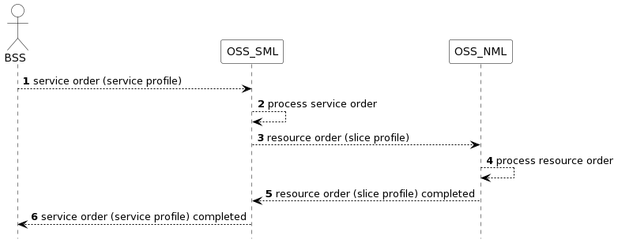

[PlantText UML Editor](https://planttext.com/?text=ZP8nRyCW48LtVWLZErYgEbPLbRYhuqPYw5WHECSec7CFQ29L_UybZbpXaY4B0jxxxd4dLZv82d6mp1-C6oN9WNluZE0Ky6-s9iBZAreaNbkf3coj0bADf87AwxJR4qQdBz9xRmAmRQflb1cb2oMNYrVfndJG60Sb-fEzkCK0r_b_dg9ArdKlDHwDs_DEMf-JDPwsKkkpzFZ0UgE1TuXXXoScOq0NXnqGkyo0rq8mbXPULI_yJOWFiMduKvefVPaqqka1_6u-ZeITiN3FPkUIIh82xvTquMqdBu77I5c4BGBQ0fe3bl1VmdDLtPp05GwZXG1wQdz6Rse_OrVWzFax_W80)

Figure 3.2.1: An example of a procedure for ordering a network slice

The relevant service order information is captured in the network resource model by the service profile in the network slice class. When the service order has been completed the management system will not have any information on the service order other than the parameters captured in a service profile.

The service order process aims to fulfil the service requirements, after the service order process is successfully completed the service requirements are met. At service operation time (e.g., the service is up and running), if part of the order, the customer may get performance assurance information to show that the performance requirements are met. Performance assurance information are for example performance measurements and KPIs. In a network slicing scenario performance assurance information can be filtered on S-NSSAI.

## 3.3 Ordering using intent expectation

The network operator receives an order which maybe to create, modify or delete an intent.:

When the intent is created the network operator needs to continuously monitor the intent fulfilment. Optionally the network operator can provide intent fulfilment monitoring information to the consumer that requested the intent. An example of the procedure for an order to create(intent) is shown in Figure 3.3.1. Since the request contains intent, it is assumed that result of the procedure is that the operator creates an entity that matches the intent. The order for intent may be handled as a resource order to create, modify, or delete an intent.

In this scenario the network operator processes the intent from the service order and if the service order requires the resource(s) configuration(s) to be created, or modified, subsequent resource order(s) are sent and processed. When the resource order(s) are completed the resource(s) are configured, or modified to fulfil the service order.

In case the resource order contains intent, after the creation or modification of the resources the network operator continuously monitors the intent fulfilment and optionally reports the intent fulfilment to service management. Service management may optionally report the intent fulfilment information to the orderer of the service intent.

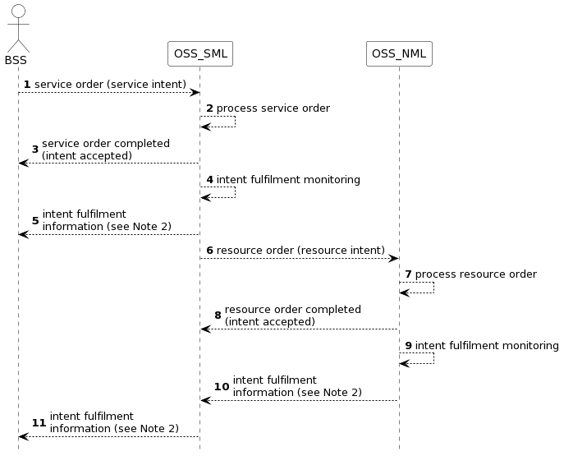

[PlantText UML Editor](https://planttext.com/?text=bPCnJyCm48Lt_mgFPOY4EYA4sh26K2a3IoNasfVMQdmNBWwjXFZlE2af2KbLM2pRT-yztoTvKNd5ldQ5gFOMIyNAoGhUQa0DyaCicUdmI0MnZ0kbzsAfFN5CR837rs6tPQhHd4elE-j1h8A_rRPKwCUwVd5IdTWS4eimbdxsNfoIXsdzhvwHIs_gdJ9qiBYLkIgglZAcuqePqvJcjs9d3SYSo6_eA5Jj2Mkt0HOd1ZBECY728gFeGJvdsMlsbCYxm9JVRK3QFa3EkgD53-XlHDSu59LC6gfgA6xDxwFeehacLnRWmQnnTlANIciemysbeE-sl2voMxXcwmXj62VCF90qsHFjQxIO4plbBM4p7RIuvNmScBQ131NL_CFZVEu3IKUo3iXGVixeg4ncNCKoZhkA9RrEyeze_Wzs0MZ2l_q2)

Figure 3.3.1: An example of a procedure of ordering an intent

NOTE1: The interactions from step 6 to 10 are not required to be based on intent even if step 1 to 5 are.

NOTE2: - The “intent fulfilment information” can happen at any time after step 3 and before the intent is removed.

- The actual intent fulfilment information may be different on different interfaces

## 3.4 Comparison of ordering using service and intent expectation

Different ordering aspects are compared when using service profile (parameters) in the order with, when using intent expectation (parameters) in the order, the comparison is shown in Table 3.4.1.1.

|  |  |  |
| --- | --- | --- |
|  | **Ordering using service profile** | **Ordering using intent expectation** |
| What is ordered? | Service defined by a ServiceProfile as specified in Rel-15 | Intent for a Service, the consumer can focus on service requirements without knowledge of the network slice details. |
| Order completed | When the Service has been allocated | When the Intent has been accepted |
| Order result monitoring and reporting | Monitoring and reporting is ordered separately after Service has been allocated. | Monitoring and reporting is included in order and starts when Intent has been accepted, reporting can be linked to SLS assurance. |
| Order delivery result | Order cannot be delivered as deviations from service profile parameters are not tolerated. | Order can be delivered when within tolerable deviations. Tolerable deviations are included in order as part of Intent. |
| Ordering approach | Operation based (allocateNsi) | Model driven (intent model) |
| Communication mode | Synchronous for Network slice allocation | Synchronous for Intent HandlingFunction and asynchronous for Network slice allocation |

Table 3.4.1.1: Comparison of ordering using service profile and intent expectation

## 3.5 Analysis

From the comparison in Table 3.4.1.1 the following observation can be made: the service order and the intent order for service are inherently different in procedure and functionality. Therefore, there is a need to map the ServiceProfile to Expectation(s) which then can be used to order a NetworkSlice through an intent based interface.

# 4 Detailed proposal

Based on the analysis in section 3.5 the group agrees that the main difference, between deployment of a network slice using provisioning procedures according to TS 28.531[1], 28.541 [2] and intent procedures in TS 28.312 [3], is the procedure and functionality on the interface.This means that intent definitions needs to be extended to cover also network slice services .