3GPP TSG-SA5 Meeting #146Bis-e S5-231014

Electronic meeting, 16 - 19 January 2023

Source: Huawei, Deutsche Telekom, Telefoncia

Title: DP on solutions for expressing slicing requirements as intent expectations

Document for: Discussion and Endorsement
Agenda Item: 6.1.1

1 Decision/action requested
The group is asked to discuss and approval.

2 References
[1] 3GPP TR 28.836: " Study on intent-driven management for network slicing v0.3.0".
[2] S5-226206 Add solution for expressing service and slice profile requirements as intent expectations.
[3] S5-226580 Discussion paper on study intent driven management for network slicing

3 Rationale
This discussion paper related to FS_eIDMS_MN SI, FS_NETSLICE_IDMS SI and eNETSLICE_PRO WI.
In SA5#146 meeting, several contributions (e.g., S5-226206[2], S5-226580[3]) proposes the solution for expressing slicing requirements for delivering network slice (subnet) as intent expectations. The main controversial part is the relation with ServiceProfile/SliceProfile. Based on the discussion, following are two potential relationship:
Option#1: The parameters in ServiceProfile/SliceProfile are already intent level, which requires a reformation of ServiceProfile/SliceProfile to follow generic intent model methodology.
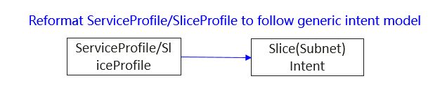
Option#2: The parameters in ServiceProfile/SliceProfile are not intent level, needs to define intent level parameters for slicing intent. The parameters in ServiceProfile/SliceProfile can be translated from intent level parameters.
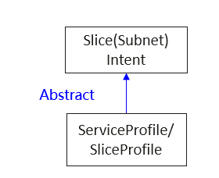

Analysis: In TS 28.541 [4], 6.3.3.1 described the service profile represents the properties of the network slice related requirements that should be supported by a NetworkSlice instance in a 5G network and clause 6.3.4.1 described the sliceprofile represents the properties of network slice subnet related requirement that should be supported by the NetworkSliceSubnet instance in a 5G network. Based on the definition for service profile and slice profile, it is obvious that service profile and slice profile represent MnS consumer’s expectations for network slice and network slice subnet, which is aligned with intent definition (expectations including requirements, goals and constraints given to a 3GPP system, without specifying how to achieve them).
Currently the ServiceProfile and SliceProfile is modelled as a set of properties, while IntentExpectation is composed of expectationObject, expectationTargets and expectationContexts, so it is necessary to investigate each attribute in ServiceProfile and SliceProfile to identify which attribute can be represented by which intent expectation components (incl. expectationObject, expectationTargets and expectationContexts).
Proposal#1: It proposes above Option#1 and investigate each attribute in ServiceProfile and SliceProfile to identify which attribute can be represented by which intent expectation components (incl. expectationObject, expectationTargets and expectationContexts).

4 Detailed proposal
Following above proposal#1, It proposes to add following content in TR 28.836.
/**************Content to be added in TR 28.836********************/

6.X Solution for expressing service and slice profile requirements as intent expectations.

6.X.1 Description
In TS 28.541 [4], clause 6.3.3.1 the description says that the service profile represents the properties of the network slice related requirements and that these should be supported by a NetworkSlice instance in a 5G network and in clause 6.3.4.1 the description says that the sliceprofile represents the properties of network slice subnet related requirements and that these should be supported by the NetworkSliceSubnet instance in a 5G network. Based on the definition for service profile and slice profile, it is obvious that service profile and slice profile represent MnS consumer’s expectations for network slice and network slice subnet, which is aligned with intent definition (expectations including requirements, goals and constraints given to a 3GPP system, without specifying how to achieve them).
Following are some benefits to introduce the intent driven approach for network slice (subnet) compared to existing slice solution:
- Model driven approach, allows using one single unified solution (CRUD operation with intent NRM fragment) to support the wide variety of slice management procedures, including slice (subnet) provisioning allocation, deallocation, modification, query, SLS assurance and feasibility check.
- Async mode support, allows decoupling the lifecycle management of network slice (subnet) requirements from the lifecycle management of the actual slice (subnet). This enables MnS consumer to focus on expressing network slicing requirements (and obtain fulfilment information for those requirements), without knowing how to deal with the detailed management of a network slice and a network slice subnet. The latter is on MnS producer side.

Currently the ServiceProfile and SliceProfile is modelled as a set of properties, while IntentExpectation is composed of expectationObject, expectationTargets and expectationContexts, so it is necessary to investigate each attribute in ServiceProfile and SliceProfile to identify which attribute can be represented by which intent expectation components (incl. expectationObject, expectationTargets and expectationContexts).
Following figure give one example to illustrate how ServiceProfile can be represented by intent expectation components.

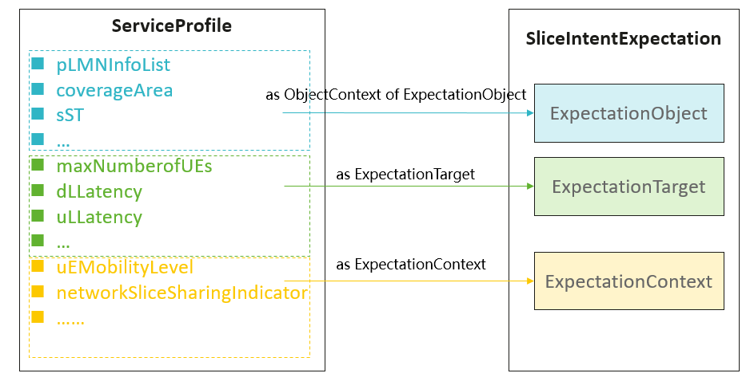
Figure 6.X.1-1 Example of how ServiceProfile will be represented by which intent expectation components
In case service and slice profile requirements are modelled as intent expectations, the network slice (subnet) lifecycle management can be alternatively supported by intent driven MnS (which are implemented by CRUD operations and intent model). MnS consumer expresses intent expectations for network slice (subnet) and MnS producer performs the management tasks for network slice (subnet) to satisfy the intent expectations for network slice (subnet). MnS consumer also can obtain the intent fulfilment information to evaluate whether the requirements for network slice (subnet) is satisfied by MnS producer.
Following subclauses will give the detailed solution for how to model service profile and slice profile as intent expectations.

6.X.2 Modelling service profile attributes as intent expectations for network slice

6.X.2.1 Definition of ExpectationObject for NetworkSlice
The definition of an expectationObject that is applicable to intent driven network slice management is shown in Table 6.X.2.1
Attribute Name | Attribute Values
ObjectType | NetworkSlice
ObjectInstance | DN of NetworkSlice instance
ObjectContexts | plmnInfoList  coverageArea  sST  radioSpectrum  sliceSimultanuousUse
Table 6.X.2.1 Definition of an ExpectationObject for a NetworkSlice instance

6.X.2.2 Definition of expectationTargets
The expectationTargets that are applicable to intent driven network slice management is shown in Table 6.X.2.2
Attributes | Attribute Values
expectationTargets | maxNumberofUEs  dLLatency  uLLatency  availability  dlThptPerUE  UlThptPerUE  dlThptPerSlice  UlThptPerSlice  maxNumberofPDUSessions  Reliability  maxDLDataVolume  maxULDataVolume
Table 6.X.2.2 Definitions of expectationTarget for a NetworkSlice instance

6.X.2.3 Definition of expectationContexts
The expectationContexts that are applicable to intent driven network slice management is shown in Table 6.X.2.3
Attributes | Attribute Values
expectationContexts | uEMobilityLevel  networkSliceSharingIndicator  delayTolerance  dLDeterministicComm  uLDeterministicComm  dLMaxPktSize  uLMaxPktSize  v2XCommModels  termDensity  activityFactor  uESpeed  survivalTime  nBIoT  synchronicity  positioning  nssaaSupport  n6Protection
Table 6.X.2.3 Definitions of expectationContext for a NetworkSlice instance

6.X.3 Modelling slice profile attributes as intent expectations for network slice subnet
Editor’s Note: The solution for modelling slice profile attributes as intent expectations for network slice subnet will be addressed when the solution for modelling service profile attributes as intent expectations for network slice is clear.

6.X.3.1 Modelling RANSliceProfile attributes as intent expectation for RAN network slice subnet
TBD

6.X.3.2 Modelling CNSliceProfile attributes as intent expectation for CN network slice subnet
TBD
/**************Content to be added in TR 28.836********************/

End of changes

