**3GPP TSG-SA5 Meeting #146Bis-e *S5-231013***

Electronic meeting, 16 - 19 January 2023

**Source: Huawei,** **Deutsche Telekom**

**Title: DP on using intent driven approach to support async network slicing provisioning**

**Document for: Discussion and Endorsement**

**Agenda Item: 6.1.1**

# 1 Decision/action requested

***The group is asked to discuss and endorse.***

# 2 References

[1] S5-226557 Add NetworkSliceController and NetworkSliceSubnetController IOCs to support asynchronous LCM operations.

[2] S5-226560 Procedures to support asynchronous Network Slice LCM operations.

[3] 3GPP TS 28.312 Intent driven management services for mobile networks.

[4] 3GPP TR 28.912 Study on enhanced intent driven management services for mobile networks.

[5] 3GPP TR 28.836 Study on intent-driven management for network slicing.

[6] S5-226206 Add solution for expressing service and slice profile requirements as intent expectations.

[7] S5-226580 Discussion paper on study intent driven management for network slicing.

# 3 Rationale

This discussion paper related to eNETSLICE_PRO WI and FS_NETSLICE_IDMS SI.

In SA5#146 meeting, following two new solutions are proposed for slicing provisioning:  
**- Solution#1:** Introduce NetworkSlice (Subnet) Controller to support async slicing provisioning (see S5-226557[1] and S5-226560 [2]); Discussed in eNETSLICE_PRO WI.

**- Solution#2:** Using intent driven approach defined in R17 for network slicing provisioning to express service and slice profile requirements as intent expectations (see S5-226206 [6] and S5-226580 [7]). Discussed in FS_NETSLICE_IDMS SI.

Both solutions discussed in different WI/SIs can be used as model driven approach for network slicing provisioning and support async mode (i.e. decouples the lifecycle management for MnS consumer’s requirements for network slice (subnet) and the lifecycle management for network slice (subnet)). So it is necessary to compare above two solutions in following aspects:

**Definition Comparison:**

|  |  |
| --- | --- |
| **Solution#1** | **Solution#2** |
| NetworkSliceController: This IOC represents the controller with the requirements of a network slice in a 5G network. | IntentHandlingFunction: contain a list of intent handling capabilities and intents.  Intent: expectations including requirements, goals and constraints given to a 3GPP system, without specifying how to achieve them.  Note: Network slice intent represents slicing requirements, goal and constraint. |

**Analysis:** NetworkSliceController is same as intent handling function (as intent driven MnS producer), which can handle MnS consumer’s intent (network slicing requirements) and trigger a series of activities (slice allocation activities) to fulfil the intent.

**Model Comparison:**

|  |  |
| --- | --- |
| **Solution#1** | **Solution#2** |
| * processMonitor * serviceProfile * operationState * availabilityStatus * administrativeState | * intentFulfilmentInfo/intentReport * intentExpectation * intentFulfilmentInfo/intentReport * intentFulfilmentInfo /intentReport * IntentAdminState |

**Analysis:**

* Attributes “processMonitor”, “operationState” and “availabilityStatus” are same as attributes in intentFulfilmentInfo/intentReport (e.g., fulfilmentStatus, notFulfilledState);
* The parameters in Attribute “serviceProfile” is same as parameters in “intentExpectation”;
* Attribute “administrativeState” is same as “IntentAdminState”.

**Procedure Comparison:**

|  |  |
| --- | --- |
| **Solution#1** | **Solution#2** |
|  |  |

**Analysis:** Both solutions include the following two sub procedures:

* Procedure for maintaining slice requirements in NetworkSliceController/Intent;
* Procedure for performing management tasks to fulfil slice requirements (modify existing NSI or create a new NSI)

**Conclusion:** Based on above analysis, the intent driven approach for network slicing can be used to fulfil the same following objective of using NetworkSlice (Subnet)Controller: 1. Model driven approach; 2. Support async mode. Additionally, intent driven approach also can be optionally support SLS assurance for NetworkSlice (Subnet). The intent driven approach is already defined in R17, so it is better to reuse the existing intent driven approach for network slicing provisioning instead of introducing new controller-based approach.

# 4 Detailed proposal

It proposes to endorse following proposals.

**Proposal#1:** It proposes to use the intent driven approach for network slicing provisioning to fulfil following objective for slicing provisioning: 1. Model driven approach; 2. Support async mode.

**Proposal#2:** It proposes to add following content in TR 28.836 to describe the procedure for intent driven approach for network slicing.

### 6.X Procedures for intent driven approach for network slice (subnet)

This clause describes the procedures for intent driven approach for network slice (subnet) based on generic intent creation procedure defined in clause 6.3.2 in TS 28.312 [5]. The intent driven network slicing solution can be used to fulfil the following objectives: 1. Model driven approach; 2. Support async mode. In additional, also can be optionally support SLS assurance for NetworkSlice (Subnet).

### 6.X.1 Procedure for creating an intent to deliver a network slice

Figure 6.X.1-1 illustrates the procedure for creating an intent to deliver a network slice.

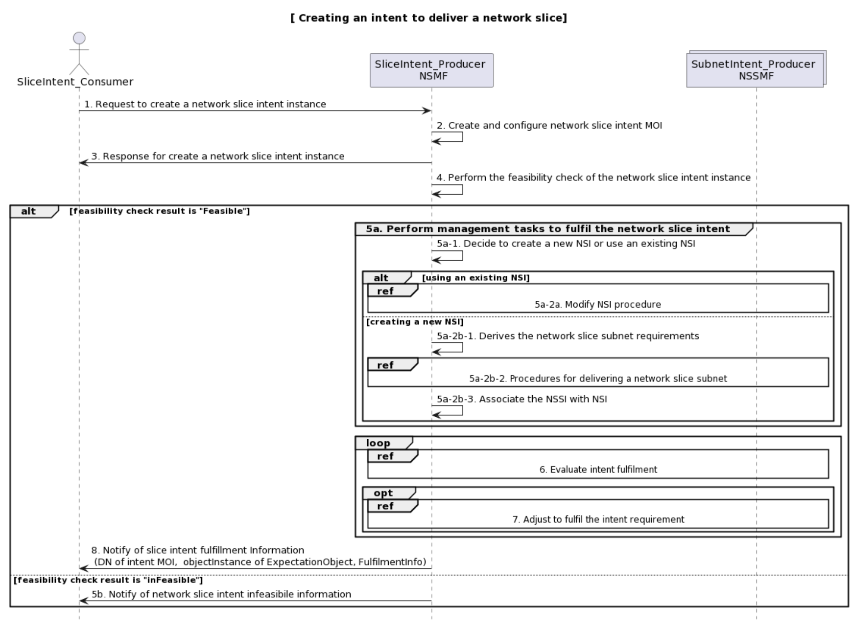

Figure 6.X.1-1 Procedure for creating an intent to deliver a network slice.

1. SliceIntent_Consumer sends a request to create a network slice intent instance (see createMOI operation defined in TS 28.532) to MnS Producer with intent information (including targets and contexts for delivering a network slice).
2. Based on the received request, the SliceIntent_Producer creates the concrete network slice intent instance (i.e. instance of intent IOC) and configures the new created network slice intent MOI with the received intent information (including network slice related targets and contexts).
3. SliceIntent_Producer sends a response (see createMOI operation defined in TS 28.532) to the SliceIntent_Consumer with DN of the created network slice intent instance.
4. Based on the created network slice intent instance, SliceIntent_Producer performs the feasibility check of the network slice intent instance.

In case the feasibility check result is 'feasible', following step 5a-step8 are executed:

5a. SliceIntent_Producer performs management tasks to fulfil the targets and contexts in the network slice intent, including:

5a-1. SliceIntent_Producer decides to create a new NSI or using an existing NSI.

5a-2a. If using an existing NSI and the existing NSI needs to be modified to satisfy the network slice intent, the SliceIntent_Producer invokes the procedure to modify the existing NSI.

5a-2b-1. If creating a new NSI, the SliceIntent_Producer derives the network slice subnet requirements from the received network slice intent.

5a-2b-2. The SliceIntent_Producer invokes the procedure for delivering a network slice subnet. The procedure for delivering network slice subnet can use intent driven approach or non-intent driven approach.

5a-2b-3 The SliceIntent_Producer creates the MOI for NetworkSlice and configures the MOI with the DN of MOI for the NetworkSliceSubnet.

6. During the execution of the intent, SliceIntent_Producer continuously monitors slice intent fulfilment information.

7. SliceIntent_Producer analyses and adjusts management tasks to ensure the slice intent is continuously satisfied.

8. SliceIntent_Producer should notify (see notifyMOIAttributeValueChanges notification) SliceIntent_ Consumer about DN of intent instance, objectInstance of ExpectationObject, and the intent fulfilment information.

In case the feasibility check result is 'infeasible', following step 5b is executed.

5b. SliceIntent_Producer notifies SliceIntent_Consumer that the result of feasibility check is ‘infeasible’ and the network slice intent instance cannot be delivered. The notification includes the reasons why the feasibility check result is infeasible (e.g. invalid intent expression, the intent conflict) and corresponding recommendations also can be included in the notification.

In addition, after step3, the SliceIntent_Consumer may check the status and completion of the network slice instance delivering procedure by monitoring the values of Intent instance attributes by querying the values or by subscribing to notifications.

### 6.X.2 Procedure for creating an intent to deliver a network slice subnet

Figure 6.X.1-1 illustrates the procedure for creating an intent to deliver a network slice subnet.

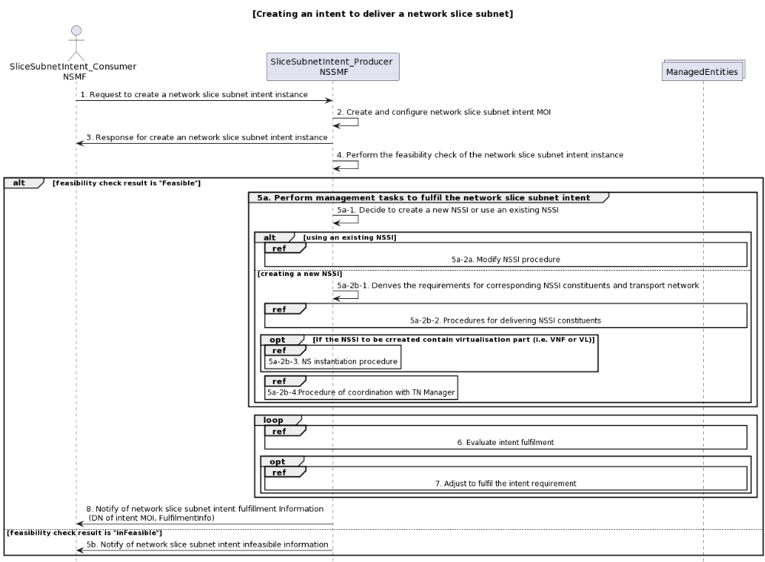

Figure 6.X.2-1 procedure for creating an intent to deliver a network slice subnet.

1. SliceSubnetIntent_Consumer sends a request to create a network slice subnet intent instance (see createMOI operation defined in TS 28.532) to MnS Producer with intent information (including targets and contexts for a network slice).
2. Based on the received request, the SliceSubnetIntent_Producer creates the concrete slice subnet intent instance (i.e. instance of intent IOC) and configures the new created slice subnet intent MOI with the received intent information(including targets and contexts for a network slice).
3. SliceSubnetIntent_Producer sends a response (see createMOI operation defined in TS 28.532) to the SliceSubnetIntent_Consumer with DN of the created intent instance.
4. Based on the created network slice subnet intent instance, SliceSubnetIntent_Producer performs the feasibility check of the network slice subnet intent instance.

In case the feasibility check result is 'feasible', following step 5a-step8 are executed:

5a. SliceSubnetIntent_Producer performs management tasks to fulfil the network slice subnet intent, including:

5a-1. SliceSubnetIntent_Producer decides to create a new NSSI or using an existing NSSI.

5a-2a. If using an existing NSSI and the existing NSSI needs to be modified to satisfy the network slice subnet intent, the SliceSubnetIntent_Producer invokes the procedure to modify the existing NSSI.

5a-2b-1. If creating a new NSSI, the SliceSubnetIntent_Producer derives the requirements for corresponding NSSI constituents and transport network from the received network slice subnet intent.

5a-2b-2. The SliceSubnetIntent_Producer invokes the intent for delivering a network slice subnet constituents.

5a-2b-3 The SliceSubnetIntent_Producer creates the MOI for NetworkSliceSubnet and configures the MOI with the DN of MOI for the NetworkSliceSubnet.

6. During the execution of the intent, SliceSubnetIntent_Producer continuously monitors network slice subnet intent fulfilment information.

7. SliceSubnetIntent_Producer analyses and adjusts the managed entities to ensure the network slice subnet intent is continuously satisfied.

8. SliceSubnetIntent_Producer should notify (see notifyMOIAttributeValueChanges notification) SliceSubnetIntent_ Consumer about DN of intent instance, objectInstance of ExpectationObject and the intent fulfilment information.

In case the feasibility check result is 'infeasible', following step 5b is executed.

5b. SliceSubnetIntent_Producer notifies SliceSubnetIntent_Consumer that the result of feasibility check is ‘infeasible’ and the network slice subnet intent instance cannot be delivered. The notification includes the reasons why the feasibility check result is infeasible (e.g. invalid intent expression, the intent conflict) and corresponding recommendations also can be included in the notification.

In addition, after step3, the SliceSubnetIntent_Consumer may check the status and completion of the network slice subnet instance delivering procedure by monitoring the values of Intent instance attributes by querying the values or by subscribing to notifications.

Annex A (informative):  
PlantUML source code

# A.1 Procedures for slice intent management

## A.1.1 Procedure for intent driven approach for delivering a network slice

@startuml

title "[ Creating an intent to deliver a network slice]"

actor "SliceIntent_Consumer " as MnS_Consumer

participant "SliceIntent_Producer \n NSMF" as MnS_Producer

Collections "SubnetIntent_Producer \n NSSMF" as NSSMF

MnS_Consumer -> MnS_Producer: 1. Request to create a network slice intent instance

MnS_Producer -> MnS_Producer: 2. Create and configure network slice intent MOI

MnS_Producer -> MnS_Consumer: 3. Response for create a network slice intent instance

MnS_Producer -> MnS_Producer: 4. Perform the feasibility check of the network slice intent instance

alt feasibility check result is "Feasible"

group 5a. Perform management tasks to fulfil the network slice intent

MnS_Producer -> MnS_Producer: 5a-1. Decide to create a new NSI or use an existing NSI

alt using an existing NSI

ref over MnS_Producer, NSSMF: 5a-2a. Modify NSI procedure

else creating a new NSI

MnS_Producer -> MnS_Producer: 5a-2b-1. Derives the network slice subnet requirements

Ref over MnS_Producer, NSSMF: 5a-2b-2. Procedures for delivering a network slice subnet

MnS_Producer -> MnS_Producer: 5a-2b-3. Associate the NSSI with NSI

end

end

loop

Ref over MnS_Producer, NSSMF: 6. Evaluate intent fulfilment

opt

Ref over MnS_Producer, NSSMF: 7. Adjust to fulfil the intent requirement

end

end

MnS_Producer -> MnS_Consumer:8. Notify of slice intent fulfillment Information\n (DN of intent MOI, objectInstance of ExpectationObject, FulfilmentInfo)

else feasibility check result is "inFeasible"

MnS_Producer -> MnS_Consumer: 5b. Notify of network slice intent infeasibile information

end

hide footbox

## @endumlA.1.2 Procedure for intent driven approach for delivering a network slice subnet

@startuml

title "[Creating an intent to deliver a network slice subnet]"

actor "SliceSubnetIntent_Consumer \n NSMF " as MnS_Consumer

participant "SliceSubnetIntent_Producer \n NSSMF" as MnS_Producer

Collections "ManagedEntities" as ManagedEntities

MnS_Consumer -> MnS_Producer: 1. Request to create a network slice subnet intent instance

MnS_Producer -> MnS_Producer: 2. Create and configure network slice subnet intent MOI

MnS_Producer -> MnS_Consumer: 3. Response for create an network slice subnet intent instance

MnS_Producer -> MnS_Producer: 4. Perform the feasibility check of the network slice subnet intent instance

alt feasibility check result is "Feasible"

group 5a. Perform management tasks to fulfil the network slice subnet intent

MnS_Producer -> MnS_Producer: 5a-1. Decide to create a new NSSI or use an existing NSSI

alt using an existing NSSI

ref over MnS_Producer, ManagedEntities: 5a-2a. Modify NSSI procedure

else creating a new NSSI

MnS_Producer -> MnS_Producer: 5a-2b-1. Derives the requirements for corresponding NSSI constituents and transport network

Ref over MnS_Producer, ManagedEntities: 5a-2b-2. Procedures for delivering NSSI constituents

opt If the NSSI to be crreated contain virtualisation part (i.e. VNF or VL)

ref over MnS_Producer: 5a-2b-3. NS instantiation procedure

end

Ref over MnS_Producer: 5a-2b-4.Procedure of coordination with TN Manager

end

end

loop

Ref over MnS_Producer, ManagedEntities: 6. Evaluate intent fulfilment

opt

Ref over MnS_Producer, ManagedEntities: 7. Adjust to fulfil the intent requirement

end

end

MnS_Producer -> MnS_Consumer:8. Notify of network slice subnet intent fulfillment Information\n (DN of intent MOI, FulfilmentInfo)

else feasibility check result is "inFeasible"

MnS_Producer -> MnS_Consumer: 5b. Notify of network slice subnet intent infeasibile information

end

hide footbox

@enduml