3GPP TSG-SA5 Meeting #145-e S5-225599
e-meeting, 15 - 24 August 2022

Title: LS on Reply on initiation new work item M.fidtom Framework of intent driven telecom operation and management
Response to: LS S5-225026 on initiation new work item M.fidtom: ""Framework of intent driven telecom operation and management"" from < ITU-T Study Group 2 >
Release: Rel-17, Rel-18
Work Item: IDMS_MN, FS_eIDMS_MN, FS_NETSLICE_IDMS
Source: 3GPP SA5
To: ITU-T Study Group 2
Cc: ITU-T SG13, IETF NMRG, TM Forum AN, 3GPP SA

Contact person: Xu Ruiyue
xuruiyue@huawei.com

Send any reply LS to: 3GPP Liaisons Coordinator, mailto:3GPPLiaison@etsi.org

Attachments: None

1 Overall description
SA5 would like to thank ITU-T Study Group 2 for the information on initiation new work item M.fidtom Framework of intent driven telecom operation and management.
SA5 is interested in intent driven management topics. SA5 started the work item intent driven management for mobile networks since 2018, and completed its Release 17 work on the intent driven management services for mobile networks in June 2022, corresponding published specification is TS 28.312 (Management and orchestration; Intent driven management services for mobile networks). SA5 has now worked on its two Release 18 study items related to intent driven management for mobile network based on R17 work: Study on enhanced intent driven management services for mobile network and Study on intent-driven management for network slicing, corresponding draft TRs are TR 28.912 (Study on enhanced intent driven management services for mobile networks) and TR 28.836 (Study on intent-driven management for network slicing).
SA5 has analysed SG2-TD095/PLEN (Draft new Recommendation ITU-T M.fidtom, "Framework of intent driven telecom operation and management".), and have following questions for clarification:
- Question 1: In 3GPP TS 28.312 clause 4.1.2, following intent categories are defined based on user types: Intent from Communication Service Customer (Intent-CSC), Intent from Communication Service Provider (Intent-CSP) and Intent from Network Operator (Intent-NOP). Based on the proposed intent definition (intent [ITU-T X.1257 (03/2016)]: The user reason or purpose for initiating the interaction with a service provider), does it mean the proposed framework are focus on Intent from Communication Service Customer (Intent-CSC).
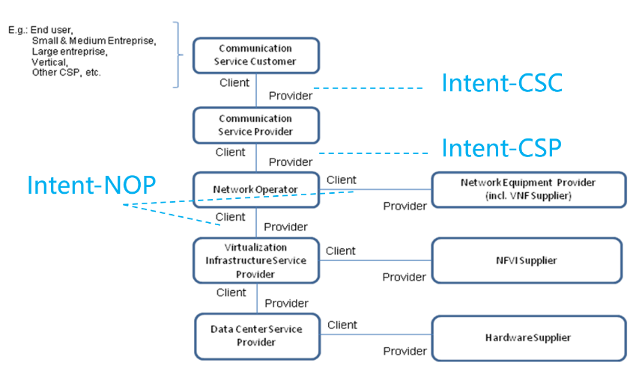

- Question 2: Both term “intent driven telecom operation and management” and “intent driven management” are used, what’s the difference.
- Question 3: Regarding the Annex A, the 3GPP SA5 specification for Intent driven management services for mobile networks specification should be TS 28.312 instead of TS 28.812.

2 Actions
To ITU-T Study Group 2
ACTION: 3GPP SA5 is looking forward to your feedback on above questions

3 Dates of next TSG SA WG 5 meetings
SA5#146 14 - 18 November 2022 Canada (TBC)
SA5#146 Ad-Hoc 16 - 20 January 2023 Electronic meeting

