3GPP TSG-SA5 Meeting #145-e S5-225427

e-meeting, 15-24 August 2022

Source: Huawei

Title: Addition of Usage Data Report

Document for: Discussion
Agenda Item: 7.5.2

1 Decision/action requested
Discuss the charging requirements for addition of Usage Data Report.

2 References
[1] GSMA TD.201: "Common Billing and Charging Processes"

3 Rationale
For the 5G roaming charging, the CDRs are generated by the CHF and then conveyed to a mediation device of BCE process. The service usage information collected with the CDRs is transferred to Usage Data Report is outlined by the following figure High Level Reporting Exchange Flow, described in the key topics "Billing and Charging Evolution" of GSMA "Interoperability Data Specifications and Settlement Group" (https://www.gsma.com/aboutus/workinggroups/interoperability-data-specifications-and-settlement-group/billing-and-charging-evolution) .
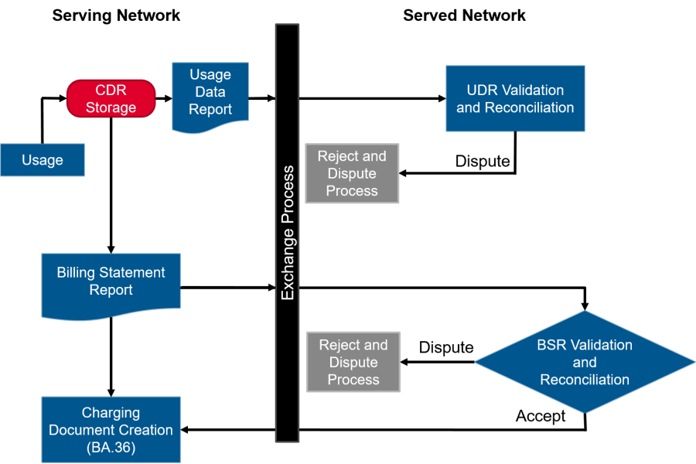
Figure1: High Level Reporting Exchange Flow
Acorrding to the TS GSMA TD.201 [1] clause 2.2.2 Usage Data Report
UDR must contain cumulative and incremental records/information, if more than one UDR is exchanged in any single invoice period. UDR will contain a cumulative record (Type 11) for each Aggregation Time Dimension, even if no usage is found for that time period.
…
In order to support the BCE process specified in the GSMA, even if no usage is found for that time period, the UDR will contain a cumulative record. The following provious process should be confirm:
- the usage should be reported to the CHF from the NFs in the core domain;
- The CDRs should be generated by the CHF to convey the service usage information to Usage Data Report.
Propose to add the new use cases for the reporting without usage.

4 Detailed proposal
First change

2 References
The following documents contain provisions which, through reference in this text, constitute provisions of the present document.
- References are either specific (identified by date of publication, edition number, version number, etc.) or non-specific.
- For a specific reference, subsequent revisions do not apply.
- For a non-specific reference, the latest version applies. In the case of a reference to a 3GPP document (including a GSM document), a non-specific reference implicitly refers to the latest version of that document in the same Release as the present document.
[1] 3GPP TR 21.905: "Vocabulary for 3GPP Specifications".
[2] 3GPP TS 32.255: "5G data connectivity domain charging; stage 2".
[3] 3GPP TS 23.503: "Policy and charging control framework for the 5G System (5GS); Stage 2".
[4] 3GPP TS 29.500: "5G System; Technical Realization of Service Based Architecture; Stage 3".
[5] 3GPP TS 32.240: "Telecommunication management; Charging management; Charging architecture and principles".
[6] 3GPP TS 32.291: "Telecommunication management; Charging management; 5G system; Charging service, stage 3".
[7] 3GPP TS 32.298: "Telecommunication management; Charging management; Charging Data Record (CDR) parameter description".
[8] 3GPP TS 32.299: "Telecommunication management; Charging management; Diameter charging application".
[9] 3GPP TS 23.501: "3GPP TS 23.501:"System Architecture for the 5G System".
[10] 3GPP TS 23.203: "Policy and charging control architecture".
[11] 3GPP TS 29.594: "5G System; Spending Limit Control Service; Stage 3".
[12] 3GPP TS 32.290: "Telecommunication management; Charging management; 5G system; Services, operations and procedures of charging using Service Based Interface (SBI)".
[13] IETF RFC 4006 (2005): "Diameter Credit-Control Application".
[14] IETF RFC 8506 (2019): "Diameter Credit-Control Application".
[15] GSMA TD.201: "Common Billing and Charging Processes".
Next change

5.1.1 General
When there is no 5G data connectivity usage, which may be quite frequent in the case of always connected, when a trigger is active and the event occurs, sending a lot of information might be unnecessary. For online the need of getting the trigger even if there is no usage depends on if it requires rating and may impact the granted quota. For the offline it will depend on the use case if the trigger event is needs to be reported in the case of no usage.
The size of a request is only limited by the maximum size of the request in TS 29.500 [4] and controlled by the NF consumer. The CHF may reject the request if the request is over that limit. There is no other way for the CHF to control the size of the message other than controlling or limit the number of charging conditions changes before reporting, this won’t state the size or take compression into consideration.
Next change

5.1.2.3 Use Case #1c BCE support if no usage
For the 5G roaming charging, such as including the home routed and Local-break out roaming sceanrios in 5G data connectivity, 5G connection and mobility and so on, the corresponding CDRs are generated by the CHF and then conveyed to a mediation device of BCE process. The service usage information collected with the CDRs is transferred to Usage Data Report for the further BCE process, described in the GSMA TD.201[15].
The UDR in BCE will contain a cumulative record for each Aggregation Time Dimension, even if no usage is found for that time period. How to support it from charging aspect should be considered.
The corresponding potential charging requirements and key issues are: REQ-CH_INFO-03, Key Issue #1x.
Next change

5.1.3 Potential charging requirements
REQ-CH_INFO-01: Optimization of charging information may be needed when zero units used.
REQ-CH_INFO-02: Support for control of charging request size.
REQ-CH_INFO-03: Support for BCE process if no usage is found for the time period .

Next change

5.1.4 Key issues
The following key issues are identified:
- Key Issue #1a: Identify the charging scenarios and triggers which can be controlled when there is no usage.
- Key Issue #1b: How to control if information is sent when there is no usage.
- Key Issue #1c: How to control if containers are created when these is no usage.
- Key Issue #1d: How to control the size of the information in the converged charging request, dependent or independent of compression.
- Key Issue #1e: How to handle when unit request and report for one rating group are split over several requests
- Key Issue #1x: How to handle when there is no usage in the CDRs
Next change

5.1.5 Solutions

5.1.5.1 Solution #1.1 Reporting if no usage
A possible solution for key issues 1c covering requirements REQ-CH_REQ-03.
The service usage charging information should be reported to the CHF when the triggers are encountered, even if there is no usage. Based on the reported charging information, CHF may genernate the zero CDRs which is conveyed to a mediation device of BCE. The UDR in BCE will contain a cumulative record for each Aggregation Time Dimension based on the zero CDRs if no usage is found for that time period.

5.1.5.2 Solution #1.2 Without reporting if no usage
A possible solution for key issues 1c covering requirements REQ-CH_REQ-03.
The service usage charging information should be reported to the CHF when the triggers are encountered. Based on the reported charging information, CHF genernate the CDRs which is conveyed to a mediation device of BCE. If the mediation device has not received the CDRs within a certain period of time, The UDR in BCE will contain a cumulative record for each Aggregation Time Dimension, based on no CDRs received if no usage is found for that time period
Editor’s note: the soltuion #1.1 and # 1.2 should comply with GSMA BCE process.
End of change

