3GPP TSG-SA5 Meeting #145-e S5-225201

e-meeting, 15 - 24 August 2022

Source: Huawei, Deutsche Telekom

Title: Add issue for intent handling capability obtaining

Document for: Approval
Agenda Item: 6.7.3.2

1 Decision/action requested
The group is asked to discuss and approval.

2 References
[1] 3GPP draft TR 28.912: "Management and orchestration; Study on enhanced intent driven management services for mobile networks v0.3.0".
[2] SP-211450 New Study on enhanced intent driven management services for mobile networks

3 Rationale
One of the objective for the SID FS_eIDMS_MN in SP-221450 is Intent capability obtaining, so this contribution proposed to add the issue for intent handling capability obtaining.

4 Detailed proposal

1st Change

4.X Issue#4.X: Intent handling capability obtaining

4.X.1 Description
In TS 28.312[2], clause 4.2.2 described that Intent-driven MnS producer (which can be intent handling MnF) have the following capabilities: validate the intent, translate the received intent to executable actions and evaluate the result/information about the intent fulfilment, and clause 6.2.2 defined different scenario specific intent expectations with different ExpectationObjects and ExpectationTargets to support different use cases. In network, multiple intent handling functions maybe deployed to support different kinds of intents. Different intent handling functions maybe deployed to support different intent expectation object domains, e.g. intent handling function A is deployed to handle the radio network related intents, intent handling function B is deployed to handle the 5GC network related intents, while intent handling function C is deployed to handle the service related intents. Or different intent handling functions are deployed to support different areas of the same intent expectation object domain, e.g. intent handling function D is deployed to support to handle the intent for radio network in Area#1, while intent handling function E is deployed to support to handle the intent for radio network in Area#2.
Before MnS consumer expresses the intent expectation targets and expectation objects to MnS producer (i.e. intent handling MnF), MnS consumer may want to know what expectation targets and expectation objects can be supported by MnS producer. Based on such supported expectation targets information and expectation objects information, the MnS consumer may use such information to select the proper intent handling MnF to express the intent.

4.X.2 Potential solutions
Following are the proposed solution based on generic intent information model defined in TS 28.312 [2].
Introduce the new IntentHandlingFunction <<IOC>> contained by ManagedEntity <<proxyClass>>, and change the Intent <<IOC>> to be contained by IntentHandlingFunction <<IOC>>. The intentHandlingFunction <<IOC>> includes a list of supportedIntentHandlingCapability <<datatype>> which represent intent handling function's capabilities in support of intent handling. The supportedIntentHandlingCapability <<datatype>> includes attribute “supportedExpectationObjects” and/or attribute “supportedExpectationTargets”.
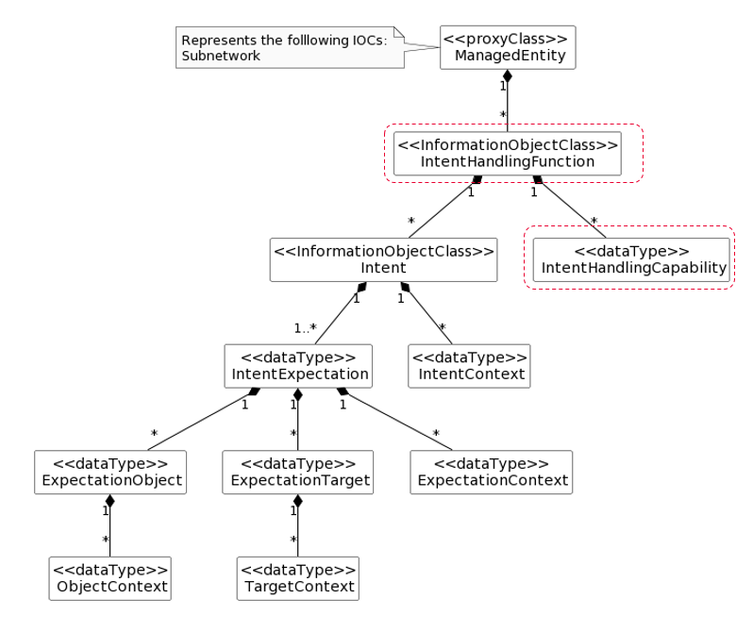
Figure 4.X.2-1 Enhancement of generic intent information model (The red highlied box are the enhanced part)
Based on the enhancement of generic intent information model, MnS consumer can query the IntentHandlingFunction <<IOC>> to obtain the intent handling capability information, and express the intent for a specific intent handling function. An authorized MnS consumer also can use the DN of IntentHandlingFunction instance to query all Intent instances handled by corresponding intent handling function.
End of changes

