3GPP TSG-SA5 Meeting #144e S5-224228

Electronic meeting, 27 June – 01 July 2022

Source: Huawei

Title: pCR TR 28.863 Issue #3 Video uploading description

Document for: Approval
Agenda Item: 6.9.4.1

1 Decision/action requested
This contribution is proposed to be approved.

2 References
[1] 3GPP TS 28.863v0.2.0: "Study on Key Quality Indicators (KQIs) for 5G service experience"

3 Rationale
The document gives the detailed description of the scenarios of video uploading.

4 Detailed proposal
It is proposed to apply the following changes as below in TR 28.863 [1].
Start of the first change

4.3 Issue # 3: KQIs for Video Uploading

4.3.1 Description

The scenario of video uploading include video generation andvideo uplink transmission. Video generation related to the process of generating the video. Video uplink transportation related to the video uplink to the server.

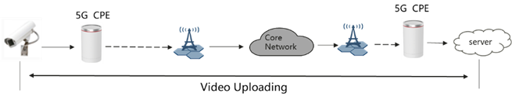
Figure 1: Video uploading scenario
Video uploading is widely used in transportation, smart city and industry automation. In video uploading, a large number of videos are captured and uploaded to the server for analysis. Different scenarios have different video requirements. Therefore, media quality-related KQIs, such as resolution and bit rate, are required to used as source elements for KQI to define video quality. If the requirements are too low, the video is not clear and the client cannot process the video. Too high video quality requirements can burden network transmission and cause unnecessary costs.
In industrial automation scenarios, e.g Grid, Mines and Port, video uploading is widely used to assist automatic control. Some scenarios have high requirements on video quality. For example, ultra-high definition video signals are required for precise control of the instruments in a port. Therefore, media quality related KQIs are required to define video requirements. In addition, the scenario of industrial automation has high requirements for video transmission. Therefore, interaction quality is required. For example, the definition of delay-related KQIs imposes requirements on such service quality.
KQIs for video uploading is important for service management:
- In the management of network slice, the consumer could express the expectation for a service through KQI to the producer;
- To inform the consumer of the quality of a certain service.
End of the first change

