3GPP TSG-SA5 Meeting # S5-224178rev3

June 2022, E-meeting

Source: Nokia

Title: pCR 28.912 Intent-driven Closed Loop control

Document for: Approval

Agenda Item: 6.7.3.2

1 Decision/action requested
The group is asked to discuss and agree on the proposal.

2 References
[1] 3GPP TR 28.864-020 “Study on enhanced intent driven management services for mobile networks”.

3 Rationale
Manual control and managememt of closed loops (including composition, goal management, etc9 from multiple managememt functions is likely to be a challenging task owing to the high number fo poetential combuination of the managemmegt functions. Accordingly, enablers and management servies are required for the automated control of closed loop based on operator intents. This pCR is to add requirememts for Intent-driven Closed Loop control.

4 Detailed proposal
Start of modification

4.3 Issues#4.N: Intent-driven Closed Loop control

4.N.1 Description
A Closed Loop (CL) is an entity that implements the capabilities to get data, analysei it, generate decision and execute those decision on the network. It may be implemented in one or more stages (in Figure 1 as 4 or 3 stages) and each may be implemented by a specific component (i.e. MnF). Each CL may implement a Closed-loop Control (CC) as the producer of CL management services that support control capabilities used to manage or control the closed loop and to support interaction with the external world.

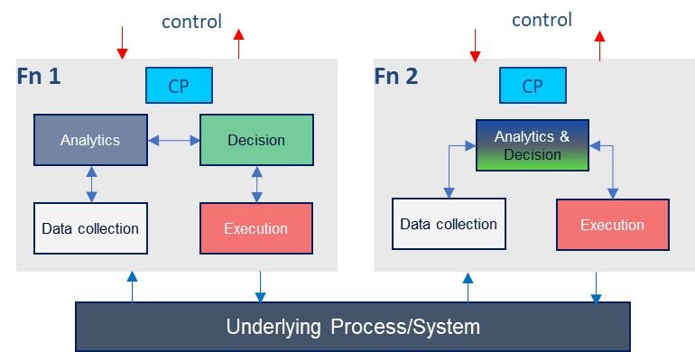
Figure 4.N.1-1: Example relations among closed loop components

Given a set of deployed network functions and/or management functions, the Closed-Loop Control may configure different network and management functions to achieve the desired closed loop goals based on intents with the input “context” (e.g. capabilities, control or use case) provided by the operator, as illustrated by Figure 4.N.1-3. Within the intent dirven system, the MnS producer for intent driven MnS may play the role of closed loop control to implement the intent driven closed loop or interact with closed loop control to control the closed loop.
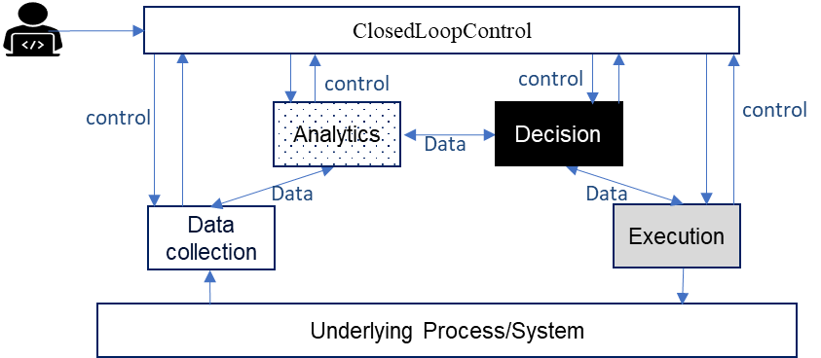
Figure 4.N.1-3: Using Intents towards Closed-Loop Control to automate closed loops managemnt and control

Editor's Note: above closed loop description needs to be revised based on content in TS 28.535 and TS 28.312.
REQ-Intent_GEN_CON_01: The 3GPP management systems shall support a capability to allow a consumer (e.g. an operator) to express an intent to enable the provider of CL management to configure a CL based on an intent that expresses the intent expectations as closed loop goals, KPI, SLS, SLA targets, input-output pairs or capabiities
REQ-Intent_GEN_CON_02: The 3GPP management systems shall support a capability to allow a consumer (e.g. an operator) to express an intent to enable the provider of CL management to configure its constituent management functions and goals to achieve the objectives/expectations of the intent.
REQ-Intent_GEN_CON_03: The 3GPP management systems shall support a capability to to inform an authorized consumer (e.g. an operator) about closed loops and managememt fucntions servicing the intent

End of modifications

