3GPP TSG-SA5 Meeting # S5-224178rev2

June 2022, E-meeting

Source: Nokia

Title: pCR 28.912 Intent-driven Closed Loop control

Document for: Approval

Agenda Item: 6.7.3.2

1 Decision/action requested
The group is asked to discuss and agree on the proposal.

2 References
[1] 3GPP TR 28.864-020 “Study on enhanced intent driven management services for mobile networks”.

3 Rationale
Manual control and managememt of closed loops (including composition, goal management, etc9 from multiple managememt functions is likely to be a challenging task owing to the high number fo poetential combuination of the managemmegt functions. Accordingly, enablers and management servies are required for the automated control of closed loop based on operator intents. This pCR is to add requirememts for Intent-driven Closed Loop control.

4 Detailed proposal
Start of modification

4.3 Issues#4.N: Intent-driven Closed Loop control

4.N.1 Description
A Closed Loop (CL) is an entitythat implements the capabilities to get data, analysei it, generate decision and execute those decision on the network. It may be implemented in one or more stages ( in Figure 1 as 4 or 3 stages) each implemented by a specific component. Each CL may implement a Closed-loop Control (CC) as the producer of CL management services that support control capabilities used to manage or control the closed loop and to support interaction with the external world.

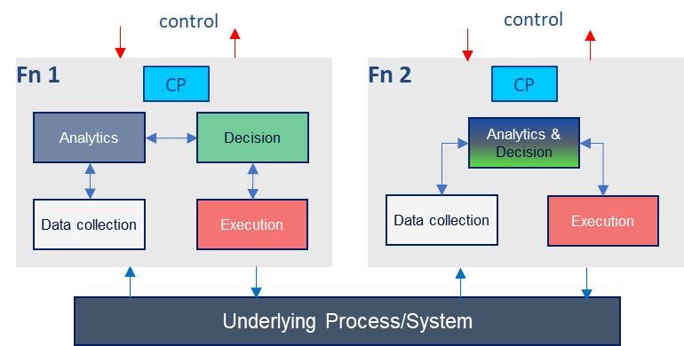
Figure 4.N.1-1: Example relations among closed loop components

A Closed Loop (CL) can be composed from multi-vendor components using standardised APIs. As illustrated by Figure 4.N.1-2, the different stages can support control interfaces (highlighted by the red lines in figure 4.N.1-2), through which another entity may control the closed loop stages. Each stage can also support the run-time interfaces (highlighted by the blue lines in Figure 4.N.1-2) through which the stages exchange data to accomplish the network management tasks. Examples of such stages may be MDAS for analysis or 5G SON for decisions.
Underlying Process/System
k-means Cluster
Instantiate
Exec 3
DC 2
DC 1
overwrite
Decrease / increase P
Mean
Figure 4.N.1-2: Manually integrated and managed Multi-vendor closed loop
The implementation in figure 4.N.1-2 typically assumes that the multi-vendor closed loop is integrated and managed by the operator. However, the number of CLs and combinations thereof is likely to be high, e.g. multiple combinations of MDAS and 5GSON capabilities are possible for different usecases. As such, enablers and management servies for the automation of closed loop control are required. Thereby, the Closed-Loop Control may configure different network and management functions to achieve the desired closed loop goals based on intents with the input “context” (e.g. capabilities, control or use case) provided by the operator, as illustrated by Figure 4.N.1-3.
Data collection
Execution
Underlying Process/System
Decision
Analytics
C
E
D
C
E
C
E
C
E
D
D
X
Closed-Loop Control
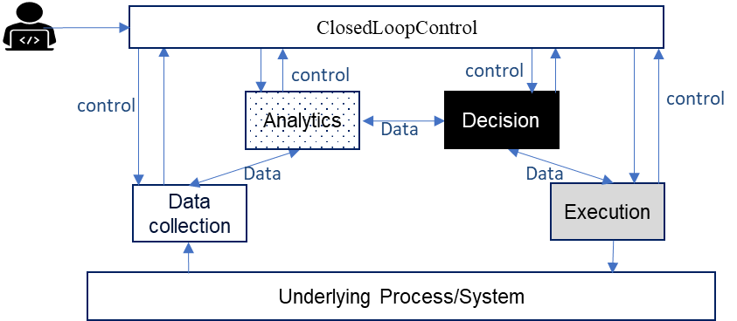
Figure 4.N.1-3: Using Intents towards Closed-Loop Control to automate closed loops managemnt and control

REQ-Intent_GEN_CON_01: The 3GPP management systems shall support a capability to enable a consumer (e.g. an operator) to express an intent to request the the provider of CL management to configure a CL based on an intent that expresses the unique identifiers of the management functions to be congigured as stages of the CL.
REQ-Intent_GEN_CON_02: The 3GPP management systems shall support a capability to enable a consumer (e.g. an operator) to express an intent to request the the provider of CL management to configure a CL based on an intent that expresses the inputs and outputs of the required stages of the CL.
REQ-Intent_GEN_CON_03: The 3GPP management systems shall support a capability to enable a consumer (e.g. an operator) to express an intent to request request the the provider of CL management to configure a CL based on an intent that expresses the capabilities of the required stages of the CL.
REQ-Intent_GEN_CON_04: The 3GPP management systems shall support a capability to enable a consumer (e.g. an operator) to request the the provider of CL management to configure a CL based on an intent that expresses the combinations of capabilities or input-output relations of the required stages of the CL.

End of modifications

