3GPP TSG-SA5 Meeting # S5-224178

June 2022, E-meeting

Source: Nokia

Title: pCR 28.912 Intent-driven Closed Loop Composition

Document for: Approval

Agenda Item: 6.7.3.2

1 Decision/action requested
The group is asked to discuss and agree on the proposal.

2 References
[1] 3GPP TR 28.864-020 “Study on enhanced intent driven management services for mobile networks”.

3 Rationale
Manual composition of closed loops from multiple managememt functions is likely to be a challenging task owing to the high number fo poetential combuination of the managemmegt functions. Accordingly, enablers and management servies are required for the automated composition of closed loop based on operator intents. This pCR is to add requirememts for Intent-driven Closed Loop Composition.

4 Detailed proposal
Start of modification

4.3 Issues#4.N: Intent-driven Closed Loop Composition

4.N.1 Description
A Closed Loop (CL) is an entitythat implements the capabilities to get data, analysei it, generate decision and execute those decision on the network. It may be implemented in one or more stages ( in Figure 1 as 4 or 3 stages) each implemented by a specific component. Each CL may implement a Closed-loop Control (CC) as the producer of CL management services that support control capabilities used to manage or control the closed loop and to support interaction with the external world.

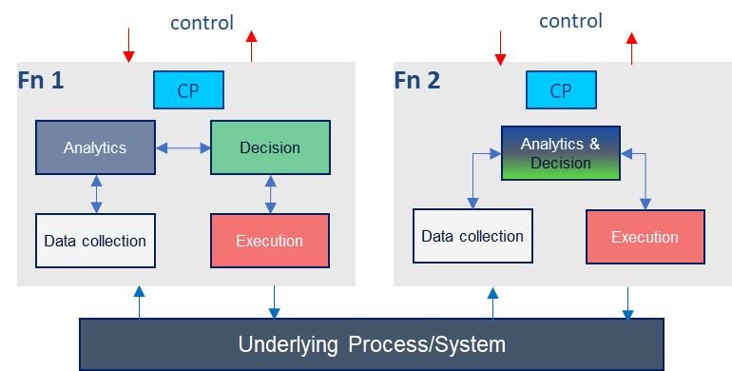
Figure 4.N.1-1: Example relations among closed loop components

A Closed Loop (CL) can be composed from multi-vendor components using standardised APIs. As illustrated by Figure 4.N.1-2, the different stages can support control and exposure interfaces (highlighted by the red lines in figure 4.N.1-2), through which an external entity may control the stages. Each stage can also support the run-time interfaces (highlighted by the blue lines in Figure 4.N.1-2) through which the stages exchange data to accomplish the network management tasks. Examples of such stages may be MDAS for analysis or 5G SON for decisions.
Underlying Process/System
k-means Cluster
Instantiate
Exec 3
DC 2
DC 1
overwrite
Decrease / increase P
Mean
Figure 4.N.1-2: Manually integrated and managed Multi-vendor closed loop
The implementation in figure 4.N.1-2 typically assumes that the multi-vendor closed loop is integrated and managed by the operator. However, the number of CLs and combinations thereof is likely to be high, e.g. multiple combinations of MDAS and 5GSON capabilities are possible for different usecases. As such, enablers and management servies for the automation of closed loop composition are required. Thereby, the Closed-Loop Control may compose the closed loop based on intents wit the input “context” (e.g. capabilities, control or use case) provided by the operator, as illustrated by figure Figure 4.N.1-3.
Data collection
Execution
Underlying Process/System
Decision
Analytics
C
E
D
C
E
C
E
C
E
D
D
X
Closed-Loop Control

Figure 4.N.1-3: Using Intents towards Closed-Loop Control to automate closed loops composition

REQ-Intent_GEN_CON_01: The 3GPP management systems shall support a capability to enable a consumer (e.g. an operator) to request request the the provider CL management to compose a CL based on an intent that expresses the unique identifiers of the management functions to be used as stages of the CL.
REQ-Intent_GEN_CON_02: The 3GPP management systems shall support a capability to enable a consumer (e.g. an operator) to request request the the provider CL management to compose a CL based on an intent that expresses the inputs and outputs of the required stages of the CL.
REQ-Intent_GEN_CON_03: The 3GPP management systems shall support a capability to enable a consumer (e.g. an operator) to request request the the provider CL management to compose a CL based on an intent that expresses the capabilities of the required stages of the CL.
REQ-Intent_GEN_CON_04: The 3GPP management systems shall support a capability to enable a consumer (e.g. an operator) to request request the the provider CL management to compose a CL based on an intent that expresses the combinations of capabilities or input-output relations of the required stages of the CL.

End of modifications

