3GPP TSG-SA5 Meeting #144e S5-224126

e-meeting, 27 June – 1 July 2022

Source: Huawei

Title: pCR 28.903 adding background information for GSMA OPG

Document for: Approval

Agenda Item: 6.9.7.2

1 Decision/action requested
The group is asked to discuss and agree on the proposal.

2 References
[1] 3GPP TR 28.903-020 “Study on alignment with ETSI MEC for Edge computing management”

3 Rationale
The background information for GSMA OPF is missing in TR 28.903-020 [1], this pCR suggests to add the background information for GSMA OPG.

4 Detailed proposal
It is proposed to add the GSMA OPG background information in clause 4.2 of TR 28.903-020 [1].
1st change

4.2 GSMA OPG
The Operator Platform (OP) is defined by GSMA OPG [2], it facilitates access to the Edge Cloud capability of an Operator or federation of operators and their partners.
The architecture scope under definition is shown below,
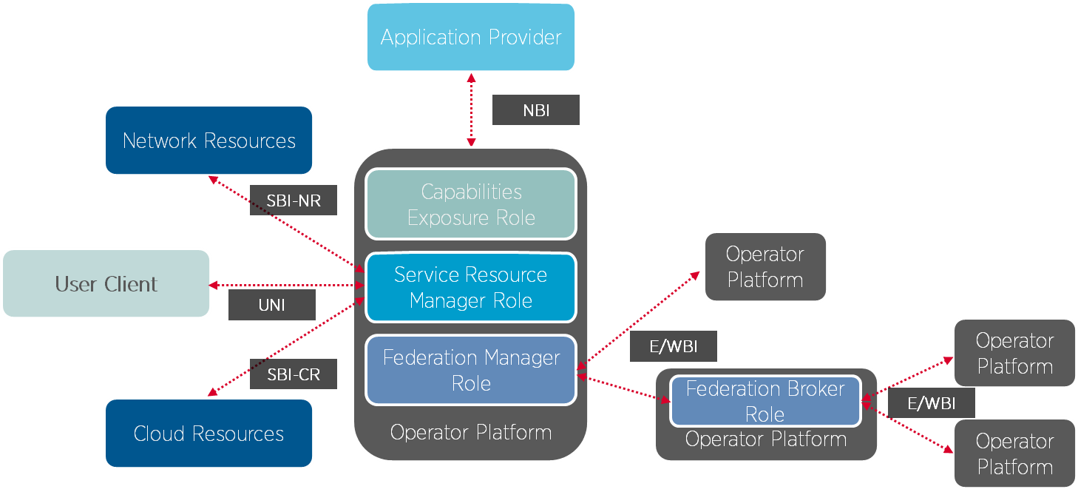
Figure 4.2-1: OP Roles and Interfaces Reference Architecture
This study is focused on the NBI requirements as defined in [2]. The NBI is the interface between the application provider and the Operator Platform, it allows an OP to advertise the above cloud capabilities that it can provide to application providers. In addition, the NBI allows an application provider to reserve a set of resources or request an Edge Cloud service with the resources and features that they require and for the OP to accept or reject the request.
In this study, it is assumed that the application provider as described in [2] maps to ASP in TS 28.538 [x], and the Operator Platform as described in [2] maps to ECSP management system in TS 28.538 [x].
End of change

