**3GPP TSG-SA5 Meeting #144-e *S5-224102rev2***

**e-meeting, 27 June - 1 July 2022**

**Source: Huawei, Deutsche Telekom**

**Title: pCR TR 28.908 Add use case on AI/ML update**

**Document for: Approval**

**Agenda Item: 6.7.5.4**

# 1 Decision/action requested

***In this box give a very clear / short /concise statement of what is wanted.***

# References

[1] SP-211443 New Study on AI/ ML management

[2] 3GPP TR 28.908-020 Management and orchestration; Study on Artificial Intelligence/Machine Learning (AI/ML) management

[3] 3GPP TS 28.105 Management and orchestration; Artificial Intelligence / Machine Learning (AI/ML) management

# 3 Rationale

The approved new SI [1] proposed to study the AI/ML management capabilities and management services to support/coordinate AI/ML in 5GS (3GPP management system, 5GC and NG-RAN). During the running period, the previously deployed AI/ML entity may no longer be applicable to the current network due to the changed network state. It is necessary to update the AI/ML entity (i.e., replace the running model with a new one) to ensure the performance of inference and analysis. This contribution proposes to add a use case on AI/ML update.

# 4 Detailed proposal

It is proposed to add the following chapter in TR 28.908 [2].

|  |
| --- |
| **1st modified section** |

### 5.X AI/ML update management

### 5.X.1 Description

Due to the complexity and time-varying nature of network, the AI/ML entities previously deployed may no longer be applicable to the current network after running for a period of time. Typically, the performance of a trained model may degrades over time. The AI/ML entitie needs to be updated timely to ensure the performance of inference and analysis.

### 5.X.2 Use cases

#### 5.X.2.2 AI/ML entities updating initiated by producer

The AI/ML entity updating may be initiated by the AI/ML MnS producer. In order to keep the model at a requested level, the AI/ML MnS producer may periodically conduct AI/ML retraining with new available training data. Once a new version AI/ML entity is obtained after the training is finished, it can be used to update the current AI/ML entity with this new version. In another condition, the AI/ML MnS producer may initiate AI/ML entity updating based on the running model performance. For example, if the performance of the running AI/ML model is decreased under a predefined threshold, the AI/ML MnS producer may decide to start ratraining and then update the AI/ML entity to a new version which performs better.

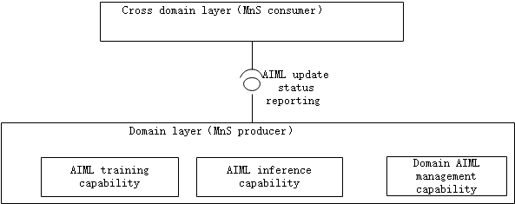

### 5.X.3 Potential requirements

|  |  |  |
| --- | --- | --- |
| Requirement label | Description | Related use case(s) |
|  |  |  |
|  |  |  |
| **REQ-AIML_UPD-CON-3** | The AI/ML MnS producer should have a capability to update the AI/ML entities and inform an authorized consumer about the update status. | AI/ML entities updating initiated by producer (clause 5.X.2.2) |

### 5.X.4 Possible solutions

TBD

|  |
| --- |
| **End of modified section** |