**3GPP TSG-SA5 Meeting #144-e *S5-224081rev1***

**e-meeting, 27 June - 1 July 2022**

**Source: Huawei**

**Title: Add exposure governance for three CAPIF alternatives**

**Document for: Approval**

**Agenda Item:** **6.9.6.3**

# 1 Decision/action requested

***For approval***

# 2 References

[1] 3GPP TR 28.824 V0.7.0 Study on network slice management capability exposure

[2] 3GPP TS 28.533 Management and orchestration; Architecture framework

[3] 3GPP S5-222189 Discussion paper on management capability exposure using CAPIF

# 3 Rationale

As described in TS 28.533 [2] clause 4.4, the exposure governance of management services means the exposure control for the basic components (e.g. management services component type A, B, C) of one management service.

The figure 4.4.1 below comes from TS 28.533 clause 4.4, showing the exposure governance applied on exposed management service. For instance, if the capability offered by management service A’ is a subset of that offered by management service A, without the exposure governance, the management service A’ consumer may have the access to consume all capability provided by management service A which will cause the illegal/improper management capabilities consumption.

Therefore, exposure governance plays an important role during the process of management capability exposure.

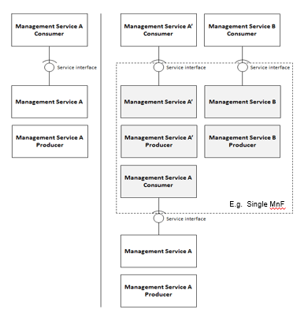

*Figure 4.4.1: Management capability exposure governance applied on exposed Management Service A*

The necessity of exposure governance is also mentioned in S5-222189 clause 4.2 [3], saying that

-----------------------------**extraction begin from S5-222189 clause 4.2 [3]**-----------------------



Figure 4.2.2: Management capability exposure with exposure governance applied

Figure 4.2.2 describes when management service A (MnS A) is exposed as management service A' (MnS A') where the transformation(s) and constraint(s) (limitation) are controlled by the management service C, this means that management service A' consumer (e.g., 3rd party) can only access the capabilities offered by the management service A producer that management service C has configured.

-----------------------------**extraction end from S5-222189 clause 4.2 [3]**-----------------------

In this case, Management service C is consumed for exposure governance.

In the CAPIF-based exposure scenarios described in TR 28.824 clause 7.9, the management capability exposure governance function is missing when exposing MnS to external MnS consumers. Therefore, this contribution proposes to add the exposure governance on management domain in three CAPIF alternatives.

# 4 Detailed proposal

This contribution proposes to make the following changes in [1].

|  |
| --- |
| **1st change** |

## 7.9 Potential solutions for network slice management capability exposure via CAPIF

### 7.9.1 Exposure via CAPIF alternative 1

This clause describes a potential solution where network slice management capability is exposed via the Common API Framework for 3GPP Northbound APIs, see TS 23.222 [14].

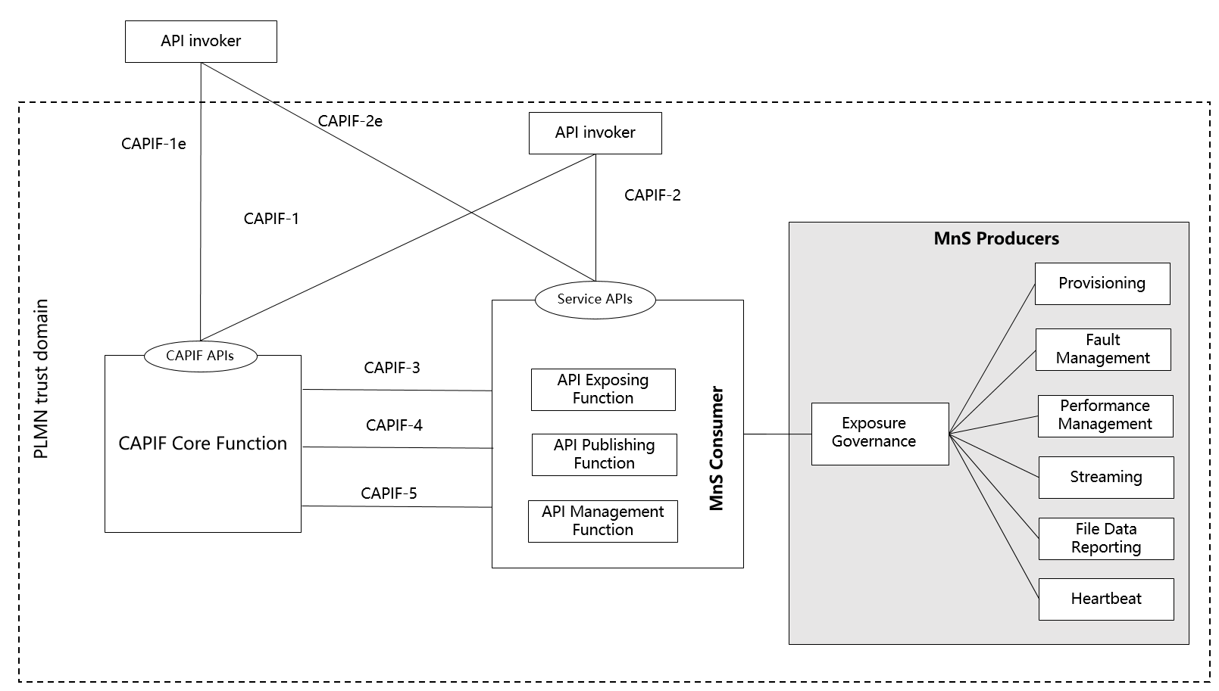

Figure 7.9.1-1: Exposure via CAPIF alternative 1

In this alternative, network slice management capability exposure provides faultMnS, fileDataReportingMnS, heartbeatNtf, perfMnS, provMnS, and streamingDataMnS as specified in TS 28.532 [15]. The exposure governance as described in TS 28.533 clause 4.4 [11] should be applied to these MnS before exposing them to MnS consumer according to MnS producers' policy. The policy for different MnS consumers may vary due to the agreement between management service producers and management service consumers. The MnS can be provided as service APIs as is, after applying relevant exposure governance, to API invoker by API exposing function.

### 7.9.2 Exposure via CAPIF alternative 2

This clause describes a potential solution where network slice management capability exposure is used in conjunction with a CAPIF core function (see TS 23.222 [14]) to expose management services to MnS consumers.

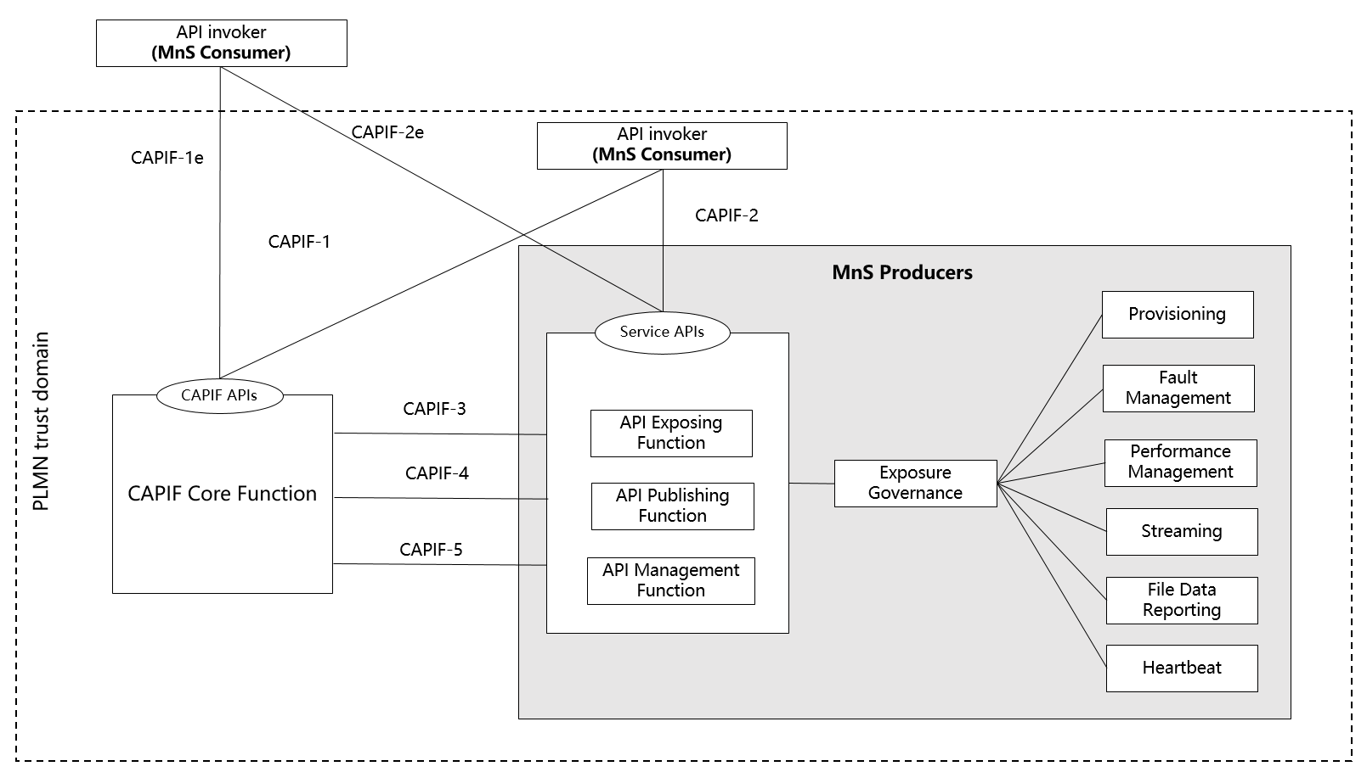

Figure 7.9.2-1: Exposure via CAPIF alternative 2

In this alternative, network slice management capability exposure consumes the interfaces at reference points CAPIF-3, CAPIF-4, and CAPIF-5 as defined in TS 23.222 [14]. It may be necessary to extend CAPIF-3/4/5 as defined in TS 23.222 [14] to support exposure of network slice management services.

Editor’s note: Whether it is necessary to extend CAPIF-3/4/5 for alternative 2 is FFS.

In this alternative, network slice management capability exposure provides the interfaces at reference point CAPIF-2/2e. It may be necessary to extend CAPIF-2/2e as defined in TS 23.222 [14] to support network slice management capability exposure and authentication of MnS consumers. The exposure governance as described in TS 28.533 clause 4.4 [11] should be applied to these MnS before exposing them to MnS consumer according to MnS producers' policy. The policy for different MnS consumers may vary due to the agreement between management service producers and management service consumers. The MnS can be provided as service APIs as is, after applying relevant exposure governance, to API invoker by API exposing function

In this alternative, MnS Consumers utilize the interfaces at reference point CAPIF-1/1e. It may be necessary to extend CAPIF-1/1e as defined in TS 23.222 [14] to support network slice management capability exposure and authorization/authentication of MnS consumers.

Table7.9.2-1 shows the CAPIF interface and the potential MnS that can be implemented within the interface for alternative 2. In addition, extension of CAPIF interface may be needed to achieve certain functionalities in the context of network slice management capability exposure.

**Table 7.9.2-1 Interface description**

|  |  |  |
| --- | --- | --- |
| **Interface** | **Related MnS** | **Gap analysis** |
| CAPIF 1/1e | - Discovery of MnS(s) from MnS registry using ProvMnS Specified in TS 28.622 [17], TS 28.623 [16], and TS 28.532 [15] | - The ServiceAPIDescription for CAPIF_Discover_Service_API needs to be extended in the context of network slice management capability exposure. The MnS address within the MnS data can indicate a dedicated producer for exposing exposed MnS after authentication and authorization.  - Management of MnS consumers includes the management of MnS consumer type and identity. The management of MnS consumer type and identity is for differentiating different access permission for different MnS consumer. |
| CAPIF 2/2e | - Authentication and authorization of MnS consumers is specified in TS 28.533 [11] clause 4.9.  - Service APIs (exposed MnS): faultMnS, fileDataReportingMnS, heartbeatNtf, perfMnS, provMnS, and streamingDataMnS Specifiedin TS 28.532 [15] after being applied with exposure governance as specified in TS 28.533 [11] clause 4.4. |  |
| CAPIF 3 | - Nchf_ConvergedCharging Specified in TS 28.201 [18] and TS 28.202 [6] | Editor’s note: Access control for an MnS consumer, which is enforced by MnS producers is FFS.  - Routing information in CAPIF needs to be extended in the context of network slice management capability exposure. A dedicated producer obtains all the routing information of MnS producers, the routing information contains the address of MnS producers that produce the proper MnS (e.g. faultMnS, PerfMnS, etc). |
| CAPIF 4 | - MnS Registry Specified in TS 28.622 [17] and TS 28.623 [16]. | - The ServiceAPIDescription for CAPIF_Publish_Service_API needs to be extended in the context of network slice management capability exposure. The MnS address within the MnS data can indicate a dedicated producer for exposing exposed MnS after authentication and authorization. |
| CAPIF 5 | - Auditing of the MnS producer is not specified |  |

Editor’s note: Whether the extension of CAPIF-3 regarding routing information is needed for alternative 2 is FFS.

Editor’s note: Whether the extension of CAPIF-4 regarding ServiceAPIDescription is needed for alternative 2 is FFS.

### 7.9.3 Exposure via CAPIF alternative 3

This clause describes a potential solution where network slice management capability exposure implements a Common API Framework for 3GPP Northbound APIs (see TS 23.222 [14]) to expose management services to MnS consumers.

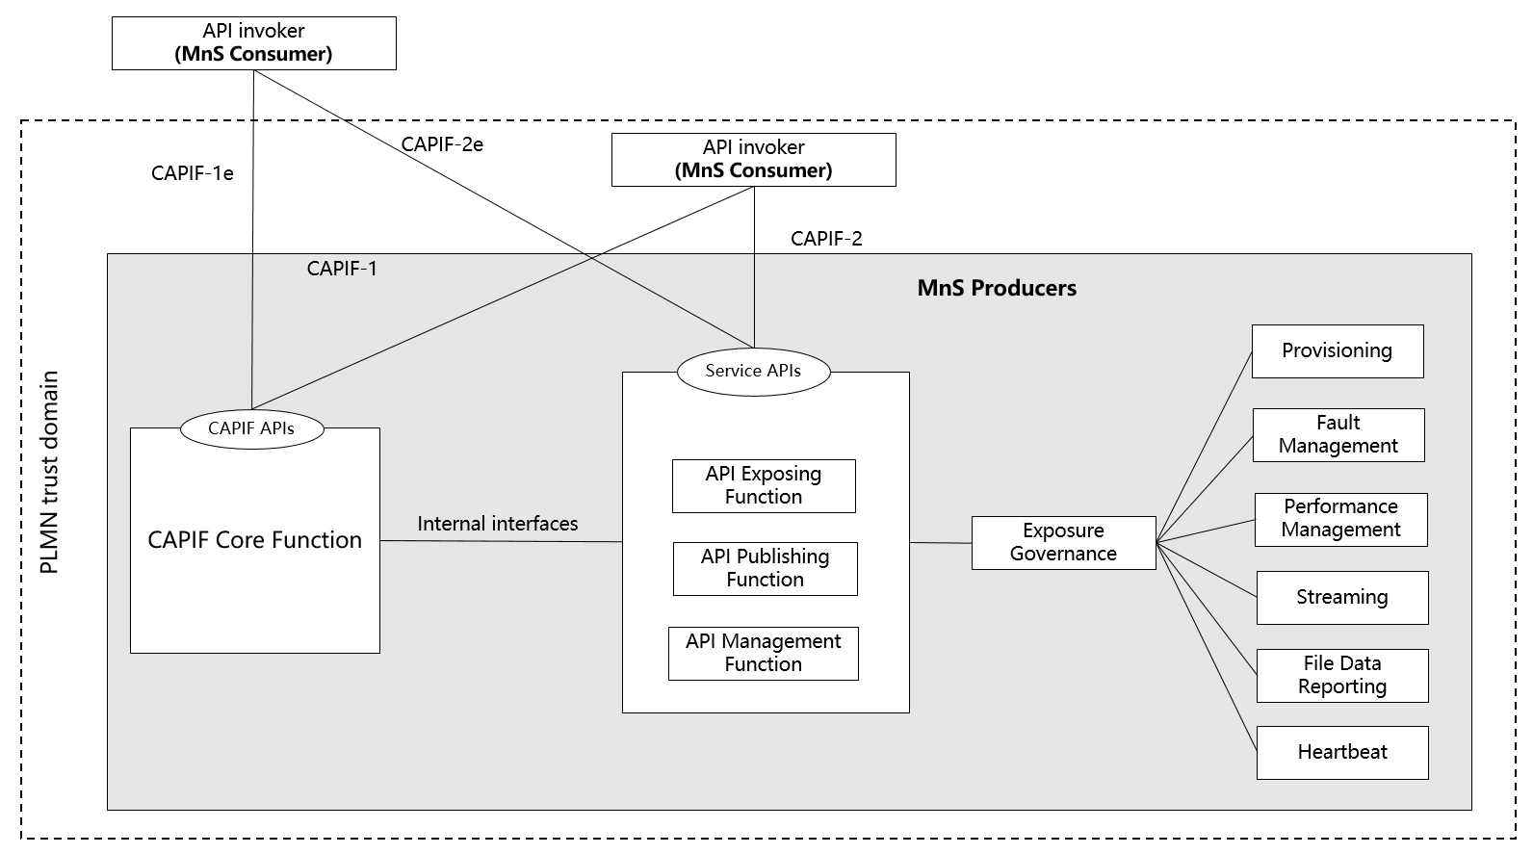

Figure 7.9.3-1: Exposure via CAPIF alternative 3

In this alternative, network slice management capability exposure may internally implement the internal interfaces using reference points CAPIF-3, CAPIF-4, and CAPIF-5 as defined in TS 23.222 [14] or may use non-standardized interfaces.

Editor’s note: Whether it is necessary to extend CAPIF-3/4/5 for alternative 3 is FFS.

In this alternative, network slice management capability exposure provides the interfaces at reference point CAPIF-1/1e. It may be necessary to extend CAPIF-1/1e as defined in TS 23.222 [14] to support authorization/authentication of MnS consumers and discovery of MnS producers.

In this alternative, network slice management capability exposure provides the interfaces at reference point CAPIF-2/2e. It may be necessary to extend CAPIF-2/2e as defined in TS 23.222 [14] to support network slice management capability exposure and authentication of MnS consumers. The exposure governance as described in TS 28.533 clause 4.4 [11] should be applied to these MnS before exposing them to MnS consumer according to MnS producers' policy. The policy for different MnS consumers may vary due to the agreement between management service producers and management service consumers. The MnS can be provided as service APIs as is, after applying relevant exposure governance, to API invoker by API exposing function.

Table7.9.3-1 shows the CAPIF interface and the potential MnS that can be implemented within the interface for alternative 2. In addition, extension of CAPIF interface may be needed to achieve certain functionalities in the context of network slice management capability exposure. Note that in CAPF alternative 3, 4, 5 in alternative 3 are internal interface. However, since external interface may bring impacts on the internal interface. The gap analysis for these interfaces is needed.

**Table 7.9.3-1 Interface description**

|  |  |  |
| --- | --- | --- |
| **Interface** | **Related MnS** | **Gap analysis** |
| CAPIF 1/1e | - Discovery of MnS(s) from MnS registry using ProvMnS Specified in TS 28.622 [17], TS 28.623 [16], and TS 28.532 [15] | - The ServiceAPIDescription for CAPIF_Discover_Service_API needs to be extended in the context of network slice management capability exposure. The MnS address within the MnS data can indicate a dedicated producer for exposing exposed MnS after authentication and authorization.  - Management of MnS consumers includes the management of MnS consumer type and identity. The management of MnS consumer type and identity is for differentiating different access permission for different MnS consumer. |
| CAPIF 2/2e | - Authentication and authorization of MnS consumers is specified in TS 28.533 [11] clause 4.9  - Service APIs (exposed MnS): faultMnS, fileDataReportingMnS, heartbeatNtf, perfMnS, provMnS, and streamingDataMnS Specified in TS 28.532 [15] after being applied with exposure governance as specified in TS 28.533 [11] clause 4.4. |  |
| CAPIF 3 | - Nchf_ConvergedCharging Specified in TS 28.201 [18] and TS 28.202 [6] | Editor’s note: Access control for an MnS consumer, which is enforced by MnS producers is FFS.  - Routing information in CAPIF needs to be extended in the context of network slice management capability exposure. A dedicated producer obtains all the routing information of MnS producers, the routing information contains the address of MnS producers that produce the proper MnS (e.g. faultMnS, PerfMnS, etc). |
| CAPIF 4 | - MnS Registry Specified in TS 28.622 [17] and TS 28.623 [16] | - The ServiceAPIDescription for CAPIF_Publish_Service_API in CAPIF-4 needs to be extended in the context of network slice management capability exposure. The MnS address within the MnS data can indicate a dedicated producer for exposing exposed MnS after authentication and authorization. |
| CAPIF 5 | - Auditing of the MnS producer is not specified |  |

Editor’s note: Whether the extension of CAPIF-3 regarding routing information is needed for alternative 3 is FFS.

Editor’s note: Whether the extension of CAPIF-4 regarding ServiceAPIDescription is needed for alternative 3 is FFS.

|  |
| --- |
| **End of changes** |