3GPP TSG-SA5 Meeting #144-e S5-224047

e-meeting, 27 June - 1 July 2022

Source: Huawei, China Mobile

Title: Add general process of evaluating the autonomous network level

Document for: Approval
Agenda Item: 6.7.2.1

1 Decision/action requested
The group is asked to discuss and approval.

2 References
[1] 3GPP draft TR 28.909: “Management and orchestration; Study on evaluation of autonomous network levels v0.1.0”.

3 Rationale
This contribution proposes to add the general process of evaluating the autonomous network level in Key Issue#2 Generic methodology for autonomous network levels evaluation based on concept for autonomous network level evaluation described in TR 29.909 [1].

4 Detailed proposal
It proposes to make the following changes to TR 28.909 [1].
1st Change

5.2 Key Issue# 2: Generic methodology for autonomous network levels evaluation
Editor's note: this clause will contain the description and potential solutions of generic methodology for quantitatively evaluating the autonomous network levels (evaluation mechanisms for autonomous network levels).

5.2.1 Description

5.2.2 Potential solutions

5.2.2.X Potential process of evaluating the autonomous network level
The general process of evaluating the autonomous network level is illustrated in Fig. 5.2.2.X-1:
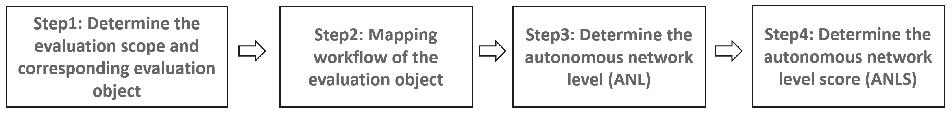
Figure. 5.2.2.X-1 General process of evaluating the autonomous network level
Step 1: Determine the evaluation scope and corresponding evaluation object
The evaluation object can be an autonomous network entire workflow for a selected individual scenario and management scope, so the evaluation object is determined by the dimensions for autonomous network levels evaluation (i.e. scenario, management scope and entire workflow). For example, the evaluation object can be [NR coverage optimization, RAN MnF, network optimization] or [NR throughput optimization, RAN MnF, network optimization].
The evaluation scope is a group of selected evaluation object(s).
Step 2: Mapping workflow of the evaluation object to corresponding standardized tasks of the generic workflow as defined in TS 28.100
In this step the workflow of the evaluation needs to be mapped to the standardized tasks of the generic workflow defined in TS 28.100 [2]. For example, the standardized tasks for generic network optimization is defined in clause 7.1.1 in TS 28.100 [2].
Step 3: Determine the autonomous network level (ANL) for the evaluation object
This step is used to determine the autonomous network level (ANL) based on the generic classification of autonomous network level for the evaluation object. For each task of the workflow, corresponding autonomy capability of the evaluation object needs to be analysed. The autonomous network level for the evaluation object can be determined based on the comparison of autonomy capability for each task and generic classification of autonomous network level defined in TS 28.100 [2].
Step 4: Determine the autonomous network level score (ANLS) for the evaluation object and evaluation scope
This step is used to derive the autonomous network level score (ANLS) for an evaluation object based on ANL derived in Step3 and further evaluation with more evaluation factors considered. Besides, the autonomous network level score for the evaluation scope (i.e. a group of selected evaluation object(s)) can be determined based on the autonomous network level scores for each evaluation object. For example, the autonomous network level for radio network optimization can be determined by all evaluation objects related to radio network optimization, or the autonomous network level for radio network can be determined by all evaluation objects related to all the selected scenario types.
Editor's Note: above process may needs to be updated based on the discussion for ANLS.
End of changes

