3GPP TSG-SA5 Meeting # S5- 224024rev2

June 2022, E-meeting

Source: Nokia

Title: pCR 28.908 Requirements on AIMLEntity Capability Discovery

Document for: Approval

Agenda Item: 6.7.5.1

1 Decision/action requested
The group is asked to discuss and agree on the proposal.

2 References
[1] 3GPP TR 28.908-010 “Study on Artificial Intelligence/Machine Learning (AI/ ML) management”.

3 Rationale
The applicability of the ML-based solutions (e.g., which AI/MLEntities shall be applied and how) for accomplishing specific automaton functionalities is not obvious. Some may need the use of AI/ML orchestration while other don’t. In both cases, management services are required to identify the capabilities of the involved AI/MLEntities and to map those capabilities to the desired automation logic. This pCR adds the UC and potential requirements on AI/ML Capability Discovery and Mapping .

4 Detailed proposal
Start of modification

5 Use cases, potential requirements and possible solutions

5.A AIMLEntity Capability Discovery and Mapping

5.A.1 Description
A network or management function that applies AI/ML to accomplish specific tasks may be considered to have one or more AI/MLEntities each having specific AIML capabilities. The AIML capabilities are either of:
- a decision-making capability which is in the form of triple <x,y,z> indicating
  - x: the object or object types for which the AI/MLEntity can undertake optimization or control
  - y: the configurable attributes on object or object types x, which the AI/MLEntity optimizes or controls to achieve the desired outcomes
  - z: the performance metrics which the AI/MLEntity optimizes through its actions
- an analysis capability which is in the form of tuple <x,z> indicating
  - x: the object or object types for which the AI/MLEntity can undertakes analysis
  - z: the network context (on object x) for which the ML app produces analysis

Different network functions may need to rely on existing AI/ML capabilities to accomplish the desired automation. However, the applicability of the ML-based solutions and the details of such ML-based solutions (i.e., which AI/MLEntities shall be applied and how) for accomplishing those automaton functionalities is not obvious. On a high-level, such ML-based solutions may be categorized into cases with or those without ML orchestration. In both cases, management services are required to identify the capabilities of the involved AI/MLEntities and to map those capabilities to the desired logic.

5.A.2 Use cases

5.A.2.1 Identifying capabilities of AI/MLEntities
Network functions, especially network automation functions, may need to rely on AI/ML capabilities that are not internal to those Network functions to accomplish the desired automation. For example, as stated in TS 28.104, “an MDA Function may optionally be deployed as one or more AI/ML-enabled function(s) in which the relevant models are used for inference per the corresponding MDA capability.” Similarly, owing to the differences in the kinds and complexity of intents that need to be fulfilled, an intent fulfilment solution may need to employ the capabilities of existing AI/ML to fulfil the intents. In any such case, management services are required to identify the capabilities of those existing AI/MLEntities.
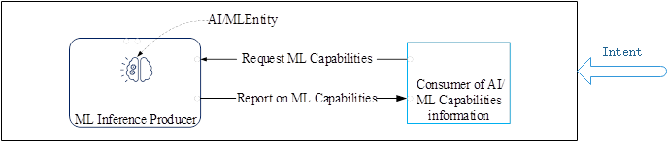
Figure 5.N.1: Request and reporting on AI/ML capabilities

5.A.2.2 Mapping of the capabilities of AI/MLEntities
Besides the discovery of the capabilities of AI/MLEntities, services are needed for mapping the AI/ML capabilities to any available automation logic. In otherwords, instead of the consuming discovering specific capabilities, the consumer may want to know the AI/MLEntities than can be used to achieve a certain outcomes. For this, the producer should be able to inform the consumer of the set of AI/MLEntities that together achieve the consumer's autmomation needs.
In the case of intents for example, the complexity of the stated intents may significantly vary - from simple intents which may be fulfilled with a call to a single AI/MLEntity to complex intents that may require an intricate orchestration of multiple AI/MLEntities. For simple intents, it may be easy to map the execution logic to the one or multiple AI/MLEntities For complex intents, it may be required to employ multiple AI/MLEntities along with a corresponding functionality that manages their inter-related execution . The usage of the the AI/MLEntities requires the awareness of the capabilities of their capabilities and interrelations
Moreover, given the complexity of the required mapping to the multiple AI/MLEntities, services should be supported to provide the mapping given a set of automation logic.

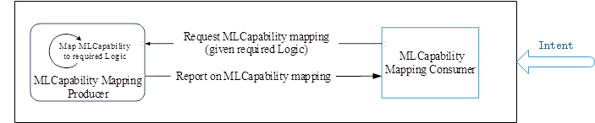
Figure 5.N.2: Mapping logic to AI/ML Capabilities

5.A.3 Potential requirements
REQ-MLCAP-1 The 3GPP Management system should have a capability for an authorized consumer (e.g. an intent fulfillment system) to request the AI/ML MnS Producer or the capabilities of existing AI/MLEntities available within the provider of AI/ML inference.
REQ-MLCAP-2 The AI/ML MnS Producer shall have a capability to report to an authorized consumer the capabilities of an AI/MLEntity as a decision described as a triplet <object(s), parameters, metrics> with the entries respectively indicating : the object or object types for which the AI/MLEntity can undertake optimization or control; the configuration parameters on the stated object or object types, which the ML app optimizes or controls to achieve the desired outcomes; and the network metrics which the ML app optimizes through its actions.
REQ-MLCAP-3 The AI/ML MnS Producer shall have a capability to report to an authorized consumer the capabilities of an AI/MLEntity as an analysis described as a tuple <object(s), characteristics> with the entries respectively indicating : the object or object types for which the ML app can undertake analysis; and the network characteristics (related to the stated object or object types) for which the ML app produces analysis.

5.A.4 Possible solutions

TBD

End of modifications

