3GPP TSG SA WG5 Meeting 142-e S5-222542rev1

e-meeting, 4 - 12 April 2022

Source: Ericsson

Title: Discussion on enhanced QoS model

Document for: Approval
Agenda Item: 6.3

1 Decision/action requested
The group is asked to discuss and endorse the proposal.

2 References
[1] 3GPP TS 28.541: " Management and orchestration; 5G Network Resource Model (NRM); Stage 2 and stage 3"

3 Rationale
This TD proposes enhancements to the QoS model involving additions to the GNBCUCPFunction, GNBCUUPFunction and GNBDUFunction.

Observation 1
The current NRM in [1] does not define a QoS model for the GNBDUFunction, which is needed in a split architecture deployment scenario.

Observation 2
In the NRM in [1] there are currently two options to model the QoS classes, either contained by the ManagedElement IOC or contained by the Subnetwork IOC. A third option is missing, to make the QoS classes contained by the NG-RAN managed functions, i.e., GNBCUCPFunction, GNBCUUPFunction and GNBDUFunction. Such option has potential advantage for Multi-RAT and Shared Networks, where such CM separation could enhance data isolation and access control by containing the sets directly within the managed functions instead of outside them.

Figure 4.2.1.1-8: NRM fragment for pre-configured 5QIs in NG-RAN in [1]

Observation 3
The DRB configurations for RLC and PDCP may vary depending on the 5QI and the associated service. However, this is not covered by the current NRM in [1] and should be added.

4 Detailed proposals

Proposal 1
Based on observation 1 and observation 2, add the option to name contain the Configurable5QISet IOC by the ManagedFunction IOC.

1st Change

4.2.1 Class diagram for gNB and en-gNB

4.2.1.1 Relationships

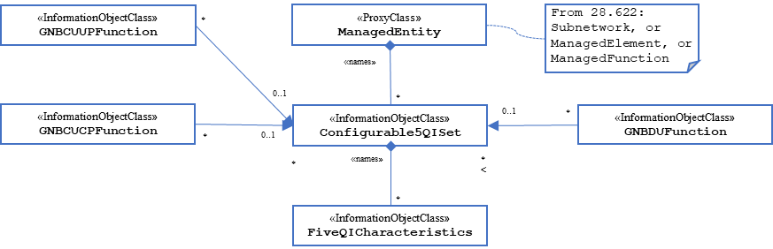
Figure 4.2.1.1-8: NRM fragment for pre-configured 5QIs in NG-RAN

2nd Change

4.3.1 GNBDUFunction

4.3.1.1 Definition
For non-split NG-RAN deployment scenario, this IOC together with GNBCUCPFunction IOC and GNBCUUPFunction IOC provide the management of gNB defined in clause 6.1.1 in 3GPP TS 38.401 [4].
For 2-split and 3-split NG-RAN architecture, this IOC provides the management representation of gNB-DU defined in clause 6.1.1 in 3GPP TS 38.401 [4].
The following table identifies the necessary end points required for the representation of gNB and en-gNB, of all deployment scenarios.

Req  Role | End point requirement for 3-split deployment scenario | End point requirement for 2-split deployment scenario | End point requirement for Non-split deployment scenario
gNB | <<IOC>>EP_F1C, <<IOC>>EP_F1U | <<IOC>>EP_F1C, <<IOC>>EP_F1U | None.
en-gNB | <<IOC>>EP_F1C, <<IOC>>EP_F1U | <<IOC>>EP_F1C, <<IOC>>EP_F1U | None.

4.3.1.2 Attributes
The GNBDUFunction IOC includes attributes inherited from ManagedFunction IOC (defined in TS 28.622[30]) and the following attributes:

Attribute name | Support Qualifier | isReadable | isWritable | isInvariant | isNotifyable
gNBDUId | M | T | T | F | T
gNBDUName | O | T | T | F | T
gNBId | M | T | T | F | T
gNBIdLength | M | T | T | F | T
rimRSReportConf | O | T | F | T | T
Attribute related to role
configurable5QISetRef | O | T | T | F | T
dynamic5QISetRef | O | T | F | F | T

4.3.1.3 Attribute constraints
None.

4.3.1.4 Notifications
The common notifications defined in subclause 4.5 are valid for this IOC, without exceptions or additions.
Proposal 2
Based on observation 3, add the DRB configuration properties for RLC as part of the GNBDUFunction and PDCP as part of the GNBCUCPFunction.
New IOCs UeCC IOC, PacketDataControlIOC and RadioLinkControl IOC are proposed to contain this data.

3rd Change

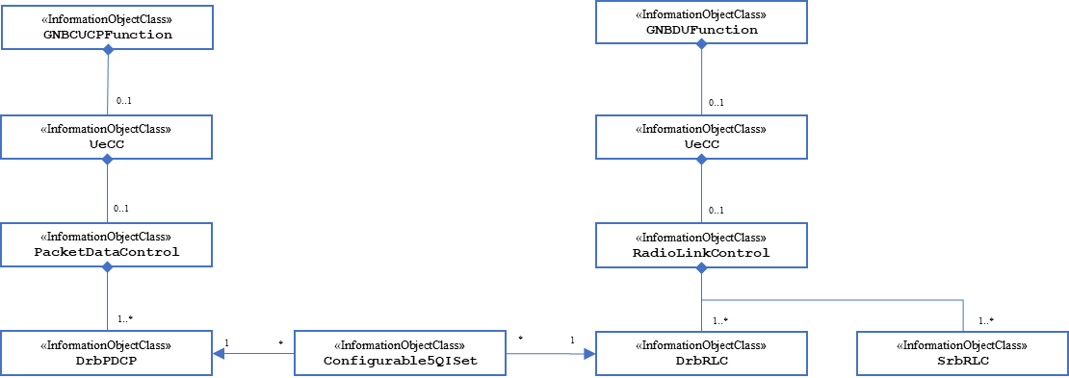
Figure 4.2.1.1-8: NRM fragment for DRB Configuration for RLC

4th Change

4.3.x UeCC

4.3.x.1 Definition
This IOC specifies the UE connection control related configuration via a container for extension to define 5QI specific DRB configuration for RLC and PDCP.

4.3.x.2 Attributes
The UeCC IOC includes attributes inherited from Top IOC (defined in 3GPP TS 28.622[33])

4.3.x.3 Attribute constraints
The Id of this MO must be UeCC=1 and created automatically when parent MO is created, unless created manually in same transaction as parent MO. MO instance UeCC=1 cannot be deleted unless parent MO is deleted.

4.3.x.4 Notifications
The common notifications defined in subclause 4.5 in 3GPP 28.541[27][27] are valid for this IOC, without exceptions or additions.

5th Change

4.3.x PacketDataControl

4.3.x.1 Definition
This IOC specifies the packet data control related configuration.

4.3.x.2 Attributes
The PacketDataControl IOC includes attributes inherited from Top IOC (defined in 3GPP TS 28.622[33]).

4.3.x.3 Attribute constraints

4.3.x.4 Notifications

6th Change

4.3.x RadioLinkControl

4.3.x.1 Definition
This IOC specifies the UE radio related configuration.

4.3.x.2 Attributes
The PacketDataControl IOC includes attributes inherited from Top IOC (defined in 3GPP TS 28.622[33]).

4.3.x.3 Attribute constraints
4.3.x.4 Notifications

7th Change

4.3.x SRBRLC

4.3.x.1 Definition
This IOC specifies the Specifies the SRB (Signaling Radio Bearer) related configuration, as defined in 3GPP TS 38.322 and TS 38.331.

4.3.x.2 Attributes
The SRBRLC IOC includes attributes inherited from Top IOC (defined in 3GPP TS 28.622[33]).
The SrbRLC IOC includes attributes inherited from Top IOC (3GPP TS 28.622[33] and RadioLinkControl and also includes below,
Attribute name | Support Qualifier | isReadable | isWritable | isInvariant | isNotifyable
tPollRetransmitDl | O | T | T | F | T
tPollRetransmitUl | O | T | T | F | T
tReassemblyDl | O | T | T | F | T
tReassemblyUl | O | T | T | F | T
dlMaxRetxThreshold | O | T | T | F | T
ulMaxRetxThreshold | O | T | T | F | T
tStatusProhibitDl | O | T | T | F | T
tStatusProhibitUl | O | T | T | F | T
dlPollPdu | O | T | T | F | T
ulPollPdu | O | T | T | F | T
dlPollByte | O | T | T | F | T
ulPollByte | O | T | T | F | T
amSNLengthUl | O | T | T | F | T
umSNLengthUl | O | T | T | F | T
amSNLengthDl | O | T | T | F | T
umSNLengthDl | O | T | T | F | T

4.3.x.3 Attribute constraints
4.3.x.4 Notifications

8th Change

4.3.x DRBRLC

4.3.x.1 Definition
This IOC specifies the Specifies the DRB (Data Radio Bearer) related configuration. DRB defined in 3GPP TS 38.322 and TS 38.331.
4.3.x.2 Attributes
The DRBRLC IOC includes attributes inherited from Top IOC (defined in 3GPP TS 28.622[33]).
The DrbRLC IOC includes attributes inherited from Top IOC (3GPP TS 28.622[33] and RadioLinkControl and also includes below,
Attribute name | Support Qualifier | isReadable | isWritable | isInvariant | isNotifyable
dlPollPdu | O | T | T | F | T
ulPollPdu | O | T | T | F | T
tPollRetransmitDl | O | T | T | F | T
tPollRetransmitUl | O | T | T | F | T
tReassemblyDl | O | T | T | F | T
tReassemblyUl | O | T | T | F | T
tStatusProhibitDl | O | T | T | F | T
tStatusProhibitUl | O | T | T | F | T
dlMaxRetxThreshold | O | T | T | F | T
ulMaxRetxThreshold | O | T | T | F | T
amSNLengthUl | O | T | T | F | T
umSNLengthUl | O | T | T | F | T
amSNLengthDl | O | T | T | F | T
umSNLengthDl | O | T | T | F | T

4.3.x.3 Attribute constraints
4.3.x.4 Notifications

9th Change

4.3.x DrbPDCP

4.3.x.1 Definition
This IOC specifies the Specifies the DRB (Data Radio Bearer) PDCP related configuration.
4.3.x.2 Attributes
The DrbPDCP IOC includes attributes inherited from Top IOC (defined in 3GPP TS 28.622[33]).
The DrbPDCP IOC includes attributes inherited from Top IOC (3GPP TS 28.622[33] and PacketDataControl and also includes below,
Attribute name | Support Qualifier | isReadable | isWritable | isInvariant | isNotifyable
tPdcpDiscard | O | T | T | F | T
pdcpSnSize | O | T | T | F | T
tReorderingUl | O | T | T | F | T
tReorderingDl | O | T | T | F | T
rlcMode | O | T | T | F | T

4.3.x.3 Attribute constraints
4.3.x.4 Notifications

