3GPP TSG-SA5 Meeting #142-e S5-222463rev2

e-meeting, 4 - 12 April 2022

Source: Huawei

Title: pCR TS 28.104 MDARequest IOC NRM correction

Document for: Approval
Agenda Item: 6.6.5

1 Decision/action requested
This contribution is for approval.

2 References
[1] 3GPP TS 28.104 Management and orchestration; Management Data Analytics (MDA)

3 Rationale
There is also an FFS in the current TS 28.104 [1] in Figure 9.2.1-1 states that “The allowedValue of Proxy Entity is FFS”. Since the MDA analysis can be in a specific area, that means, MDARequest could be created in the subnetwork. This pCR is proposed to making the MDARequest IOC contained by the subnetwork.

4 Detailed proposal
It is proposed to add the following chapter in TS 28.104[1].
1st Change

9.1 Imported and associated information entities

9.1.1 Imported information entities and local labels
Label reference | Local label
TS 28.622 [16], IOC, SubNetwork | SubNetwork
TS 28.622 [19], IOC, ManagedElement | ManagedElement
TS 28.622 [19], IOC, ManagedFunction | ManagedFunction

Next Change

9.2 Class diagram

9.2.1 Relationships
This clause provides the relationships of relevant classes in UML.

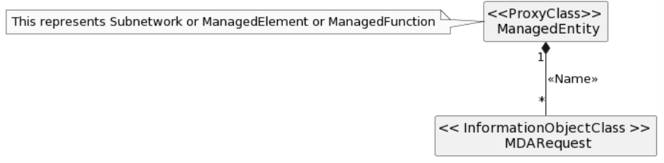
Figure 9.2.1-1: NRM fragment for MDA Request

End of changes

