**3GPP TSG-SA5 Meeting #142-e *S5-222354***

**e-meeting, 4 - 12 April** **2022**

**Source: Huawei**

**Title: pCR TR 28.925 Add issue on the applicable content from TS 32.101 section 7**

**Document for: Approval**

**Agenda Item: 6.5.8**

# 1 Decision/action requested

***Discuss and approve on the proposal.***

# 2 References

[1] 3GPP TR 28.925 enhancement of service based management architecture v0.4.0

# 3 Rationale

There are descriptions on management functions in TS 32.101. Some of the management functions are still valid in SBMA and there are also some enhanced features provided in SBMA. Some analysis needs to be done to check whether the content in section 7 of TS 32.101 could be applicable to service based archietecture. It’s useful to elaborate the overall management functions description in TS 28.533 with taking into account of the description in TS 32.101.

It is proposed to add solutions to add a issue in TR 28.925 [1].

=====================Extract from TS 32.101 start=====================

## 7.1 TM architectural aspects

The basic aspects of a TM architecture, which can be, considered when planning and designing a TM are:

- the functional architecture;

- the information architecture;

- the physical architecture.

The management requirements from the business needs are the base for the functional architecture, which describe the functions that have to be achieved. The information architecture defines what information that has to be provided so the functions defined in the functional architecture can be achieved. The physical architecture has to meet both the functional architecture and the information architectures. These relationships are shown in figure 5.

The present document addresses the functional architecture. The physical architecture is addressed in TS 32.102 [101].



Figure 4: Architectural relationship

Allmanagement processes have functions in several management areas. By identifying only those processes and interfaces relating to a certain management function, for example performance management, it is possible to take a slice through the Enhanced Telecom Operations Map that details the functional architecture for performance management, this will be the approach taken by the present document.

The management functions are:

- Performance management;

- Roaming management;

- Fraud management;

- Fault management;

- Security management;

- Software management

- Configuration management;

- Accounting management;

- Subscription management;

- Quality of Service (QoS) management (see informative annex D);

- User equipment management.

The 3GPP IRP methodology focuses on providing the definitions for the O&M operations and notifications needed to support the business requirements provided by the eTOM framework for such management functions.

=====================Extract from TS 32.101 end=====================

# 4 Detailed proposal

This document proposes the following changes in TR 28.925 [1].

|  |
| --- |
| **1st Change** |

## 4.x Issue #X:

### 4.x.1 Description

The following information is documented in TS 32.101 to describe the TMN architecture aspects and the management functions.

### 

Analysis:

1. TS 32.101 defines the management principles and high-level requirements for the management of PLMNs. Some descriptions in corresponding area in clause 7 of TS 32.101 can be improved and used for SBMA.



2. The following management features are captured in annex of TS 28.533, as follows.

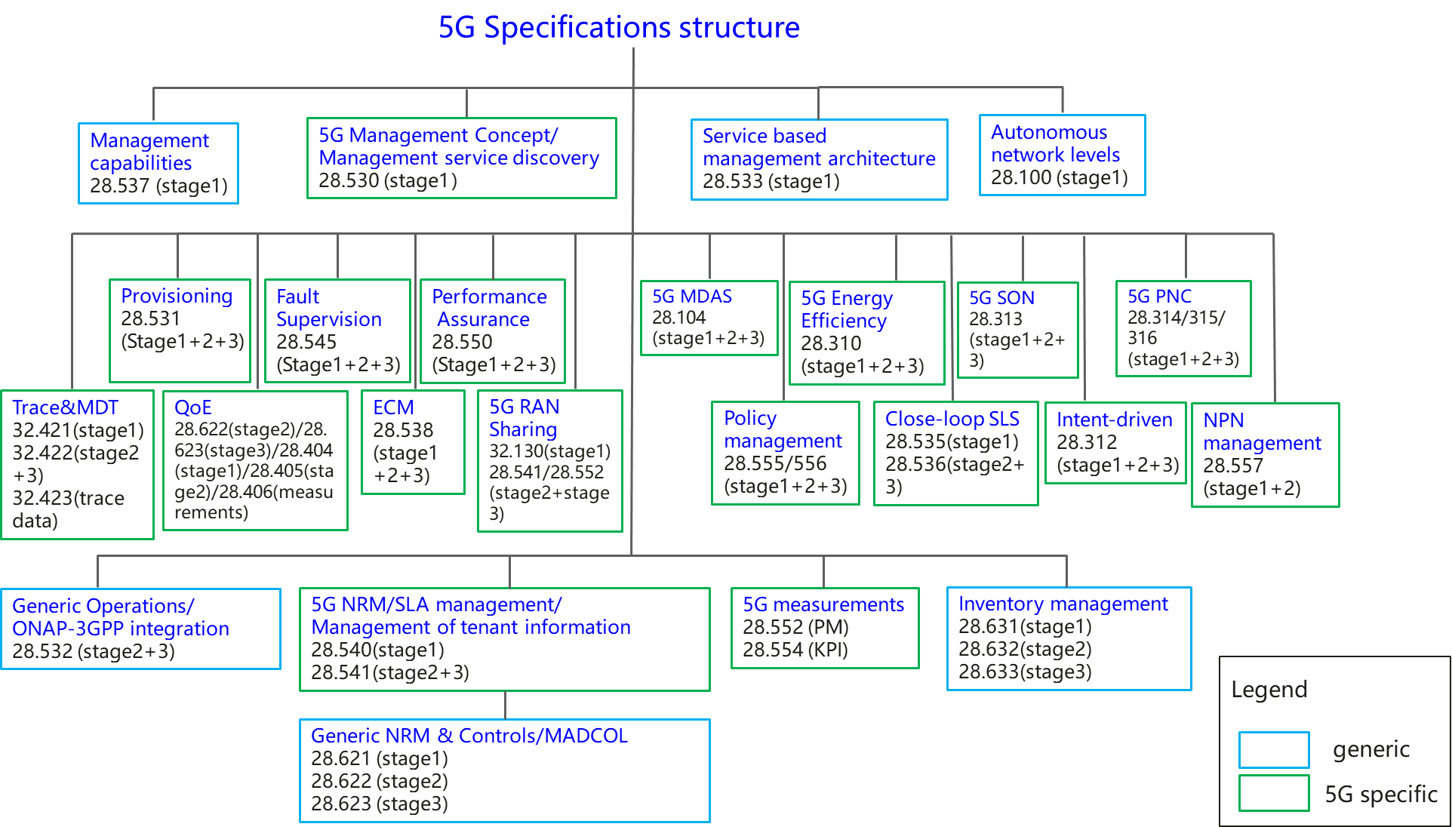

**Figure x: Overview of 5G management specifications**

The related management features description in TS 28.533[2] are limited compared with the management functions description in TS 32.101[1].

### 4.x.2 Potential solutions

Elaborate the management functional overviews in TS 28.533 with taking into account of the management function description information in TS 32.101 section 7.

|  |
| --- |
| **End of change** |