**3GPP TSG-SA5 Meeting #142-eS5-222327**

**e-meeting, 4 - 12 April 2022**

**Source: Huawei**

**Title: pCR 28.824 Describe possible solution for EGMF**

**Document for: Approval**

**Agenda Item: 6.5.22**

# 1 Decision/action requested

***For approval***

# 2 References

[1] 3GPP TR 28.824 V0.5.0 Study on network slice management capability exposure

# 3 Rationale

This contribution describes potential solutions where network slice management capability is exposed via the Common API Framework for 3GPP Northbound APIs.

TS 23.222 Annex B.0 describes how a service API provider may use the Common API Framework (CAPIF).



Figure 3-1: Functional model for the CAPIF

# 4 Detailed proposal

This contribution proposes to make the following changes in [1].

|  |
| --- |
| **1st change** |

# 2 References

The following documents contain provisions which, through reference in this text, constitute provisions of the present document.

- References are either specific (identified by date of publication, edition number, version number, etc.) or non‑specific.

- For a specific reference, subsequent revisions do not apply.

- For a non-specific reference, the latest version applies. In the case of a reference to a 3GPP document (including a GSM document), a non-specific reference implicitly refers to the latest version of that document *in the same Release as the present document*.

[1] 3GPP TR 21.905: "Vocabulary for 3GPP Specifications".

[2] TM Forum TMF622 Product Order API REST Specification

[3] TM Forum TMF641 Service Ordering API

[4] TM Forum TMF652 Resource Order Management API

[5] 3GPP TS 28.531: "Management and orchestration; Concepts, use cases and requirements"

[6] 3GPP TS 28.202: "Charging management; Network slice management charging in the 5G System (5GS); Stage 2"

[7] 3GPP TR23.700-99 “Study on Network Slice Capability Exposure for Application Layer Enablement (NSCALE)”

[8] 3GPP TS23.434 “Service Enabler Architecture Layer for Verticals (SEAL); Functional architecture and information flows.”

[9] 3GPP TS 28.541: "Management and orchestration; 5G Network Resource Model (NRM); Stage 2 and stage 3"

[10] 3GPP TS 28.537: "Management and orchestration; Management capabilities"

[11] 3GPP TS 28.533: "Management and orchestration; Architecture framework"

[12] TM Forum TMF633 Service Catalogue Management API

[13] TM Forum TMF620 Product Catalogue Management API

[x1] 3GPP TS 23.222: "Functional architecture and information flows to support Common API Framework for 3GPP Northbound APIs; Stage 2"

[x2] 3GPP TS 28.532: "Management and orchestration; Generic Management Service"

[x3] 3GPP TS 28.623: "Telecommunication management; Generic Network Resource Model (NRM) Integration Reference Point (IRP); Solution Set (SS) definitions"

[x4] 3GPP TS 28.622: " Telecommunication management; Generic Network Resource Model (NRM) Integration Reference Point (IRP) Information Service (IS)"

[x5] 3GPP TS 28.201: "Charging management; Network slice performance and analytics charging in the 5G System (5GS); Stage 2"

|  |
| --- |
| **2nd change** |

## 7.x Potential solutions for network slice management capability exposure via CAPIF

### 7.x.1 Exposure via CAPIF alternative 1

This clause describes a potential solution where network slice management capability is exposed via the Common API Framework for 3GPP Northbound APIs, see TS 23.222[x1].

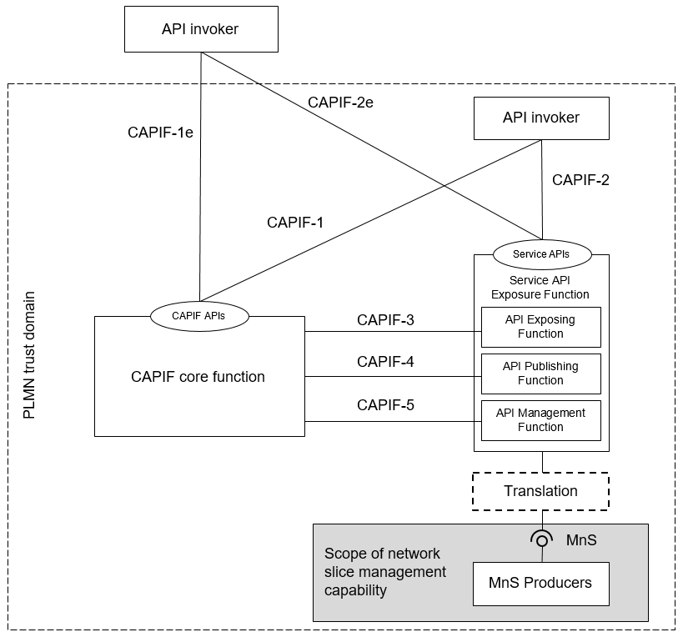

Figure 7.x.1-1: Exposure via CAPIF alternative 1

In this alternative, network slice management capability is used in conjunction with a Service API Exposure Function and a CAPIF core function to expose APIs to API invokers. Optionally, service translation may be possible between the management service and the Service API Exposure Function.

In this alternative, the scope of network slice management includes specification of the following interfaces:

|  |  |  |
| --- | --- | --- |
| **Interface** | **Exposed services** | **Supported by MnS** |
| MnS | - Fault management, File data reporting, Heartbeat, Performance management, Povisioning, Streaming. | - Service APIs (MnS): faultMnS, fileDataReportingMnS, heartbeatNtf, perfMnS, provMnS, and streamingDataMnS Specified in in TS 28.532 [x2] |

### 7.x.2 Exposure via CAPIF alternative 2

This clause describes a potential solution where network slice management capability is exposed via the Common API Framework for 3GPP Northbound APIs, see TS 23.222[x1].

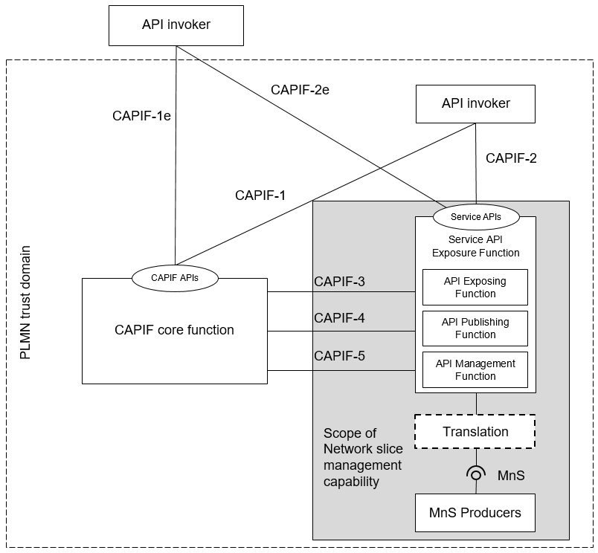

Figure 7.x.2-1: Exposure via CAPIF alternative 2

In this alternative, network slice management capability is used in conjunction with a CAPIF core function to expose APIs to API invokers. Network slice management capability includes a Service API Exposure Function. Optionally, service translation may be possible between the management service and the Service API Exposure Function.

In this alternative, the scope of network slice management includes specification of the following interfaces:

|  |  |  |
| --- | --- | --- |
| **Interface** | **Exposed services** | **Supported by MnS** |
| CAPIF 1/1e | - CAPIF_Discover_Service_API  - CAPIF_Events_API  - CAPIF_API_Invoker_Management_API  - CAPIF_Security_API  Specified in TS 29.222 [11] | - Discovery of MnS(s) from MnS registry using ProvMnS Specified in TS 28.622 [x4], TS 28.623 [x3], and TS 28.532 [x2]  - MnS consumer management is not specified |
| CAPIF 2/2e | - AEF_Security_API Specified in TS 29.222 [11]  - Service APIs: (Fault management, File data reporting, Heartbeat, Performance management, Povisioning, Streaming) | - Authentication and authorization of MnS consumers is specified in TS 28.533 [11] clause 4.9  - Service APIs (MnS): faultMnS, fileDataReportingMnS, heartbeatNtf, perfMnS, provMnS, and streamingDataMnS Specified in in TS 28.532 [x2] |
| CAPIF 3 | - CAPIF_Events_API  - CAPIF_Security_API  - CAPIF_Logging_API_Invocation_API  - CAPIF_Access_Control_Policy_API  - CAPIF_Routing_Info_API  Specified in TS 29.222 [11]  - Nchf_ConvergedCharging Specified in TS 32.254 [13] | - Access control for an MnS consumers by an MnS producer is not specified  - Routing of an MnS consumers request by an MnS producer is not specified  - Nchf_ConvergedCharging Specified in TS 28.201 [x5] and TS 28.202 [5] |
| CAPIF 4 | - CAPIF_Events_API  - CAPIF_Publish_Service_API  Specified in TS 29.222 [11] | - Registration of MnS by an MnS producer Specified in TS 28.622 [x4] and TS 28.623 [x3] |
| CAPIF 5 | - CAPIF_Events_API  - CAPIF_Monitoring_API  - CAPIF_Auditing_API  - CAPIF_API_Provider_Management_API  Specified in TS 29.222 [11] | - Management of MnS consumers is not specified  - Auditing of the MnS producer is not specified |

### 7.x.3 Exposure via CAPIF alternative 3

This clause describes a potential solution where network slice management capability is exposed via the Common API Framework for 3GPP Northbound APIs, see TS 23.222[x1].

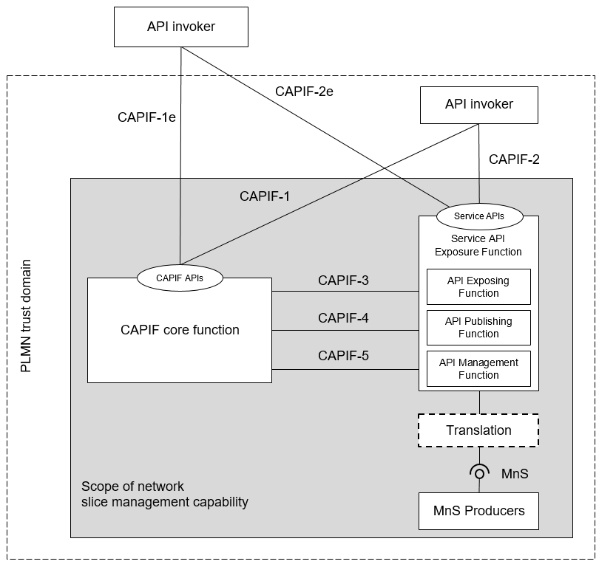

Figure 7.x.3-1: Exposure via CAPIF alternative 3

In this alternative, network slice management capability exposes APIs to API invokers. Network slice management capability includes a Service API Exposure Function and CAPIF core function. Optionally, service translation may be possible between the management service and the Service API Exposure Function.

In this alternative, the scope of network slice management includes specification of the following interfaces:

|  |  |  |
| --- | --- | --- |
| **Interface** | **Exposed services** | **Supported by MnS** |
| CAPIF 1/1e | - CAPIF_Discover_Service_API  - CAPIF_Events_API  - CAPIF_API_Invoker_Management_API  - CAPIF_Security_API  Specified in TS 29.222 [11] | - Discovery of MnS(s) from MnS registry using ProvMnS Specified in TS 28.622 [x4], TS 28.623 [x3], and TS 28.532 [x2]  - MnS consumer management is not specified |
| CAPIF 2/2e | - AEF_Security_API Specified in TS 29.222 [11]  - Service APIs: (Fault management, File data reporting, Heartbeat, Performance management, Povisioning, Streaming) | - Authentication and authorization of MnS consumers is specified in TS 28.533 [11] clause 4.9  - Service APIs (MnS): faultMnS, fileDataReportingMnS, heartbeatNtf, perfMnS, provMnS, and streamingDataMnS Specified in in TS 28.532 [x2] |

|  |
| --- |
| **End of changes** |