**3GPP TSG-SA5 Meeting #142-e *S5-222125***

**e-meeting, 4 - 12 April 2022**

**Source: China Mobile, Huawei**

**Title: pCR 28.909 Add concept description for autonomous network level evaluation**

**Document for: approval**

**Agenda Item: 6.5.2**

# 1 Decision/action requested

***The group is asked to discuss and approval.***

# 2 References

[1] 3GPP draft TR 28.909: “Management and orchestration; Study on evaluation of autonomous network levels v0.0.0”.

[2] SP-211445 "New Study on evaluation of autonomous network levels"

[3] 3GPP TS 28.100 "Management and orchestration; Levels of autonomous network"

# 3 Rationale

Based on the objectives in SP-211445[2] and autonomous network level definition in TS 28.100, it proposes to add description for autonomous network level evaluation and key effectiveness indicator.

TS 28.100 [3] already provide a framework approach for evaluating autonomous network levels and generic requirements for autonomous network levels, which can be used as qualitative evaluation approach of autonomous network levels. This qualitative evaluation approach describes the level (range) of autonomy capabilities of the telecom system for individual scenario with certain management scope. Following aspects haven't be considered:

* Different telecom systems with different autonomy capabilities but belong to same autonomous network level.
* Different telecom systems belonging to same autonomous network level but have different effect by introducing such autonomy capabilities. For example, telecom system A takes one day to optimize the radio network and obtain the 10% coverage performance gains, wherever, telecom system B takes one hour to optimize the radio network and obtain the 20% coverage performance gains.

# 4 Detailed proposal

It proposes to make the following changes to TR 28.909[1].

|  |
| --- |
| **1st Change** |

# 2 References

The following documents contain provisions which, through reference in this text, constitute provisions of the present document.

- References are either specific (identified by date of publication, edition number, version number, etc.) or non‑specific.

- For a specific reference, subsequent revisions do not apply.

- For a non-specific reference, the latest version applies. In the case of a reference to a 3GPP document (including a GSM document), a non-specific reference implicitly refers to the latest version of that document *in the same Release as the present document*.

[1] 3GPP TR 21.905: "Vocabulary for 3GPP Specifications".

[X] 3GPP TS 28.100 "Management and orchestration; Levels of autonomous network"

|  |
| --- |
| **2nd Change** |

## 4.X Concept for autonomous network level evaluation

### 4.X.1 Introduction

Autonomous network level evaluation describes an approach for evaluating the autonomy capability of the autonomous network, which includes qualitative description evaluation and quantitative evaluation.

### 4.X.1 Autonomous network level qualitative evaluation

TS 28.100 [X] provides an approach for evaluating autonomous network levels based on the qualitative description of the autonomy capability (participation of the human and telecom system) for each task in the entire workflow, which is used for evaluating the autonomy capability of telecom system for individual scenario with certain management scope. Such evaluation approach is a qualitative evaluation approach for the autonomy capability of the telecom system, and the evaluation result can be Level 1, Level 2, Level 3, Level 4 and Level 5. For example, if RAN MnF implemented the following autonomy capability for radio coverage optimization, the qualitative evaluation result is level 2 (see the Figure 4.X.1-1) based on the generic classification of autonomous network level for network optimization in clause 7.1.2 in TS 28.100 [X].

* Task C (Coverage related information collection), Task D (Coverage issues identification), Task F (Coverage issues demarcation) and Task G (Coverage issue root cause analysis) are accomplished by RAN MnF with human specified control information;
* Task J (Coverage adjustment solutions execution) is fully accomplished by RAN MnF
* Other Tasks are accomplished by Human.

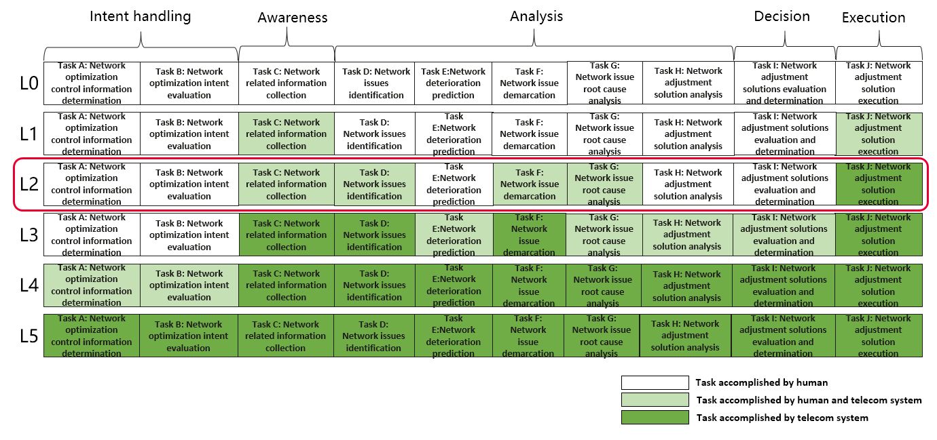

Figure 4.X.1-1 Example of Autonomous network level qualitative evaluation result

## 4.X.2 Autonomous network level quantitative evaluation

In order to further differentiate different telecom systems with different autonomy capabilities but belong to same autonomous network level (result of qualitative evaluation), a quantitative evaluation approach needs to be introduced. The quantitative evaluation approach is used to derive the concrete autonomous network level score (ANLS) by considering more evaluation factors. The Autonomous network level score is derived based on the autonomous network level (derived from the qualitative evaluation) and further quantitative evaluation. The quantitative evaluation can be used to evaluate the autonomy capabilities for individual scenario scenarios and/or management scope, as well as the whole telecom system for all scenarios.

## 4.X.3 Key effectiveness indicator

Key effectiveness indicator (KEI) describes the effective of introducing autonomy capability into telecom system. Existing KPIs and measurements could be used to evaluate the performance of the network, but it is not sufficient to reflect the effect from autonomous management and control perspective. Key effectiveness indicators could be used to help the NOPs to understand what benefits from autonomous management and control perspective they could get from upgrading their telecom system with more autonomy capabilities.

|  |
| --- |
| **End of Changes** |