3GPP TSG-SA5 Meeting #142-e S5-222057

Online, , 4 - 12 April 2022
CR-Form-v12.1
CHANGE REQUEST
 | 28.533 | CR | draftCR | rev | - | Current version: | 17.2.0
For HELP on using this form: comprehensive instructions can be found at
http://www.3gpp.org/Change-Requests.

Proposed change affects: | UICC apps |  | ME |  | Radio Access Network | X | Core Network | X

Title: | Rel-17 28.533 enhancement to support access control
Source to WG: | Nokia, Nokia Shanghai Bell
Source to TSG: | S5
Work item code: | MSAC |  |  |  |  |  | Date: |  |  | 2022-01-06
Category: | B |  |  |  |  |  | Release: |  |  | Rel-17
 | Use one of the following categories:  F (correction)  A (mirror corresponding to a change in an earlier release)  B (addition of feature),  C (functional modification of feature)  D (editorial modification)  Detailed explanations of the above categories can  be found in 3GPP TR 21.900. |  |  |  |  |  |  |  | Use one of the following releases:  Rel-8 (Release 8)  Rel-9 (Release 9)  Rel-10 (Release 10)  Rel-11 (Release 11)  …  Rel-15 (Release 15)  Rel-16 (Release 16)  Rel-17 (Release 17)  Rel-18 (Release 18)
Reason for change: |  | According to discussion paper (S5-215226) and requirements related to access control. The Access control workflow in D.1, especially the procedure of requesting access token, there is unclarify regarding how the resource related to the access token is used in the interface. Also in preconditions, access right provisioning lacks clarity when a new MOI created or an exising MOI deleted, etc.
Summary of change: |  | Add the resource in procedure of D.1 workflow and add a new informative Annex for better understanding of the preconditions
Consequences if not approved: |  | No standardized way for access control on management service of 3GPP management system, that may cause interoperability issue once security feature is enabled.
Clauses affected: |  | 2, D.1, Annex X(new)
 |  | Y | N
Other specs |  |  | X | Other core specifications |  |  |  | TS/TR ... CR ...
affected: |  |  | X | Test specifications |  |  |  | TS/TR ... CR ...
(show related CRs) |  |  | X | O&M Specifications |  |  |  | TS/TR ... CR ...
Other comments:
This CR's revision history:

Start of Change

2 References
The following documents contain provisions which, through reference in this text, constitute provisions of the present document.
- References are either specific (identified by date of publication, edition number, version number, etc.) or non-specific.
- For a specific reference, subsequent revisions do not apply.
- For a non-specific reference, the latest version applies. In the case of a reference to a 3GPP document (including a GSM document), a non-specific reference implicitly refers to the latest version of that document in the same Release as the present document.
[1] 3GPP TR 21.905: "Vocabulary for 3GPP Specifications".
[2] Void
[3] 3GPP TS 28.530: "Management and orchestration of networks and network slicing; Concepts, use cases and requirements".
[4] 3GPP TS 28.541: "Management and orchestration of 5G networks; Network Resource Model (NRM); Stage 2 and stage 3".
[5] 3GPP TS 28.552: "Management and orchestration of 5G networks; Performance measurements and assurance data".
[6] 3GPP TS 28.554: "Management and orchestration of 5G networks; 5G End to end Key Performance Indicators (KPI)".
[7] 3GPP TS 32.425: "Telecommunication management; Performance Management (PM); Performance measurements Evolved Universal Terrestrial Radio Access Network (E-UTRAN)".
[8] 3GPP TS 28.531: "Management and orchestration of 5G networks; Provisioning; Stage 1".
[9] 3GPP TS 28.532: "Management and orchestration; Management services".
[10] 3GPP TS 28.500: "Telecommunication management; Management concept, architecture and requirements for mobile networks that include virtualized network functions"
[11] 3GPP TS 28.510; "Telecommunication management; Configuration Management (CM) for mobile networks that include virtualized network functions; Requirements".
[12] 3GPP TS 28.511; "Telecommunication management; Configuration Management (CM) for mobile networks that include virtualized network functions; Procedures".
[13] 3GPP TS 28.512; "Telecommunication management; Configuration Management (CM) for mobile networks that include virtualized network functions; Stage 2".
[14] 3GPP TS 28.513: "Telecommunication management; Configuration Management (CM) for mobile networks that include virtualized network functions; Stage 3".
[15] 3GPP TS 28.515; "Telecommunication management; Fault Management (FM) for mobile networks that include virtualized network functions; Requirements".
[16] 3GPP TS 28.516: "Telecommunication management; Fault Management (FM) for mobile networks that include virtualized network functions; Procedures".
[17] 3GPP TS 28.517: "Telecommunication management; Fault Management (FM) for mobile networks that include virtualized network functions; Stage 2".
[18] 3GPP TS 28.518: "Telecommunication management; Fault Management (FM) for mobile networks that include virtualized network functions; Stage 3".
[19] 3GPP TS 28.520: "Telecommunication management; Performance Management (PM) for mobile networks that include virtualized network functions; Requirements".
[20] 3GPP TS 28.521: "Telecommunication management; Performance Management (PM) for mobile networks that include virtualized network functions; Procedures".
[21] 3GPP TS 28.522: "Telecommunication management; Performance Management (PM) for mobile networks that include virtualized network functions; Stage 2".
[22] 3GPP TS 28.523: "Telecommunication management; Performance Management (PM) for mobile networks that include virtualized network functions; Stage 3".
[23] 3GPP TS 28.525: "Telecommunication management; Life Cycle Management (LCM) for mobile networks that include virtualized network functions; Requirements".
[24] 3GPP TS 28.526: "Telecommunication management; Life Cycle Management (LCM) for mobile networks that include virtualized network functions; Procedures".
[25] 3GPP TS 28.527: "Telecommunication management; Life Cycle Management (LCM) for mobile networks that include virtualized network functions; Stage 2".
[26] 3GPP TS 28.528: "Telecommunication management; Life Cycle Management (LCM) for mobile networks that include virtualized network functions; Stage 3".
[27] ETSI GS NFV 003: "Network Functions Virtualisation (NFV); Terminology for Main Concepts in NFV V1.3.1 (2018-01)".
[28] 3GPP TS 28.545: "Management and orchestration; Fault Supervision (FS)".
[29] ETSI GS ZSM 002: "Zero-touch Network and Service Management (ZSM); Reference Architecture V.1.1 (2019-08)".
[30] 3GPP TS 23.288: "Architecture enhancements for 5G System (5GS) to support network data analytics services".
[31] 3GPP TS 23.501: "System Architecture for the 5G system".
[32] 3GPP TS 28.622: "Telecommunication management; Generic Network Resource Model (NRM) Integration Reference Point (IRP); Information Service (IS)".
[33] IETF RFC 8446: "The Transport Layer Security (TLS) Protocol Version 1.3".
[34] IETF RFC 4253: "The Secure Shell (SSH) Transport Layer Protocol".
[35] 3GPP TS 28.100: "Management and orchestration; Levels of autonomous network".
[36] 3GPP TS 28.533: "Management and orchestration; Architecture framework".
[37] 3GPP TS 28.535: "Management services for communication service assurance; Requirements ".
[38] 3GPP TS 28.536: "Management services for communication service assurance; Stage 2 and stage 3".
[39] 3GPP TS 28.537: "Management and orchestration; Management capabilities".
[40] 3GPP TS 28.538: "Management and orchestration; Edge Computing Management".
[41] 3GPP TS 28.540: "Management and orchestration; 5G Network Resource Model (NRM); Stage 1".
[42] 3GPP TS 28.550: "Management and orchestration; Performance assurance".
[43] 3GPP TS 32.421: "Telecommunication management; Subscriber and equipment trace; Trace concepts and requirements".
[44] 3GPP TS 32.422: "Telecommunication management; Subscriber and equipment trace; Trace control and configuration management ".
[45] 3GPP TS 32.423: "Telecommunication management; Subscriber and equipment trace;Trace data definition and management".
[46] 3GPP TS 28.312: "Management and orchestration; Intent driven management services for mobile networks".
[47] 3GPP TS 28.557: "Management and orchestration; Management of Non-Public Networks (NPN); Stage 1 and stage 2".
[48] 3GPP TS 28.404: "Telecommunication management; Quality of Experience (QoE) measurement collection; Concepts, use cases and requirements".
[49] 3GPP TS 28.405: "Telecommunication management; Quality of Experience (QoE) measurement collection; Control and configuration".
[50] 3GPP TS 28.406: "Telecommunication management; Quality of Experience (QoE) measurement collection; Information definition and transport".
[51] 3GPP TS 28.631: "Telecommunication management; Inventory Management (IM) Network Resource Model (NRM) Integration Reference Point (IRP); Requirements".
[52] 3GPP TS 28.632: "Telecommunication management; Inventory Management (IM) Network Resource Model (NRM) Integration Reference Point (IRP); Information Service (IS)".
[53] 3GPP TS 28.633: "Telecommunication management; Inventory Management (IM) Network Resource Model (NRM) Integration Reference Point (IRP); Solution Set (SS) definitions".
[54] 3GPP TS 28.623: "Telecommunication management; Generic Network Resource Model (NRM) Integration Reference Point (IRP); Solution Set (SS) definitions".
[55] 3GPP TS 32.130: "Telecommunication management; Network sharing; Concepts and requirements".
[56] 3GPP TS 28.310: "Management and orchestration; Energy efficiency of 5G".
[57] 3GPP TS 28.104: "Management and orchestration; Management Data Analytics".
[58] 3GPP TS 28.313: "Self-Organizing Networks (SON) for 5G networks".
[59] 3GPP TS 28.314: "Management and orchestration; Plug and Connect; Concepts and requirements".
[60] 3GPP TS 28.315: "Management and orchestration; Plug and Connect; Procedure flows".
[61] 3GPP TS 28.316: "Management and orchestration; Plug and Connect; Data formats".
[62] 3GPP TS 28.555: "Management and orchestration; Network policy management for 5G mobile networks; Stage 1".
[63] 3GPP TS 28.556: "Management and orchestration; Network policy management for 5G mobile networks; Stage 2 and stage 3".
[x] IETF RFC 6749: "The OAuth 2.0 Authorization Framework".
[y] OpenID: OpenID connect protocol:
https://openid.net/specs/openid-connect-core-1_0.html

Start of next Change

D.1 Explicit authentication and authorization

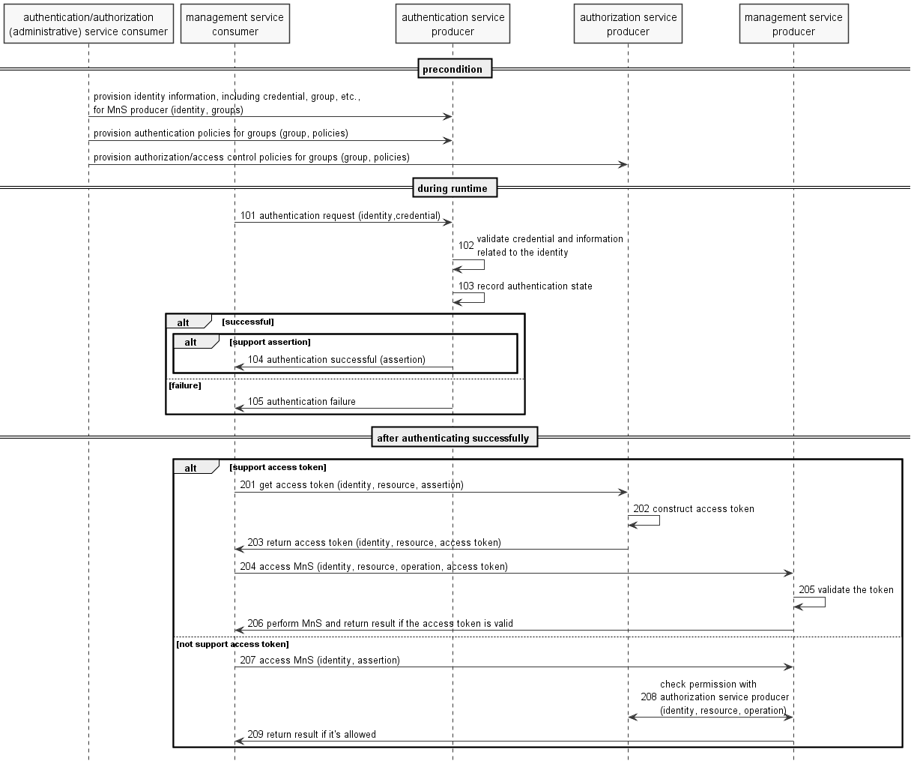

NOTE 1: the authentication (administrative) service consumer could be a portal or other operator tool acting on behalf of an administrator of operator.
Precondition:
Mutual authentication between authentication (administrative) service consumer and authentication/management service producer, as well as between MnS producer and authentication service producer, has been done, according to operator's implementation.
Authentication service producer contains authentication information required to perform authentication such as identities (including credential of the identity), and/or groups, and/or authentication policies. The specific information required will depend on the implementation.
The MnS consumer successfully authenticated (or validated the authenticity of) authentication/management service producer.

Procedure:
101. When authentication request is received, authentication service producer gets the identifier and credential of the MnS consumer, along with other context information (e.g. address of the client) from the request.
NOTE 2: challenges may be exchanged between MnS consumer and authentication service producer for some authentication protocols.
102. Based on identifier in the request, authentication service producer gets identity information, e.g. status of the identity, associated group(s) of the identity, credential of the identity, etc., from data store. Then the producer authenticates the MnS consumer by validating the identity information and other context (e.g. time, location of the consumer) according to authentication policies (e.g. authentication factor, protocol, supported time, location, status of the consumer, etc. ) associated to the group(s) the MnS consumer belongs to.
103. The authentication service producer updates the authentication state of the MnS consumer in the data store after authenticated the MnS consumer.
NOTE 3: If authenticate successfully and authentication assertion is supported by the protocol, the authentication service producer constructs authentication assertion and may update the assertion of the MnS consumer in the data store.
104. If authenticate successfully and authentication assertion is supported by the protocol, the authentication service producer sends successful response with an authentication assertion to the MnS consumer.

105. If fail for authentication, the authentication service producer sends failure response to the MnS consumer.
After the MnS consumer is authenticated:
If access token is supported by the MnS producer and consumer:
201. The MnS consumer gets access token from authorization service producer by providing the identity, list of resources and assertion from authentication session.
202. The authorization service producer validates the assertion and construct access token.
203. The authorization service producer returns access token to the MnS consumer for the resource indicated in step 201.
204. The MnS consumer accesses MnS with the access token.
205. The MnS producer validates the token.
206. The MnS producer performs the operation and returns result to the MnS consumer if the token is valid.
If access token is not supported by the MnS producer and consumer:
207. The MnS consumer accesses MnS from MnS producer.
208. The MnS producer validate the authentication assertion and check permission of the MnS consumer with authorization service producer.
NOTE 4: The MnS producer may authorize the MnS request of MnS consumer according to local policies.
209. The MnS producer performs the operation and returns result to the consumer if the MnS request is allowed according to permissions.

D.1.x Authenticate and authorize human management service consumer
The OpenID connect protocol (see [y]) and OAuth 2.0 Authorization Code Grant (see RFC 6749 [x]) are used to authenticate and authorize human management service consumer, as shown in Figure D.1.x-1.
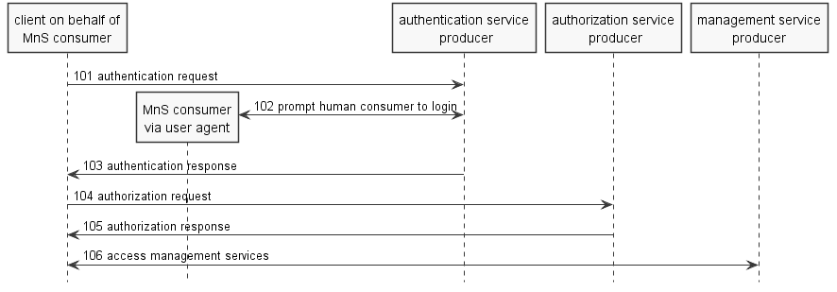
Figure D.1.x-1 Authentication and authorization for human MnS consumer
The authentication service producer implements OpenID Provider (OP), and authorization endpoint of OAuth 2.0 which authenticates the end user in OAuth 2.0 authorization code grant scenario.
The MnS consumer is end user of OpenID connect protocol and resource owner of OAuth 2.0.
The client acting on behalf of human MnS consumer implements Relaying Party (RP) of OpenID connect protocol, and confidential client of OAuth 2.0.
The authorization service producer implements token endpoint of OAuth 2.0, which issue access token to the client.
The management service producer implements resource server of OAuth 2.0.
The procedure is as follows:
101) The RP (Client on behalf of MnS consumer) sends an authentication request to the OpenID Provider (OP).
102) The OP authenticates the MnS consumer and authentication assertion.
103) Authentication service producer returns authentication assertion to the MnS consumer once successfully authenticate the MnS consumer.
104) With the authentication assertion, the MnS consumer asks permissions from authentication service producer via Authorization Request.
105) Authorization service producer validates the assertion, check the role/group of the MnS consumer and assigns related permissions to the MnS consumer. Authorization service producer constructs access token based on granted permissions and sends back the token to the MnS consumer.
106) The MnS consumer checks the access token, construct a service request based on permissions in the token, and sends service request, including access token, to MnS producer. MnS producer validates the access token, perform the request and return result to the MnS consumer
Note: Authentication of human MnS consumer includes two steps, the client on behalf of human user sends authentication request is the first step, and the human user logins with credentials is the second step. The steps to redirect user agent (e.g. browser) to authentication service producer (by the client on behalf of MnS consumer) to send authentication request, and redirect user agent back to the client (by authentication service producer) to send authentication response are ignored in the figure for sake of simplicity and conciseness.

D.1.y Authenticate and authorize machine management service consumer
OAuth 2.0 Client Credentials Grant (see RFC 6749 [x]) is used to authenticate and authorize machine management service consumer, as shown in Figure D.1.y-1.
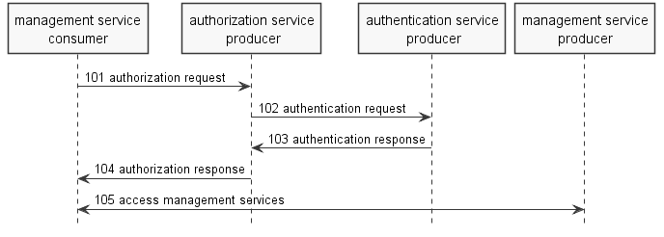
Figure D.1.y-1 Authentication and authorization for machine MnS consumer
- The authentication service producer authenticates management service consumer by validate the client credential.
- The management service consumer implements confidential client of OAuth 2.0.
- The authorization service producer implements token endpoint of OAuth 2.0, which issue access token to the client.
- The management service producer implements resource server of OAuth 2.0.
The procedure is as follows:
101) The Management Service Consumer authenticates with the authorization server and requests an access token
102,103) The authentication service producer authenticates management service consumer by validate the client credential
104) After the authorization server authenticating the client; the authorization service producer issues an access token.
105) The MnS consumer checks the access token, construct a service request based on permissions in the token, and sends service request, including access token, to MnS producer. MnS producer validates the access token, perform the request and return result to the MnS consumer
Note: Authentication service producer is preconfigured in authorization service producer, and vice versa. Trust relationship between the two entities is established.

Start of next Change

Annex X (Informative):
An example of Access control workflow for preconditions
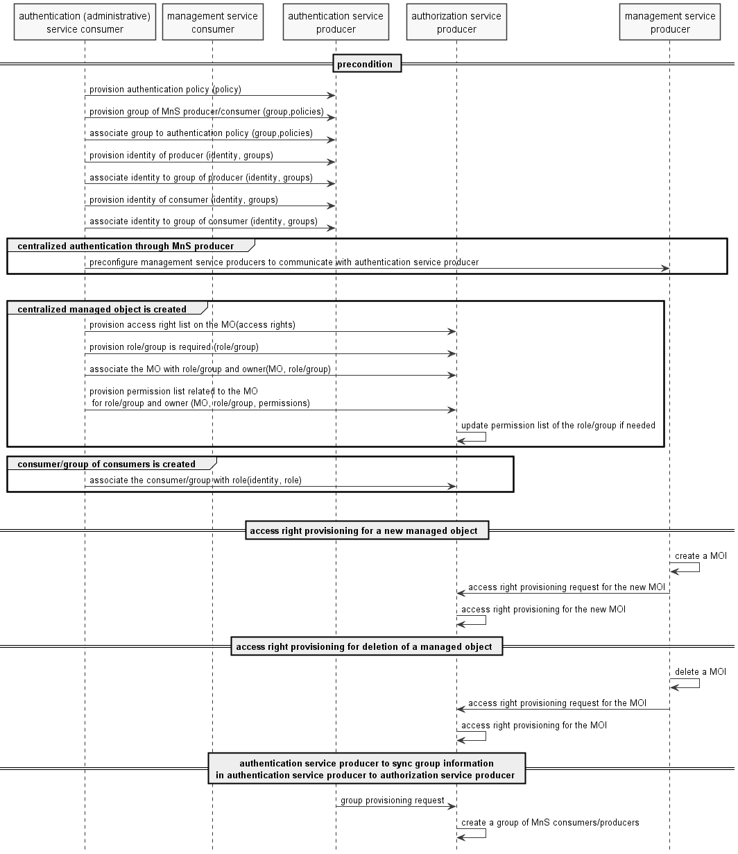
Precondition:
Authorization service producer creates/updates/deletes access right list for a managed object when received access right provisioning request. The request could be triggered by creating/updating/deleting a managed object (e.g. MOI of Subnetwork, ManagedElement, ManagedFunction, NetworkSlice, NetworkSliceSubnet, etc.) or other changes, e.g. change of organization policies.
Note 1: the access right of a managed object could be:
create/delete child MO instance (MOI) of the current MO (objectClass of the child MOI)
The child MOI could be controller MOI (e.g. PM controller, subscription controller, etc., contained by a managed entity) or other functional MOI (e.g. network slice, network slice subnet, etc. contained by a subnetwork )
read MOI tree (objectInstance of the current MOI)
delete MOI (objectInstance of the current MOI)
read MOIattribute (objectInstance of the current MOI + attributeName)
Note: maybe consider value of the attribute as further access condition when assign permission to a group/role. e.g. in a NetworkSlice MOI, the consumer can only read service profiles for the services allocated to the consumer.
update MOIattribute (objectInstance of the current MOI + attributeName)
Note 2: maybe consider value of the attribute as further access condition when assign permission to a group/role
create/read/update/delete access right/permission of the current MO
Authorization service producer creates/updates/deletes a group of MnS consumers/producers when received group provisioning request. The request could be triggered by authentication service producer to sync group information in authentication service producer to authorization service producer.
Note 3: S-NSSAI, PLMNInfo could be linked to a group
Authorization service producer creates/updates/deletes a role when received role provisioning request. The request could be triggered by creating/updating/deleting a managed object or creating/updating/deleting a MnS consumer or group of MnS consumers.
Authorization service producer assigns owner to the managed object, associates the managed object with group of MnS producers, group of MnS consumers/roles based the request.
Authorization service producer add/remove/update permissions of group of MnS consumers/role for the managed object based on the request.
Note 4: the permission is constructed as subject + access right + context/conditions
Authorization service producer update permission list of groups of MnS consumers/role according to permissions of the group of MnS consumers/role on each managed object.
Authorization service producer associates a MnS consumer or group of MnS consumers with role based on the request. The request could be triggered by creating/updating a MnS consumer or group of MnS consumers.
Note 5: the sequence of above procedures could be different
The MnS consumer successfully authenticated authorization service producer and MnS producer.

End of Change

