3GPP TSG-SA5 Meeting #140e S5-216284rev5

e-meeting, 15 - 24 November 2021 Revision of S5-21xxxx

Source: Alibaba Group, AsiaInfo

Title: Exposure of network slice as a service

Document for: Approval
Agenda Item: 6.5.4

1 Decision/action requested
The group is asked to discuss and agree on the proposal.

2 References
[1] TR 28.824 0.2.0: Study on network slice management capability exposure

3 Rationale
This contribution proposes to add a use case for Exposure of network slice as a service.

4 Detailed proposal
This document proposes the following changes in TR 28.824 [1].

1st Change

5 Use case for network management capability expsoure

5.6 Exposure of network slice as a service

5.6.1 Description
This use case involves the following roles:
- NSP: Network Slice Provider
- NSC: Network Slice Customer
- NOP: Network Operator
- CSC: Communication Service Customer
- CSP: Communication Service Provider
, and the following systems:
- BSS: Business Support System
- OSS: Operations Support System, made up of the two following sub-systems:
- SML: Service Management Layer
- NML: Network Management Layer (for sake of simplicity, network management and network element / function management are both in the NML).

5.6.1.1 Sub-use case 1: NSP and NOP play by the same organization
In this scenario, the following organizations play aforementioned roles as follows:
- Company-V, which has a contract with Company-A for the exposure directly via OSS, plays the role of NSC
- Company-A plays the role of NSP and NOP
- As NSP, it has:
- a BSS, e.g. to manage its customers, products, contracts, and
- a SML, to manage the services that support its products, to manage the customer’s request for exposed MnS
- As NOP, it has:
- its own 5G network (RAN + core). In this sub-use case, Company-A owns the whole set of network resources used by the service that can potentially support the service required by Company-V
- a NML, to manage the network resources used by services
NOTE 1: NSC may have connection with Company-A BSS for the product-level interaction. If not, the OSS/SML may have an embedded BSS functionalities for the product-level interaction.
Editor’s notes: Whether the embedded BSS functionalities are implemented in EGMF or other management function is FFS.
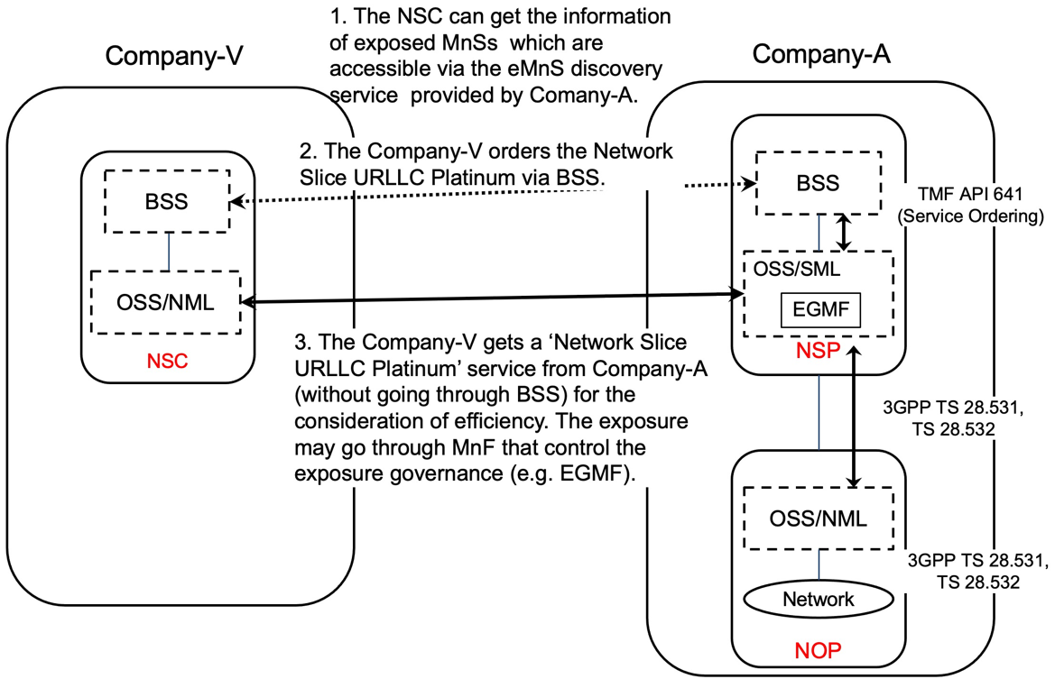

Figure 5.6.1.1-1 Sub-use case – NSP and NOP played by the same organization

Company-A proposes the following product offering together with the exposure capability:
- Network Slice eMBB with the exposure capability of getMOIAttributes, related KPI monitoring and alarm notification

In this sub-use case 1:
1. Company-V (as the NSC) gets the information regarding eMnSs that are accessible via the eMnS discovery service from the Company-A.
2. Company-V sends a request to Company-A (as the NSP) for the access of exposed MnS set ‘Network Slice eMBB’, which contains the exposure capabilities such as, getMOIAttributes, related KPI monitoring and alarm notification. To achieve this, a candidate API is the interface with the MnF that controls the exposure governance (e.g. EGMF).
2.1 Company-A SML determines which service supports the exposed MnS being requested by Company-V.
2.2 Company-A OSS / SML sents a response, including the authentication materials (e.g. key, token) for access the chosen exposed MnS.

3. The company-V can direct access the exposed MnS (e.g. getMOIAttributes, KPI monitoring and alarm notification) from SML of the Company-A’s 3GPP management system.

5.6.1.2 Sub-use case 2: NOP role played simultaneously by different organizations
In this scenario, the following organizations play aforementioned roles as follows:
- Company-V, which has a contract with Company-A for the exposure directly via OSS, plays the role of NSC
- Company-A plays the role of NSP and NOP
- As NSP, it has:
- a BSS, e.g. to manage its customers, products, contracts, and
- a SML, to manage the services that support its products, to manage the customer’s request for exposed MnS
- As NOP, it has:
- its own 5G core network. In this sub-use case, Company-A owns the whole set of 5G core network resources used by the service that can potentially support the service required by Company-V
- a NML, to manage the 5G core network resources used by services
As Company-A has no RAN in all requested areas, it relies on a different organization with a specific contract (e.g. exposure directly via OSS), namely Company-B Spain and Company-C USA, to provide RAN coverage in the Spain and in the USA respectively. Therefore:
- Company-A plays the role of Communication Service Customer (CSC) wrt. Company-B Spain and Company-C USA who both play the role of Communication Service Provider (CSP)
- Both Company-B Spain and Company-C USA have their own services to offer RAN coverage in their respective countries
- Both Company-B Spain and Company-C USA play the role of CSP (for their respective product offerings) and NOP (for their respective RAN).
NOTE 2: NSC may have connection with Company-A BSS for the product-level interaction. If not, the OSS/SML may have an embedded BSS functionalities for the product-level interaction.
Editor’s notes: Whether the embedded BSS functionalities are implemented in EGMF or other management function is FFS.
NOTE 3: If the external customer can get access to the OSS directly, it must maintain a copy of a part of the operator’s MIB. If the customer wants to e.g. receive alarms or performance measurements or KPIs related to the network slice the customer has ordered to the NSP, these alarms / perf. meas / KPIs need to relate to some MOIs known at customer side. All these MOIs shall be part of a containment tree in the copy of the Operators’ MIB maintained by the customer.
Editor’s notes: Whether and how does the external customer obtain the copy of a part of the operator’s MIB is FFS.
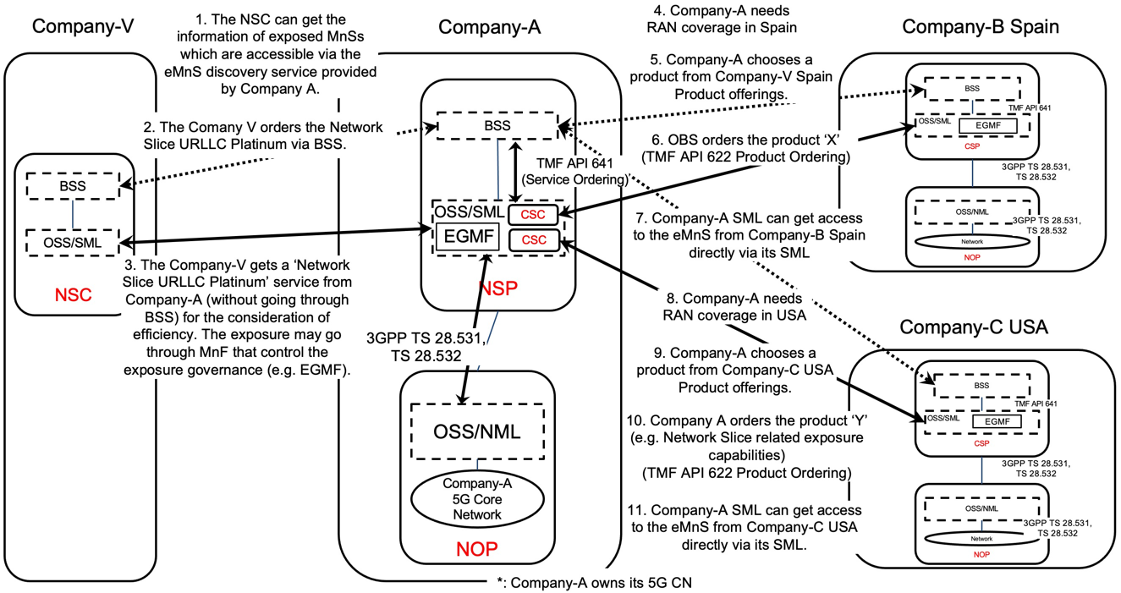

Figure 5.6.1.1-2 Sub-use case – NOP role played simultaneously by different organizations

Company-A proposes the following product offering together with the exposure capability:
- Network Slice eMBB with the exposure capability of getMOIAttributes, related KPI monitoring and alarm notification

In this sub-use case 2:
1. Company-V (as the NSC) gets the information regarding eMnSs that are accessible via the eMnS discovery service from the Company-A.
2. Company-V sends a request to Company-A (as the NSP) for the access of exposed MnS set ‘Network Slice eMBB Platinum’, which contains the exposure capabilities such as, getMOIAttributes, related KPI monitoring and alarm notification. To achieve this, a candidate API is the interface with the MnF that controls the exposure governance (e.g. EGMF).
2.1 Company-A SML determines which service supports the exposed MnS being requested by Company-V.

2.2 Company-A OSS / SML determines which network resources support the service being requested and:
2.2.1 based on its knowledge that required RAN resources are not available internally, the SML, acting as a CSC, issues a request to Company-C USA to request service to get RAN coverage in the US. To achieve this, a candidate API is the interface with the MnF that controls the exposure governance (e.g. EGMF) of Company-C USA. Company-C USA, as the CSP, receives the service request. Company-C USA SML determines which service supports the exposed MnS being requested by Company-A. This service can be e.g. a network slice. Company-C USA OSS / SML determines which network resources support the service being requested, etc. Once completed, Company-C USA SML informs Company-A SML that the exposed MnS which has been requested is now available to Company-A. The Company-A SML can get access to the eMnS from Company-C USA directly via its SML.

2.2.3 acting as a CSC, issues a request to Company-B Spain to request service to get RAN coverage in Spain. To achieve this, a candidate API is the interface with the MnF that controls the exposure governance (e.g. EGMF) of Company-B Spain. Company-B Spain, as the CSP, receives the service request. Company-B Spain SML determines which service supports the exposed MnS being requested by Company-A. This service can be e.g. a network slice. Company-B Spain OSS / SML determines which network resources support the service being requested, etc. Once completed, Company-B Spain SML informs Company-A SML that the exposed MnS which has been requested is now available to Company-A. The Company-A SML can get access to the eMnS from Company-B Spain directly via its SML.

3. Company-A (as the NSP) sends a reply to Company-V to inform that the exposed MnS requested is now available to Company-V. The reply may also include the authentication materials (e.g. key, token) for access the chosen exposed MnS.
NOTE 4: NSP may not have network at all. In this case, if and how NSP can offer exposure services to NSC is FFS.

NOTE 5: in this use case, aspects related to Transport Network(s) are not addressed as they are out of 3GPP scope.

End of changes

