3GPP TSG-SA5 Meeting #140e S5-216284rev1

e-meeting, 15 - 24 November 2021 Revision of S5-21xxxx

Source: Alibaba Group, AsiaInfo

Title: Exposure of network slice as a service

Document for: Approval
Agenda Item: 6.5.4

1 Decision/action requested
The group is asked to discuss and agree on the proposal.

2 References
[1] TR 28.824 0.2.0: Study on network slice management capability exposure

3 Rationale
This contribution proposes to add a use case for Exposure of network slice as a service.

4 Detailed proposal
This document proposes the following changes in TR 28.824 [1].

1st Change

5 Use case for network management capability expsoure

5.6 Exposure of network slice as a service

5.6.1 Description
This use case involves the following roles:
- NSP: Network Slice Provider
- NSC: Network Slice Customer
- NOP: Network Operator
- CSC: Communication Service Customer
- CSP: Communication Service Provider
, and the following systems:
- BSS: Business Support System
- OSS: Operations Support System, made up of the two following sub-systems:
- SML: Service Management Layer
- NML: Network Management Layer (for sake of simplicity, network management and network element / function management are both in the NML).

5.6.1.1 Sub-use case 1: NSP and NOP play by the same organization
In this scenario, the following organizations play aforementioned roles as follows:
- Company-V, which has a contract with Comany-A for the exposure directly via OSS, plays the role of NSC
- Company-A plays the role of NSP and NOP
- As NSP, it has:
- a BSS, e.g. to manage its customers, products, contracts, and
- a SML, to manage the services that support its products, to manage the customer’s request for exposed MnS
- As NOP, it has:
- its own 5G network (RAN + core). In this sub-use case, Company-A owns the whole set of network resources used by the service that can potentially support the service required by Company-V
- a NML, to manage the network resources used by services
NOTE1: NSC may have connection with Company-A BSS for the product-based interaction. If not, the OSS/SML may have an embedded BSS functionalities for the product-based interaction.
Editor’s notes: Whether the embedded BSS functionalities are implemented in EGMF or other management function is FFS.
NOTE2: The Company-A BSS connects to the BSS part of NSC and the Company-A OSS/SML connect to the OSS/SML part of Company-V.
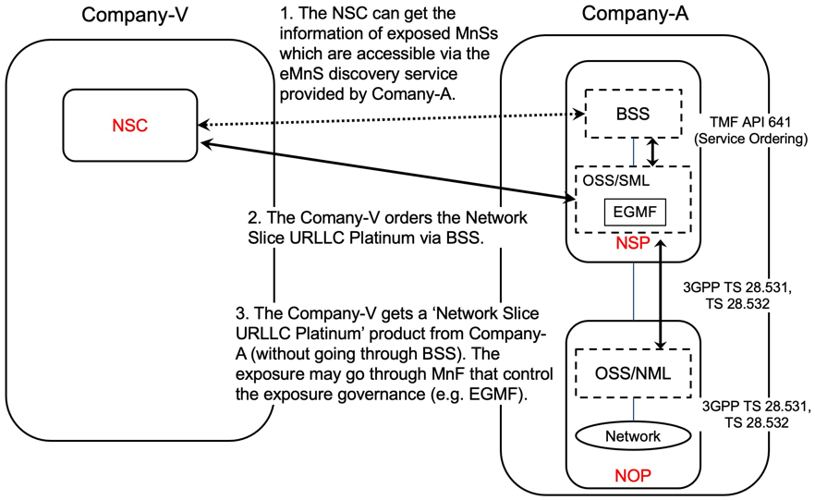
Figure 5.6.1.1-1 Sub-use case – NSP and NOP played by the same organization

Company-A proposes the following product offering together with the exposure capability:
- Network Slice eMBB with the exposure capability of modifyMOIAttributes, related KPI monitoring and alarm notification

In this sub-use case 1:
1. Company-V (as the NSC) gets the information regarding eMnSs that are accessible via the eMnS discovery service from the Company-A.
2. Company-V sends a request to Company-A (as the NSP) for the access of exposed MnS set ‘Network Slice eMBB’, which contains the exposure capabilities such as, modifyMOIAttributes, related KPI monitoring and alarm notification. To achieve this, a candidate API is the interface with the MnF that controls the exposure governance (e.g. EGMF).
2.1 Company-A SML determines which service supports the exposed MnS being requested by Company-V.
2.2 Company-A OSS / SML sents a response, including the authentication materials (e.g. key, token) for access the chosen exposed MnS.

3. The company-V can direct access the exposed MnS (e.g. modifyMOIAttributes, KPI monitoring and alarm notification) from SML of the Company-A’s 3GPP management system.

5.6.1.2 Sub-use case 2: NOP role played simultaneously by the same organization with different regions
In this scenario, the following organizations play aforementioned roles as follows:
- Company-V, which has a contract with Comany-A for the exposure directly via OSS, plays the role of NSC
- Company-A plays the role of NSP and NOP
- As NSP, it has:
- a BSS, e.g. to manage its customers, products, contracts, and
- a SML, to manage the services that support its products, to manage the customer’s request for exposed MnS
- As NOP, it has:
- its own 5G core network. In this sub-use case, Company-A owns the whole set of 5G core network resources used by the service that can potentially support the service required by Company-V
- a NML, to manage the 5G core network resources used by services
As Company-A has no RAN in all requested areas, it relies on same organization within different region (e.g. different divisions), namely Company-A Spain and Company-A USA, to provide RAN coverage in the Spain and in the USA respectively. Therefore:
- Company-A plays the role of Communication Service Customer (CSC) wrt. Company-A Spain and Company-A USA who both play the role of Communication Service Provider (CSP)
- Both Company-A Spain and Company-A USA have their own services to offer RAN coverage in their respective countries
- Both Company-A Spain and Company-A USA play the role of CSP (for their respective product offerings) and NOP (for their respective RAN).
NOTE3: NSC may have connection with Company-A BSS for the product-based interaction. If not, the OSS/SML may have an embedded BSS functionalities for the product-based interaction.
Editor’s notes: Whether the embedded BSS functionalities are implemented in EGMF or other management function is FFS.
NOTE4: The Company-A BSS connects to the BSS part of NSC and the Company-A OSS/SML connect to the OSS/SML part of Company-V.

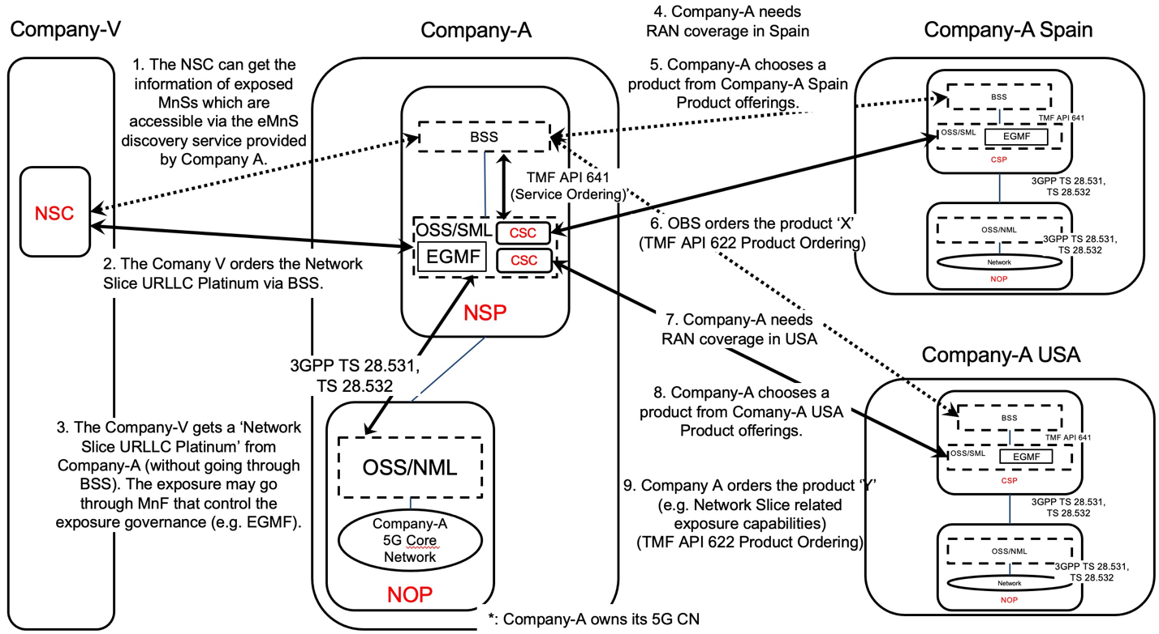

Figure 5.6.1.1-2 Sub-use case – NOP role played simultaneously by the same organization with different regions

Company-A proposes the following product offering together with the exposure capability:
- Network Slice eMBB with the exposure capability of modifyMOIAttributes, related KPI monitoring and alarm notification

In this sub-use case 2:
1. Company-V (as the NSC) gets the information regarding eMnSs that are accessible via the eMnS discovery service from the Company-A.
2. Company-V sends a request to Company-A (as the NSP) for the access of exposed MnS set ‘Network Slice eMBB Platinum’, which contains the exposure capabilities such as, modifyMOIAttributes, related KPI monitoring and alarm notification. To achieve this, a candidate API is the interface with the MnF that controls the exposure governance (e.g. EGMF).
2.1 Company-A SML determines which service supports the exposed MnS being requested by Company-V.

2.2 Company-A OSS / SML determines which network resources support the service being requested and:
2.2.1 based on its knowledge that required RAN resources are not available internally, the SML, acting as a CSC, issues a request to Company-A USA to request service to get RAN coverage in the US. To achieve this, a candidate API is the interface with the MnF that controls the exposure governance (e.g. EGMF) of Company-A USA. Company-A USA, as the CSP, receives the service request. Company-A USA SML determines which service supports the exposed MnS being requested by Company-A. This service can be e.g. a network slice. Company-A USA OSS / SML determines which network resources support the service being requested, etc. Once completed, Company-A USA SML informs Company-A SML that the exposed MnS which has been requested is now available to Company-A

2.2.3 acting as a CSC, issues a request to Company-A Spain to request service to get RAN coverage in Spain. To achieve this, a candidate API is the interface with the MnF that controls the exposure governance (e.g. EGMF) of Company-A Spain. Company- A Spain, as the CSP, receives the service request. Company-A Spain SML determines which service supports the exposed MnS being requested by Company-A. This service can be e.g. a network slice. Company-A Spain OSS / SML determines which network resources support the service being requested, etc. Once completed, Company-A Spain SML informs Company-A SML that the exposed MnS which has been requested is now available to Company-A

3. Company-A (as the NSP) sends a reply to Company-V to inform that the exposed MnS requested is now available to Company-V. The reply may also include the authentication materials (e.g. key, token) for access the chosen exposed MnS.
NOTE: in this use case, aspects related to Transport Network(s) are not addressed as they are out of 3GPP scope.

End of changes

