3GPP TSG-SA5 Meeting #140-e S5-216233

e-meeting, 15 - 24 November 2021

Source: Huawei

Title: Add key issue on modelling of MnF

Document for: Approval
Agenda Item: 6.5.6

1 Decision/action requested
Discuss and approve on the proposal.

2 References
[1] 3GPP TS 28.622 Generic Network Resource Model (NRM). Integration Reference Point (IRP); Information Service (IS)
[2] 3GPP TS 28.533 Management and orchestration; Architecture framework
[3] 3GPP TR 28.925 enhancement of service based management architecture
[4] S5-212088 TD Modeling of Managed Management Functions
[5] S5-214399 Add key issue on modelling of MnF
[6] S5-215104 Add key issue on modelling of MnF

3 Rationale
Observation#1: Management Function Definition and Concept in TS 28.533[2].
A Management Function (MnF) is a logical entity playing the roles of MnS consumer and/or MnS producer.
Management Function can be deployed as a separate entity or embedded in Network Function to provide MnS(s). Following figure 1 shows an example (on the left) which MnF deployed as a separate entity to provide MnS(s) and another example (on the right) which MnF is embedded in Network Function to provide MnS(s):
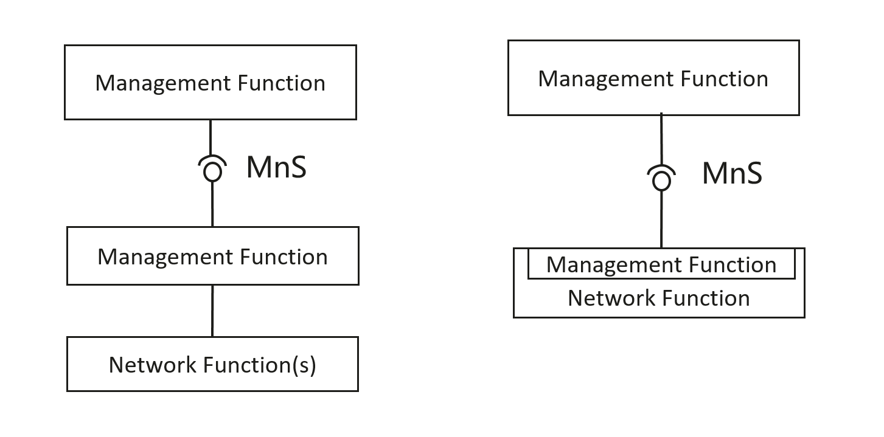
Figure 1：Examples of MnS deployment scenario
Observation#2: Network Element definition in TR 21.905.
Network Element: A discrete telecommunications entity which can be managed over a specific interface e.g. the RNC.
Observation#3: Network Function definition in TS 28.533.
Network Function (NF): defined in TS 23.501[31].
TS 23.501:
Network Function: A 3GPP adopted or 3GPP defined processing function in a network, which has defined functional behaviour and 3GPP defined interfaces.
NOTE 1: A network function can be implemented either as a network element on a dedicated hardware, as a software instance running on a dedicated hardware, or as a virtualised function instantiated on an appropriate platform, e.g. on a cloud infrastructure.

Observation#3: ManagedElement, ManagedFunction IOC definition in TS 28.622.
MaangedElement: This IOC represents telecommunications equipment or TMN entities within the telecommunications network providing support and/or service to the subscriber. A ManagedElement IOC is used to represent a Network Element defined in TS 32.101[1] including virtualization or non-virtualization scenario.
ManagedFunction: This IOC is provided for sub-classing only. It provides attribute(s) that are common to functional IOCs. Note that a ManagedElement may contain several managed functions, a managed function may contain other managed functions as specified for the specific subclass.This IOC can represent a telecommunication function either realized by software running on dedicated hardware or realized by software running on NFVI.
Observation#4: SA5 has specified some management related features like DANRManagementFunction, DESManagementFunction, MDA, COSLA etc. Such features also need to be managed in the same way as managing network node in 3GPP management system.
Observation#5: The ManagedElement IOC is used to represent a Network Element. So we think the ManagedElement should contain at least one NetworkFunction.
Observation#6: we think it is needed to differentiate the model for NF and MnF, we propose to keep the existing ManagedFunction for modelling Network Function, and add new ManagementFunction for modelling Management Function.
To summarize, the SBMA related concepts do not contain a generic corresponding IOCs to represent Management Function. And based on the figure 1 above, Management Function takes an important role to build the links with Network Element, Network Function and other Management Functions. Management Function is also needed to be managed from 3GPP management system using the same approach as managing network node. We propose to add corresponding ManagementFunction IOC to show the completeness of SBMA concept.

4 Detailed proposal
It is proposed to add a new Key issue on modelling for MnF. This document proposes the following changes in TR 28.925 [1].

1st Change

4.x Issue #x: Use of Models in SBMA

4.x.1 Description
The following existing concepts are related to SBMA:
- TS 28.533 Management Function: A Management Function (MnF) is a logical entity playing the roles of MnS consumer and/or MnS producer. Management Function can be deployed as a separate entity or embedded in Network Function to provide MnS(s).

Figure 4.x-1: Examples of MnS deployment scenario
- TR 21.905 Network Element: A discrete telecommunications entity which can be managed over a specific interface e.g. the RNC.
- TS 28.533 / TS 23.501 Network Function: A 3GPP adopted or 3GPP defined processing function in a network, which has defined functional behaviour and 3GPP defined interfaces.
The following IOCs are specified:
- TS 28.622 ManagedElement IOC: This IOC represents telecommunications equipment or TMN entities within the telecommunications network providing support and/or service to the subscriber. A ManagedElement IOC is used to represent a Network Element defined in TS 32.101[1] including virtualization or non-virtualization scenario.
- TS 28.622 ManagedFunction IOC: This IOC is provided for sub-classing only. It provides attribute(s) that are common to functional IOCs. Note that a ManagedElement may contain several managed functions, a managed function may contain other managed functions as specified for the specific subclass.This IOC can represent a telecommunication function either realized by software running on dedicated hardware or realized by software running on NFVI.

4.x.2 Potential solutions
This clause provides the description of using NRM to represent management of management function, network function, and nework element.
Management Function could be deployed in following different deployment scenarios:
- The Management Function can be deployed in management system, including
  - The Management Function deployed in domain management system.
  - The Management Function deployed in cross domain management system.
- The Management Function deployed in Network Element.
Management Functions need to be managed as managing network node in 3GPP management system. The way of managing the Management Function are modelled in corresponding management function IOC.
The Management Function are managed by corresponding management function IOC:
- Management of D-SON function of ANR in TS 28.541 DANRManagementFunction IOC
- Management capabilities of Distributed SON Energy Saving (ES) functions in TS 28.541 DESManagementFunction IOC
- Management capabilities of Centralized SON Energy Saving (ES) functions in TS 28.541 CESManagementFunction IOC
Editor’s note: other management functions to be added with working progress.

The following table captures the relation between the concepts and related models:
Concepts | Illustration of Related Management Models
TS 28.533 Management Function | The corresponding XXXManagementFunction IOC is used to support the managing of XXXMnF.
TR 21.905 Network Element | A network element is represented by ManagedElement IOC defined in TS 28.622.
TS 28.533 / TS 23.501 Network Function | A Network function is represented by ManagedFunction IOC defined in TS 28.622.

It’s recommended to document the descriptions of ManagentFuntion IOCs and related MnF to improve the readability in Rel-18.

End of change

