3GPP TSG-SA5 Meeting #140-e S5-216220

e-meeting, November 15 – 24 2021

Source: Huawei

Title: Add concept of intent translation

Document for: Approval
Agenda Item: 6.4.10

1 Decision/action requested
The group is asked to discuss and approval.

2 References
[1] 3GPP draft TS 28.312: “Management and orchestration; Intent driven management services for mobile networks v0.6.0”.

3 Rationale
This contribution proposes to add concept of intent translation which described in TR 28.812 in clause 4.1.4.

4 Detailed proposal
It proposes to make the following changes to TS 28.312[1].
1st Change

4.2.X Intent translation
The Intent driven MnS producer is the provider of Intent driven MnS and is responsible for deriving activities for networks and services or other intent(s).
The MnS consumer may consume Intent Driven MnS(s) provided by the Intent driven MnS producer(s) or may have the consumer role for non-intent MnS producers.
The conflict(s) including conflict between the intent and other intent(s) and/or Non-intent requirements needs to be detected and resolved during the intent translation. Figure 4.2.X-1 illustrate the potential way to satisfy intents originating from CSC:
- Intent-CSC MnS producer provides intent driven MnS for communication services. Intent-CSC MnS producers receive the expressed intent and translate it to Intent-CSP or network requirements, then may consume Intent-CSP MnS(s) or Non-Intent MnS(s) for network to fulfil the intent-CSC.
- Intent-CSP MnS producer provides intent driven MnS for network services. Intent-CSP MnS producers receive the intent and translate it to new Intents for NOP or network element requirements, then may consume Intent-NOP MnS(s) or Non-Intent MnS(s) for NE to fulfil the intent-CSP.
- Intent-NOP MnS producer provides intent driven MnS for network equipment. Intent-NOP MnS Producers receive the expressed intent, and translate it to detailed network element requirements, then takes some internal actions to fulfil the intent-NEP.
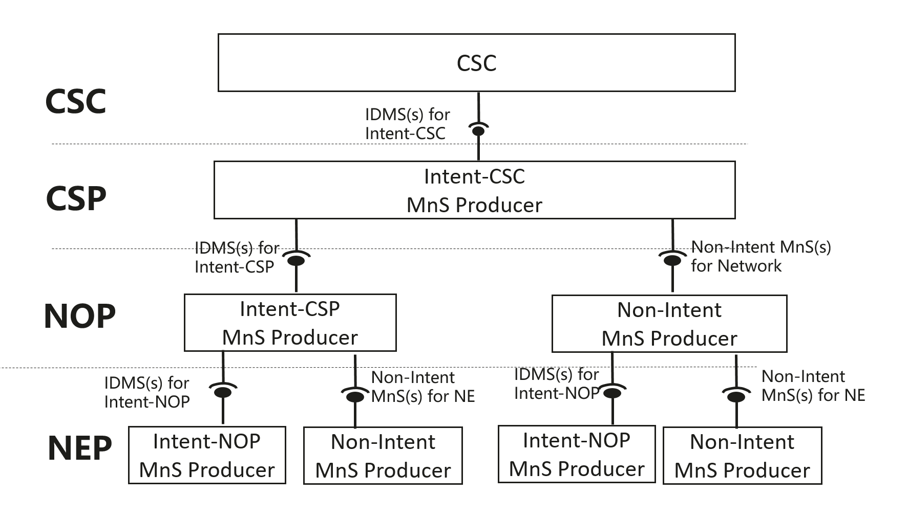
Figure 4.2.X-1: Potential way to satisfy intent-CSC originating from CSC

End of changes

