**3GPP TSG-SA5 Meeting #140-e *S5-216134***

**e-meeting, 15 - 24 November 2021**

**Source: China Unicom**

**Title: Discussion on enhanced MIMO PRB Usage for cell**

**Document for: Approval and Endorsement**

**Agenda Item: 6.4.6**

# 1 Decision/action requested

***It proposes to discuss and endorse***

# 2 References

[1] 3GPP TS 28.552 “Management and orchestration 5G performance measurements”

[2] 3GPP TS 38.314 “NR; Layer 2 measurements”

# 3 Rationale

Following are some observations related to NR PRB usage.

**Observation#1: Lack of NR MIMO PRB usage definition in TS 28.552.**

MASSIVE MIMO has been widely used in wireless networks as a key technology of 5G. Radio resources have expanded from the time domain and frequency domain to the space domain. Therefore, the evaluation of wireless network resource utilization should also take the number of spatial layers into consideration. However, PRB usage defined in TS 28.552[1] follows traditional statistic method of PRB usage in LTE network, that is, only the occupation percentage of frequency domain resource is considered.

**Observation#2: Disadvantages of the MIMO PRB usage defined in TS 38.314.**

TS 38.314 [2] introduced PDSCH PRB Usage for MIMO in the DL per cell and PUSCH PRB Usage for MIMO in the UL per cell. PRB usage defined in TS 38.314[2] has added a new factor alpha to evaluate utilization of space resource. The formula is as follows:

$$M\left(T\right)=\left\lfloor \frac{\sum_{∀i}{\sum_{∀j}{\{{M1}_{ij}(T)*L_{ij}(T)\}}}}{N\left(T\right)*P\left(T\right)*Alpha}*100\right\rfloor$$

In the PRB usage formula for the MIMO scenario, variables representing the number of layers are added to the numerator and denominator respectively. $L_{ij}(T)$ denotes the number of MIMO layers scheduled for UE 𝑖 at sampling occasion 𝑗. Alpha is a constant value configured by OAM with integer value range:1-100. With this parameter, M(T) should be reasonable (not be larger than 100).

**Disadvantage#**There is no detailed suggestions and specific methods for the factor alpha proposed in TS 38.314[2]. And with the contant Alpha, the result of M(T) can not be guaranteed in the range of 0-100.

By analyzing the formula in TS38.314 [2], it can be seen that resource utilization evaluation in MIMO scenario takes into account both frequency resources and space resources. The numerator of the formula in TS 38.314[2] contains the actual number of occupied PRBs and the number of actually scheduled layers, and the denominator contains the number of available PRBs per layer and the space factor alpha, which means that alpha represents the number of available layers for the cell.

The characteristics of MIMO technology show that the number of layers available for the cell is related to the geographic environment of the cell, radio wave propagation model, and user distribution. The number of layers available will change as the environment and users change.

There is no detailed suggestions and specific methods for the factor alpha proposed in TS 38.314[2]. Only one requirement is put forward that the value of alpha as a constant could not make the PRB usage greater than 100.

In the evaluation of actual resource utilization, factors such as the geographical environment where each cell is located, the different location distribution of users, the different types of services carried and the different business volumes will cause the number of spatial layers that the cell can reach to be different, that is, the number of available layers will change over time and space. Alpha with constant value in TS 38.314 is used as a space factor, which cannot faithfully reflect the actual space capabilities of different cells in different user distribution scenarios. If alpha is artificially set to a fixed constant, it will result in data anomalies:

* When alpha is set large, the unreachable limit capacity is used as the denominator in some cells, which leads to the low utilization rate of PRB but poor user perception.
* When alpha is set small, the PRB usage of some cells may exceeds 100 which is not reasonable.

In the above scheme, in order to meet the requirement that PRB usage does not exceeds 100, alpha needs to be set larger, which results in abnormal data in some cells.

**Observation#3: The report granularity of PRB usage defined in TS 38.314[2] cannot meet the requirements in TS 28.552[1].**

PRB usage algorithm in TS 38.314[2] is defined to report “per UE”, while in the latest version of TS 28.552, section 5.1.0 makes it clear that measuremnts defined in TS 28.552 should be reported per NRCellDU. As a result, it is not suitable to introduce the PRB usage definition in TS 38.314 into TS 28.552[1].

**Observation#4: The tdocs to introduce time domain average maximum layer number were agreed in SA5#139-e meeting (11-20 October 2021).**

The CR, S5-215650 to introduce time domain average maximum layer number was agreed in SA5#139-e meeting (11-20 October 2021). The following definition was agreed. The measurement of time-domain average maximum scheduled layer number for MIMO scenario could provide operators the scheduled layer number, the actural spatial capability of a cell under MIMO scenario and can help operators to calculate the radio resource untilization rate, which can be used as the spatial factor to represent the capability of a cell dynamically.

////////////////////////////////////////////////Start of the reference to agreed SA5 CR S5-215650////////////////////////////////////////

##### 5.1.1.30.x PDSCH Time-domain average Maximum Scheduled Layer Number of cell for MIMO scenario

a) This measurement provides the Time-domain average maximum scheduled layer number for PDSCH under MIMO scenario in the downlink.

b) SI

c) This measurement is obtained as:

$$LM\left(T\right)=\frac{\sum_{j}{{Lmax}_{j}\left(T\right)}}{K\left(T\right)}，K\left(T\right)=\sum_{j,{Lmax}_{j\left(T\right)}≠0}{1}$$

Where *LM(T)* denotes the Time-domain average of maximum scheduled layer number for PDSCH under MIMO scenario in the downlink in the time period T. ${Lmax}_{j}(T)$ denotes the maximum number of scheduled layer of PDSCH at sampling occasion j; *K(T)* denotes the number of sampling occasions at which ${Lmax}_{j}(T)$ is not 0; *T* denotes the time period during which the measurement is performed; and *j* denotes the sampling occasion during time period T, a sampling occasion is 1 symbol.

d) A single real value.`

e) RRU.MaxLayerDlMimo, which indicates the PDSCH Time-domain average maximum scheduled layer number for MIMO scenario in the downlink.

f) NRCellDU.

g) Valid for packet switching.

h) 5GS.

i) One usage of this measurement is evaluate the actural spatial capability of a cell in the downlink under MIMO scenario.

##### 5.1.1.30.y PUSCH Time-domain average Maximum Scheduled Layer Number of cell for MIMO scenario

a) This measurement provides the Time-domain average maximum scheduled layer number for PUSCH under MIMO scenario in the uplink.

b) SI

c) This measurement is obtained as:

$$LM\left(T\right)=\frac{\sum_{j}{{Lmax}_{j}\left(T\right)}}{K\left(T\right)}，K\left(T\right)=\sum_{j,{Lmax}_{j\left(T\right)}≠0}{1}$$

Where *LM(T)* denotes the Time-domain average of maximum scheduled layer number for PUSCH under MIMO scenario in the uplink in the time period T. ${Lmax}_{j}(T)$ denotes the maximum number of scheduled layer of PUSCH at sampling occasion j; *K(T)* denotes the number of sampling occasions at which ${Lmax}_{j}(T)$ is not 0; *T* denotes the time period during which the measurement is performed; and *j* denotes the sampling occasion during time period T, a sampling occasion is 1 symbol.

d) A single real value.

e) RRU.MaxLayerUlMimo, which indicates the PUSCH Time-domain average maximum scheduled layer number for MIMO scenario in the uplink.

f) NRCellDU.

g) Valid for packet switching.

h) 5GS.

i) One usage of this measurement is evaluate the actural spatial capability of a cell in the uplink under MIMO scenario.

##### A.X Monitoring of Time-domain average Maximum Scheduled Layer Number for MIMO scenario

The Time-domain average maximum scheduled layer number for MIMO scenario measurement could provide operators the scheduled layer number, the actural spatial capability of a cell under MIMO scenario and can help operators to calculate the radio resource untilization rate.

////////////////////////////////////////////////End of the reference to agreed SA5 CR S5-215650////////////////////////////////////////

**Proposal# Introduction of enhanced MIMO PRB usage measurements reported per cell into TS 28.552.**

Based on the observations above, the measurements defined in TS 28.552 cannot perform PRB usage measurement per cell for MIMO scenario. And the definition of PRB usage in TS 38.314 has some obvious disadvantages. Moreover, the report granularity and statistic granularity of the PRB usage defined in TS 38.314 are not in accordance with the requirement put forword in TS 28.552. As a result, an enhanced MIMO PRB usage measurements reported per cell is proposed, the number of PRBs used and available are all measured by the granularity of cell, and time domain average maximum scheduled layer number is used to dynamically represent the actual spatial multiplexing capability of a cell.

**Enhanced MIMO PRB usage measurements reported per cell**

Take the downlink as an example, the PDSCH PRB usage reported per cell for MIMO is defined as follows:



Where,

$M_{E}\left(T\right)$ denotes total PDSCH PRB usage per cell which is percentage of PRBs used, averaged during time period 𝑇 with integer value range: 0-100;

$R_{ij}\left(T\right)$ denotes the number of PDSCH PRBs multiplexed by *i* MIMO layers at sampling occasion *j*.

 denotes total number of PDSCH PRBs available for sampling occasion j on single MIMO layer per cell;

*LM(T)* denotes the maximum scheduled layer number of PDSCH in time period T defined in CR S5-215650;

NOTE: At every sampling occasion the maximum scheduled layer number of all PRBs included in PDSCH is collected as a sampling value and at the end of statistical duration the average of all sampling values is the measuremnt result as defined in TS 28.552.

*T* denotes the time period during which measurement is performed;

*i* is an integer denoting a MIMO layer number that is scheduled in time period T;

*j* denotes sampling occasion (e.g. 1 slot) during time period T.

Since the time-domain average maximum scheduled layer number is automatically calculated based on the pre-defined algorithm by system, an enhanced PRB usage calculated by this method can be guaranteed to be less than 100, and the available space resources under different user distribution scenarios in different cells can be reflected in real time.

The calculation algorithm of time domain average maximum scheduled layer number performs arithmetic average of all effective sampling points during the statistical period. Since the statistical period is much larger than the sampling interval, we can accumulate a large number of sampling points. The large number of collected data can effectively shield the influence of singular points on the overall value. Therefore, the calculation result can reflect the actual capacity of a cell.

**The following shows an example.**

Assume that the downlink bandwidth of cell A is 100M, the available PRB is 273, and the number of downlink configuration layers is 16. There are a total of 3 sampling occasions in the time period T. At the first sampling occasion, 10 PRBs are occupied with 1 layer, 30 PRBs are occupied with 2 layers, 30 PRBs are occupied with 3 layers, and 100 PRBs are occupied with 5 layers. At the second sampling occasion, 20 PRBs are occupied with 1 layer, 40 PRBs are occupied with 2 layers, 70 PRBs are occupied with 3 layers, and 90 PRBs are occupied with 7 layers. At the third sampling occasion, there is no PRB occupied.

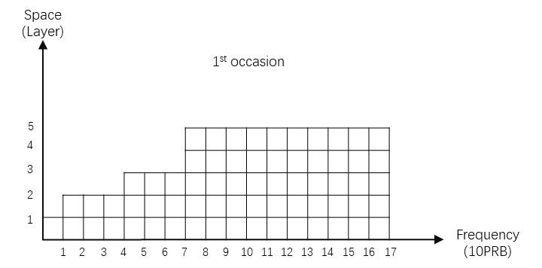

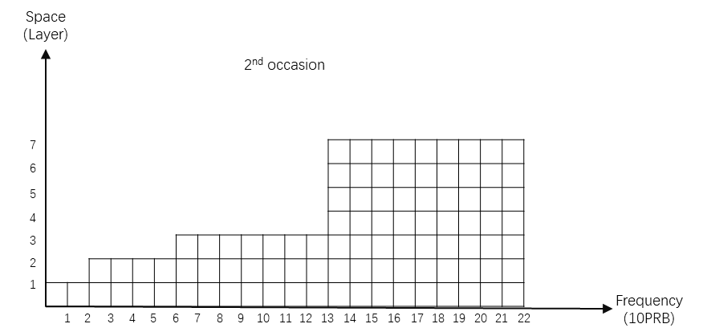

Calculation result:

LM(T) = （5+7）/2=6

$\sum_{∀i}{\sum_{∀j}{\{{M1}_{ij}(T)*L_{ij}(T)\}}}$ = 10*1+30*2+30*3+100*5+20*1+40*2+70*3+90*7=1600

$N\left(T\right)*P\left(T\right)*LM(T)$ = 273*6*3=4914

$M_{E}\left(T\right)$ = 1600/4914=32.56%

**Advantages of the scheme in this proposal**

This scheme has the following technical advantages

1、It provides a detailed, operable and realizable calculation method for the actual space capacity of the cell, and dynamically displays the actual schedulable resources in the space domain of the cell;

2、There is no need to adjust fixed parameter values frequently and repeatedly with different cell scenarios, user distribution or MU-MIMO activation;

3、PRB usage of a single cell will not exceed 100;

4、Considering the actual space capacity of a cell comprehensively, the PRB usage is more reasonable.

# 4 Detailed proposal

**Proposal#** Introduction of enhanced PDSCH PRB Usage per cell for MIMO measurements and enhanced PUSCH PRB Usage per cell for MIMO into TS 28. 552.