3GPP TSG SA WG5 Meeting 140-e TDoc S5-216097

electronic meeting, online, 15 - 24 November 2021

Source: Ericsson

Title: pCR 28.315 Plug and Connect; Procedure flows; Minor updates

Document for: Approval
Agenda Item: 6.4.19

1 Decision/action requested
The meeting is asked to approve this contribution.

2 References
[1] 3GPP TS 28.315 v0.2.0 Management and orchestration; Plug and Connect; Procedure flows.
[2] 3GPP TS 32.160 Management and orchestration; Management service template.

3 Rationale
This contribution contains minor editorial changes for TS 28.315 [1].

4 Detailed proposal
First change

2 References
The following documents contain provisions which, through reference in this text, constitute provisions of the present document.
- References are either specific (identified by date of publication, edition number, version number, etc.) or non-specific.
- For a specific reference, subsequent revisions do not apply.
- For a non-specific reference, the latest version applies. In the case of a reference to a 3GPP document (including a GSM document), a non-specific reference implicitly refers to the latest version of that document in the same Release as the present document.
[1] 3GPP TR 21.905: "Vocabulary for 3GPP Specifications".
[2] 3GPP TS 28.314: " Management and orchestration; Plug and Connect; Concepts and requirements”.
[3] 3GPP TS 28.316: "Management and orchestration; Plug and Connect; Data formats".

Second change

5 Procedure flows

5.1 High-level plug-and-connect
The high level procedure for " plug-and-connect" is described next and illustrated in figure 5.1-1.
Operators may deploy their management infrastructure in different ways. The following options are possible:
- One or multiple SCS for each vendor (e.g. an Initial SCS and zero or more Serving SCS);
- One or more SeGW (e.g. one SeGW for OAM and one or more for each CN, and/or one SeGW per vendor);
- Zero or more IP Autoconfiguration services in the Secure Operator Network;
- Zero or more DNS servers in the Secure Operator Network;
- One or more IP Autoconfiguration services in the External Network / non-Secure Operator Network;
- Zero or more DNS servers in the External Network / non-Secure Operator Network;
- One or more CA/RA (e.g. one per vendor).
Editor’s note: SCS is logical entity which can be applicable to EM in the IRP architecture or MnF in SBMA.
The procedure described in this clause applies to all deployment options listed above.
The procedure begins when the NE is powered up and ends when all mandatory steps in this procedure are completed or when an exception occurs. Examples of NEs are:
- gNB
- eNB
The NE within virtualization is not addressed.
Editor’s Note: This procedure is applicable to RAN NE and maybe applicable to other types of NE in need of plug-and-connect. Other types of NE are FFS.
The pre-conditions for this procedure are:
- The NE is physically installed;
- IP connectivity exists between involved telecom resources (functional elements listed in clause 4.2);
- The involved telecom resources (functional elements listed in clause 4.2) are functional;
- The relevant information is stored and available.
The post-conditions for this procedure are:
- One or more secure connection exists between NE and SCS and the Core Network(s);
- Via the connection to the SCS the NE can receive further instructions to become operational and carry user traffic (e.g. the administrativeState is set to "unlocked").
The exceptions:
- One of the steps outlined in the procedure fails.
Procedure steps:
1) If a VLAN ID is available the NE uses it. Otherwise the NE uses the native VLAN where PnC traffic is sent and received untagged.
2) In this step NE invokes the "Initial IP Autoconfiguration" procedure (described in clause 5.2) and acquires its IP address through stateful or stateless IP Autoconfiguration. There may be additional information provided to the NE.
3) In this step NE invokes the "Certificate Enrolment" procedure (described in clause 5.3).
4) In this step NE invokes the "Establishing Secure Connection" procedure (described in clause 5.4) and connects to the OAM SeGW.
5) In this step NE invokes the "Establishing Connection to SCS" procedure (described in clause 5.5). In this step SCS may provide the NE with new configuration. The configuration may contain an address to another SCS that this specific node shall use as SCS. The configuration may contain an address to another SeGW that should be used before connecting to the SCS.
6) If the configuration obtained in step 5 contains the address or FQDN of the SeGW and/or SCS different from the one that NE is currently connected to, the NE may execute steps 6.1 and 6.2 until the configured SeGW and SCS will match the connected SeGW and SCS. The configuration may also contain OAM VLAN Id to be used from this step onwards.
6.1) In this step, if the NE is connected to the OAM SeGW different from the SeGW that is configured, it releases the connection to the current SeGW and invokes the "Establish Secure Connection" procedure (described in clause 5.4) and connects to the configured SeGW.
6.2) In this step, if the NE is connected to the SCS different from the SCS that is configured, it releases the connection to the current SCS and invokes the "Establish Connection to SCS" procedure (described in clause 5.5) and connects to the configured SCS.
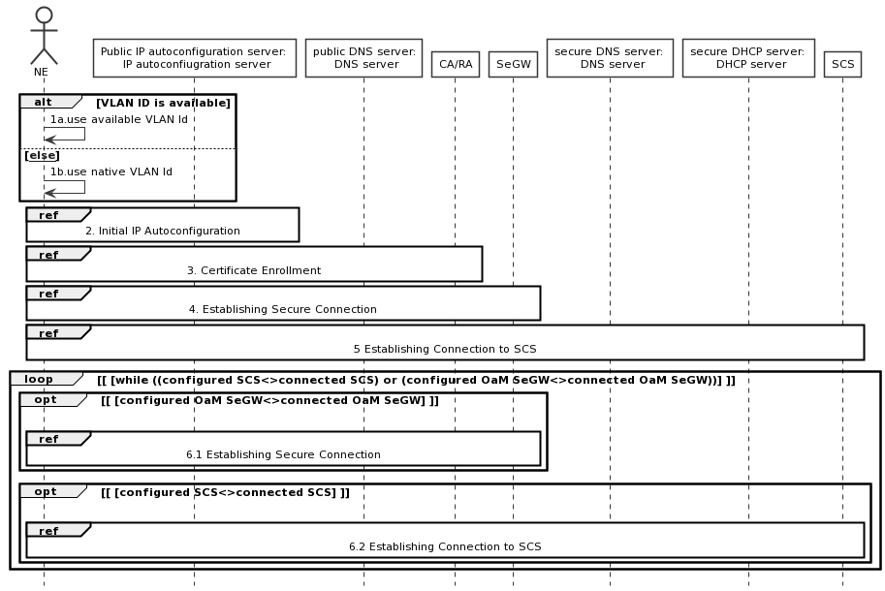
Figure 5.1-1: High-level plug-and-connect flow

5.2 Initial IP Autoconfiguration
The procedure for initial IP Autoconfiguration is described next and illustrated in figure 5.2-1.
Operators may deploy their management infrastructure in different ways. Specifically, the following options are possible:
- IP Autoconfiguration service is configured with basic IP configuration only (e.g. IP address, netmask, gateway, domain name, DNS server address);
- IP Autoconfiguration service is configured with basic IP configuration and the IP address of CA/RA, and other CA/RA attributes defined in TS 28.316 [3] section 4.2.2;
- IP Autoconfiguration service is configured with basic IP configuration and the FQDN of CA/RA, and other CA/RA attributes defined in TS 28.316 [3] section 4.2.2;
- IP Autoconfiguration service is configured with basic IP configuration and the IP addresses of CA/RA and SeGW, and other CA/RA attributes defined in TS 28.316 [3] section 4.2.2;
- IP Autoconfiguration service is configured with basic IP configuration and the FQDNs of CA/RA and SeGW, and other CA/RA attributes defined in TS 28.316 [3] section 4.2.2;
- IP Autoconfiguration service is configured with basic IP configuration and the IP addresses of CA/RA, SeGW and SCS, and other CA/RA attributes defined in TS 28.316 [3] section 4.2.2;
- IP Autoconfiguration service is configured with basic IP configuration and the FQDNs of CA/RA, SeGW and SCS, and other CA/RA attributes defined in TS 28.316 [3] section 4.2.2;
- IP Autoconfiguration service is unable to recognize that the client is an NE performing
the plug-and-connect procedure;
- IP Autoconfiguration service is able to recognize that the client is an NE performing
the plug-and-connect procedure;
- IP Autoconfiguration service is unable to recognize that the client is an NE performing
the plug-and-connect procedure and the specific NE vendor.
The procedure described in this clause applies to all deployment options listed above.
The exceptions:
- One of the steps outlined in the procedure fails.
Procedure steps:
1.1) In this step NE sends a request for IP address configuration to the IP Autoconfiguration service (e.g. DHCP server). The NE may include the vendor specific identifier. The data format used by the NE in this step is specified in 3GPP TS 28.316 [3].
1.2) Depending on the particular operator deployment scenario, the information configured in the IP Autoconfiguration service may be different and the IP Autoconfiguration service may or may not be able to recognize the specific details about the client (whether it is an NE performing plug-and-connect procedure and the specific NE vendor). Therefore, in this step the following replies by the IP Autoconfiguration service are possible:
1.2.a) Client IP configuration only (e.g. IP address, netmask, gateway, domain name, DNS server address);
1.2.b) Client IP configuration and the IP address of CA/RA, and other CA/RA attributes defined in TS 28.316 [3] section 4.2.2;
1.2.c) Client IP configuration and the FQDN of CA/RA, and other CA/RA attributes defined in TS 28.316 [3] section 4.2.2;
1.2.d) Client IP configuration and the IP addresses of CA/RA and SeGW, and other CA/RA attributes defined in TS 28.316 [3] section 4.2.2;
1.2.e) Client IP configuration and the FQDNs of CA/RA and SeGW, and other CA/RA attributes defined in TS 28.316 [3] section 4.2.2;
1.2.f) Client IP configuration and the IP addresses of CA/RA, SeGW and SCS, and other CA/RA attributes defined in TS 28.316 [3] section 4.2.2;
1.2.g) Client IP configuration and the FQDNs of CA/RA, SeGW and SCS, and other CA/RA attributes defined in TS 28.316 [3] section 4.2.2.
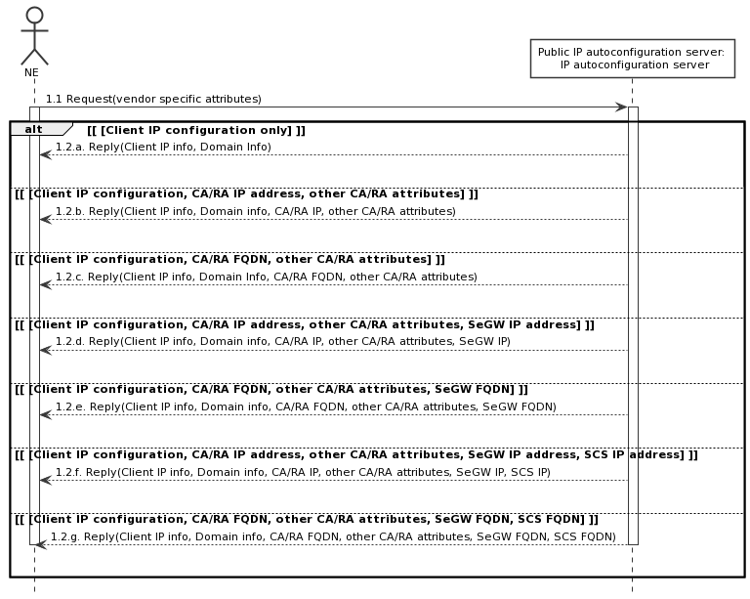
Figure 5.2-1: Initial IP Autoconfiguration flow

Third change

A.5 Establishing connection to Software and Configuration Server (SCS)
The following PlantUML source code is used to describe the procedure for Establishing connection to SCS as depicted by Figure 5.5-1:
@startuml
actor NE

participant "secure DNS server:\n DNS server" as S_DNS_Server
participant "secure DHCP server: \n DHCP server" as S_DHCP_Server
activate NE
opt [ [SCS IP address unavailable] ]
|||
alt [ [Secure DHCP server info available] ]
NE -> S_DHCP_Server: 1.1. Request()
activate S_DHCP_Server
S_DHCP_Server --> NE: 1.2. SCS IP address
deactivate S_DHCP_Server
Else [ [Secure DNS server info available] ]
NE->S_DNS_Server: 2.1. ResolveIP(SCS FQDN)
activate S_DNS_Server
S_DNS_Server->NE: 2.2. SCS IP address
deactivate S_DNS_Server
Else [ [both Secure DHCP and Secure DNS server info available] ]
NE->S_DHCP_Server: 3.1. Request()
activate S_DHCP_Server
S_DHCP_Server->NE: 3.2. SCS FQDN
deactivate S_DHCP_Server
NE->S_DNS_Server: 4.1. ResolveIP(SCS FQDN)
activate S_DNS_Server
S_DNS_Server-->NE: 4.2. SCS IP address
deactivate S_DNS_Server
End
End
NE->SCS: 5.1. Connect()
activate SCS
par
opt [ [Connected SCS has new configuration for this NE] ]
SCS --> NE: 5.2. Configuration
End
opt [ [Connected SCS has new software for this NE] ]
SCS-->NE: 5.3. Software
deactivate SCS
deactivate NE
End
End

hide footbox
skinparam DefaultFontSize 11

skinparam sequenceActorBackgroundColor #FFFFFF
skinparam sequenceParticipantBackgroundColor #FFFFFF
skinparam noteBackgroundColor #FFFFFF
autonumber "#'.'"
skinparam monochrome true
skinparam shadowing false
@enduml

End of changes

