3GPP TSG SA WG5 Meeting 140-e S5-216094

electronic meeting, online, 15– 24th Nov 2021
CR-Form-v12.0
CHANGE REQUEST
 | 28.405 | CR |  | rev |  | Current version: | 16.1.0
For HELP on using this form: comprehensive instructions can be found at
http://www.3gpp.org/Change-Requests.

Proposed change affects: | UICC apps |  | ME |  | Radio Access Network | X | Core Network | X

Title: | Adding Management Based Activation and Temporary stop and restart during RAN overload in NR
Source to WG: | Ericsson
Source to TSG: | S5
Work item code: | eQoE |  |  |  |  |  | Date: |  |  | 2021-11-03
Category: | B |  |  |  |  |  | Release: |  |  | Rel-17
 | Use one of the following categories:  F (correction)  A (mirror corresponding to a change in an earlier release)  B (addition of feature),  C (functional modification of feature)  D (editorial modification)  Detailed explanations of the above categories can  be found in 3GPP TR 21.900. |  |  |  |  |  |  |  | Use one of the following releases:  Rel-8 (Release 8)  Rel-9 (Release 9)  Rel-10 (Release 10)  Rel-11 (Release 11)  …  Rel-15 (Release 15)  Rel-16 (Release 16)  Rel-17 (Release 17)  Rel-18 (Release 18)
Reason for change: |  | The features are missing in the specification
Summary of change: |  | Adding Management Based Activation and Temporary stop and restart during RAN overload in NR. Reference list updated and definition of parameter Slice Scope added.
Consequences if not approved:
Clauses affected: |  | 2, 4.x (new), 4.x.1 (new), 4.x.3 (new), 4.x.3.1 (new) 4.x.3.2 (new), 4.x.4 (new), 5.x (new)
 |  | Y | N
Other specs |  |  | x | Other core specifications |  |  |  | TS/TR ... CR ...
affected: |  |  | x | Test specifications |  |  |  | TS/TR ... CR ...
(show related CRs) |  |  | x | O&M Specifications |  |  |  | TS/TR ... CR ...
Other comments: |  | To be included in a draft CR
This CR's revision history:

First change

2 References

[x] 3GPP TS 38.331: " NR; Radio Resource Control (RRC); Protocol specification".
[y] 3GPP TS 38.413: " NG-RAN; NG Application Protocol (NGAP)".

Next change

4.x Management based activation in NR

4.x.1 Activation of measurement collection job and reporting of collected information in NR
The parameters for the network request session are sent from the management system to the gNBs that host the cells that are included in the collection job request in the activateAreaQMCJob operation [3]. The gNB starts a network request session, with the Network request session id [3] given in activateAreaQMCJob operation [3]. For the duration of the network request session, the gNB(s) checks for connections where the UE has the QoE-MeasReport capability [x] for collection of the Service type in the activateAreaQMCJob. The UE capability is sent from the UE to gNB via the core network in message UE CAPABILITY INFO INDICATION [y].
When a session is found that has a UE with the wanted UE capability, the gNB starts a UE request session and sends a RRCReconfiguration [x] to the UE.
The AT command +CAPPLEVMC [5] activates provisioning of measurement reporting from the lower layers to the application within the UE by an unsolicited result code +CAPPLEVMC. When information about a measurement report is received in the UE from the network, the unsolicited result code +CAPPLEVMC contains the relevant parameters (service_type, start_stop-indication and config-file & config-file length if applicable) that are provided from the lower layers in the UE to the application.

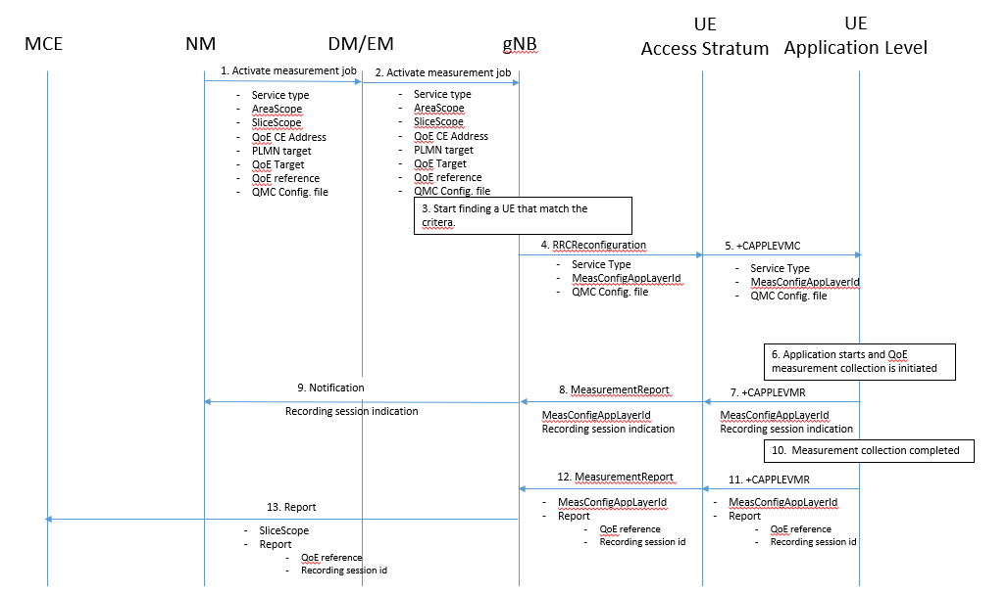
1. The NM sends activateAreaQMCJob to DM/EM that controls the impacted gNB(s), and includes the parameters: serviceType, areaScope, SliceScope, qoECollectionEntityAddress, pLMNTarget, qoETarget, qoEReference and QMC configuration file.
2. The DM/EM forwards activateAreaQMCJob to impacted gNB(s), and includes the parameters: serviceType, areaScope, SliceScope, qoECollectionEntityAddress, pLMNTarget, qoETarget, qoEReference and QMC configuration file.
3. The gNB checks for connections where the UE has the UE capability [y] that match the criteria for serviceType in the activateAreaQMCJob.
4. When a connection is found that has the wanted UE capability [y], the gNB starts a UE request session and stores the associated QoECollectionEntityAddress, sends the message RRCReconfiguration to the UE, and includes the following: serviceType, MeasReportAppLayer and QMC configuration file.
5. The access stratum in the UE sends the AT command +CAPPLEVMC to application level and includes the following: serviceType, MeasReportAppLayer and QMC configuration file.
6. When the application in the serviceType starts, the QMC is initiated.
7. The application layer sends the AT command +CAPPLEVMR MeasReportAppLayer including a recording session indication that indicates that a session is started to the access stratum.
8. The UE sends the message MeasReportAppLayer including the recording session indication to the gNB.
9. The gNB sends a notification including the recording session indication to the NM.
10. When the QMC is completed, the recorded information is collected in a QMC report [6], [7], including qoEReference and recordingSessionId. The qoEReference, Client Id [6] and [7] in the reporting container (that represent the UE request session), and recordingSessionId are needed in the QMC collection entity for post processing purposes.
11. The application layer sends the AT command +CAPPLEVMR including MeasReportAppLayer and the QMC report to the access stratum.
12. The UE sends the message MeasReportAppLayer including MeasReportAppLayer and the QMC report to the gNB.
13. The gNB sends the QMC report to the MCE associated to the qoEReference and SliceScope.

4.x.3 Deactivation of measurement collection job in NR

4.x.3.1 Forced deactivation
When the operator technician or the management application wants to deactivate a measurement collection job, the management system sends the deactivateQMCJob operation [3] to the gNB. The gNB sets the network request session to ended, but does not delete the UE request session id and the Collection Entity Address parameters [3], as the UE still may send reports which shall be send to the collection centre. For UE request sessions which have reported that a recording session is started, the gNB sends the RRCReconfiguration message [x] to relevant UEs. The RRCReconfiguration message is including measConfigAppLayer set to discard application layer measurement report information in otherConfig [x]. The Access stratum sends +CAPPLEVMC AT command [5] to the application with the discard request. The application stops the recording session and stops recording of the requested information. The UE request session id and the Collection Entity Address parameters [3] in the gNB are deleted when the UE request session is ended.

4.x.3.2 Deactivation of recording session
The recording session continues to be active until the session for the application is ended.
Next change

4.x.4 Temporary stop and restart of QoE information reporting during RAN overload in NR
In case of overload in RAN, the gNB may temporarily stop the reporting from the UE by sending the RRCReconfiguration message [x] to relevant UEs. The RRCReconfiguration message [x] is including measConfigAppLayer set to temporarily stop application layer measurement reporting in otherConfig [x]. The Access stratum sends +CAPPLEVMC AT command [5] to the application with the temporary stop request. The application stops the reporting.The application continues recording further information until the data storage capacity in the reporting container is fully used or the UE request session ends. Then the recorded data is kept until it is reported or when the UE request session is ended.
When the overload situation in RAN is ended the gNB restart the reporting from the UE by send the RRCReconfiguration message [x] to relevant UEs. The RRCReconfiguration message is including measConfigAppLayer set to restart application layer measurement reporting in otherConfig [x]. The Access stratum sends +CAPPLEVMC AT command [5] to the application with the restart request. The application restarts the reporting and recording if it was stopped.
Next change

5.x Slice scope (CM)
This parameter contains a list of S-NSSIAs (Single Network Slice Selection Assistance Information). A Network Slice end to end is identified by S-NSSAI.

End change

