3GPP TSG-SA5 Meeting #131e S5-203292

e-meeting 25th May-3rd June 2020

Source: Ericsson, Huawei, Deutsche Telekom

Title: Remove CSI from clause 4.1.1

Document for: Approval
Agenda Item: 6.4.7

1 Decision/action requested
In this box give a very clear / short /concise statement of what is wanted.

2 References
Not applicable

3 Rationale
At the last meeting is was decided that the entity subject to a managed control loop cannot be a communication service instance as we have no definition of communication service instance. The CSI and related terms are used throughout the 28.536 and to avoid misunderstanding the CSI has to be removed or rephrased where applicable.
This contribution proposes to update Figure 4.1.1.1 and remove CSI (5x) from the text.

4 Detailed proposal

4.1.1 Overview of interfaces
Communication service assurance relies on a set of management services that together provide the CSP with the capability to assure the communication service as per agreement with a CSC (e.g. enterprise). The overall solution and information flows between management services and control steps [2] are shown in Figure 4.1.1.1.
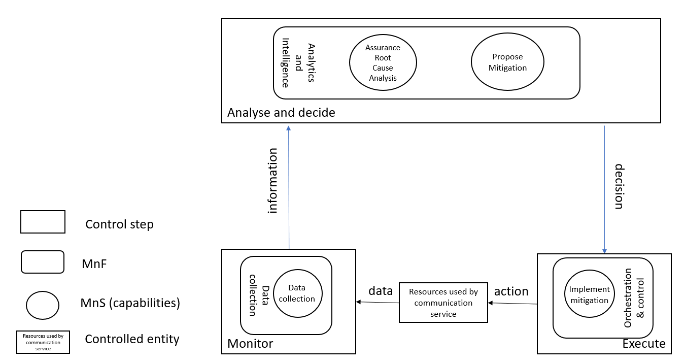
Figure 4.1.1.1 Overview of information flows
In Figure 4.1.1.1 the controlled entity represents the resources used by a communication service and the assurance of this communication service is provided by the loop between the different management services provided by the management system. The input to the loop is the data concerning the resources used by the communication service which is monitored by the control step Monitor and the output of the step “Analysis and Decide” may be a possible action from the control step “Execute”, when for example the service experience degrades, the resources used by a communication service have to be adjusted. The data associated with the communication service is monitored by the management services for data collection and threshold monitoring, the management service provides information to the assurance root cause analysis management service and based on that information the assurance root cause analysis takes place followed by propose mitigation or suggestion to solve the problem. The mitigation or problem-solving suggestion is executed to bring the behaviour of the communication service within the requested boundaries of the metrics (SLS goals) that are controlled by the loop.
The management services available between the control step for “Monitor” and “Analyse” as well as “Decide” are based on file transfer described in 28.550 [3], or data streaming described in 28.550 [3] and notifications described in 28.545 [4].
Editor’s Note: Further details including the relationship between the content of the figure “Overview of information flows”, Trace as well as MDT are FFS

