3GPP TSG-SA5 Meeting #129-e S5-201416

February 24 – 28, 2020 s5-2abcde
CR-Form-v11.4
CHANGE REQUEST
 | 28.541 | CR | 0257 | rev | - | Current version: | 16.3.0
For HELP on using this form: comprehensive instructions can be found at
http://www.3gpp.org/Change-Requests.

Proposed change affects: | UICC apps |  | ME |  | Radio Access Network | X | Core Network

Title: | Add IOCs to support SON functions
Source to WG: | Intel
Source to TSG: | S5
Work item code: | SON_5G |  |  |  |  |  | Date: |  |  | 2020-02-14
Category: | B |  |  |  |  |  | Release: |  |  | Rel-16
 | Use one of the following categories:  F (correction)  A (mirror corresponding to a change in an earlier release)  B (addition of feature),  C (functional modification of feature)  D (editorial modification)  Detailed explanations of the above categories can  be found in 3GPP TR 21.900. |  |  |  |  |  |  |  | Use one of the following releases:  Rel-8 (Release 8)  Rel-9 (Release 9)  Rel-10 (Release 10)  Rel-11 (Release 11)  Rel-12 (Release 12)  Rel-13 (Release 13)  Rel-14 (Release 14)  Rel-15 (Release 15)  Rel-16 (Release 16)
Reason for change: |  | The NRM to support SON functions as defined in TS 28.313 is needed.
Summary of change: |  | Add the following changes:  - SON functions NRM fragment  - IOC MobilityRobustnessOptimization  - IOC RachOptimization  - IOC PCIConfiguration  - SON attributes
Consequences if not approved: |  | The 5G SON functions are not complete.
Clauses affected: |  | 2, 4.2, 4.3, 4.4
 |  | Y | N
Other specs |  |  | X | Other core specifications |  |  |  | TS/TR ... CR ...
affected: |  |  | X | Test specifications |  |  |  | TS/TR ... CR ...
(show related CRs) |  |  | X | O&M Specifications |  |  |  | TS/TR ... CR ...
Other comments:

1st Modified Section

2 References
The following documents contain provisions which, through reference in this text, constitute provisions of the present document.
- References are either specific (identified by date of publication, edition number, version number, etc.) or non-specific.
- For a specific reference, subsequent revisions do not apply.
- For a non-specific reference, the latest version applies. In the case of a reference to a 3GPP document (including a GSM document), a non-specific reference implicitly refers to the latest version of that document in the same Release as the present document.
[1] 3GPP TR 21.905: "Vocabulary for 3GPP Specifications".
[2] 3GPP TS 23.501: "System Architecture for the 5G System".
[3] 3GPP TS 38.300: "NR; Overall description; Stage-2".
[4] 3GPP TS 38.401: "NG-RAN; Architecture description".
[5] 3GPP TS 38.413: "NG-RAN; NG Application Protocol (NGAP)".
[6] 3GPP TS 38.420: "NG-RAN; Xn general aspects and principles".
[7] 3GPP TS 38.470: "NG-RAN; F1 general aspects and principles".
[8] 3GPP TS 38.473: "NG-RAN; F1 application protocol (F1AP)".
[9] 3GPP TS 37.340: "NR; Multi-connectivity; Overall description; Stage 2".
[10] 3GPP TS 28.540: "Management and orchestration; 5G Network Resource Model (NRM);Stage 1".
[11] 3GPP TS 28.662: "Telecommunication management; Generic Radio Access Network (RAN) Network Resource Model (NRM) Integration Reference Point (IRP); Information Service (IS) ".
[12] 3GPP TS 38.104: "NR; Base Station (BS) radio transmission and reception".
[13] 3GPP TS 23.003: "Numbering, Addressing and Identification".
[14] 3GPP TS 36.410: "Evolved Universal Terrestrial Radio Access Network (E-UTRAN); S1 general aspects and principles".
[15] 3GPP TS 36.423: "Evolved Universal Terrestrial Radio Access Network (E-UTRAN); X2 application protocol".
[16] 3GPP TS 36.425: "Evolved Universal Terrestrial Radio Access Network (E-UTRAN); X2 interface user plane protocol".
[17] 3GPP TS 28.625: "State Management Data Definition Integration Reference Point (IRP); Information Service (IS)".
[18] ITU-T Recommendation X.731: "Information technology - Open Systems Interconnection - Systems Management: State management function".
[19] 3GPP TS 28.658: "Telecommunications management; Evolved Universal Terrestrial Radio Access Network (E-UTRAN) Network Resource Model (NRM) Integration Reference Point (IRP): Information Service (IS)".
[20] 3GPP TS 28.702: "Core Network (CN) Network Resource Model (NRM) Integration Reference Point (IRP); Information Service (IS)".
[21] 3GPP TS 28.708: "Telecommunication management; Evolved Packet Core (EPC) Network Resource Model (NRM) Integration Reference Point (IRP): Information Service (IS)".
[22] 3GPP TS 23.040: "Technical realization of the Short Message Service (SMS)".
[23] 3GPP TS 29.510: "5G system; Network Function Repository Services; Stage 3".
[24] 3GPP TS 29.531: "5G System; Network Slice Selection Services Stage 3".
[25] Void.
[26] 3GPP TS 28.531: "Management and orchestration; Provisioning".
[27] 3GPP TS 28.554: "Management and orchestration; 5G End to end Key Performance Indicators (KPI)".
[28] 3GPP TS 22.261: "Service requirements for next generation new services and markets".
[29] ETSI GS NFV-IFA 013 V2.4.1 (2018-02) "Network Function Virtualisation (NFV); Management and Orchestration; Os-Ma-nfvo Reference Point - Interface and Information Model Specification".
[30] 3GPP TS 28.622: "Telecommunication management; Generic Network Resource Model (NRM) Integration Reference Point (IRP); Information Service (IS)".
[31] Void.
[32] 3GPP TS 38.211: "NR; Physical channels and modulation".
[33] 3GPP TS 32.616: "Telecommunication management; Configuration Management (CM); Bulk CM Integration Reference Point (IRP); Solution Set (SS) definitions".
[34] 3GPP TS 28.623: "Telecommunication management; Generic Network Resource Model (NRM) Integration Reference Point (IRP); Solution Set (SS) definitions".
[35] 3GPP TS 28.532: "Management and orchestration; Management services".
[36] Void.
[37] IETF RFC 791: "Internet Protocol".
[38] IETF RFC 2373: "IP Version 6 Addressing Architecture".
[39] IEEE 802.1Q: "Media Access Control Bridges and Virtual Bridged Local Area Networks".
[40] ETSI GR NFV-IFA 015 (V2.4.1): "Network Function Virtualisation (NFV) Release 2; Management and Orchestration; Report on NFV Information Model".
[41] 3GPP TS 38.213: "NR; Physical layer procedures for control".
[42] 3GPP TS 38.101-1: "NR; User Equipment (UE) radio transmission and reception; Part 1: Range 1 Standalone".
[43] 3GPP TS 32.156: "Telecommunication management; Fixed Mobile Convergence (FMC) model repertoire".
[44] IETF RFC 4122: "A Universally Unique IDentifier (UUID) URN Namespace".
[45] IETF RFC 8528: "YANG Schema Mount".
[46] IETF RFC 8340: "YANG Tree Diagrams".
[47] 3GPP TS 32.160: "Management and orchestration; Management Service Template".
[48] 3GPP TS 38.463: "NG-RAN; E1 application protocol (E1AP)".
[x] 3GPP TS 28.313: "Self-Organizing Networks (SON) for 5G networks".

Next Modified Section

4.2 Class diagram

4.2.1 Class diagram for gNB and en-gNB

4.2.1.1 Relationships
This clause depicts the set of classes (e.g. IOCs) that encapsulates the information relevant for this gNB and en-gNB. For the UML semantics, see 3GPP TS 32.156 [43]. Subsequent clauses provide more detailed specification of various aspects of these classes.
The model fragments are for management representation of gNB and en-gNB for all NG-RAN deployment scenario as listed below.
- Non-split NG-RAN deployment senario, represents the gNB defined in TS 38.401[4].
- 2-split NG-RAN deployment scenario, represents the gNB consist of gNB-CU and gNB-DU defined in TS 38.401[4] clause 6.1.1.
- 3-split NG-RAN deployment scenario, represents the gNB consist of gNB-CU-CP, gNB-CU-UP and gNB-DU defined in TS 38.401[4] clause 6.1.2.

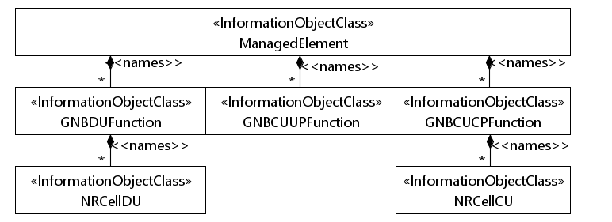
Figure 4.2.1.1-1: NRM for all deployment scenarios
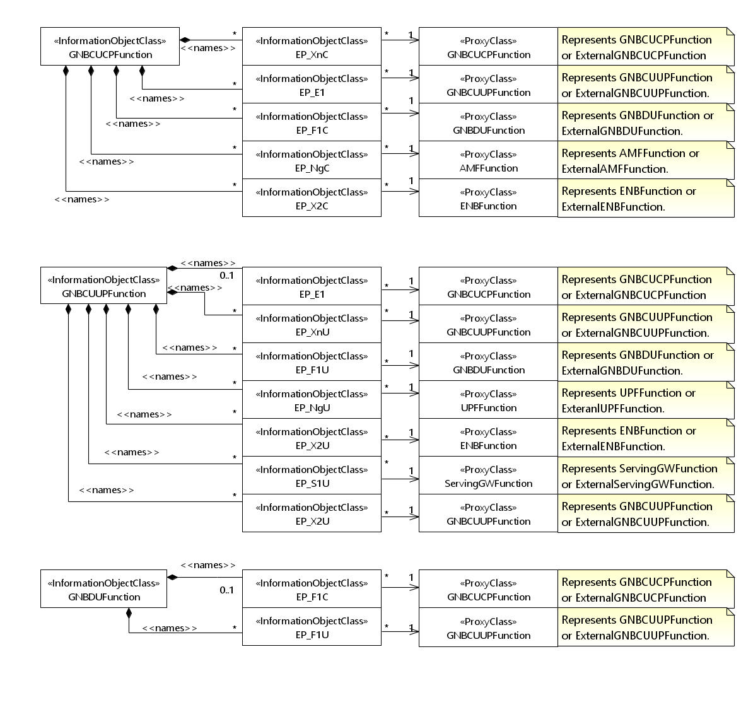
Figure 4.2.1.1-2: NRM for EPs for all deployment scenarios

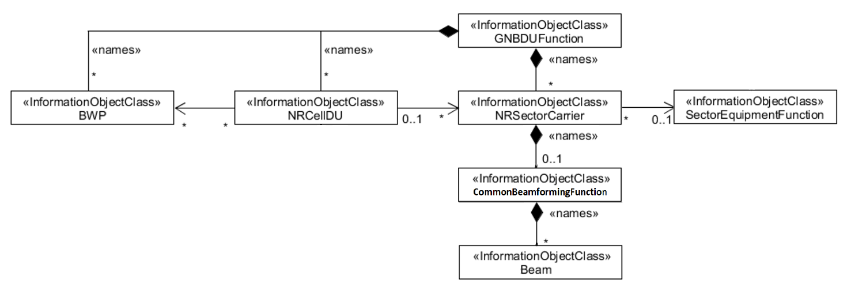
Figure 4.2.1.1-3: NRM for <<IOC>>NRSectorCarrier and <<IOC>>BWP for all deployment scenarios

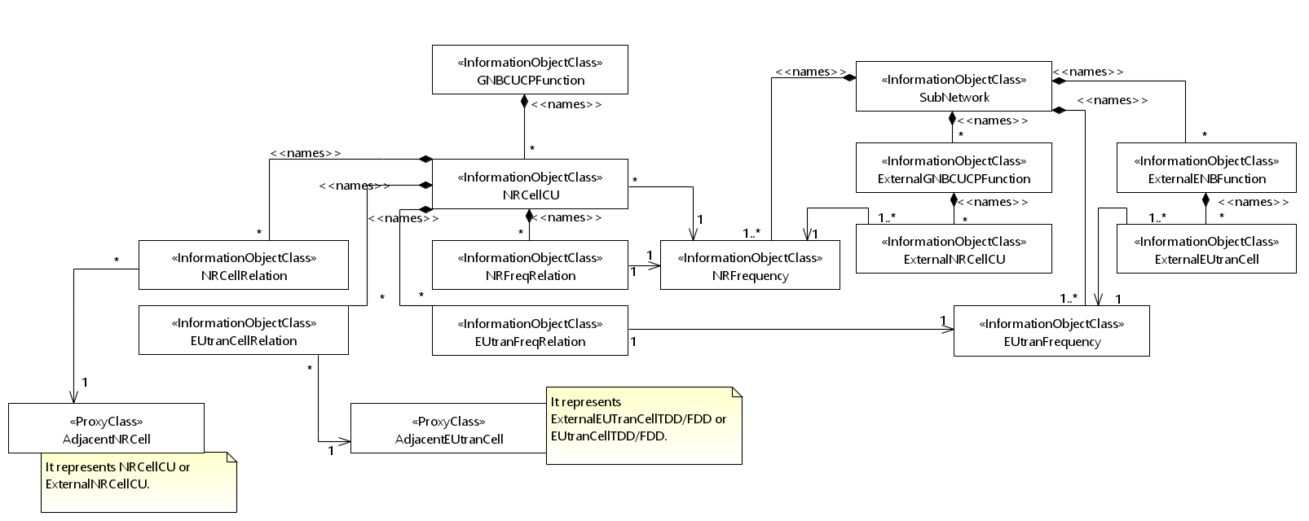
Figure 4.2.1.1-4: Cell Relation view for all deployment scenarios
NOTE 1: The above NRM fragment uses SubNetwork to hold both NR and LTE external entities and frequencies.
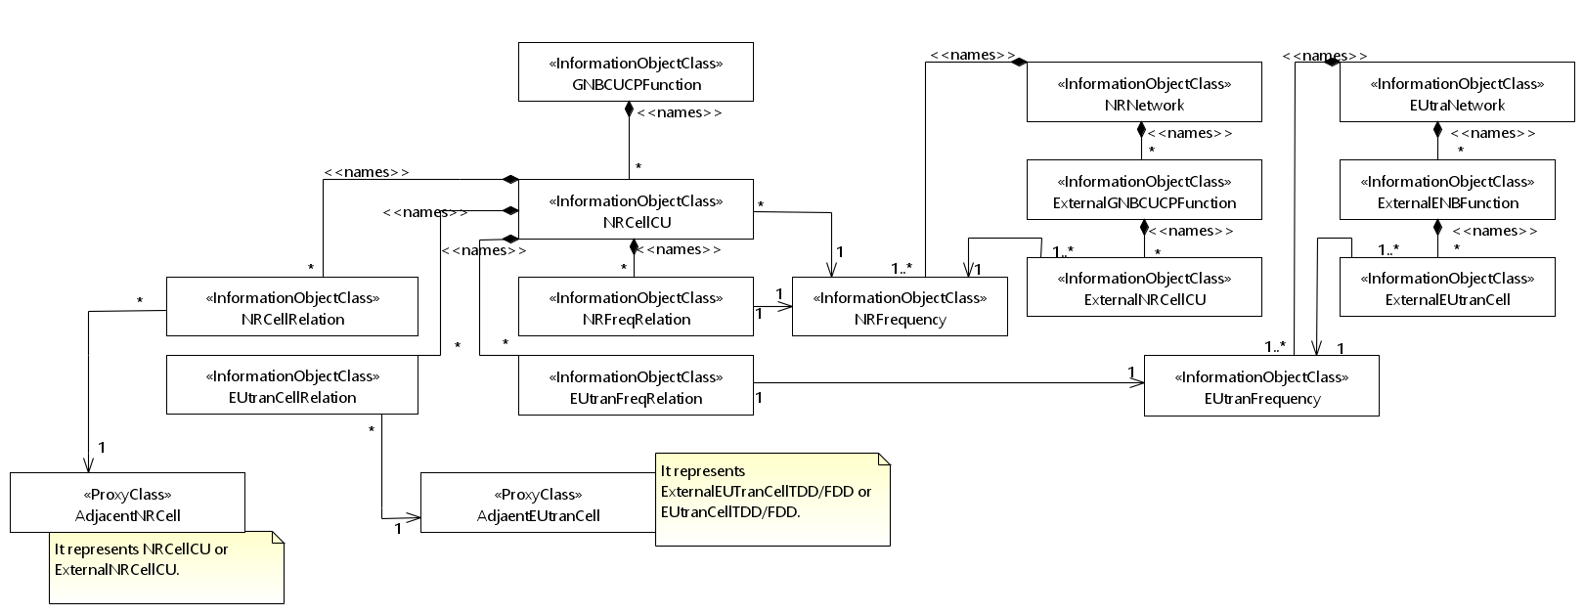
Figure 4.2.1.1-5: Cell Relation view for all deployment scenarios
NOTE 2: The above NRM fragment uses NRNetwork to hold NR external entities and frequency and using EUtraNetwork to hold LTE external entities and frequency. The NRNetwork and EUtraNetwork are subclasses of SubNetwork (defined in TS 28.622 [30]) with no additional attributes. The reason using NRNetwork and EUtraNetwork is for a clean separation of NR external entities and frequency and LTE external entities and frequency.

Figure 4.2.1.1-x: SON functions NRM fragment
NOTE: in the case where an IOC (e.g. RachOptimizationFunction) contained under multiple level of containment tree, IOC at the lowest level (e.g. NRCellCU) overrides the IOCs at higher level(s) of the same containment tree.

4.2.1.2 Inheritance

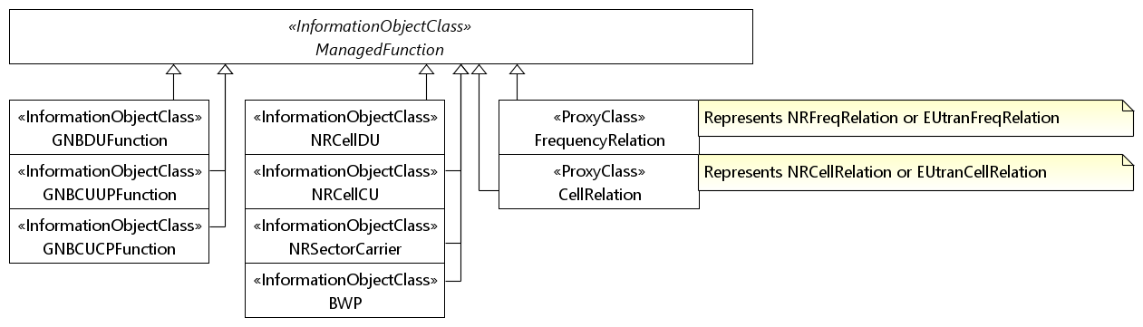
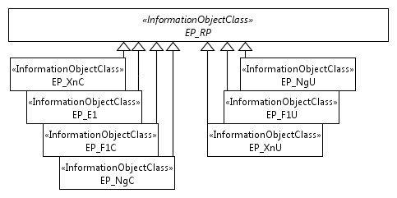
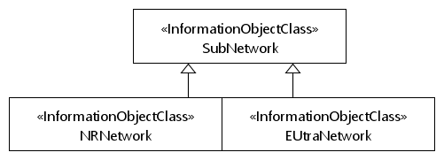

Figure 4.2.1.2-1: Inheritance Hierarchy

Next Modified Section

4.3 Class definitions

4.3.x RachOptimizationFunction

4.3.x.1 Definition
This IOC contains attributes to support the SON function of RACH optimization (See clause 7.1.1 in TS 28.313 [x]).

4.3.x.2 Attributes

Attribute name | Support Qualifier | isReadable | isWritable | isInvariant | isNotifyable
ueAccProbilityDistPerSSB | CM | M | M | - | M
ueAccProbilityDistPerCSI | CM | M | M | - | M
ueAccDelayProbilityDistPerSSB | CM | M | M | - | M
ueAccDelayProbilityDistPerCSI | CM | M | M | - | M
contentiousRACHAttemptsPerSSB | CM | M | M | - | M
contentiousRACHAttemptsPerCSI | CM | M | M | - | M
rachOptimizationControl | CM | M | M | - | M

4.3.x.3 Attribute constraints

Name | Definition
ueAccProbilityDistPerSSB CM Support Qualifier | RACH Optimization is supported
ueAccProbilityDistPerCSI CM Support Qualifier | RACH Optimization is supported
ueAccDelayProbilityDistPerSSB CM Support Qualifier | RACH Optimization is supported
ueAccDelayProbilityDistPerCSI CM Support Qualifier | RACH Optimization is supported
contentiousRACHAttemptsPerSSB CM Support Qualifier | RACH Optimization is supported
contentiousRACHAttemptsPerCSI CM Support Qualifier | RACH Optimization is supported
rachOptimizationControl CM Support Qualifier | RACH Optimization is supported.

4.3.x.4 Notifications
The common notifications defined in subclause 4.5 are valid for this IOC, without exceptions or additions

4.3.y MobilityRobustnessOptimizationFunction

4.3.y.1 Definition
This IOC contains attributes to support the SON function of MRO (See clause 7.1.2 in TS 28.313 [x]).

4.3.y.2 Attributes

Attribute name | Support Qualifier | isReadable | isWritable | isInvariant | isNotifyable
totalHoFailureRate | CM | M | M | - | M
intraRATHoFailureRate | CM | M | M | - | M
intraRATTooEarlyHoFailureRate | CM | M | M | - | M
intraRATTooLateHoFailureRate | CM | M | M | - | M
intraRATHoToWrongCellFailureRate | CM | M | M | - | M
interRATHoFailureRate | CM | M | M | - | M
interRATTooEarlyHoFailureRate | CM | M | M | - | M
interRATTooLateHoFailureRate | CM | M | M | - | M
interRATUnnecessaryHoFailureRate | CM | M | M | - | M
interRATPingPongHoFailureRate | CM | M | M | - | M
mroControl | CM | M | M | - | M

4.3.y.3 Attribute constraints

Name | Definition
totalHoFailureRate CM Support Qualifier | MRO is supported
intraRATHoFailureRate CM Support Qualifier | MRO is supported
intraRATTooEarlyHoFailureRate CM Support Qualifier | MRO is supported
intraRATTooLateHoFailureRate CM Support Qualifier | MRO is supported
intraRATHoToWrongCellFailureRate CM Support Qualifier | MRO is supported
interRATHoFailureRate CM Support Qualifier | MRO is supported
interRATTooEarlyHoFailureRate CM Support Qualifier | MRO is supported
interRATTooLateHoFailureRate CM Support Qualifier | MRO is supported
interRATUnnecessaryHoFailureRate CM Support Qualifier | MRO is supported
interRATPingPongHoFailureRate CM Support Qualifier | MRO is supported
mroControl CM Support Qualifier | MRO is supported

4.3.y.4 Notifications
The common notifications defined in subclause 4.5 are valid for this IOC, without exceptions or additions

4.3.z DSONPciCIConfigurationFunction

4.3.z.1 Definition
This IOC contains attributes to support the D-SON function of PCI configuration (See clause 7.1.3 in TS 28.313 [x]).

4.3.z.2 Attributes

Attribute name | Support Qualifier | isReadable | isWritable | isInvariant | isNotifyable
dSONPciConfigurationControl | CM | M | M | - | M
pciList | CM | M | M | - | M

4.3.z.3 Attribute constraints

Name | Definition
dSONPpciConfigurationControl CM Support Qualifier | D-SON PCI configuration is supported
pciList CM Support Qualifier | D-SON PCI configuration is supported

4.3.z.4 Notifications
The common notifications defined in subclause 4.5 are valid for this IOC, without exceptions or additions

4.3.w CSONPciConfigurationFunction

4.3.w.1 Definition
This IOC contains attributes to support the C-SON function of PCI configuration (See clause 7.1.3 in TS 28.313 [x]).

4.3.w.2 Attributes

Attribute name | Support Qualifier | isReadable | isWritable | isInvariant | isNotifyable
cSONPciConfigurationControl | CM | M | M | - | M
nrCellpciValue | CM | M | M | - | M
csonPciList | CM | M | M | - | M

4.3.w.3 Attribute constraints

Name | Definition
cSONPciConfigurationControl CM Support Qualifier | C-SON PCI configuration is supported
nrCellpciValue CM Support Qualifier | C-SON PCI configuration is supported
csonPciList CM Support Qualifier | C-SON PCI configuration is supported

4.3.w.4 Notifications
The common notifications defined in subclause 4.5 are valid for this IOC, without exceptions or additions

4.3.v DSONPciConfigControlFunction

4.3.v.1 Definition
This <<IOC>> DSONPciConfigControlFunction represents the control information of D-SON PCI configuration.

4.3.v.2 Attributes
The DSONPciConfigControlFunction IOC includes attributes inherited from Top IOC (defined in TS 28.622[30]) and the following attributes:
Attribute name | Support Qualifier | isReadable | isWritable | isInvariant | isNotifyable
dsonPciConfigurationSwitch | CM | M | M | - | M

4.3.v.3 Attribute constraints
Name | Definition
dsonPciConfigurationSwitch CM Support Qualifier | D-SON PCI configuration is supported
.

4.3.v.4 Notifications
The common notifications defined in subclause X.1.5 are valid for this IOC, without exceptions or additions.

Next Modified Section

5.4 Attribute definitions

5.4.1 Attribute properties
The following table defines the attributes that are present in several Information Object Classes (IOCs) of the present document.
Attribute Name |  | Documentation and Allowed Values |  | Properties
aMFIdentifier |  | The AMFI is constructed from an AMF Region ID, an AMF Set ID and an AMF Pointer. The AMF Region ID identifies the region, the AMF Set ID uniquely identifies the AMF Set within the AMF Region, and the AMF Pointer uniquely identifies the AMF within the AMF Set. (Ref. 3GPP TS 23.003 [13]) |  | type: Integer  multiplicity: 1  isOrdered: N/A  isUnique: N/A  defaultValue: None  allowedValues: N/A  isNullable: False
aMFSetId |  | It represents the AMF Set ID, which is uniquely identifies the AMF Set within the AMF Region.  allowedValues: defined in subclause 2.10.1 of 3GPP TS 23.003 [13]. |  | type: Integer  multiplicity: 1  isOrdered: N/A  isUnique: N/A  defaultValue: None  allowedValues: N/A  isNullable: False
aMFSetMemberList |  | It is the list of DNs of AMFFunction instances of the AMFSet.  allowedValues: N/A |  | type: DN  multiplicity: 1  isOrdered: N/A  isUnique: True  defaultValue: None  isNullable: False
aMFRegionId |  | It represents the AMF Region ID, which identifies the region.  allowedValues: defined in subclause 2.10.1 of 3GPP TS 23.003 [13]. |  | type: Integer  multiplicity: 1  isOrdered: N/A  isUnique: N/A  defaultValue: None  allowedValues: N/A  isNullable: False
localAddress | This parameter specifies the localAddress including IP address and VLAN ID used for initialization of the underlying transport.  First string is IP address, IP address can be an IPv4 address (See RFC 791 [37]) or an IPv6 address (See RFC 2373 [38]).  Second string is VLAN Id (See IEEE 802.1Q [39]). |  | type: String  multiplicity: 2  isOrdered: True  isUnique: N/A  defaultValue: None  isNullable: False
remoteAddress | Remote address including IP address used for initialization of the underlying transport.  IP address can be an IPv4 address (See RFC 791 [37]) or an IPv6 address (See RFC 2373 [38]). |  | type: String  multiplicity: 1  isOrdered: N/A  isUnique: N/A  defaultValue: None  isNullable: False
nfProfileList |  | It is a set of NFProfile(s) to be registered in the NRF instance. NFProfile is defined in 3GPP TS 29.510 [23]. |  | type: <<dataType>>  multiplicity: *  isOrdered: N/A  isUnique: N/A  defaultValue: None  allowedValues: N/A  isNullable: False
nSIIdList |  | It is a set of NSI Id. The NSI ID is defined in subclause 6.1.6.2.8 of 3GPP TS 29.531 [24]. |  | type: String  multiplicity: *  isOrdered: N/A  isUnique: N/A  defaultValue: None  allowedValues: N/A  isNullable: False
sNSSAIList |  | See subclause 4.4.1.
sBIFQDN |  | It is used to indicate the FQDN of the registered NF instance in service-based interface, for example, NF instance FQDN structure is:  nftype<nfnum>.slicetype<sliceid>.mnc<MNC>.mcc<MCC>.3gppnetwork.org |  | type: String  multiplicity: 1  isOrdered: N/A  isUnique: N/A  defaultValue: None  allowedValues: N/A  isNullable: False
sBIServiceList |  | It is used to indicate the all supported NF services registered on service-based interface. |  | type: String  multiplicity: *  isOrdered: N/A  isUnique: N/A  defaultValue: None  allowedValues: N/A  isNullable: False
nRTACList |  | It is the list of Tracking Area Codes (either legacy TAC or extended TAC).  allowedValues:  Legacy TAC and Extended TAC are defined in clause 9.3.3.10 of TS 38.413 [5]. |  | type: Integer  multiplicity: 1..*  isOrdered: N/A  isUnique: N/A  defaultValue: None  allowedValues: N/A  isNullable: False
supportedBMOList |  | It is used to indicate the list of supported BMOs (Bridge Managed Objects) required for integration with TSN system. |  | type: String  multiplicity: *  isOrdered: N/A  isUnique: N/A  defaultValue: None  allowedValues: N/A  isNullable: False
managedNFProfile |  | This parameter defines profile for managed NF (See TS 23.501 [22]).  allowedValues: N/A |  | type: ManagedNFProfile  multiplicity: 1  isOrdered: N/A  isUnique: N/A  defaultValue: None  allowedValues: N/A  isNullable: False
nfInstanceID |  | This parameter defines unique identity of the NF Instance. The format of the NF Instance ID shall be a Universally Unique Identifier (UUID) version 4, as described in IETF RFC 4122 [44]  allowedValues: N/A |  | type: String  multiplicity: 1  isOrdered: F  isUnique: N/A  defaultValue: None  isNullable: False
nfType |  | This parameter defines type of Network Function  allowedValues: See TS 23.501[22] for NF types |  | type: ENUM  multiplicity: 1..*  isOrdered: N/A  isUnique: N/A  defaultValue: None  isNullable: False
fqdn |  | This parameter defines FQDN of the Network Function (See TS 23.003 [5])  allowedValues: N/A |  | type: String  multiplicity: 1  isOrdered: F  isUnique: N/A  defaultValue: None  isNullable: False
ipAddress |  | This parameter defines IP Address of the Network Function. It can be IPv4 address (See RFC 791 [24]) or IPv6 address (See RFC 2373 [25]).  allowedValues: N/A |  | type: String  multiplicity: 1  isOrdered: F  isUnique: N/A  defaultValue: None  isNullable: False
authzInfo |  | This parameter defines NF Specific Service authorization information. It shall include the NF type (s) and NF realms/origins allowed to consume NF Service(s) of NF Service Producer (See TS 23.501[22]).  allowedValues: N/A |  | type: String  multiplicity: 1  isOrdered: F  isUnique: N/A  defaultValue: None  isNullable: True
locality |  | The parameter defines information about the location of the NF instance (e.g. geographic location, data center) defined by operator (See TS 29.510[23]).  allowedValues: N/A |  | type: String  multiplicity: 1  isOrdered: F  isUnique: N/A  defaultValue: None  isNullable: True
capacity |  | This parameter defines static capacity information in the range of 0-65535, expressed as a weight relative to other NF instances of the same type; if capacity is also present in the nfServiceList parameters, those will have precedence over this value (See TS 29.510[23])  allowedValues: 0-65535 |  | type: Integer  multiplicity: 1  isOrdered: N/A  isUnique: N/A  defaultValue: None  allowedValues: N/A  isNullable: False
nFInfo |  | This parameter includes NF specific data in Managed NF profile  allowedValues: N/A |  | type: NFInfo  multiplicity: 1  isOrdered: N/A  isUnique: N/A  defaultValue: None  allowedValues: N/A  isNullable: False
hostAddr |  | This parameter defines host address of a NF  allowedValues: N/A |  | type: HostAddr  multiplicity: 1  isOrdered: N/A  isUnique: N/A  defaultValue: None  allowedValues: N/A  isNullable: False
priority |  | This parameter defines Priority (relative to other NFs of the same type) in the range of 0-65535, to be used for NF selection; lower values indicate a higher priority. If priority is also present in the nfServiceList parameters, those will have precedence over this value (See TS 29.510[23]).  allowedValues: 0-65535 |  | type: Integer  multiplicity: 1  isOrdered: N/A  isUnique: N/A  defaultValue: None  allowedValues: N/A  isNullable: False
supportedDataSetIds |  | This parameter defines list of supported data sets in the UDR instance (See TS 29.510[23]).  allowedValues: "SUBSCRIPTION", "POLICY", EXPOSURE", "APPLICATION" |  | type: ENUM  multiplicity: 1..*  isOrdered: N/A  isUnique: False  defaultValue: None  isNullable: False
nFSrvGroupId |  | This parameter defines identity of the group that is served by the NF instance (See TS 29.510[23]).  allowedValues: N/A |  | type: String  multiplicity: 1  isOrdered: F  isUnique: N/A  defaultValue: None  isNullable: False
smfServingAreas |  | This parameter defines the SMF service area(s) the UPF can serve (See TS 29.510[23]).  allowedValues: N/A |  | type: String  multiplicity: 1..*  isOrdered: F  isUnique: True  defaultValue: None  isNullable: False
isRemoveAllowed |  | This indicates if the subject NRCellRelation can be removed (deleted) or not.  If YES, the subject NRCellRelation instance can be removed (deleted).  If NO, the subject NRCellRelation instance shall not be removed (deleted) by any entity but an MnS consumer.  allowedValues: YES, NO |  | type: ENUM  multiplicity: 1  isOrdered: N/A  isUnique: N/A  defaultValue: None  isNullable: False
isHOAllowed |  | This indicates if HO is allowed or prohibited.  If YES, handover is allowed from source cell to target cell. The source cell is identified by the name-containing NRCellCU of the NRCellRelation that contains the isHOAllowed. The target cell is referenced by the NRCellRelation that contains this isHOAllowed.  If NO, handover shall not be allowed.  allowedValues: YES, NO |  | type: ENUM  multiplicity: 1  isOrdered: N/A  isUnique: N/A  defaultValue: None  isNullable: False
x2BlackList |  | This is a list of DNs of NRCellCU and ExternalNRCellCU. If the target node DN is a member of the source node’s NRCellCU.x2BlackList, the source node is:  1) Prohibited from sending X2 connection request to target node;  2) Forced to tear down established X2 connection to target node  3) Not allowed to accept incoming X2 connection request from target node.  The same DN may appear here and in NRCellCU.x2WhiteList. In such case, the DN in x2WhiteList shall be treated as if it is absent. |  | type: DN  multiplicity: 1..*  isOrdered: False  isUnique: True  defaultValue: None  isNullable: False
xnBlackList |  | This is a list of DNs of NRCellCU and ExternalNRCellCU. If the target node DN is a member of the source node’s NRCellCU.xnBlackList, the source node is:  1) Prohibited from sending Xn connection request to target node;  2) Forced to tear down established Xn connection to target node  3) Not allowed to accept incoming Xn connection request from target node.  The same DN may appear here and in NRCellCU.xnWhiteList. In such case, the DN in xnWhiteList shall be treated as if it is absent. |  | type: DN  multiplicity: 1..*  isOrdered: False  isUnique: True  defaultValue: None  isNullable: False
x2WhiteList |  | This is a list of DNs of NRCellCU and ExternalNRCellCU. If the target node DN is a member of the source node’s NRCellCU.x2WhiteList, the source node:  - is allowed to request the establishment of X2 connection with the target node;  - is not allowed to initiate the tear down of established X2 connection to target node  The same DN may appear here and in NRCellCU.x2BlackList. In such case, the DN here shall be treated as if it is absent. |  | type: String  multiplicity: 1..*  isOrdered: False  isUnique: True  defaultValue: None  isNullable: False
xnWhiteList |  | This is a list of DNs of NRCellCU and ExternalNRCellCU. If the target node DN is a member of the source node’s NRCellCU.xnWhiteList, the source node:  - is allowed to request the establishment of Xn connection with the target node;  - is not allowed to initiate the tear down of established Xn connection to target node  The same DN may appear here and in NRCellCU.xnBlackList. In such case, the DN here shall be treated as if it is absent. |  | type: String  multiplicity: 1..*  isOrdered: False  isUnique: True  defaultValue: None  isNullable: False
x2XnHOBlackList |  | This is a list of DNs of any number and combination of cells represented by the following IoCs:  NRCellCU  ExternalNRCellCU.  ExternalEUtranCellTDD  ExternalEUtranCellFDD  EUtranCellTDD  EUtranCellFDD  For all the entries in NRCellCU.x2XnHOBlackList, the subject NRCellCU is prohibited to use the X2 or Xn interface for HOs even if an X2 or Xn interface exists to the target cell. |  | type: DN  multiplicity: 1..*  isOrdered: False  isUnique: True  defaultValue: None  isNullable: False
groupId |  | This parameter identiies a list of target NF services on which the same communication model is applied to.  allowedValues: N/A |  | type: Integer  multiplicity: 1  isOrdered: N/A  isUnique: False  defaultValue: None  isNullable: False
commModelType |  | This parameter defines communication model used by a NF to interact with NF service(s) (See TS 23.501 [2]).  allowedValues:”DIRECT_COMMUNICATION_WO_NRF”, “DIRECT_COMMUNICATION_WITH_NRF”, “INDIRECT_COMMUNICATION_WO_DEDICATED_DISCOVERY”, “INDIRECT_COMMUNICATION_WITH_DEDICATED_DISCOVERY” |  | type: ENUM  multiplicity: 1  isOrdered: N/A  isUnique: N/A  defaultValue: None  allowedValues: N/A  isNullable: False
targetNFServiceList |  | This parameter lists target NF services sharing same communication model and configuration.  allowedValues: N/A |  | type: DN  multiplicity: 1..*  isOrdered: F  isUnique: N/A  defaultValue: None  isNullable: False
commModelConfiguration |  | This parameter defines configuration parameters for specific communication model for a group of NF Services.  allowedValues: N/A |  | type: String  multiplicity: 1  isOrdered: N/A  isUnique: N/A  defaultValue: None  allowedValues: N/A  isNullable: False
supportedFuncList |  | This parameter lists functionalities supported by a SCP. Refer to TS 23.501 [2]. |  | type: SupportedFunction  multiplicity: 1..*  isOrdered: N/A  isUnique: False  defaultValue: None  isNullable: False
address |  | This parameter defines address of a SCP instance, it can be IP address (either IPv4 address (See RFC 791 [24]) or IPv6 address (See RFC 2373 [25])) or FQDN (See TS 23.003 [5]). |  | type: Integer  multiplicity: 1  isOrdered: N/A  isUnique: N/A  defaultValue: None  allowedValues: N/A  isNullable: False
function |  | This parameter defines name of a functionality supported by a SCP. |  | type: String  multiplicity: 1  isOrdered: F  isUnique: N/A  defaultValue: None  isNullable: False
policy |  | This parameter defines configuration policies of a functionality supported by a SCP. |  | type: String  multiplicity: 1  isOrdered: N/A  isUnique: N/A  defaultValue: None  allowedValues: N/A  isNullable: False
capabilityList |  | This parameter lists capabilities supported by a NEF. Refer to TS 23.501 [2].  allowedValues: N/A |  | type: String  multiplicity: 1..*  isOrdered: N/A  isUnique: False  defaultValue: None  isNullable: False
isINEF |  | This parameter defines if the NEF is an Intermediate NEF.  allowedValues: TRUE, FALSE |  | type: Boolean  multiplicity: 1  isOrdered: N/A  isUnique: N/A  defaultValue: None  allowedValues: N/A  isNullable: False
isCAPIFSup |  | This parameter defines if the NEF support Common API Framework.  allowedValues: TRUE, FALSE |  | type: Boolean  multiplicity: 1  isOrdered: F  isUnique: N/A  defaultValue: None  isNullable: False
sEPPType |  | This parameter defines the type of a SEPP entity. Refer to TS 33.501 [52].  allowedValues: “CSEPP”, “PSEPP” |  | type: ENUM  multiplicity: 1  isOrdered: N/A  isUnique: False  defaultValue: None  isNullable: False
sEPPId |  | This parameter is identifier of a SEPP, it is unique inside a PLMN.  allowedValues: N/A |  | type: Integer  multiplicity: 1  isOrdered: N/A  isUnique: N/A  defaultValue: None  allowedValues: N/A  isNullable: False
remotePlmnId |  | This parameter defines PLMNId of the remote SEPP.  allowedValues: N/A |  | Type: PLMNId  multiplicity: 1  isOrdered: N/A  isUnique: N/A  defaultValue: None  isNullable: False
remoteSeppAddress |  | This parameter defines address of the remote SEPP. It can be IP address (either IPv4 address (See RFC 791 [24]) or IPv6 address (See RFC 2373 [25])) or FQDN(See TS 23.003 [5]).  allowedValues: N/A |  | type: String  multiplicity: 1  isOrdered: F  isUnique: N/A  defaultValue: None  isNullable: False
remoteSeppId |  | This parameter defines identifier of the remote SEPP. it is unique inside a PLMN.  allowedValues: N/A |  | type: Integer  multiplicity: 1  isOrdered: N/A  isUnique: N/A  defaultValue: None  allowedValues: N/A  isNullable: False
n32cParas |  | This attribute is used to configure parameters to establish security link between two SEPPs.  allowedValues: N/A |  | type: String  multiplicity: 1  isOrdered: F  isUnique: N/A  defaultValue: None  isNullable: False
n32fPolicy |  | This attribute is used to configure policies to protect the messages exchanged between SEPPs.  allowedValues: N/A |  | type: String  multiplicity: 1  isOrdered: F  isUnique: N/A  defaultValue: None  isNullable: False
withIPX |  | This attribute defines if there’s an IPX interconnected between two SEPPs.  allowedValues: TRUE, FALSE |  | type: Boolean  multiplicity: 1  isOrdered: N/A  isUnique: N/A  defaultValue: None  allowedValues: N/A  isNullable: False
totalHoFailureRate |  | This indicates the target of the number of handover failure events divided by the total number of handover events, together with its targetWeight.  This target is suitable for MRO or LBO.  allowedValues:  hoFailureRate:  Integer 1..100 (percentage).  targetWeight:  Integer 1..N. The higher the number the higher the weight. |  | type: <<data type>>  multiplicity: 0..*  isOrdered: N/A  isUnique: N/A  defaultValue: None  isNullable: True
intraRATHoFailureRate |  | This indicates the assigned target of the number of handover failure events divided by the total number of intra-RAT handover events, together with its targetWeight.  This target is suitable for MRO or LBO.  allowedValues:  hoFailureRate:  Integer 1..100 (percentage).  targetWeight:  Integer 1..N. The higher the number the higher the weight. |  | type: <<data type>>  multiplicity: 0..*  isOrdered: N/A  isUnique: N/A  defaultValue: None  isNullable: True
intraRATTooEarlyHoFailureRate |  | This indicates the assigned target of the number of too early handover failure events divided by the total number of intra-RAT handover events, together with its targetWeight.  This target is suitable for MRO or LBO.  allowedValues:  hoFailureRate:  Integer 1..100 (percentage).  targetWeight:  Integer 1..N. The higher the number the higher the weight. |  | type: <<data type>>  multiplicity: 0..*  isOrdered: N/A  isUnique: N/A  defaultValue: None  isNullable: True
intraRATTooLateHoFailureRate |  | This indicates the assigned target of the number of too late handover failure events divided by the total number of intra-RAT handover events, together with its targetWeight.  This target is suitable for MRO or LBO.  allowedValues:  hoFailureRate:  Integer 1..100 (percentage).  targetWeight:  Integer 1..N. The higher the number the higher the weight. |  | type: <<data type>>  multiplicity: 0..*  isOrdered: N/A  isUnique: N/A  defaultValue: None  isNullable: True
intraRATHoToWrongCellFailureRate |  | This indicates the assigned target of the number of handover to wrong cell failure events divided by the total number of intra-RAT handover events, together with its targetWeight.  This target is suitable for MRO or LBO.  allowedValues:  hoFailureRate:  Integer 1..100 (percentage).  targetWeight:  Integer 1..N. The higher the number the higher the weight. |  | type: <<data type>>  multiplicity: 0..*  isOrdered: N/A  isUnique: N/A  defaultValue: None  isNullable: True
interRATHoFailureRate |  | This indicates the assigned target of the number of handover failure events divided by the total number of inter-RAT handover events, together with its targetWeight.  This target is suitable for MRO or LBO.  allowedValues:  hoFailureRate:  Integer 1..100 (percentage).  targetWeight:  Integer 1..N. The higher the number the higher the weight. |  | type: <<data type>>  multiplicity: 0..*  isOrdered: N/A  isUnique: N/A  defaultValue: None  isNullable: True
interRATTooEarlyHoFailureRate |  | This indicates the assigned target of the number of too early handover failure events divided by the total number of inter-RAT handover events, together with its targetWeight.  This target is suitable for MRO or LBO.  allowedValues:  hoFailureRate:  Integer 1..100 (percentage).  targetWeight:  Integer 1..N. The higher the number the higher the weight. |  | type: <<data type>>  multiplicity: 0..*  isOrdered: N/A  isUnique: N/A  defaultValue: None  isNullable: True
interRATTooLateHoFailureRate |  | This indicates the assigned target of the number of too late handover failure events divided by the total number of inter-RAT handover events, together with its targetWeight.  This target is suitable for MRO or LBO.  allowedValues:  hoFailureRate:  Integer 1..100 (percentage).  targetWeight:  Integer 1..N. The higher the number the higher the weight. |  | type: <<data type>>  multiplicity: 0..*  isOrdered: N/A  isUnique: N/A  defaultValue: None  isNullable: True
interRATUnnecessaryHoFailureRate |  | This indicates the assigned target of the number of unnecessary handover failure events divided by the total number of inter-RAT handover events, together with its targetWeight.  This target is suitable for MRO or LBO.  allowedValues:  hoFailureRate:  Integer 1..100 (percentage).  targetWeight:  Integer 1..N. The higher the number the higher the weight. |  | type: <<data type>>  multiplicity: 0..*  isOrdered: N/A  isUnique: N/A  defaultValue: None  isNullable: True
interRATPingPongHoFailureRate |  | This indicates the assigned target of the number of ping-pong handover failure events divided by the total number of inter-RAT handover events, together with its targetWeight.  This target is suitable for MRO or LBO.  allowedValues:  hoFailureRate:  Integer 1..100 (percentage).  targetWeight:  Integer 1..N. The higher the number the higher the weight. |  | type: <<data type>>  multiplicity: 0..*  isOrdered: N/A  isUnique: N/A  defaultValue: None  isNullable: True
mroControl |  | This attribute determines whether the MRO function is enabled or disabled.  allowedValues: On, Off |  | type: <<enumeration>>  multiplicity: 1  isOrdered: N/A  isUnique: N/A  defaultValue: None  isNullable: True
pciList |  | This holds a list of physical cell identities that can be assigned to the NR cells.  This attribute shall be supported if D-SON PCI configuration function is supported. See subclause 8.2.3, 8.3.1 in TS 28.313 [x].  allowedValues: See TS 38.211 [32] subclause 7.4.2 for legal values of pci. The number of pci in the list is 0 to 1007. |  | type: Integer  multiplicity: 1..*  isOrdered: N/A  isUnique: N/A  defaultValue: None  isNullable: False
dSONPciConfigurationControl |  | This attribute determines whether the D-SON PCI configuration function at NR cell DU is enabled or disabled.  allowedValues: On, Off |  | type: <<enumeration>>  multiplicity: 1  isOrdered: N/A  isUnique: N/A  defaultValue: None  isNullable: True
nrCellpciValue |  | This holds the physical cell identities that can be assigned to a NR cell.  This attribute shall be supported if C-SON PCI configuration function is supported. See subclause 8.2.3, 8.3.1 in TS 28.313 [x].  allowedValues: See TS 38.211 [32] subclause 7.4.2 for legal values of pci. The number of pci in the list is 0 to 1007. |  | type: Integer  multiplicity: 1  isOrdered: N/A  isUnique: N/A  defaultValue: None  isNullable: False
cSONPciConfigurationControl |  | This attribute determines whether the C-SON PCI configuration function is enabled or disabled.  allowedValues: On, Off |  | type: <<enumeration>>  multiplicity: 1  isOrdered: N/A  isUnique: N/A  defaultValue: None  isNullable: True
dsonPciConfigurationSwitch |  | This attribute determines whether the D-SON PCI configuration Function at NR cell CU is activated or deactivated.  allowedValues: On, Off |  | type: boolean  multiplicity: 1  isOrdered: N/A  isUnique: N/A  defaultValue: None  isNullable: True
csonPciList |  | This holds a list of physical cell identities that can be assigned to the pci attribute by gNB. The assignment algorithm is not specified.  This attribute shall be supported if and only if the Domain-Centralized is supported. See TS 28.313, ref [X] subclause 7.1.3.  allowedValues: See TS 38.211 [32] subclause 7.4.2.1 for legal values of pci. The number of pci in the list is 1 to 100X. |  | type: Integer  multiplicity: 1..*  isOrdered: N/A  isUnique: N/A  defaultValue: None  isNullable: False
ueAccProbilityDistPerSSB |  | This is a list of target Access Probability (AP_{n}) for the RACH optimization function.  Each instance AP_{n} of the list is the probability that the UE gets access on the RACH channel per SSB within n number of preambles sent over an unspecified sampling period.  This target is suitable for RACH optimization.  allowedValues: Each element of the list, AP_{n,} is a pair (a, n) where a is the targetProbability (in %) and n is the number of preambles sent.  The legal values for a are 25, 50, 75, 90.  The legal values for n are 1 to 200.  The number of elements specified is 4. The number of elements supported is vendor specific. The choice of supported values for a and n is vendor-specific. |  | type: <<data type>>  multiplicity: 0..*  isOrdered: N/A  isUnique: N/A  defaultValue: None  isNullable: True
ueAccProbilityDistPerCSI |  | This is a list of target Access Probability (AP_{n}) for the RACH optimization function.  Each instance AP_{n} of the list is the probability that the UE gets access on the RACH channel per CSI within n number of preambles sent over an unspecified sampling period.  This target is suitable for RACH optimization.  allowedValues: Each element of the list, AP_{n,} is a pair (a, n) where a is the targetProbability (in %) and n is the number of preambles sent.  The legal values for a are 25, 50, 75, 90.  The legal values for n are 1 to 200.  The number of elements specified is 4. The number of elements supported is vendor specific. The choice of supported values for a and n is vendor-specific. |  | type: <<data type>>  multiplicity: 0..*  isOrdered: N/A  isUnique: N/A  defaultValue: None  isNullable: True
ueAccDelayProbilityDistPerSSB |  | This is a list of target Access Delay probability (AD_{P}) for the RACH optimization function.  Each instance AD_{P} of the list is the target time before the UE gets access on the RACH channel per SSB, for the P percent of the successful RACH Access attempts with lowest access delay, over an unspecified sampling period.  This target is suitable for RACH optimization.  allowedValues: Each element of the list, AD_{p,} is a pair (p, d) where p is the targetProbability (in %) and d is the access delay (in milliseconds).  The legal values for p are 25, 50, 75, 90.  The legal values for d are 10 to 560.  The number of elements specified is 4. The number of elements supported is vendor specific. The choice of supported values for a and b is vendor-specific. |  | type: <<data type>>  multiplicity: 0..*  isOrdered: N/A  isUnique: N/A  defaultValue: None  isNullable: True
ueAccDelayProbilityDistPerCSI |  | This is a list of target Access Delay probability (AD_{P}) for the RACH optimization function.  Each instance AD_{P} of the list is the target time before the UE gets access on the RACH channel per CSI, for the P percent of the successful RACH Access attempts with lowest access delay, over an unspecified sampling period.  This target is suitable for RACH optimization.  allowedValues: Each element of the list, AD_{p,} is a pair (p, d) where p is the targetProbability (in %) and d is the access delay (in milliseconds).  The legal values for p are 25, 50, 75, 90.  The legal values for d are 10 to 560.  The number of elements specified is 4. The number of elements supported is vendor specific. The choice of supported values for a and b is vendor-specific. |  | type: <<data type>>  multiplicity: 0..*  isOrdered: N/A  isUnique: N/A  defaultValue: None  isNullable: True
contentiousRACHAttemptsPerSSB |  | This indicates the assigned target of the number of RACH attempts with contention detected divided by the total number of RACH attempts for each SSB.  This target is suitable for RACH optimization.  allowedValues:  Integer 1..100 |  | type: <<data type>>  multiplicity: 0..*  isOrdered: N/A  isUnique: N/A  defaultValue: None  isNullable: True
contentiousRACHAttemptsPerCSI |  | This indicates the assigned target of the number of RACH attempts with contention detected divided by the total number of RACH attempts for each CSI.  This target is suitable for RACH optimization.  allowedValues:  Integer 1..100 |  | type: <<data type>>  multiplicity: 0..*  isOrdered: N/A  isUnique: N/A  defaultValue: None  isNullable: True
rachOptimizationControl |  | This attribute determines whether the RACH Optimization function is enabled or disabled.  allowedValues: On, Off |  | type: <<enumeration>>  multiplicity: 1  isOrdered: N/A  isUnique: N/A  defaultValue: None  isNullable: True

End of Modified Sections

