**3GPP TSG- Meeting # *r01***

**, , -**

|  |  |  |  |  |  |  |  |  |
| --- | --- | --- | --- | --- | --- | --- | --- | --- |
| *CR-Form-v12.3* | | | | | | | | |
| **CHANGE REQUEST** | | | | | | | | |
|  | | | | | | | | |
|  |  | **CR** |  | **rev** |  | **Current version:** |  |  |
|  | | | | | | | | |
| *For* [***HE******LP***](http://www.3gpp.org/3G_Specs/CRs.htm#_blank)*on using this form: comprehensive instructions can be found at* [*http://www.3gpp.org/Change-Requests*](http://www.3gpp.org/Change-Requests)*.* | | | | | | | | |
|  | | | | | | | | |

|  |  |  |  |  |  |  |  |  |
| --- | --- | --- | --- | --- | --- | --- | --- | --- |
| ***Proposed change affects:*** | UICC apps |  | ME | **X** | Radio Access Network |  | Core Network | **X** |

|  |  |  |  |  |  |  |  |  |  |  |
| --- | --- | --- | --- | --- | --- | --- | --- | --- | --- | --- |
|  | | | | | | | | | | |
| ***Title:*** |  | | | | | | | | | |
|  |  | | | | | | | | | |
| ***Source to WG:*** |  | | | | | | | | | |
| ***Source to TSG:*** | S4 | | | | | | | | | |
|  |  | | | | | | | | | |
| ***Work item code:*** |  | | | | |  | ***Date:*** | | |  |
|  |  | | | |  | |  | | |  |
| ***Category:*** | **F** |  | | | | | ***Release:*** | | |  |
|  | *Use one of the following categories:* ***F*** *(correction)* ***A*** *(mirror corresponding to a change in an earlier release)* ***B*** *(addition of feature),* ***C*** *(functional modification of feature)* ***D*** *(editorial modification)*  Detailed explanations of the above categories can be found in 3GPP [TR 21.900](http://www.3gpp.org/ftp/Specs/html-info/21900.htm). | | | | | | | | *Use one of the following releases: Rel-8 (Release 8) Rel-9 (Release 9) Rel-10 (Release 10) Rel-11 (Release 11) … Rel-17 (Release 17) Rel-18 (Release 18) Rel-19 (Release 19)  Rel-20 (Release 20)* | |
|  |  | | | | | | | | | |
| ***Reason for change:*** | | Reference point M10 is currently only defined for downlink Media AS service chaining (M10d). This introduces inconsistencies around service chaining on the uplink. Defining M10u for uplink Media AS service chaining addresses these inconsistencies. This CR also aligns TS 26.501 with changes proposed in TS 26.510 CR 0016 and TS 26.512 CR 0086. | | | | | | | | |
|  | |  | | | | | | | | |
| ***Summary of change:*** | | Definition of reference point M10u (service chaining interface) within the 5GMSu architecture and its use within the 5GMSu uplink procedures. | | | | | | | | |
|  | |  | | | | | | | | |
| ***Consequences if not approved:*** | | Inconsistencies concerning reference point M10 remain and use cases requiring uplink service chaining are not supported. | | | | | | | | |
|  | |  | | | | | | | | |
| ***Clauses affected:*** | | 4.1.2.4, 4.3.1, 6.1 | | | | | | | | |
|  | |  | | | | | | | | |
|  | | **Y** | **N** |  | | | |  | | |
| ***Other specs*** | | **X** |  | Other core specifications | | | | TS 26.510 CR 0016, TS 26.512 CR 0086 | | |
| ***affected:*** | |  | **X** | Test specifications | | | |  | | |
| ***(show related CRs)*** | |  | **X** | O&M Specifications | | | |  | | |
|  | |  | | | | | | | | |
| ***Other comments:*** | |  | | | | | | | | |
|  | |  | | | | | | | | |
| ***This CR's revision history:*** | | S4aI250097: Agreed at S4 MBS SWG AHG meeting on July 10, 2025.  S4-251278: Resubmission for agreement. | | | | | | | | |

===== CHANGE =====

Table 4.1.2.4-1 Mapping of 5GMS reference points to generalized Media Delivery architecture

|  |  |  |
| --- | --- | --- |
| Generalized Media Delivery architecture reference point | 5GMSd reference point | 5GMSu reference point |
| M1 | M1d | M1u |
| M2 | M2d | M2u |
| M3 | M3d | M3u |
| M4 | M4d | M4u |
| M5 | M5d | M5u |
| M6 | M6d | M6u |
| M7 | M7d | M7u |
| M8 | M8d | M8u |
| M9 | Not defined | Not defined |
| M10 | M10d | M10u |
| M11 | M11d | M11u |
| M12 | Not defined | Not defined |
| M13 | M13d | M13u |

===== CHANGE =====

## 4.3 Uplink 5G Media Streaming architecture

### 4.3.1 Media architecture

The 5GMSu Application Provider uses 5GMSu functions for uplink streaming services. It provides a 5GMSu-Aware Application on the UE the ability to make use of 5GMSu Client and network functions using 5GMSu interfaces and APIs.



Figure 4.3.1-1: Media architecture for unicast uplink media streaming

NOTE 1: The functions indicated by the yellow filled boxes are in scope of stage 3 specifications for 5GMS. The functions indicated by the grey boxes are defined in 5G System specifications. The functions indicated by the blue boxes are neither in scope of 5G Media Streaming nor 5G System specifications.

The architecture in figure 4.3.1-1 above represents the specified 5GMSu functions within the 5G System (5GS) as defined in TS 23.501 [2]. Three main functions are defined:

- **5GMSu AF:** An Application Function similar to that defined in TS 23.501 [2] clause 6.2.10, dedicated to 5G Uplink Media Streaming.

- **5GMSu AS:** An Application Server dedicated to 5G Uplink Media Streaming.

NOTE 2: When a 5GMSd AS ingests content directly from a 5GMSu AS, the 5GMSu AS plays the role of a 5GMSd Application Provider. For more details of this scenario, see clause A.15.3.

- **5GMSu Client:** A UE-internal function dedicated to 5G Uplink Media Streaming.

5GMSu AF and 5GMSu AS are Data Network (DN) functions and communicate with the UE via reference point N6 as defined in TS 23.501 [2].

Functions in trusted DNs, e.g., a 5GMSu AF in the Trusted DN, are trusted by the operator's network as illustrated in figure 4.2.3-5 of TS 23.501 [2]. Therefore, such AFs may directly communicate with relevant 5G Core functions.

Functions in external DNs, e.g., a 5GMSu AF in the External DN, may only communicate with 5G Core functions via the NEF using reference point N33.

The architecture in figure 4.3.1-2 below represents the media architecture connecting UE internal functions and related network functions for 5G Uplink Media Streaming.



**Figure 4.3.1-2: Media architecture for unicast uplink media streaming**

NOTE 2: The functions indicated by the yellow filled boxes are in scope of stage 3 for 5GMSu. The functions indicated by the grey boxes are defined in 5GS. The interfaces indicated by solid lines are in scope of stage 3 for 5GMSu. The interfaces indicated by dashed lines are defined in 5GS. The interfaces indicated by dotted lines are neither in scope of 5GS nor 5GMSu, but are considered as part of informative call flows.

NOTE 3: Red ovals indicate API provider functions.

NOTE 4: The 5GMSu AF may also interact with the NEF for NEF-enabled API access. However, within Release 16, the NEF is only used by the 5GMSu AF to interact with the Policy and Charging Function (PCF) in 5GMS specifications.

NOTE 5: Some information might also be exchanged between 5GMSu entities and the OAM, although the OAM is not explicitly shown in the architecture.

The following functions are defined:

- 5G Media Streaming Client for uplink (**5GMSu Client**) on UE: Originator of 5GMSu service that may be accessed through well-defined interfaces/APIs. The UE may also be implemented in a self-contained manner such that interfaces M6u and M7u are not exposed at all.

- The 5GMSu Client contains two subfunctions:

- **Media Session Handler:** A function on the UE that communicates with the 5GMSu AF in order to establish, control and support the delivery of a media session, and that may perform QoE metrics reporting. The Media Session Handler exposes APIs that can be used by the 5GMSu-Aware Application. The Media Session Handler may be launched by a 3GPP-defined Service URL (see clause 4.10).

- **Media Streamer:** A function on the UE that communicates with the 5GMSu AS in order to perform real-time or non-real-time uplink streaming of media content and provides a service to both the 5GMSu-Aware Application for media capturing and uplink streaming and the Media Session Handler for media session control.

- **5GMSu-Aware Application:** The 5GMSu Client is typically controlled by an external media application, e.g. an App, which implements external application or content service provider specific logic and enables a media session to be established. The 5GMSu-Aware Application is not defined within the 5G Media Streaming specifications, but the function makes use of 5GMSu Client and network functions using 5GMSu interfaces and APIs.

- **5GMSu AS:** An Application Server which hosts 5G media functions. Note that there may be different realizations of a 5GMSu AS, for example a Content Delivery Network (CDN) server.

- **5GMSu Application Provider:** External application or content-specific media functionality, e.g., media storage, consumption, transcoding and redistribution that uses 5GMSu interfaces to receive streaming media from 5GMSu Aware Applications.

- **5GMSu AF:** An Application Function that provides various control functions to the Media Session Handler on the UE and/or to the 5GMSu Application Provider. It may relay or initiate a request for different Policy or Charging Function (PCF) treatment or interact with other network functions via the NEF.

NOTE 6: There may be multiple 5GMSu AFs present in a deployment and residing within the Data Network, each exposing one or more APIs.

The following interfaces are defined for 5G Uplink Media Streaming:

- M1u (5GMSu Provisioning API): External API, exposed by the 5GMSu AF and which enables the 5GMSu Application Provider to provision the usage of the 5G Media Streaming system for uplink media streaming and to obtain feedback.

- M2u (5GMSu Publish API): Optional External API exposed by the 5GMSu AS used when the 5GMSu AS in the trusted DN is selected to receive the content for the streaming service.

- M3u: Internal API used by a 5GMSu AF to configure and manage a 5GMSu AS instance.

- M4u (Uplink Media Streaming APIs): APIs exposed by a 5GMSu AS to the Media Streamer to stream media content.

- M5u (Media Session Handling API): APIs exposed by a 5GMSu AF to the Media Session Handler for media session handling, control and assistance that also include appropriate security mechanisms e.g. authorization and authentication, and QoE metrics reporting.

- M6u (UE Media Session Handling APIs): APIs that may be exposed by a Media Session Handler to the Media Streamer for client-internal communication, and to the 5GMSu-Aware Application to make use of 5GMSu functions. This API may be supported by a 3GPP-defined Service URL (see clause 4.10).

- M7u (UE Media Streamer APIs): APIs that may be exposed by a Media Streamer to the 5GMSu-Aware Application and Media Session Handler to make use of the Media Streamer, including configuration of QoE metrics to be measured and logged, and the collection of metrics measurement logs.

- M8u: (Application API): application interface used for information exchange between the 5GMSu-Aware Application and the 5GMSu Application Provider, for example to provide Service Access Information to the 5GMSu-Aware Application. This API is external and not specified in the 5GMS architecture.

- M10u: (Service Chaining Interface): Interface between one instance of the 5GMSu AS and another for the purposes of distributed service chaining.

- M11u (UE Media Session Handling and Media Streamer APIs): APIs exposed by the Media Session Handler and Media Streamer to each other for the purpose of client-internal communication.

- M13u (External uplink Media Streaming interface): Interface exposed by the 5GMSu Application Provider to the Media Streamer to stream media. This reference point is not further defined by the present document.

NOTE 7: Non-Standalone, Roaming, Non-3GPP Access and EPC-5GC interworking aspects are FFS.

===== CHANGE =====

# 6 Procedures for uplink media streaming

## 6.1 General

The procedures for uplink media streaming allow a 5GMSu Application Provider to create, modify, establish and delete sessions. Uplink media streaming sessions exist between a 5GMSu Client and a 5GMSu AS.

The uplink streaming procedures follow a general high-level workflow, starting from provisioningto the actual uplink streaming sessions. The Egest Session refers to the time period during which media content is uplink streamed to the 5GMSu AS and optionally egested from there to the 5GMS Application Provider. The Provisioning Session refers to the time period during which the 5GMSu Client is permitted to upload stream media content. Interactions between the 5GMSu AF and the 5GMSu Application Provider may occur at any time while the Provisioning Session is active.

The 5GMSu Provisioning API allows the selection of Media Session Handling (M5u) and Uplink Streaming (M4u) options, including whether the media content is published to trusted 5GMSu ASs. The 5GMSu AF selects the M5u interface according to the provisioning option. The Media Session Handling interface exposed by the 5GMSu AF can be used for metrics reporting, requesting different policy and charging treatments, or 5GMSu AF-based Network Assistance.

When the 5GMSu AF and 5GMSu AS reside in the same DN, then the 5GMSu AF selects the 5GMSu AS. Interactions between a 5GMSu AF and a 5GMSu AS (M3u interactions) take place for Content Egest (M2u) and Uplink Streaming (M4u) resource reservations. The 5GMSu AS allocates M2u and M4u resources and communicates resource identifiers back to the 5GMSu AF. The 5GMSu AF provides information about the provisioned resources (in the form of resource identifiers) for Media Session Handling, Content Egest, and Uplink Streaming to the 5GMSu Application Provider. The resource identifiers for Media Session Handling and Uplink Streaming are needed by the 5GMSu Client to access the selected features.

5GMSu Client can (in principle) start the uplink streaming by activating its uplink streaming session. The uplink streaming session for a given UE (or for each UE) is active from the time at which the 5GMSu-Aware Application activates the transmission of an uplink streaming service until its termination.

The 5GMSu-Aware Application receives application metadata from the 5GMSu Application Provider before transmitting the uplink streaming media. The application metadata contains Service Access Information, which acts as an entry point for the 5GMSu Client to start the uplink streaming session. The 5GMSu Client may either receive the Service Access Information from the 5GMSu Application Provider (using a not standardized interface) or instructions for a remote-control session through the 5GMS-Aware Application.

The Network Assistance (NA) feature enables a UE that is receiving an uplink media stream to improve the QoE of the media streaming session, by being able to make use of two distinct facilities.

The first facility is **bit rate recommendation** (**throughput estimation**). This enables the UE to start an uplink streaming session at the most appropriate bit rate for the network conditions at hand, or to obtain a recommendation from the network which will remain valid until further notice during a media streaming session. The recommended bit rate is based on network estimations or predictions of available link bandwidth. This function is provided as an additional tool to support the UE, in addition to the common approach of the UE performing its own estimation based on measurement of the uplink traffic in the past.

The second facility is the **delivery boost**. The 5GMSu Client uses this function to indicate to the network that a temporary boost, i.e., a temporary increase of network throughput for this client is needed, for example in order to prevent the uplink media streaming buffer in the Media Streamer from overflowing.

Network Assistance may be offered to the UE in one of two ways:

- Based on interaction between the UE and the 5GMSu AF, with a subsequent interaction between the 5GMSu AF and the PCF (or the NEF), as defined in clause 6.5.

- Based on interaction between the UE and the RAN, re-using the ANBR-based RAN signalling as defined in clause 6.7.

The UE shall not use both approaches on the same Network Assistance session.

Figure 6.1-1 provides a basic high-level call flow for uplink streaming. The corresponding collaboration scenario is defined in clause A.10.

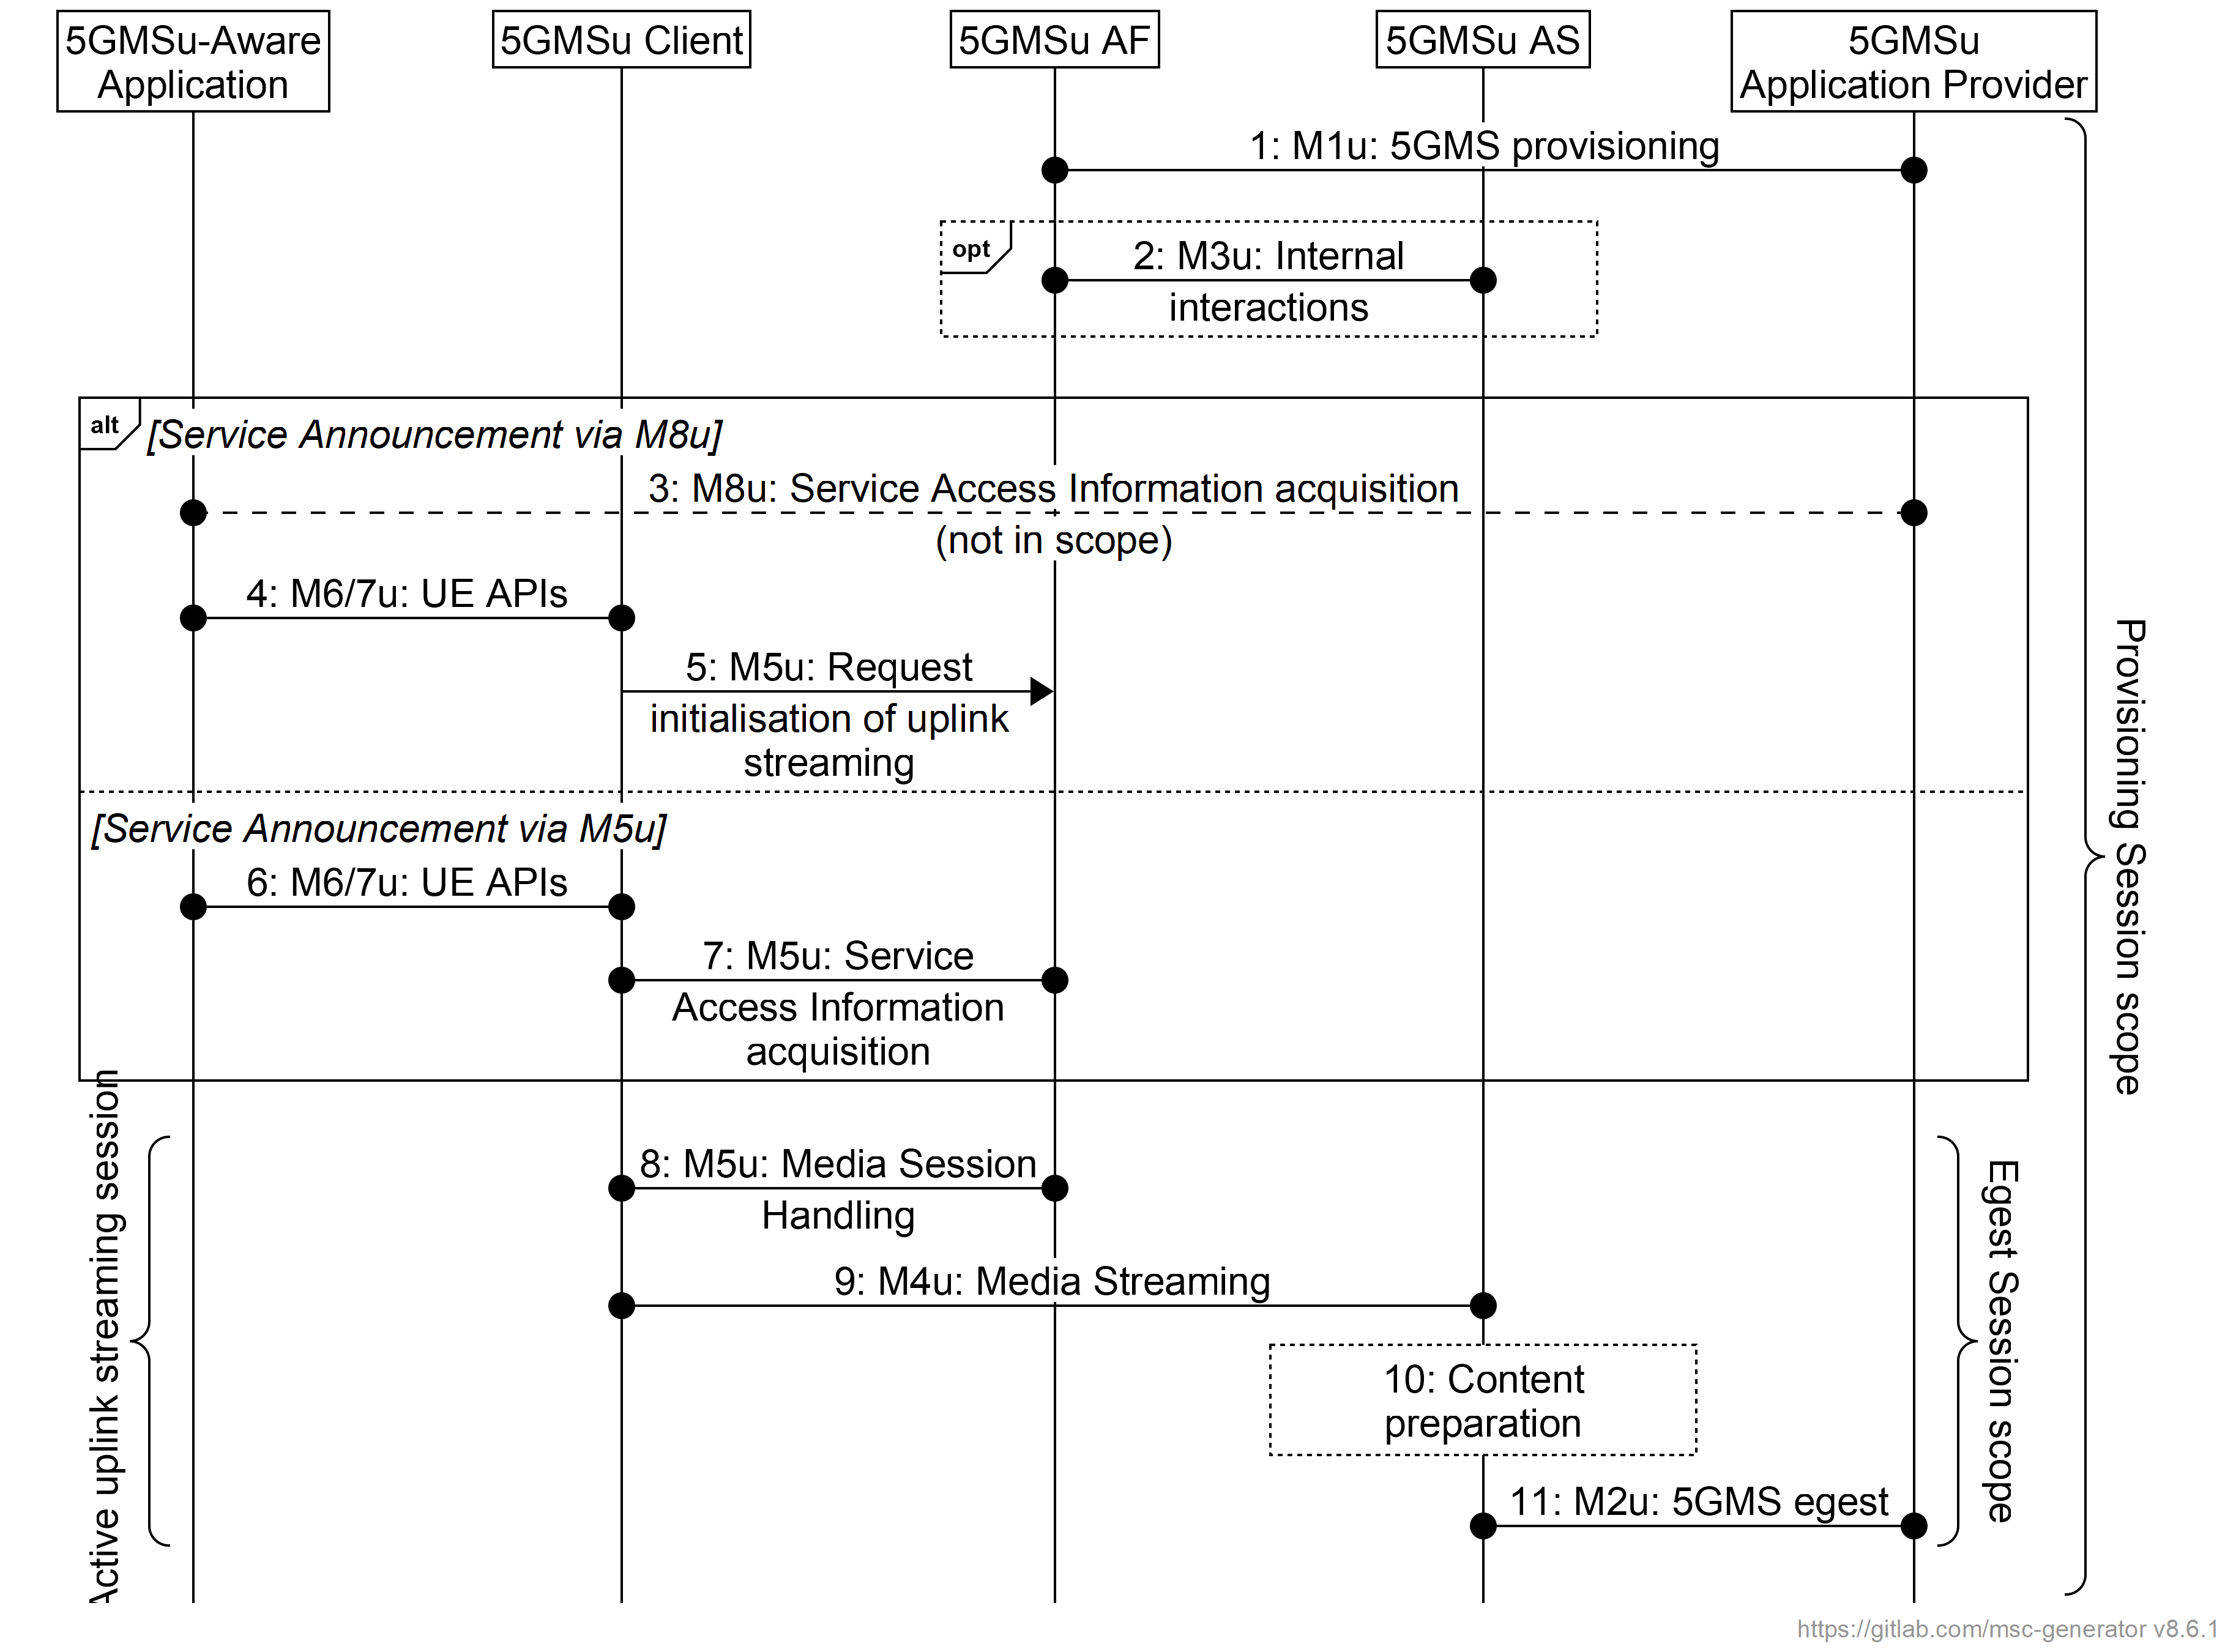

Figure 6.1-1: High-level call flow for uplink media streaming

Steps:

1. The 5GMSu Application Provider provisions the 5GMSu AF at reference point M1u, including a Content Publishing Configuration for content egest and, optionally, Content Preparation Templates.

2. When Content Publishing is offered and selected, there may be interactions between the 5GMSu AF and the 5GMSu AS at reference point M3u, e.g., to configure Server Certificates and/or Content Preparation Templates and to confirm the availability of resources for Content Preparation and Content Egest by providing a Content Publishing Configuration (defined in clause 6.2.3). The 5GMSu AS provides resource identifiers for the allocated resources to the 5GMSu AF, which then provides the information to the 5GMSu Application Provider.

At some later point in time:

3. The 5GMSu Application Provider provides Service Access Information to the 5GMS-Aware Application at reference point M8u.

4. When the 5GMSu-Aware Application decides to activate an uplink media streaming session, the Service Access Information is provided to the 5GMSu Client.

5. The 5GMSu Client requests the 5GMSu AF to initialise uplink media streaming (M5u).

Alternatively:

6. The 5GMS-Aware Application requests the 5GMSu Client to start an uplink streaming session (M6u/M7u).

7. The 5GMSu Client requests Service Access Information from the 5GSMu AF at reference point M5u.

Then:

8. The 5GMSu Client starts the Egest Session by activating the uplink streaming session.

9. Uplink media streaming starts from the 5GMSu Client to the 5GMSu AS via reference point M4u.

10. If content preparation was provisioned in step 1, the uplinked media may be manipulated by the 5GMSu AS prior to egest.

11. Media streaming egest starts from the 5GMSu AS to the 5GMSu Application Provider at reference point M2u.

NOTE: Media may be egested from one 5GMSu AS instance to another at reference point M10u prior to egest to the 5GMSu Application Provider at reference point M2u.

Clauses A.11 to A.15 define additional collaboration scenarios for uplink streaming. The call flow for each collaboration scenario is also included in each clause.