**3GPP TSG-SA WG4 Meeting #131S4-250194**

**Geneva, Switzerland, 17 – 21 February 2025**

**Source: InterDigital Canada**

**Title: [FS_ARSpatial] Pseudo-CR on Call Flow for Spatial Computing Sessions**

**Spec: 3GPP TR 26.819**

**Agenda item: 9.9**

**Document for: Agreement**

**1. Introduction**

The Study on Spatial Computing for AR Services (FS_ARSpatial) was approved during SA#104 meeting. The objectives of the study include identifying where spatial computing functions run and which media, metadata, and description formats are used for exchange between these elements based on the architecture defined in the TS 26.506, notably in split processing scenarios. And document relevant procedures, flows, configurations, and transport protocols.

This document provides a call flow for spatial computing session establishment and operation based on a mapping of spatial computing functions to the general Media Delivery architecture in TS 26.506 presented in S4-250193.

**2. Reason for Change**

To complete clause 7 in the technical report and progress one of the main objectives of the study by describing the call flow for spatial computing sessions based on the architecture mapping.

**3. Proposal**

It is proposed to agree the following changes to 3GPP TR 26.819.

* * * First Change * * * *

## 7.4 Call flow for spatial computing session setup and operation

The spatial computing operation can be described by the call flow in Figure 7.4.1.

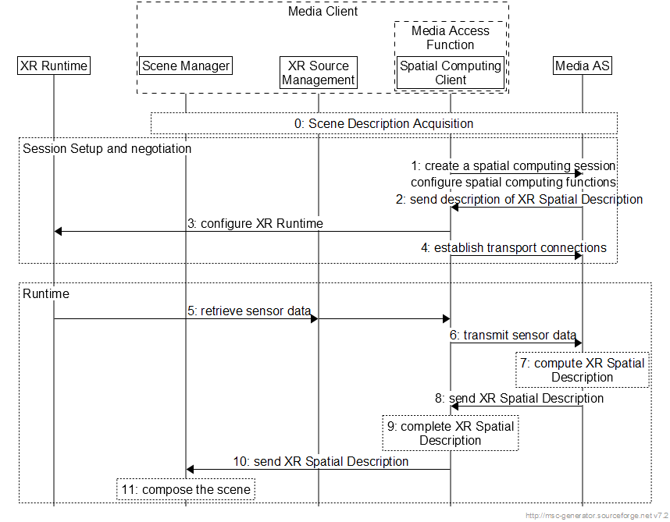

Figure 7.4-1 High-level call flow for Spatial computing session setup and operation

The steps are:

0. The Scene Manager acquires the scene description information and discovers the needed spatial computing functions for the XR experience.

1. The Media Client discovers Media AS and sets up a connection to it. It provides information about the spatial computing capabilities of the UE.

2. The XR runtime is configured. This configuration aims to provide sensor data needed for the Spatial Computing functions configured in the Media AS in step 0.

3. In response to step 1, the Media AS creates and transmits a description of the XR Spatial Description format, the configuration data and the input it expects to receive from the Spatial Computing Client to the Media Client.

4. The Spatial Computing Client requests the instantiation of pipelines for XR Spatial Description from the Media Access Function, which in turn establishes a connection to the Media AS.

5. The Source Manager retrieves sensor data from the XR runtime and provides them to the Media Access Function.

6. The Media Access Function sends sensor data to the Media AS.

7. The Media AS uses that data to invoke the spatial computing functions and compute the XR Spatial Description.

8. The Media AS transmits the generated XR Spatial Description to the Media Access Function.

9. Spatial Computing Client may complete XR Spatial Description using sensor data.

10. Spatial Computing Client provides the XR Spatial Description to the Scene Manager.

11. The Scene Manager composes the scene using the XR Spatial Description.

* * * End of Changes * * * *