**3GPP TSG- Meeting #**

**, , -**

|  |  |  |  |  |  |  |  |  |
| --- | --- | --- | --- | --- | --- | --- | --- | --- |
| *CR-Form-v12.3* | | | | | | | | |
| **CHANGE REQUEST** | | | | | | | | |
|  | | | | | | | | |
|  |  | **CR** |  | **rev** |  | **Current version:** |  |  |
|  | | | | | | | | |
| *For* [***HE******LP***](http://www.3gpp.org/3G_Specs/CRs.htm#_blank)*on using this form: comprehensive instructions can be found at* [*http://www.3gpp.org/Change-Requests*](http://www.3gpp.org/Change-Requests)*.* | | | | | | | | |
|  | | | | | | | | |

|  |  |  |  |  |  |  |  |  |
| --- | --- | --- | --- | --- | --- | --- | --- | --- |
| ***Proposed change affects:*** | UICC apps |  | ME | **x** | Radio Access Network | **x** | Core Network | **x** |

|  |  |  |  |  |  |  |  |  |  |  |
| --- | --- | --- | --- | --- | --- | --- | --- | --- | --- | --- |
|  | | | | | | | | | | |
| ***Title:*** |  | | | | | | | | | |
|  |  | | | | | | | | | |
| ***Source to WG:*** |  | | | | | | | | | |
| ***Source to TSG:*** |  | | | | | | | | | |
|  |  | | | | | | | | | |
| ***Work item code:*** |  | | | | |  | ***Date:*** | | |  |
|  |  | | | |  | |  | | |  |
| ***Category:*** |  |  | | | | | ***Release:*** | | |  |
|  | *Use one of the following categories:* ***F*** *(correction)* ***A*** *(mirror corresponding to a change in an earlier release)* ***B*** *(addition of feature),* ***C*** *(functional modification of feature)* ***D*** *(editorial modification)*  Detailed explanations of the above categories can be found in 3GPP [TR 21.900](http://www.3gpp.org/ftp/Specs/html-info/21900.htm). | | | | | | | | *Use one of the following releases: Rel-8 (Release 8) Rel-9 (Release 9) Rel-10 (Release 10) Rel-11 (Release 11) … Rel-17 (Release 17) Rel-18 (Release 18) Rel-19 (Release 19)  Rel-20 (Release 20)* | |
|  |  | | | | | | | | | |
| ***Reason for change:*** | | Data burst duration has been discussed in regard to the definitions of data burst and time to the next burst (TTNB) in 5G_RTP_Ph2.  In Solution #24 of TR26.822, experimental results on the burst characteristics were shown for XR split rendering, but without any results on the burst duration. | | | | | | | | |
|  | |  | | | | | | | | |
| ***Summary of change:*** | | Add experimental results on the burst duration for XR split rendering. | | | | | | | | |
|  | |  | | | | | | | | |
| ***Consequences if not approved:*** | | Lack of experimental data on burst duration for split rendering XR to suport the ongoing discussions of the definitions of the data burst and TTNB. | | | | | | | | |
|  | |  | | | | | | | | |
| ***Clauses affected:*** | |  | | | | | | | | |
|  | |  | | | | | | | | |
|  | | **Y** | **N** |  | | | |  | | |
| ***Other specs*** | | **x** |  | Other core specifications | | | | TS/TR ... CR ... | | |
| ***affected:*** | |  |  | Test specifications | | | | TS/TR ... CR ... | | |
| ***(show related CRs)*** | |  |  | O&M Specifications | | | | TS/TR ... CR ... | | |
|  | |  | | | | | | | | |
| ***Other comments:*** | |  | | | | | | | | |
|  | |  | | | | | | | | |
| ***This CR's revision history:*** | |  | | | | | | | | |

.

* * * * 1st change (all new) * * * *

#### 6.24.2.4 Burst duration

In an XR split rendering session, the downlink traffic consists of both audio and video, and for video it may further consists of two video streams, one for each eye.

The departure time of the multiplexed media streams at the split rendering server in the experimental setup in Figure 6.24.2.3-2 is shown in Figure 6.24.2.4-1. Because the video streams and the audio stream have different periodicities, the groups of packets shift relatively in time and may overlap from time to time. Note tha the burst duration of the first right video frame is more than 1.5ms.

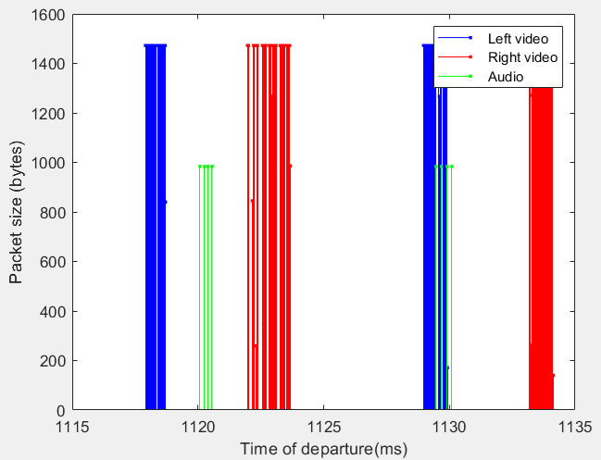

Figure 6.24.2.4-1: Time to departure of the video (left and right) and audio PDUs at the split rendering server

The data burst is defined in version 18.1.0 of [2] as follows:

***Data Burst:*** *A data burst is a set of multiple PDUs generated and sent by the application such that there is an idle period between two data bursts. A Data Burst can be composed of one or multiple PDU Sets.*

To group the PDUs into data bursts, the split rendering server needs to decide how to apply the idle period. In one implementation, the split rendering server imposes an *idle period threshold* on the idle period: if two adjacent PDUs are separated by more than the threshold, they belong to two different data bursts; otherwise, they belong to the same data burst. Once the data bursts are determined, the burst durations can be calculated.

For audio, each frame consists of 4 packets and the inter-packet delay is greater than 0.1ms, which is seen in Figure 6.24.2.4-2. Therefore, when we select the idle period threshold, we avoid 0.1ms.

The burst duration as a function of time is plotted in Figure 6.24.2.4-3, for idle period thresholds, 1.0 ms, 0.5 ms, and 0.2 ms, respectively. It is noted that, when the threshold decreases, the data burst duration also decreases.

Figure 6.24.2.4-3: Data burst duration for the multiplexed media traffic at the split rendering server for different idle period threshold : 1.0ms (top), 0.5ms (middle), and 0.1ms (bottom)

The distributions (cumulative distribution functions) of the burst duration for different idle period threholds are plotted in 6.24.2.4-4. It is observed that:

- for idle period threshold 1.0 ms, 66.5% of the data burst is longer than 1ms

- for idle period threshold 0.5 ms, 47.0% of the data burst is longer than 1ms

- for idle period threshold 0.2 ms, 15.1% of the data burst is longer than 1ms.

Figure 6.24.2.4-4: Distribution of the burst duration for the multiplexed media traffic at the split rendering server for different idle period threshold : 1.0ms (red), 0.5ms (blue), and 0.2ms (green)

**Conclusion 1:** for split rendering XR, the burst duration distribution for the downlink multiplexed traffic may be significantly affected by the idle period threshold, and may be much larger than 1ms.

* * * * End of 1st change * * * *