Source: Xiaomi (Rapporteur)
Title: MeCAR Permanent Document v10.0.0
Version: 10.0.0
Agenda Item: 14.4
Document for: Agreement
Work Item information:
Work Item Name | Media Capabilities for Augmented Reality
Acronym | MeCAR
Unique ID | 950015
Target release | 18

Source details:
Rapporteur | Name | Emmanuel THOMAS
Rapporteur | Company | Xiaomi
Rapporteur | Email | thomase@xiaomi.com
Editor | Name | Gilles TENIOU
Editor | Company | Tencent
Editor | Email | teniou@global.tencent.com

Revision history:
Version | Date | Meeting | Subject/Comment
1.0.0 | 2022-04-14 | SA4#118e | - Added  - Working assumptions  - Example media capabilities
2.0.0 | 2022-05-20 | SA4#119e | - Added  - Clause 2 on definitions, including Optical see-through device and Video see-through device  - Clause 4 on device categories, including draft EDGAR-1 architecture (4.2)  - Clause 5.3 on media capability validation framework, including Khronos 3D Commerce conformance example (5.3.1), a possible media capability evaluation framework (5.3.2) and its MeCAR scope (5.3.3)  - Clause 6 on sensor and user environment data types including the view-related information (6.2)  - Clause 7 on activities in external organizations, including the AVTCORE WG in IETF (7.1)
3.0.0 | 2022-08-26 | SA4#120e | - Added:  - Clause 5.4 Examples of media capabilities based on existing specifications, based on TS 26.511.  - Clause 3.6 Transparency information.  - Clause 3.7 Media Type Categories and Characteristics  - Clause 6.3 User surroundings information  - Clause 5.3 Display capability
3.1.0 | 2022-11-03 | SA4 Video SWG Telco (November 2, 2022) | - Added:  - Clause 5.5 Examples of display capabilities and possible impact on media capabilities
4.0.0 | 2022-11-18 | SA4#121 | - Added:  - Clause 3.7.3 AR/MR Data Type characteristics  - Clause 3.7.4 Real-time metadata transport  - Clause 4.2 Thin Augmented Reality User Equipment (Thin AR UE)  - Clause 6.7 Minimum Media Capabilities  - Clause 6.8 Media capability for RTC  - Clause 3.8.2 Media-related conformance aspects of OpenXR  - Clause 4.1 Candidate XR Baseline Client  - Modified:  - Clause 4.3 Augmented Reality User Equipment (AR UE) with new architecture diagram and added text on the relationship with the Thin AR UE (4.2) and added descriptive text
5.0.0 | 2023-02-24 | SA4#122 | - Removed:  - 6.9 Media capability for RTC since follow-up in iRTCW and SmartTAR  - Moved:  - Moved 6.4 Examples of media capabilities based on existing specifications under 6.2 Examples of media capabilities  - Moved 6.5 Examples of display capabilities and possible impact on media capabilities under 6.3 Display capability  - Modified:  - Environment blend mode in 3.6.1 Interest of transparency information  - Added:  - 10.1 Volumetric video support in MPEG-I V3C  - 4.4 XR User Equipment (XR UE)  - 5.2 Metrics Observation Points and KPIs  - 7 Metadata formats (pose prediction and action format)  - 8.3 Pose information  - Eye gaze as interaction type in Table 2  - 3.9 MPEG-I Scene Description  - 4.3.2.2 Video decoding interface, code point like decoding and encoding for concurrent decoding instance support
5.1.0 | 2023-03-27 | SA4 post #122 | - Added:  - 4.1.3 Example Technologies  - 10.3 MPEG-I Video Decoding Interface
6.0.0 | 2023-04-11 | SA4#123-e | - Modified:  - Added content to 5.1 Interoperability Points for Visual and Audio  - Removed:  - 9 AR data transport analysis
7.0.0 | 2023-04-20 | SA4#123-e | - Added:  - 3.10 Working assumption on operation points for MeCAR  - 9.1.4 3D media capabilities considerations  - 8.5 Available visualization space  - 8.6 User interaction  - 6.7 System capabilities  - 6.7 Audio function and capabilities, for split rendering capabilities  - 6.8 XR Runtime capabilities, for split rendering capabilities  - 6.10.1 Color conversion module  - Modified:  - 5.2.3 Typical Latencies in networked AR Services and their Measurements  - 8.3 Pose information  - 9.1.2 Systems aspect of V3C  - Eye gaze in Table 2 in 3.7.2 Media types definition  - 6.6.3 Video decoding interface, for split rendering capabilities
7.0.1 | 2023-05-16 | SA4#124 | - Modified:  - Miscellaneous editorial improvements and fixes.
8.0.0 | 2023-05-26 | SA4#124 | - Modified:  - 3.9 MPEG-I Scene Description (S4-230867)  - 8.3.1 QoE timing information (S4-230948)  - 5.2.3 Typical Latencies in networked AR Services and their Measurements (S4-230913)  - 9.1.2.6 V3C Performance and 9.1.3 Implementations (S4-230943)  - 6.6.3 Video decoding interface and 4.1 Candidate XR Baseline Client (S4-230921)  - 6.7 Candidate Audio function and capabilities (S4-231033)  - 5.2.1 Metrics Observation Points (S4-231077)  - 8.5 Available visualization space (S4-231061)  - 9.1.1 Content Creation and 9.1.2 Levels of Immersion, related to V3C (S4-231063)  - 6.8.1 Support of RGBD content, MIV related (S4-231064)
8.1.0 | 2023-06-26 | SA4 post #124 | - Added:  - 9.4 W3C WebXR Augment Reality Module  - Modified  - Typo in 3.9.2 MPEG-I glTF extensions
8.2.0 | 2023-07-28 | SA4 post #124 | - Modified:  - 6.8.1.4 Processing of RGBD content  - 6.8.1.6 Storage of RGBD content
8.2.1 | 2023-08-15 | SA4 post #124 | - Modified:  - Added missing references in Table 2  - Clause 7.2 and 7.3 replaced by note about inclusion to draft TS.  - Some editor’s notes turned into regular notes.  - Miscellaneous typo fixes
9.0.0 | 2023-08-25 | SA4#125 | - Added:  - 9.5 Overview of media performance definitions on Android  - Modified:  - 5.2.1 Metrics Observation Points  - 3.6.2 Processing transparency information  - 9.4 Immersive Web applications and runtime  - 6.5 MeCAR Media Capabilities - Overview
10.0.0 | 2023-11-17 | SA4#126 | - Added:  - 1.2 Overview of MeCAR progress  - 6.8.2 Candidate solution for depth carriage specification  - 6.11 Device capabilities signaling  - 9.6 Universal Scene Description

Contents
Contents 5
1 Introduction 9
1.1 Overview of MeCAR objectives 9
1.2 Overview of MeCAR progress 9
2 Definitions, symbols and abbreviations 11
2.1 Definitions 11
2.2 Abbreviations 11
3 Working assumptions 11
3.1 Prioritization of AR optical see-through 11
3.2 Device design types 12
3.2.1 General 12
3.2.2 Device design type 1 12
3.2.3 Device design type 2 14
3.2.4 Device design type 3 14
3.2.5 Device design type 4 15
3.3 General functional architecture 16
3.4 5G_STAR EDGAR-type device architecture 16
3.5 Media Access Function for AR 17
3.6 Transparency information 18
3.6.1 Interest of Transparency information 18
3.6.2 Processing transparency information 19
3.6.3 Carrying transparency information 20
3.7 Media Type Categories and Characteristics 22
3.7.1 General 22
3.7.2 Media types definition 22
3.7.3 AR/MR Data Type characteristics 25
3.7.4 Traffic characteristics 26
3.8 Background on OpenXR 27
3.8.1 Visual rendering in OpenXR 27
3.8.2 Media-related conformance aspects 29
3.9 MPEG-I Scene Description 32
3.9.1 Overview 32
3.9.2 MPEG-I glTF extensions 32
3.10 Working assumption on operation points for MeCAR 34
4 Device categories 35
4.1 Candidate XR Baseline Client 35
4.1.1 General 35
4.1.2 Architecture 37
4.1.3 Example Technologies 37
4.2 Thin Augmented Reality User Equipment (Thin AR UE) 38
4.2.1 Device architecture 38
4.2.2 XR Runtime and Source processing 39
4.2.3 XR Visual Processing 40
4.2.4 XR Audio Processing 41
4.3 Augmented Reality User Equipment (AR UE) 42
4.3.1 Device architecture 42
4.3.2 Visual capabilities 44
4.4 eXtended Reality User Equipment (XR UE) 45
4.4.1 Device architecture 45
4.4.2 Visual capabilities 46
5 Interoperability points and metrics 46
5.1 Interoperability Points for Visual and Audio 46
5.2 Metrics Observation Points and KPIs 51
5.2.1 Metrics Observation Points 51
5.2.2 Timestamps and observation points 52
5.2.3 Delay Measurements 52
5.2.4 Relevant KPIs for XR and AR according to TR 26.998 53
5.2.5 Typical Latencies in networked AR Services and their Measurements 57
5.2.6 XR application’s Player Loop 59
6 Media capabilities 63
6.1 Categories of media capabilities 63
6.2 Examples of media capabilities 64
6.2.1 Examples of media capabilities based media capabilities categorisation 64
6.2.2 Examples of media capabilities based on existing specifications 65
6.3 Display capability 68
6.3.1 General 68
6.3.2 Examples of display capabilities and possible impact on media capabilities 69
6.4 Media capability validation framework 70
6.4.1 Example framework by Khronos on 3D Commerce conformance (glTF viewer) 70
6.4.2 Possible capability evaluation framework 72
6.4.3 Possible scope of media capability 73
6.5 MeCAR Media Capabilities - Overview 74
6.6 Visual functions and capabilities 74
6.6.1 Video Decoding 74
6.6.2 Video Encoding 75
6.6.3 Video decoding interface 76
6.6.4 Minimum Requirements 77
6.7 Candidate audio function and capabilities 77
6.7.1 Audio Decoding 77
6.7.2 Audio Encoding 77
6.8 System capabilities 78
6.8.1 Support of RGBD content 78
6.8.2 Candidate solution for depth carriage specification 86
6.3 Systems capabilities 86
6.3.1 Depth map capabilities 86
6.9 XR Runtime capabilities 89
6.10 Image processing capabilities 89
6.10.1 Color conversion module 89
6.11 Device capabilities signalling 90
7 Metadata formats 91
7.1 General 91
7.2 Pose Prediction Format 91
7.3 Action Format 91
7.4 JSON Schema 91
8 Sensor and user environment data types 94
8.1 General 94
8.2 View-related information 94
8.3 Pose information 95
8.3.1 QoE timing information 95
8.3.2 Pose information delays and QoE 97
8.4 User surroundings information 97
8.5 Available visualization space 98
8.5.1 General 98
8.5.2 Possible solution 98
8.5.3 Potential implementation 98
8.6 User interaction 101
8.6.1 General 101
8.6.2 QoE timing information 101
8.6.3 QoE measurement 102
8.6.4 Interactivity delays and QoE 103
9 Relevant activities in external organizations 103
9.1 Volumetric video support in MPEG-I V3C 103
9.1.1 Content Creation 103
9.1.2 Levels of Immersion 105
9.1.3 Coding aspect of V3C 106
9.1.4 Systems aspect of V3C 107
9.1.5 Implementations 110
9.1.6 Capabilities considerations 112
9.1.7 3D media capabilities considerations 114
9.2 IETF AVTCORE WG 117
9.3 MPEG-I Video Decoding Interface [34] 117
9.3.1 Introduction 117
9.3.2 Use Cases 118
9.3.3 Background 118
9.3.5 Relevancy for MECAR 122
9.4 Immersive Web applications and runtime 123
9.4.1 General 123
9.4.2 Specification work status and overview 123
9.4.3 WebXR Device API 123
9.4.4 WebXR device model 124
9.4.5 WebXR Augment Reality Module 124
9.4.6 Application Flow 126
9.4.7 Software support 126
9.4.8 Existing product support 126
9.4.9 Running sample code and application 126
9.5 Overview of media performance definitions on Android 127
9.5.1 Android media requirements, a.k.a. Compatibility Definition Document (CDD) 127
9.5.2 Android performance classes 129
9.6 Information on Universal Scene Description (USD) 132
9.6.1 Overview 132
9.6.2 Product support for USD 132
10 Technical status 132
10.1 List of elements open for work 132
10.2 List of completed elements 133
10.3 List of open issues requiring specific attention 133
11 References 133
Annex A – Additional information on MIV metadata 136

Introduction

1.1 Overview of MeCAR objectives
During SA4#117-e the New Work Item on “Media Capabilities for Augmented Reality” (MeCAR) in S4-220332 was agreed and afterwards approved in by SA#95e in SP-220242.
The media capabilities of AR devices typically contribute to three main functionalities: 1) simple media rendering, 2) split-rendering, for which a pre/scene-rendering of the scene and views is carried out in the cloud/edge and 3) uplink streaming of sensor and device data to the network in order to support network-based processing of device sensor information.
To support basic interoperability for AR applications in the context of 5G System based delivery, a set of well-defined media capabilities are essential to create the conditions of a successful ecosystem. Therefore, the MeCAR work item defines those media capabilities for AR devices in a service-independent manner. In particular, the following objectives are considered:
- Define at least one AR device category that addresses the constraints of an EDGAR-type AR glass
  - Note: Additional device categories may be defined, but with lower priority.
- For each AR device category
  - Define a reference terminal architecture regarding media capability aspects for this AR device category
  - Define media types and formats produced and consumed by the AR device, including basic scene descriptions, audio, graphics and video as well as sensor information and metadata about user and environment.
  - Define the integration of the relevant existing 3GPP codecs into the reference terminal architecture
  - Define decoding capabilities, including support for multiple parallel decoders
  - Define encoding capabilities
  - Define security aspects related to the media capabilities
  - Define the required, recommended and optional media capabilities for this AR device category
- Integrate IVAS into suitable AR device categories, once IVAS is available
- Define capability exchange mechanisms based on complexity of AR media and capability of device to support EAS KPIs for provisioning of edge/cloud resources
  - Note: Identify a suitable existing capability framework, or if it does not exist, we need to work with the broader industry (e.g., IETF, KHRONOS, W3C, etc.) to get this done.
- Identify which QoE metrics from VR QoE metrics can be reused or enhanced for AR media (e.g., resolution per eye, Field of view (FOV), round-trip interaction delay, etc.) and define relevant KPIs that are dedicated to AR/MR
- Specify additional relevant KPIs and simple QoE Metrics for AR media
- Specify encapsulations into RTP, ISOBMFF and CMAF
- Specify the relevant codec-level parameters for session setup and negotiation of the media delivery and provide instantiations for SDP and DASH MPD
- Enable AR media in 5G Media Streaming by defining suitable 5GMS profiles based on AR media capabilities
- Define typical traffic characteristics for AR media

1.2 Overview of MeCAR progress

# | Objective | Status
1 | Define at least one AR device category that addresses the constraints of an EDGAR-type AR glass. | ✔ Done in TS 0.2, device type 1 and 2.
2 | For each AR device category:
2.1 | Define a reference terminal architecture regarding media capability aspects for this AR device category. | ✔ Done in TS 0.2, XR Baseline terminal architecture, clause 5.1 in TS 26.119 v0.2.
2.2 | Define media types and formats produced and consumed by the AR device, including basic scene descriptions, audio, graphics and video as well as sensor information and metadata about user and environment. | In TS 0.2:  - ✘ basic scene descriptions 1779, 1828  - ✘ audio 1670, 1694?, 1862  - ✘ graphics 1779, 1692?  - ☐ video 1694, 1863  - ✔ sensor information (e.g. pose)  - ✔ metadata (e.g. AVS)
2.3 | Define the integration of the relevant existing 3GPP codecs into the reference terminal architecture. | ✔ Done in TS 0.2, XR Baseline terminal architecture, clause 5.1 in TS 26.119 v0.2.
2.4 | Define decoding capabilities, including support for multiple parallel decoders. | In TS 0.2:  - ☐ video 1694, 1863  - ✘ audio 1670, 1694?, 1862
2.5 | Define encoding capabilities. | In TS 0.2:  - ☐ video 1694, 1863  - ✘ audio 1670, 1694?, 1862
2.6 | Define security aspects related to the media capabilities. | In TS 0.2: ✘
2.7 | Define the required, recommended and optional media capabilities for this AR device category. | In TS 0.2:  - ☐ video 1694, 1863  - ✘ audio 1670, 1694?, 1862
3 | Integrate IVAS into suitable AR device categories, once IVAS is available. | In TS 0.2:  ✘ audio 1670, 1694?, 1862
4 | Define capability exchange mechanisms based on complexity of AR media and capability of device to support EAS KPIs for provisioning of edge/cloud resources. | In TS 0.2:  ✘ 1803
5 | Identify which QoE metrics from VR QoE metrics can be reused or enhanced for AR media (e.g., resolution per eye, Field of view (FOV), round-trip interaction delay, etc.) and define relevant KPIs that are dedicated to AR/MR. | In TS 0.2:  ✘ 1795
6 | Specify additional relevant KPIs and simple QoE Metrics for AR media. | In TS 0.2:  ✘ 1795
7 | Specify encapsulations into RTP, ISOBMFF and CMAF | In TS 0.2:  No new media format identified at this point.
8 | Specify the relevant codec-level parameters for session setup and negotiation of the media delivery and provide instantiations for SDP and DASH MPD. | In TS 0.2:  No new media format identified at this point.
9 | Enable AR media in 5G Media Streaming by defining suitable 5GMS profiles based on AR media capabilities. | In TS 0.2:  No new media format identified at this point.
10 | Define typical traffic characteristics for AR media. | ✘ Empty table in MeCAR PD v9.0

2 Definitions, symbols and abbreviations

2.1 Definitions
Optical see-through device: Device providing a view of the surrounding world by letting the light from the real world directly reaches the user’s eyes through an optical system.
Video see-through device: Device providing a view of the surrounding world by capturing the light from the real world and then presenting it through a display system to the user.

2.2 Abbreviations
PLR Point Local Reconstruction
EOM Enhanced Occupancy Mode
VUI Volumetric Usability Information (when used in reference to V3C)

3 Working assumptions

3.1 Prioritization of AR optical see-through
Optical see-through devices have the advantage of not requiring any additional video streams for rendering the surrounding environment. The natural light passing through the lenses of the device provides the user with a clear and natural view of the surrounding environment and does not add additional rendering latencies since the only media data that needs to be streamed by the device is the AR data. Therefore, even display systems with limited capabilities can offer the user a high level of experience.
Prioritizing optical see-through devices will allow us to focus on the overlaid AR data that is displayed on the glasses and synchronized (time and space) with the real word. It will make possible to offer a good level of user experience relying on relatively lower KPIs, in terms of FoV, resolutions, etc., and leads to lighter constraints on the design of the glasses, making easier the emergence of near to mid-term solutions.

3.2 Device design types

3.2.1 General
The MeCAR Work Item aims at being in line with device manufacturing constraints so that the specifications as output of MeCAR when published can be as relevant as possible for the AR ecosystem. As a result, the following clause lists typical device designs that are considered to be the illustrative of the current or future manufactured AR devices. Those device types are not meant to constitute interoperability points in the MeCAR specifications but rather serve as reality check during the development of MeCAR work to verify this desired alignment. If and when gaps are identified in terms of media capabilities between those device types and the current draft specification, it would be expected to update the draft specification for a better alignment with those current and future AR devices.
The current list of device design types are :
- Device type 1: Standalone physically-constrained AR glasses
- Device type 2: 5GUE-tethered physically-constrained AR glasses
- Device type 3: 5GUE-powered lightweight AR glasses
- Device type 4: 5GUE XR device
At present, the device design types are numbered in increasing order of media capability performances. However, this is not a fixed rule and more device design types in the future may be listed which would differ based on other criteria as long as they represent a realisation of AR Glasses with a different design.

3.2.2 Device design type 1
Looking at existing AR Glasses, based on the study in TR 26.998 [1] and based on information from chipset manufacturers on existing and emerging devices, an AR Glass designed for AR experiences does integrate complex functionalities and many of those relate to capabilities. Figure 1 is a picture providing an overview of an AR glass.
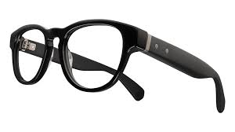
Hinge
SoC Media
Connectivity
Eye Tracking + Camera/Sensor Aggregator
Figure 1 – Overview of AR glasses of device design type 1
Typical functions of such a AR glass consists of:
- Peripheries including
  - Displays
  - Cameras
  - Microphones
  - Sensors
  - Camera/Sensor Aggregators
  - Perception functionality: Eye Tracking, Face Tracking, etc.
- SoC Media
  - Display Processing
  - GPU functionalities: Composition/Reprojection
  - Decoding
  - Decryption
  - Camera Front ends
  - Perception functionality: 6DoF, etc.
  - Encoding
- Connectivity
  - Wi-Fi, Bluetooth, 5G, etc.
An interesting aspect to consider from the above is that the device consists of different thermal islands, hence division in multiple chips in the headset is highly desirable. This means that both minimizing the power consumption per thermal island as well as minimizing the overall power consumption is an essential design constraint for the device battery life.
In addition, such type of devices require to partition workloads to remote devices or the cloud to some extent to balance the power load. Based on this, media capabilities are also possibly required on UE that acts as a hub for a tethered glass. Architectures and processing for this will be discussion SmartAR. The main target device in the MeCAR work item remains glasses as shown above.
It should be noted that such AR glasses are predominantly served with media that can directly be rendered by the peripheries, or produce media captured on the device and sent to remote processing.
It is considered that for media capabilities related to this primary AR category, only capabilities of the SoC media are to be part of the media capability definitions. We also note that the XR experience observed by the user depends on more aspects than the media capabilities, such as the display, the optics, the quality of the sensors, the stability of the connection and so on. However, such aspects are not considered to be part of the media capabilities for AR.
Initial System-on-Chip (SoC) media will likely rely on existing hardware, for example from lower end mobile chipsets. Some people consider XR even a hack that uses existing components in a smart manner. However, a core aspect of XR experiences different from traditional mobile devices is the concurrent operation of multiple encoders and/or decoders to address different sensors, eye buffers, layers and so on, as well as the rendering to GPU instead of directly going to the display.
Only over time, such hardware will get added specific functionalities, but not in the near and mid-term. Expected in the future are higher render and display resolutions, multi-layer composition, etc.
Given that many functionalities are defined through Khronos OpenXR, defining capabilities for example by mandating or recommending support of certain APIs or parameter settings on API may be relevant. In some cases it may not even be possible to define capabilities, but for example rely on test signals and benchmarking requirements that estimate the performance of a device.
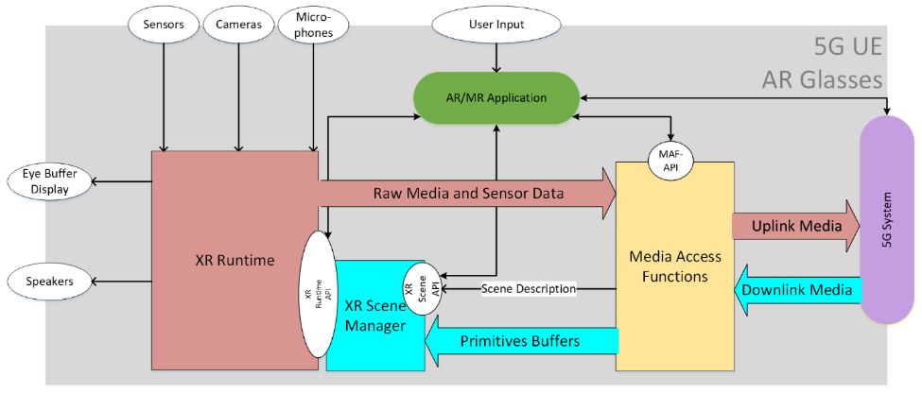
Figure 2 – Example architecture of AR glasses based on device design type 1
Based on these observations, an initial main objective of a standard is to create near to mid-term interoperability for media capabilities based existing and emerging media SoCs.

3.2.3 Device design type 2
Similar as in the case for the device design type 1 introduced in 3.2.1, the AR Glasses runs an AR/MR application that uses the capabilities of the glass to create a service.
However, the AR glasses does not provide a 5G connection, but is tethered to a 5G device. The AR glasses may only use the 5G connectivity of the phone, or it may use capabilities on the phone for additional processing support. As a result, this device type is expected to have higher media capabilities compared to the device type 1 which is the most constrained one.
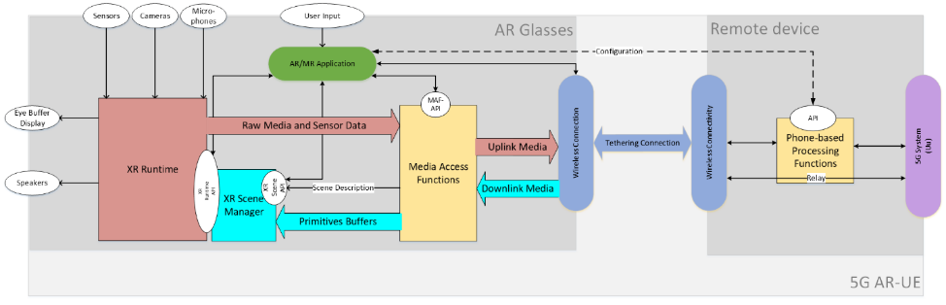
Figure 3 – Example architecture of AR glasses based on device design type 2

3.2.4 Device design type 3
The AR Glasses is tethered to a 5G device that includes the application and the XR functions. The tethering may be wireless or wired, but it is proprietary.
The 5G device runs the application that uses the Media access and rendering capabilities of the 5G device to run an AR/MR experience. The AR glass is connected to the 5G Device, but the XR runtime API is exposed to the 5G device/phone.
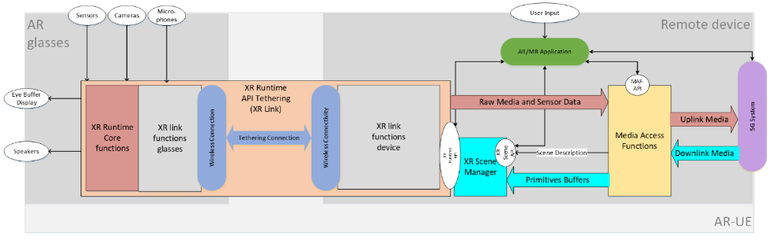
Figure 4 – Example architecture of AR glasses based on device design type 3
In this case, the connection between the phone and glass is handled by a proprietary system that tethers the XR Runtime API running on the 5G device to the XR Runtime core functions on the glass. The overall function is referred to as XR Link.
In order to determine the media capabilities of such a device, it is assumed that the media access and rendering functions of a high-end smart phone can be used.

3.2.5 Device design type 4
The considered device is not referring to optical see-through glasses, but may for example be a regular 5G phone with extended AR/XR capabilities. The capabilities include 6DOF rendering, pose tracking and other type of rendering functionalities.
The 5G device runs the XR application that uses the Media access and rendering capabilities of the 5G device to run an XR experience. All XR functionalities are included in a single device.
The device is possibly not head-mounted, i.e. tracking information may not be the head pose, but relate to the location and orientation of the XR device.
Figure 5 – Example architecture of an XR device based on device design type 4
In order to determine the media capabilities of such a device, it is assumed that the media access and rendering functions of a high-end smart phone can be used.

3.3 General functional architecture
For any type of AR devices targeted by MeCAR, the functional architecture depicted in Figure 6 is applicable.
Figure 6 – General functional architecture of AR device

3.4 5G_STAR EDGAR-type device architecture
From TR 26.998 [1], the architecture of the EDGAR device type was defined as illustrated in Figure 7. Note that EDGAR in TR 26.998 stands for EDGe-dependent AR (EDGAR) UE.
Figure 7 – Architecture of 5G_STAR EDGAR-type device

3.5 Media Access Function for AR
The Media Access Function defined in TR 26.998 [1] supports the AR UE to access and stream media. Figure 8 depicts its different functions and buffer elements.
Figure 8 – Media Access function for AR as defined in TR 26.998 [1]

3.6 Transparency information

3.6.1 Interest of Transparency information
It is desirable to support the transmission of transparency information (alpha_channel) in addition to the colour (e.g., RGB) information. Augmented reality services may overlay of virtual objects on the real world which are accessed directly through the “optical see-through” glasses. The overlay is not a full picture but only part of it, the other pixels of the picture being transparent or partially transparent, in case of a shadow effect for instance.
Figure 9 below depicts the overlay of a virtual dragon on the table of a real living room. If the whole video is overlayed, the dragon may appear in the middle of a rectangle corresponding to the video size. This is illustrated on the left picture. With additional transparency information, only the part of the video corresponding to the dragon is overlayed, as illustrated on the right picture.
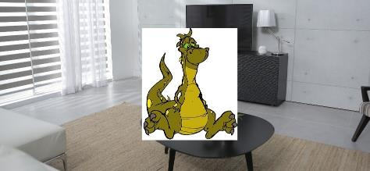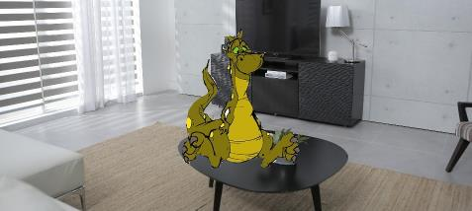
Figure 9 – Video overlay without (left) and with (right) transparency information
The following text is extracted from the OpenXR specification [11] as illustrative purposes. It specifies how the XR Runtime has to render the views:
- blended with a captured view of the real world,
- presented on top of the real world based on optical see-through display, or
- not related to a real-world scene (e.g. VR).
Start of quote
After the compositor has blended and flattened all layers (including any layers added by the runtime itself), it will then present this image to the system’s display. The composited image will then blend with the user’s view of the physical world behind the displays in one of three modes, based on the application’s chosen environment blend mode.
VR applications will generally choose the XR_ENVIRONMENT_BLEND_MODE_OPAQUE blend mode, while AR applications will generally choose either the XR_ENVIRONMENT_BLEND_MODE_ADDITIVE or XR_ENVIRONMENT_BLEND_MODE_ALPHA_BLEND mode.
The possible blend modes are specified by the XrEnvironmentBlendMode enumeration:
typedef enum XrEnvironmentBlendMode {
XR_ENVIRONMENT_BLEND_MODE_OPAQUE = 1,
XR_ENVIRONMENT_BLEND_MODE_ADDITIVE = 2,
XR_ENVIRONMENT_BLEND_MODE_ALPHA_BLEND = 3,
XR_ENVIRONMENT_BLEND_MODE_MAX_ENUM = 0x7FFFFFFF
} XrEnvironmentBlendMode;
Enumerant Descriptions
- XR_ENVIRONMENT_BLEND_MODE_OPAQUE. The composition layers will be displayed with no view of the physical world behind them. The composited image will be interpreted as an RGB image, ignoring the composited alpha channel. This is the typical mode for VR experiences, although this mode can also be supported on devices that support video passthrough.
- XR_ENVIRONMENT_BLEND_MODE_ADDITIVE. The composition layers will be additively blended with the real world behind the display. The composited image will be interpreted as an RGB image, ignoring the composited alpha channel during the additive blending. This will cause black composited pixels to appear transparent. This is the typical mode for an AR experience on a see-through headset with an additive display, although this mode can also be supported on devices that support video passthrough.
- XR_ENVIRONMENT_BLEND_MODE_ALPHA_BLEND. The composition layers will be alpha-blended with the real world behind the display. The composited image will be interpreted as an RGBA image, with the composited alpha channel determining each pixel’s level of blending with the real world behind the display. This is the typical mode for an AR experience on a phone or headset that supports video passthrough.

End of quote
As can be seen on the specification, OpenXR indicates that the AR glasses as discussed in MeCAR are supposed to operate in the XR_ENVIRONMENT_BLEND_MODE_ADDITIVE mode. In this mode, the alpha channel if present is ignored. Instead, the transparency effect is achieved by “black composited pixels to appear transparent”. Therefore, transparency information does not seem to be relevant for the current AR MeCAR devices when it comes to display virtual objects as overlay on the real scene as depicted in section 3.6.1 of this document.
Therefore, transparency information in the transmitted data seems to be relevant for AR devices which are able to occlude the real-world (e.g. smartphone, VR headset, video-see through device) but are not relevant for AR devices such as current optical-see through AR Glasses which are not capable of occluding the real-world.

3.6.2 Processing transparency information
Depending on how the transparency information is carried, it may be processed at different functional blocs.
For example, transparency information may be processed in the Media Access Function block. This processing might include extracting transparency information carried in media tracks and using the decoder if transparency information is carried as auxiliary pictures. Transparency information may also be processed by an AR scene manager, when the transparency information is carried in the scene description.
There should be a distinction between transparency info for compositing layers and transparency information of the entire view to compose with the environment for optical see-through display. In this section, we further detail the transparency information for composing the entire view with the environment (unless stated otherwise) – which takes place after composing the layers.
On top of the carriage of the transparency information, applying this information for the blending process can depend on the device display type. For video see-through devices, it is recommended to use Alpha Blend, where the RGBA of the environment video is blended using an additive function (for each component) with the RGBA of the video to be rendered. For optical see-through devices, Additive or Alpha Blend can be used. In Additive, the transparency information is ignored (or applied as black colour mask on the respective pixels – before the blending function). However, for AR devices that are able to support rendering of black (or near-black), using Alpha Blend is possible. The summary of the above is shown in Table 1. On a per-pixel basis the layer compositing blend mode might vary (depending on the application), and the final environment blend can be decided by querying the underlying device during setup.

Table 1 - Recommendations of blending mode per optical device type
 | Additive blending | Alpha blending
Optical see-through device | Recommended  (Alpha is discarded) | Recommended for devices that can render black
Video see-through device | Not-recommended  (No transparency) | Recommended  (Alpha is preserved)

After the processing of transparency, including the blending, the final image is forwarded to the display so that only the appropriate parts of the picture are displayed.

3.6.3 Carrying transparency information

3.6.3.1 Carriage as auxiliary pictures in the video stream
The carriage of transparency information may be achieved by using the concept of auxiliary pictures defined by both the AVC and HEVC codecs.

3.6.3.1.1 AVC
The AVC (H.264) specification provides guidelines for carrying transparency information.
It defines the concept of alpha-blending in clause 3.5 : “A process not specified by this Recommendation | International Standard, in which an auxiliary coded picture is used in combination with a primary coded picture (…) the samples of an auxiliary coded picture are interpreted as indications of the degree of opacity (or, equivalently, the degrees of transparency) associated with the corresponding luma samples of the primary coded picture.” AVC specification precises in clause 3.7 that “An auxiliary coded picture must contain the same number of macroblocks as the primary coded picture. Auxiliary coded pictures have no normative effect on the decoding process.” It also mentions (clause 3.1) that “In addition to the primary coded picture, an access unit may also contain (…) one auxiliary coded picture”.

Clause 7.3.2.1.2 (Sequence parameter set extension RBSP syntax) of the AVC specification defines fields related to alpha blending (alpha_incr_flag, alpha_opaque_value and alpha_transparent _value) and the semantics are detailed in clause 7.4.2.1.2 (Sequence parameter set extension RBSP semantics). The same clause also explains that “aux_format_idc equal to 1 indicates that exactly one auxiliary coded picture is present in each access unit of the coded video sequence, and that for alpha blending purposes the decoded samples of the associated primary coded picture in each access unit should be multiplied by the interpretation sample values of the auxiliary coded picture in the access unit in the display process after output from the decoding process.”

3.6.3.1.2 HEVC
HEVC also defines how to carry an alpha channel in the same video bitstream as the base video. In this case, each frame contains two parts: a base layer containing the video, and an alpha layer containing the alpha channel information. Both layers are compressed using the HEVC codec. The two layers are signalled by a specific HEVC syntax element, namely a specific alpha channel information SEI message has to be added, so that the decoder knows how to interpret the auxiliary pictures. A decoder incapable of handling this SEI message only decodes the base layer.
The concept of auxiliary picture is defined in Annex F of the HEVC specification [49]:
F.3.5 auxiliary picture: A picture that has no normative effect on the decoding process of primary pictures, and with a nuh_layer_id value such that AuxId[ nuh_layer_id ] is greater than 0.

In the same Annex, Table F.2 details the different types of auxiliary pictures:
Table F.2 – Mapping of AuxId to the type of auxiliary pictures
AuxId | Name of AuxId | Type of auxiliary pictures | SEI message describing interpretation of auxiliary pictures
1 | AUX_ALPHA | Alpha plane | Alpha channel information
2 | AUX_DEPTH | Depth picture | Depth representation information
3..127 |  | Reserved
128..159 |  | Unspecified
160..255 |  | Reserved

3.6.3.1.3 V3C MIV
MIV Extended profile allows the presence of attribute of type ATTR_TRANSPARENCY. The constraint can be further applied on the profile to minimize the number of required video decoders to 3 (one for color information, one for depth information, and one for transparency information, ptl_max_decodes_idc equal to 2) and number of atlases to 1 (ptc_max_atlas_count_minus1 equal to 0)
Profile Summary:
- ptl_profile_toolset_idc equal to 65 (MIV Extended)
- ptl_max_decodes_idc equal to 2 (maximum 3 decoders)
- ptc_max_atlas_count_minus1 equal to 0 (only 1 atlas)
- ptc_multiple_map_streams_constraint_flag equal to 1 (only 1 map)
- ptc_max_map_count_minus1 equal to 0
- ptc_attribute_max_dimension_minus1 equal to 2
- ptc_attribute_max_dimension_partitions_minus1 equal to 0
- ai_attribute_count equal to 2
- ai_attribute_type_id equal to 0 (ATTR_TEXTURE) or 2 (ATTR_TRANSPARENCY)
- mvp_num_views_minus1 equal to 0 (only 1 view)
The number of decoders needed can be minimized as described in clause 6.8.1.3.2.1.

3.6.3.2 Carriage in ISOBMFF-based formats
ISO/IEC 14496-12 (ISO Base Media File Format) defines a general format which is used as a basis for defining other carriage formats such as MP4, CMAF, HEIF, AVIF, etc. It defines general concepts for the transport and carriage of data in an ISOBMFF-based container format and therefore nothing specific for the transport of auxiliary pictures is mentioned. Among many other things, ISOBMFF specifies the concept of non-timed items that can be used to store static images, and the concept of tracks that can be used to define the carriage of timed video. The format is flexible enough to allow carriage of auxiliary picture information, such as transparency, in the same structure (e.g., using a single item or a single video track) as well as using multiple tracks or items, with dependencies signaled by the item or track reference concept. For example, in the latter case an auxiliary video track needs to be used together with the ‘auxl’ track reference type as defined in clause 8.3.3.
HEIF (High Efficiency Image File format, ISO/IEC 23008-12) builds on top of ISOBMFF and defines a format for carriage of images and image sequences. Because the format is derived from ISOBMFF, transparency information can be carried in a single item or using multiple items, although the latter requires an ‘auxl’ item reference type similar to the video example above.
MIAF (Multi Image Application Format, ISO/IEC 23000-22), which defines additional constraints for HEIF, describes in its clause 7.3.5 how MIAF auxiliary image items can be used to carry alpha planes. In particular, it mentions that “MIAF renderers shall interpret alpha planes and should support alpha blending using alpha-plane auxiliary images. This is especially important for image overlays”. It also details in its clause 6.7 (MAIF renderer processing model) the interpretation of alpha planes.
Carriage of MIV over ISOBMFF is defined in clause 6.8.1.6.1.

3.6.3.3 Carriage in Scene Descriptions
Possible carriage of transparency information or associated transparency information via the scene description has also to be considered. In particular, this may be a solution when an auxiliary picture carrying transparency information is available and not to rely on the SEI messages which not be decoded by all decoders (see HEVC chapter).
As an example for carrying transparency information in scene descriptions, clause 3.9 on Materials in the glTF 2.0 specification has a subclause “additional-texture” and a subclause “alpha-coverage” which describe how to use the fourth (alpha) component, if present, of a texture.
The ongoing ISO/IEC 23090-14 Amendment 1 of MPEG-I SD addresses the support of V3C MIV content in a scene description.

3.7 Media Type Categories and Characteristics

3.7.1 General
AR/MR applications are expected to deal with various media types that have different characteristics and levels of dependency on real-time transport. This clause introduces how and where some of the AR/MR media types are defined and provides an assessment on their levels of dependency on real-time transport and size/bitrate characteristics.

3.7.2 Media types definition
Based on the metadata definition and the description, the AR/MR data can be classified into three categories:
- Device capability: the metadata specifying the device capabilities and features such as camera information and projection information. The information is usually available at the beginning of an AR/MR session and may not change within an AR/MR session.
- Media description: the metadata describing the space or object media content such as scene description, spatial description, and 3D visual mode to be consumed by the UEs. The data size may be large (>10MB) and the information usually does not change frequently and may be event driven.
- Interaction: the metadata representing the user inputs or haptics such as user pose, viewport, gesture, body action, facial expression, FOV and AR anchor point. The interaction may trigger the event at the receiver side and the sender may expect low-latency response (50~1000ms). The interaction data size may be small, but the frequency could be high (>1KHz). The data transport may be continuously or may require burst transport. Depending on the applications, the interactive metadata may be synchronized to each other, or synchronized to other media streams, and the reliability may be strict or not strict.
Table 3 – AR/MR Data type definitions
AR/MR Data category | AR/MR  Data type | Definition | Media type description (Examples)
Media Description | Scene Description | Clause 4.4.2 of 3GPP TR 26.998[1]  Scene description is used to describe the composition of a 3D scene, referencing and positioning the different 2D and 3D assets in the scene typically using a tree or a graph structure. | Type: glTF2.0, JSON format  Organization: MPEG-I and Khronos
Media Description | Spatial Description | Clause 4.4.7.3 of 3GPP TR 26.998[1]  Visual features, keyframes, and spatial maps are used for mapping the real world, typically as part of the SLAM process. | Type: For example:  https://www.khronos.org/registry/OpenXR/specs/1.0/html/xrspec.html#XR_FB_spatial_entity  Organization: OpenXR
Media Description | 3D Visual Model | Clause 4.6.3.5.2 of 3GPP TR 26.928[2]  3D visual object description as a list of vertices, faces and other elements, along with associated attributes. | Type: PoLYgon  Organization: None
Media Description | Split rendered 2D projection video | 2D video containing projected and rendered AR/MR media with the projection information. | Type: 2D video with projection information metadata.  Organization: MPEG
 | Split rendered 2D depth map video | Monochrome 2D auxiliary video containing depth map in the same perspective view with primary picture. | Type: 2D auxiliary video with depth type defined in I.13.2.3 of ISO/IEC 14496-10 [48] and G.14.3.3 of ISO/IEC 23008-2 [49].  Organization: MPEG
 | Split rendered 2D alpha channel video | 2D auxiliary video containing alpha channel information in the same perspective view with primary picture. | Type: 2D auxiliary video with alpha channel information defined in 7.3.2.1.2 of ISO/IEC 14496-10 [48] and F.14.3.8 of ISO/IEC 23008-2 [49].  Organization: MPEG
Interaction | AR Anchor | The AR anchor is meant to identify a point in the user space to be used to anchoring a visual object (2D or 3D) | Type: Metadata allowing accurate overlaying/rendering of text, graphics or video contents to support Use Case 8 of TR 26.928.  Organization: None
Interaction | User Pose | Clause 4.4.3.1 of 3GPP TR 26.998[1]  Representation of the user position and orientation | Type: It consists of a quaternion for orientation and a 3D vector for position. Timestamp is represented by a 64 bit monotonically increasing nano-second-based integer.  Organization: Khronos OpenXR
Interaction | FOV | Y.6.2.3 of 3GPP TS 26.114[3]  The Field of View (FOV) is the extent of observable world at any given moment | Type: It consists of vertical fov and horizontal fov.  Organization: None
Interaction | Viewport | Y.7.2 of 3GPP TS 26.114[3]  The viewport corresponds to the projection of the user View onto a target display | Type: It shall contain all of the parameters Viewport_azimuth, Viewport_elevation, Viewport_tilt, Viewport_azimuth_range and Viewport_elevation_range  Organization: None
Interaction | Gesture | TBD | Type: A array of finger joint position.  For example: https://www.khronos.org/registry/OpenXR/specs/1.0/html/xrspec.html#XR_EXT_hand_tracking  Organization: OpenXR
Interaction | Body action | TBD | Type: bvh format.  Frequency: at least 1kHz  Organization: BioVision company
Interaction | Facial expression | TBD | Type: An array of key point position.  For example: https://www.khronos.org/registry/OpenXR/specs/1.0/html/xrspec.html#XrSystemFacialTrackingPropertiesHTC  Organization: None
Interaction | Sensor information | TBD | Type: a new interaction profile path  For example, OpenXR EXT format offers the possibility to developers to integrate and benefit from new controllers and sensor subsystems, (e.g., https://registry.khronos.org/OpenXR/specs/1.0/html/xrspec.html#XR_EXT_hp_mixed_reality_controller, etc.).  Organization: OpenXR
Interaction | Eye gaze  (see note below table) | Eye gaze typically consists of a gaze origin (a point positioned between the user’s eyes) and a gaze direction, a ray pointing towards where the user is looking at, and gaze point, a three-dimensional position where the user is looking at. | Type: 3D vector for gaze origin and gaze point, a quaternion for gaze direction.  For example, OpenXR defines a new interaction profile path for eye gaze input:  https://registry.khronos.org/OpenXR/specs/1.0/html/xrspec.html#XR_EXT_eye_gaze_interaction, , and Unity defines methods to get the gaze information: https://docs.unity3d.com/ScriptReference/XR.Eyes.html  Organization: OpenXR
Device capability | Camera information | TBD | Type: The camera parameters such as focal length, principal points, calibration parameters and the pose of the camera all contribute in understanding the relevance between points in the volumetric scene and pixels in the captured image.  Organization: None
Device capability | Projection information | Parameters associated to the projection to the 3D scene. Perspective, orthogonal and omnidirectional are the projection types to be used. | Type: In the case of omnidirectional projection, the signaling of projection type such as Equirectangular and Cubemap are defined in sub clauses of clause D.2.35 1 Equirectangular projection SEI message semantics of ISO/IEC 14496-10 [48] and clause D.3.41 Semantics of omnidirectional video specific SEI messages of ISO/IEC 23008-2 [49], or as ISOBMFF box in clause 7.6.2 of ISO/IEC 23090-2 [50].  Organization: MPEG

NOTE The way of measuring the gaze point is out of scope of this specification. Device may have eye tracking cameras, sensors, and may perform calibration procedures to accommodate different disparity and different screen to eye distance by different face shapes.

3.7.3 AR/MR Data Type characteristics
The AR media can be classified to three categories according to its real time characteristics:
- Non timed: Scene Description/3D Model/FOV/Sensor information.
- Sparsely timed (event based): Spatial Description/AR Anchor/Camera information/Projection information.
- Continuous: User Pose/Viewport/Gesture/Body action/Facial expression.
Therefore, the AR media transporting solution should support unreliable, partial reliable and reliable for each categories.
NOTE: the mapping of the reliability with the real time characteristics is TBD.
Table 4 illustrates the characteristics of each AR/MR metadata category.
Table 4 – AR/MR Data characteristics
AR/MR data characteristics | Device capability | Media description | Interaction
metadata | camera information, projection information | Scene description, spatial description, 3D visual mode | FOV, AR anchor, user pose, viewport, gesture, body action, facial expression
Data size | Small | Large (>10MB) | Small
Frequency | Beginning of the session | Low (event based) | High (>1KHz)
Real-time | Sparsely timed (event based)/Non timed | Sparsely timed (event based)/Non timed | Timed
Latency |  |  | 50~1000ms
Reliability | reliable | reliable | reliable/unreliable
Uplink/downlink |  | DL | UL
Synchronization | N | Y | Y
Table 5 – Real Time Characteristics of AR/MR Media Types
AR/MR Metadata  Media Type | Real Time Characteristics
Scene Description | Non timed
Spatial Description | Sparsely timed (event based)
3D Model | Non timed
AR Anchor | Sparsely timed (event based)
User Pose | Continuous
FOV | Non timed
Viewport | Continuous
Gesture | Continuous
Body action | Continuous
Facial expression | Continuous
Sensor information | Non timed
Camera information | Sparsely timed (event based)
Projection information | Sparsely timed (event based)
Split rendered 2D projection video | Continuous
Split rendered 2D depth map video | Continuous
Split rendered 2D alpha channel video | Continuous

3.7.4 Traffic characteristics
Table 6 – Typical size and bitrate of AR/MR Media Types
AR/MR Metadata  Media Type | Typical size or bitrate
Scene Description | TBD
Spatial Description | TBD
3D Model | TBD
AR Anchor | TBD
User Pose | TBD
FOV | TBD
Viewport | TBD
Gesture | TBD
Body action | TBD
Facial expression | TBD
Sensor information | TBD
Camera information | TBD
Projection information | TBD
Split rendered 2D projection video | TBD
Split rendered 2D depth map video | TBD
Split rendered 2D alpha channel video | TBD

3.8 Background on OpenXR

3.8.1 Visual rendering in OpenXR
As described in the OpenXR Reference Guide [7], an OpenXR application is composed of different cycles as depicted in Figure 10.
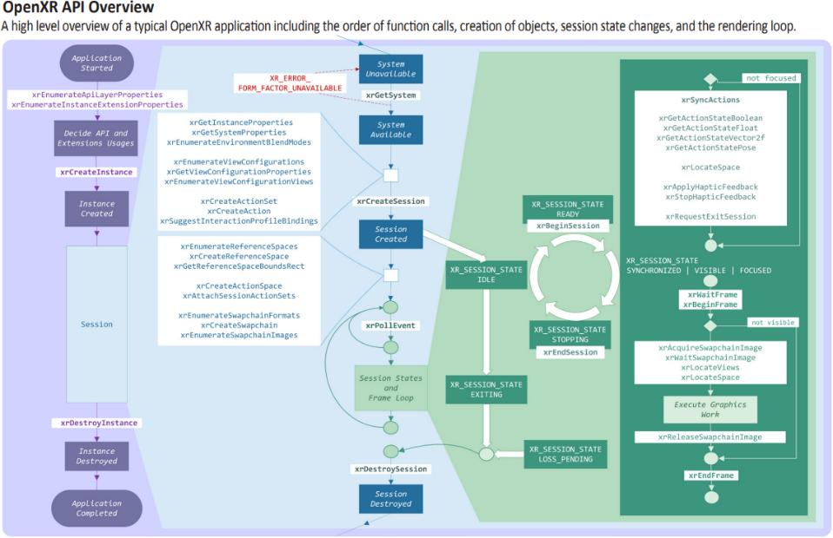
Figure 10 – OpenXR application lifecycle [7]
After creating an OpenXR session, the application starts a frame loop. The frame loop is executed for every frame. The frame loop consists of the following steps:
- Synchronize actions: this step consists of retrieving the action state, e.g. the status of the controller buttons and the associated pose. During this step, the application also establishes the location of different trackables. The application may also send haptics feedback.
- Start a new frame: this step starts with waiting for a frame to be provided by the XR runtime. This step is necessary to synchronize the application frame submission with the display. The xrWaitFrame function returns a frame state for the requested frame that includes a predictedDisplayTime, which is a prediction of when the corresponding composited frame will be displayed. This information is used by the application to request the predicted pose at display. Once the xrWaitFrame function completes, the application calls xrBeginFrame to signal the start of the rendering process.
- Retrieve rendering resources: the application starts by locating the views in space and time by calling the xrLocateViews function, provided with the predicted display time and the XR space. It then acquires the swap chain image associated with every view of the composition layer. It waits for the swap chain image to be made available so it can write into it.
- Rendering: the application then performs its rendering work. This is for instance what the scene manager is tasked with. It iterates over the scene graph nodes and renders each object to the view. This step usually uses a Graphics Framework such Vulkan, OpenGL, or Direct3D to perform the actual graphics operations.
- Release resources: once the rendering is done for a view, the application releases the corresponding swap chain image. Once all views are rendered, it sends them for display by calling the xrEndFrame function.
In terms of rendering operation, the relevant part is located between the call to xrBeginFrame and the call to xrEndFrame on the bottom right part of the diagram.
When the application calls the xrEndFrame function, the application provides the structure XrFrameEndInfo which contains all necessary information to render the frame that is:
- The time at which this frame should be displayed.
- The mode to be used for blending the user’s envriromnent with the submitted frame
One or more layers which composes the submitted frame

As documented in the OpenXR specification:
“XrFrameEndInfo may reference swapchains into which the application has rendered for this frame. From each XrSwapchain only one image index is implicitly referenced per frame, the one corresponding to the last call to xrReleaseSwapchainImage.”
This describes how the XR runtime and the application can exchange visual data, i.e. via the use of swapchains.
A key feature of the XR runtime is its ability to perform layer composition. A Compositor in the runtime is responsible for taking all the received layers from xrEndFrame calls, performing any necessary corrections such as pose correction and lens distortion, compositing them, and then sending the final frame to the display. An application may use multiple composition layers for its rendering. The number of supported composition layers may be queried by the application.
OpenXR supports different types of layers, with the main ones being:
- Projection Composition Layer: represents planar projected images, one rendered for each eye using a perspective projection.
- Quad Composition Layer: is useful for rendering user interface elements or 2D content on a planar area in the world.
- Cube Composition Layer: consists of a cube map with 6 views to be rendered by the application.
- Equirectangular Composition Layer: consists of an equirectangular image that is mapped onto the inside of a sphere in the world.
- Depth Composition Layer: provides an extra composition layer to allow applications to submit depth maps to assist with the pose correction of projected images of a project layer.
Figure 11 depicts an example of a projection composition layer and the resulting composited distorted image (image courtesy of Khronos).
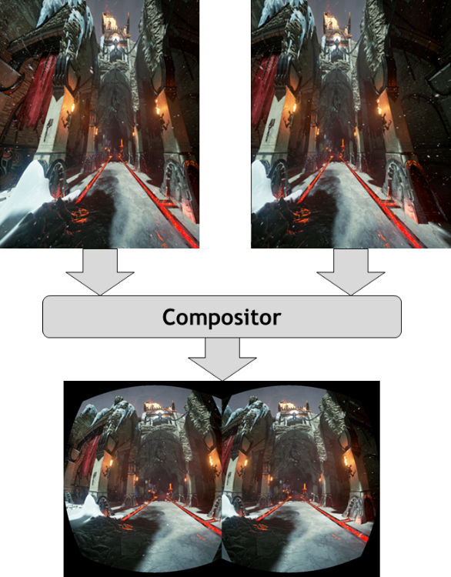
Figure 11 – Example illustrating composition of a stereoscopic image submitted to the Compositor
Another relevant configuration when setting up the XR session is the choice of the view configuration, which depends on the target device and its capabilities. Mono and Stereo are natively supported by all XR runtimes. Some advanced types like the primary quad, defined as a vendor extension provide support for foveated rendering.

3.8.2 Media-related conformance aspects

3.8.2.1 General
This analysis of media related conformance aspects was performed on the specification Version 1.0.25: from git ref release-1.0.25 [11].

3.8.2.2 Composition layer

3.8.2.2.1 Specification quote
The XrSystemGraphicsProperties structure is defined as:

typedef struct XrSystemGraphicsProperties {
uint32_t maxSwapchainImageHeight;
uint32_t maxSwapchainImageWidth;
uint32_t maxLayerCount;
} XrSystemGraphicsProperties;

Member Descriptions
• maxSwapchainImageHeight is the maximum swapchain image pixel height supported by this
system.
• maxSwapchainImageWidth is the maximum swapchain image pixel width supported by this
system.
• maxLayerCount is the maximum number of composition layers supported by this system. The
runtime must support at least XR_MIN_COMPOSITION_LAYERS_SUPPORTED layers.

// Provided by XR_VERSION_1_0
#define XR_MIN_COMPOSITION_LAYERS_SUPPORTED 16

XR_MIN_COMPOSITION_LAYERS_SUPPORTED defines the minimum number of composition layers that a conformant runtime must support. A runtime must return the XrSystemGraphicsProperties::maxLayerCount at least the value of XR_MIN_COMPOSITION_LAYERS_SUPPORTED.

…

(10.4. Frame Submission)

XR_ERROR_LAYER_LIMIT_EXCEEDED must be returned if XrFrameEndInfo::layerCount exceeds XrSystemGraphicsProperties::maxLayerCount or if the runtime is unable to composite the specified layers due to resource constraints.
…

(10.4.5. Composition Layer Types)

The core specification defines XrCompositionLayerProjection and XrCompositionLayerQuad layer types.

The projection layer type represents planar projected images rendered from the eye point of each eye using a perspective projection. This layer type is typically used to render the virtual world from the user’s perspective.

The quad layer type describes a posable planar rectangle in the virtual world for displaying two-dimensional content. Quad layers can subtend a smaller portion of the display’s field of view, allowing a better match between the resolutions of the XrSwapchain image and footprint of that image in the final composition. This improves legibility for user interface elements or heads-up displays and allows optimal sampling during any composition distortion corrections the runtime might employ.

3.8.2.2.2 Media capabilities
Regarding composition layers, the study of OpenXR shows the following mandatory support:
- The Runtime must at least accepts 16 layers per submitted frame. However, note that at runtime, the system may reject the composition of those layers if resource are not available for it.
- The Runtime must support at least the projection layer and quad layer from the core specification.

3.8.2.3 Tracking

3.8.2.3.1 Specification quote
The XrSystemTrackingProperties structure is defined as:
typedef struct XrSystemTrackingProperties {
XrBool32 orientationTracking;
XrBool32 positionTracking;
} XrSystemTrackingProperties;

Member Descriptions
• orientationTracking is set to XR_TRUE to indicate the system supports orientational tracking of
the view pose(s), XR_FALSE otherwise.
• positionTracking is set to XR_TRUE to indicate the system supports positional tracking of the
view pose(s), XR_FALSE otherwise.

3.8.2.3.2 Tracking capabilities
Regarding tracking, the core specification does not seem to mandate the presence of tracking capabilities.

3.8.2.4 Swapchains

3.8.2.4.1 Specification quote
(10.1. Swapchain Image Management)
The runtime must allow applications to create multiple swapchains.

Swapchain image format support by the runtime is specified by the xrEnumerateSwapchainFormats function. Runtimes should support R8G8B8A8 and R8G8B8A8 sRGB formats if possible.

3.8.2.4.2 Swapchain format capabilities
Regarding swapchains, the study of OpenXR shows the following mandatory support:
- The Runtime must allow multiple swapchains (i.e. more than one)
- The Runtime should support at least support R8G8B8A8 and R8G8B8A8 sRGB.

There seems thus to be little constraints in terms of swapchain image format to be mandatory supported.

3.9 MPEG-I Scene Description
NOTE: As part of the working assumptions MPEG-I SD functionalities will be evaluated, as a candidate solution, against the device capabilities and requirements of MeCAR.

3.9.1 Overview
As described in section 4.6.5 of TR 26.998 [1], a key technology in enabling immersive 3D user experiences is scene description. Scene description is used to describe the composition of a 3D scene, referencing and positioning the different 2D and 3D assets in the scene. The information provided in the scene description is then used by an application to render the 3D scene properly, using techniques such as Physically-Based Rendering (PBR) that produce realistic views
To address the needs of immersive applications, MPEG Scene Description (SD) specified a collection of extensions to glTF to support scene description. glTF 2.0 [32] provides a solid and efficient baseline for exchangeable and interoperable scene descriptions.
A white paper providing an overview of MPEG Scene Description is available [33].

Khronos glTF 2.0 specification was released in 2017. Khronos allows to extend the glTF specifications through an extension mechanism. The process of registering MPEG extensions as Khronos Vendor extensions is now in its final stage.

MPEG SD defines the following extensions:
- the First Edition of MPEG-I Scene Description (ISO/IEC 23090-part14) is a set of extensions providing support for audio, timed media, and scene update.
- Amendment 1 provides support for immersive media (MIV and V-PCC, V3C standards). (April 2023, DAM1 [36])
- Amendment 2 provides support for immersive audio, AR anchoring, interactivity, lighting, avatar, haptics.(April 2023, CDAM2 [37])

In the MPEG SD Technologies under Consideration (TuC) document, support for advanced interactivity and for real environment are under study for an Amendment 3.

3.9.2 MPEG-I glTF extensions

3.9.2.1 The anchoring extension
The anchoring extension enables the sharing of a common spatial reference among multiple users by specifying trackables and anchors.

Trackable is an element of the real world which features can be extracted. This element can then be detected and tracked over time.
An anchor is a virtual object defining a local reference space for the virtual scene.
The anchor is attached to this trackable. The anchor position is then relative to the trackable it is attached to.

The MPEG Scene Description anchoring extension is defined in Amd2 clause 8.1. It includes all the necessary syntax to define the trackable, the anchor, the relative position of the anchor in relation to the trackable.

The anchoring extension is defined in Amendment 2.

3.9.2.2 The interactivity extension
MPEG-I Scene Description Amendment 2 defines an interactivity framework for the description of allowed runtime interactions between a user with the virtual scene objects and between the virtual objects themselves. The framework relies on the definition of behavior, composed of a logical combination of generic triggers and of the related actions to be launched sequentially or in parallel.

The trigger types are :
- Visibility trigger, allowing to detect if a 3D object in a virtual scene is visible from the user viewpoint,
- Proximity trigger, allowing to detect the proximity of the user to a 3D object of a virtual scene,
- Collision trigger, allowing to determine a collision between 3D objects,
- User-input trigger, allowing to detect a specific user input.

The physical parameters to animate the 3D objects according to physical laws are provided through interactivity extension.

The interactivity extension is defined in Amendment 2, clause 8.2.

3.9.2.3 The lighting extensions
The lighting extensions enable the signaling of light sources can be of two natures: real or virtual. In both cases, the light sources is represented by the same mathematical models (punctual light, ambient light, etc.). A common model to reconstruct realistic lighting, which is reused in MPEG-I SD, is composed of three elements:
- Main directional light which represents the main light source. It can be used to cast shadows.
- Ambient spherical harmonics which represents the remaining ambient light energy in the scene.
- An environment cubemap (texture) which can be used to render reflections in shiny metallic objects.
As background, there exist several lighting extensions for glTF 2.0 as part of the official Khronos glTF repository that are EXT_lights_image_based, KHR_lights_punctual and EXT_lights_ies. Those MPEG-I SD extensions add the ability to have dynamic lighting properties, spatialized of lighting properties
The lighting extensions are defined in Amendment 2.

3.9.2.4 The avatar extension
The avatar extension is signaling value that informs whether the node in the scene graph is an avatar or not (“True” or “False”) as well as the format of the avatar.

In addition, the Annex H provides an avatar model called Morgan where the correspondence between vertices’ and faces’ ranges and the all associated semantic labels are described. The LoD of the Morgan avatar is described as low, medium and high resolutions, and each is accompanied by different mesh and skeleton topologies. As part of the Morgan avatar, a basic glTF format description is available to visualize the basic geometry and to encode the hierarchical skeletal structure.

The avatar extension is defined in Amendment 2.

3.9.2.5 The haptic extension
The first avatar extension at the node-level allows to attach haptic data directly to a node. The second avatar extension at the mesh-level allows a more accurate description of the haptic properties of an object by attaching the haptic data directly to a mesh using haptic textures. This haptic information can be used directly to render timed haptic data or it can be used with the interactivity framework to provide interactive haptic feedback.

The lighting extension are defined in Amendment 2.

3.9.2.6 The extension for Volumetric Video (V3C) support
This extension allows to support V3C compressed objects in MPEG-I Scene Description which can be objects coded as V-PCC or as MIV representation which are based on a common V3C scheme.

The V3C extension is defined in Amendment 1.

3.9.2.7 MPEG SD extensions in the TuC
Extensions described in the TuC document include, but are not limited to:
- Advanced interactivity: this extension addresses the need to support scene updates generated at runtime from the activation of triggers. The advanced interactivity extension is typically required in the case of a common virtual scene, shared between multiple users, each of them interacting and modifying the scene at runtime.

Real environment: this extension aims at providing scene understanding by supporting a real-world representation in scene description to achieve a seamless integration of the virtual into the real world (an example may be the interaction of virtual objects falling on a real surface).

3.9.2.8 Availability of MPEG-I glTF extensions
The MPEG-I SD extensions are developed un the vendor-extension “MPEG_” prefix to glTF2.0. The Khronos glTF repository [38] collects the submitted extensions.

3.10 Working assumption on operation points for MeCAR
Before starting the work on defining the required media capabilities related to 3D video, Operations Points are to be considered, where Operation Point is aligned with the definition in TS26.118 as "a collection of discrete combinations of different content formats including spatial and temporal resolutions, colour mapping, transfer functions, rendering metadata or the encoding format."
The MeCAR specification would define operation points for immersive video in IF-4, i.e. the interface between the Media Access Function and the 5G System for user plane data as defined in section 4.1.
However, in contrast to TS26.118, where the bitstreams conforming to Operation Points were defined to be self-contained omnidirectional experiences, in TS26.119, the bitstreams may be added to a scene that renders and composes data contained in multiple bitstreams.
Hence, carrying forward the definition from TS 26.118 into TS 26.119 may not be straightforward. We may need to differentiate three cases:
- The operation point is such that no action or pose-based rendering is needed, i.e. that operation point is directly consumable by the XR Runtime as the media is already projected (left/right eye), equirectangular, etc., possibly with some simple colour conversion. Note that this may require some amount of metadata processing.
- The operation point describes an asset and includes asset metadata that requires a GPU-based rendering taking into account the viewer pose, but can be projected into a composition layer to be consumed by the run-time
- The operation point is a scene that requires a GPU-based rendering taking into account the viewer pose and also address local input an actions, but then is projected into a composition layer to be consumed by the run-time.
The above operation points may require different capabilities on the device:
  - Video decoding capabilities: needed by all three cases
  - Rendering capabilities: needed by 2 and 3
  - Scene composition capabilities: needed by 3
Hence, the MeCAR specification would define at least three capabilities:
- video decoding capability
- rendering capabilities based on asset metadata information, describing the mapping from 3D space to the 2D video frame (texture, depth, etc).
- rendering and scene composition capabilities to render scenes and included assets
Video decoding capability would be defined by the requirements as per clause 6.6 in this document.
Rendering capabilities for asset metadata information may require the ability to render information provided by the video decoder output combined with asset metadata this could include. Asset metadata may for example be:
- Certain SEI messages,
- Atlas metadata as defined in V3C profiles, or
Finally, scene rendering includes the ability to interpret a scene and render the scene and the referenced objects. There may be for example:
- A gltf scene
- A gltf scene with MPEG-I Scene Description extensions.
For the asset metadata information, MeCAR may evaluate, for example,
- Relevant rendering metadata in SEI messages
- MIV and V-PCC profiles of V3C,.
NOTE Further clarifications need to be added on 3D video and asset metadata. The terminology ‘operation points’ can be further refined to match the terminology agreed in MeCAR. Rendering capabilities for devices need to be further studied.

4 Device categories

4.1 Candidate XR Baseline Client

4.1.1 General
The XR Baseline Client represents the functionalities, the peripherals, and the interfaces that are present on a generic XR UE. The actual device may be realized by a single device, or a combination of devices linked together. The details on how to instantiate an XR Baseline Client in the context of a service or deployment scenario is left for the respective Work Items and Study Items to define.
In terms of functionalities, an XR Baseline Client is composed of:
- An XR application: a software application that integrates audio-visual content into the user’s real-world environment
- An XR Runtime: a set of functions that interface with a platform to perform commonly required operations, such as accessing the controller/peripheral state, getting current and/or predicted tracking positions, performing spatial computing, as well as submitting rendered frames to the display processing unit and rendered audio to the speakers with a late stage re-projection to the latest pose.
- An XR Source Management: management of data sources provided through the XR runtime such as microphones, cameras, trackers, etc, for instance, making the information available to the XR application or providing it to the MAF for sending in the uplink.
- A Media Access Function: A set of functions that enables access to media and other XR-related data that is needed in the Scene manager or XR Runtime to provide an XR experience as well to create delivery formats for information provided by the XR Source Management.
- A Scene Manager: a set of functions that supports the application in arranging the logical and spatial representation of a multisensorial scene based on support from the XR Runtime.
- A Presentation Engine: a set of composite renderers, rendering the component of the scenes, based on the input from the Scene Manager.
- A Media Session Handler: a set of functions responsible for handling all 5G control plane operations, such as requesting network assistance, discovering and allocating edge resources, etc. This may be realized as a 5G-RTC MSH, 5GMS Media Session Handler, or any other function
In addition, those functional blocks are integrated together via interfaces. Interfaces may be made of APIs and/or data formats and collectively act as a contract between the two sides of the interface.
The XR Baseline Client contains the following interfaces:
- IF-1 lies between the XR Runtime on one side and the Application (1a), the XR Source Management (1b) and the Presentation Engine (1c). IF-1 is implemented as an API (API-1) that exposes functions provided by the XR Runtime. An example of this API is the Khronos OpenXR API.
- IF-2 describes the functions exposed by the XR Source Management that can be accessed and controlled by the XR application, or possibly other functions in the device. IF-2 is typically implemented as an API.
- IF-3 lies between the XR Source Management and the Media Access Function and provides serialized information accessible on XR Runtime to the MAF.
- IF-4 lies between the Media Access Function and the 5G System for user plane data.
- IF-5 lies between the UE and the 5G System, implementing control sessions (such as 5G Media Streaming, IMS). This interface provides for instance the functionality of the RTC-5 interface as defined by TS26.506.
- IF-6 lies between the Media Session Handler and the Application/MAF. It offers the tools for them to activate 5G media functionality such as network assistance and edge resource discovery. The IF-6 is realized through an API (API-6).
- IF-7 lies between the XR Application and the Media Access function to configure Media Access. This is typically implemented as an API (API-7) that exposes functions of the MAF.
- IF-8 is an interface that allows the XR application to make use of 5G System connectivity.
- IF-9 lies between the Scene Manager and the Media Access Function.
- IF-10 lies between the Scene Manager and the XR Application.
NOTE The renumbering was done to align IF-4, IF-5, IF-6, IF-7 and IF-8 with 5GMS interfaces.

4.1.2 Architecture
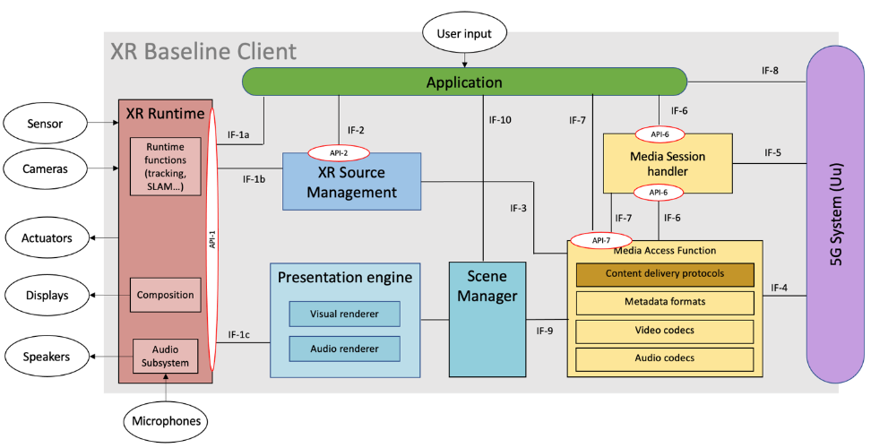
Figure 12 - XR Baseline Client architecture
Editor’s Note: Derived figures in Clauses 4.2.1 (Thin AR UE), 4.3.1 (AR UE), 4.4.1 (XR UE) will be aligned on this figure.

4.1.3 Example Technologies
The current clause is purely informative and intend to give some ideas about the different technology blocks and specifications that could be relevant for realizing a concrete instance of a XR baseline client. The interfaces could be enabled as follows:
- IF-1 as an example is OpenXR API.
- IF-2 source management is for example provided by Snapdragon Spaces, Unity or Unreal.
- IF-3 is expected to be defined in TS 26.119 as a reference.
- IF-4 is expected to build on protocols including webRTC, IETF user plane protocols and 3GPP or MPEG codecs.
- IF-5 lies between the UE and the 5G System, implementing control sessions (such as 5G Media Streaming, IMS). This interface provides for instance the functionality of the RTC-5 interface as defined by TS26.506.
- IF-6 provides a communication between the app and the 3GPP session handling.
- IF-7 provides an API to be defined in TR 26.119.
- IF-8 is a regular application connection to a server OTT delivery, for example using HTTP.
- IF-9 is for example described as part of a glTF2.0 presentation.
- IF-10 is for example exposed by Unity or Unreal such that an application can use the underlying rendering.
Figure 13 provides an illustration of those example technologies mapped onto the XR baseline client architecture.
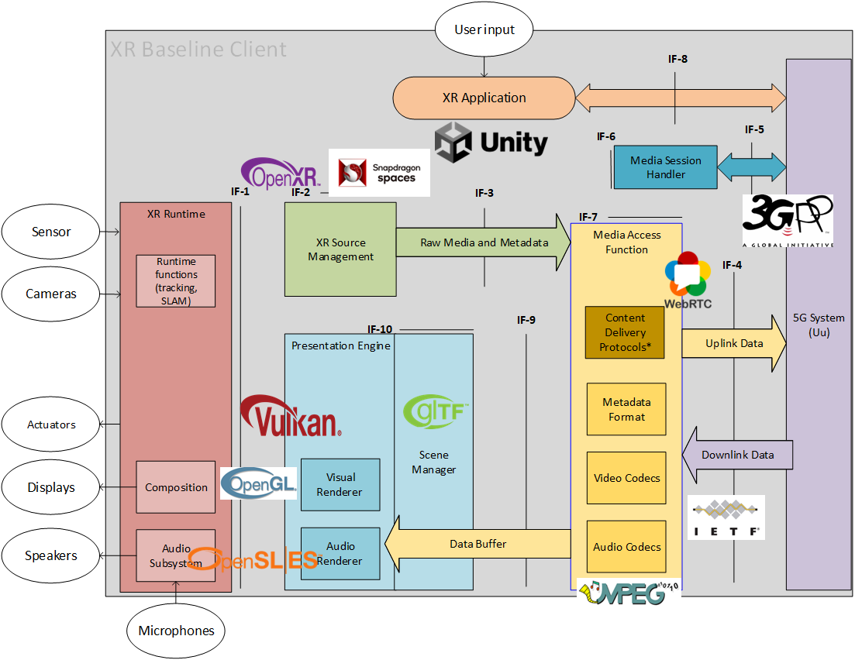
Figure 13 - Example Technologies in an XR Baseline Client

4.2 Thin Augmented Reality User Equipment (Thin AR UE)

4.2.1 Device architecture
The simplified version of an AR device follows the principles of a 5G_STAR EDGAR-type device architecture with a standalone 5G System integrated. It is referred to as "Thin AR UE". In this case it is taken into account that the device is not capable of rendering complex 3D scenes or objects, but basically only makes use of the composition capabilities of the XR runtime.
In a typical use case, the media is pre-rendered for a specific point in time in the future and a specific render pose by an entity outside of the device, for example in the 3GPP network, and the Scene Manager only converts the data to be compatible with the XR Runtime formats in the swap chain. Pre-rendering for video may be done to 2D video projections, possibly augmented with additional depth information (indicated as 2.5D in Figure 15). For audio, equivalent pre-rendering formats may be considered. In the uplink, a coded representation of the 6DoF pose sampled from the XR Runtime needs to be made available such that it can be used remotely for prerendering to the latest pose. As a result, such a UE may be used in a split rendering application.
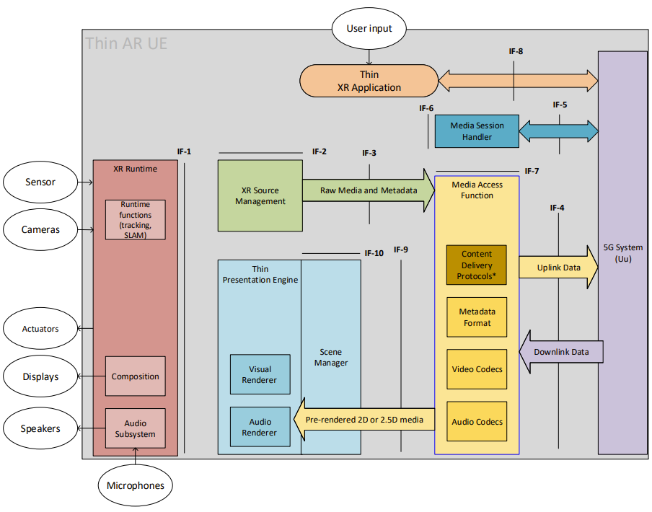
Figure 14 – Thin AR UE device architecture
In the following, initial assumptions and potential requirements for the XR Runtime for visual and audio processing are provided taking into account existing systems, in particular OpenXR, OpenGL ES and OpenSL ES. In all cases, the focus is on the functional methods of these specifications. Reference to specifics in these specifications does not imply that we mandate any of these specifications, but they serve as a reference.
Implementations may be done differently.

4.2.2 XR Runtime and Source processing
For XR source processing, the following is assumed
- The application (including the Scene Manager) has access to the viewer pose and projection parameters that are needed to render the different views. The XR Runtime provides the viewer pose and projection parameters needed to render using a function equivalent to the OpenXR xrLocateViews function to render each view for use in a composition projection layer. The xrLocateViews function returns the view and projection info for a particular display time. This time is typically the target display time for a given frame. Repeatedly calling xrLocateViews with the same time may not necessarily return the same result. Instead the prediction gets increasingly accurate as the function is called closer to the given time for which a prediction is made. This allows an application to get the predicted views as late as possible in its pipeline to get the least amount of latency and prediction error. The viewer pose and projection parameters may need to be provided to the MAF.
- The specification does not define any requirements on input actions or haptics. However, input actions may be provided to the XR Source Management to be delivered to the network. In summary
  - A 6DoF predicted pose for a target display time can be sampled from XR Runtime at a frequency of at least 1kHz
  - This information may be provided to a pose compressor that may send a compressed and quantized version to the network
- Other audio or video sources may be provided to the XR source manager.

4.2.3 XR Visual Processing
For visual processing, OpenXR and OpenGL ES aligned terminology is used as a reference, but this does not imply that we mandate any of these specifications. The following is assumed:
- To present images to the user, the runtime provides images organized in swapchains for the application to render into. The XR Runtime is expected to allow applications to create multiple swapchains (at least 4).
- The XR Runtime may support different swapchain image formats and the supported image formats may be provided to the application through the runtime API. The XR Runtime is expected to at least support R8G8B8A8 and R8G8B8A8 sRGB formats. Details may depend on the graphics API specified in xrCreateSession. Options include DirectX or OpenGL.
- Support for OpenGL ES as a reference is assumed, i.e. an extension equivalent to the functionalities provided in XR_KHR_opengl_es_enable. OpenGL ES is platform independent and suited for embedded systems. The version and a subset of functionalities is still to be determined, likely 3.2. Again note that this is assumed as a reference.
- Swapchain images can be 2D or 2D Array. Arrays allow to extract a subset of the 2D images for rendering.
- The application or Scene Manager can offload the composition of the final image to a XR Runtime-supplied compositor. By this, the rendering complexity is significantly lower since details such as frame-rate interpolation and distortion correction are performed by the XR Runtime. It is assumed that the XR Runtime provides these functionalities.
- A XR Runtime is expected to support at least the equivalent functionalities of OpenXR composition, namely
  - XrCompositionLayerProjection: The projection layer type represents planar projected images rendered from the eye point of each eye using a perspective projection. This layer type is typically used to render the virtual world from the user’s perspective.
  - XrCompositionLayerQuad: The quad layer type describes a posable planar rectangle in the virtual world for displaying two-dimensional content. Quad layers can subtend a smaller portion of the display’s field of view, allowing a better match between the resolutions of the XrSwapchain image and footprint of that image in the final composition. This improves legibility for user interface elements or heads-up displays and allows optimal sampling during any composition distortion corrections the runtime might employ.
- A XR Runtime may support additional OpenXR composition functionalities, namely
  - XR_TYPE_COMPOSITION_LAYER_CUBE_KHR: This extension adds an additional layer type that enables direct sampling from cubemaps. The cube layer is the natural layer type for hardware accelerated environment maps. Without updating the image source, the user can look all around, and the compositor can display what they are looking at without intervention from the application.
  - XR_TYPE_COMPOSITION_LAYER_CYLINDER_KHR: This extension adds an additional layer type where the XR runtime must map a texture stemming from a swapchain onto the inside of a cylinder section. It can be imagined much the same way a curved television display looks to a viewer. This is not a projection type of layer but rather an object-in-world type of layer, similar to XrCompositionLayerQuad. Only the interior of the cylinder surface must be visible; the exterior of the cylinder is not visible and must not be drawn by the runtime.
  - XR_TYPE_COMPOSITION_LAYER_EQUIRECT_KHR and XR_TYPE_COMPOSITION_LAYER_EQUIRECT2_KHR: This extension adds an additional layer type where the XR Runtime must map an equirectangular coded image stemming from a swapchain onto the inside of a sphere. The equirect layer type provides most of the same benefits as a cubemap, but from an equirect 2D image source. This image source is appealing mostly because equirect environment maps are very common, and the highest quality you can get from them is by sampling them directly in the compositor.
  - XR_KHR_composition_layer_depth: This extension defines an extra layer type which allows applications to submit depth images along with color images in projection layers, i.e. XrCompositionLayerProjection. The XR Runtime may use this information to perform more accurate reprojections taking depth into account. Use of this extension does not affect the order of layer composition as described in Compositing.
- Each image that is provided to the runtime for rendering has assigned a reference pose defining the position and orientation of the projection in the reference frame of the associated space.
- The runtime provides information about a predicted display time for the next time that the runtime predicts a composited frame will be displayed, i.e. using xrFrameState if in context to OpenXR
- The composition may refer to a sub-image as for example defined in XrSwapchainSubImage, i.e. representing the valid portion of the image to use, in pixels. It also implicitly defines the transform from normalized image coordinates into pixel coordinates.

4.2.4 XR Audio Processing
Editor’s Note: From SA4#121, The current clause is work-in-progress and will be further discussed and worked on during the upcoming telcos.
[
For audio processing, OpenXR and OpenSL ES aligned terminology is used as a reference, but this does not imply that we mandate any of these specifications. The following is assumed to reflect a typically possible decomposition of steps for immersive audio rendering:
- An interface to the XR runtime is available hand over raw audio buffers to determine how the XR application and scene manager would access a device’s audio capabilities. In order address a concrete implementation example, the model of OpenSL ES is used as a reference for. OpenSL ES supports both file-based and in-memory data sources, as well as buffer queues, for efficient streaming of audio data from memory to the audio system. Buffer queues in OpenSL may be viewed as equivalent to visual swap chains. OpenSL ES may be viewed as companion to 3D graphic APIs such as OpenGL ES. The 3D graphics engine will render the 3D graphics scene to a two-dimension display device, and the OpenSL ES implementation will render the 3D audio scene to the audio output device.
- In addition to the functionalities from such buffer queues, different types of audio signals may be provided, and additional/alternative processing steps may be carried out. Audio signals (i.e. the combination of metadata and buffer queues) may be
  - non-immersive or also known as non-diegitic, i.e. they are not rendered according to the pose.
  - Immersive and describe a full 6DoF experience in the reference space of the XR session. In this case, the XR runtime will create a rendered signal according to the latest pose.
  - Immersive and pre-rendered for a specific render pose. In this case, the signals have been prepared such that the runtime can use the audio signal and the associated render pose and supplementary data for a pose correction to the latest pose.
  - a mixture of such signals that are jointly presented.
  - the signals may originate from different source, for example some may be generated locally, others may be part of a pre-rendering or a full scene created in the network.
- Of particular interest is a simple use case, for example prominent for split rendering is a combination of signals a) non-diegetic, c) pre-rendered with assigned render pose, d) mixture of those. At least a), b), d) and e) from above follows the principle of what is defined in TS 26.118, figure 4.5-1 providing a Block diagram of Common Informative Binaural Renderer. Pre-processing of content to HOA may for example be done based on TS 26.118, Annex B.3. The displacement of the scene to adjust to the latest head pose if done for example based on what is described in TS 26.118, Annex B.4. The headphone output signal computation may follow TS 26.118, Annex B.5. As a starting point, the renderer in Annex B of TS 26.118 may be considered as a reference renderer. However, note that this renderer may have certain limitations and, for example, not be fully usable for translational movements as well as to address signal types c from above. Detailed analysis from audio experts is needed if Annex B renderer is sufficient as reference.
The renderer according to these principles may be applicable in a use case for split rendering which is a combination of signals a) non-diegetic, c) pre-rendered with assigned render pose, d) mixture of those. Suitable formats for this purpose may be
  - Mono signal (non-diegetic signals) that is not adapted to the latest viewer pose and position
  - Stereo signal (non-diegetic signals) that is not adapted to the latest viewer pose and position
  - Stereo signal (diegetic signal) with pre-render pose that is not adapted to the latest viewer pose and position
  - HOA signal with pre-render pose (for example the position) which then is only rotated to the latest pose (pre-dominantly orientation).

From audio experts, it would be excellent to get a list of formats and a reference renderer that can address the above use case in a manner that realization using similar interfaces as provided in OpenSL ES can be provided.

Addressing full 6DoF audio scenes with rendering on the device may be subject of future work.
]

4.3 Augmented Reality User Equipment (AR UE)

4.3.1 Device architecture
A render centric-UE would support additional rendering capabilities in the device such as more complex 3D rendering (meshes and point clouds), uplink media capturing and so on. The basic principle of what is described in clause 4.2.2 remains. The additional capabilities may be expressed initially as optional extensions to the minimum capabilities in clause 4.2.2. No additional device classes are needed for now.
However, such extensions then would need to be done by identifying and adding the relevant capability checks.
Figure 15 provides the technical architecture of the AR UE.
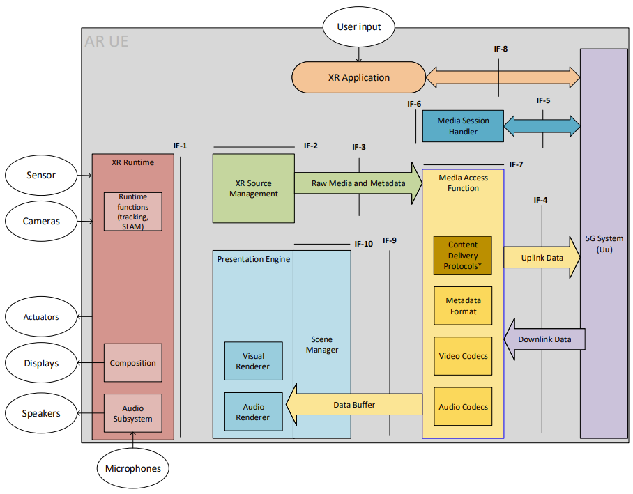
Figure 15 – AR UE device architecture
The AR UE is regular 5G UE with 5G connectivity provided through an embedded 5G modem and 5G system components. The AR UE also features several sensors and user controllers relevant for AR experiences that are cameras, microphones, speakers, display and generic user input. The AR/MR Application is responsible for orchestrating the various device resources to offer the AR experience to the user. In particular, the AR/MR Application can leverage the main internal components on the device which are:
- The Media Access Functions (MAF)
- The XR Runtime
- The Presentation Engine
- The Scene Manager together with the Presentation Engine that includes functions such as scene composition and possible complex audio or visual rendering
- The XR Source Management address the management or sources provided through the XR Runtime such as microphones, cameras, trackers, etc. The XR Source Management may expose information to the application or may provide a subset to the media access function to be sent remote.

The AR/MR Application can communicate with those three components via dedicated APIs. Exposed in are:
- the XR Runtime API which provides access to the core functionalities of an XR device.
- the MAF-API, which is essential to allow the application to make use of dedicated media functions available on the XR device

In addition, it is expected that an application can communicate with the Scene Manager and the Presentation Engine to establish the presented scene. It can also communicate with the XR Source Management in order to coordinate which data is made available for uplink streaming.
Among other functionalities, those APIs also enables the AR/MR Application to discover and query the media capabilities in terms of support as well as available resources at runtime.

Regarding rendering, it is expected that the XR Scene Manager has access to the latest pose and tracking information from the XR Runtime which is then provided. Based on this information, the Scene Manager may for example determine the objects visible to the user at a given point in time or more generally the objects that may be needed to be rendered in the next rendering cycles. The Scene Manager is responsible together with the Presentation Engine to submit the rendered views to the XR Runtime as frames written to the images of the Swapchains. Swapchains are established during the configuration phase of the XR Session using the information provided by the XR Runtime API. From those images in the Swapchains, the XR Runtime then generates the left and right eye buffers possibly based on late adjustment techniques using updated head pose information, if available, commonly known as late stage reprojection (LSR).

Once the XR application is running, the downlink media flows from the 5G System to the MAF in compressed form and then from the MAF to the Scene Manager in the form of primitive buffers. Note that for real-time media, the primitive buffers are provided with a rendering time and an associated pose. The Scene Manager may be guided by a static or dynamically updated scene description.
In parallel, the AR UE is capable of establishing an uplink data flow from the XR Runtime to the MAF wherein the data may be in an uncompressed form and then from the MAF to the 5G System wherein the MAF may have compressed the data in order to facilitate the expected transmission over the network.
A typical call flow for establishing an XR Presentation is as follows:
- The AR/MR Application is launched
- The AR/MR application launches and XR Session in the runtime
- The AR/MR application communicates with the scene manager to provide a scene description either through an application interface or through a well-defined scene description document, possibly retrieved over the network
- Based on the scene requirements, the capabilities of the XR Runtime, as well as the capabilities of the media access function, a set of media pipelines in the uplink and downlink are established.
- The media access function accesses the network resources or sends data to the network using the established media pipelines.
- The XR Runtime captures and renders the relevant data to match the device capabilities and the user interaction.

4.3.2 Visual capabilities

4.3.2.1 Video decoding
The AR UE shall support video decoding AVC-FullHD-Dec as defined in clause 6.6.1.
The AR UE should support video decoding HEVC-FullHD-Dec as defined in clause 6.6.1.

4.3.2.2 Video decoding interface
The AR UE shall support the video decoding interface AVC-HEVC-2-Dec defined in clause 6.6.3.

4.3.2.3 Video encoding
The AR UE shall support video encoding AVC-FullHD-Enc as defined in clause 6.6.2.
The AR UE should support video encoding HEVC-FullHD-Enc as defined in clause 6.6.2.

4.4 eXtended Reality User Equipment (XR UE)

4.4.1 Device architecture
The XR UE would typically be running the application on a phone form factor without any specific peripheries. The basic principles of the UE as described in clause 4.2.2 as well as the extensions in 4.3.2 remain. The additional capabilities may be expressed initially as optional extensions to the minimum capabilities in clause 4.2.2.
However, such extensions then would need to be done by identifying and adding the relevant capability checks.
Figure 16 provides the technical architecture of the XR UE.
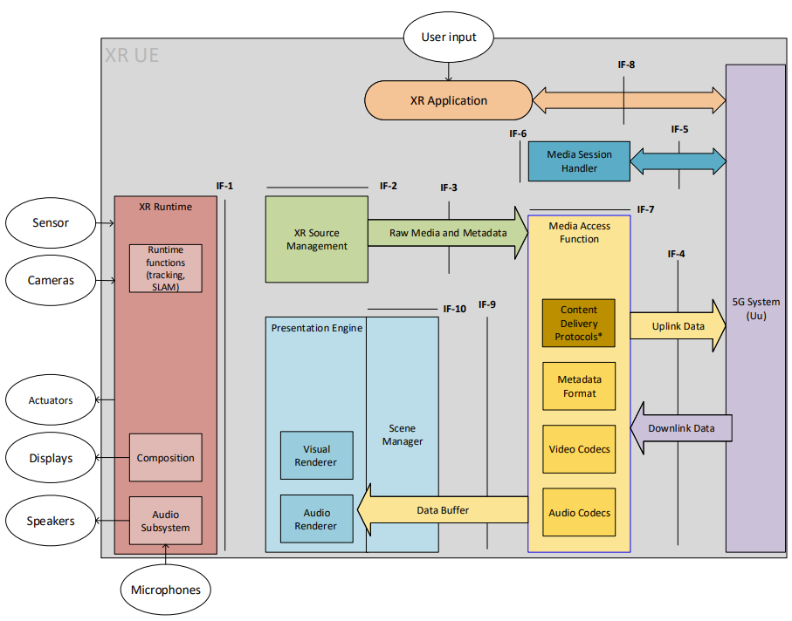
Figure 16 – XR UE device architecture
The same principles as in clause 4.3.1 apply.
The capabilities shall be aligned with high-end smartphone and is aligned with the capabilities defined in TS 26.511.

4.4.2 Visual capabilities

4.4.2.1 Video decoding
The video decoding capabilities shall be aligned with TS 26.511 and the following shall be supported:
- HEVC-UHD-Dec as defined in clause 4.2.2.1 of TS 26.511
The video decoding capabilities shall be aligned with TS 26.511 and the following should be supported:
- HEVC-8k-Dec as defined in clause 4.2.2.1 of TS 26.511

4.4.2.2 Video decoding interface
The XR UE shall support the video decoding interface AVC-HEVC-4-Dec defined in clause 6.6.3.

4.4.2.3 Video encoding
The XR UE shall support video encoding HEVC-4k-Enc as defined in TS 26.511.

4.4.2.4 Visual Rendering
tbd

5 Interoperability points and metrics

5.1 Interoperability Points for Visual and Audio
Figure 17 provides multiple interoperability points and interfaces that may or may not be relevant for the MeCAR specification.
Figure 17 – Interoperability points and Interfaces of interest for TS 26.119
Note that the interfaces align with operation points in TS 26.118.
Discussion for each interface is provided in the following in terms of functionalities as well relevancy for the specification in Table 7.
Table 7 – Interfaces of relevance
IF | Name | Summary of functionalities | Specification (normative, reference)
1 | XR Runtime API | The functionalities of the API include what is documented in clause 4.2.2 predominantly, namely  - Creation of a XR Session  - Providing controller and pose information to support immersive and 6DoF based rendering.  - Visual composition through swap chains including associated timing and predicted pose information and adapted to the latest pose and the output peripheries.  - Audio composition to through buffers including associated timing and predicted pose information and adapted to the pose and the output peripheries.  - Synchronization of audio-visual output  - Collection of audio and video sources provided to the XR source management.  - Query of optional processing and rendering capabilities, for example projection formats  Uncompressed data formats | The specification will assume that an XR Session is established and that the device provides access to the device peripheries and XR capabilities using an XR Runtime API.  - During the development of MeCAR work, OpenXR will be used, where applicable, as a reference instantiation of the API for the XR runtime.  It is assumed that an equivalent functionality of all mandatory functionalities of OpenXR are available through a run-time.  For Visual rendering, it is assumed that at least all functionalities of OpenGL ES are available.  For Audio rendering, it is assumed that at least all functionalities of OpenSL ES and TS 26.118 are available.  This API is similar and an extension to the combination of the VR-API and the 3GPP VR Viewport test point in TS 26.118. See Figure XX, the blue interface.
2 | XR Source media and metadata formats | The functionalities of this API include the configuration on how to access the data from the XR run-time and pre-process in order to serialize the data for delivery and assign the sampling and action tiem of the data. | The configuration is conceptually relevant in order to select the sources of the device to deliver upstream and to define an appropriate format for the metadata, using typical XR Runtime API semantics.  However, the detailed API is not specified in TS26.119.
3 | Scene Information and buffers formats | Uncompressed buffer format  The functionalities of this interface include to collect information from the XR Runtime that then may be serialized, time-stamped, and compressed, including:  - Viewer pose and projection parameters needed to render using the xrLocateViews function to render each view for use in a composition projection layer.  - Camera output  - Microphone output  Other sensor and haptics data | For XR metadata to be possibly delivered over a network interface, the raw formats including information on timing needs to be defined in order to permit serialization of the data in metadata delivery. Information includes viewer pose, triggers and actions, etc.  For this specification the following needs to be defined:  Input [compressor] binary [decompressor] output  - The input is sampled from the XR runtime API. After compression and decompression, the output needs to be represented as if it would be provided from the XR runtime.  - Compressor and binary formats are defined in MAF.  Input/output formats need to be determined and are conceptually assigned to this function
4 | MAF-API | These are the core network interfaces to support media delivery in the downlink and uplink.  The functionality includes:  - Scene Description delivery and updates  - Audio and video formats for parallel decoding of multiple buffers  - Audio and video encoding for multiple buffers  - Coding and delivery of pose information  - Metadata delivery  - 5GMS based Content Delivery protocol based on DASH/CMAF  - RTP-based delivery  - Encryption and security  Rate control | Core of the specification for TS 26.119  This API is equivalent to the 3GPP VR OP as defined in TS 26.118.  The DASH API is not defined as the entry point is the Scene Description.
5 | MeCAR media formats | This API and function allows to support integration into the 5G System to support 5G Network functionalities such as session establishment, QoS, QoE reporting, discovery and establishment of edge capabilities, etc. | This aspect is outside of MeCAR, but is included in 3GPP system specs that adds MeCAR capabilities to the system.  Example for such systems are IMS, 5G Media Streaming, etc.
6 | Internal Interprocess communication | The application may have access to control the runtime and the sources in order to configure the work flow | This is outside of the scope of the specification
7 | Application network communication | A functionality to configure and control the media access and delivery by the scene manager, the XR source manager and/or the application in order to set up media delivery pipelines. The API is rich enough to support configuration of  - Downlink access for media  - Downlink access of scene description  - Uplink delivery for media  - Uplink delivery for metadata  The information may include for example dynamic information such as updated pose information, etc. | A reference API should be specified for the MAF in order to configure the pipelines. While this API may not be mandatory, it is a reference to support the functionalities of media pipelines.  This part is included in the VR-API as defined in TS 26.118.
8 | Application network communication | The application may connect to the network to identify entry points or deal with XR Runtime specific data. | Basic entry point assumptions may be documented, but do not have to be specified in TS26.119.
9 | Scene Information and buffers formats | Uncompressed buffer format  The functionality of this interface is to define a set of primitive buffers for different media types that can be rendered by the Visual and Audio renderer. In combination with the Scene description, the information can be used to render 3D and immersive scenes by the Scene manager and the presentation engine.  The combination of the scene description information, possibly generated from the application or in a scene description delivery document, as well as the primitive buffers provide sufficient information to the presentation engine in order create an immersive audio-visual experience | A reference scene description format based on glTF2.0 as a reference.  The scene description is specified as one way to support it, but equivalent application functions may be defined. A proper subset of glTF2.0 with possible extensions need to be defined.  This information is similar to what was defined as VR Scheme in the context of TS 26.118
10 | Scene Manager API | This interface allows to configure the scene manager | The configuration is conceptually relevant in order to establish the rendering pipelines.  However, the detailed API is not specified in TS26.119.

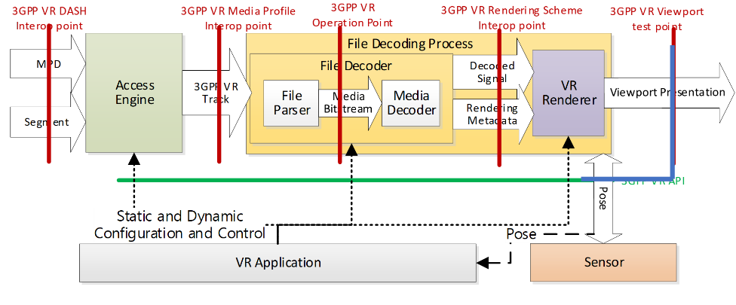

5.2 Metrics Observation Points and KPIs

5.2.1 Metrics Observation Points
[Editor’s note: The content of this clause 5.2.1 has been moved with modifications to the draft MeCAR TS 26.119 0.3.0 at SA4#125. Please consult the latest draft MeCAR TS 26.119 available to obtain the most recent version of this clause.]

5.2.1.1 General
In a similar fashion as for operation points and interface, metrics observation points may be defined to specify basic metrics as shown in Figure 18. It contains a number of observation points where specific metric-related information can be made available to the application. The application can use and combine information from the different observation points to calculate more complex metrics.
Figure 18 – Metrics Observation Points of interest for TS 26.119
In the following potential KPIs as documented in TR 26.998, clause 4.5.2 are summarized. Specifically, the latencies as introduced in TR 26.998 are rediscussed in the context of the MeCAR work item.

5.2.1.2 Observation Point 1
Observation point 1 (OP-1) is derived from the XR Runtime API which exchanges information between the XR Runtime and the XR Source Management/Presentation Engine. The OP-1 which corresponds to the IF-1, is implemented as an API-1 that exposes functions provided by the XR Runtime. An example of this API is the Khronos OpenXR API.

5.2.1.3 Observation Point 2
Observation point 2 (OP-2) collects information at the input of the Scene Manager. The OP-2 corresponds to the IF-10 for information coming from the application and the IF-9 for data received from the Media Access Function.

5.2.1.4 Observation Point 3
Observation point 3 (OP-3) is derived from the API which exchanges information between the Media Access Function and the 5G System. It corresponds to the IF-4 interface.

5.2.1.5 Observation Point 4
Observation point 4 (OP-4) is derived from the API which exchanges information between the XR Source Management and the Media Access Functions. It corresponds to the IF-3 interface.

5.2.2 Timestamps and observation points
The timestamps collected at the observation points are listed in Table 8.
Table 8 - Timestamps definition and collection
Timestamp | Definition | Observation Point / Interface
pose prediction time (T1) | The time when the viewer pose prediction is made. It corresponds to the time when the predicted viewer pose is collected using the XR runtime API-1 by the application or the XR Source Manager. | OP-1 / IF-1a
lastChangeTime | The time when the user action is made. It corresponds to the lastChangeTime field in the action information defined as the timestamp of the last change to the state of the action. | OP-1 / IF-1a
sceneUpdateTime (T6) | The time when the Scene Manager starts to update the 3D scene graph according to the viewer pose and the user actions. | OP-2 / IF-10
startRenderTime (T3) | The time when the renderer starts to render the scene according to the viewer pose. | OP-1 / IF-1
predicted displayTime (T2.actual) | It is the predicted display time of the rendered frame in the swapchain. The display time is available through the XR runtime.  With OpenXR, the frame’s predicted display time is reported by xrWaitFrame in XrFrameState.predictedDisplayTime. | OP-1 / IF-1c

5.2.3 Delay Measurements
Using all the timestamps collected at the Observation Points, the application may compute the delays and latencies listed in the Table 9.
Table 9 - Delays and latencies computation
Name | Definition | Computation
pose-to-render-to-photon | The time used to provide the pose information from the XR runtime to the renderer and the renderer using this pose to generate the displayed media. The final pose correction to the latest pose may always be done in the XR runtime. | T2.actual – T1
roundtrip-interaction-delay | The time duration between the moment at which a user action is initiated and the time such an action is presented to the user.  This delay is the sum of the age-of-content and the user-interaction-delay. | T2.actual – lastChangeTime
render-to-photon-delay | The time duration between the start of the rendering and the display of the rendered frame to the user. | T2.actual – T3
user-interaction-delay | The time duration between the moment at which a user action is initiated and the time such an action is taken into account by the content creation engine in the scene manager. | T6 – lastChangeTime
age-of-content | The time duration between the moment the content is created in the scene by the Scene Manager and the time it is presented to the user. | T2.actual – T6
scene-update-delay | the time spent by the Scene Manager to update the scene graph. | T3 – T6

5.2.4 Relevant KPIs for XR and AR according to TR 26.998
In TR 26.928, some high-level statements on experience KPIs for AR are provided. To achieve Presence in Extended and Augmented Reality, seamless integration of virtual content and physical environment is required. Like in VR, the virtual content has to align with user's expectations. For truly immersive AR and in particular MR, it is expected that users cannot discern virtual objects from real objects.
Also relevant for VR and AR, but in particular AR, is not only the awareness for the user for the environment. This includes, safe zone discovery, dynamic obstacle warning, geometric and semantic environment parsing, environmental lighting and world mapping.
Table 5.2.2-1 provides the KPIs from TR 26.998, Table 4.5.2-1 with focus on AR and in particular glasses. For some background and additional details refer for example to [10], [11], [49], [50], and [51].
[10] Daniel Wagner, Louahab Noui, Adrian Stannard, "Why is making good AR displays so hard?", LinkedIn Blog, August 7, 2019, https://www.linkedin.com/pulse/why-making-good-ar-displays-so-hard-daniel-wagner/
[11] Daniel Wagner, "MOTION TO PHOTON LATENCY IN MOBILE AR AND VR", Medium Blog, August 20, 2018, https://medium.com/@DAQRI/motion-to-photon-latency-in-mobile-ar-and-vr-99f82c480926
[49] Oscar Falmer: “AR Headsets Landscape”, 10th September 2021, https://docs.google.com/spreadsheets/d/1aUO8nuXWCnL1xYnpe9tvSgCphifhMRLrFj1enayv0X8/edit#gid=0
[50] Oscar Falmer: “Mobile AR Features Landscape”, 20th September 2021, https://docs.google.com/spreadsheets/d/1S1qEyDRCqH_UkcSS4xVQLgcMSEpIu_mPtfHjsN02GNw/edit#gid=0
[51] Microsoft, Coordinate Systems, https://docs.microsoft.com/en-us/windows/mixed-reality/design/coordinate-systems
Table 4.5.2-1 AR KPIs from TR 26.998 with relevance for MeCAR
Feature | KPIs for AR glasses | Relevance for MeCAR
Tracking
Freedom Tracking | 6DoF | It is a device feature and an assumption/requirement for the device, but not a metric to be computed.
Translational Tracking Accuracy | Sub-centimeter accuracy - tracking accuracy of less than a centimeter | It is a device feature and an assumption/requirement for the device, but not a metric to be computed.
Rotational Tracking Accuracy | Quarter-degree-accurate rotation tracking is desired | It is a device feature and an assumption/requirement for the device, but not a metric to be computed.
AR tracking space | In AR, the tracking space is theoretically unlimited. However, when moving, tracking accuracy may not be assured beyond a certain level of space or trajectory distance. SLAM based methods quickly introduce a large drift in large scale mapping. To correct the scaling issues, a loop closure technique [12] needs to be applied in order to continuously harmonize the local coordinate systems with global ones. | It is a device feature and an assumption/requirement for the device, but not a metric to be computed.
World-scale experience | World-scale experiences that let users wander beyond  - orientation-only or seated-scale experiences  - standing-scale or room-scale experiences  To build a world-scale experience, techniques beyond those used for room-scale experiences, namely creating an absolute room-scale coordinate system that is continuously registered with the world coordinate system, typically requiring dynamic sensor-driven understanding of the world, continuously adjusting its knowledge over time of the user's surroundings. | It is a device feature and an assumption/requirement for the device, but not a metric to be computed.
Tracking frequency | At least 1000 Hz | It is a device feature and an assumption/requirement for the device, but not a metric to be computed.
Latency (for more details refer to clause 4.5.3)
motion-to-photon latency | Less than 20 ms, and preferably even sub 10ms for AR as you may observe movement against the real world. | This latency is run-time internal.  It is a device feature and an assumption/requirement for the device, but not a metric to be computed.
pose-to-render-to-photon latency | 50-60ms for render to photon is desired in order to avoid wrongly rendered content with late warping applied. | This is a relevant metric and measuring this should be in scope of MeCAR.  For details refer to clause 5.2.3.
Video Rendering and Display
Persistence – Duty time | Turn pixels on and off every 2 - 4 ms to avoid smearing / motion blur | It is a device feature and an assumption/requirement for the device, but not a metric to be computed.
Display refresh rate | 60 Hz minimum  90 Hz acceptable  120 Hz and beyond desired  240 Hz would allow always on display at 4ms | It is a device feature and an assumption/requirement for the device, but not a metric to be computed.
Colour | RGB colours  Accurate colours independent of viewpoint. | It is a device feature and an assumption/requirement for the device, but not a metric to be computed.
Spatial Resolution per eye | for 30 x 20 degrees  - 1.5K by 1K per eye is required  - 1.8K by 1.2K per eye is desired  for 40 x 40 degrees  - 2K by 2K required  - 2.5 K by 2.5 K desired  ultimate goal for display resolution is reaching or going slightly beyond the human vision limit of roughly one arcmin (1/60°) | It is a device feature and an assumption/requirement for the device, but not a metric to be computed.  However, the resolution of the content is relevant and is a metric that should be computed.
Content frame rates | Preferably matching the display refresh rate for lowest latency  Lower frame rates for example 60 fps or 90 fps may be used but add to overall end to end delay. | This is a feature that can be handled together with latency. For more details refer to clause 5.2.3.
Brightness | 200-500 nits for indoor  Up to 2K for state-of-the-art devices in 2021 [49]  10K to 100K nits for full outdoor experiences | It is a device feature and an assumption/requirement for the device, but not a metric to be computed.
Optics
Field of View | Augmentable FoV  - typically, 30 by 20 degrees FoV acceptable  - 40 by 40 degrees desired  maximize the non-obscured field of view | It is a device feature and an assumption/requirement for the device, but not a metric to be computed.
Eye Relief | the minimum and maximum eye-lens distance wherein a comfortable image can be viewed through the lenses.  at least 10mm, ideally rather 20mm | It is a device feature and an assumption/requirement for the device, but not a metric to be computed.
Calibration | correction for distortion and chromatic aberration that exactly matches the lens characteristics | It is a device feature and an assumption/requirement for the device, but not a metric to be computed.
Depth Perception | Avoid vergence and accommodation conflict (VAC) for accommodation being different for the real and virtual object | It is a device feature and an assumption/requirement for the device, but not a metric to be computed.  However, it relates also to the content and may be checked for metrics.
Physics
Maximum Available Power | AR Glass: below 1 W, typically 500mW  For less design-oriented devices, additional power may be available. | It is a device feature and an assumption/requirement for the device, but not a metric to be computed.
Maximum Weight | AR Glass: around 70g. However, if the weight is well distributed, several hundred grams may be acceptable. | It is a device feature and an assumption/requirement for the device, but not a metric to be computed.
Audio Related metrics
Tbd | Tbd | tbd

5.2.5 Typical Latencies in networked AR Services and their Measurements
Building on top of the architectures introduced in TR 26.998, in this document as well as the latency considerations in TR 26.928, Figure 4.5.3-1 provides a summary of different latencies involved networked AR services. Based on TR 26.928 as well as Table 5.2.3-1, two relevant latency requirements for adequate user experience matter:
- motion-to-photon latency being less 20ms, but preferably even single digit latency below 10ms.
- pose-to-render-to-photon latency: as small as 50-60ms
It is important to note that the motion-to-photon latency is primarily a function of the device implementation as it is basically covered within the AR runtime. What matters and is relevant is the time used to provide the pose information from the AR runtime to the renderer and the renderer using this pose to generate the displayed media. Final pose correction to the latest pose may always be done in the AR runtime.
Figure 5.2.3-1 (based on Figure 4.5.3-1 from TR 26.998) provides different latency critical uplink and downlink operations, depending on where the rendering is done, locally, in the edge or in the cloud. If done in the edge or cloud, rendered data needs to be delivered in low-latency and high-quality over the network. The typical operations in this case include:
- pose detection in the UE
- sending the pose through a 5G uplink network to the edge of cloud.
- rendering the scene in the edge or cloud
- compressing and encrypting the rendered scene and delivering to the UE
- decrypting and decompressing the rendered scene
- composition of the scene
- applying the latest pose in the pose correction and display the immersive media.
Note that Figure 5.2.3-1 also adds buffers that are typically handled by the AR Runtime, namely eye and depth as well as sound buffers.
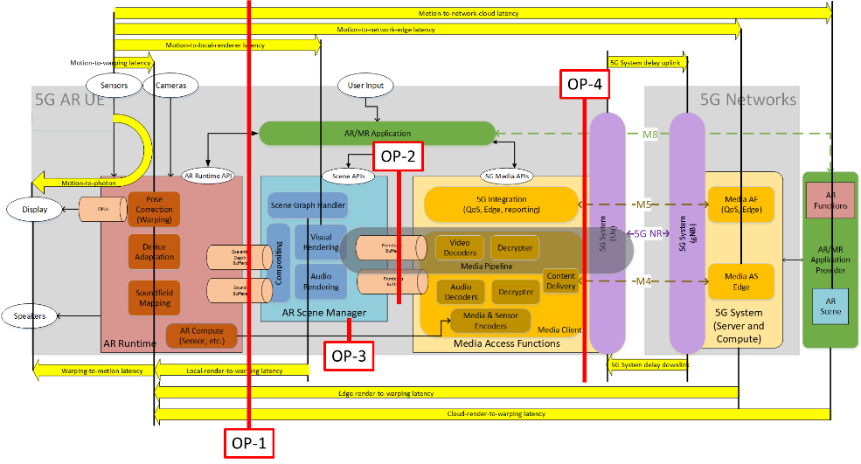
Figure 5.2.3-1: Typical Latencies in networked AR services with OPs
It is ultimately relevant that in case of networking the rendering loop, the processes in the loop are executed such that the end-to-end latency requirements for the pose-to-render-to-photon latency are ensured. Clearly the “closer” the rendering happens at the AR UE, the easier it is to meet latency requirements. However, with proper support of 5G system and media functionalities, these networked AR challenges are solved. This is subject of the remaining discussion of this report.
With reference to TR 26.928 , other types of latencies impact the user experience, for example when used for cloud gaming, interactive scenes or in case of real-time network-based processing of sensor data. These aspects are not specific to AR but are also relevant.
Figure 5.2.3-1 also adds the OPs.
Editor’s Note: the above diagram is expected to be further updated and refined based on the agreements of the XR baseline client.
Based on the OPs, a subset of the latencies can be measured.
In order to collect the information related to latencies, the rendering loop of an XR Runtime needs to be understood. This rendering loop here is a low-level rendering loop, i.e. the Scene Manager is on purpose not represented. More concretely, this rendering loop considered here may refer for instance to the OpenXR rendering loop described in clause 3.8.1 and illustrated in Figure 10.
Once a session is running and is in focused state, the rendering loop as shown in Figure 19 can be used:
1) Before an application can begin writing to a swapchain image, it first waits on the image to avoid writing to it before the Compositor has finished reading from it. Then an XR application synchronizes its rendering loop to the runtime. In the common case that an XR application has pipelined frame submissions, the application is expected to compute the appropriate target display time using both the predicted display time and predicted display interval.
2) Once the wait time completes, the application initiates the rendering process. In order to support the application in rendering different views the XR Runtime provides access to the viewer pose and projection parameters that are needed to render the different views. The view and projection info is provided for a particular display time within a specified XR space. Typically, the target/predicted display time for a given frame.
3) the application then performs its rendering work. Rendering work may be very simple, for example just directly copying data from the application into the swap chain or may be complex, for example iterating over the scene graph nodes and rendering complex objects. Once all views/layers are rendered, the application sends them to the XR Runtime for final compositing including the expected display time as well as the associated render pose.
4) The XR application offloads the composition of the final image to an XR Runtime-supplied compositor. After the compositor has blended and flattened all layers, it then presents this image to the system’s display at a specific display time.
Core aspect in metrics computation are:
- The time difference when the view and projection info is sampled from the run time and the time when the corresponding rendered information is provided to the run time for display with the associated render pose.
- The difference of the associated render pose and the actual pose at the time when the data is rendered.
Figure 19 - Rendering loop for visual data
Detailed algorithms are ffs.

5.2.6 XR application’s Player Loop

5.2.6.1 Frame submission with OpenXR
The article Frame submission of the OpenXR guide [51] details the OpenXR frame timing including common calling patterns, optimizations and pitfalls. The article explains the role of the three functions xrWaitFrame, xrBeginFrame and xrEndFrame to manages the frame submission in OpenXR.
As detailed in section “Call order restriction” of article, a frame can be in one of two states: pre-rendering and rendering.
- After xrWaitFrame returns, a new frame is active in the pre-rendering or scene update stage. During this period, the scene manager updates the representation of the scene. This operation consists of adding/removing objects to the scene, updating the properties and the pose of virtual objects according to physics simulation, defined animations, runtime input actions and/or pose estimation updates of Augmented Reality (AR) anchor(s).
- After xrBeginFrame, the frame passes from pre-rendering state to a rendering state. 3D engines are supposed to queue their work on GPU when in this state, using the swapchain.
- At the end of the rendering process, the rendered layers are submitted to the XR runtime by calling xrEndFrame.

Figure 20 - Player loop stages with OpenXR callsFigure 20 shows the player loop stages executed sequentially for each frame with the called OpenXR functions and the functional blocks involved.

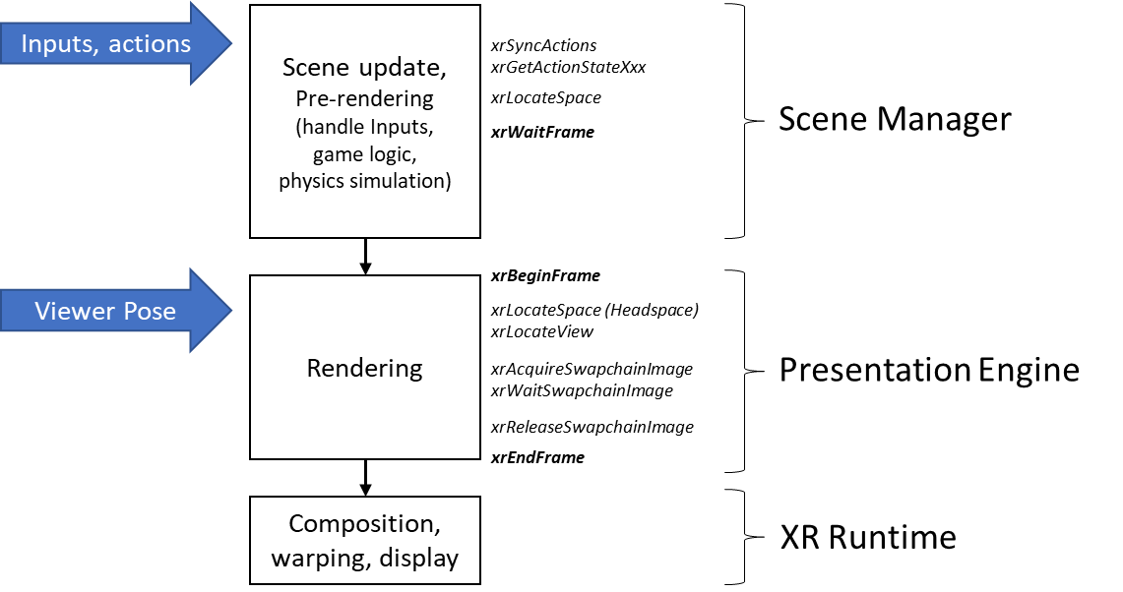
Figure 20 - Player loop stages with OpenXR calls

5.2.6.2 Single threaded & Multithreading
In case of multithreading, the scene update and the rendering processes may run concurrently on several successive frames for OpenXR [51]. The scene update of frame N+1 is performed while previous frame N is rendered. The total processing time spent for one frame is the sum of the scene update time and the rendering time.
In case of single threaded, the application must keep the total time spent working on a frame under the native frame duration in order to maintain full framerate. Therefore, when scene update and rendering stages are brief, a single-threaded approach of the player loop may be suitable to meet the full framerate.

5.2.6.3 Unity’s Player Loop examples
Unity is a game engine used to create 2D or 3D game and application. It implements a player loop (called PlayerLoop) for processing each frame. The section “Order of execution” for event functions of the Unity User Manual [51] details the player loop with event functions called on each stage. Figure 21 shows a simplified sequence of the Unity’s PlayerLoop with the two stages Scene update and Rendering.

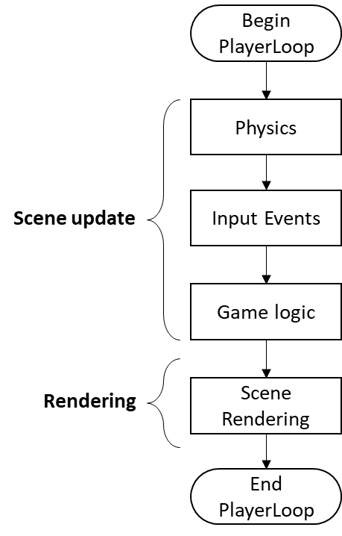
Figure 21 - Unity’s PlayerLoop sequence
Unity provides Profiler tool to monitor the time spent on executing each stage of the PlayerLoop. Figure 22 and Figure 23 below are screen capture of the Unity profiler for two different XR applications using a Meta Quest Pro device.
The first application, example 1 on Figure 22, is a scene composed of several objects and a very simple game logic without physic simulation, animation, collision.
The second application, example 2 on Figure 23, is a scene composed of several objects and a complex game logic.
Both figures show the different stages of Unity’s PlayerLoop on one frame according to the Order of execution of Unity [52], comprising:
- Scene update: EarlyUpdate and Update.
- Scene rendering between the OpenXR xrBeginFrame and xrEndFrame as described in above section 5.2.6.1 Frame submission with OpenXR.

Note that the scene update and the rendering are executed sequentially for each frame.
Example 1 shows a scene update delay shorter than the rendering delay.
In contrast, example 2 shows a scene update delay longer than the rendering delay.
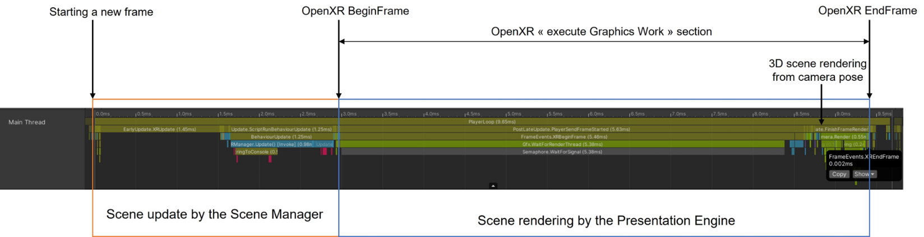
Figure 22 - Unity profiler example 1
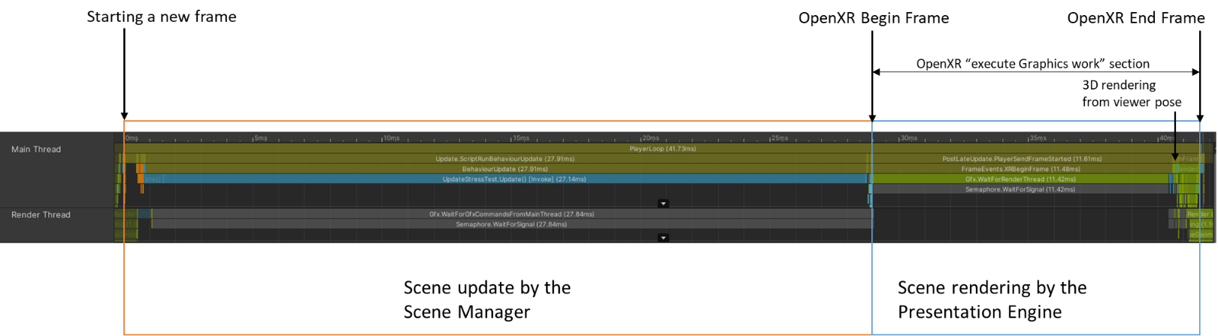
Figure 23 - Unity profiler example 2

5.2.6.4 Player Loop latencies
The processing times of the two stages of the player loop, scene update and rendering, depend on different factors. The time spent updating the scene may be longer or shorter than spent for rendering the scene as illustrated on Figure 22 and Figure 23. Their duration may vary from one frame to another. The parameters influencing the processing time are different for both stages of the player loop:
- scene updates: number of objects, animations, colliders, physics,
- rendering: resolution, lights, level of detail.

Therefore, it is critical to distinguish the scene update and the rendering stages for the measurement of the quality experience, such as scene update and rendering delays. Measuring delays enables corrective actions to be taken to improve the user experience.
Observation points are defined to collect timestamps to measure the scene update delay and rendering delay.
The observation points are defined on the XR Baseline terminal architecture on Figure 18 in section 5.2.1 of the MeCAR Permanent Document.
In the XR Baseline terminal architecture, the rendering stage is performed by the Presentation engine and the scene update stage is performed by the Scene Manager.
The rendering loop involves the XR application, the Presentation engine and the XR runtime.
The player loop including the rendering loop, involves the XR application, the Scene manager, the Presentation engine and the XR runtime.
The timestamps and the observation points involved to measure the scene update delay and the rendering delay are the following:
Scene update delay:
- Start time: it can be observed on the OP-2. It corresponds to the sceneUpdateTime (T6) in the table 7. The XR Application determines the appropriate start time of the scene update at the beginning of a player loop iteration.
For scene update, the XR Application communicates with the XR runtime to collect actions and predicted poses of XR spaces (e.g., action and anchor spaces). Then the Scene manager updates the representation of the scene. It adds/removes objects to the scene, updates the properties and the pose of virtual objects according to physics simulation, defined animations.
- End time: It can be observed on the OP-1. The end time of the Scene update is defined by the XR application before the beginning of the rendering stage. With OpenXR API, it is typically before calling xrBeginFrame.
Rendering delay:
- Start time: It can be observed on the OP-1. It corresponds to the startRenderTime (T3) in the table 7.
The XR Runtime provides the viewer predicted pose for a given display time. Then the Presentation engine performs its rendering works into the swap chain. The XR Application determines the appropriate start time of the rendering stage. With OpenXR API, the rendering start time is typically after xrBeginFrame returns.
- End time: It can be observed on the OP-1 that is the interface between the Presentation engine and the XR runtime. The end time of the rendering stage is at the submission of the rendered layers to the XR runtime. With OpenXR API, it is typically before calling xrEndFrame.

The observation points OP-1 and OP-2 are used to measure the delays of the player loop (i.e., the scene update delay and the rendering delay).
These observation points are defined in the XR Baseline terminal architecture and, for example, can be defined in an XR application using OpenXR API and/or the Unity’s PlayerLoop.

6 Media capabilities

6.1 Categories of media capabilities
Media capabilities may be defined for those categories:
- Audio
  - Capture
  - Playback
  - Codec
  - Formats
  - Framework (multiple codecs, etc.)
- Camera
  - RGB
  - Depth
- Display
  - Processing
  - Number of Displays
  - Bit depth
  - Color format
- GPU
  - Functionalities/APIs
  - Performance
- Security
  - Content Protection
  - Cryptography
  - Key Management
- Non-media sensors
  - Types: Accelerometer, Magnetometer, Gyroscope, ambient light
  - Access for example through OpenXR APIs
- Video
  - Playback/Decoding
  - Processing
  - Recording/Encoding
  - Formats (bit depth, color components, chroma subsampling, etc.)
  - Framework (multiple codecs, etc.)
- Runtime
  - APIs
  - Performance

6.2 Examples of media capabilities

6.2.1 Examples of media capabilities based media capabilities categorisation
Given the categories listed in clause 3.1, the following are examples of media capabilities for those categories:
- Video
  - Playback/Decoding
    - H.264 High, Main and Baseline profile
    - H.265 Main and Main 10 Profile
    - Maximum processing: Up to 8,294,400 Macroblocks per second (corresponding to 8192x4320 @ 60fps)
    - HEIF
  - Processing
  - Recording/Encoding
    - H.264 High, Main and Baseline profile
    - H.265 Main and Main 10 Profile
    - Maximum processing: Up to 3,888,000 Macroblocks per second (corresponding to 3840x2160 @ 120fps)
    - Low-latency encoding
    - Error-robustness, slicing, intra refresh, long term prediction
  - Formats
    - 8-Bit: NV12, UBWC, YV12, RGBA888
    - 10-Bit: UBWC TP10, P010
  - Framework (multiple codecs, etc.)
    - Maximum number of combined encoding and decoding instances: 16
- GPU
  - Functionalities
    - tbd
  - Performance
    - Examples
      - 3D Triangle Rate
      - 3D Pixel Draw Rate
      - Texture Fetch Rate
      - Z reject rate (pixels/sec)
    - The issue is that GPU capabilities are more defined through benchmarks. A way to address is to define a set of test signals that a GPU needs to be able to handle in real-time.
- Audio
  - Capture
  - Playback
  - Codec
  - Formats
  - Framework (multiple codecs, spatial audio support etc.)
    - Low-Latency: input, output, roundtrip
    - Game Audio Playback up to 8/16/32 simultaneous streams

6.2.2 Examples of media capabilities based on existing specifications
In the next chapter, different video profiles are listed which may be considered as relevant for consideration in MeCAR. These candidates do not reflect the final recommendations which MeCAR will produce. Additionally the lists may be refined and updated as the work in MeCAR progresses.

6.2.2.1 Possible 2D video profiles candidates
2D video encoding and decoding capabilities have of course to be considered. First, a basic scenario for AR is the virtual TV-set, where a 2D video stream is displayed as an overlay to the real world (for instance on the wall of the living room). Then, 2D video encoding/decoding capabilities may be used to display 3D objects on AR glasses, using the stereoscopic effect, by feeding the two eyes buffers of the AR glasses with the appropriate 2D videos.
It is referred here to video capabilities which have been referenced in clause 4.2 of TS 26.511 (“5G Media Streaming, Profiles, Codecs and Formats”) [5]. No video profiles published in TS 26.118 (“Virtual Reality (VR) profiles for streaming applications”) [6] are here listed. They indeed refer to a 360° immersive context, which may not be relevant for the optical see-through device types.

Lastly, the here listed candidates do not preclude of the result of the work which shall be carried on within MeCAR. Especially, if both encoding and decoding profiles are listed as they are referenced in clause 4.2 of TS 26.511 [5], requirements for encoding and decoding capabilities may differ.

6.2.2.1.1 AVC

6.2.2.1.1.1 Decoding
TS 26.511 [5] has defined the following decoding capabilities for H.264 (AVC4) in its clause 4.2.1.1:
- AVC-HD-Dec: the capability to decode H.264 (AVC) Progressive High Profile Level 3.1 [2] bitstreams, for which the maximum VCL Bit Rate is constrained to be 14 Mbps with cpbBrVclFactor and cpbBrNalFactor being fixed to be 1,000 and 1,200, respectively.
- AVC-FullHD-Dec: the capability to decode H.264 (AVC) Progressive High Profile Level 4.0 [2] bitstreams.
- AVC-UHD-Dec: the capability to decode H.264/AVC Progressive High Profile Level 5.1 [2] bitstreams for H.264/AVC with the following additional restrictions and requirements:
- the maximum VCL Bit Rate is constrained to be 120 Mbps with cpbBrVclFactor and cpbBrNalFactor being fixed to be 1250 and 1500, respectively.
- the bitstream does not contain more than 10 slices per picture.
NOTE: High Profile for H.264/AVC excludes Flexible macro-block order, Arbitrary slice ordering, Redundant slices, Data partition.

6.2.2.1.1.2 Encoding
The corresponding encoding capabilities (in the sense that their bitstream are decodable by the decoder with the same name) have been defined:
- AVC-HD-Enc:
- up to 108,000 macroblocks per second;
- up to a frame size of 3,600 macroblocks;
- up to 120 frames per second;
- the chroma format being 4:2:0; and
- the bit depth being 8 bits;
- AVC-FullHD-Enc:
- up to 245,760 macroblocks per second;
- up to a frame size of 8,192 macroblocks;
- up to 240 frames per second;
- the chroma format being 4:2:0; and
- the bit depth being 8 bits;
- AVC-UHD-Enc:
- up to 983,040 macroblocks per second;
- up to a frame size of 36,864 macroblocks;
- up to 480 frames per second;
- the chroma format being 4:2:0; and
- the bit depth being 8 bits.

6.2.2.1.2 HEVC

6.2.2.1.2.1 Decoding
TS26.511 [5] has defined the following decoding capabilities for H.265 (HEVC) in its clause 4.2.2.1:
- HEVC-HD-Dec: the capability to decode H.265 (HEVC) Main Profile, Main Tier, Level 3.1[3] bitstreams that have general_progressive_source_flag equal to 1, general interlaced_source_flag equal to 0, general_non_packed_constraint_flag equal to 1, and general_frame_only_constraint_flag equal to 1.
- HEVC-FullHD-Dec: the capability to decode H.265 (HEVC) Main10 Profile, Main Tier, Level 4.1[3] bitstreams that have general_progressive_source_flag equal to 1, general interlaced_source_flag equal to 0, general_non_packed_constraint_flag equal to 1, and general_frame_only_constraint_flag equal to 1.
- HEVC-UHD-Dec: the capability to decode H.265 (HEVC) Main10 Profile, Main Tier, Level 5.1[3] bitstreams that have general_progressive_source_flag equal to 1, general interlaced_source_flag equal to 0, general_non_packed_constraint_flag equal to 1, and general_frame_only_constraint_flag equal to 1.
- HEVC-8K-Dec: the capability to decode H.265 (HEVC) Main10 Profile, Main Tier, Level 6.1[3] bitstreams that have general_progressive_source_flag equal to 1, general interlaced_source_flag equal to 0, general_non_packed_constraint_flag equal to 1, and general_frame_only_constraint_flag equal to 1 with the following further limitations:
- the bitstream does not exceed the maximum luma picture size in samples of 33,554,432,
- the maximum VCL Bit Rate is constrained to be 80 Mbps with CpbVclFactor and CpbNalFactor being fixed to be 1000 and 1100, respectively.
Note that HEVC_8K-Dec is mentioned as a reminder of TS 26.511 references. It may not be relevant in the context of AR glasses. As said in introduction to this chapter, this discussion is left for further study.

6.2.2.1.2.2 Encoding
The corresponding encoding capabilities (in the sense that their bitstream are decodable by the decoder with the same name) have been defined:
- HEVC-HD-Enc:
- up to 33,177,600 luma samples per second;
- up to a luma picture size of 983,040 samples;
- up to 120 frames per second;
- the Chroma format being 4:2:0; and
- the bit depth being 8 bits;
- HEVC-FullHD-Enc:
- up to 133,693,440 luma samples per second;
- up to a luma picture size of 2,228,224 samples;
- up to 240 frames per second;
- the Chroma format being 4:2:0; and
- the bit depth being either 8 or 10 bits;
- HEVC-UHD-Enc:
- up to 534,773,760 luma samples per second;
- up to a luma picture size of 8,912,896 samples;
- up to 480 frames per second;
- the Chroma format being 4:2:0; and
- the bit depth being either 8 or 10 bits.

6.3 Display capability

6.3.1 General
The capability of a display for AR glasses may be characterised by its ability to reproduce colour and the ability to change its opacity comprised in to a given opacity range.
The followings are the relevant information to describe the capability of such display.
- display
  - Reference colour space (For example, https://registry.khronos.org/OpenXR/specs/1.0/html/xrspec.html#XR_FB_color_space)
  - Perceptible colours (For example, https://registry.khronos.org/OpenXR/specs/1.0/html/xrspec.html#XR_KHR_composition_layer_color_scale_bias)
  - Coordinate of primary colours in the reference colour space (For example, https://registry.khronos.org/OpenXR/specs/1.0/html/xrspec.html#XR_FB_color_space)
  - Colour map (For example, https://registry.khronos.org/OpenXR/specs/1.0/html/xrspec.html#XrPassthroughColorMapMonoToRgbaFB)
  - Opacity range (For example, https://registry.khronos.org/OpenXR/specs/1.0/html/xrspec.html#XrPassthroughStyleFB)
- sensor
  - Ambient light intensity (For example, https://www.w3.org/TR/ambient-light)
  - Ambient light intensity range
NOTE: The ambient light parameters from W3C have been primarily defined for regular displays. It is still to be checked if they are applicable to AR glasses.
The reference colour space is the colour space in which the display is compatible.
The perceptible colours is a list of the colours perceptible or reproducible. Primary colours such as R, G, B and their coordinates in the reference colour space are listed. The display may provide the colour space coordinate according to dedicated reference condition, or according to measured ambient light.
The colour map is the array of colours that remapped by the device. It is a list of colours and their target RGBA values in the reference colour space. The application may provide the colours map according to dedicated display capability of a device.
The opacity range is the range of supported opaque/transparency level of the display. From fully opaque as 1.0 to fully transparent as 0.0, the display may provide its capability on blocking light rays from outside.
The ambient light intensity is the intensity of the ambient light measured at a given point in time.
The ambient light intensity range is the minimum and maximum level of light in the unit of lux that the sensor can measure and provide.

6.3.2 Examples of display capabilities and possible impact on media capabilities
TR 26.998 [1] in clause 4.5.2 has gathered a collection of features and KPIs focusing on AR glasses. These features detail, among others, display capabilities which are listed as KPIs, as a capability level in order to provide the required user experience of a good sense of presence in immersive scenes. The display capabilities and their associated KPIs, as defined in clause 4.5.2 of TR 26.998 [1], are listed in the first and second columns of Table 10.

The third column details which category of media capabilities among the list given in the clause 5.1 of the permanent document may be impacted by each the display capability. This last column may be further updated with additional categories and the listed categories may be further expanded by detailing for each of them which individual media capabilities are concerned.

Table 10 is intended to be used as a helping and guidance tool through the selection of media capabilities.

Table 10 – Examples of display capabilities and impact on media capabilities
Display capability | KPIs for AR glasses  (Table 4.5.2-1 from TR 26.998 [1], clause 5.4.2) | Possibly impacted Category of Media Capability (as listed in clause 5.1)
Persistence – Duty time | Turn pixels on and off every 2 - 4 ms to avoid smearing / motion blur | - Display  - Processing  - GPU  - Performance (refresh rate)
Display refresh rate | - 60 Hz minimum  - 90 Hz acceptable  - 120 Hz and beyond desired  - 240 Hz would allow always on display at 4ms | - Video  - Playback/Decoding (codecs profile)  - Framework (multiple codecs, etc.)  - GPU  - Performance (refresh rate)
Colour | - RGB colours  - Accurate colours independent of viewpoint. | - Display  - Bit depth  - Color format  - Video  - Formats (bit depth, color components)
Spatial Resolution Per Eye | For 30 x 20 degrees:  - 1.5K by 1K per eye is required  - 1.8K by 1.2K per eye is desired  For 40 x 40 degrees:  - 2K by 2K required  - 2.5 K by 2.5 K desired  Ultimate goal for display resolution is reaching or going slightly beyond the human vision limit of roughly one arcmin (1/60°) | - Display  - Number of Displays (at least two, one per eye)  - Video  - Playback/Decoding (codec profile)  - Formats (Image resolution)
Brightness | - 200-500 nits for indoor  - Up to 2K for state-of-the-art devices in 2021 [49]  - 10K to 100K nits for full outdoor experiences | - Video  - Formats (high dynamic range)
Field of View | Augmentable FoV  - typically, 30 by 20 degrees FoV acceptable  - 40 by 40 degrees desired maximize the non-obscured field-of-view | - Display  - Number of Displays (at least two, one per eye)  - Video  - Playback/Decoding (codecs profiles)  - Formats (image resolution)

In addition, commercial optical see-through devices are starting to emerge in the market. The Nreal Light AR glasses, which may be considered as one of the most advanced implementation of optical see-through AR glasses currently available in the market. As can be found in [8], the technical specifications of the Nreal Light AR glasses are:

- Persistence – Duty time
  - No data
- Display refresh rate
  - 60Hz
- Colour
  - RGB, 106% color gamut
  - Color depth 8 bits for 16.773 million colors
  - OLED display
- Spatial Resolution Per Eye
  - 52° FoV
  - 42 pixels per degree
  - 1920x1080 per eye
- Brightness
  - Up to 280 nits perceived brightness.
- Field of View
  - 52°

6.4 Media capability validation framework

6.4.1 Example framework by Khronos on 3D Commerce conformance (glTF viewer)

6.4.1.1 General
The Khronos group defines many specifications that rely on hardware capabilities and, in particular, its specifications are largely powered by Graphics Processing Units (GPU). As a result, the deployment of Khronos specification depends significantly on the ability for a vendor to evaluate whether its products meets the requirement of those specifications.
To this end, Khronos offers the Khronos 3D Commerce Viewer Certification Program which “enables any company to demonstrate that their viewer is capable of accurately displaying 3D Products that have been created using the 3D Commerce asset creation guidelines”.
The relevant part in the context of MeCAR is the certification process described in [2].
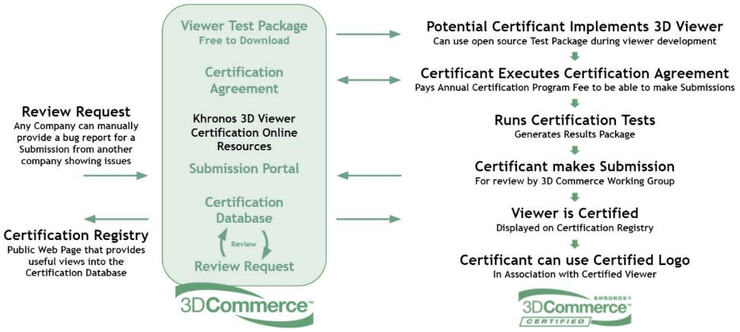
Figure 24 - Khronos' 3D commerce certification process

6.4.1.2 Relevant steps in the MeCAR context
From this certification process only a subset of those steps are relevant for us which are:
- Viewer Test Package
  - What does it contain? What are the file formats?
- Run Certifications Test
  - How are those test described? Are the test objective or subjective? On which criteria and/or metrics do they rely on?
- Generates Results packages
  - How are expressed, in format, the performance of a 3D viewer against the tests? Is the result binary, i.e. passed/not passed? Or a score on a given scale with a minimum threshold?

To answer, those questions more documentation is available at the Khronos Group 3DC Certification repository [3]. The following was found based on the available documentation.
- Viewer Test Package
  - The package contains a list of glTF models [4]:
    - AnalyticalCubes
    - AnalyticalGrayscale
    - AnalyticalSpheres
    - GreenChair
    - Mixer
    - Shoe
    - TennisRacquet
    - WickerChair
- Run Certifications Test
  - The test plan defines how the tested viewer must operate to render the test models:
    - “The Certification Program Test Plan document defines the detailed requirements for generating the certification images.”
  - Some test are verified by mathematical functions some by humans.
    - “Certification renders will be evaluated programmatically and through human checks”
    - Example of subjective test:
      - “Strings should appear translucent outside of the blue star area”
    - Example of objective test:
      - “When scored by the evaluation tool included in the repository an SSIM or PSNR lower than their respective thresholds will automatically flag the image for review.”
- Generates Results packages
  - To evaluate whether a glTF viewer is conformant, the tested renders must generate images from the glTF model and those images are programmatically verified against reference renders.
    - “All certification images must be 1024x1024 and displayed according to the embedded cameras. The five retail models have three cameras each. One of the analytical models (spheres) is displayed in four different IBLs. All certification images need to be created according to the rules specified in the Test Plan document.”
  - How are expressed, in format, the performance of a 3D viewer against the tests? Is the result binary, i.e. passed/not passed? Or a score on a given scale with a minimum threshold?

6.4.3.3 Takeaways from the certification process
Here are some takeaways from the certification test:
- A set of test models is essential for defining the test and the evaluation criteria.
- Objective tests are a minimum to pass but subjective tests via human verification are here to confirm for hard cases, e.g. transparency, reflection, etc.
- For objective tests, PSNR or SSIM is used to evaluated the rendered images from the test models.
- The tests are limited to static images and not rendering of the models over time.

6.4.2 Possible capability evaluation framework
In the context of MeCAR, the goal is not to certify a device but to define the media capabilities that are required at minimum for a given device category. The figure below depicts a possible workflow for implementing the evaluation of graphics capabilities in rendering glTF models and scenes.

Figure 25 - Possible framework for defining media and graphics capabilities
The first type of requirements is the playback of the test vectors. The test vectors are composed of a set of glTF tests models and scenes as well as pose traces. The MeCAR UE is supposed to render views of those glTF test models under the given poses coded in the test pose traces). The second type of requirements is whether the playback of the test vectors is correct. To this end, the generated views could be considered as a rendered videos (similar to the rendered image in the Khronos example). Such videos could be then checked against a reference video for the given test vector. The video validator could verify for the entire video:
- correct number of frames
- correct frame rate
- correct coded resolution of frames
- correct chroma sampling
- correct bit depth
- correct disparity between left and right views
- correct timing with respect to real-time rendering constraints

For each frame, the video validator could verify that each rendered image does not deviate too much from the reference image in the reference video. To validate the real-time nature of the rendering, the test run environment should also limit the time allowed to run the test scene.

6.4.3 Possible scope of media capability
In contrast to the Khronos example, the goal in MeCAR is not to establish a certification process. As a result, we would define the scope of the MeCAR graphics capability that does not fully cover the framework described in clause 3.1. The possible scope would cover he following elements:
- The glTF test models (possibly included media assets).
- The test pose traces associated with the glTF test models. The pose traces could be specific to each glTF test model.
- The test plan that defines the criteria to evaluate the rendered video (resolution, number of frames, etc…)
- Optionally, the generation of the reference rendered videos could be included to facilitate the reuse of this framework. However, since MeCAR may not define the reference scene render, providing these reference rendered video may actually go beyond MeCAR scope. This should be further discussed.

6.5 MeCAR Media Capabilities - Overview
A MeCAR device can query the capabilities of the XR Runtime, the Scene Manager and the Presentation Engine for audio and visual media, and the MAF.
A MeCAR device at the minimum shall support:
- A set of XR Runtime functionalities
  - allowing to establish a XR Session
  - enabling 6DoF and AR video rendering based on swapchain APIs (as defined for example in OpenXR) with pose correction
  - enabling rendering of audio signals with pose correction
  - providing a 6DoF pose of the user to the application
- A subset of 2D video codecs to support display characteristics as defined in 6.4.1.2.1
- A subset of audio codecs (to be defined)
- Basic delivery formats
- A media playback entry point (e.g. a scene description)
- A security framework

A MeCAR device may in addition support:
- Additional functionalities of XR Runtime or other APIs beyond the minimum set supported
- 3D rendering capabilities that, for example, allow to render point clouds, meshes, depth, etc. present in the scenes
- Additional audio and video encoding and decoding capabilities
- Decoding of streaming formats encapsulated in CMAF
- Delivery of data with RTP and SRTP
- Capabilities to be exchanged with the network in order to support cloud/edge rendering

6.6 Visual functions and capabilities

6.6.1 Video Decoding
In alignment with TS 26.511, clause 4.2
- AVC-FullHD-Dec: the capability to decode H.264 (AVC) Progressive High Profile Level 4.0 [2] bitstreams.
- AVC-UHD-Dec: the capability to decode H.264/AVC Progressive High Profile Level 5.1 [2] bitstreams for H.264/AVC with the following additional restrictions and requirements:
- the maximum VCL Bit Rate is constrained to be 120 Mbps with cpbBrVclFactor and cpbBrNalFactor being fixed to be 1250 and 1500, respectively.
- the bitstream does not contain more than 10 slices per picture.
- HEVC-FullHD-Dec: the capability to decode H.265 (HEVC) Main10 Profile, Main Tier, Level 4.1[3] bitstreams that have general_progressive_source_flag equal to 1, general interlaced_source_flag equal to 0, general_non_packed_constraint_flag equal to 1, and general_frame_only_constraint_flag equal to 1.
- HEVC-UHD-Dec: the capability to decode H.265 (HEVC) Main10 Profile, Main Tier, Level 5.1[3] bitstreams that have general_progressive_source_flag equal to 1, general interlaced_source_flag equal to 0, general_non_packed_constraint_flag equal to 1, and general_frame_only_constraint_flag equal to 1.
- HEVC-8K-Dec: the capability to decode H.265 (HEVC) Main10 Profile, Main Tier, Level 6.1[3] bitstreams that have general_progressive_source_flag equal to 1, general interlaced_source_flag equal to 0, general_non_packed_constraint_flag equal to 1, and general_frame_only_constraint_flag equal to 1 with the following further limitations:
- the bitstream does not exceed the maximum luma picture size in samples of 33,554,432,
- the maximum VCL Bit Rate is constrained to be 80 Mbps with CpbVclFactor and CpbNalFactor being fixed to be 1000 and 1100, respectively.

6.6.2 Video Encoding
In alignment with TS 26.511
- AVC-FullHD-Enc: the capability to encode a video signal with:
- up to 245,760 macroblocks per second;
- up to a frame size of 8,192 macroblocks;
- up to 240 frames per second;
- the chroma format being 4:2:0; and
- the bit depth being 8 bit;
to a bitstream that is decodable by a decoder that is AVC-FullHD-Dec capable as defined in clause 6.6.1
- HEVC-FullHD-Enc: the capability to encode a video signal with
- up to 133,693,440 luma samples per second;
- up to a luma picture size of 2,228,224 samples;
- up to 240 frames per second;
- the Chroma format being 4:2:0; and
- the bit depth being either 8 or 10 bit;
to a bitstream that is decodable by a decoder that is HEVC-FullHD-Dec capable as defined in clause 6.6.1.
- HEVC-UHD-Enc: the capability to encode a video signal with
- up to 534,773,760 luma samples per second;
- up to a luma picture size of 8,912,896 samples;
- up to 480 frames per second;
- the Chroma format being 4:2:0; and
- the bit depth being either 8 or 10 bit;
to a bitstream that is decodable by a decoder that is HEVC-UHD-Dec capable as defined in clause 6.6.1.

6.6.3 Video decoding interface

6.6.3.1 Definition
Simultaneous Video Decoding Instances are defined as follows.
For N video bitstreams encoded according to a video codec profile, decoding units flow into the coded picture buffer (CPB) for each stream according to a specified arrival schedule and are delivered by the common Hypothetical Stream Scheduler (HSS) that schedules the N bitstreams for decoding each of the units. For each access unit
- all data associated with an access unit is removed and decoded instantaneously by the instantaneous decoding process at CPB removal time of the access unit.
- Each decoded picture is placed in the Decoded Picture Buffer (DPB) for being referenced by the decoding process of this stream as well as for output and cropping.
- A decoded picture is removed from the DPB at the time that it becomes no longer needed for inter-prediction reference as well as the output time of the access unit is the largest of all decoded pictures remaining in the group of N decoders
Then at any point time,
- each of the individual streams conforms to the signaled profile/level/tier and HRD parameters of the individual stream.
- The sum of the CPB size conforms to common profile/level/tier signaling
- The aggregate decoder processing speed (samples per seconds) conforms to common profile/level/tier signaling.
- The sum of the DPB size conforms to common profile/level/tier signaling
- The common DPB size conforms to common profile/level/tier signaling
A set of N Simultaneous Video Decoding Instances conforms to a common profile/level, if a set of up to N bitstreams encoded to be decodable by the HRD above, is decodable within the timing limits.
In addition, the simultaneous decoding of different video codecs is defined.

6.6.3.2 Relevant Capabilities
Based on this definition, the following Simultaneous Video Decoding Instances are defined
AVC-UHD-Dec-4: The capability of supporting up to N=4 Simultaneous Video Decoding Instances with the aggregate capabilities of AVC-UHD-Dec
HEVC-UHD-Dec-4: The capability of supporting up to N=4 Simultaneous Video Decoding Instances with the aggregate capabilities of HEVC-UHD-Dec
UHD-Dec-4: The capability supporting up to N=4 Simultaneous Video Decoding Instances with either
- the aggregate capabilities of AVC-UHD-Dec-4, or
- the aggregate capabilities of HEVC-UHD-Dec-4, or
- the capability of decoding up to 4 bitstreams for which each bitstream does not exceed the capability of being decodable either with AVC-FullHD-Dec or HEVC-FullHD-Dec
HEVC-8K-Dec-8: The capability of supporting up to N=8 Simultaneous Video Decoding Instances with the aggregate capabilities of HEVC-UHD-Dec
8K-Dec-8: The capability supporting up to N=8 Simultaneous Video Decoding Instances with either
- the aggregate capabilities of AVC-UHD-Dec-4, or
- the aggregate capabilities of HEVC-8K-Dec-8, or
- the capability of decoding up to
- 8 bitstreams for which each bitstream does not exceed the capability of being decodable either with AVC-FullHD-Dec or HEVC-FullHD-Dec or,
- 4 bitstreams for which each bitstream does not exceed the capability of being decodable either with AVC-UHD-Dec or HEVC-UHD-Dec

6.6.4 Minimum Requirements
A MeCAR Client shall support
- the AVC-UHD-Dec decoding capability.
- the HEVC-UHD-Dec decoding capability.
- the AVC-UHD-Dec-4 decoding capability.
- the HEVC-UHD-Dec-4 decoding capability.
- the UHD-Dec-4 decoding capability.
A MeCAR Client may support
- the HEVC-8K-Dec decoding capability.
- the 8K-Dec-8 decoding capability.
[

6.7 Candidate audio function and capabilities
                - NOTE: While considering audio codec capabilities, it is necessary to identify the targeted services and clarify the associated requirements (e.g., for 5GMS, split rendering, pixel streaming…), in terms of bit rate operation, algorithmic delay vs. motion to sound delay, quality, complexity…

6.7.1 Audio Decoding

AUDIO-DEC-1: the capability to decode MPEG-4 Low Delay AAC v2 Profile (AAC-ELDv2) Level 2 bitstreams [AAC-ELDv2].
AUDIO-DEC-2: the capability to decode EVS [EVS] bitstreams with output sampling rate of 32 or 48kHz.

6.7.2 Audio Encoding
AUDIO-ENC-1: the capability to encode an audio signal to a bitstream that is decodable by a decoder that is AUDIO-DEC-1 capable.
AUDIO-ENC-2: the capability to encode audio to a bitstream using EVS [EVS].
]

6.8 System capabilities

6.8.1 Support of RGBD content

6.8.1.1 General
RGBD content refers to a data sequence composed of a video sequence and a depth map sequence that share a known temporal and spatial relation. A depth map may be represented as a video frame of a video sequence in which case each pixel of this depth map sequence may represent a measure of the distance between the surface of an AR object, point (A) and the camera centre (C). Conventionally, the distance is represented by the coordinate of the point on the z-axis obtained by the orthogonal projection of the point (A) on this axis, here denoted as the point (A’). The measured distance is thus the length of the segment (CA’) as depicted in Figure 26.
Figure 26 - Pixel representation of depth images
A depth map thus contains pixels with the distance attribute (e.g., depth). Distance is one-dimensional information and may be represented in an absolute/relative or linear/non-linear manner. Metadata to interpret the pixels of a depth map image may be provided as well as to determine the spatial and temporal relationship between pixels of the depth video sequence and pixels of the texture video sequence.

6.8.1.2 Metadata describing RGBD content

6.8.1.2.1 OpenXR extension XR_KHR_composition_layer_depth

As described in the OpenXR specification, the multi-vendor XR_KHR_composition_layer_depth extension defines “an extra layer type which allows applications to submit depth images along with color images in projection layers. The XR runtime may use this information to perform more accurate reprojections taking depth into account. Use of this extension does not affect the order of layer composition as described in Compositing”.

The depth information provided as an extra layer is thus described with the data structure and is defined as follows:
// Provided by XR_KHR_composition_layer_depth
typedef struct XrCompositionLayerDepthInfoKHR {
XrStructureType type;
const void* next;
XrSwapchainSubImage subImage;
float minDepth;
float maxDepth;
float nearZ;
float farZ;
} XrCompositionLayerDepthInfoKHR;
Member Descriptions
- type is the XrStructureType XrStructureType of this structure.
- next is NULL or a pointer to the next structure in a structure chain. No such structures are defined in core OpenXR or this extension.
- subImage identifies the depth image XrSwapchainSubImage to be associated with the color swapchain. The swapchain must have been created with a faceCount of 1.
- minDepth and maxDepth are the window space depths that correspond to the near and far frustum planes, respectively. minDepth must be less than maxDepth. minDepth and maxDepth must be in the range [0, 1].
- nearZ and farZ are the positive distances in meters to the near and far frustum planes, respectively. nearZ and farZ must not be equal. nearZ and farZ must be in the range (0, +infinity].

6.8.1.3 Compression of RGBD information

6.8.1.3.1 Video-based depth compression
As described in clause 6.6.1.1, RGBD is essentially composed of a texture video sequence along with a depth sequence. This depth sequence is represented as a sequence of depth frame which constitute a video sequence as well.
Since texture and depth video sequence are by nature different, their spatial resolution, frequency sampling, bit depth may differ. In addition, a texture video sequence is composed of three colour channels while a depth video sequence is essentially a monochrome video sequence.
For those reasons, it is desirable to carry RGBD content as the combination of two independent sequences as opposed to artificially stitching them into one.
In terms of compression, the video coding standard HEVC/H.265 has provisions to carry in a compressed form depth video sequence as auxiliary picture of type AUX_DEPTH.
Since a depth video sequence is essentially a monochrome video sequence, monochrome profiles defined in HEVC (Monochrome, Monochrome 12, Monochrome 16) are also thus relevant for coding the depth sequence.

6.8.1.3.2 V3C MIV-based solution
An input to MIV encoder is one or more views, where the view represents a field of view of a volumetric frame for a particular view position and orientation. Each view, at a given time instance, may be represented by one 2D frame providing geometry information (depth) plus one 2D frame per attribute, providing attribute information (e.g., color and transparency). Occupancy information that may either be embedded within geometry 2D frame or represented explicitly as another 2D frame. The information about how the views were stored in 2D frames and how to interpret is provided in the atlas data.
To ensure that a decoder can properly interpret different bitstreams (e.g., geometry, attribute, atlas), the ISO/IEC 23090-5 specification defines a V3C bitstream format. The V3C bitstream encapsulates encoded V3C video components and V3C atlas components in V3C units. Each V3C unit consists of a V3C unit header and a V3C unit payload pair. The V3C unit header contains information such as atlas ID, component type, map index, attribute index, and a flag indicating if auxiliary data are present. The component type indicates whether the payload contains atlas, geometry, occupancy, or attribute information. V3C bitstreams also contain at least one V3C unit which carries V3C parameter set (VPS) information. In case the component type is attribute the V3C_AVD, the VPS provide information about the attribute type itself by mapping attribute index provided in V3C unit header to ai_attribute_type_id.
Table 11 - V3C attribute types as defined in ISO/IEC 23090-5
ai_attribute_type_id[ j ][ i ] | Identifier | Attribute type
0 | ATTR_TEXTURE | Texture
1 | ATTR_MATERIAL_ID | Material ID
2 | ATTR_TRANSPARENCY | Transparency
3 | ATTR_REFLECTANCE | Reflectance
4 | ATTR_NORMAL | Normals
5..14 | ATTR_RESERVED | Reserved
15 | ATTR_UNSPECIFIED | Unspecified

The use case of RGBD discussed in S4-230738 version 7.0.0 is equivalent V3C MIV with only one view (mvp_num_views_minus1 equal to 0). This simplifies the operation of MIV encoder/decoder as no duplication of information between the views need to be examined.
The RGBD use case can be achieved utilizing MIV Main profile with further constraint. The constraint can minimize the number of required video decoders to 2 (one for color information and one for depth information, ptl_max_decodes_idc equal to equal to 1) and number of atlases to 1 (ptc_max_atlas_count_minus1 equal to 0)
In this use case atlas would provide the following information:
- Where in 2D frames (geometry, attributes) the view is present through patch_data_unit(), shown in Table 17 in Annex A. In RGBD scenario where only one view is considered, patch would correspond to the whole 2D frame.
- how to interpret the luma samples of geometry 2D frame through depth_quantization(), shown in Table 18 in Annex A.
- About camera used to capture the content and how to reproject the depth information through camera_intrinsics(), shown in Table 19 in Annex A. Equirectangular, perspective, and orthographic projection format are supported.
- where the camera is placed in virtual space through camera_extrinsics(), shown in Table 20 in Annex A.
Additionally, VPS and V3C unit headers would allow to identify the different video bitstreams.
An example of the V3C data that provide the information on how to interpret the video bitstream is provided in Table 22 in Annex A.
Profile Summary:
- ptl_profile_toolset_idc equal to 64 (MIV Main)
- ptl_max_decodes_idc equal to 1 (maximum 2 decoders)
- ptc_max_atlas_count_minus1 equal to 0 (only 1 atlas)
- ptc_multiple_map_streams_constraint_flag equal to 1 (only 1 map)
- ptc_max_map_count_minus1 equal to 0
- ptc_attribute_max_dimension_minus1 equal to 2
- ptc_attribute_max_dimension_partitions_minus1 equal to 0
- ai_attribute_count equal to 1
- ai_attribute_type_id equal to 0 (ATTR_TEXTURE)
- mvp_num_views_minus1 equal to 0 (only 1 view)
For the use cases with multiple views defined in 6.8.1.2, the same profile applies without the constraint on mvp_num_views_minus1.

6.8.1.3.3 Minimizing number of encoders/decoders
The number of the decoders can be further constrained in MIV Extended profile to just one encoder/decoder instance (ptl_max_decodes_idc equal to 0). This can be achieved utilizing packed video type that allow to put geometry and attribute data in one 2D frame. The information on how to extract each component data from the packed frame is provided by V3C parameter set.
Profile Summary:
- ptl_profile_toolset_idc equal to 65 (MIV Extended)
- ptl_max_decodes_idc 0 (maximum 1 decoders)
- ptc_max_atlas_count_minus1 equal to 0 (only 1 atlas)
- ptc_multiple_map_streams_constraint_flag equal to 1 (only 1 map)
- ptc_max_map_count_minus1 equal to 0
- ptc_attribute_max_dimension_minus1 equal to 2
- ptc_attribute_max_dimension_partitions_minus1 equal to 0
- vps_packed_video_present_flag equal to 1
  - pin_geometry_present_flag equal to 1
  - pin_attribute_present_flag equal to 1
- pin_attribute_count equal to 1 or 2
- pin_attribute_type_id equal to 0 (ATTR_TEXTURE) or 2 (ATTR_TRANSPARENCY)
- mvp_num_views_minus1 equal to 0 (only 1 view)
An example of the V3C data that provide the information on how to interpret the video bitstream is provided in.

6.8.1.4 Processing of RGBD content

6.8.1.4.1 Processing described in MIV
The Annex H in the MPEG-I MIV standard provides informative hypothetical transcoding and rendering processes. An application can combine multiple processes.
- The sample 3D reconstruction process (in clause H.2 of Annex H) specifies how to reconstruct an atlas sample to a 3D point in space.
- The entity-filtering process (in clause H.3 in Annex H) specifies how to filter a block to patch map by entity ID prior to transcoding or rendering, for instance to render only the foreground objects in a scene.
- The geometry video scaling process (in clause H.5 in Annex H) specifies how to upscale a geometry frame with preservation of thin foreground edges.
- The pruned view reconstruction process (in clause H.6 in Annex H) specifies how to reconstruct a pruned view from multiple atlases.
- The sample weighting recovery process (in clause H.7 in Annex H) specifies how to use a pruning graph to recover a view blending weight for a sample within a pruned view.
- The MPI reconstruction process (in clause H.9 in Annex H) specifies how to reconstruct a multi-plane image (MPI), from a decoded volumetric frame with ptc_restricted_geometry_flag equal to 1.
Regarding the depth data, MPEG-I MIV supports unprojection functions, i.e. retrieving the spatial position of a point in the scene from the depth-coded value, for perspective, ERP and orthogonal projections.
For instance for the perspective projection:
sampleX = sampleR
sampleY = – ( sampleR / ViewPerspectiveFocalHor[ viewIdx ] ) *
( u0 + u + 0.5 – ViewPerspectivePrincipalPointHor[ viewIdx ] )
sampleZ = – ( sampleR / ViewPerspectiveFocalVer[ viewIdx ] ) *
( v0 + v + 0.5 – ViewPerspectivePrincipalPointVer[ viewIdx ] )
NOTE Please see 6.8.1.6.3 Current State in MPEG-I Immersive Video for the definition of the variable sampleR.

6.8.1.4.2 Processing described in MPEG-C part 3
In processing RGBD content for AR applications, especially in the context of split-rendering, typically the depth values are used to produce stereoscopic views or reconstructing volumetric information for the AR experience - i.e. the depth it is not displayed and any processing of the depth aims to prepare it to be used for processing the video.
RGBD is consumed uncompressed, typically with 8bit for representing the Depth value. Common processing includes calculating the planes (e.g. kfar and nfar in 6.8.1.6.1), correcting the projection, calculating parallax etc. We put here as an example the screen parallax calculation as in the informative annex of ISO/IEC 23002-3.
Given a picture I and a depth map z at the receiver side, a new picture can be created by shifting the viewpoint. The resulting sample position shift on the display is called “screen parallax”. This allows generating different images for the left and right eye of the viewer, giving the impression of a 3D scene with a depth effect.
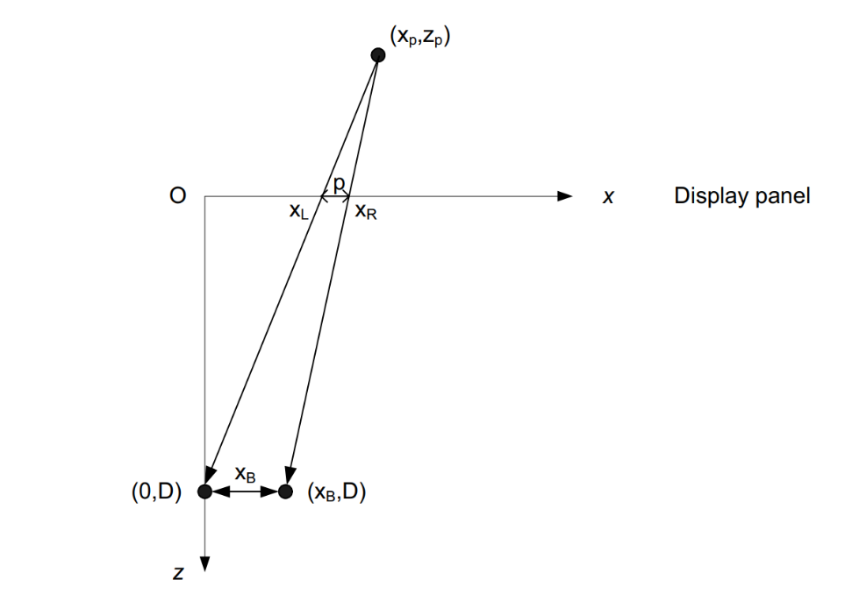
The figure above illustrates the geometry on a horizontal plane. The origin of the coordinate system is taken at the display. The problem can be seen as the x-axis being a frosted glass and how the object is mapped onto the frosted glass as seen from the 2 different viewpoints.
The z-coordinate points towards the viewer. The central image is assumed to be viewed by the left-eye which is located at (0,D). A right-eye image can now be created by selecting a new viewpoint at location (x_{B},D). Figure shows that the same object point ($x_{p}$, $z_{p}$) is shifted to the right on the display. This effect is called screen parallax.
Let $x_{L}$ denote the coordinate of the left-eye view and let $x_{R}$ denote the coordinate of the right-eye view for that object on the display. Using equal triangles, the following equation applies:

$$\frac{x_{L}}{D}=\frac{x_{p}}{D-z_{p}}$$
And
$$\frac{x_{R}-x_{B}}{D}=\frac{x_{p}-x_{B}}{D- z_{p}}$$
From the previous:
$$\frac{x_{L}-x_{R}-x_{B}}{D}=\frac{x_{B}}{D- z_{p}}$$
So the parallax ${p= x}_{R}-x_{L}$ is given by:
$$p=x_{B}\left(1-\frac{D}{D-z_{p}}\right)$$

Equation (A-4) indicates that, in its exact formulation, parallax is a non-linear function of the z-coordinate.

6.8.1.5 Carriage of RGBD content over RTP

6.8.1.5.1 Option 1: Single RTP stream
A first option is to carry the RGBD sequence in a single RTP stream which means that both sequences can be part of the same elementary stream. In order to do so, a possible option is to use the concept of independent layers when present in video codec. For instance with the HEVC codec, both the texture and the depth sequences may constitute different layers of the same elementary stream.

6.8.1.5.2 Option 2: Two RTP streams
In this second option, the RGBD sequence is transmitted over two concurrent RTP streams. Both video streams may be encoded with different encoding characteristics and even different codecs. The temporal relation between both sequence will be given by the timestamps.

6.8.1.5.3 Option 3: RTP carriage of MIV
RTP payload for V3C has in the IETF working group draft stage (https://datatracker.ietf.org/doc/draft-ietf-avtcore-rtp-v3c/).
An example of RGBD data provided over RTP that is signalled by SDP is presented in Table 21 in Annex A.
RGBD support is also needed for AR conversational. TS 26.113 clause 5.3.1 states that an iRTC client in terminal can be connected to one or more color cameras, and one or more depth cameras. Further, the iRTC Permanent document clause 5.2.4 on 3D video present the use case with multiple RGBD cameras, i.e. views, as input to the sender.

6.8.1.6 Storage of RGBD content

6.8.1.6.1 General
In terms of depth coding, there are two approaches documented in this clause that are:
- Coding of depth value(e.g. in MPEG-C part 3 and other RGBD format, see 6.8.1.6.2)
- Coding of the inverse of the depth value (e.g. in MPEG-I MIV, see 6.8.1.6.3)

6.8.1.6.2 Current State in ISOBMFF
Currently ISO Base Media File Format (ISOBMFF) supports accompanying video with depth via auxiliary tracks – with reference_type as ’auxl’ or ‘vdep’ (or both). This allows to signal a texture video track along with a depth map video track. However, further metadata is needed to be able to interpret the depth map pixels. To this end, ISO/IEC 23002-3 “Representation of auxiliary video and supplemental information” defines such metadata, e.g. stride, near/far plane, to be carried as item of type ‘auvd’ in the auxiliary video metadata of ISOBMFF spec. These two specifications combined merely provide a partial solution for a RGBD storage and would require further specification in order to ensure interoperability for the applications targeted in MeCAR, e.g. split rendering.
For calculating the near and far planes the depth parameters nkfar and nknear are used, having the following syntax:depth_params( ) { | Descriptor
nkfar | u(8)
nknear | u(8)
}

The knear and kfar are signalled as nknear and nkfar respectively, and are inferred as follows:
$kfar=\frac{nkfar}{16}$ and $knear=\frac{nknear}{64}$
A depth value $z_{p}$ is represented by an unsigned N-bit value m, and should non-normatively be inferred as follows:
$$z_{p}=\frac{m}{2^{N}}\left(knear*W+kfar*W\right)-kfar*W$$

kfar and knear specify the range of the depth information respectively behind and in front of the picture relatively to W. W represents the screen width at the receiver side. W and $z_{p}$ is expressed using the same distance units.
6.8.1.6.3 Current State in MPEG-I Immersive Video
For an MIV-based solution, carriage of visual volumetric video-based coding data (ISO/IEC 23090-10), is derived from ISO/IEC 14496-12 and provided information how V3C content such as MIV should be stored in ISOBMFF file. The specification introduces three methods for storing V3C-coded content in ISOBMFF: single-track storage, multi-track storage, and non-timed storage. However only multi-track and non-timed storage should be considered for MeCAR work. Multi-track storage encapsulates each V3C component of the V3C bitstream into its own ISOBMFF track. Non-timed storage mode enables the storage of static V3C objects.
Carriage of MIV over ISOBMFF is defined in clause 9.1.4.
Regarding the depth information, the syntax element depth_quantization in the MPEG-I MIV specification signals information to reconstruct the depth information as shown below:
depth_quantization( v ) { | Descriptor
dq_quantization_law[ v ] | ue(v)
if( dq_quantization_law[ v ] == 0 ) {
dq_norm_disp_low[ v ] | fl(32)
dq_norm_disp_high[ v ] | fl(32)
}
dq_depth_occ_threshold_default[ v ] | ue(v)
}

for( v = 0; v < NumViews; v++ ){
ViewQuantizationLaw[ v ] = dq_quantization_law[ v ] ViewNormDispLow[ v ] = dq_norm_disp_low[ v ] ViewNormDispHigh[ v ] = dq_norm_disp_high[ v ] ViewOccThreshold[ v ] = dq_depth_occ_threshold_default[ v ]
}
The variable sampleD is the integer depth value, in the range 0 .. maxSampleD and the variable sampleR, indicates the depth as a range value in scene units (e.g. meters) from the cardinal point of the camera to the Cartesian coordinates of the point that is associated with the atlas sample.
If ViewQuantizationLaw[ v ] is equal to 0, the depth expansion process operates as follows:

n1 = ViewNormDispLow[ viewIdx ]
n2 = ViewNormDispHigh[ viewIdx ]
normDisp = n1 + ( n2 – n1 ) * ( sampleD ÷ maxSampleD )
sampleR = 1.0 ÷ normDisp6.8.1.6.4 Possible encapsulation analysis
Even though there are already some tools in ISOBMFF for RGBD storage, there is lack of a single RGBD storage format that is a content-centric, but application and codec agnostic which would enable the encapsulation of RGBD content.
Some example depth information that must be available prior to accessing the data for immersive real time communication scenarios would be:
- Depth range
- Depth projection properties
- Depth coding properties
- Projection format of depth image
- Disparity between texture and depth image

6.8.2 Candidate solution for depth carriage specification
The following clause is a candidate specification text for the definition of depth map definition and its carriage in a video bitstream. The text is written against TS 29.119 v0.2.

6.3 Systems capabilities

6.3.1 Depth map capabilities

6.3.1.1 General
Within an XR Session, the XR View may contain a depth layer in addition to the projected views as described in 4.1.2.2. Based on this depth layer, the XR Runtime can make use of this information to improve accuracy of the final rendered images. Another usage of depth maps is for representing volumetric content composed of two video sequences: a texture and a depth map video sequences, generally referred to as RGBD content.

6.3.1.2 Definition of depth map
In this specification, a depth map is defined as a mono channel image wherein each sample represents the distance between the surface of an object, point (A) and the camera centre (C), projected on the z-axis, which corresponds to the length of the segment (CA’) as depicted in Figure 6.3.1.1-1.
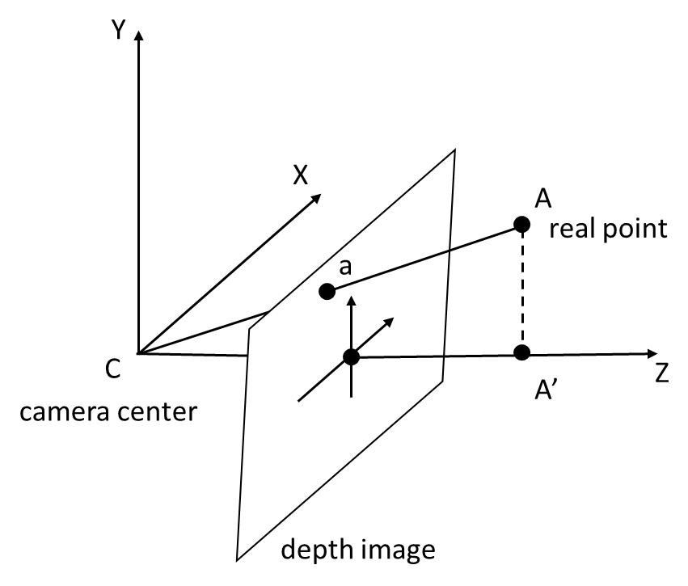
Figure 6.3.1.1-1 Depth map representation
A depth map sequence is a sequence of depth maps at different time instances.

6.3.1.3 Depth map coding
A coded depth map is a normalized depth map where the normalized values are comprised between a near and far depth values defining a depth range.
When the far depth value is greater than the near depth value, then the normalized value represents a depth value as defined by the Equation 6.3.1.3-1:
Dnormalized=Dvalue-DnearDfar-Dnear (Eq. 6.3.1.3-1)
When the near depth value is greater than the far depth value, then the normalized value represents as defined by the Equation 6.3.1.3-2.
Dnormalized=1Dvalue-1Dfar1Dnear-1Dfar (Eq. 6.3.1.3-2)

The depth map information provides the mean to interpret the sample values of a depth map. Those information are defined by the object depthMapInformation and shall follow the format defined in Table 6.2.5-1.
Table 6.2.5-1 – Depth map information format
Name | Type | Cardinality | Description
depthMapInformation | Object | 0..1 | An object providing information to interpret the sample values of a depth map image.
nearDepth | float | 1 | The positive distance in meters to the near depth value.
farDepth | float | 1 | The positive distance in meters to the far depth value.

6.3.1.4 HEVC depth map sequences
An HEVC depth map sequence is encoded as a single coded video sequence that is decodable by a decoder HEVC-FullHD-Dec capable as defined in clause 6.1.
Since an HEVC depth map sequence is encoded in a colour format with a luma plane and chroma planes, i.e. as 4:2:0 YCbCr, only the luma plane carries a coded depth map, and the chroma planes can be ignored.
[Editor’s note: It was mentioned by the proponent that the usage of SEI below may not even be necessary in the final design given the static metadata can also be signalled at the split rendering session description level.]
The depthMapInformation object, defined in clause 6.3.1.3, should be signalled in a HEVC bitstream using the depth representation information SEI message, defined in G.14.2.4 in the HEVC specification, with the following constraints:
- The nearDepth, respectively farDepth, corresponds to the ZNear variable, respectively ZFar variable.
- The value of the depth_representation_type syntax element shall be equal to 0 or 2.
- The depth representation information SEI message shall be associated with layer whose the nuh_layer_id equal to 0.
- The syntax elements d_min_flag and d_max_flag shall be equal to 0.
- The ZNear and ZFar values shall be expressed in meters.

B.2.4 Relation XrCompositionLayerDepthInfoKHR with depth maps format
The extension XR_KHR_composition_layer_depth defines an extra layer that can be submitted with the projection layer. This extra layer provides a depth image which can be used by the XR Runtime to produce the final display buffer.
To this end, the structure XrCompositionLayerDepthInfoKHR can be passed on by the application and is defined as shown below:
typedef struct XrCompositionLayerDepthInfoKHR {
XrStructureType type;
const void* next;
XrSwapchainSubImage subImage;
float minDepth;
float maxDepth;
float nearZ;
float farZ;
} XrCompositionLayerDepthInfoKHR;
As defined in clause 6.3.1.3, a depth map stream carries the depth information via the HEVC depth representation information (DRI) SEI. Table B.2.4-1 provides the mapping between the variables associated with this SEI message and the OpenXR data structure to be generated from it.
Table B.2.4-1 – Mapping between XrCompositionLayerDepthInfoKHR and HEVC DRI SEI
OpenXR variable | HEVC DRI SEI variable
minDepth | None, set to 0.0f
maxDepth | None, set to 1.0f
nearZ | ZNear
farZ | ZFar

6.9 XR Runtime capabilities
XR-Pose-Cap 1: the UE shall be able to retrieve one or more pose predictions for each view and for every frame to be rendered as defined in clause 7.
XR-Pose-Cap 2: the UE shall be able to retrieve and collect the user actions that occurred during an identified time interval.

6.10 Image processing capabilities

6.10.1 Color conversion module
Color Conversion is needed for various use cases. An example is for raster-based split rendering defined in TR 26.928 clause 6.2.5 for which colors of the frame buffers are typically RGB but may be converted from YUV, as YUV is typically used in video compression standards.
Another example is for Device design type 4, some encoders may not be directly on RGBA, the extended color conversion module in combination with available acceleration frameworks (e.g., NDK) may also be needed.
These conversion may require certain resources and should be included as part of the media capabilities of a MeCAR device.
YUV, which stands for luma (Y') and chroma (U, V), can be further subdivided into various planar and storage formats such as YUV I420, YUV420sp (NV12), YUV420sp (NV21) and others. A generic YUV format, capable of describing any 4:2:0 chroma subsampled planar or semi planar buffer (but not fully interleaved), is an 8 bits per colour sample. The conversion between RGB and YUV color spaces can be carried out based on the conversion formulas defined in BT.601, BT.709, and BT.2020 in order to calculate each Y, U, V values, and the alpha_channel can be support as additional transparency information.
The conversion needs to be done such that it is compatible with the runtime rendering formats, typically R8G8B8A8.
An example of color conversion procedures for Device design type 4 descriptions as follows:
- The XR Application sends the rendered frame to the color conversion module.
- The color conversion module gets the pixel data of the rendered frame by copying it into a provide bitmap.
- The color conversion module uses the RGB to YUV conversion formula to convert the R, G, B value into the Y, U, V value. The alpha_channel value is set to be 0 as a typical LCD screen of current smartphone devices, used as an optical transmitter, is based on a RGB_888 color space system.
- Finally, the color conversion module follows the YUV storage format to store the Y, U, V values..

6.11 Device capabilities signalling
The device capabilities shall have the following information and signalled to the network when needed.

Name | Cardinality | Description
deviceType | 0..N | Device profile identifier. The profile identifiers are listed in Annex X.
videoCapabilities | 0..1 | Describes the device's video capabilities.
videoDecoding | 1 | Video decoding capabilities.
decoder | 1 | List of supported decoders
decoderInterface | 1 | Decoder interface capabilities
videoEncoding | 1 | Video encoding capabilities.
encoder | 1 | List of supported encoders
encoderInterface | 1 | Encoder interface capabilities
audioCapabilities | 0..1 | Describes the device's audio capabilities.
audioDecoding | 1 | Audio decoding capabilities.
decoder | 1 | List of supported decoders
decoderInterface | 1 | Decoder interface capabilities
audioEncoding | 1 | Audio encoding capabilities.
encoder | 1 | List of supported encoders
encoderInterface | 1 | Encoder interface capabilities
xrRuntime | 0..1 | Capabilities of the device XR runtime
sceneManager | 0..1 | Capabilities of the device scene manager
presEngine | 0..1 | Capabilities of the device presentation engine
xrSourceManagment | 0..1 | Capabilities of the device XR source management

7 Metadata formats

7.1 General
In the “3gpp-sr” data channel sub-protocol, the message content depends on the type of the message. Message types shall be unique identifiers in the URN format. This clause defines a set of message types and their formats. The messages are derived from the OpenXR API to ensure smooth operation with AR devices that support OpenXR. In case other XR APIs are used, mapping the message payload to the appropriate XR API structures shall be performed by the split rendering client.

7.2 Pose Prediction Format
This clause has been moved to the draft TS 26.119 v0.2.0 at SA4#124.

7.3 Action Format
This clause has been moved to the draft TS 26.119 v0.2.0 at SA4#124.

7.4 JSON Schema
The JSON schema for the message and the defined message types is provided in the following table:
{
"$schema" : "http://json-schema.org/draft-07/schema",
"title" : "Split Rendering Metadata Format",
"type" : "object",
"description": "Defines the split rendering timed metadata message format.",
"properties" : {
"version": {
"type": "number",
"default": 1
},
"type": {
"oneOf": [
{"type": "string",},
{"enum": ["sr-pose", "sr-action"]}
]
},
"timestamp": {
"type": "string"
},
"content": {
"oneOf": [
{"$ref": "#/$message/poseInfo"},
{"$ref": "#/$message/actionSet"},
{"type": "object"}
]
},
"$message": {
"poseInfo": {
"type": "object",
"properties": {
"displayTime": {
"type": "number"
},
"xrSpace": {
"type": "number"
},
"viewPoses": {
"type": "array",
"items": {
"$ref": "#/$components/viewPose"
}
}
}
},
"actionSets": {
"type": "object",
"properties": {
"type": "array",
"items": {
"$ref": "#/$components/action"
}
}
}
},
"$components": {
"ViewPose": {
"type": "object",
"properties": {
"pose": {
"type": "#/$components/pose"
},
"fov": {
"type": "#/$components/fov"
}
}
},
"pose": {
"type": "object",
"properties": {
"orientation": {
"type": "#/$components/position"
},
"position": {
"type": "#/$components/orientation"
}
}
},
"position": {
"type": "object",
"properties": {
"x": {
"type": "number"
},
"y": {
"type": "number"
},
"z": {
"type": "number"
}
}
},
"orientation": {
"type": "object",
"properties": {
"x": {
"type": "number"
},
"y": {
"type": "number"
},
"z": {
"type": "number"
},
"w": {
"type": "number"
}
}
},
"fov": {
"type": "object",
"properties": {
"angleLeft": {
"type": "number"
},
"angleRight": {
"type": "number"
},
"angleUp": {
"type": "number"
},
"angleDown": {
"type": "number"
}
}
},
"action": {
"type": "object",
"properties": {
"identifier": {
"type": "string"
},
"subactionPath": {
"type": "string"
},
"state": {
"$ref": "#/$components/state"
}
}
},
"state": {
"type": "object",
"properties": {
"lastChange": "number",
"oneOf": [
{
"currentStateBool": {
"type": "boolean"
}
},
{
"currentStateNum": {
"type": "number"
}
},
{
"currentStateVec2": {
"type": "object",
"properties": {
"v1": {"type": "number"},
"v2": {"type": "number"}
}
}
}
]
}
}
}
},
"required": [ "version", "type", "timestamp" ]
}

8 Sensor and user environment data types

8.1 General
This clause collects data types that can be consumed or produced by a MeCAR device and relates to Sensor and user environment data types.

8.2 View-related information
The device may generate static or dynamic data streams related to view information. The different types of data are listed as follows.
- Device pose information
  - Position in user’s volumetric space (maybe relative coordinate to user’s space origin)
  - Position in global space (maybe absolute coordinate)
  - Viewing direction in user’s volumetric space (maybe relative direction to user’s space origin)
  - Viewing direction in global space
  - Device pose timestamp
- Device frustum information
  - Field of view
  - Aspect ratio
  - Z-near
  - Z-far
  - Resolution of display
  - Screen to eye distance
  - Eye gaze point (on display or space)
The device may also receive media content representing pre-rendered views of a scene along with descriptive information. The different types of data are listed as follows.
- Pre-rendered media
- Codec, resolution, and profile of the pre-rendered media
- Estimated pose used to generate the pre-rendered media
- Estimated presentation time used to generate the pre-rendered media
- Frustum information of the pre-rendered media (in case device does not provide its frustum information)

8.3 Pose information

8.3.1 QoE timing information
The MeCAR device sends a group of pose information to the server's split render function to generate rendered media frames based on the poses. Each pose is associated with time metadata, such as the time when the pose estimation was made (T1), the estimated target display time of the content (T2.estimated), and the time the group of poses was sent (T1').
The gap between the actual-target-display-time (T2.actual) and the pose estimate time (T1) is the pose-to-render-to-photon delay, which allows the MeCAR device to know the amount of processing time as well as the connection delay required for a loop of split rendering. The next round of pose estimation should refer to the pose-to-render-to-photon delay for the estimation of a new T2.estimated.
The split render function in the server may refer to T1', which is the time when the group of poses is sent from device, if multiple pairs of pose and metadata for the same target display time are received from the device. The T1’ information may be used to manage poses by the server, such as allowing the MeCAR device to update former estimations by resubmitting a new pose with the same estimated-target-display-time.
The split render function in the server sends rendered media frames and associated metadata. The metadata shall include the pose used for the rendered frame, as well as corresponding time information, such as T1, T2.estimated, and may include the time when the rendering started (T3), all sent to the MeCAR device in order to measure the render-to-photon delay.
The (T5) is the time information at the output of the Split Rendering Server (SRS).
The (T5) timestamp can be used to:
- measure the server processing delay, (T3 – T5)
- the overall application delay excluding the server processing delay,
Note: the downlink delay can be measured with T5 and inferred timing from the MAF, and the uplink delay can be measured with (T1’ - T3).
In the case where there are poses stacked in the server’s pose buffer, for example with a granularity finer than the device's supported frame rate, the split render function should select the pose closest to the display time, according to the previous-render-to-photon delay. The previous-render-to-photon delay from the most recent frame information may help the server to make this selection.

Procedure
- The pose-to-render-to-photon delay is predicted.
- The XR Source Management queries for the next display time from the XR Runtime.
- The XR Runtime replies with the next display time.
- The XR Source Management predicts a target display time (T2.predicted) based on a predicted pose-to-render-to-photon delay and the frame rate.
- The XR Source Management queries for the pose for time (T2.predicted).
- The XR Runtime does pose prediction, completed at time T1.
- The XR Runtime replies with a predicted pose.
- The XR Source Management forwards the predicted pose to MAF.
- The UE MAF sends the predicted pose or group of poses and the associated time metadata. The MAF appends to the time metadata the (T1’) which is the time when the group of poses is sent from device.
- The Scene Manager in the Split Rendering Server renders the scene based on the received predicted pose. It records the time when the rendering started (T3) and appends it to the time metadata.
The predicted pose used for rendering with its associated time metadata is stored with the output rendered media frame.
In the case where there are poses stacked in the server’s pose buffer, the Scene Manager in the Split Rendering Server should select one of the (predicted pose, T2.estimated ) pair following a local estimation of the display time by using the previous render-to-photon delay received in the time metadata.
- The rendered media frame is sent to the video encoder with the associated time metadata.
- The Split Rendering Server encodes the rendered media frame together with the associated time metadata. The (T5) timestamp is recorded at the output of the Split Rendering Server. The encoded media frame is sent from the Split Rendering Server to the UE MAF with the associated time metadata.
- The UE MAF decodes the media data. The rendered frame is then shared to the Presentation Engine and the XR runtime.
- The XR runtime performs further processing such pose correction using the latest pose. The UE records the time (T4) of the latest pose.
- The frame is displayed at the actual display time (T2.actual).

8.3.2 Pose information delays and QoE
The timing metadata are used to measure the following delays:
- pose-to-render-to-photon delay = T2.actual – T1
- render-to-photon delay = T2.actual – T3
- pose-to-render delay = T3 – T1
By using all the history of delay measurements, the Application can estimate the delays for the next poses and rendered frames.
- Pose and timestamp information from the device:
  - Predicted pose: it includes location and direction information
  - (T1): the time when the pose estimation was made
  - (T2.estimated): the estimated target display time for the media frame which will be rendered, using to this pose.
  - (T1’): the actual time when a pose or a group of poses is sent from the device to the Split Rendering Server
  - previous-render-to-photon: the render-to-photon delay for the most recent frame (T2.actual – T3).
- Pose and timestamp information associated with rendered media frame from the Split Rendering Server:
  - Pose used for rendering
  - (T1): the time when the pose estimation was made
  - (T2.estimated): the estimated target display time for the media frame which is rendered.
  - (T3): is the actual time when the renderer in the Split Rendering Server starts to render the associated media frame
  - T5 : is the time when the rendered media frame is output from the Split Rendering Server

8.4 User surroundings information
User surroundings is a structural and geometric representation of user's environment based on primitives. Examples of primitives are for instance mesh, plane and 3D object. The information on the user surrounding is listed as follows:
- User surroundings information
  - Primitive (including mesh, plane, and other shape of objects. For example, XR_FB_triangle_mesh https://registry.khronos.org/OpenXR/specs/1.0/html/xrspec.html#XR_FB_triangle_mesh and XR_MSFT_scene_understanding https://registry.khronos.org/OpenXR/specs/1.0/html/xrspec.html#XR_MSFT_scene_understanding)
  - Level of detail (for example, https://registry.khronos.org/OpenXR/specs/1.0/html/xrspec.html#XrMeshComputeLodMSFT)

8.5 Available visualization space

8.5.1 General
A visual 3D scene may be required to be rendered within a specific visualization area to ensure that visual objects will fit into the available space surrounding the user. Primarily addressing a need for AR games, the proposed approach is meant to be applicable for any type of service such as AR streaming, AR conversational and other applications.
An AR experience is achieved by the integration of visual objects into the user environment. Depending on the available space around the user, the AR experience may be unreal by the perceived collision between the virtual 3D objects and the real environment.

8.5.2 Possible solution
In order to appropriately render an AR scene into the real environment, the system needs to know the available space in which visual objects can be rendered. The visual area capability defines the available volume in size and coordinates in space inside which the 3D objects can be easily rendered.
Such a rendering space may be defined with a simple shape (e.g., cylinder, cube, sphere) for which the size and coordinates can be easily signaled.
A more complex and precise space may also be defined thanks to the device capabilities to capture accurately the shape of objects (e.g., with LiDAR sensors). In this case, the available rendering space may either be calculated in the device itself of by the server if the LiDAR scene is uploaded to the server. But this second case may cause some privacy issues. For many applications, defining the free space with a simple shape is adequate.

8.5.3 Potential implementation
Assuming the visualization space is represented by a simple shape, the UE needs to signal the type and dimensions of the shape.
In the example of a cylinder as illustrated below the radius, the height (if not infinite) and the angle (if only part of the cylinder is covered, as shown in green below) is signaled.
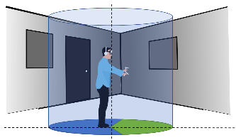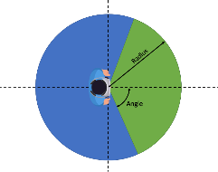
Figure 27 - Example of cylinder-shape visualization space
In the example of a cube, only the distance from the center of the cube to any face of it (half the distance of an edge) is signaled, assuming that the cube is centered on the viewer’s viewpoint. An extension of cube signaling is when the 3 sizes of a cubic space (depth, width and height) are signaled.
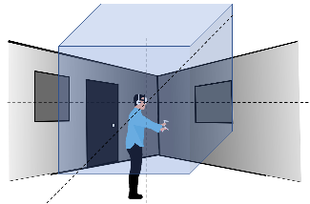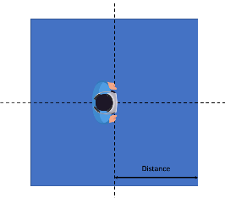
Figure 28 - Example of cube-shape visualization space
In the case of a sphere, only its radius is signaled, also assuming that the center if the sphere is the user’s viewpoint.

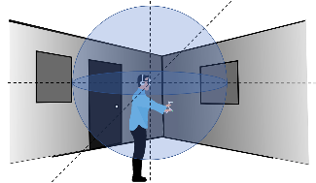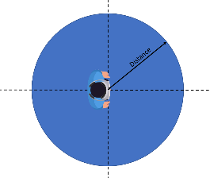
Figure 29 - Example of sphere-shape visualization space
For the above examples here is the required signaling:
Table 12 - Visualization space shape properties
Shape | Cylinder | Partial cylinder | Cuboid | Sphere
Measures | - Height (if not infinite)  - Radius | - Height (if not infinite)  - Radius  - Angle | - Side 1  - Side 2  - Side 3 | - Radius

The parameters Height, Side X and Radius are defined in meter, with floating point representation.
The parameter for Angle is defined in degree, ranges from 0 to 360, with floating point representation.
At this point, only Cuboid visualization space is in the scope of this work.

8.5.3.1 Persistency
The capturing the available visual space by the device is outside of the document. A device may use a manual input for defining the available visual space at the beginning of session or use an assisted method to define that space. In these cases, the available visual space is static.
A device may use its capturing sensors and derives the available visual space automatically. In this case, it may possibly update the visual space dynamically during the session. Since this document does not define the process of capturing the visual space, this specification only defines whether the available visualization space is static (no changing) or dynamic in IF-2 by Application, and if it is dynamic the frequency of update and/or an event-driven (action) update.

8.5.3.2 Implementation in OpenXR
The openXR XR_FB_scene extension allows to define the boundary room and also boundary space and objects in the space:
1. xrGetSpaceBoundingBox3DFB provides the defined rectangular cube XrRect3DfFB (by defining the offset XrOffset3DfFB and the extend XrExtent3DfFB, in x,y,z dimensions).
2. xrGetSpaceSemanticLabelsFB may provide a way to describe the semantic meaning of an space entity.
This extension provides a mechanism to retrieve a rectangular bounding box that possibly can be marked as the available visualization space. However, at least one semantic keyword for such indication needs to be defined by this document to mark the space as “available visualization space”.
8.5.4 Use of available space information by the server
With the knowledge of the available rendering space, a server can ensure that the virtual objects fit into it. What the server decides to do remains out of scope of 3GPP and is the responsibility of the service provider. The following is just an illustration of the possible content adaptations at the server side:
- The server may decide to downscale the 3D scene so that all objects fit into the rendering volume.
- The server may decide to clip the scene and only send the virtual objects fully present in the rendering volume.
- The server may decide to deny the service due to incompatibility between the immersive experience and the available space around the user.
- In case of multiple users in different spaces, the server may decide to downscale the 3D scene for some or upscale for others to create a symmetric experience for all users.
As an example in Figure 31, the following scene with 3 objects has one object (orange cylinder) within the rectangle visualization space one object partially inside the cube (yellow rectangle) and one object out of the rendering volume (green cylinder).
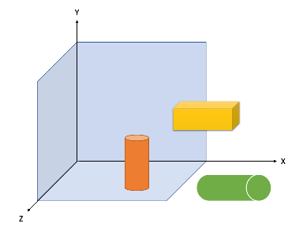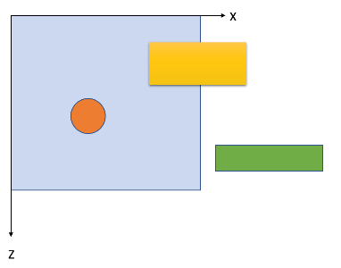
Figure 30 - Example scene before adaptation

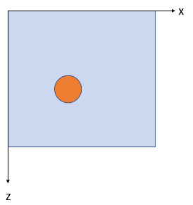  Figure 31 - Example scene after clipping | 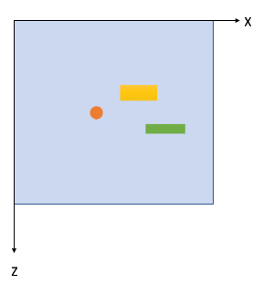  Figure 32 - Example scene after downscaling

8.6 User interaction

8.6.1 General
In use cases such as shared interactive immersive services, the user interaction is sent from a UE to a server. The server handles the user’s request to the immersive media scene (e.g., changing the context such as translation, rotation, and scaling or adding a new object in the scene). With the edge assisted UE type, the UE offloads the scene rendering to the Split Rendering Server, the server rasterizes the XR viewport and does pre-rendering to generate a XR media which is encoded and delivered to the UE.

8.6.2 QoE timing information
In the context of interactive immersive services, one important parameter to estimate the user quality of experience is the roundtrip interaction delay which is defined in the TR 26.928 [35] section 4.2.2. “Interaction Delays and Age of Content”.
The roundtrip interaction delay is defined as the sum of the Age of Content and the User Interaction Delay.
The User interaction delay is defined as the time duration between the moment at which a user action is initiated and the time such an action is taken into account by the content creation engine. It is impacted by the uplink latency of the wireless network.
The Age of content is defined as the time duration between the moment the content is created and the time it is presented to the user. It is impacted by the downlink latency of the wireless network.
The interactivity Quality of Experience (QoE) is highly dependent on the roundtrip interaction delay. Furthermore, the acceptable delay may differ according to the use case and the type of interaction. Several type of interactions with different roundtrip interaction delay thresholds may coexist in one application.
The Table X lists four categories of interaction/application defined in the TR 26.928 [35] with respect to roundtrip interaction delay:
Table 13 - Roundtrip interaction delay threshold
Interaction/application Categories | Roundtrip interaction delay threshold
Ultra-Low-Latency | ≤ 50 ms
Low-Latency | ≤ 100 ms
Moderate latency | ≤ 200 ms
Non-critical latency | > 200 ms

The user interaction may be a single event which is utterly asynchronous from other data flows or may occur at different frequency.

8.6.3 QoE measurement
For the Edge dependent MeCAR XR device type, the server’s split render function is in charge to pre-render the scene for the UE using the latest user pose, encodes the rendered frame and sends it back to the UE. The UE decodes the rendered frame, performs further post-processing like pose correction before presenting the frame to the user.
The procedures of the interactivity pipeline are detailed in Figure 33.
Figure 33 - User action call flow
Procedure:
- The raw user action is acquired from the XR runtime by the XR source management, including the lastChangeState timestamp of the last change to the state of this action.
- The XR source management formats and gathers the raw user action into an action message. The action message is shared with the Media access Function (MAF).
- The MAF sends the action message to the Scene Manager in the Split Rendering Server.
- The action message is received by the Split Rendering Server and buffered before being handled during the next iteration of the update loop of the Scene manger. The Scene manager in the server processes the interaction task according to the actions in the action message from the UE and updates the scene. The Scene Manager records in the timeInfo metadata the sceneUpdateTime timestamp when it starts to process the action.
The scene manager may ignore the action according to the application policy: too many actions, actions too late or lower priority.
- The Scene manager shares the updated scene with the renderer.
- The scene is rendered using the predicted user pose.
- The rendered media frame is shared with the Media Delivery Function.
- The Split Rendering Server encodes the rendered media frame together with the associated time metadata. The encoded media frame is sent from the Split Rendering Server to the UE MAF with the associated time metadata.
- The UE MAF decodes the media data. The rendered frame is then shared to the Presentation Engine and the XR runtime.
- The XR runtime performs further processing such pose correction using the latest pose.
- The rendered frame with the interaction response is displayed to the user at the actual display time (T2.actual).

8.6.4 Interactivity delays and QoE
Using all the timestamps from the Split Rendering Server and the UE, the application can calculate the interaction delays:
- User-interaction-delay = sceneUpdateTime - lastChangeState
- Age-of-content = T2.actual - sceneUpdateTime
- Roundtrip-interaction-delay = T2.actual - lastChangeState

Those delays allow to estimate the interactivity QoE taking into account the category of interaction defined in the TR 26.928 [35]and listed in the Table X.
By using all the history of delay measurement, the Application can estimate the delays between the next user action and rendered frames.
- Action and timestamp information from the device:
  - Action information: the user action information which are grouped into action sets. Each action has a unique identifier of the action
  - lastChangeTime: the time when the user action is made. It corresponds to the lastChangeTime field in the action information defined as the timestamp of the last change to the state of the action.
- Action and timestamp information associated with rendered media frame from the Split Rendering Server:
  - Action identifiers: The identifiers of the actions which are handled by the scene manager and rendered in the associated media frame
  - sceneUpdateTime: the time when the Scene manager processes the interaction task according to the actions in the action message from the UE and updates the scene.

9 Relevant activities in external organizations

9.1 Volumetric video support in MPEG-I V3C

9.1.1 Content Creation

9.1.1.1 Point cloud
Point clouds are generated from one or more cameras and depth sensors. These point clouds may contain from thousands up to billions of points with colours, materials, and other properties. They provide the ability to reproduce a scene with high realism and free interaction and navigation. The viewer is relatively close to the object or subject that can be looked at from all sides. Example of point cloud content are provided in the figure below.
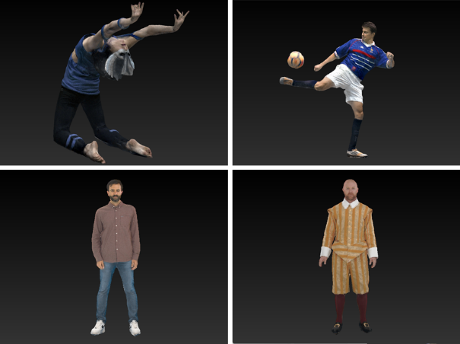
Figure 34 - XD Productions Acrobat 01 (on top left) and Soccer02 (on top right), Volograms Rafa (on bottom left) and Sir Frederick (on bottom right)

9.1.1.2 Multi-view + depth
Multi-view videos are typically generated by one or more cameras that capture a scene from different viewpoints. Cameras can be 2D cameras, range sensing cameras, or both. Calibration of camera colour and intrinsics may be performed ahead of time using checkerboard patterns, and calibration of camera extrinsics (camera poses) may be performed after acquisition by matching the camera images. After that, multiview depth estimation or refinement creates full resolution depth maps in correspondence with the texture maps.
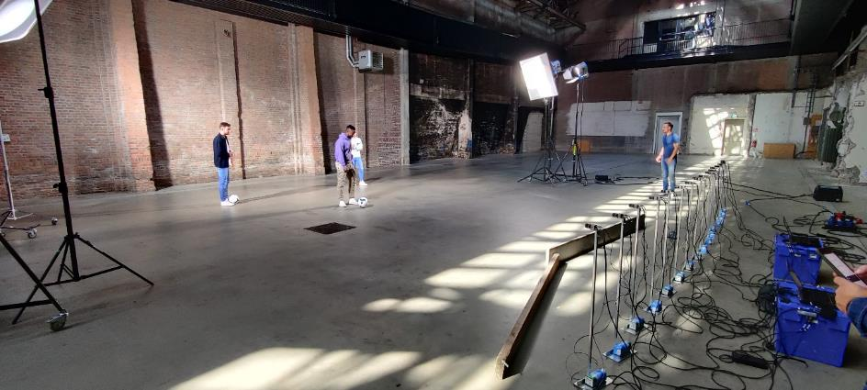
Figure 35 - Shooting of MIV content in Veghel, Netherlands, September 2022

9.1.1.3 Multi-planar images
Content in a multi-view + depth representation may be further processed using volume rendering to estimate volume densities and slice the scene into many layers. Depending on the projection type these layers are called planes (perspective projection), or spheres (equirectangular projection), resulting in multi-planar image (MPI) or multi-spherical image (MSI) representations.
While more effort may be needed to pre-process and encode, rendering is simplified because the layers can be rendered in order without z-buffering or view blending using the inverse painter's algorithm. However, MPI can be easily created by CGI sources.
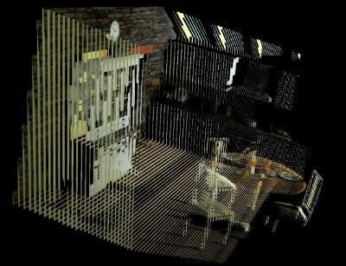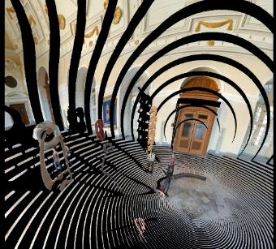
Figure 36 - MPI processed images (front-parallel on the left, multiple sphere image on the right)

9.1.2 Levels of Immersion
V3C offers visual comfort and immersiveness over 2D video. Different levels of immersions can be distinguished (Figure 37):
- 3 degrees of freedom (3DoF) videos also called the 360° video is the ability to look around.
- 3DoF+ video adds the ability to move your head while standing or sitting on a chair meaning that there is a limited head movement.
- 6DoF video extends that by being able to walk a few steps or view the object from all sides.

In general, V3C is useful for a variety of applications such as sports events, media performances, immersive teleconferencing, remote assistance, tele-learning, post-event analysis, virtual tours, cultural heritage, and interactive advertisement and customer experiences.
Some key distinctions between MIV and V-PCC enabling the selection of the relevant technology for specific use cases include:
- AR and MR are enabled by V-PCC.
- Standalone VR is enabled by MIV.
- A scene description can integrate Immersive media (V3C) and notably V-PCC dynamic and static objects, while MIV can be seen as a “scene in itself” and as a standalone solution.
- In simple deployment, the capability of interacting and viewing a content from all angles is enabled by V-PCC, while the movement of a user for an MIV content is more limited, unless multiple complex rig sets are deployed.
- Generally, V-PCC is looking inward (focusing on an object to look at), while MIV is looking outward (from the viewpoint of the user, and include the background).

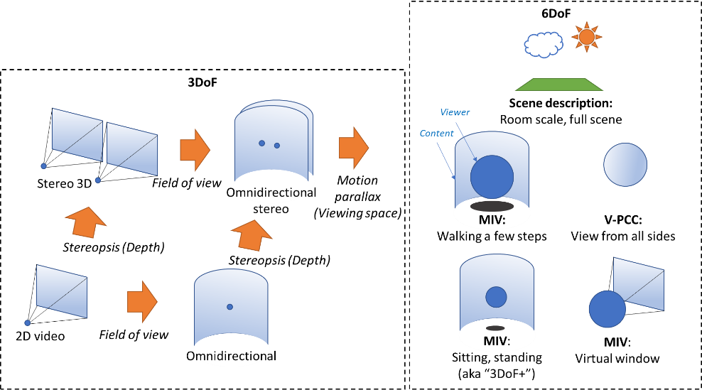
Figure 37 - Levels of Immersion

9.1.3 Coding aspect of V3C
V3C encoding of a volumetric frame is achieved through a conversion of a volumetric frame from its 3D representation to multiple 2D representations and a generation of associated data, also known as the atlas data.
2D representations, known as V3C video components, of a volumetric frame are encoded using traditional 2D video codecs (such as AVC or HEVC). The V3C video component may, for example, include occupancy, geometry, attribute data, or packed data. The occupancy data informs a V3C decoder which pixels in other V3C video components contribute to the reconstructed 3D representation. The geometry data describes information on the position of the reconstructed voxels, while attribute data provides properties of that voxel, e.g. color or material information. The packed data component, introduced in 2nd edition of the standard, allows to limit the number of the video components required and pack all types of video component data (i.e. occupancy, geometry, and attributes) into one video frame.
Atlas data, known as V3C atlas component, provides information to interpret the V3C video components and enables the reconstruction from a 2D representation back into a 3D representation of a volumetric frame. The atlas data is composed of a collection of patches. Each patch identifies a region in all V3C video components and provides the necessary information to perform the appropriate inverse projection of the indicated region back into 3D space. The shape of the patch region is determined by a 2D bounding box associated with each patch as well as their coding order. The 2D shape of these patches is further refined based on occupancy data.
Figure 38 visualizes the reconstruction from patches and different video components of V3C content.
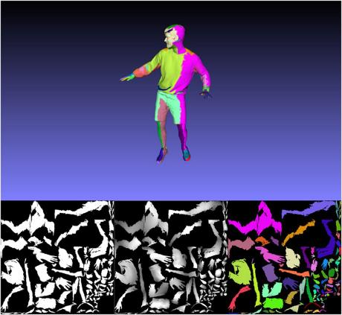
Figure 38 - Example of reconstructed point 3D frame with one color per patch (Top), occupancy video frame (bottom-left), geometry video frame (bottom-middle) and one color per patch texture frame (bottom-right).
To enable parallelization, random access, as well as a variety of other functionalities, an atlas frame can be divided into one or more rectangular partitions referred to as tiles. Tiles are not allowed to overlap and are independently decodable. The functionality of tiles, closely resembles similar mechanisms in video codecs, such as motion constraint tiles in HEVC or sub-pictures in VVC.
The binary form of V3C video components, i.e. video bitstream, and V3C atlas components, i.e. V3C atlas bitstream, can be collected and represented by a single V3C bitstream. The V3C bitstream is composed of a set of V3C units. Each V3C unit has a V3C unit header and a V3C unit payload. The V3C unit header describes the V3C unit type for the payload and the V3C unit payload contains the data for V3C video components, V3C atlas components or V3C parameter set. V3C video component, i.e. occupancy, geometry, attribute, or packed corresponds to video data units (e.g. NAL units defined in (ISO/IEC 23008-2)) that could be decoded by an appropriate video decoder. The V3C atlas component contains V3C NAL units as defined in (ISO/IEC 23090-5 and ISO/IEC 23090-12). The same standards also define how to decode said V3C NAL units.

9.1.4 Systems aspect of V3C

9.1.4.1 General
The ISO/IEC JTC1/SC29 MPEG Systems workgroup (WG3) has developed a standard to support efficient and interoperable storage and transport of compressed visual volumetric media content with 6 degrees of freedom. The standard defines how to carry V3C bitstreams in an ISOBMFF container and is based on and derived from the ISO/IEC 14496-12 standard [3] and extends the Dynamic Adaptive Streaming over Hypertext Transfer Protocol (HTTP) (DASH) and MPEG Media Transport (MMT) frameworks by adding additional signaling to enable delivery of V3C-coded content over a network. A comprehensive overview of the generic V3C carriage concepts and related functionalities defined by the specification is presented in [15]. A V3C streaming demo based on the technologies defined in this standard was presented during the SA4#122 meeting and described in S4-230217.

9.1.4.2 Encapsulation File Format
The ISO/IEC 23090-10 specification is derived from ISO/IEC 14496-12 and specifies how boxes defined in ISO/IEC 14496-12 should be used for storing V3C-coded content. It also defines new boxes required to store a V3C bitstream in an ISOBMFF container and to support various functionalities, such as recommended viewports and spatial partial access. The specification introduces three methods for storing V3C-coded content in ISOBMFF, where each mode defines a number of sample entries that impose certain constraints on the track(s) supported by that mode and a specific sample format for these tracks in addition to other mode-specific tools. The supported storage modes are: single-track storage, multi-track storage, and non-timed storage.
A single-track encapsulation mode represents the V3C bitstream in ISOBMFF as one track, V3C bitstream track. V3C bitstream track is identified by a sample entry with type ‘v3e1’ or ‘v3eg’. This encapsulation mode is intended for direct ISOBMFF encapsulation without any additional pre-processing or de-multiplexing of the ingested V3C bitstream. While simple, this encapsulation mode does not support partial access and a client is not able to select only a subset of the V3C components for playback.
The multi-track encapsulation mode stores the V3C bitstream in the ISOBMFF file as several tracks, where each track represents either part of or a complete V3C component. This is the preferred mode for streaming applications since a number of independent encoders can run in parallel and the resulting bitstreams can be stored into an ISOBMFF-compliant file or set of files as separate tracks. This provides a flexibility where the extraction and direct processing of each V3C component by their respective decoder becomes much easier without the need to reconstruct the V3C bitstream.
Finally, the non-timed encapsulation mode represents the V3C bitstream in ISOBMFF as items, as defined in [3], where each item represents part of or a complete V3C component. This mode is well suited, for example, to store a V3C bitstream encoded with a still picture profile that has less strict decoding requirements and limited coding tool support.
To signal to a parser which storage mode is used and what type of functionality needs to be supported to play the file, a number of ISOBMFF brands are defined by ISO/IEC 23090-10. A brand might indicate the type of encoding used, how the data of each encoding is stored, constraints and extensions that are applied to the file, the compatibility, or the intended usage of the file.
The single-track encapsulation mode is identified by the brand ‘v3st’. Multi-track encapsulation is identified by the ‘v3mt’ and ‘v3mp’ brands. The ‘v3mt’ brand informs the parser that the file contains V3C content stored using a basic multi-track storage mode, while the brand ‘v3mp’ indicates a multi-track storage mode with additional features present, such as spatial partial access or recommended viewports. The non-timed encapsulation mode is identified by the brand ‘v3nt’.

9.1.4.3 Streaming Support
The ISO/IEC 23090-10 specification supports delivering V3C content using MPEG-DASH as well as MMT. In the case of MPEG-DASH, the standard defines how to signal V3C content in the Media Presentation Description (MPD) for both the single-track and multi-track encapsulation modes, including defining V3C-specific DASH descriptors, and defines restrictions on the DASH segments generated for the content.

9.1.4.3.1 DASH Single Track Mode
In this mode, the V3C content is represented with a single Adaptation Set in the MPD with one or more Representations. The only constraint on the Representations of this Adaptation Set is that the codec used for encoding a given V3C video component must be identical across all Representations. There is no requirement, however, that all the V3C video components in one Representation must be encoded using the same codec.

9.1.4.3.2 DASH Multi-track Mode
As with encapsulation, the multi-track mode provides more flexibility over the single-track mode by enabling adaptation across several dimensions as each V3C component is represented by its own Adaptation Set. By separating the V3C video component bitstreams into multiple Adaptation Sets, a streaming client can prioritize or completely drop some components or maps when making adaptation decisions. Moreover, V3C video component representations can be encoded using different video codecs or different bitrates to allow for efficient adaptive bitrate streaming. In addition, the multi-track mode defines number of constrains on the segments of the Adaptation Sets describing V3C components.

9.1.4.4 RTP
In order to transport V3C compressed content over RTP, an appropriate payload format is needed for both 1) video, and 2) data components (atlas).
The RTP payload format for V3C video component is defined by appropriate Internet Standards for the applicable video codecs. For example, RFC 7798 defines the payload format for HEVC, and RFC 6184 defines the payload format for H.264.
The RTP payload format for V3C atlas component is under development in the IETF AVTCORE WG and reached working group draft status in December 2022 (IETF – avtcore 2023). As the atlas bitstream uses the high-level syntax NAL unit concept known from existing video codecs, the proposed payload format tries to re-use as much as possible from RTP payload formats for existing modern video codecs. Additionally, the internet draft [16] provides information on how the association between the V3C atlas component and the V3C video components can be signalled on SDP level, e.g., by defining groups of RTP streams to contain V3C encoded data (RFC 5888), or by defining a way to bundle multiple RTP streams in a single transport (RFC 8843).
The following figure shows the end-to-end overview of a V3C communication system in a uni-directional conversational scenario.
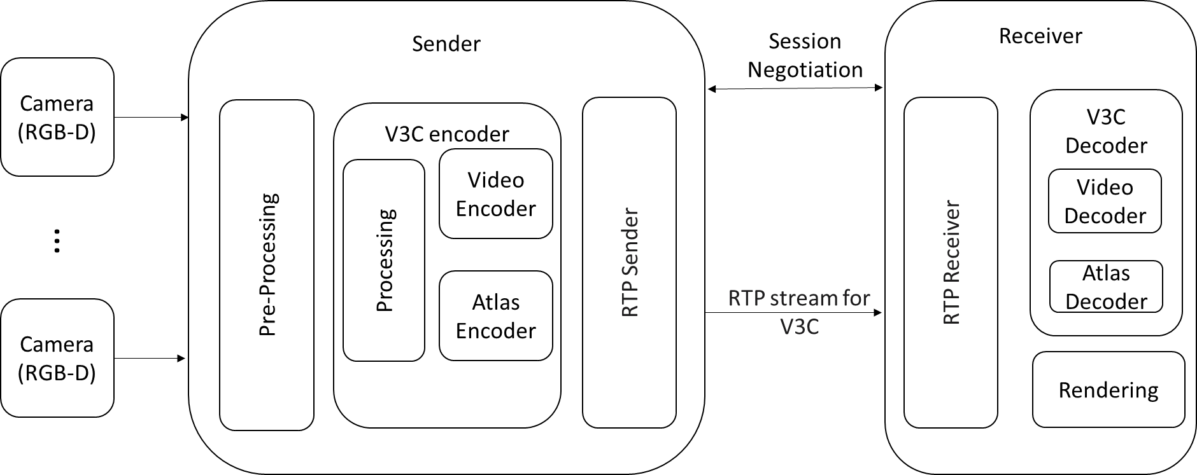

Figure 39 - High level overview of a V3C system for one way conversational communication.

9.1.4.5 V3C Applications
The V3C standard defines a generic mechanism for coding volumetric video and can be used by applications targeting different flavors of volumetric content, such as point clouds, immersive video with depth, or even mesh representations of visual volumetric frames. Compression of mesh representations is currently ongoing in MPEG under Video-based Dynamic Mesh Compression (V-DMC) [17].

9.1.4.5.1 Video-based Point Cloud Compression (V-PCC)
V-PCC addresses lossless and lossy coding of 3D point clouds with associated attributes such as colors and reflectance. Point clouds are typically represented by extremely large amounts of data, which is a significant barrier for mass market applications. However, the relative ease of capturing and rendering 3D information as point clouds compared to other volumetric video representations makes point clouds increasingly popular to present immersive volumetric data. With the current V-PCC encoder implementation providing a compression in the range of 100:1 to 300:1, a dynamic point cloud of one million points could be encoded at 8 Mbit/s with good perceptual quality. Real-time decoding and rendering of V-PCC bitstreams has also been demonstrated on current mobile hardware. The overview of coding aspects of V-PCC is provided in [12][13].

9.1.4.5.2 MPEG-I Immersive Video (MIV)
MIV enables the compression of multi-view content, multi-view plus depth and multi-plane image source data. MIV was developed to support compression of immersive video content, in which a real or virtual 3D scene is captured by multiple real or virtual cameras. The standard builds on capabilities defined in 23090-5, by adding more flexible video component packing strategies, depth encoding formats and camera models. The new camera models support arbitrary orientation and translation properties as well as equirectangular, perspective, or orthographic projections. Observed in demos, by pruning and packing views, MIV can achieve typical bit rates around 5 to 30 Mb/s using HEVC and a pixel rate up to HEVC Level 5.2. The overview of coding aspects of MIV is provided in [14][31].

9.1.4.6 V3C Performance

9.1.4.6.1 V-PCC Results
Subjective verification results for V3C V-PCC conclude that the MPEG developed test model significantly outperforms the reference anchor (point cloud library). More detailed information is available in the full test report [30].
A performance analysis done in the SMPTE Motion Imaging Journal [39] provides a comparative study on the combination of different V-PCC tools and gives conclusions in terms of objective and subjective tests while comparing different profiles. Faithful reconstruction results can be obtained with only one map for the current atlas and by activating the Point Local Reconstruction and the Occupancy Synthesis with Patch Border Filtering tools. The eight direction improves the visual quality of the reconstructed point cloud by capturing more points during the projection phase of the encoding.

9.1.4.6.2 MIV Results
Subjective verification results for V3C MIV conclude that the MPEG developed test model significantly outperforms the reference anchor. More detailed information is available in the full test report [40].

9.1.5 Implementations
In order to support generation of content for V3C encoder, it is recommended that a device be capable of capturing depth + texture video, also sometimes referred to as RGBD. However, as indicated by the geometry absent profile as defined in ISO/IEC 23090-12, depth capture is not sometimes even needed to generate volumetric video. Even a device with a single depth + texture camera sensor can generate point cloud sequences. Currently, in the mobile industry we see an increased number of handheld devices which support depth sensing, like the iPhone 12 or 13. There are also dedicated cameras like Microsoft Kinect Azure or Intel Realsense, which support depth sensing. Over the last 4 years there were number of implementations in the industry showing how V3C encoded can be consumed by different types of devices.
In January 2019 Nokia shared a demo based on an open-sourced implementation [18] using standard mobile device hardware to decode and render V3C encoded content [19].
In September 2019 InterDigital demonstrated V-PCC implementation at IBC 2019 [41].
In January 2020 Futurewei also contributed to describing a mechanism for GPU friendly rendering on mobile platforms using geometry shaders and presented V3C rendering capabilities on a mobile device [20].
In January 2021 Intel demonstrated MIV video playback on the Intel Max GPU using its media and graphics hardware engines [21]. The proof of concept “Freeport Player” uses a modified open source VLC player, DirectX11 implementation of TMIV decoder and renderer, and a face tracking system. The demo was interactive, using a normal web camera to track viewer motion, and a normal PC display to show rendered viewports.
In August 2022 Interdigital and Philips showcased real-time decoding of V3C bitstreams using three simultaneous HEVC hardware decoders [22][23]. The demo showed that V3C standard is ready for deployment for public application as it relies on 2D conventional video codecs and is codec agnostic. So, it does not require specialized hardware.
In October 2022 Interdigital showcased streaming of V-PCC compressed content to Nreal AR glasses [24][25] over DASH as described in 23090-10.
In October 2022, KDDI announced the first real time V-PCC encoder [42].
In February 2023 Nokia provided description of the V3C-based real-time delivery demo [26] that showcase the V3C capabilities for conversational scenarios, where data is delivered over RTP streams. The demo utilized commercially available RGB-D cameras [27], standard PC desktop as a sender and Meta Quest 2 as a receiver. The demo was updated in April 2023 [43] to support bi-directional real-time communication in an AR see-through mode using Pico4 devices for receiving the encoded bitstream and decoding it. The receiver can synthesize views at over 70 fps while the system keeps end-to-end system latency conversational well below 200ms. The compressed bitrates vary between 5 Mbit/s to 20 Mbit/s.
In February 2023 InterDigital showcased at MWC'23 and in April 2023 Philips showcased at MPEG meeting a real time implementation of a V3C (V-PCC and MIV) decoding and rendering running on Android phone [44].
The demonstration comprises:
- a streaming server that converts V3C bitstreams into DASH segments that are streamed to multiple streaming clients over the Internet ; and
- an client implementation of a player and video decoder supporting multiple V3C configurations (V3C V-PCC, V3C MVD, V3C MPI) and real-time HEVC decoding. This implementation receives DASH segments via the DASH streaming client (or local storage) and passes downloaded data chunks to the decoder module (the native decoder plugin in Figure x) which is connected to a host application that renders the final view on the end-user’s device.
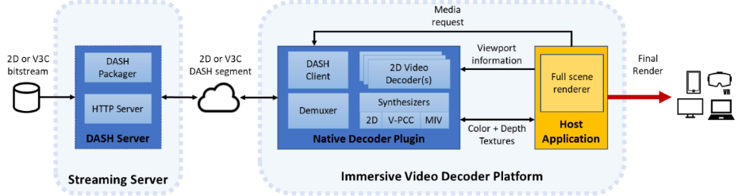
Figure 40 - 2D and V3C streaming and rendering implementation
The native decoder plugin (C++, OpenGL) manages both the decoding and rendering of HEVC, V3C V-PCC and V3C MIV bitstreams. It implements the Unity native render plugin API to leverage the engine's cross-platform capabilities and the numerous XR devices supported. The plugin is composed of a pipeline with 5 main stages: a data interface stage, a demultiplexing stage, a decoding stage (leveraging hardware-accelerated 2D video decoder(s) : 3 video decoders for V-PCC, 2 for MIV MVD or MIV MPI, 3 for MIV MVD with Transparency), a scheduling stage, and a synthesizing stage (OpenGL rendering in GPU).
The host application manages end-user’s input, camera movement, and full scene rendering.
The implementation is capable of decoding the V3C content in real time on mobile phones running an Android operating system with a rendering frame rate of 25 fps and 30 fps for the MPEG reference sequences (e.g. Soccer Red (V-PCC) and Barn (MIV) contents), as well as for additional point cloud content provided by XD Productions (V-PCC encoded) and self-captured MVD content (MIV encoded).
In April 2023 Philips demonstrated a “bullet-time” use case in the form of a smart phone that plays back a sequence with soccer tricks. When pausing the video, an atlas is retrieved which makes it possible to seamlessly reposition the virtual camera. When unpausing the video, the playback continuous from the camera feed that is closest to the virtual camera. Further details are available in Philips contribution to MPEG [45].
In April 2023 ETRI demonstrated a prototype MIV player that is capable of real-time view-synthesis using face tracker to provide viewing pose information. TMIV (MIV test model in MPEG) decoding and rendering functionalities are implemented using CUDA and the protype MIV player performs most of the main functional blocks that have been supported by the TMIV 13.1 reference software. Currently the frame rates for synthesized frames varies between sequences from ~13 fps to ~50 fps. Further details are available in ETRI MPEG contribution [46].
All the demonstrations indicate that both generating V3C content as well as decoding and displaying it using existing commercially available hardware is both possible as well as practical. Different types of implementations also display the flexibility of the V3C family of standards. More consideration about the performance requirements can be found in [28]. Some practical examples of the recommended minimum GPU requirements are provided below:
- Functionalities at least one of the following
  - Minimum OpenGL 3.0
  - Minimum OpeGLES 2.0
  - Minimum Vulkan 1.0
  - Minimum DirectX 9.0
  - Minimum Metal 1.0
- Performance
  - Minimum Adreno 540 or Apple A11 equivalent mobile GPU.

9.1.6 Capabilities considerations
Until now, V3C defines two applications: video-based point cloud compression (V-PCC) specified in ISO/IEC 23090-5 and MPEG immersive video (MIV) specified in ISO/IEC 23090-12. V3C specifications provide restrictions on the bitstreams and hence limits on the capabilities needed to decode the bitstreams utilizing profiles, tiers, and levels. Profiles are also used to indicate the application of V3C bitstream, i.e. V-PCC or MIV, in other words indicate the algorithmic features and limits that must be supported by decoders conforming to given profile.
ISO/IEC 23090-5 describes several codec group profiles for its applications, V-PCC and MIV, in Annex A, extracted from Annex A, is copied below for convenience. There are currently five codec groups defined: AVC Progressive high, HEVC Main 10, HEVC 444, VVC Main 10 and MP4RA. The details for the profiles defined in TS 26.118 for the subset of codecs can be reviewed from the table below.
For any given profile, a level (ptl_level_idc) of a tier (ptl_tier_flag) generally corresponds to a particular decoder processing load and memory capability. While defining the levels in V3C specification MPEG took into account the video codec requirements for 3GPP devices specified in TS 26.118 based on [29]. For advanced use cases, the HEVC Main10 profile, Main tier, at level 5.1 is mandated in TS 26.118, which corresponds to level 2.0 in V3C specification with 534 773 760 maximum aggregated luma sample rate per second (roughly corresponds to two 4k decoders running at 30 fps).
Table 14 - CodecGroup profile component supported functionality in ISO/IEC 23090-5.
 |  | AVC Progressive High |  |  | HEVC Main10 |  |  | HEVC444 |  |  | VVC Main 10 |  |  | MP4RA
 | Capability | Occupancy | Geometry | Attributes, Packed video | Occupancy | Geometry | Attributes, Packed video | Occupancy | Geometry | Attributes, Packed video | Occupancy | Geometry | Attributes, Packed video | Occupancy | Geometry | Attributes, Packed video
Chroma format | Mono |  |  |  |  |  |  | ✓ | ✓ | ✓ | ✓ | ✓ | ✓ | ‒ | ‒ | ‒
Chroma format | 4:2:0 | ✓ | ✓ | ✓ | ✓ | ✓ | ✓ | ✓ | ✓ | ✓ | ✓ | ✓ | ✓ | ‒ | ‒ | ‒
Chroma format | 4:4:4 |  |  |  |  |  |  |  |  | ✓ |  |  |  | ‒ | ‒ | ‒
Bit depth | 8 bit | ✓ | ✓ | ✓ | ✓ | ✓ | ✓ | ✓ | ✓ | ✓ | ✓ | ✓ | ✓ | ‒ | ‒ | ‒
Bit depth | 10 bit |  |  |  | ✓ | ✓ | ✓ | ✓ | ✓ | ✓ | ✓ | ✓ | ✓ | ‒ | ‒ | ‒
Video coding specification | name | ISO/IEC  14496-10 |  |  | ISO/IEC 23008-2 |  |  |  |  |  | ISO/IEC DIS 23090-3 |  |  | As defined by a component codec mapping SEI (F.2.11)
Video coding specification | profile | Progressive High as specified in ISO/IEC 14496-10 |  |  | Main 10 as specified in ISO/IEC 23008-2 |  |  | Main 4:4:4 10 as specified in ISO/IEC 23008-2 |  |  | VVC Main 10 as specified in ISO/IEC DIS 23090-3 |  |  | ‒
To fully define decoding capability V3C uses a combination of syntax elements ptl_profile_codec_group_idc and ptl_profile_toolset_idc. The toolsets are used to describe the required V3C atlas codec features and are copied for convenience in Table 2. V3C specifies two toolset profiles for V-PCC applications and four toolset profiles for MIV applications. Additionally, V-PCC toolsets can be differentiated for static and dynamic volumetric content using ptc_one_v3c_frame_only_flag.
For V-PCC applications, the V-PCC Extended toolset profile allows for more than one map of geometry and attribute and enables the usage of tools for increased performance, such as Extended Occupancy Map patches (EOM patches, which transmits occupancy information between two maps), Point Local Reconstruction (PLR, which creates new points using interpolation parameters), among others, and also allows for more flexibility in patch placement (including patch rotations) and in patch projection directions (including directions rotated by 45-degrees). Furthermore, the V-PCC Extended profile also does not restrict the number of channels in V3C video component.
MIV applications allow only I_INTRA patch type compared to V-PCC that is provided per GOP of video frames. Additionally, the MIV toolsets are more flexible with regard to the amount and types of V3C video components. For example it allows a packed version of V3C video components that enables one video encoder/decoder V3C use case. MIV toolsets profile also clearly limits the number of attribute V3C video components.
Table 15 - Available toolset profile components in ISO/IEC 23090-5.
Ptl_profile_toolset_idc | ptc_one_v3c_frame_only_flag | Toolset profile component | Type
0 | 0 | V-PCC Basic  /* Specified in Annex H * / | Dynamic
0 | 1 | V-PCC Basic Still  /* Specified in Annex H */ | Static
1 | 0 | V-PCC Extended  /* Specified in Annex H */ | Dynamic
1 | 1 | V-PCC Extended Still  /* Specified in Annex H */ | Static
64 | 0 | MIV Main  /* Specified in ISO/IEC 23090-12 */ | Dynamic
65 | 0 | MIV Extended  /* Specified in ISO/IEC 23090-12 */ | Dynamic
66 | 0 | MIV Geometry Absent  /* Specified in ISO/IEC 23090-12 */ | Dynamic
2..63, 67..255 | - | Reserved | -

It should be pointed out that the V3C coding standards do not specify how the content should be displayed to the user / rendered. Similarly to 2D video codecs, the display should be application specific; thus, individual applications can decide on the optimal reconstruction and rendering techniques. This allows the V3C standard to remain relevant, when novel rendering and reconstruction techniques and hardware acceleration features become available.

9.1.7 3D media capabilities considerations

9.1.7.1 General
ISO/IEC 23090-5 specifies a generic mechanism for volumetric video coding, i.e., visual volumetric video-based coding (V3C), that may be used by applications targeting volumetric content, such as point clouds or immersive video with depth. The applications of V3C target point cloud representations of volumetric frames in Annex H of ISO/IEC 23090-5 (V-PCC). ISO/IEC 23090-12 specifies the applications of V3C targeting Immersive Video (MIV).
Unlike two dimensional image or video coding standards, the V3C standard specifies profiles as a combination of three components, namely CodecGroup, Toolset, and Reconstruction components.
The CodecGroup component indicates video decoding specifications and their profiles, e.g., Main 10 as specified in ISO/IEC 23008-2, that is used for encoding V3C video components. The CodeGroup profile component affects only V3C video components and does not have impact on V3C atlas component. The Toolset profile component indicates the coding tools that could be used to generate the conformant bitstream and shall be supported by a decoder. The Toolset profile component affects only the V3C atlas components and does not have impact on the V3C video component. The CodecGroup and Toolset components specify conformance point A in ISO/IEC 23090-5.
The Reconstruction profile component describes conformance point B in ISO/IEC 23090-5 and it specifies the pre-reconstruction, reconstruction, post-reconstruction, and adaptation tools supported or recommended to achieve conformance in terms of 3D reconstruction. A decoder may support and may be able to conform to multiple reconstruction profiles specified in ISO/IEC 23090-5. However, the Reconstruction profile that a decoder selects to operate in, is outside the scope of ISO/IEC 23090-5. When a decoder claims to be operating at a particular conformance point B, it shall be capable of reconstructing a volumetric frame according to the reconstruction recommendations specified by that profile.
The following subsections further summarize profile, tier and level structure for V3C codecs.

9.1.7.2 V3C decoder conformance points
V3C profiles follow a structured and flexible definition to allow for clearly identifying two distinct conformance points, Conformance Point A and Conformance Point B. These conformance points are illustrated in the decoding block diagram shown in Figure 41.
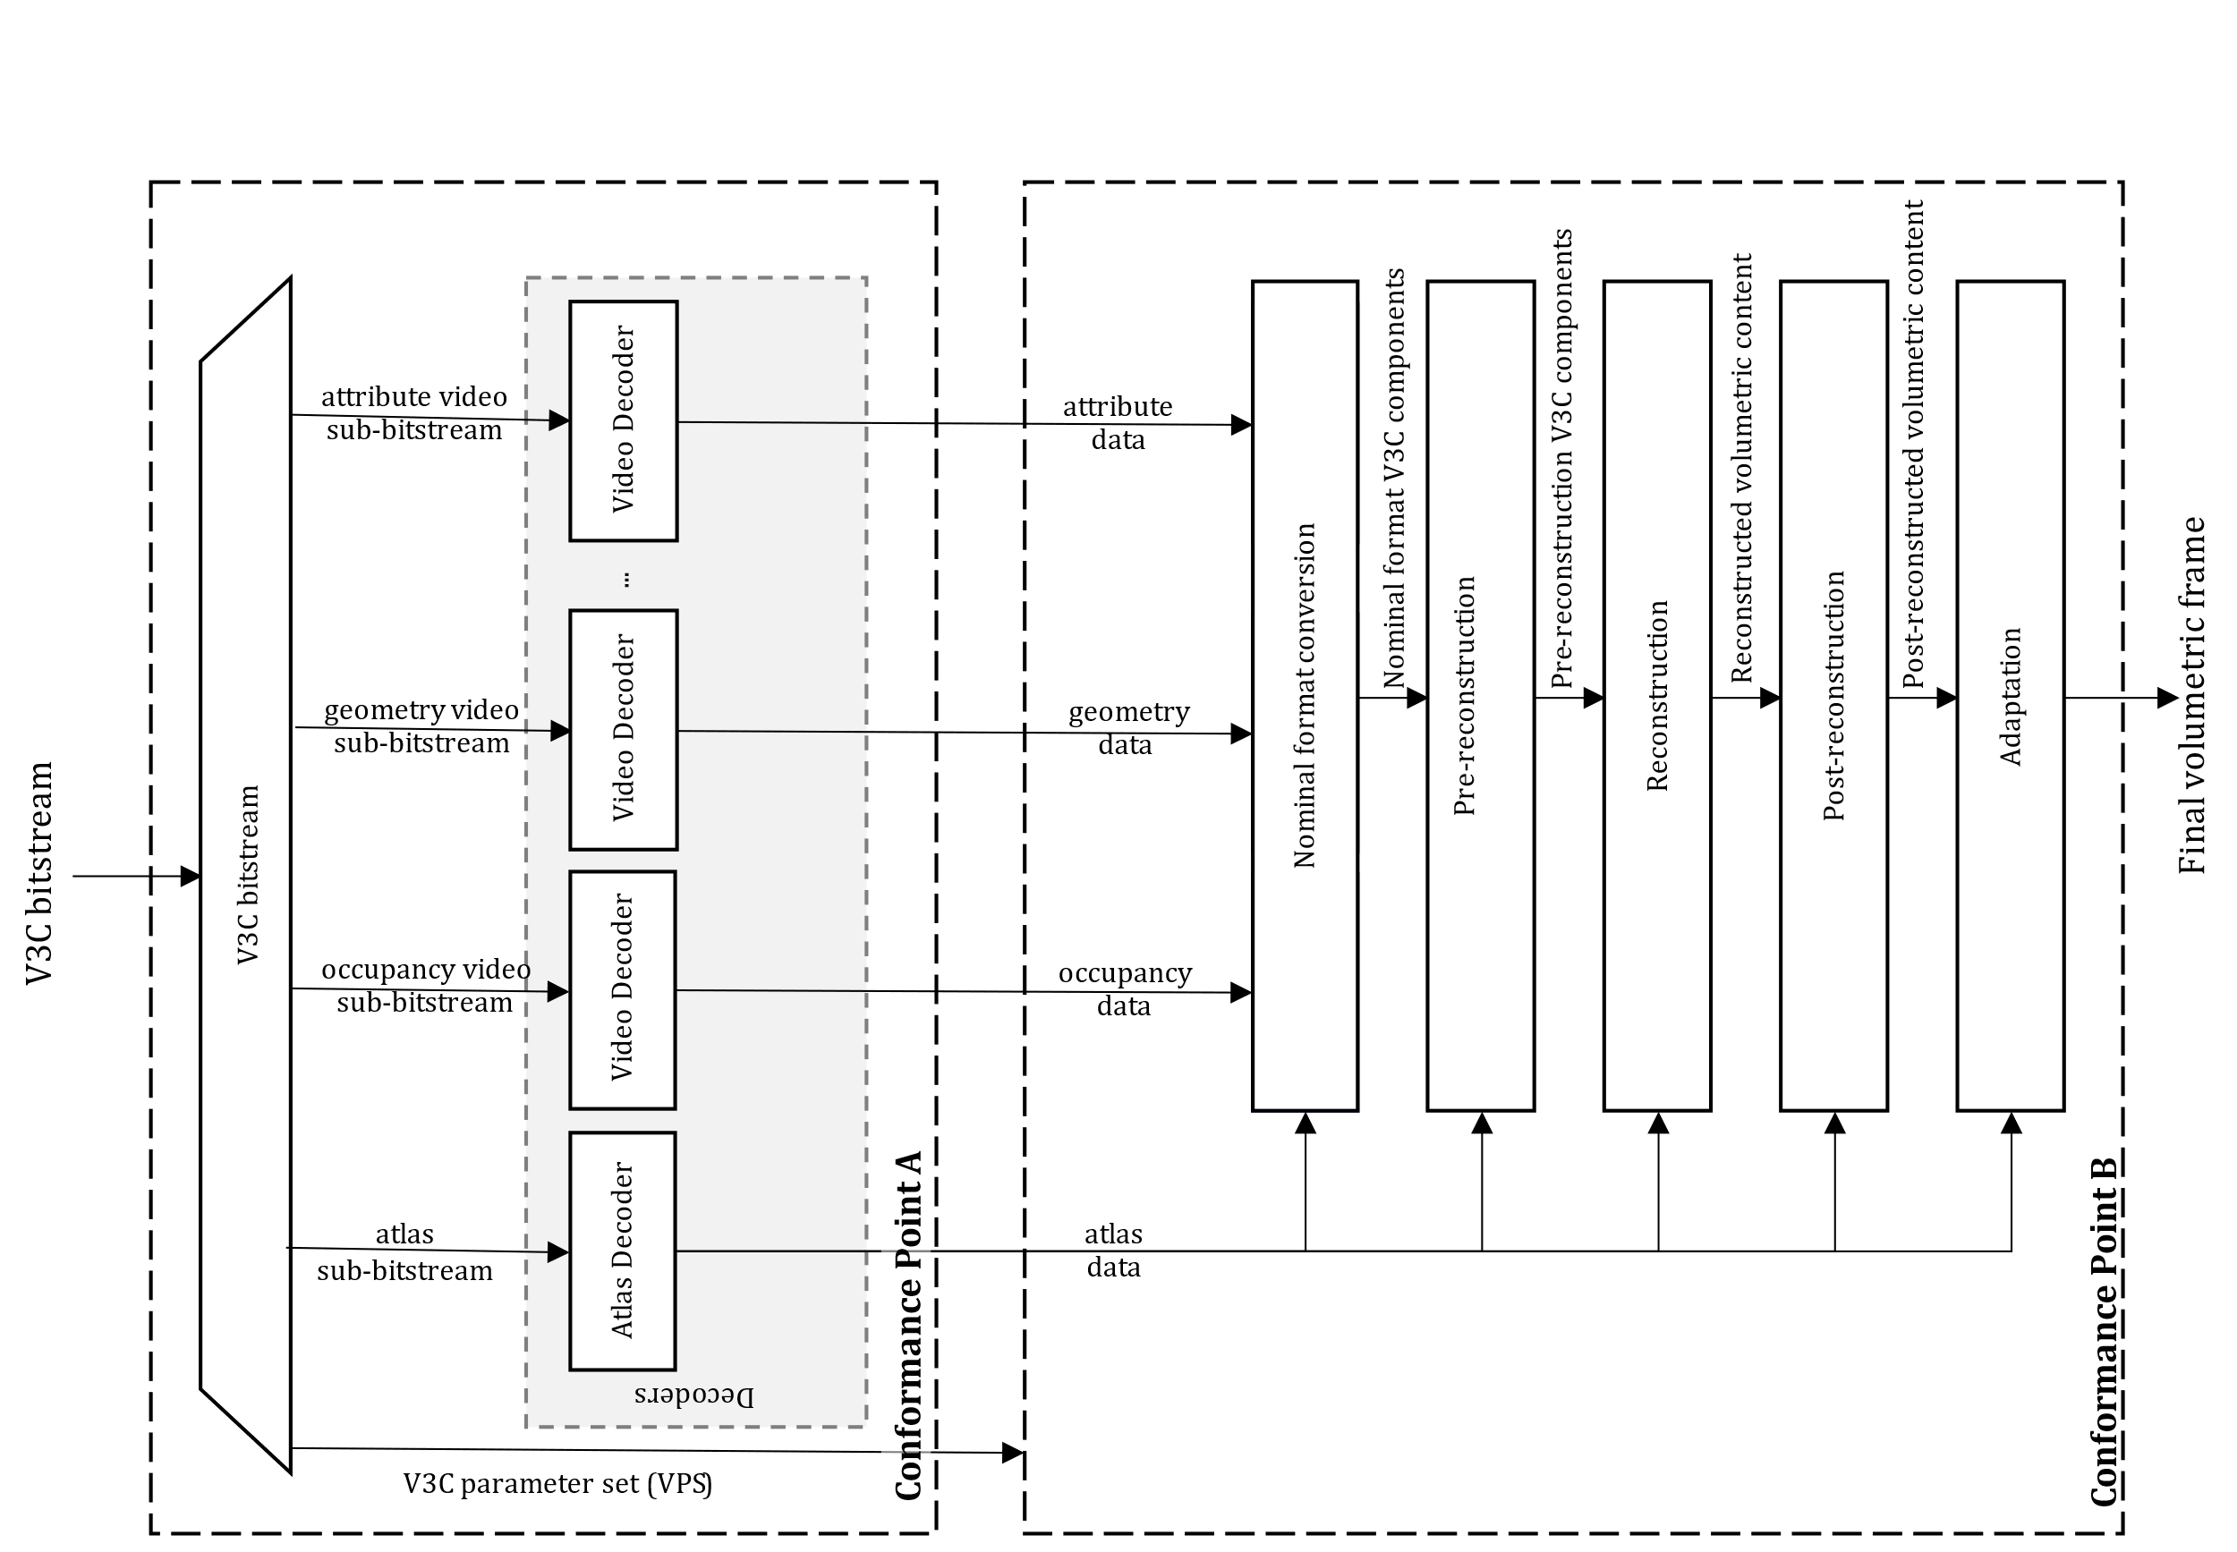
Figure 41 - V3C decoding block diagram with decoding conformance points A and B
The first conformance point, point A, covers the decoded video sub-bitstreams and atlas sub-bitstream. It also covers the derived block to patch map information. The second conformance point, point B, covers the reconstruction process.
In order to signal the required decoding capability at a given conformance point V3C utilizes a combination of syntax elements ptl_tier_flag, ptl_level_idc, ptl_profile_codec_group_idc, ptl_profile_toolset_idc, and ptl_profile_reconstruction_idc that are present in the V3C bitstream. A mapping of the syntax elements to a given conformance point is shown in Figure 42.
Figure 42 - V3C profile, level, and tier structure
V3C bitstreams conforming to a specified tier and level obey the following constraints for each atlas bitstream, where tiers, main (MT) and high (HT) relate directly to the video bitstream level limits.
- V3C bitstream level
  - Maximum of PROJECTED, EOM, and RAW points per second
  - Maximum of PROJECTED, EOM, and RAW points per atlas frame
  - Maximum number of maps
  - Maximum number of attributes
  - Maximum number of attribute dimensions (channels)
- Atlas bitstream level
  - Maximum of PROJECTED, EOM, and RAW patches per atlas frame
  - Maximum of PROJECTED, EOM, and RAW patches per second
  - Maximum number of tiles per atlas
  - Maximum atlas size
  - Maximum atlas bitrate
- Video bitstream level
  - Maximum luma picture size
  - Maximum aggregated luma sample rate
  - Maximum bitrate per video stream
  - Maximum aggregated video stream bitrate
The CodecGroup and Toolset profile components describe conformance point A. More specifically, CodecGroup describes video decoding specifications and their profiles, and Toolset specifics tools (e.g., use of EOM and PLR etc) allowed, i.e., define constrains on the atlas bitstream syntax structures.
- CodecGroup
  - AVC Progressive High
  - HEVC Main10
  - HEVC444
  - VVC Main 10
  - HEVC Main
  - MP4RA (codec specified by a fourcc registered at mp4ra.org)
- Toolset
  - V-PCC Basic (specified Annex H of ISO/IEC 23090-5)
  - V-PCC Basic Still (specified Annex H of ISO/IEC 23090-5)
  - V-PCC Extended (specified Annex H of ISO/IEC 23090-5)
  - V-PCC Extended Still (specified Annex H of ISO/IEC 23090-5)
  - MIV Main (specified Annex A of ISO/IEC 23090-12)
  - MIV Extended (specified Annex A of ISO/IEC 23090-12)
  - MIV Geometry Absent (specified Annex A of ISO/IEC 23090-12)
The V3C bitstream profile, level and tier syntax further indicates the number of maximum required video decoder instantiations, from 0 to a maximum of 32 video decoder instances.
To indicate profile conformance of a bitstream or decoder at conformance point A, it is only needed to consider the CodecGroup and Toolset profile components. Decoders conforming to a V3C profile at conformance point A at a specific level of a specific tier shall be capable of decoding all V3C bitstreams or collection of V3C sub-bitstreams, for which all of the following conditions apply:
- The V3C bitstream or the collection of V3C sub-bitstreams are indicated to conform to the supported CodecGroup and Toolset profile components.
- The V3C bitstream or the collection of V3C sub-bitstreams are indicated to conform to a level that is lower than or equal to the specified level.
- The V3C bitstream or the collection of V3C sub-bitstreams are indicated to conform to a tier that is lower than or equal to the specified tier.
The Reconstruction profile component describes conformance point B, specifying the pre-reconstruction, reconstruction, post-reconstruction, and adaptation tools supported or recommended to achieve conformance in terms of 3D reconstruction.
A decoder may support and may be able to conform to multiple reconstruction profiles as specified. When a decoder claims to be operating at a particular conformance point B, it shall be capable of reconstructing a volumetric frame according to the reconstruction recommendations specified by that profile.

9.2 IETF AVTCORE WG
MPEG has published a group of standards, under the umbrella of Visual Volumetric Video-based Coding (V3C). The V3C family of standards covers the aspects of encoding, storage, and transport of volumetric video and consists of three documents:
- ISO/IEC 23090-5 Visual volumetric video-based coding (V3C) and video-based point cloud compression (V-PCC)
- ISO/IEC 23090-12 MPEG Immersive video, which specifies the compression of volumetric video content captured by multiple cameras; and
- ISO/IEC 23090-10 Carriage of visual volumetric video-based coding (V3C) data.
A V3C encoder converts volumetric video frames, i.e., 3D volumetric information, into a collection of 2D images, and associated data, known as atlas data. The converted 2D images are subsequently encoded using existing video or image/video codecs, while the atlas data is encoded with mechanisms specified in ISO/IEC 23090-5.
The RTP payload format for V3C atlas component is under development in the IETF AVTCORE WG (see Internet draft https://datatracker.ietf.org/doc/draft-ilola-avtcore-rtp-v3c/). The draft provides information on how the association between the V3C atlas component and the V3C video components can be done on SDP level, e.g., by defining groups of RTP streams to contain V3C encoded data (RFC 5888), or by defining a way to bundle multiple RTP streams in a single transport (RFC 8843).
The authors of the RTP payload format for V3C keep a public repository of the project where the latest status of the work can be followed: https://github.com/laurilo/draft-ilola-avtcore-rtp-v3c.

9.3 MPEG-I Video Decoding Interface [34]

9.3.1 Introduction
One of the most distinctive features of immersive media compared to 2D media is that only a portion of the content created by the author is presented to the user. Such a portion is interactively selected at the time of consumption. For example, a user can typically not see a point cloud object’s front and back sides simultaneously. Thus, for efficiency reasons and depending on the users’ viewpoint, only the front or back sides may be delivered, decoded, and presented. Similarly, parts of the scene behind the observer may not need to be accessed.
At the 140th MPEG meeting, MPEG Systems (WG 3) reached the final milestone of the Video Decoding Interface for Immersive Media (VDI) standard (ISO/IEC 23090-13) by promoting the text to Final Draft International Standard (FDIS). At the time of writing (March 2023), the publication of the International Standard which is the the final published version is still pending. The standard defines the basic framework and specific implementation of this framework for various video coding standards, including support for application programming interface (API) standards that are widely used in practice, e.g., OpenMax and Vulkan by Khronos.
The VDI standard allows for dynamic adaptation of video bitstreams to provide the decoded output pictures in such a way that the number of actual video decoders can be smaller than the number of the elementary video streams to be decoded. In other cases, virtual instances of video decoders can be associated with the portions of elementary streams required to be decoded. With this standard, the resource requirements of a platform running multiple virtual video decoder instances can be further optimized by considering the specific decoded video regions to be presented to the users rather than considering only the number of video elementary streams in use. The first edition of the VDI standard includes support for the following video coding standards: High Efficiency Video Coding (HEVC), Versatile Video Coding (VVC) and Essential Video Coding (EVC).

9.3.2 Use Cases
While built under the MPEG-I umbrella, VDI addresses several relevant use cases as shown in Figure 43. It includes XR experiences, 360 VR as well as multi object AR scenes, but also video calls with multiple video streams or TV multi-stream functionalities.
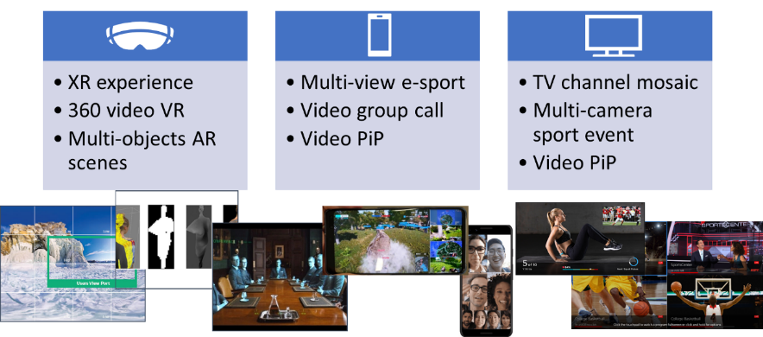
Figure 43 - Example use cases for Video Decoding Interface
An example for a dynamic mesh decoding is shown in Figure 44.
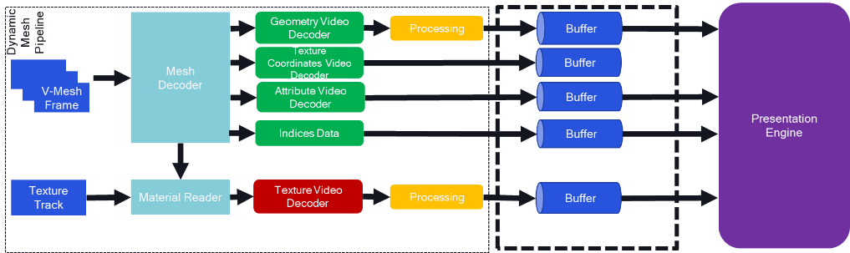
Figure 44 - Example use cases for Video Decoding Interface
Multiple video decoders need to operate in parallel, including a geometry, texture, and attribute decoder. Another decoding instance may be provided for the texture track. In order to operate a decoding platform, there is a need for synchronizing the various video decoder instances.

9.3.3 Background
Typical video decoding stacks for mobile devices are provided in Figure 45.
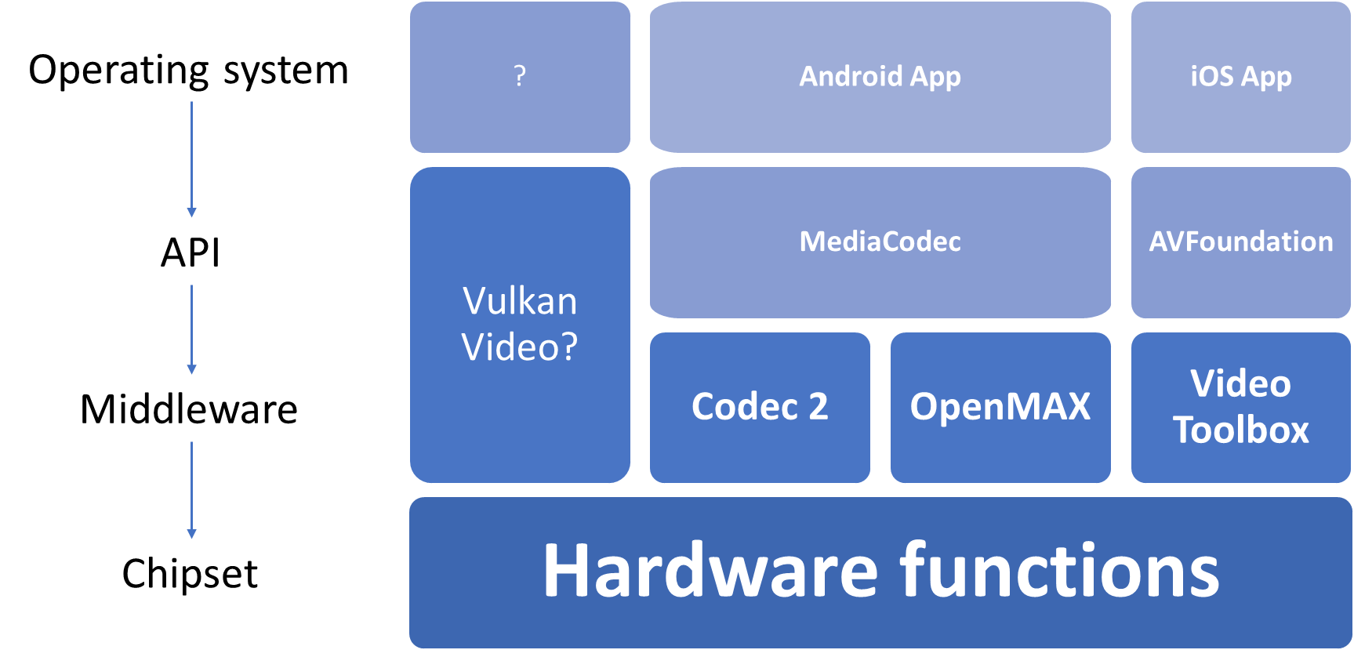
Figure 45 - Video decoding stacks for mobile devices
In this case, applications access codecs through OS APIs, which in itself rely on underlying hardware abstractions such as Khronos OpenMAX, to abstract the chipset and hardware functionalities. Vulkan Video is a new API from Khronos offering such functionalities, however there is no evidence yet of support of Vulkan Video on mobile platforms as opposed to computer desktops, even though the core Vulkan API is supported on Android for instance.
A specific example need to support use cases shown in clause 9.3.2 is provided in Figure 46. An application may instruct a decoder to decode multiple video bitstreams concurrently and provides those for joint GPU processing to generate a viewport.
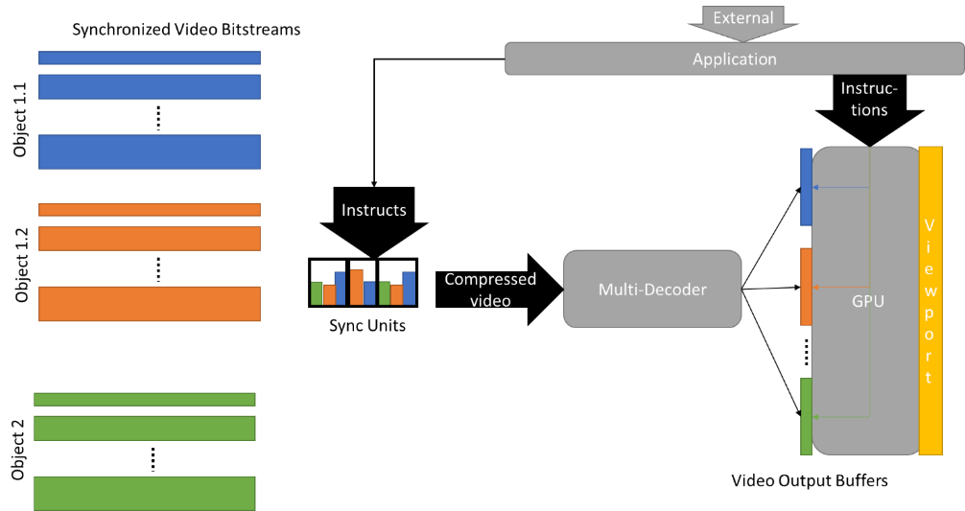
Figure 46 - Multi-decoder support
Preferably, such a configuration of a multi-decoder instance is simple enough for an application to create such workflows.
Current APIs exposing video decoding functions may have the following shortcomings:
- API cannot allocate a group of decoder instances on a SoC for a single application.
- API cannot indicate the maximum number of HW video decoders available for a certain profile and level constraint.
- SoC are underused to guarantee that an app will be able to run based on a minimal requirement, e.g. 1 HW and 1 CPU decoders.
- Higher user experience or lower consumption could be achieved, if no CPU decoders are used.
- Secure rendering pipelines for multi-decoder combination in GPU.
These shortcomings result in challenges for app developers such as lack of interoperability for the processing of concurrent video streams, unavailability of sufficient amount of instances, or synchronized decoder output into swap-chain buffers for concurrent rendering.
ISO/IEC 23090-13 address this issue by extending existing APIs to support multiple video decoders as shown in Figure 47.
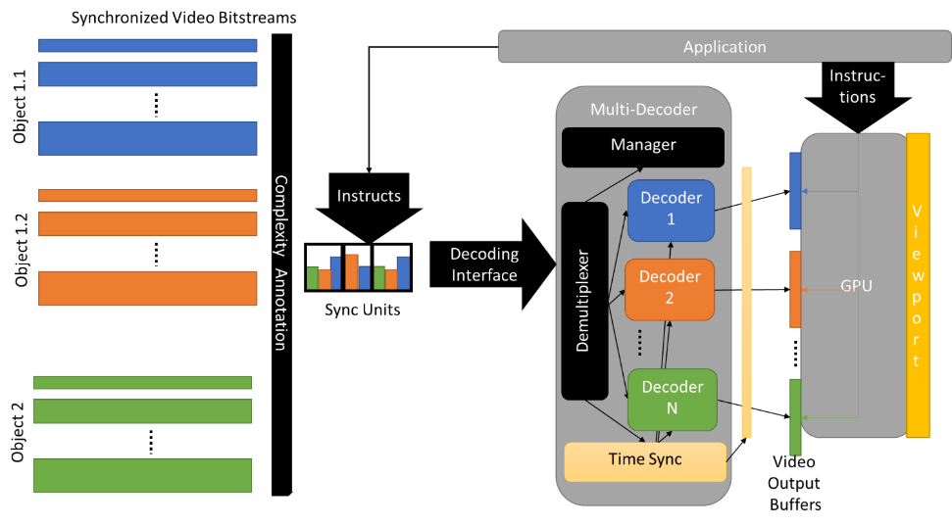
Figure 47 - Multiple decoder management
The manager in the multi-decoder manages the resources to provide time synchronized output buffers to the GPU. In a variant of this, all instructions and decoding are done in a secure hardware pipeline as shown in Figure 48.
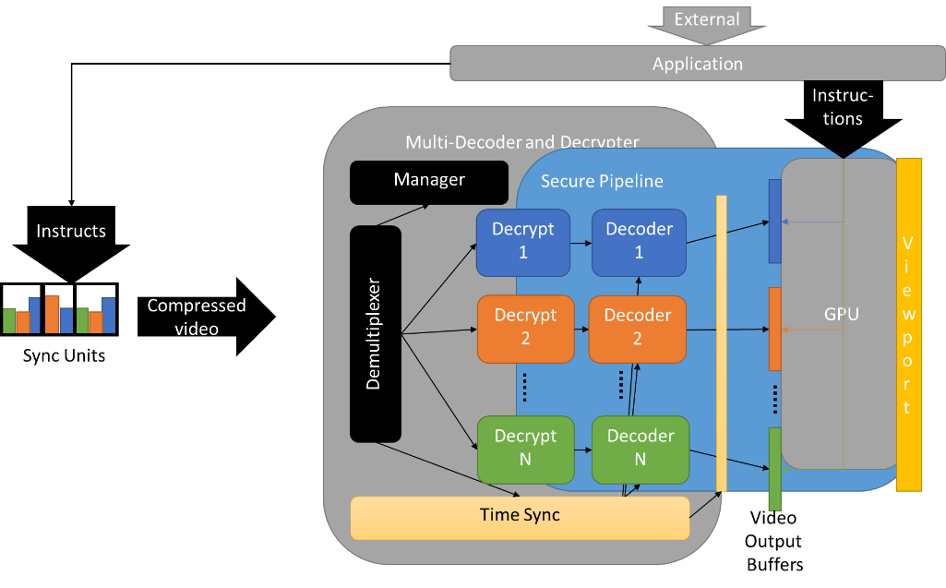
Figure 48 - Multiple decoder management with secure HW pipeline

MPEG-I Video decoding interface as specified in ISO/IEC 23090-13 addresses the challenges and requirements of XR applications, namely:
- 3D object => several components => 2D decoder instance per component
- Decoders for same object need to be synced and paced
- Synchronization at frame accuracy (different from A/V sync)
It provides the following functionalities:
- Manage decoding resources efficiently and with certainty
- Enhance control interface for decoder platform
- Specify pre- and post-processing instructions for input and output
- Abstract API with mappings to
  - OpenMAX
  - WebCodecs
  - Vulkan Video API
The principle architecture is shown in Figure 49.
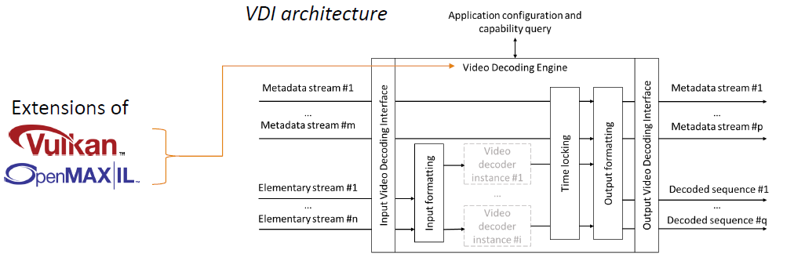
Figure 49 - MPEG-I VDI Architecture
The VDI specification provides abstract API definition using IDL for the following functionalities:
- function to query the instantaneous aggregate capabilities of a decoder platform for a specific codec component
- setting up decoder instances belonging to a same group means that the VDE treats those instances collectively such that the decoding statuses of those instances progress in synchrony and not in competition against each other
- setting up a configuration for the output buffer
- extended parameter settings and query such as subframe output, cropping, or timing.
Extensions of current video decoding API are provided for:
- Mapping on OpenMAX™ Integration Layer (OpenMAX IL)
- Mapping on Vulkan® Video

9.3.5 Relevancy for MECAR
MPEG-I VDI is clearly of relevance of MeCAR functionalities to address several use cases:
- decoding and processing multiple eye buffers, possibly also a depth buffer
- decoding and processing multiple layers
- decoding and processing multiple video streams associated to 3 D objects
- decoding and processing the streams of multiple objects (possibly each with multiple streams)
Hence, beyond the capabilities of video decoding as defined in clauses 4.3.2.2 and 6.6.3, the capabilities should refer to the capabilities as defined in ISO/IEC 23090-13 using terminology and the capability descriptions according to clause 5.4.1.1
The IDL declarations of the queryCurrentAggregateCapabilities() function along with the AggregateCapabilities and PerformancePoint structures and the capabilities flags are defined as follows:
const unsigned long CAP_INSTANCES_FLAG = 0x1;
const unsigned long CAP_BUFFER_MEMORY_FLAG = 0x2;
const unsigned long CAP_BITRATE_FLAG = 0x4;
const unsigned long CAP_MAX_SAMPLES_SECOND_FLAG = 0x8;
const unsigned long CAP_MAX_PERFORMANCE_POINT_FLAG = 0xA;

struct PerformancePoint {
float picture_rate;
unsigned long width;
unsigned long height;
unsigned long bit_depth;
};

struct AggregateCapabilities {
unsigned long flags;
unsigned long max_instances;
unsigned long buffer_memory;
unsigned long bitrate;
unsigned long max_samples_second;
PerformancePoint max_performance_point;
};

AggregateCapabilities queryCurrentAggregateCapabilities (
in string component_name,
in unsigned long flags
);

In addition, the MAF should support
- setting up decoder instances belonging to a same group
- setting up a configuration for the output buffer
- extended parameter settings and query such as subframe output, cropping, or timing.

9.4 Immersive Web applications and runtime

9.4.1 General
The goal of realizing Immersive Web applications by the W3C Immersive Web Working Group [53] is to bring high-performance XR applications to the open Web via APIs. This is achieved in conjunction with the interaction with XR device hardware and sensors in browsers.
The Immersive Web Working Group works together with the Immersive Web Community Group [54] in building the immersive web platform.

9.4.2 Specification work status and overview
The W3C Immersive Web Working Group [53] is chartered to develop recommendations, two of them have progressed in Candidate Recommendation Draft status [55]:
- The WebXR Device API [56] publication is at its 6th Candidate Recommendation Draft status [55], and
- The WebXR Augmented Reality Module [47].

The current charter of the working group is planned to end by July 2024 [57].

9.4.3 WebXR Device API
The goals of WebXR Device API [56] are to enable XR applications on the web by allowing webpages to do the following [58]:
- Detect if XR capabilities are available.
- Query the XR device capabilities.
- Poll the XR device and associated input device state.
- Display imagery on the XR device at the appropriate frame rate.

Given the significant progress (6th candidate recommendation) and the timelines [3] bring this in good alignment with 3GPP specification work in this direction. The following subclauses are mainly focusing on the WebXR Device API [4].

9.4.4 WebXR device model
The XR device model from Clause 2 of [56] is replicated in the following, which already incorporates mobile devices: An XR device is a physical unit of hardware that can present immersive content to the user. Content is considered to be “immersive” if it produces visual, audio, haptic, or other sensory output that simulates or augments various aspects of the user’s environment. Most frequently this involves tracking the user’s motion in space and producing outputs that are synchronized to the user’s movement. On desktop clients, this is usually a headset peripheral. On mobile clients, it may represent the mobile device itself in conjunction with a viewer harness. It may also represent devices without stereo-presentation capabilities but with more advanced tracking.

9.4.5 WebXR Augment Reality Module
WebXR was developed by the W3C group to serve XR experiences in a web environment. A more detailed introduction to WebXR is available under clause 4.9.2.4 of 3GPP TR 26.928 [35] and clause 4.6.4.2 of 3GPP TR 26.998 [1]. The WebXR Augmented Reality module expands the WebXR Device API with the functionality available on compatible AR hardware [47]. This module may be achieved with see-through displays, or video pass-through systems like handheld mobile AR with a phone (Device design type 4 in MeCAR). The extended WebXR Device APIs are summarized below in Table 16.
Table 16 - WebXR Device API integration
WebXR Device API | Extension | Definition
XRSessionMode | Type: enum  Value: "immersive-ar" | The "immersive-ar" session mode indicates that the session’s output will be given exclusive access to the immersive XR device display and that content is intended to be blended with the real-world environment.
XREnvironmentBlendMode | Type: enum  Value: "opaque" | When performing opaque environment blending, the rendered buffers obtained by the XR Compositor are composited using source-over blending on top of buffers containing exclusively 100% opaque black pixels.  Displays: Opaque and Pass-through  Mode: "immersive-vr" or "inline"
XREnvironmentBlendMode | Type: enum  Value: "alpha-blend" | When performing alpha-blend environment blending, the rendered buffers obtained by the XR Compositor are composited using source-over blending on top of buffers containing pixel representations of the real-world environment.  Displays: Pass-through  Mode: "immersive-ar"
XREnvironmentBlendMode | Type: enum  Value: "additive" | When performing additive environment blending, the rendered buffers obtained by the XR Compositor are composited using lighter blending before being presented on the XR device.  Displays: See-through  Mode: "immersive-vr" or "immersive-ar" or "inline"
XRInteraction  Mode | Type: enum  Value: "screen-space" | The XRInteractionMode value of "screen-space" indicates that the UI elements should be drawn directly to the screen without projection, e.g., the UI for handheld phone AR.
XRInteraction  Mode | Type: enum  Value: "world-space" | The XRInteractionMode value of "world-space" indicates that the UI elements should be drawn in the world space, perhaps at some distance from the user's head so that they may interact with it using controllers, e.g., the UI for headworn AR.
XRView -  First Person Observer View | Type: boolean  Value: true | The XRView interface's read-only isFirstPersonObserver property is a boolean indicating if the XRView is a first-person observer view.
Security & Privacy | https://github.com/immersive-web/webxr-ar-module/blob/main/security-privacy-questionnaire.md

The IDL declarations of the WebXR Augmented Reality module are defined as follows:
enum XREnvironmentBlendMode {
"opaque",
"alpha-blend",
"additive"
};
partial interface XRSession {
// Attributes
readonly attribute XREnvironmentBlendMode environmentBlendMode;
};
enum XRInteractionMode {
"screen-space",
"world-space",
};
partial interface XRSession {
// Attributes
readonly attribute XRInteractionMode interactionMode;
};
partial interface XRView {
readonly attribute boolean isFirstPersonObserver;
};

9.4.6 Application Flow
Clause 1.2. of [56] outlines a non-normative application flow, and is reproduced below for information:
Most applications using the WebXR Device API will follow a similar usage pattern:
- Query navigator.xr.isSessionSupported() to determine if the desired type of XR content is supported by the hardware and UA.
- If so, advertise the XR content to the user.
- Wait for the window to have transient activation. This is most commonly indicated by the user clicking a button on the page indicating they want to begin viewing XR content.
- Request an XRSession within the user activation event with navigator.xr.requestSession().
- If the XRSession request succeeds, use it to run a frame loop to respond to XR input and produce images to display on the XR device in response.
- Continue running the frame loop until the session is shut down by the UA or the user indicates they want to exit the XR content.

9.4.7 Software support
The software effort under the "Immersive Web Working Group/Community Group" including source code, sample application etc. is published at [54]. Development experimental work status and progress on Chrome, Edge, Firefox, and Safari browsers is reported regularly at [59].

9.4.8 Existing product support
WebXR is supported by the following products as an example:
- Resources published for visionOS [60] are provided here for information. Interested reader is referred to instructions available at [60] and [61] to explore further on WebXR support.
- As published here at [62], the Meta Quest Browser has added support for WebXR mixed reality services on Meta Quest 2 and Meta Quest Pro headsets since 2022.

9.4.9 Running sample code and application
Samples available on [63] can be tested using guideline at [60] on Safari for visionOS. Note: in order to enable Safari support [61] for WebXR in visionOS 1.0, enable feature flags in Settings -> Apps -> Safari --> Advanced --> Feature Flags. These are turned off by default.

Figure 50 - WebXR support displayed in Safari for visionOS.
Immersive VR Session sample screenshot (source code available at [64]).
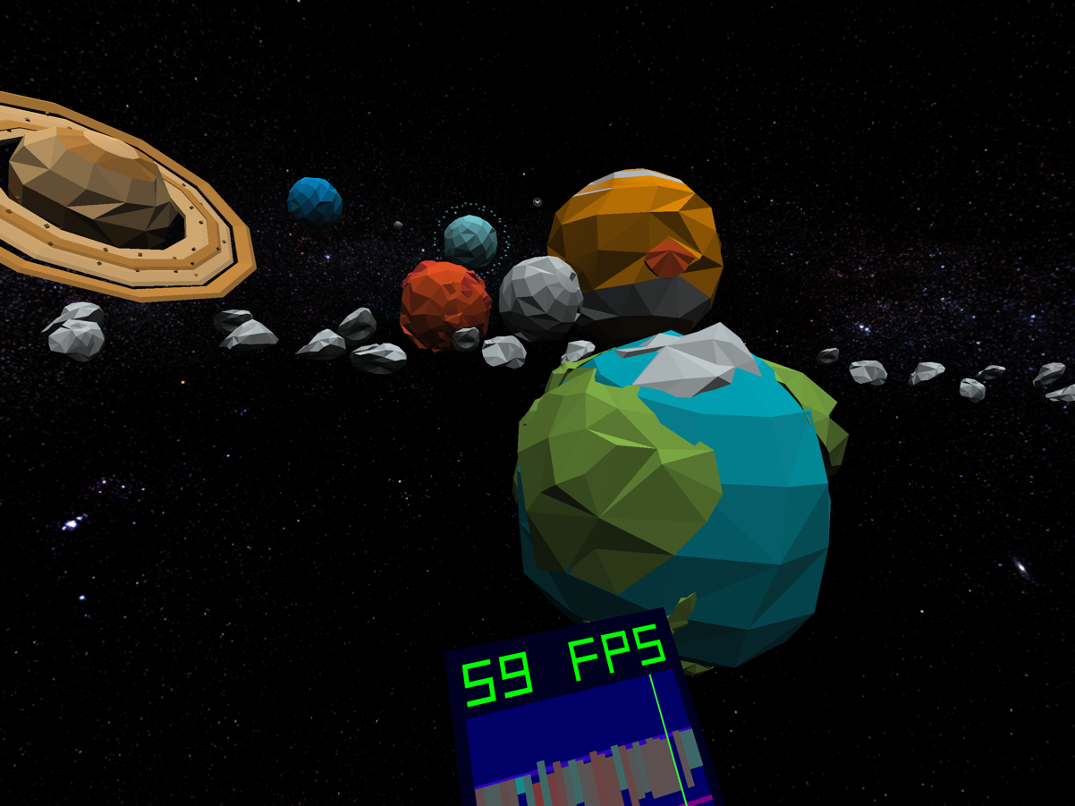

9.5 Overview of media performance definitions on Android

9.5.1 Android media requirements, a.k.a. Compatibility Definition Document (CDD)
The CDD enumerates the software and hardware requirements of a compatible Android device. There are requirements in the core category which means every Android device must comply with. In addition, the CDD also considers different devices types for which specific requirements may be defined. As of the latest version, version 14, the device types are:
- Handheld device
- Television
- Watch
- Automotive
- Tablet

The requirements can set on different topics, for instance:
- Software, including API, libraries, user interface, etc.
- Application Packaging Compatibility, defining the .apk support
- Multimedia Compatibility, covering media codecs, playback network protocols, DRM, etc.
- Developer Tools and Options Compatibility,
- Hardware Compatibility, including display, graphics, input devices, sensors, cameras, etc.
- Performance and Power, including power-saving modes, file I/O, etc.
- Security Model Compatibility, on privacy, multi-user, etc.
- Software Compatibility Testing, requiring the support of test suite execution
- Updatable Software, requiring the device to allow for updates

As of Android 10 (Sep 3, 2019), multimedia requirements merely specified which codec, profile, tier and level to support.
For instance, here are the core requirements for HEVC decoding from the CDD Android 10:
Table 17 - HEVC decoding core requirement in CDD Android 10

5.3.5. H.265 (HEVC)
If device implementations support H.265 codec, they:
- [C-1-1] MUST support the Main Profile Level 3 Main tier and the SD video decoding profiles as indicated in the following table.
- SHOULD support the HD decoding profiles as indicated in the following table.
- [C-1-2] MUST support the HD decoding profiles as indicated in the following table if there is a hardware decoder.
If the height that is reported by the Display.getSupportedModes() method is equal to or greater than the video resolution, then:
- [C-2-1] Device implementations MUST support at least one of H.265 or VP9 decoding of 720, 1080 and UHD profiles.
 | SD (Low quality) | SD (High quality) | HD 720p | HD 1080p | UHD
Video resolution | 352 x 288 px | 720 x 480 px | 1280 x 720 px | 1920 x 1080 px | 3840 x 2160 px
Video frame rate | 30 fps | 30 fps | 30 fps | 30/60 fps  (60 fps) | 60 fps
Video bitrate | 600 Kbps | 1.6 Mbps | 4 Mbps | 5 Mbps | 20 Mbps
If device implementations claim to support an HDR Profile (HEVCProfileMain10HDR10, HEVCProfileMain10HDR10Plus) through the Media APIs:
- [C-3-1] Device implementations MUST accept the required HDR metadata (MediaFormat#KEY_HDR_STATIC_INFO for all HDR profiles) from the application using MediaCodec API, as well as support extracting the required HDR metadata (MediaFormat#KEY_HDR_STATIC_INFO for all HDR profiles, as well as MediaFormat#KEY_HDR10_PLUS_INFO for HDR10Plus profiles) from the bitstream and/or container as defined by the relevant specifications. They MUST also support outputting the required HDR metadata (MediaFormat#KEY_HDR_STATIC_INFO for all HDR profiles) from the bitstream and/or container as defined by the relevant specifications.
- [C-SR] The device implementations are STRONGLY RECOMMENDED to support outputting the metadata MediaFormat#KEY_HDR10_PLUS_INFO for HDR10Plus profiles via MediaCodec#getOutputFormat(int).
- [C-3-2] Device implementations MUST properly display HDR content for HEVCProfileMain10HDR10 profile on the device screen or on a standard video output port (e.g., HDMI).
- [C-SR] Device implementations are STRONGLY RECOMMENDED to properly display HDR content for HEVCProfileMain10HDR10Plus profile on the device screen or on a standard video output port (e.g., HDMI).

As said above, each device type may add further requirement. For instance, still in CDD Android 10, the television device type adds:
Table 18 - HEVC decoding requirement in for Television device type
Television device implementations with H.265 hardware decoders MUST support H.265 decoding, as detailed in Section 5.3.5, at standard video frame rates and resolutions up to and including:
- [5.3.5/T-1-1] HD 1080p at 60 frames per second with Main Profile Level 4.1

In conclusion, the Android media requirement up to Android 10 are for a single decoding instance.

9.5.2 Android performance classes
In Android 11 (Sep 8, 2020), the CDD introduces a new concept which are performance classes. For each Android CDD version, the device may support a certain set of performance classes. It is important to realize that Android version and performance classes are orthogonal and the CDD of an Android version merely defines what classes are allowed for this version.
With this design, it is possible to upgrade an Android device to a certain Android version while the performance class may not change. Since the performance classes are mostly linked to hardware capabilities, certain devices may not be able to guarantee a higher performance class and cannot be simply “updated.” Nevertheless, they may still upgrade to the higher Android version as long as their current performance class is allowed by the higher CDD. This is reflected in Figure 51 [65].

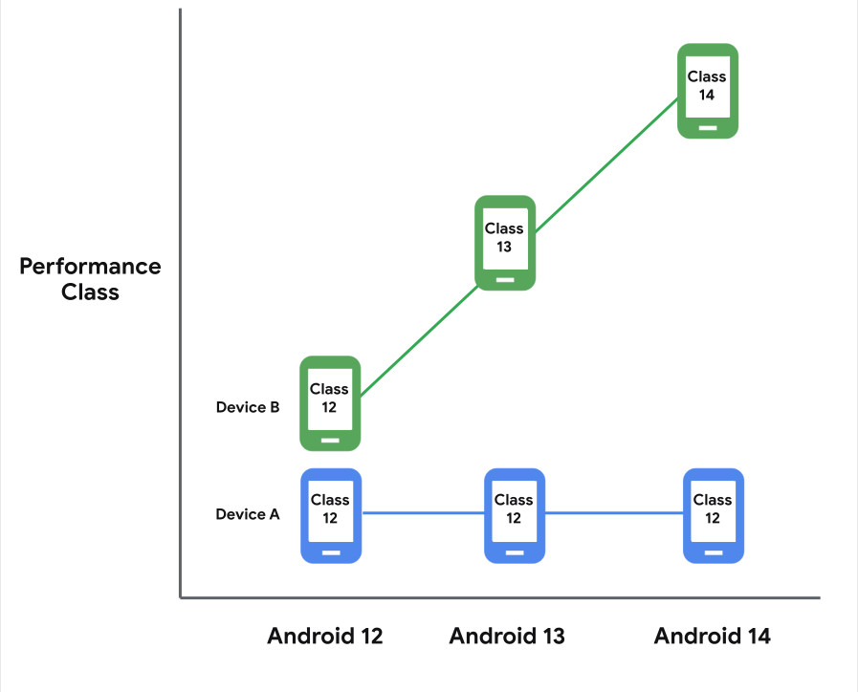
Figure 51 - Possible evolutions of Android versions and performance classes for different devices
As example of performance classes 13 and 12, here is high-level summary found in [66]:

Table 19 - Summary of performance classes 12 and 13 [66]

The interesting aspect of performance classes for handheld devices is that they introduce the support of concurrent instances for decoding but also encoding. For instance, a handheld device type in CDD Android 12 [66] with a performance class S requires that :
Table 20 - Media requirement for performance class S in CDD Android 12
If Handheld device implementations return android.os.Build.VERSION_CODES.S for android.os.Build.VERSION.MEDIA_PERFORMANCE_CLASS, then they:
- [5.1/H-1-1] MUST advertise the maximum number of hardware video decoder sessions that can be run concurrently in any codec combination via the CodecCapabilities.getMaxSupportedInstances() and VideoCapabilities.getSupportedPerformancePoints() methods.
- [5.1/H-1-2] MUST support 6 instances of hardware video decoder sessions (AVC, HEVC, VP9* or later) in any codec combination running concurrently at 720p resolution@30 fps. *Only 2 instances are required if VP9 codec is present.
- […]

As a reminder, here are the two methods mentioned in Table 20.

getSupportedPerformancePoints

Added in API level 29
public List<MediaCodecInfo.VideoCapabilities.PerformancePoint> getSupportedPerformancePoints ()
Returns the supported performance points. May return null if the codec did not publish any performance point information (e.g. the vendor codecs have not been updated to the latest android release). May return an empty list if the codec published that if does not guarantee any performance points.
This is a performance guarantee provided by the device manufacturer for hardware codecs based on hardware capabilities of the device.
The returned list is sorted first by decreasing number of pixels, then by decreasing width, and finally by decreasing frame rate. Performance points assume a single active codec. For use cases where multiple codecs are active, should use that highest pixel count, and add the frame rates of each individual codec.
getMaxSupportedInstances
Added in API level 23
public int getMaxSupportedInstances ()
Returns the max number of the supported concurrent codec instances.
This is a hint for an upper bound. Applications should not expect to successfully operate more instances than the returned value, but the actual number of concurrently operable instances may be less as it depends on the available resources at time of use.
In conclusion, the Android performance classes starting from Android 11 define concurrent decoding instances support. The Android performance class define the support of concurrent decoding instance
in terms of number of concurrent instances at a given resolution and frame rate, regardless of the codec.

9.6 Information on Universal Scene Description (USD)

9.6.1 Overview
The following provides a high-level overview of USD, with more references to see further details.
- USD organizes data into hierarchical namespaces of Prims (short for “primitive”).
- In addition to child prims, each prim can contain Attributes and Relationships, collectively known as Properties.
- Attributes have typed values that can vary over time; Relationships are multi-target “pointers” to other objects in a hierarchy.
- Both prims and properties can also have (non-time-varying) metadata.
- Prims and their contents are organized into a file abstraction known as a Layer.
- Built on top of this low-level, generic scene description, USD provides a set of schemas that establish a standard encoding and client API for common 3D computer graphics concepts like geometry, shading, model and assets.
- For further details on the API and the basic data types, refer to the USD core API documentation [69] and basic data types in [70].

9.6.2 Product support for USD
USD creation and consumption is supported by a variety of devices with iOS, macOS, visionOS [71]. Apple adopted USD in platforms in 2017 and is using USD as the primary format for 3D renderers, Augmented Reality content and 3D content on visionOS. The guidelines at [71] outline creating USD content that works on Apple platforms including macOS, iOS, iPadOS, and visionOS. Furthermore, several Apple AR Creation Tools support USD and allow for a convenient workflow when working with 3D content. Safari also introduced support for 3D Content with the Model element which can embed a USD file into a webpage.
In addition to this, USD has a wide support in many 3D Content Creation Applications and Ecosystems across the industry. Some of the products which support USD are listed at the OpenUSD webpage [75] including Apple, Pixar, Adobe, Unity, Unreal Engine, Autodesk, NVIDIA [72], AMD, Blender Foundation etc.
The importance of USD in the industry is also evident from the fact that on August 1st 2023, Pixar, Adobe, Apple, Autodesk, and NVIDIA, together with the Joint Development Foundation (JDF), an affiliate of the Linux Foundation, launched the Alliance for OpenUSD [73] to promote the standardization, development, evolution, and growth of Universal Scene Description technology.

10 Technical status

10.1 List of elements open for work
The work-in-progress elements are:
- Integration of 3GPP codecs in the EDGAR-type architecture
- Security aspects related to the media capabilities of the EDGAR-type
- Encapsulations into RTP, ISOBMFF and CMAF
- Codec-level parameter for SDP and DASH
- Capability exchange mechanisms to support edge provisioning
- Addition of AR Media Capabilities for 5G Media Streaming
- AR Audio Capabilities

10.2 List of completed elements
The completed elements thus far are:
- None

10.3 List of open issues requiring specific attention
The current open issues that are identified are:
- None

11 References
- 3GPP TR 26.998, “Support of 5G Glass-type Augmented Reality / Mixed Reality (AR/MR) devices”
- 3D Commerce Viewer Certification Program, https://www.khronos.org/3dcommerce/certification/
- Khronos Group 3DC Certification documents, https://github.com/KhronosGroup/3DC-Certification/
- Khronos Group 3DC Certification models, https://github.com/KhronosGroup/3DC-Certification/tree/main/models
- 3GPP TS 26.511, “5G Media Streaming (5GMS); Profiles, codecs and formats”
- 3GPP TS 26.118, “Virtual Reality (VR) profiles for streaming applications”
- OpenXR 1.0 Reference Guide, https://www.khronos.org/files/openxr-10-reference-guide.pdf
- Nreal Glasses Technical Specifications, Online: https://www.nreal.ai/specs/.
- IETF RFC3550, "RTP: A Transport Protocol for Real-Time Applications", July 2003
- IETF RFC8831, "WebRTC Data Channels", January 2021
- The OpenXR Specification, Copyright (c) 2017-2022, The Khronos Group Inc., Version 1.0.25: from git ref release-1.0.25
- Graziosi, D., Nakagami, O., Kuma, S., Zaghetto, A., Suzuki, T., and Tabatabai, A. (2020). An Overview of Ongoing point Cloud Compression Standardization Activities: Video-Based (V-PCC) and Geometry-Based (G-PCC). APSIPA Trans. Signal Inf. Process. 9 (13).
- Schwarz, S., Preda, M., Baroncini, V., Budagavi, M., Cesar, P., Chou, P. A., et al. (2019). Emerging MPEG Standards for Point Cloud Compression. IEEE J. Emerg. Sel. Top. Circuits Syst. 9 (1), 133–148.
- Boyce, J. M., Dore, R., Dziembowski, A., Fleureau, J., Jung, J., Kroon, B., et al. (2021). MPEG Immersive Video Coding Standard. Proc. IEEE 109 (9), 1521–1536.
- Ilola L, Kondrad L, Schwarz S and Hamza A (2022) An Overview of the MPEG Standard for Storage and Transport of Visual Volumetric Video-Based Coding. Front. Sig. Proc. 2:883943. doi: 10.3389/frsip.2022.883943.
- IETF – avtcore, RTP Payload Format for Visual Volumetric Video-based Coding (V3C), https://datatracker.ietf.org/doc/draft-ietf-avtcore-rtp-v3c/, [accessed: 01.02.2023].
- ISO/IEC 23090-29 Information Technology — Coded Representation of Immersive media — Part 29: Video-based dynamic mesh coding (V-DMC).
- Nokia, Video Point Cloud Coding (V-PCC) AR Demo, https://github.com/nokiatech/vpcc, [accessed 01.02.2023].
- S. Schwarz, M. Pesonen, “Real-time Decoding and AR playback of the Merging MPEG Video-based Point Cloud Compression Standard”, International Broadcasting Convention 2019.
- [V-PCC] GPU efficient rendering for mobile platforms, input contribution m52641, MPEG meeting, January 2020.
- Immersive video playback of HEVC bitstream on Intel GPU, input contribution m55800, MPEG meeting, January 2021.
- Promotion of V3C during Set Expo, input contribution m60663, MPEG meeting, September 2022.
- https://s3.amazonaws.com/files.interdigital.com/55bd0288af0b0930ba599bd0c4b7ca38/resources/uploads/resources/Philips_and_InterDigital_Showcasing_SBTVD_TV_30_technologies_at_SET_expo_2022.pdf.
- BOG Report on Scene Description for MPEG-I, input contribution m61243, MPEG meeting, October 2022.
- https://www.nreal.ai.
- S4-230073, [iRTCW] An implementation of real-time V3C streaming for conversational scenario, Nokia Corporation, 3GPP TSG SA WG 4 meeting # 122, February 2023.
- https://azure.microsoft.com/en-us/products/kinect-dk/.
- [PCC] On V-PCC decoder output conformance, input contribution m44728, MPEG meeting, October 2018.
- V-PCC level considerations, input contribution m50998, MPEG meeting, October 2019.
- Subjective verification test report for V-PCC, ISO/IEC JTC1/SC29/WG7, MDS 20992, Output document, October 2021.
- V. K. M. Vadakital, A. Dziembowski, G. Lafruit, F. Thudor, G. Lee, P. Rondao Alface, “The MPEG immersive video standard—current status and future outlook”, IEEE multimedia 29(3), 2022, pp. 101-111.
- glTF 2.0 specification https://registry.khronos.org/glTF/specs/2.0/glTF-2.0.html
- MPEG-I Scene Description, White Paper https://www.mpeg.org/wp-content/uploads/mpeg_meetings/140_Mainz/w22138.zip
- ISO - ISO/IEC DIS 23090-13 - Information technology — Coded representation of immersive media — Part 13: Video decoding interface for immersive media, https://www.iso.org/standard/80899.html
- 3GPP TR 26.928, “Extended Reality (XR) in 5G”
- ISO/IEC JTC 1/SC 29/WG 03 N0859, “Potential improvement of ISO/IEC 23090-14 DAM 1 Support for immersive media codecs in scene description”, 2023-05-17
- ISO/IEC JTC 1/SC 29/WG 03 N0861, “Potential improvements of ISO/IEC 23090-14 CDAM 2 Support for haptics, augmented reality, avatars, interactivity, MPEG-I audio and lighting”
- glTF/README.md at main · KhronosGroup/glTF · GitHub, https://github.com/KhronosGroup/glTF/blob/main/extensions/README.md
- SMPTE, C. Guede, P. Andrivon, J. -E. Marvie, J. Ricard, B. Redmann and J. -C. Chevet, "V-PCC Performance Evaluation of the First MPEG Point Codec," in SMPTE Motion Imaging Journal, vol. 130, no. 4, pp. 36-52, May 2021, doi: 10.5594/JMI.2021.3067962, V-PCC Performance Evaluation of the First MPEG Point Codec | SMPTE Journals & Magazine | IEEE Xplore
- ISO/IEC JTC 1/SC 29/WG 04 N0341, Verification test report of MPEG immersive video
- C. Guede, R. Schaefer, and IBC 2019, Sep. 2019. [Online], Available: https://www.interdigital.com/videos/v--pcc-the-firstmpeg-codec-for-point-cloud-compression
- World’s first real-time encoder development for point-cloud-compression compliant with the latest international standard. | KDDI Research, Inc. (kddi-research.jp), https://www.kddi-research.jp/english/newsrelease/2022/102401.html
- S4-230807, Update on V3C Implementations for AR conversational Tdoc, SA4#124
- m63058, Real-time decoding and rendering demo on a smart phone, input contribution, MPEG meeting, April 2023
- m63047, Demonstration of the bullet time concept, input contribution, MPEG meeting, April 2023.
- m63112, Prototype MIV player for demonstration, input contribution, MPEG meeting, April 2023.
- W3C, "WebXR Augmented Reality Module - Level 1", Editor’s Draft, https://immersive-web.github.io/webxr-ar-module/
- ISO/IEC 14496-10:2022, Information technology — Coding of audio-visual objects — Part 10: Advanced video coding
- ISO/IEC 23008-2:2020, Information technology — High efficiency coding and media delivery in heterogeneous environments — Part 2: High efficiency video coding
- ISO/IEC 23090-2:2023, Information technology — Coded representation of immersive media — Part 2: Omnidirectional media format
- OpenXR Guide, Frame submission section: https://github.com/KhronosGroup/OpenXR-Guide/blob/main/chapters/frame_submission.md
- Unity User Manual: Order of execution for event functions: https://docs.unity3d.com/2023.2/Documentation/Manual/ExecutionOrder.html
- Immersive Web Working Group, https://www.w3.org/groups/wg/immersive-web/, https://www.w3.org/immersive-web/
- The Immersive Web Working Group/Community Group, https://immersive-web.github.io
- Immersive Web Working Group – Publications, https://www.w3.org/groups/wg/immersive-web/publications/
- WebXR Device API, https://www.w3.org/TR/webxr/
- Immersive Web Working Group Charter, https://www.w3.org/2022/07/immersive-web-wg-charter.html
- WebXR Device API Explained, https://github.com/immersive-web/webxr/blob/master/explainer.md
- WebXR web-platform-tests dashboard, https://wpt.fyi/results/webxr?label=master&label=experimental&aligned
- Discover visionOS, https://developer.apple.com/visionos/
- Meet Safari for spatial computing, https://developer.apple.com/videos/play/wwdc2023/10279/
- Mixed Reality Support in Meta Quest Browser, https://developer.oculus.com/documentation/web/webxr-mixed-reality/
- WebXR Sample pages, https://immersive-web.github.io/webxr-samples/
- immersive-vr-session, source code: https://github.com/immersive-web/webxr-samples/blob/main/immersive-vr-session.html
- Performance class | App quality | Android Developers, https://developer.android.com/topic/performance/performance-class
- Android 12 Compatibility Definition | Android Open Source Project, https://source.android.com/docs/compatibility/12/android-12-cdd#2271_media
- ["Universal Scene Description," https://www.openusd.org/release/index.html#
- "Introduction to USD," https://www.openusd.org/release/intro.html#
- "Usd : Universal Scene Description (Core)," https://www.openusd.org/release/api/usd_page_front.html
- "Basic Datatypes for Scene Description Provided by Sdf," https://www.openusd.org/release/api/_usd__page__datatypes.html
- "Creating USD files for Apple devices," https://developer.apple.com/documentation/realitykit/creating-usd-files-for-apple-devices
- "Building the Open Metaverse With Universal Scene Description," https://www.nvidia.com/en-us/omniverse/usd/
- "Alliance for OpenUSD," https://aousd.org
- "Explore the USD ecosystem" Apple WWDC23: https://developer.apple.com/videos/play/wwdc2023/10086/
- "Products Using USD," https://openusd.org/release/usd_products.html

Annex A – Additional information on MIV metadata
Table 17 - Patch data unit syntax as defined in ISO/IEC 23090-5
patch_data_unit( tileID, patchIdx ) { | Descriptor
pdu_2d_pos_x[ tileID ][ patchIdx ] | ue(v)
pdu_2d_pos_y[ tileID ][ patchIdx ] | ue(v)
pdu_2d_size_x_minus1[ tileID ][ patchIdx ] | ue(v)
pdu_2d_size_y_minus1[ tileID ][ patchIdx ] | ue(v)
pdu_3d_offset_u[ tileID ][ patchIdx ] | u(v)
pdu_3d_offset_v[ tileID ][ patchIdx ] | u(v)
pdu_3d_offset_d[ tileID ][ patchIdx ] | u(v)
if( asps_normal_axis_max_delta_value_enabled_flag )
pdu_3d_range_d[ tileID ][ patchIdx ] | u(v)
pdu_projection_id[ tileID ][ patchIdx ] | u(v)
pdu_orientation_index[ tileID ][ patchIdx ] | u(v)
if( afps_lod_mode_enabled_flag ) {
pdu_lod_enabled_flag[ tileID ][ patchIdx ] | u(1)
if( pdu_lod_enabled_flag[ tileID ][ patchIdx ] ) {
pdu_lod_scale_x_minus1[ tileID ][ patchIdx ] | ue(v)
pdu_lod_scale_y_idc[ tileID ][ patchIdx ] | ue(v)
}
}
if( asps_plr_enabled_flag )
plr_data( tileID, patchIdx )
if( asps_miv_extension_present_flag )
pdu_miv_extension( tileID, patchIdx ) /* Specified in ISO/IEC 23090-12 */
}

Table 18 - Depth quantization syntax as defined in ISO/IEC 23090-12
depth_quantization( v ) { | Descriptor
dq_quantization_law[ v ] | ue(v)
if( dq_quantization_law[ v ] == 0 ) {
dq_norm_disp_low[ v ] | fl(32)
dq_norm_disp_high[ v ] | fl(32)
}
dq_depth_occ_threshold_default[ v ] | ue(v)
}
Table 19 - Camera intriniscs syntax as defined in ISO/IEC 23090-12
camera_intrinsics( v ) { | Descriptor
ci_cam_type[ v ] | u(8)
ci_projection_plane_width_minus1[ v ] | u(16)
ci_projection_plane_height_minus1[ v ] | u(16)
if( ci_cam_type[ v ] == 0 ) { /* equirectangular */
ci_erp_phi_min[ v ] | fl(32)
ci_erp_phi_max[ v ] | fl(32)
ci_erp_theta_min[ v ] | fl(32)
ci_erp_theta_max[ v ] | fl(32)
} else if( ci_cam_type[ v ] == 1 ) { /* perspective */
ci_perspective_focal_hor[ v ] | fl(32)
ci_perspective_focal_ver[ v ] | fl(32)
ci_perspective_principal_point_hor[ v ] | fl(32)
ci_perspective_principal_point_ver[ v ] | fl(32)
} else if( ci_cam_type[v] == 2 ) { /* orthographic */
ci_ortho_width[ v ] | fl(32)
ci_ortho_height[ v ] | fl(32)
}
}
Table 20 - Camera extrinsics syntax as defined in ISO/IEC 23090-12
camera_extrinsics( v ) { | Descriptor
ce_view_pos_x[ v ] | fl(32)
ce_view_pos_y[ v ] | fl(32)
ce_view_pos_z[ v ] | fl(32)
ce_view_quat_x[ v ] | i(32)
ce_view_quat_y[ v ] | i(32)
ce_view_quat_z[ v ] | i(32)
}

Table 21 - An example of SDP RGBD content deliver as packed V3C video component over RTP
v=0
o=- 20518 0 IN IP4 203.0.113.1
s=
c=IN IP4 203.0.113.1
t=0 0
m=video 5002 RTP/AVP 97
a=rtpmap:97 H265/90000
a=fmtp:97 profile-id=1;packetization-mode=1;v3c-unit-header=KAAAAA==;v3c-parameter-set=AUH/AAAP/zwAAAAAACgIAtEAgQLAIAAUQBACWAM5QEDgQCAIAAAAABP8CzwAAAAAAAAAQAAAtAE/wLPAAAAAAAg=;v3c-atlas-data=SAGAFAQBaKjuXgABQEKA,SgHmIA==,LgFoDOAFAABaAAAAAAA+;v3c-common-atlas-data=YAEHgFA=,YgEAMAAAC/B0qcvv/Dbr/pTvb8oqfhC5JQVS9jn7kAQT/As9EFyrjRBcmxEQe+j5DuGbTT9mZmZAQAAAoA==
a=sendonly

Table 22 - An log of V3C data related to atlas that provide information about RGBD data stored as packed video V3C component
INFO:Container:
profile_tier_level = Container:
ptl_tier_flag = 0
ptl_profile_codec_group_idc = 1
ptl_profile_toolset_idc = 65
ptl_profile_reconstruction_idc = 255
ptl_reserved_zero_16bits = 0
ptl_max_decodes_idc = 0
ptl_reserved_0xfff_12bits = 4095
ptl_level_idc = 60
ptl_num_sub_profiles = 0
ptl_extended_sub_profile_flag = 0
ptl_sub_profile_idc = None
ptl_toolset_constraints_present_flag = 0
vps_v3c_parameter_set_id = 0
vps_reserved_zero_8bits = 0
vps_atlas_count_minus1 = 0
vps_atlas_information = ListContainer:
Container:
vps_atlas_id = 0
vps_frame_width = 1280
vps_frame_height = 720
vps_map_count_minus1 = 0
vps_auxiliary_video_present_flag = 0
vps_occupancy_video_present_flag = 0
vps_geometry_video_present_flag = 0
vps_attribute_video_present_flag = 0
vps_extension_present_flag = 1
vps_extension_count = 2
vps_extensions_length_minus1 = 43
vps_extensions_information = ListContainer:
Container:
vps_extension_type = 2
vps_extension_length = 1
vps_extension = Container:
vme_geometry_scale_enabled_flag = 0
vme_embedded_occupancy_enabled_flag = 1
gm_group_count = 1
gm_group_id = ListContainer:
0
Container:
vps_extension_type = 1
vps_extension_length = 37
vps_extension = Container:
packing_information = ListContainer:
Container:
vps_packed_video_present_flag = 1
packing_information = Container:
pin_codec_id = 0
pin_occupancy_present_flag = 0
pin_geometry_present_flag = 1
pin_attribute_present_flag = 1
pin_geometry_information = Container:
pin_geometry_2d_bit_depth_minus1 = 7
pin_geometry_msb_align_flag = 0
pin_geometry_3d_coordinates_bit_depth_minus1 = 10
pin_attribute_information = Container:
pin_attribute_count = 1
pin_attribute_entry = ListContainer:
Container:
pin_attribute_type_id = 0
pin_attribute_2d_bit_depth_minus1 = 7
pin_attribute_msb_align_flag = 0
pin_attribute_map_absolute_coding_persistence_flag = 0
pin_attribute_dimension_minus1 = 2
pin_attribute_dimension_partitions_minus1 = 0
pin_regions_count_minus1 = 1
pin_regions_information = ListContainer:
Container:
pin_region_tile_id = 0
pin_region_type_id_minus2 = 2
pin_region_top_left_x = 0
pin_region_top_left_y = 0
pin_region_width_minus1 = 1279
pin_region_height_minus1 = 719
pin_region_unpack_top_left_x = 0
pin_region_unpack_top_left_y = 0
pin_region_rotation_flag = 0
pin_region_map_index = 0
pin_region_auxiliary_data_flag = 0
pin_region_attr_index = 0
pin_region_attr_partition_index = 0
Container:
pin_region_tile_id = 0
pin_region_type_id_minus2 = 1
pin_region_top_left_x = 0
pin_region_top_left_y = 720
pin_region_width_minus1 = 1279
pin_region_height_minus1 = 719
pin_region_unpack_top_left_x = 0
pin_region_unpack_top_left_y = 0
pin_region_rotation_flag = 0
pin_region_map_index = 0
pin_region_auxiliary_data_flag = 0
byte_alignment = Container:
alignment_bit_equal_to_one = 1
alignment_bit_equal_to_zero = 0
INFO:Container:
casps_common_atlas_sequence_parameter_set_id = 0
casps_log2_max_common_atlas_frame_order_cnt_lsb_minus4 = 2
casps_extension_present_flag = 1
casps_miv_extension_present_flag = 1
casps_extension_7bits = 0
casps_miv_extension = Container:
casme_depth_low_quality_flag = 0
casme_depth_quantization_params_present_flag = 1
casme_vui_params_present_flag = 0
rbsp_trailing_bits = Container:
rbsp_stop_one_bit = 1
rbsp_alignment_zero_bit = 0
INFO:Container:
caf_common_atlas_sequence_parameter_set_id = 0
caf_common_atlas_frm_order_cnt_lsb = 0
caf_extension_present_flag = 1
caf_miv_extension_present_flag = 1
caf_extension_7bits = 0
caf_miv_extension = Container:
miv_extension_info = Container:
mvp_num_views_minus1 = 0
mvp_explicit_view_id_flag = 0
camera_extrinsics = ListContainer:
Container:
camera_extrinsics = Container:
ce_view_pos_x = -0.52848219871521
ce_view_pos_y = -0.4995378851890564
ce_view_pos_z = -1.8227221965789795
ce_view_quat_x = -56449055
ce_view_quat_y = 194138197
ce_view_quat_z = 795058105
mvp_inpaint_flag = 0
mvp_intrinsic_params_equal_flag = 0
camera_intrinsics = ListContainer:
Container:
ci_cam_type = 1
ci_projection_plane_width_minus1 = 1279
ci_projection_plane_height_minus1 = 719
ci_camera_intrinsics = Container:
ci_perspective_focal_hor = 604.6701049804688
ci_perspective_focal_ver = 604.605712890625
ci_perspective_principal_point_hor = 635.9100341796875
ci_perspective_principal_point_ver = 368.8033142089844
mvp_depth_quantization_params_equal_flag = 0
depth_quantization = ListContainer:
Container:
dq_quantization_law = 0
dq_norm_disp_low = 0.8999999761581421
dq_norm_disp_high = 3.0
dq_depth_occ_threshold_default = 0
mvp_pruning_graph_params_present_flag = 0
rbsp_trailing_bits = Container:
rbsp_stop_one_bit = 1
rbsp_alignment_zero_bit = 0
INFO:Container:
asps_atlas_sequence_parameter_set_id = 0
asps_frame_width = 1280
asps_frame_height = 720
asps_geometry_3d_bit_depth_minus1 = 10
asps_geometry_2d_bit_depth_minus1 = 7
asps_log2_max_atlas_frame_order_cnt_lsb_minus4 = 2
Log2MaxAtlasFrmOrderCntLsb = 6
MaxAtlasFrmOrderCntLsb = 64
asps_max_dec_atlas_frame_buffering_minus1 = 0
asps_long_term_ref_atlas_frames_flag = 0
asps_num_ref_atlas_frame_lists_in_asps = 1
ref_list_struct = ListContainer:
Container:
num_ref_entries = 0
asps_use_eight_orientations_flag = 1
asps_extended_projection_enabled_flag = 1
asps_max_number_projections_minus1 = 0
asps_normal_axis_limits_quantization_enabled_flag = 0
asps_normal_axis_max_delta_value_enabled_flag = 0
asps_patch_precedence_order_flag = 0
asps_log2_patch_packing_block_size = 0
PatchPackingBlockSize = 1
asps_patch_size_quantizer_present_flag = 0
asps_map_count_minus1 = 0
asps_pixel_deinterleaving_enabled_flag = 0
asps_raw_patch_enabled_flag = 0
asps_eom_patch_enabled_flag = 0
asps_plr_enabled_flag = 0
asps_plr_information = None
asps_vui_parameters_present_flag = 0
asps_extension_present_flag = 1
asps_vpcc_extension_present_flag = 0
asps_miv_extension_present_flag = 1
asps_extension_6bits = 0
asps_miv_extension = Container:
asme_ancillary_atlas_flag = 0
asme_embedded_occupancy_enabled_flag = 1
asme_depth_occ_threshold_flag = 0
asme_geometry_scale_enabled_flag = 0
asme_patch_constant_depth_flag = 0
asme_patch_attribute_offset_enabled_flag = 0
asme_max_entity_id = 0
asme_inpaint_enabled_flag = 0
rbsp_trailing_bits = Container:
rbsp_stop_one_bit = 1
rbsp_alignment_zero_bit = 0
INFO:Container:
afps_atlas_frame_parameter_set_id = 0
afps_atlas_sequence_parameter_set_id = 0
atlas_frame_tile_information = Container:
afti_single_tile_in_atlas_frame_flag = 1
afti_signalled_tile_id_flag = 0
NumTilesInAtlasFrame = 1
AftiSignalledTileIDBitCount = 0
afti_tile_id = None
afps_output_flag_present_flag = 0
afps_num_ref_idx_default_active_minus1 = 0
NumRefIdxActive = 1
afps_additional_lt_afoc_lsb_len = 0
afps_lod_mode_enabled_flag = 0
afps_raw_3d_offset_bit_count_explicit_mode_flag = 0
afps_extension_present_flag = 0
rbsp_trailing_bits = Container:
rbsp_stop_one_bit = 1
rbsp_alignment_zero_bit = 0
INFO:Container:
atlas_tile_header = Container:
ath_no_output_of_prior_atlas_frames_flag = 0
ath_atlas_frame_parameter_set_id = 0
ath_atlas_adaptation_parameter_set_id = 0
ath_id = None
ath_type = 1
ath_atlas_output_flag = None
ath_atlas_frm_order_cnt_lsb = 0
ath_ref_atlas_frame_list_asps_flag = 1
ath_non_skip_tile = Container:
AthPosMinDQuantizer = 0
byte_alignment = Container:
alignment_bit_equal_to_one = 1
alignment_bit_equal_to_zero = 0
atlas_tile_data_unit = ListContainer:
Container:
atdu_patch_mode = 0
patch_information_data = Container:
patch_data = Container:
pdu_2d_pos_x = 0
pdu_2d_pos_y = 0
pdu_2d_size_x_minus1 = 1279
pdu_2d_size_y_minus1 = 719
pdu_3d_offset_u = 0
pdu_3d_offset_v = 0
pdu_3d_offset_d = 0
pdu_3d_range_d = None
pdu_projection_id = 0
pdu_orientation_index = 0
Container:
atdu_patch_mode = 14
rbsp_trailing_bits = Container:
rbsp_stop_one_bit = 1
rbsp_alignment_zero_bit = 0

