January 31, 2023

**Invitation to the 3GPP SA3#89-LI Meeting**

**25-28 April, 2023**

**Washington DC, USA**

Dear Colleagues,

I am pleased to invite you to the 3GPP SA3#89-LI meeting, which will be held in Washington, DC, US.

Meeting start: Tuesday 25 April 2023, 09:00.

Meeting end: Friday 28 April 2023, 13:00.

The meeting will be held at **ATIS, Alliance for Telecommunications Industry Solutions.**

Address:1200 G St, NW Washington, DC.

A **limited room block** has been made at **Washington Marriot at Metro Center**.

Address: 775 12th Street, NW, Washington, DC. **This hotel is 2-minute walk from ATIS.**

**Link to reserve a room at a rate of $319 USD + tax:** [**https://book.passkey.com/e/50479039**](https://book.passkey.com/e/50479039)**.**

It is **mandatory to register for the meetings** on the 3GPP website. This provides the MCC and meeting planners with important planning information critical to the success of your meeting. The registration form can be found on the 3GPP website. Please take a moment after making your hotel reservations and visit [www.3gpp.org](http://www.3gpp.org) to register online. **Please be sure to print your name badge prior to the meeting and bring a badge holder. Badges must be worn at all times.** Name badges are longer be provided at meetings.

We are looking forward to seeing you in Washington, DC.

Sincerely,

Alex Leadbeater, Chair, [aleadbeater@gsma.com](mailto:aleadbeater@gsma.com)

Carmine (Lino) Rizzo, Technical Officer and Secretary, [carmine.rizzo@etsi.org](mailto:carmine.rizzo@etsi.org)

**VISA APPLICATION GUIDANCE FOR U.S. MEETINGS**

Thank you for your interest in traveling to Washington, DC to participate in the 3GPP SA3-LI meeting. The U.S. visa application process is significantly different than the process in many other countries. The following guidance is intended for delegates planning to attend U.S.-hosted meetings to more clearly understand the process for application.

**Step One: Be Informed**

We urge you to carefully review all the information on procedures for non-immigrant visa application provided by the U.S. State Department. The following online location provides an official source of information about U.S. visa policy and procedures: <https://travel.state.gov/content/travel/en/us-visas.html>

Please follow all instructions provided on the website for your local U.S. Embassy or Consulate General website to avoid costly delays.

U.S. visa policy permits citizens of certain countries to travel to the U.S. without a visa. For information about whether you may require a visa, please find such information at the following location online:

<https://travel.state.gov/content/travel/en/us-visas/tourism-visit/visa-waiver-program.html>

Please remember that your application must be submitted through the U.S. Embassy or Consulate General that has jurisdiction over your place of residence.The following is a link to the list of all U.S. Embassies and Consulates worldwide: <https://www.usembassy.gov/>

**Step Two: Apply Early**

Due to potentially long wait times for a visa interview and possible requirements for additional processing, applicants are encouraged to begin the visa application process as early as possible – no less than 30 days and **ideally** **at least 90 days in advance of the intended travel.** Wait times for a visa interview can range from a few days to several months, depending on location and time of year.

Applicants engaged in certain sensitive scientific or technical fields may be subject to additional administrative processing procedures, which can add additional time to the visa application procedures, in some cases up to 120 days.

**Step Three: Be Prepared**

Applicants for U.S. visas should come to the visa interview with a thorough understanding of their travel plans and logistics. They should bring their invitation letter, copies of meeting agendas, travel itineraries and other documents on official letterhead, as well as documentation to help demonstrate “strong ties” to their home country. For information on what constitutes “strong ties”, please see:   
  
<https://travel.state.gov/content/travel/en/us-visas/visa-information-resources/visa-denials.html>

* INA Section 214(b) – Visa Qualifications and Immigrant Intent

**\*\*\*VISA INVITATION LETTER REQUEST\*\*\***

**If a visa invitation letter is required for your travel to Washington, DC, please complete the following online form:**

[**https://www.atis.org/international-partnerships/3gpp/dc-2023-visa-letter-request/**](https://www.atis.org/international-partnerships/3gpp/dc-2023-visa-letter-request/)

After you enter your personal information, the completed form will be automatically processed. Signed letters will be returned via email. The invitation letter cannot be completed without including your hotel information and confirmation number. Letters may take up to 14 working days to be processed. Please note, after March 24, 2023 hard copies of the invitation letter will not be physically sent. They will only be sent via email.

**If you have not received your letter within 14 working days, or if you have any changes or questions after receiving your emailed letter, please contact:** Elaine Jakins at [visas@atis.org](mailto:visas@atis.org).

# 

# **ANNEX – LOCATION MAP**

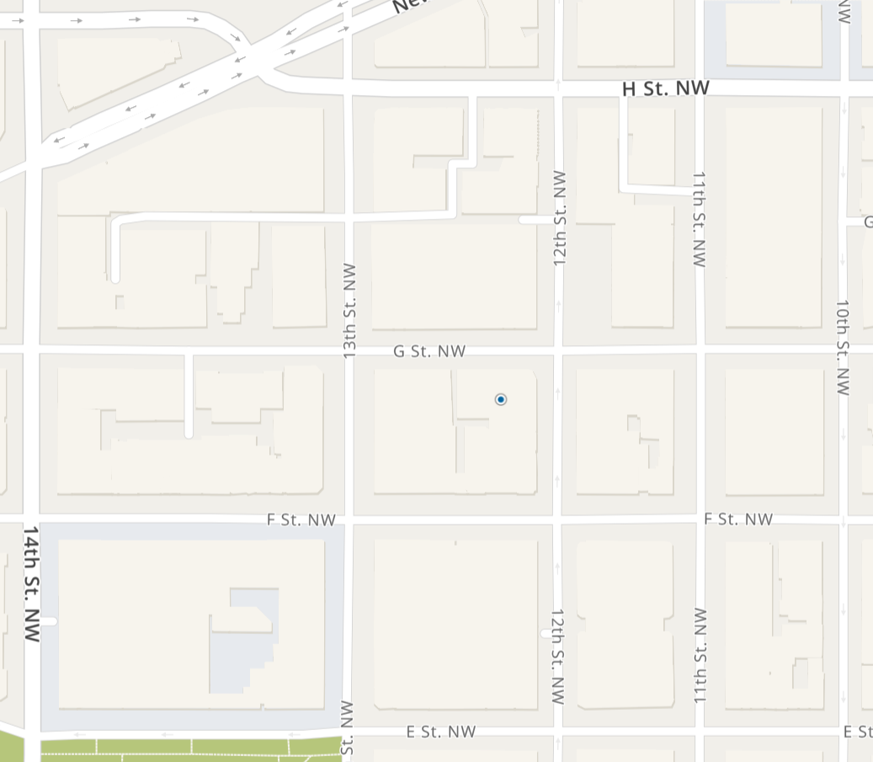

Map credit: MapQuest

[**https://goo.gl/maps/fsBNXbSiqCr3jqc9A**](https://goo.gl/maps/fsBNXbSiqCr3jqc9A)